Asynchronous FIFO -RX Functional Design Specifications
  - Design and Implementation of CSI Controller IP
  - Version 4.0.1

  - Block Owner
Hana Samy Ahmed
  - Authors
Hana Samy Ahmed

This Page is left Blank Intentionally

Table of Contents
1 Table of Contents 1
2 Revision History 2
3 Overview 3
4 Operation and Description 3
4.1 Digital Interface 3
4.1.1 Parameters Names 3
4.1.2 Ports Names 3
4.2 Functional Description 3
4.3 Block Diagram 3
4.4 Timing Diagram 3
4.5 Verification Requirements 3

Revision History
Version | Date | Author(s) | Revision Notes | Owner Approval
1 | 6-2-2026 | Hana Samy
2 | 14-6-2026 | Hana Samy | V1 area-optimized update: reduced P_FIFO_DEPTH default from 1024 to 64 to match the RTL DEPTH parameter. Updated the Parameters table, Flow Control description, and Verification Requirements to reflect that this FIFO no longer buffers a full line and depends on the downstream AXI Streaming-TX block’s Cut-Through mode to drain it in time.

Overview
The Asynchronous FIFO serves as the Clock Domain Crossing (CDC) bridge between the Video Receiver domain (RX Clock) and the System AXI domain (AXI Clock).
Its primary purpose is to buffer pixel data arriving from the Unpacker (at the potentially variable or bursty RX rate) and allow the AXI Streaming Bridge to read it at the steady system clock rate. It ensures data integrity across the asynchronous boundary using Gray-code pointer synchronization.

Operation and Description

Digital Interface

Parameters Names
Parameter Name | Default | Description
P_DATA_WIDTH | 24 | Must match Unpacker P_PIX_WIDTH.
P_FIFO_WIDTH | 26 | With the two sideband signals
P_FIFO_DEPTH | 64 | Buffer depth. Reduced from 1024 to 64 words for area optimization (V1 area-optimized configuration). At this depth the FIFO no longer buffers a full line and relies on the downstream AXI Streaming-TX block’s Cut-Through mode (STORE_FULL_LINE = 0) to begin draining the FIFO before it fills.

Ports Names
Port Name | Port Width | Port Type | Description
Write Domain (RX)
i_w_clk | 1 | Input | Connects to i_clk_rx.
i_w_rst_n | 1 | Input | Connects to i_rst_n.
i_w_data | 24 | Input | Pixel Data from Unpacker.
i_w_last | 1 | Input | EOL Flag from Unpacker.
i_w_user | 1 | Input | SOF Flag from Unpacker.
i_w_valid | 1 | Input | Valid flag from Unpacker.
Read Domain (AXI)
i_r_clk | 1 | Input | Connects to System AXI Clock.
w | 24 | Output | Pixel Data. (Connects to Bridge i_pix_data).
o_r_last | 1 | Output | Pixel EOL. (Connects to Bridge i_pix_last).
o_r_user | 1 | Output | Pixel SOF. (Connects to Bridge i_pix_user).
o_r_valid | 1 | Output | Pixel Valid. (Connects to Bridge i_pix_valid).
i_r_ready | 1 | Input | Read Ready. (Connects to Bridge o_pix_ready).

Functional Description
The block is implemented as a standard dual-clock RAM-based FIFO.
- Storage:
  - The internal memory width corresponds to the aggregate width of the data signals: P_DATA_WIDTH (24) + User (1) + Last (1).
  - Pixel data is stored compactly as 24-bit entries.
- Clock Domain Crossing (CDC):
  - Write Pointer: Generated in i_w_clk domain, converted to Gray code, and synchronized to i_r_clk domain via 2-stage synchronizers to generate "Empty" flags.
  - Read Pointer: Generated in i_r_clk domain, converted to Gray code, and synchronized to i_w_clk domain via 2-stage synchronizers to generate "Full" flags.
- Data Path (1:1 Mapping):
  - Input: The Unpacker provides 24-bit data (e.g., RGB888).
  - Output: The FIFO outputs the exact same 24-bit data on o_r_data.
  - Note: The downstream AXI Streaming Bridge is responsible for zero-padding these 24 bits to 32 bits (or other widths) before placing them on the AXI bus.
- Flow Control:
  - Write Side (Push): The Unpacker pushes data when i_w_valid is high. With P_FIFO_DEPTH reduced to 64, the FIFO no longer absorbs an entire line burst on its own; it relies on the AXI Streaming-TX read side beginning to drain the FIFO (Cut-Through / STORE_FULL_LINE = 0) well before it fills, to avoid wfull-driven backpressure mid-line.
  - Read Side (Handshake): The FIFO asserts o_r_valid when data is available. It holds the data on o_r_data until i_r_ready is asserted by the Bridge.

Block Diagram
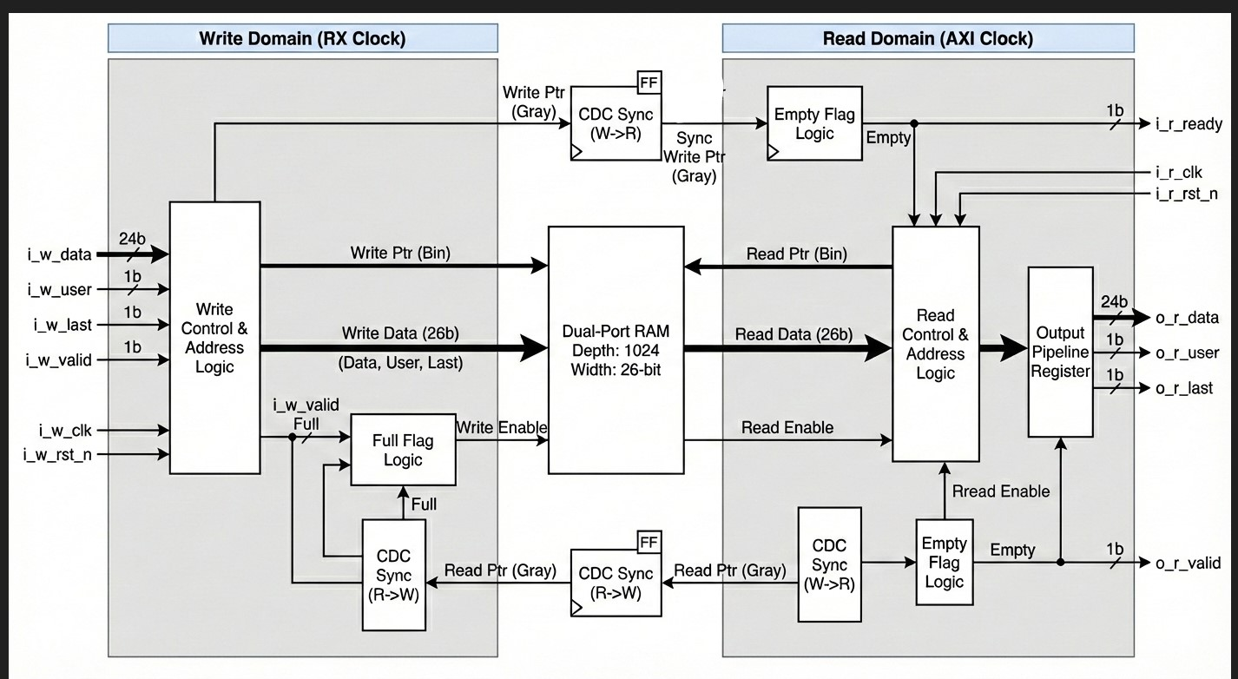

Timing Diagram
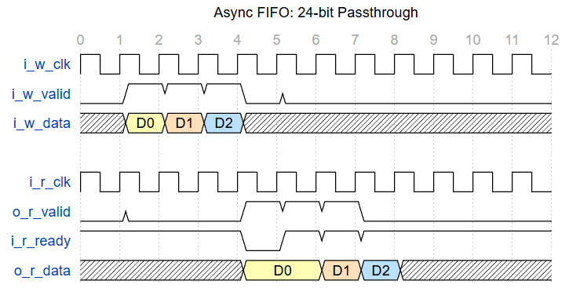

Verification Requirements
- CDC Robustness: Verify no data corruption or metastability occurs when i_w_clk and i_r_clk are asynchronous and varying in frequency ratios.
- Data Integrity: Write a known pattern of 24-bit values (e.g., 0xFFFFFF, 0xAABBCC) and verify o_r_data matches exactly on the read side without bit shifts.
- Handshake Compliance:
- Verify o_r_valid goes Low if the FIFO is empty.
- Verify data is held stable on o_r_data if o_r_valid is High but i_r_ready is Low (Backpressure).
- Flag Logic: Verify Full and Empty conditions internally. Ensure the FIFO does not overwrite unread data even if i_w_valid persists (simulate overflow condition to check failsafe)
- Reduced-Depth Throughput Matching: With P_FIFO_DEPTH = 64, verify end-to-end that the downstream AXI Streaming-TX block (configured with FIFO_DEPTH = 64, STORE_FULL_LINE = 0, FIFO_START_THRESHOLD = 16) begins draining this FIFO early enough, across supported i_w_clk/i_r_clk frequency ratios, to prevent wfull-driven backpressure from interrupting an active line.

