MIPI Descrambler Functional Design Specifications
  - MIPI CSI Controller IP
  - Version 1.0

  - Block Owner
Abdelrahman Elsayed
  - Authors
Abdelrahman Elsayed

This Page is left Blank Intentionally

Table of Contents
1 Table of Contents 1
2 Revision History 2
3 Overview 3
4 Operation and Description 3
4.1 Digital Interface 3
4.1.1 Parameters Names 3
4.1.2 Ports Names 3
4.2 Functional Description 3
4.3 Block Diagram 3
4.4 Timing Diagram 3
4.5 Verification Requirements 3

Revision History
Version | Date | Author(s) | Revision Notes | Owner Approval

Overview
The Data Descrambler is a critical receive-side module within the MIPI CSI Controller IP. It acts as the direct counterpart to the transmit-side Scrambler. By utilizing an identical 16-bit Linear Feedback Shift Register (LFSR) and symmetric XOR logic, the Descrambler accurately recovers the original plaintext byte stream from the incoming ciphered payload. It operates at a high-speed rate of one byte per clock cycle to maintain pipeline throughput.

Operation and Description

Digital Interface

Parameters Names
Parameter Name | Default | Description
LANE_SEED | 16'h0810 | The 16-bit initialization vector (seed) used to synchronize the receive-side LFSR state with the transmit-side.

Ports Names
Port Name | Port Width | Port Type | Description
i_clk | 1 | Input | System core clock.
i_rst_n | 1 | Input | Active-low asynchronous system reset.
i_scram_en | 1 | Input | Runtime enable control (1 = descramble data, 0 = passthrough bypass). Must match the TX configuration.
i_scrambled_data | 8 | Input | Incoming scrambled (ciphered) byte stream from the RX pipeline.
i_lane_vld | 1 | Input | Valid signal indicating active payload data on the input bus.
o_descrambled_data | 8 | Output | The recovered plaintext output byte stream.
o_lane_vld_out | 1 | Output | The output valid signal, matching the input valid.

Functional Description
The MIPI Descrambler relies on the symmetric property of the XOR cipher (where A XOR B XOR B = A). The operation is identical to the Scrambler and features three primary mechanisms:
- Symmetric Keystream Generation (Unrolled LFSR): To keep up with the high-speed data rate, the sequential LFSR equations are hardware-unrolled. Wide XOR logic computes 8 future feedback bits (w_fb[0:7]) concurrently. This allows the LFSR to advance 8 states per clock cycle, generating an 8-bit keystream (w_key_stream) that perfectly mirrors the transmitter's keystream.
- Deterministic Synchronization: For the cipher to be successfully broken, the TX and RX LFSRs must remain perfectly in sync. The internal state (r_lfsr_state) is forced to LANE_SEED during inter-packet idle periods or when the module is bypassed (i_scram_en = 0). During an active transmission, the LFSR only shifts to generate the next key when a valid payload byte is received (i_lane_vld = 1).
- Priority MUX & Cipher Cancellation: The output routing is controlled by a 3-level priority mechanism:
  - If i_lane_vld is 0, the output is forced to 8'h00 to prevent residual data leakage.
  - If i_scram_en is 0, the scrambled data bypasses the XOR logic and flows to the output unaltered.
  - Otherwise, the output is the bitwise XOR operation between the input i_scrambled_data and the w_key_stream. Because the TX applied the exact same keystream, this second XOR operation cancels the cipher and recovers the plaintext.

Block Diagram
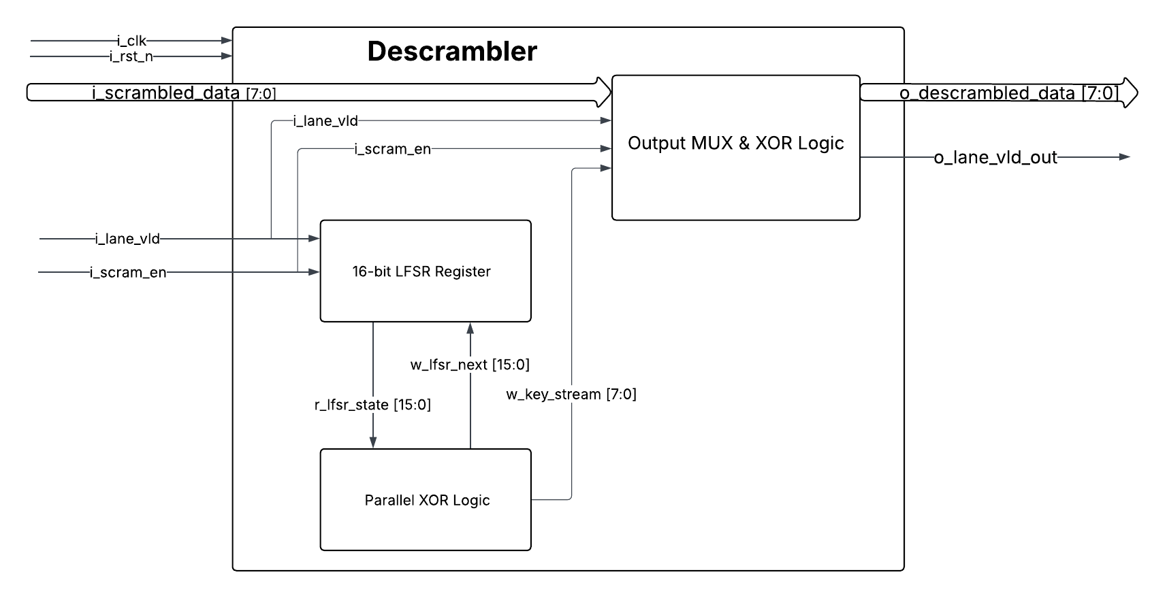

Timing Diagram
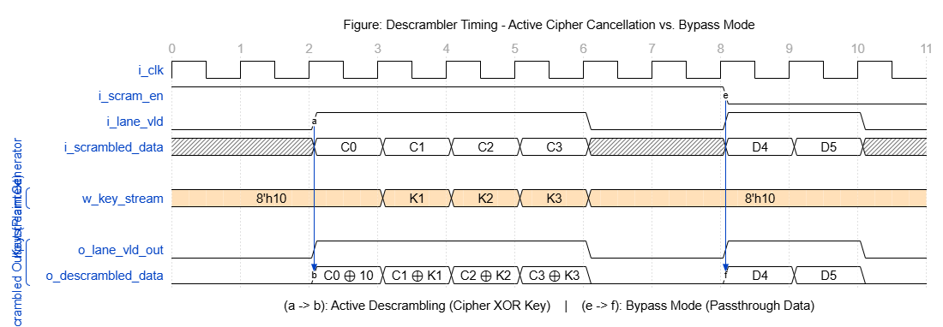

Verification Requirements

