AXI Streaming-TX Functional Design Specifications
  - Design and Implementation of CSI Controller IP
  - Version 4.0.1

  - Block Owner
Hana Samy Ahmed
  - Authors
Hana Samy Ahmed

This Page is left Blank Intentionally

Table of Contents
1 Table of Contents 1
2 Revision History 2
3 Overview 3
4 Operation and Description 3
4.1 Digital Interface 3
4.1.1 Parameters Names 3
4.1.2 Ports Names 3
4.2 Functional Description 3
4.3 Block Diagram 3
4.4 Timing Diagram 3
4.5 Verification Requirements 3

Revision History
Version | Date | Author(s) | Revision Notes | Owner Approval
1 | 15-1-2026 | Hana Samy
2 | 14-6-2026 | Hana Samy | V1 area-optimized, pipelined update: reduced FIFO_DEPTH default to 64 and FIFO_START_THRESHOLD default to 16, set STORE_FULL_LINE default to 0 (Cut-Through), and added a registered output skid-buffer stage (one i_byte_clk cycle of added latency) for 350 MHz timing closure. Updated parameter descriptions, Overview, Functional Description, and Verification Requirements accordingly.

Overview

The AXI Streaming-TX block serves as the input interface bridge for the CSI-2 Transmitter IP. Its primary function is to accept standard video data via an industry-standard AXI4-Stream protocol and translate it into a "Native" generic pixel stream for internal processing.
This block performs three critical tasks:
- Protocol Translation: Converts AXI4-Stream control signals (TUSER, TLAST) into internal flags (SOF, EOL).
- Data Unpacking: removes padding bits from the 32-bit AXI container to extract valid pixel data based on the selected Data Type (ex: RAW10, RGB888).
- Clock Domain Crossing (CDC): Safely transfers data from the Pixel Clock domain to the high-speed MIPI Byte Clock domain using an asynchronous FIFO
- Output Pipelining: Registers the Native output interface through a skid-buffer stage to close timing at high byte-clock frequencies, at the cost of one extra i_byte_clk cycle of latency.

Operation and Description

Digital Interface

Parameters Names
Parameter Name | Default | Description
AXI_DATA_WIDTH | 32 | Width of the AXI input bus. Fixed at 32 to support 24-bit RGB888 inside a word-aligned container.
FIFO_DEPTH | 64 | Depth of the internal Asynchronous FIFO. Reduced from 2048 to 64 words for area optimization. With this reduced depth, the FIFO is sized for the Cut-Through (STORE_FULL_LINE = 0) operating mode and must be paired with an appropriately small FIFO_START_THRESHOLD to avoid overflow.
FIFO_WIDTH | 26 | The maximum width of a single valid pixel plus the two sideband signals(tuser and tlast).
MAX_PIXEL_WIDTH | 24 | The maximum width of a single valid pixel (e.g., 24 for RGB888).
STORE_FULL_LINE | 0 | Primary Mode.  1: Wait for TLAST (End of Line) before starting. Safest for preventing underflow.  0: Use the Threshold below to start transmission earlier for lower latency. (Default) Cut-through mode is enabled by default in this configuration, paired with the reduced FIFO_DEPTH and FIFO_START_THRESHOLD values.
FIFO_START_THRESHOLD | 16 | FIFO Level Trigger. Usage depends on STORE_FULL_LINE:  If STORE_FULL_LINE = 1: This value is not evaluated by the threshold logic. o_fifo_threshold_met is asserted only once a complete line (terminated by i_axis_tlast) has been written into the FIFO, irrespective of FIFO_START_THRESHOLD.  If STORE_FULL_LINE = 0: Acts as the sole trigger. Transmission starts as soon as the FIFO read count (fifo_rd_count) reaches this value.

Ports Names
Port Name Port Width Port Type Description
Port Name | Port Width | Port Type | Description
Clocks and Resets
i_pixel_clk | 1 | Input | The User/Sensor clock (Write domain).
i_pixel_rst_n | 1 | Input | Active-low asynchronous reset.
I_byte_clk | 1 | Input | The MIPI Byte clock (Read domain).
i_byte_rst_n | 1 | Input | Active-low asynchronous reset for the MIPI Byte clock (Read) domain.
AXI4-Stream Input
i_axis_tdata | 32 | Input | Data container holding the pixel + padding.
i_axis_tvalid | 1 | Input | Valid data indicator.
o_axis_tready | 1 | Output | Backpressure signal (FIFO Full).
i_axis_tuser | 1 | Input | Start of Frame (SOF) marker.
i_axis_tlast | 1 | Input | End of Line (EOL) marker.
Configuration
i_cfg_data_type | 6 | Input | MIPI Data Type code (masks valid bits).
Native Output
o_native_data | 24 | Output | Clean pixel data to Pixel-to-Byte Converter.
o_native_valid | 1 | Output | Valid Indicator
i_native_ready | 1 | Input | Read enable from downstream.
o_native_sof | 1 | Output | Start of Frame flag.
o_native_eol | 1 | Output | End of Line flag.
Status Flags
o_fifo_threshold_met | 1 | Output | Status signal to the Controller indicating it is safe to start emptying the FIFO. The assertion condition depends on STORE_FULL_LINE (see FIFO_START_THRESHOLD parameter description).
o_fifo_stat | 1 | Output | Reserved status output. Tied off to constant 0 in the current implementation.

Functional Description
The operation of this block is divided into three stages:
1. The Unpacker & Masking Logic (Pixel Clock Domain) This combinational logic inspects the incoming 32-bit i_axis_tdata container and the i_cfg_data_type input.
- It masks out (discards) the padding bits (zeros) that were added to align the pixel to the 32-bit boundary.
  - Example (RAW10): Extracts bits [9:0].
  - Example (RGB888): Extracts bits [23:0].
- It concatenates the cleaned pixel data with the sideband signals i_axis_tuser (SOF) and i_axis_tlast (EOL) into a single wide data vector to be written into the FIFO.
2. Asynchronous Buffering (CDC) An Asynchronous FIFO bridges the timing gap between the slow i_pixel_clk (Write Domain) and the fast i_byte_clk (Read Domain).
- Write Side: Controlled by i_axis_tvalid. Data is written only when o_axis_tready is HIGH (FIFO not full).
- Read Side: Controlled by i_native_ready from the downstream block, but gated by the internal o_fifo_threshold_met status.
- Trigger Logic (o_fifo_threshold_met): This signal informs the Controller that it is safe to start emptying the FIFO. The logic depends on the STORE_FULL_LINE parameter:
  - Mode 1: Store Full Line
    - o_fifo_threshold_met is asserted once a complete line (terminated by i_axis_tlast) has been written into the FIFO. This is tracked internally by the lines_in_fifo counter. FIFO_START_THRESHOLD is not evaluated in this mode.
  - Mode 0: Low Latency / Threshold Mode
    - o_fifo_threshold_met is asserted once the FIFO read count (fifo_rd_count) reaches FIFO_START_THRESHOLD. The line-completion (i_axis_tlast) condition is not evaluated in this mode.
3. Output Pipeline Stage (Skid Buffer, Byte Clock Domain) To close timing at high byte-clock frequencies (e.g., 350 MHz), the native output interface is no longer driven directly from the FIFO read data. Instead, the FIFO output passes through a registered skid-buffer stage before reaching o_native_data, o_native_valid, o_native_sof, and o_native_eol.
- FIFO Read Enable: The FIFO is read only when the FIFO has data ready for transmission (tx_active and not empty) AND the pipeline register is able to accept new data (downstream ready, or pipeline register currently empty).
- Skid Behavior: The output pipeline register updates whenever i_native_ready is HIGH or the register is currently empty, allowing one pixel to be held (“skidded”) without data loss if the downstream consumer stalls.
- Latency Impact: This stage adds one i_byte_clk cycle of latency between a word being read out of the FIFO and its appearance on the o_native_* outputs.

Block Diagram
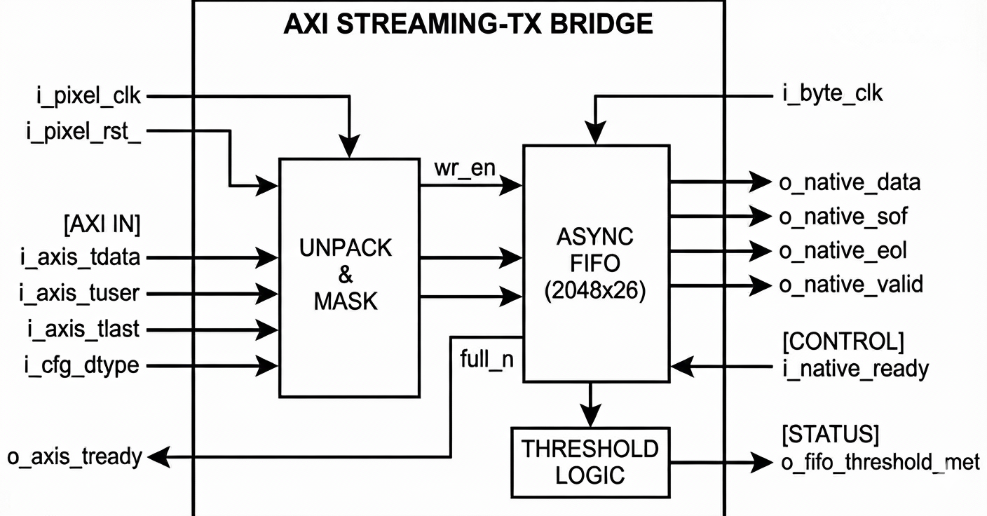

Timing Diagram

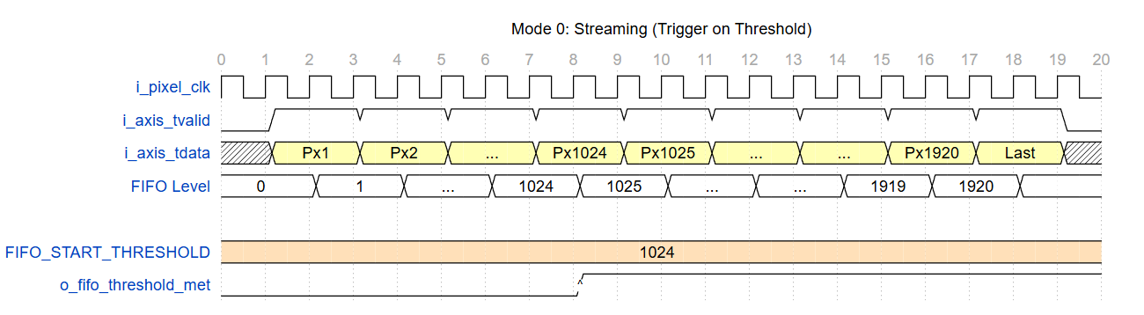
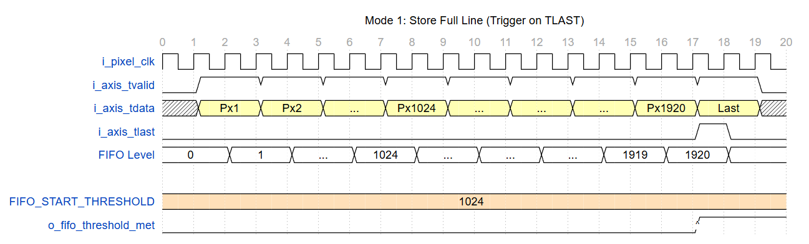

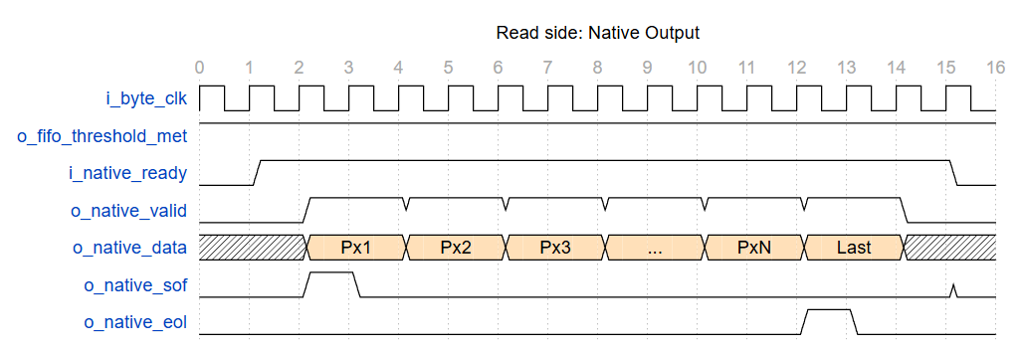

Verification Requirements
To ensure this block functions correctly, the following scenarios must be verified:
- Protocol Compliance: Verify o_axis_tready goes Low when the FIFO is full (Backpressure check).
- Data Integrity: Verify that a standard image enters via AXI and exits via the Native interface bit-perfect, with no padding bits remaining.
- Sideband Propagation: Verify that o_native_sof asserts only on the first pixel and o_native_eol asserts only on the last pixel.
- Clock Domain Crossing: Perform simulation with i_byte_clk running both slower and faster than i_pixel_clk to ensure the Async FIFO handles underflow/overflow logic correctly.
- Output Pipeline (Skid Buffer): Verify the one-cycle latency introduced by the output pipeline stage, and confirm no data is lost or duplicated when i_native_ready toggles low and high while the pipeline register is occupied (skid condition).
- Reduced-Depth Cut-Through Operation: With the default FIFO_DEPTH = 64, STORE_FULL_LINE = 0, and FIFO_START_THRESHOLD = 16, verify that o_axis_tready (backpressure) asserts in time to prevent FIFO overflow for the i_pixel_clk/i_byte_clk frequency ratios supported by this configuration, and that o_native_valid does not underflow (drop low mid-line) once transmission has started.

