MIPI Scrambler Functional Design Specifications
  - MIPI CSI Controller IP
  - Version 1.0

  - Block Owner
Abdelrahman Elsayed
  - Authors
Abdelrahman Elsayed

This Page is left Blank Intentionally

Table of Contents
1 Table of Contents 1
2 Revision History 2
3 Overview 3
4 Operation and Description 3
4.1 Digital Interface 3
4.1.1 Parameters Names 3
4.1.2 Ports Names 3
4.2 Functional Description 3
4.3 Block Diagram 3
4.4 Timing Diagram 3
4.5 Verification Requirements 3

Revision History
Version | Date | Author(s) | Revision Notes | Owner Approval

Overview
The Data Scrambler module is a critical transmit-side component within the MIPI CSI Controller IP. It is designed to reduce Electromagnetic Interference (EMI) by scrambling the outgoing high-speed data stream. The module utilizes a 16-bit Linear Feedback Shift Register (LFSR) with parallel feedback logic, processing one full byte per clock cycle to match the high-speed requirements of the Protocol-to-PHY Interface (PPI).

Operation and Description

Digital Interface

Parameters Names
Parameter Name | Default | Description
LANE_SEED | 16'h0810 | The 16-bit initialization vector (seed) used to initialize the LFSR state. This can be configured per lane.

Ports Names
Port Name | Port Width | Port Type | Description
i_clk | 1 | Input | System core clock.
i_rst_n | 1 | Input | Active-low asynchronous system reset.
i_scram_en | 1 | Input | Runtime enable control (1 = scramble data, 0 = passthrough bypass).
i_lane_data | 8 | Input | Original (plaintext) byte stream to be transmitted.
i_lane_vld | 1 | Input | Valid signal indicating active payload data on the input bus.
o_scrambled_data | 8 | Output | The scrambled (ciphered) output byte stream.
o_lane_vld_out | 1 | Output | The output valid signal, matching the input valid.

Functional Description
The operation of the MIPI Scrambler is based on a standard MIPI D-PHY scrambling polynomial and is divided into three main operational phases:
- Hardware-Unrolled Parallel Feedback Logic: To process an entire byte in a single clock cycle, the sequential LFSR equations are hardware-unrolled. Wide XOR logic computes 8 future feedback bits (w_fb[0:7]) simultaneously, allowing the LFSR to jump 8 states ahead in one cycle without stalling the high-speed pipeline.
- LFSR State Management: The LFSR state register (r_lfsr_state) initializes to LANE_SEED on hard reset. To ensure deterministic behavior and glitch-free toggling, the state is forced back to LANE_SEED whenever scrambling is disabled (i_scram_en = 0) or during inter-packet idle periods. During an active transmission, the state only advances to generate the next key when a valid payload byte is presented (i_lane_vld = 1).
- Priority MUX Output Masking: The final data output is controlled by a 3-level priority mechanism:
  - If i_lane_vld is 0, the output is clamped to 8'h00 to prevent unknown data leakage.
  - If i_scram_en is 0, the input data flows transparently to the output unaltered (Bypass mode).
  - Otherwise, the output is the bitwise XOR operation between the input data (i_lane_data) and the lower 8 bits of the LFSR (w_key_stream).

Block Diagram

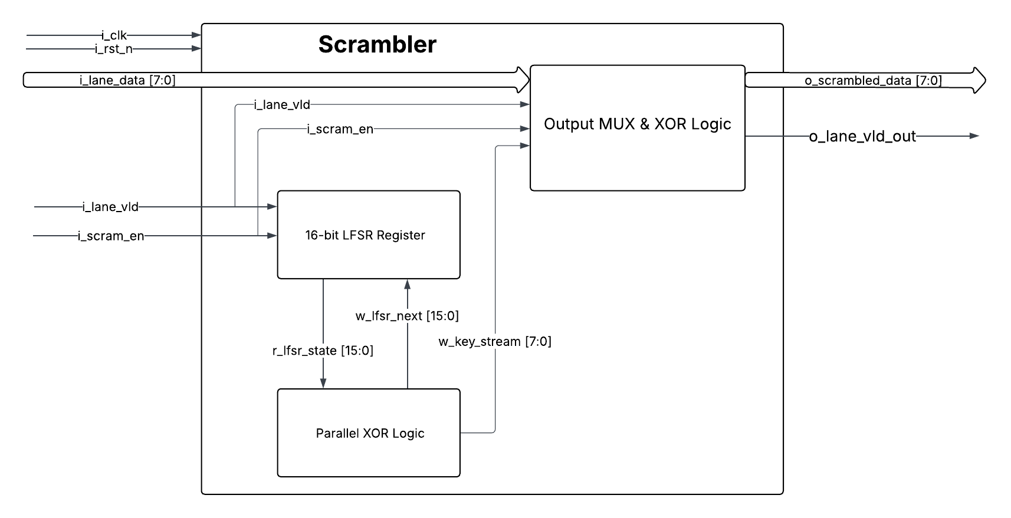

Timing Diagram
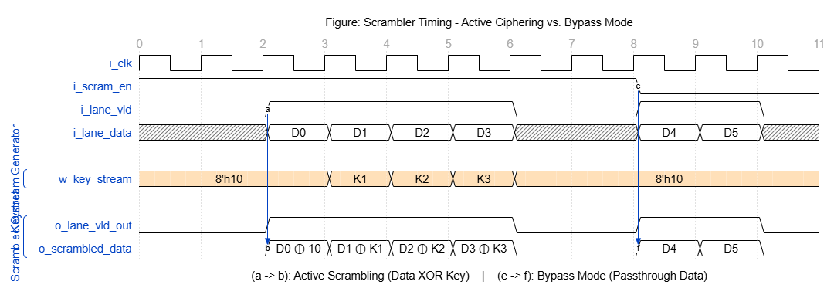

Verification Requirements

