Lane Distributor Functional Design Specifications
  - Project NameMIPI CSI Controller IP
  - Version 1.0

  - Block Owner
Abdelrahman Elsayed
  - Authors
Abdelrahman Elsayed

This Page is left Blank Intentionally

Table of Contents
1 Table of Contents 1
2 Revision History 2
3 Overview 3
4 Operation and Description 3
4.1 Digital Interface 3
4.1.1 Parameters Names 3
4.1.2 Ports Names 3
4.2 Functional Description 3
4.3 Block Diagram 3
4.4 Timing Diagram 3
4.5 Verification Requirements 3

Revision History
Version | Date | Author(s) | Revision Notes | Owner Approval

Overview
The Lane Distributor (Demultiplexer) is a critical core module within the MIPI CSI Controller IP. It is responsible for accepting a continuous, sequential byte stream from the preceding Packetizer block and dynamically distributing it across 1, 2, or 4 parallel MIPI D-PHY lanes. The distribution process adapts in real-time based on the system's active lane configuration, ensuring zero-latency data routing.

Operation and Description

Digital Interface

Parameters Names
Parameter Name | Default | Description
N/A | N/A | This module does not utilize instantiation parameters. Lane configuration is handled dynamically via input ports.

Ports Names
Port Name | Port Width | Port Type | Description
i_clk | 1 | Input | System core clock.
i_rst_n | 1 | Input | Active-low asynchronous system reset.
i_pkt_data | 8 | Input | Serial byte stream coming from the Packetizer.
i_pkt_vld | 1 | Input | Valid signal accompanying the incoming packet data.
i_cfg_active_lanes | 2 | Input | Configuration threshold defining the number of active lanes (e.g., 0 for 1-lane, 1 for 2-lanes, 3 for 4-lanes).
o_lane[0:3]_data | 8 | Output | Parallel data buses driving each respective MIPI lane.
o_lane[0:3]_vld | 1 | Output | Valid signals indicating valid parallel data is ready on the respective lane.
o_req_hs | 1 | Output | Look-ahead early High-Speed request signal to awaken the D-PHY.

Functional Description
- Dynamic Demultiplexing & Programmable Lane Counter: Seamlessly switches between 1-lane, 2-lane, and 4-lane distribution topologies. A synchronized counter (r_lane_cnt) tracks the target lane for the incoming byte. It increments on every valid byte and wraps around automatically when it hits the configured active lane threshold (i_cfg_active_lanes), ensuring cyclic distribution.
- Byte Demultiplexer: Acting as a high-speed router, it reads the current lane counter state and latches the incoming i_pkt_data into the corresponding o_laneX_data output register without introducing dead cycles.
- Valid Generation & Smart Flush Logic: During normal operation, valid signals for the parallel lanes are asserted only when a complete set of bytes is buffered. If i_pkt_vld deasserts prematurely while the counter is non-zero, the w_flush_en condition is triggered. This forces the module to safely push out partially filled parallel lane registers, preventing data loss or physical layer misalignment.
- Early HS Wake-up: To meet MIPI D-PHY timing requirements, o_req_hs is logically OR-ed with the incoming packet valid, a delayed valid, and the output lane 0 valid. This ensures the PHY transitions into High-Speed mode concurrently with the arrival of active packet data and remains active during the flush cycle.

Block Diagram
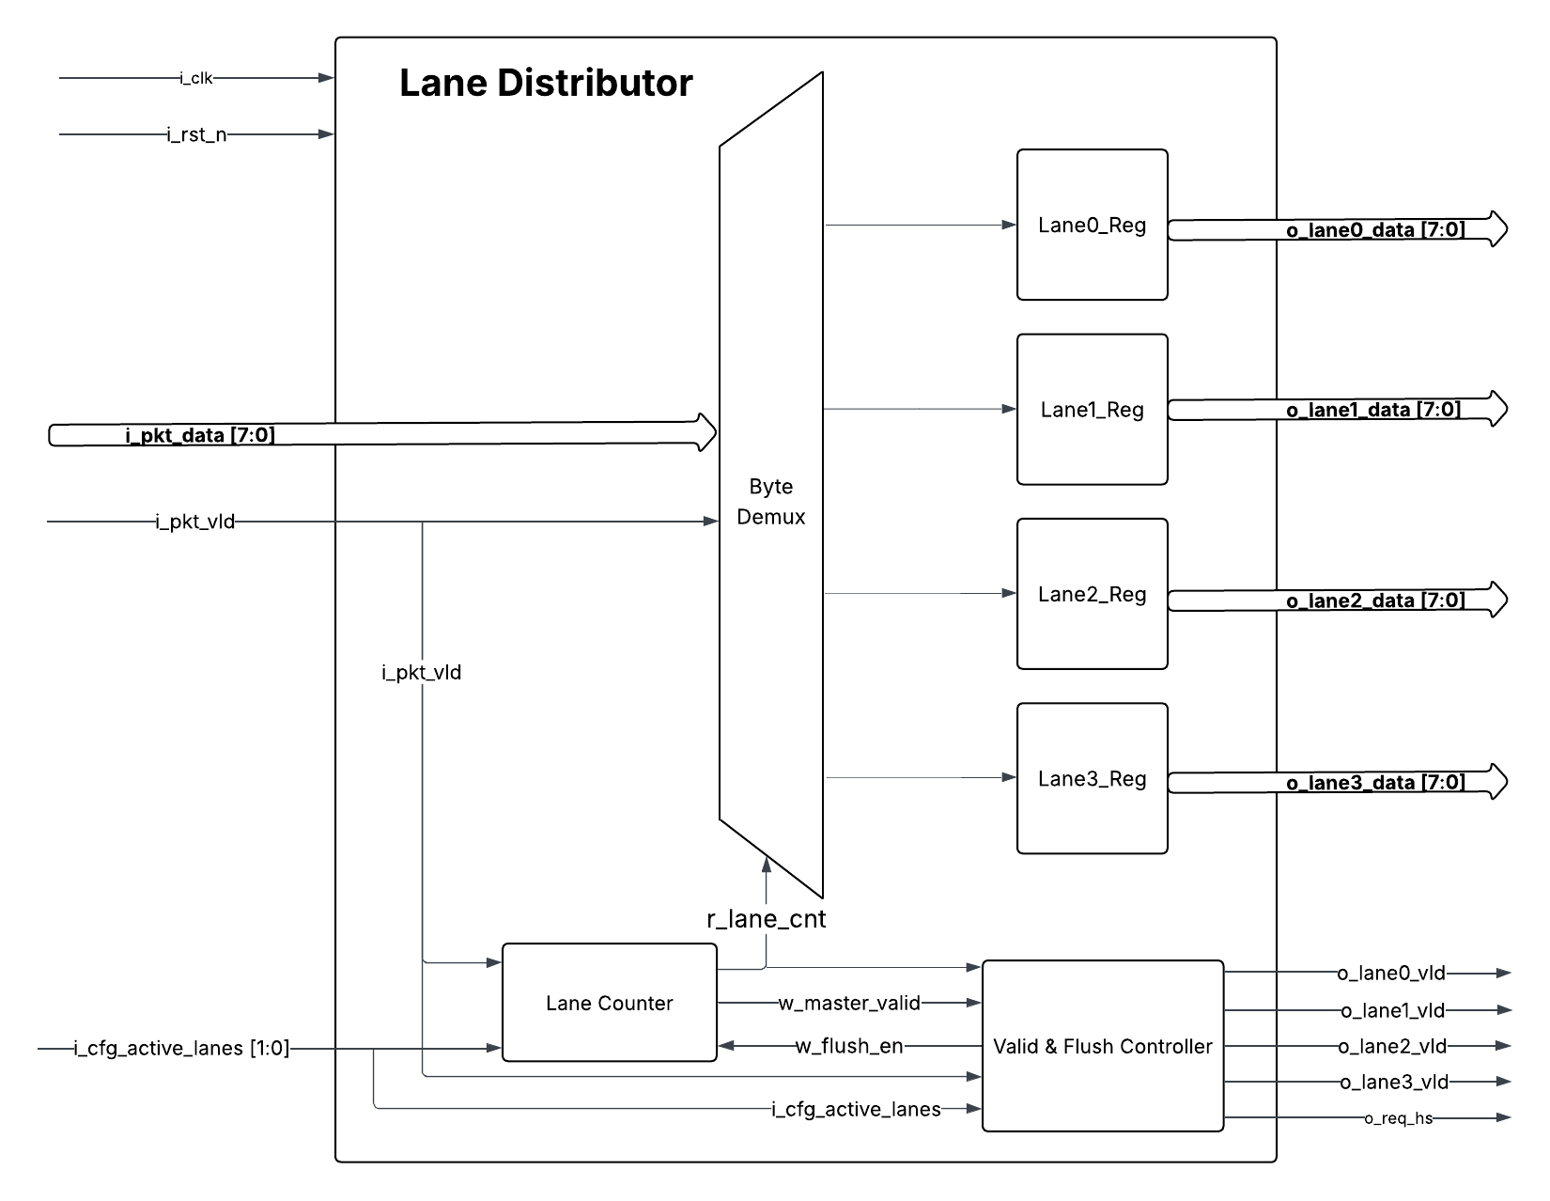

Timing Diagram
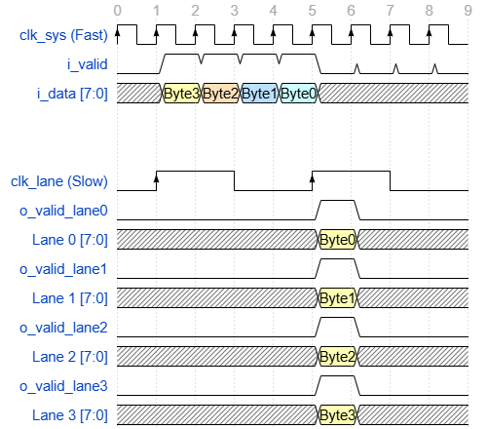

Verification Requirements

