
ASSIGNMENT

MAY 2019 SEMESTER

SUBJECT CODE | : | CCN413
SUBJECT TITLE | : | COMPUTER COMMUNICATIONS &  NETWORKING
LEVEL | : | BACHELOR

STUDENT’S NAME | : | Hanas Bayu Pratama
MATRIC NO. | : | C30101190125
PROGRAMME | : | BICT (HONS)
ACADEMIC FACILITATOR | : | Mr. Defiana Arnaldy
LEARNING CENTRE | : | CITRA BUNGA NUSANTARA (CBN)

INSTRUCTIONS TO STUDENTS

- This assignment consists of FOUR (4) questions. Answer all questions.

- Plagiarism in all forms is forbidden. Students who submit plagiarised assignment will be penalised.

- Your assignment will be examined based on the followings
- a complete working solution.
- ability of using methods available in the learning materials.

- This assignment carries a 60% weightage toward final grade.

THERE ARE FOUR [4] OF , INCLUDING THIS PAGE.
INSTRUCTION: Answer ALL questions. [Total : 60 Marks]

Question 1
Figure 1 below shows the components used in building up a computer stick system in a home network. Choose a product brand which is available from the market and explain briefly the components involved and how it works (includes cable, adapter and relevant picture).

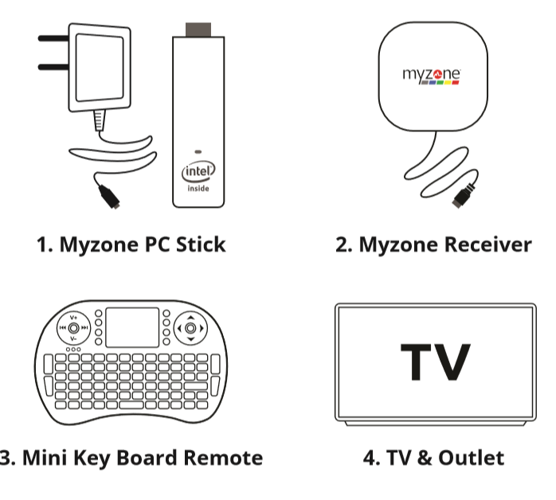
Figure 1
[15 Marks]

Question 2
WhatsApp is a chat application software product. It offers a service that allows you to chat between an ordinary phones or personal computers such as shown in Figure 2. When a call is made, it must pass through both the Internet and the telephone network. Discuss how this might be done technically.
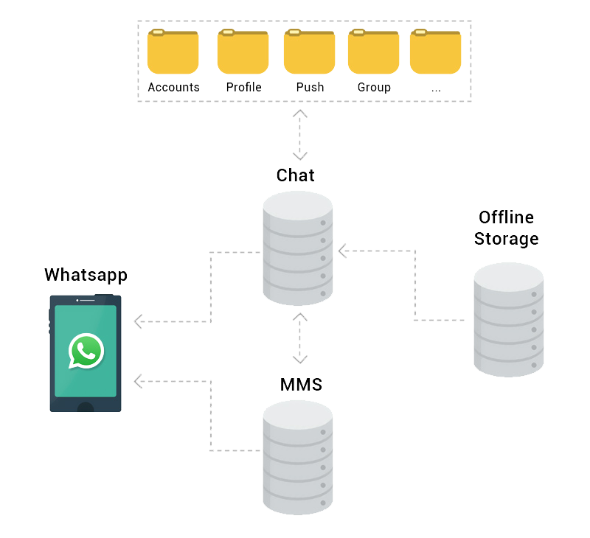
Figure 2
[15 Marks]

Question 3

a) Why is it necessary to have a cloud backup? [2 Marks]

b) Using your own words, explain how the cloud backup and recovery are done. [8 Marks]

[Total : 10 Marks]

Question 4

a) Given a router that is the default gateway in Figure 3, state all the subnets first hosts, last hosts and broadcast addresses by filling up Table 1 below.
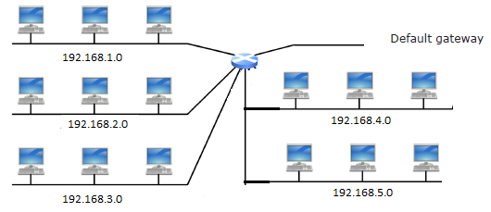
Figure 3

Table 1
Subnet
First Host
Last Host
Broadcast

[10 Marks]

b) With the aid of a diagram, design a router table with configuration below. Specify the routers, segments and other symbols in the design.

Two routers : 192.168.20.1 and 192.168.20.2

Four segments : 192.168.1.1, 192.168.2.1, 192.168.18.1 and 192.168.17.1

Workgroup1: .45
Workgroup2: .146, .147
Workgroup3: .3, .4
Workgroup4: .245 [10 Marks]

[Total : 20 Marks]

END OF ASSIGNMENT QUESTIONS

ANSWER
1. The Components of Panasonic TV are :
- Cathode Ray Tube
The cathode ray tube works by sending a beam of electrons which then landed on the tv screen and made a visual display so the image is seen on television.
How a cathode-ray tube (CRT) TV works

  - Satellite TV receives signals through an antenna that can catch radio waves from the transmitter so that the signal comes from a satellite dish which is mounted on the wall or roof of the house and if using cable tv then via underground fiber optic cable.

  - Then on the back of the tv, a signal is inserted into the antenna socket.

  - For more than one station (program) on a TV, electronic circuits only select the station that the user wants to watch and share the signal for this station into separate audio (sound) and video (image) information, each forwarded to a separate circuit for processing Furthermore.

  - To move three electron weapons, electron weapon circuits dividing the radio signal into red, blue and green signals who are separated from each other.

  - Three electron weapons (one red, one blue, and one green) below Cathode rays are then fired at the fire circuit.

  - Then the electromagnet directs the electron beam so that it sweeps back and forth across the screen, line by line because the electron beam passes through the electromagnetic ring and elections can be controlled by a magnet because it has a negative electrical charge.

  - Then a grid of holes called masks is passed through an electron beam where the grid of holes directs them so that it places right on the TV screen where they make red, blue and green dots by smashing phosphorus (colored chemicals) on the screen and the screen stays dark elsewhere. Color images are very quickly formed through a pattern of red, blue and green dots.

  - Meanwhile, the audio information (sound) from the incoming signal switches to a separate audio circuit.

  - The loudspeaker is driven by an audio circuit so that the sound is in time with moving images created by the audio circuit.

- Light Valve
Light valves provide a fixed light source to power electrons from the cathode ray tube so that the light valves and cathode rays can be seen on the screen and they work together to provide a clear image. The sophistication of the light valve also provides clear images for TV.
- Logic Board
the logic board saves transformers, coils, chokes, and resistors because the logic board is the brain of tv. the circuit provides electricity and sends messages to various TV devices so that the logic board can function.
- Capacitors
the capacitor in a tv device will give a severe electric shock if we touch it because a capacitor is a device that stores an electric charge between two metal plates and releases energy as light thus storing large amounts of power.
- Screen and Surround
The most obvious TV components are the screen and TV surround. traditional screens made of glass and modern screens such as LCD and plasma made of plastic. the around the tv is made of plastic durable and this is the outer shell that protects the internal components of the tv.

- How WhatsApp can work ?
When you use WhatsApp you will send messages and messages it will reach its destination online. Online messages will automatically stored in online storage. when you use messages offline, you cannot send messages even though you guys have typed it. however, if you write a message and send it when offline then the message automatically there is no warning failed to send the message but the message will be saved to the offline storage. well here messages will be temporarily stored while offline and when we are online again then the message is automatically sent to the destination. so whatsapp has 2 storage, online and offline storage. whatsapp to send messages offline and online using MMS (Multimedia Messaging Service).

MMS is a standard way to send messages that include multimedia content from cellphones using cellular networks. messages like PXT, picture message, or multimedia message. MMS allows you to send messages by includingMultimedia content directly to the phone.

- Answer for Number 3
    - Because cloud backup is a backup of data to remote cloud-based servers. Then Cloud backup data as a form of cloud storage is stored and accessed from many distributed and connected resources. cloud backup can also be used virtually to store and back up all types of data or applications so it is very flexible. besides cloud backup, too is a service used to create, edit, manage, and restore data, services, or save applications even cloud backup providesbackup data when natural disasters occur somewhere.
    - Cloud Backup can copy data and save it Other media or other storage systems to For easy access when a recovery situation occurs In the organization's data center. function of the backup Cloud is as an off-site facility for many Organizations Although there are several options and approaches For off-site backups.
Off-site servers may have companies to host The Cloud service but for managing the backup environment Using the Chargeback method will be the same if the company Using the service provider.
Here are some ways to do Cloud backups :
- Back up directly to public cloud.
One technique to Mcnyimpan resources Organizations by duplicating resources in public clouds. AWS (Amazon Web Services) or Microsoft Azure uses Which method requires Pura writing the data directly To a cloud provider. The organization uses its backup software to make copies of the data to be sent to the cloud storage service. The cloud storage service then provides the destination and mcnyimpan data, but does not specifically provide backup applications.
In this case, the permissible backup software is capable of interacting with cloud storage services.
- Back up to service provider
In this case, data is centralized for managed service backups Offered by the organization that writes data to the provider Cloud services.
- Using online cloud backup systems
the all-in-one backup engine is alternative hardware that provides data backup to cloud backup services including backup software and disk capacity along with server reserve. Dell EMC, Cohesion, Rubric, StorageCraft, Unitrends, Asigra, and Quantum are vendors that offer cloud interface backup equipment. the advantage of using this equipment is that recovery can be done from local backup copies, saving time, and transmission costs.
- Select a Cloud-to-Cloud backup (C2C).
This service specializes in backing up Registered data is in the cloud, both as data stored in the cloud backup service Or as data created using a software as a service (SaaS) application. How the Cloud-to-Cloud backup service works is to copy data from one cloud to another and usually Host the software that handles this process.
- Answer for Number 4
- The network will appear like this
Subnet | 1.0 | 2.0 | 3.0 | 4.0 | 5.0
First Host | 1.1 | 2.1 | 3.1 | 4.1 | 5.1
Last Host | 1.254 | 2.254 | 3.254 | 4.254 | 5.254
Broadcast | 1.255 | 2.255 | 3.255 | 4.255 | 5.255

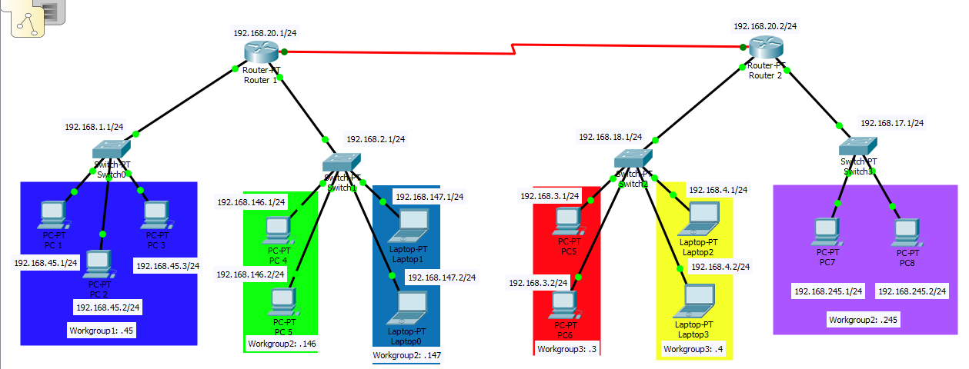
- The Schema of Neworking like this

