Nama : Hanas Bayu Pratama

Subject : Portfolio

The pictures Below are my Portfolio

<https://epic>[-raman-69af4e.netlify.app/](https://epic-raman-69af4e.netlify.app/)



<http://kecapbetawi.epizy.com/index.php>

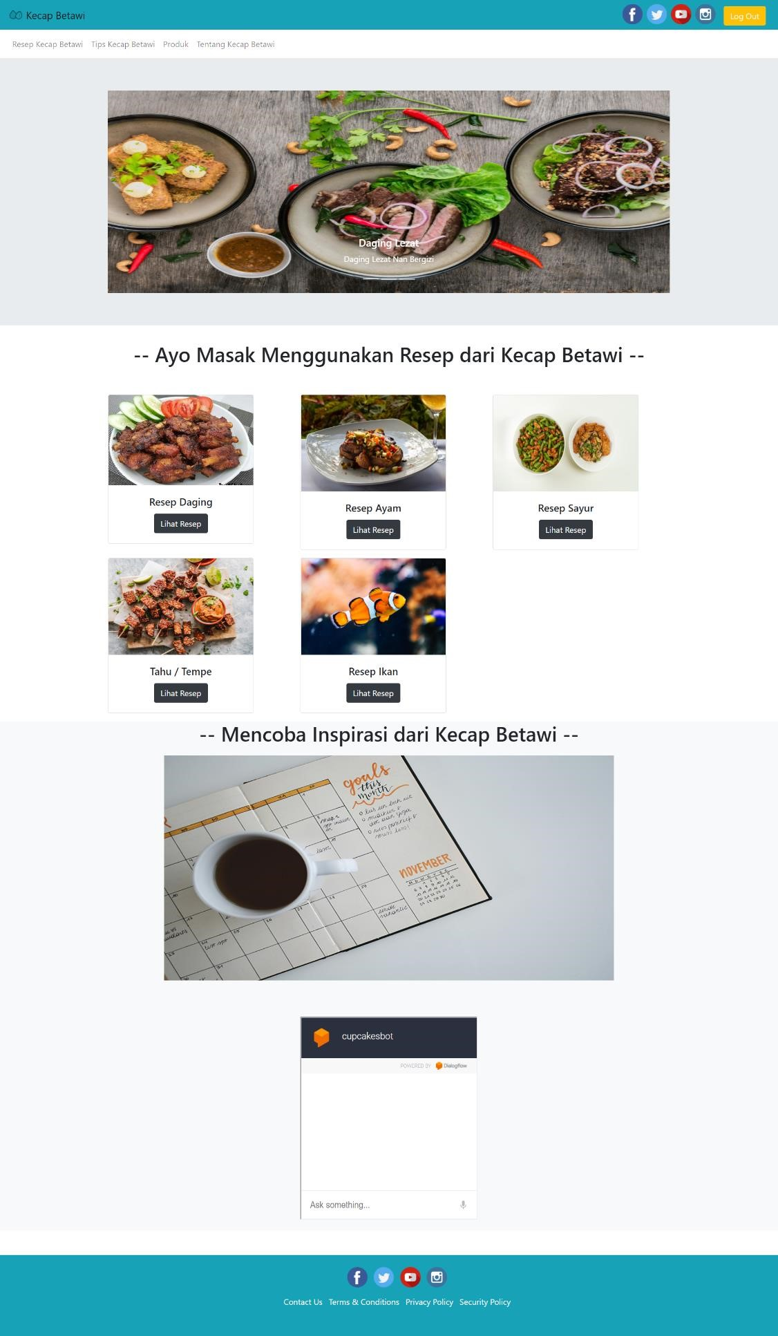

<https://brave-stonebraker-fc5e08.netlify.app/>



<https://musing-leavitt-2b1a54.netlify.app/>

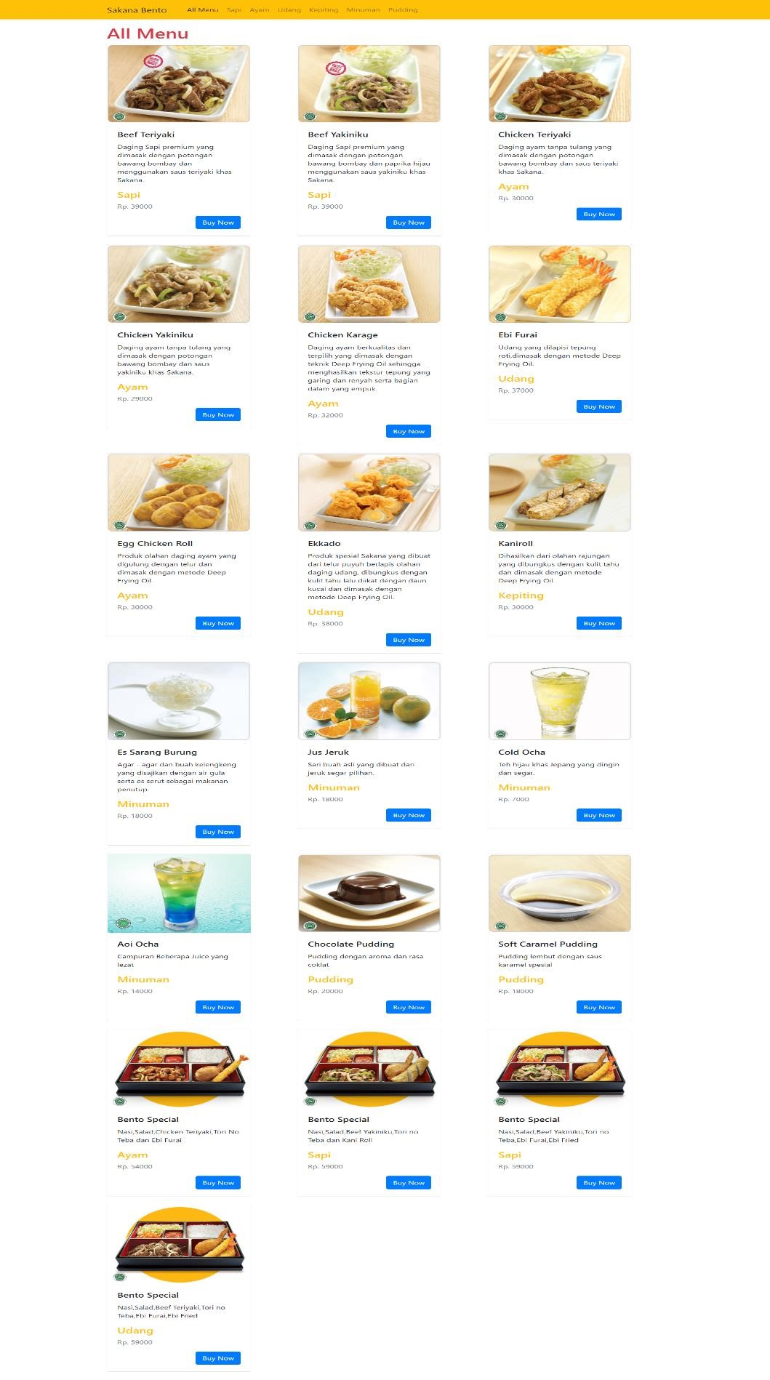

<https://musing-payne-31700b.netlify.app/>



<https://app.netlify.com/sites/dazzling-cray-b92544/overview>

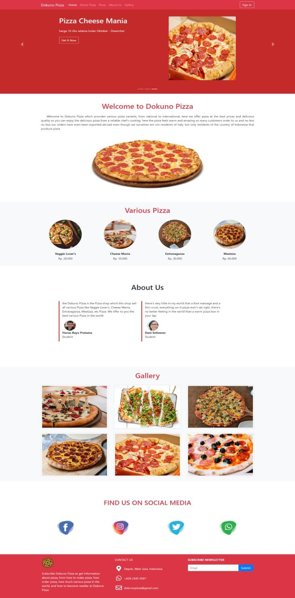

Modalin Application

https://github.com/hanasoke/modalin.git

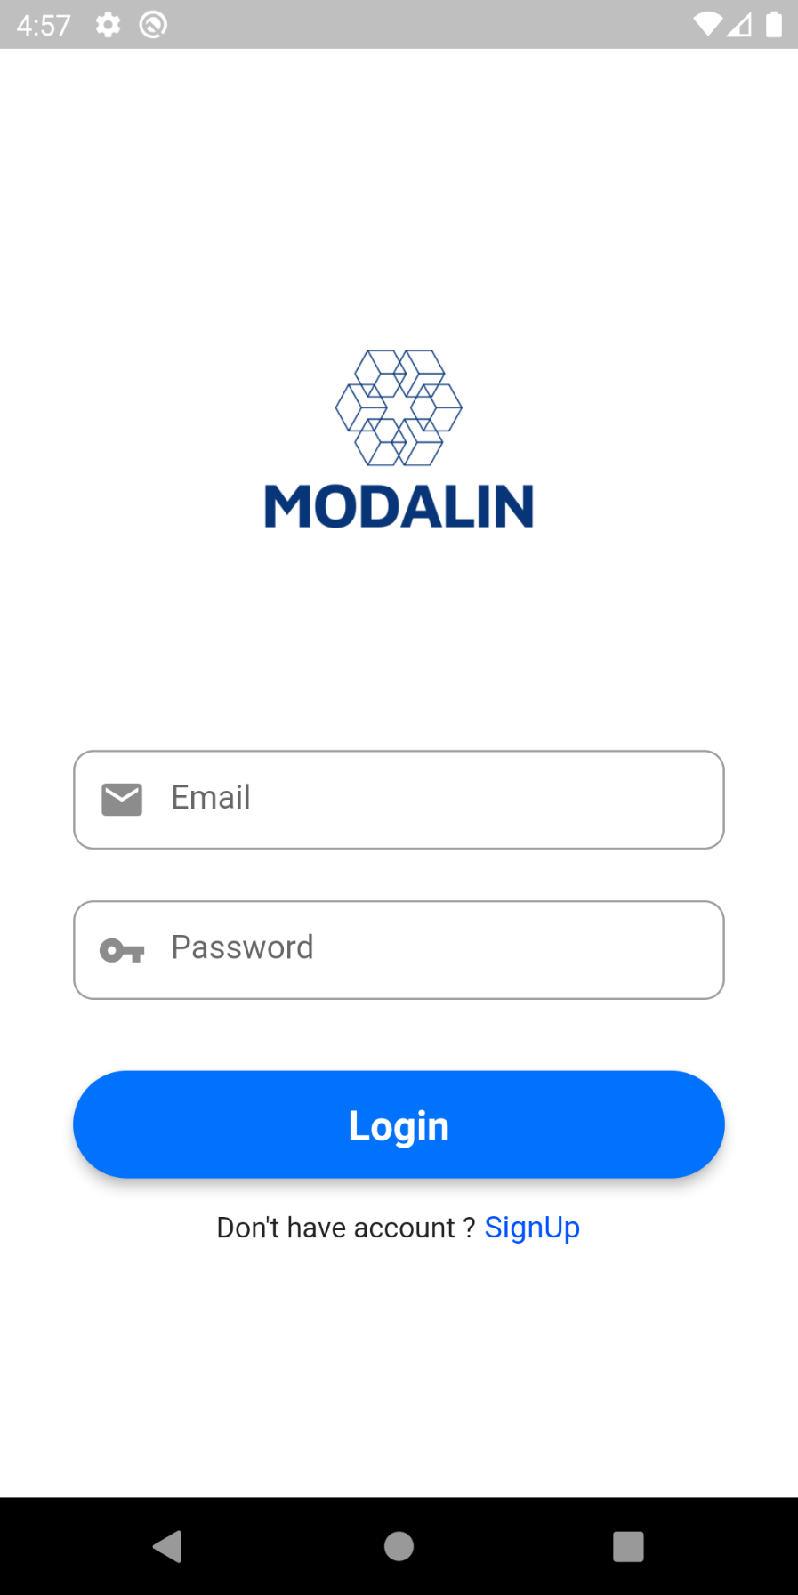

Login Page

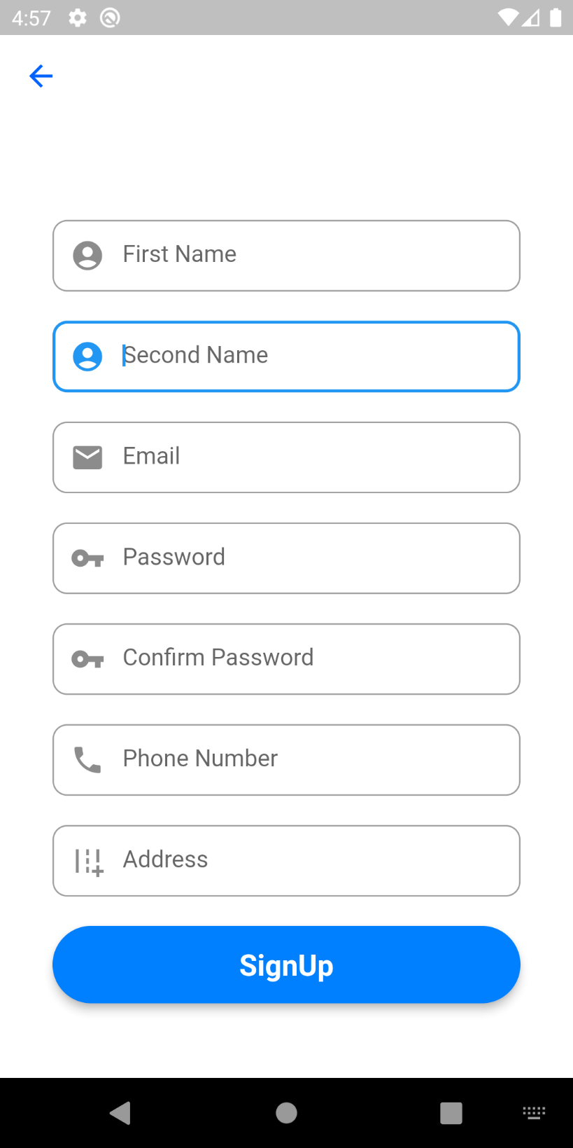

Register Page



Home Page



Loan Page

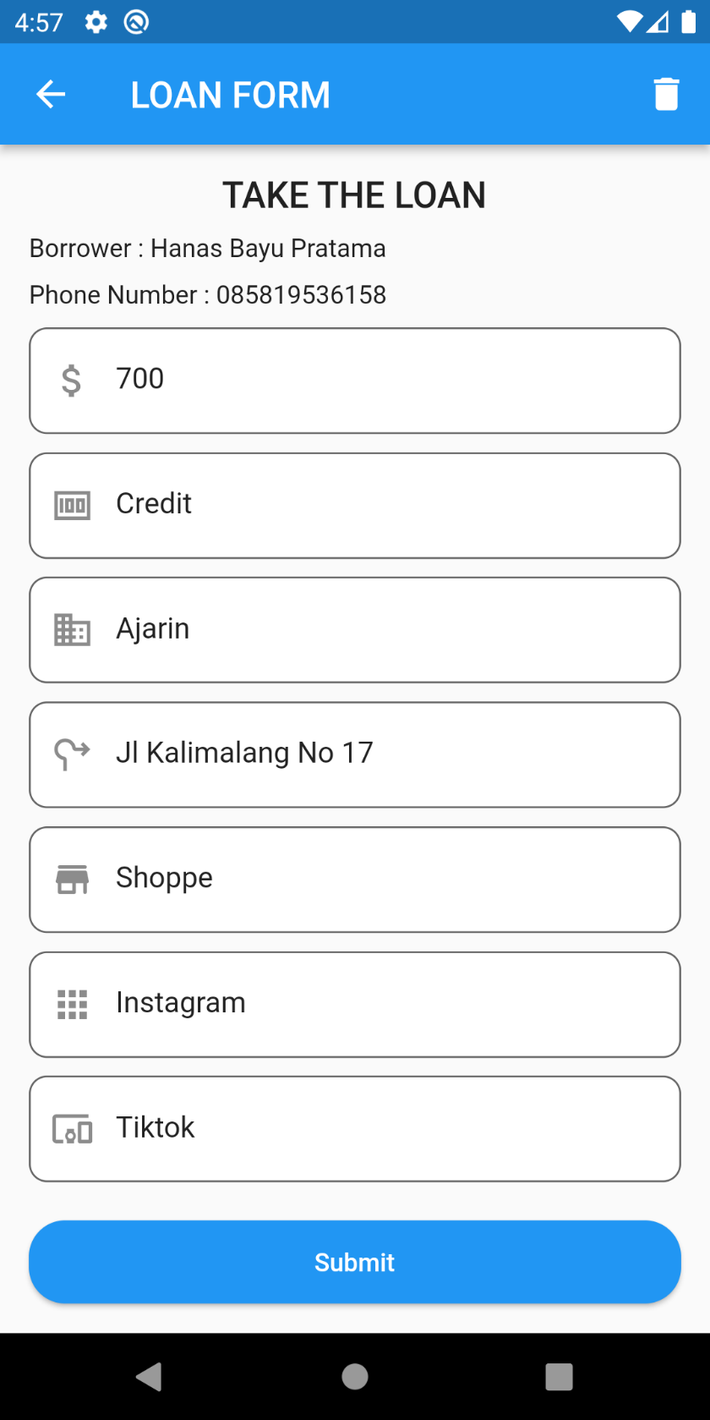

Loan Register Page



Investment Page



Investment Register Page



Bussiness Page

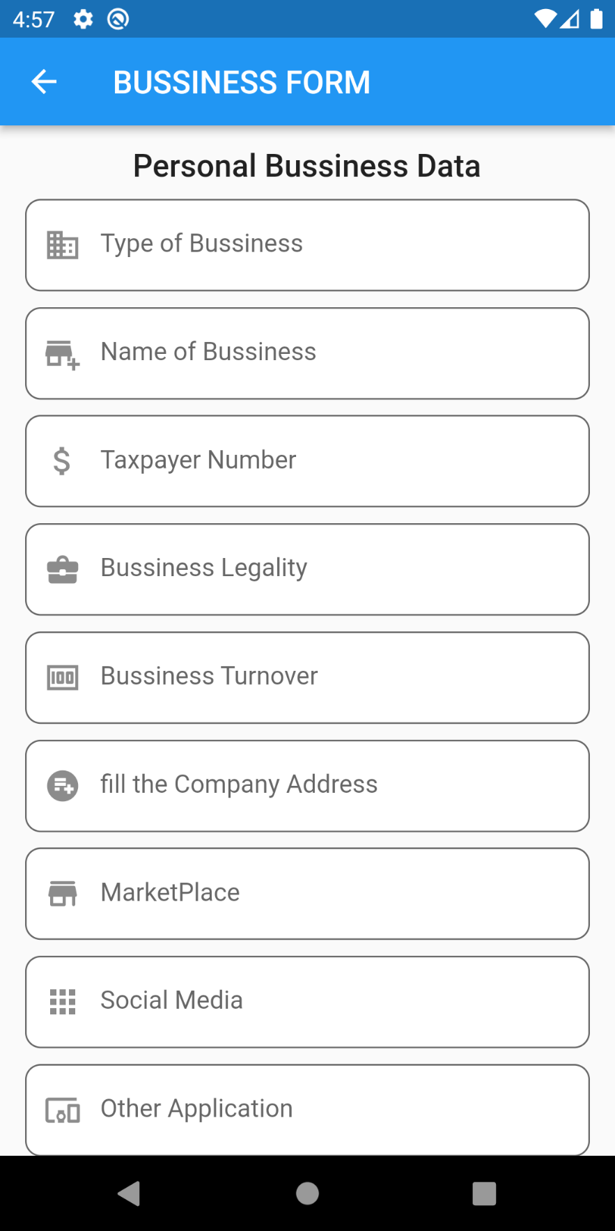

Bussiness Register Page

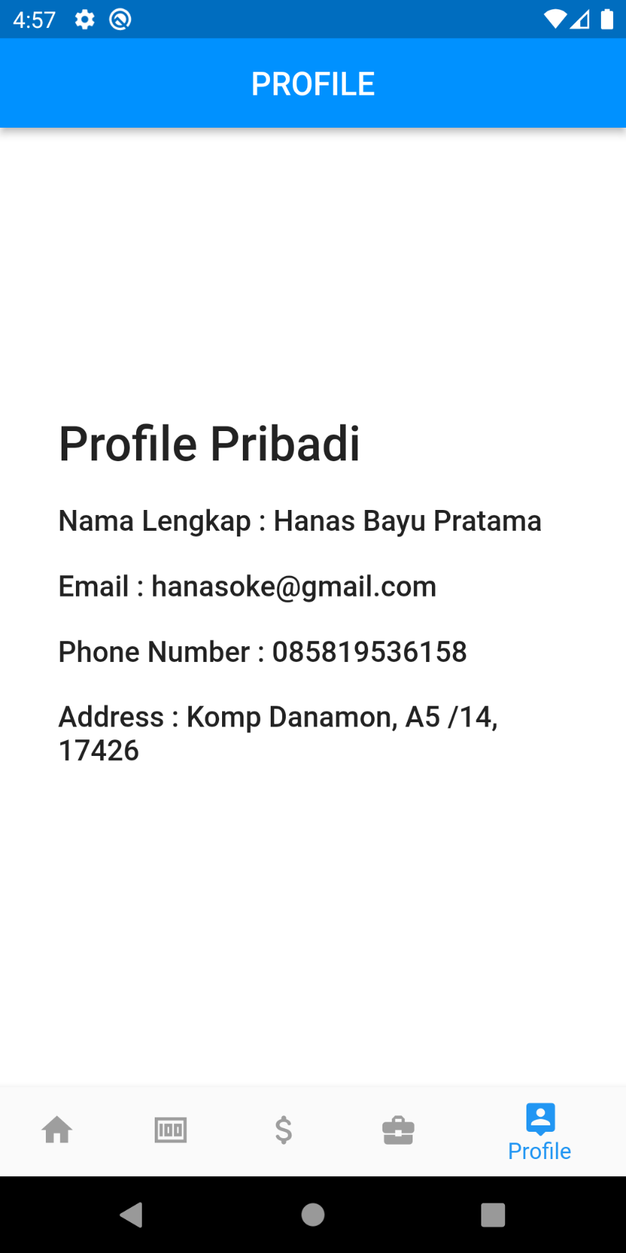

Profile Page