# Usage of the visualizer

The entry point of the visualizer is GraphVisualizer::main. When compiling, make sure the libraries and the file “ui.css” is under the working directory. You can also use the pre-compiled jar file to run by double-click on it.

The visualizer will start by download and process the data. During the process, the inputs are disabled until the data is properly processed and the graph is built.

## Main functions

There are three basic functions of the visualizer, add an actor/actress to the visualizer, find a link between two people and display the link to the visualizer, and get diameter of the graph and display it on the visualizer.

First, the node (actor/actress) added to the graph by the user will be displayed larger with a yellow color. When added to the graph, up to 15 of its largest-degree neighbors will also be added to the graph. If the newly added node has some edge between it and some nodes already in the visualizer, the edge will also be displayed.

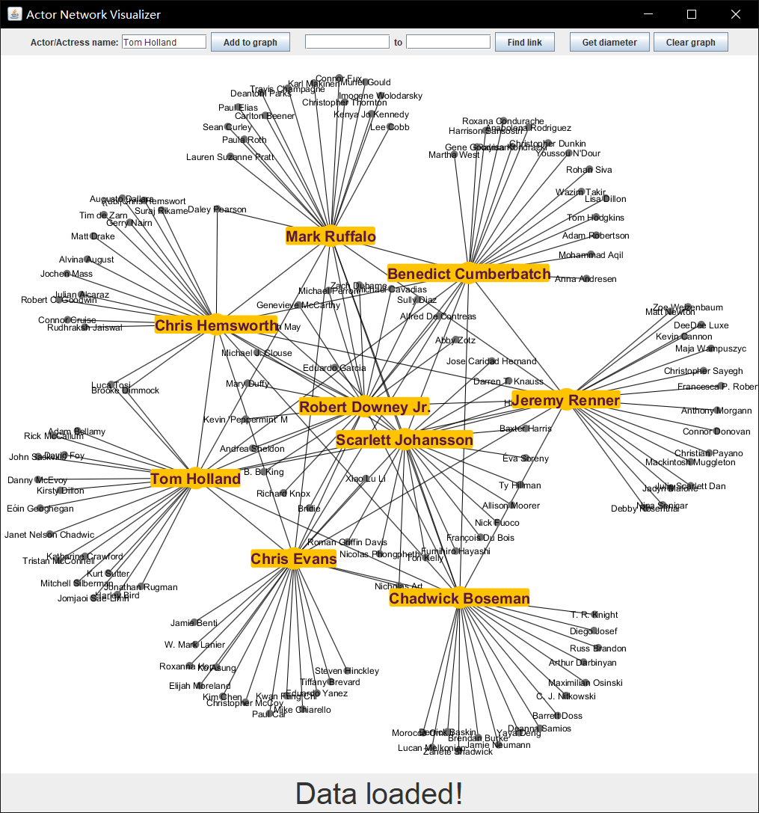

The find link function is similar to use. The user is to input the starting actor and ending actor, and the program will find the shortest path between them. The visualizer will highlight the link and the path in blue. The numbers of hops (distance) will also be displayed on the edge. The highlight will be cleared when a new path is found. Note that each time it will shuffle the neighbors ordering so you could possibly find a new shortest path.

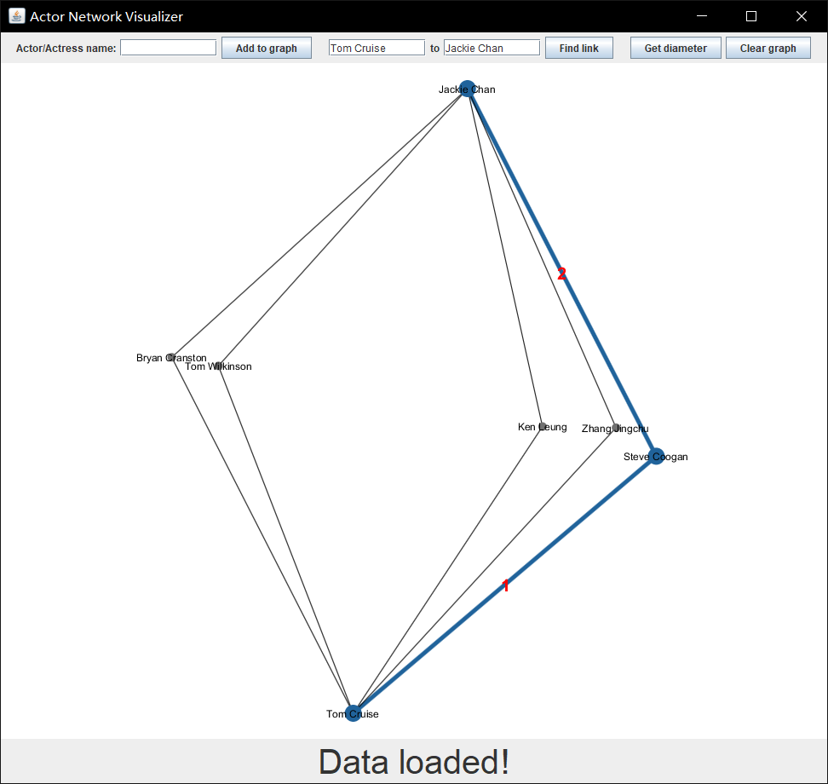

The get diameter function is straightforward, just press the button and the longest shortest path will be added to the visualizer. Again, every time a new distinct path will be founded.

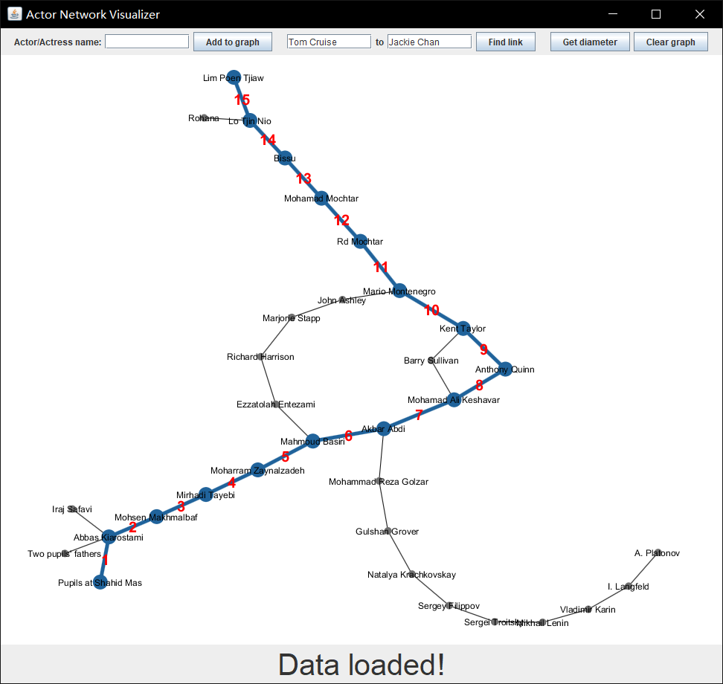

## Extras

First, you can see that there’s a “clear visualizer” button on the side of the top bar. Click on that will clear the visualizer, but not deleting the graph. If you only want to delete one node, right click on the node, and select “delete node” from the pop-up menu. When a node is deleted, some of its neighbors may be left alone in the visualizer, so that node will also be deleted.

By right click on a specific node, you can also copy the name of the node (actor/actress’s name) by selecting “copy name” in the pop-up menu.

You can drag any node by holding a node with left mouse button. Notice that after the drag the graph will automatically rearrange the graph using Barnes–Hut simulation (which is provided by the library we use).

Lastly, you can use your mouse wheel to zoom in a specific place on the graph, by pointing your mouse to a place and scroll up to zoom in and down to zoom out (this works best when using a mouse). You can use keyboard arrows to move to up, left, right and down.

# Program Detail

This program is consisting of 3 main classes for building the network and graph visualization.

## DataProcessing

DataProcessing is a class for downloading and processing the data from <https://oracleofbacon.org/data.txt.bz2>. This is the data set provided The Oracle of Bacon website under its “How the Oracle of Bacon Works” (<https://oracleofbacon.org/how.php>) page. The data set is a txt file with each line being a JSON encoded object which includes movie’s title, year, an array of cast, and so on. The data set is provided to us being compressed using bzip2 compression software.

In the acquireData method of DataProcessing, we first connect to the URL with java.net.URLConnection, and we use a library org.apache.commons.compress.compressors.bzip2.BZip2CompressorInputStream to decompress the file. Then, we prepared a class Util.MovieInfo for binding the JSON object. We then use com.fasterxml.jackson.databind.ObjectMapper to extract every JSON object into the class, and save the movie information into a list.

The getAllCasts method is able to extract all casts from each movie into a list of string array. Notice that in every actor in a string array has an edge between them, i.e., each string array forms a clique.

## ActorsNetwork

ActorsNetwork is a class for all graph calculation and algorithms. It takes in a set of strings as nodes, and build a graph based on these nodes. Inside, it will assign each node a distinct integer id as the true identification of each node. The map nameToID and idToName is used for keeping track of the mapping.

The addEdge method will add an undirected edge between the given node with string u and v; getID gets the ID with a given name as string; getName gets the name with a given ID as integer; getDegree gets the degree of the node with given ID as integer; getSize gets the number of nodes in the graph, with ID from 0 to size-1.

breadthFirstSearchWithLength implements a BFS algorithm with a starting node and returns an array of distance of the given node to other nodes. breadthFirstSearchWithIncoming implements a BFS algorithm with a starting and ending node and returns an array of the incoming node (parent in the BFS tree). Notice that the former will finish after traversing through the whole graph, and the latter finishes after meeting the ending node.

shortestPath gives the shortest path between two nodes and returns the list of nodes the path goes through. This algorithm uses BFS as in breadthFirstSearchWithIncoming since the graph is unweighted and undirected.

getDiameter gives the diameter (the longest shortest path) of the graph. This algorithm starts at a random node p, run breadthFirstSearchWithLength once to find the node u with largest distance from the starting node, and then run breadthFirstSearchWithLength again to find the node v with largest distance from u. We know from lectures (CIS 121 or NETS classes) that this will give us the diameter of the graph. Notice that there exists a small probability that the starting node is not in the largest connected components, which would yield a result of a longest shortest path of that connected component.

## GraphVisualizer

GraphVisualizer contains the entry point for the program. We use our own ActorsNetwork for algorithm, and uses the library org.graphstream.graph for visualization.

The method init will download and process the data and add all nodes to the graph class we wrote. The method addEdge will added an edge with given two nodes to the visualizer. displayNeighbors would display the node itself and up to 15 neighbors with the largest-degree on the visualizer. findLink will find the shortest path between the given two nodes and add it to the visualizer. getDiameter would get the diameter of the graph and display it on the visualizer.

The rest of the methods are related to the building of Swing components, and the code is mainly routines and pretty self-explanatory.