**Empirical and Statistical Analysis**

NETS150 Final Project

Hanbang Wang, Jarett Schwartz, Adrian Wang

# What is the average degree in the network and what can we say about the distribution of degrees?

Hypothesis: We expect that the distribution of degrees in the network will be heavy-tailed with a few actors having a very high degree, and most having a relatively small degree. This is an observed pattern in most real-world networks, and it would make sense for it to exist and this network, as there are a small number of actors who have appeared in many films.

Conclusion: As predicted the data has a very heavy-tailed distribution of degrees. There are a very high number of actors in the network with a low degree, between 0 and 50. Then, the frequency of degrees drops off very quickly, going to zero.

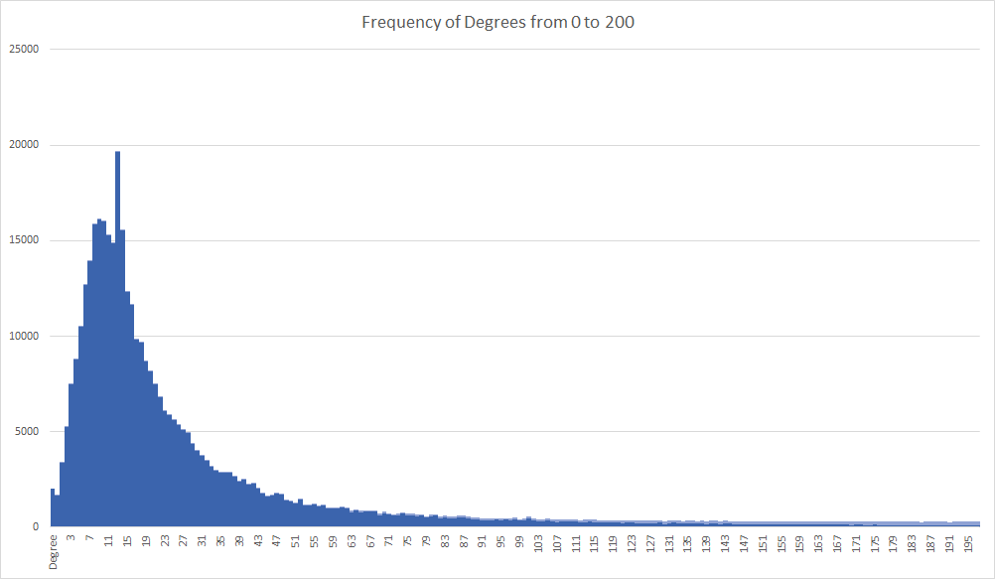

The above graph shows the frequency associated with different degrees in the network. For the sake of readability, the graph only shows degrees 0 to 200, but understandably the frequency continues to drop off to 0. Clearly, most actors have a degree in the network between 0 and 25 and relatively few have a degree over 150.

# What is the primary genre of the actors with the highest degree in the network?

Hypothesis: It is reasonable to believe that the actors with the highest degree in the network will be action movie actors. This is because actors who do action movies, tend to do a lot of action movies. While many action movie actors branch out into drama or comedy, action movie actor seem like they overall tend to make mostly action movies and a lot of them.

Conclusion: The actors in the network with the highest degree span many genres from dramas and thrillers, to comedies and action movies. There are relatively more actors with high degree that have starred in comedies, but the difference among genres is not considerable. A difference that is quite noticeable is that the actors with the highest degree tend to be Indian film actors, with many starring in Malayalam films. This is likely stems from India producing films in very high quantities. Upon further inspection it has been found that India produces more films than any other country in the world with around 2000 per year.

# What is the length of the longest shortest path in the network?

Hypothesis: The length of the longest path should be between 10 and 15. As a hypothesis this is simply a rough estimate, but it is based on the fact that we expect the average shortest path to be between 4 and 6, like most other real-world networks, and there are many obscure actors and actors from generations ago, so between 10 and 15 seems like a reasonable estimate.

Conclusion: The longest shortest path in the network is of length 15. There are actually multiple paths of length 15, but one such path goes from Iraj Safavi to Yessi Gusman. This path is shown below. Iraj Safavi has worked on Iranian films, and Yessi Gusman is Indonesian, so it makes sense that the shortest path between them is quite long. A path of 15 may seem quite long, but most paths are much shorter than this.

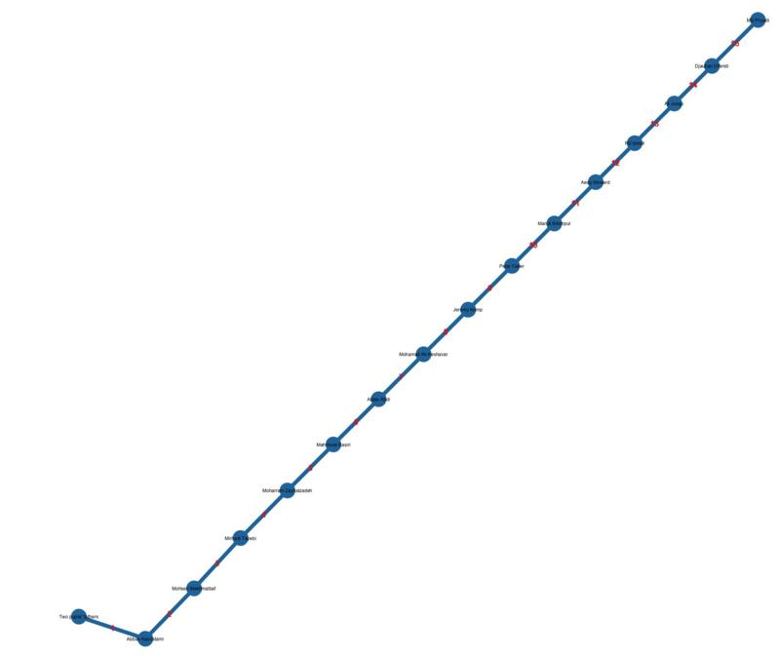

# Are there any interesting characteristics about the highest paid actors of all time?

Hypothesis: It would make sense that the highest paid actors of all time would be closely connected to some other of the highest paid actors of all time. The reason this would make sense is because highly paid actors are highly paid because they star in blockbuster films, then presumably with other highly paid actors.

Conclusion: The highest paid actors of all time tend to have a very high degree. For example, Samuel L. Jackson, who is listed by Forbes as the highest paid actor of all time, has a degree in the network of over 1873, and Harrison Ford who is listed as the second-highest paid actor of all time has a degree of 1569. While these numbers are not close to the highest degree in the network, they are still far above average. This trend makes logical sense since because generally the more movies a person makes, the more money they will make and the more people they will have costarred with in different movies.