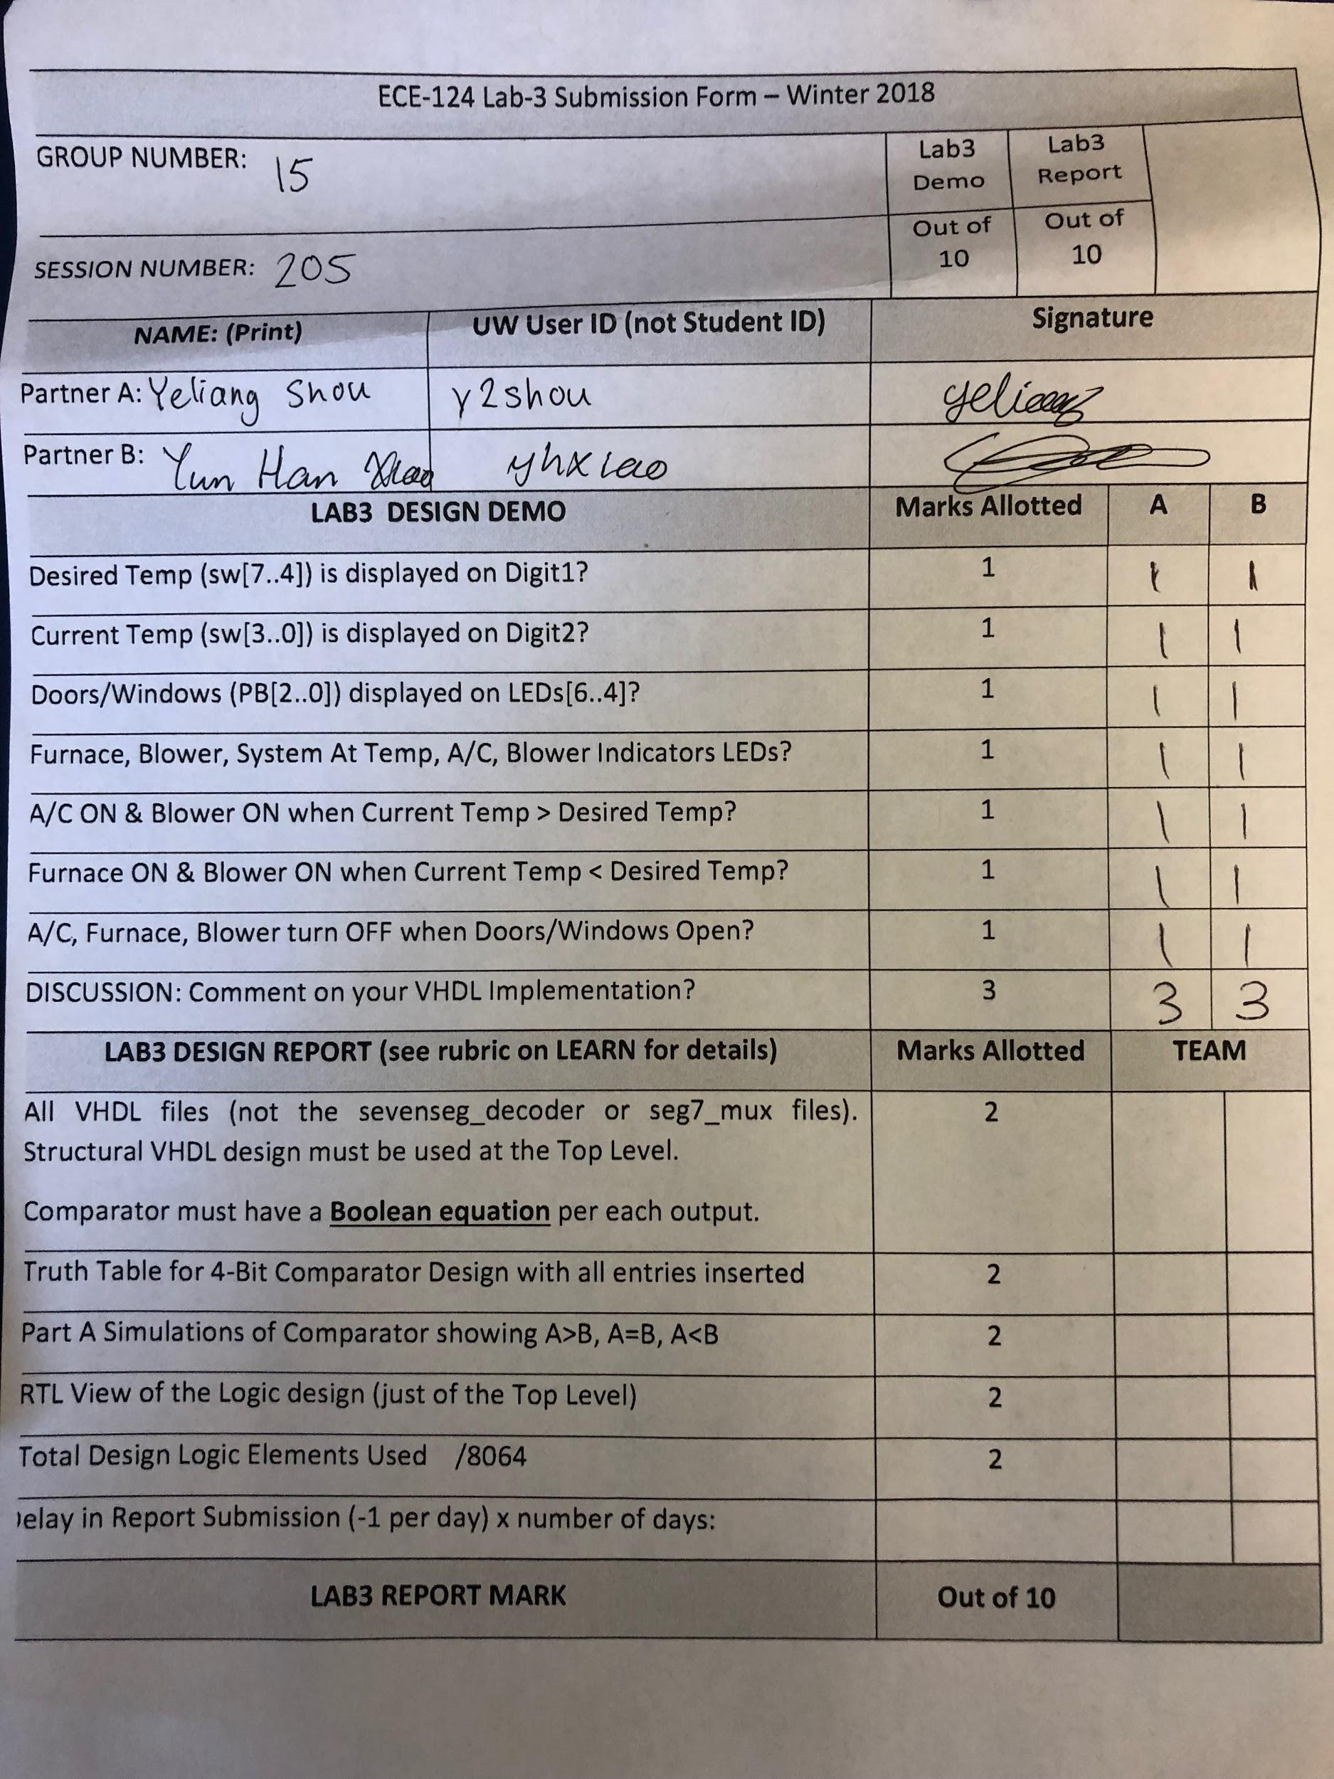

**LogicalStep_Lab3.vhd**

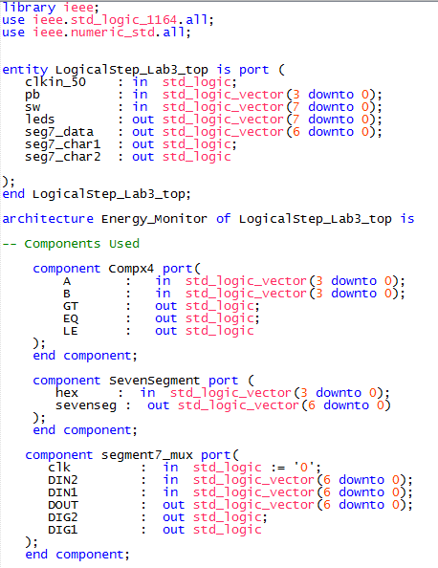

*In this first part, we declared the component including the 4 bits comparators (Compx4) and the muxes necessary for Character Display.*

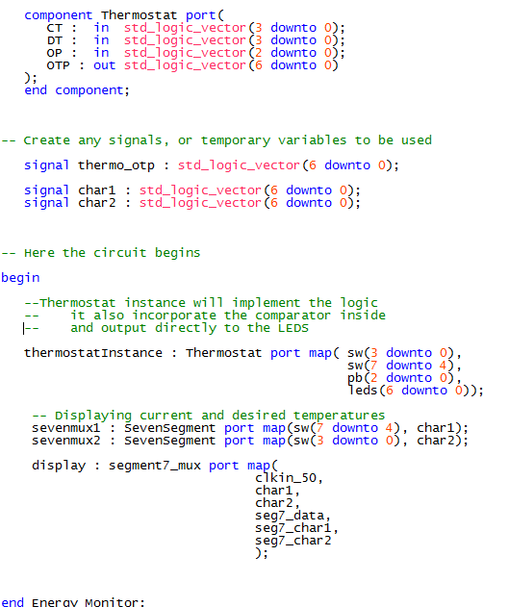

*Here, we declared a Thermostat component which will be a sub-module responsible for handling the logic. We instantiate the Thermostat by mapping our input switches [7..4] as desired temperature and sw[3..0] as current temperature (each a 4 bit input). The output of the Thermostat will be directly mapped to the appropriate LED through the 7 bit LED vector.*

*We have also instantiated the necessary components for the Seven Seg Display.*

**Compx4.vhd**

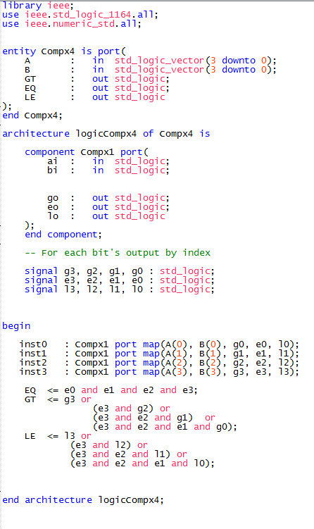

*Here, we applied the 1-bit comparator to each of the 4 bits in input A and B, we then applied the necessary logical operation to obtain an overall result on Greater or Equal or Less.*

**Compx1.vhd**

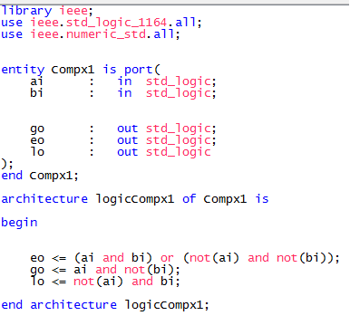

*The one bit comparator is straightforward and trivial, if both bits are one or both are zero, then they are equal, if the A bit is one while the B is zero, we then have greater, conversely we will output “Less”.*

Table 1: Logic Table for 4-bit Magnitude Comparator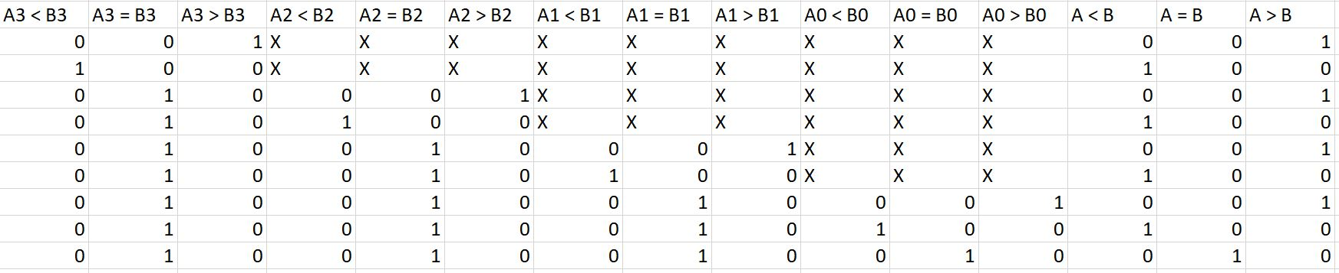

**Thermostat.vhd**

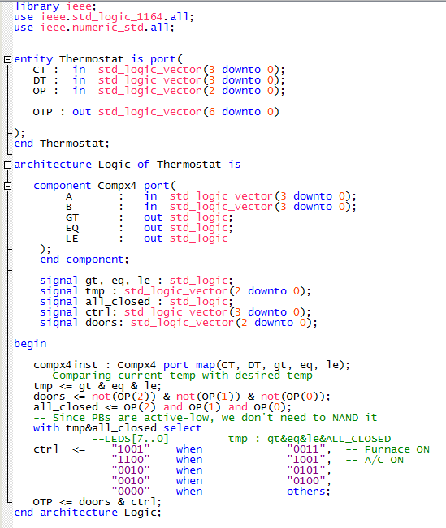

*The Thermostat logic first compares desired and current temperature (each a 4 bit vector) using the 4 bit comparator declared earlier. We also inspect if all the windows/door are closed, to do so is fairly trivial, consider that the PBs are active-low, by applying AND to all 3 PB inputs, if such returns True, then we know all doors/windows are closed. For implementing the logic of Thermostat, we used a straightforward case by case approach with our select statements.*

**Wave Simulation for 4-Bits Comparator**

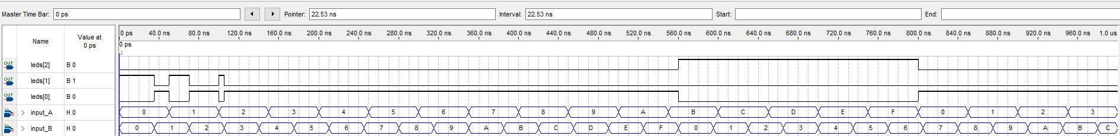

**RTL Overview of LogicStep_3.vhd**

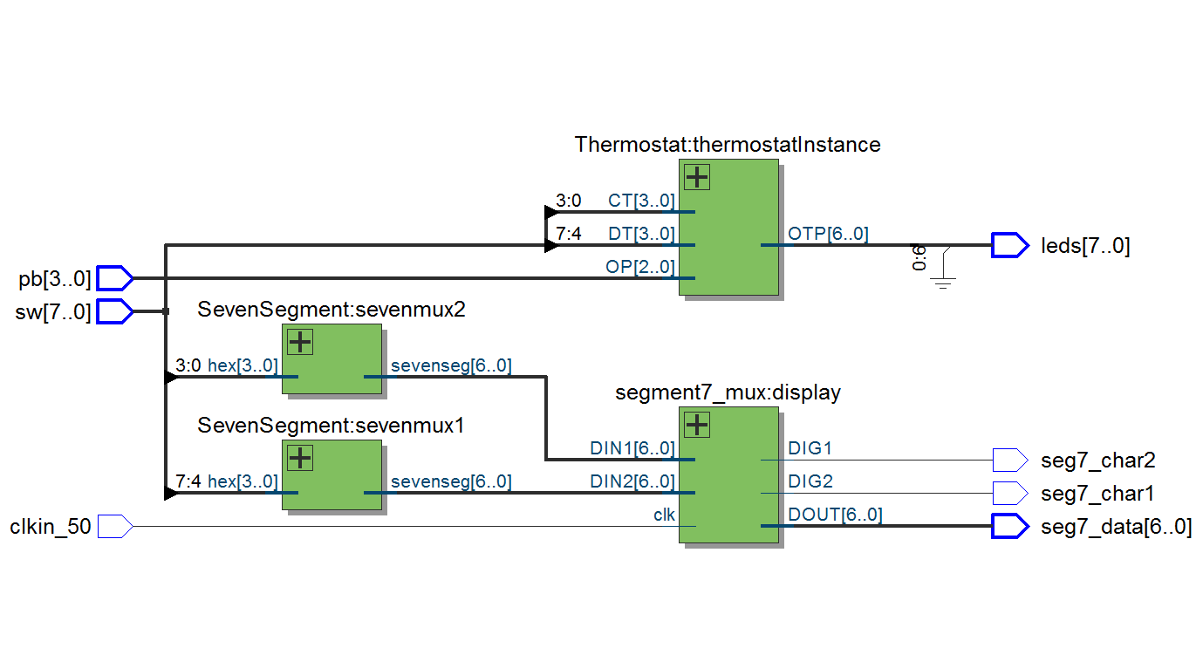

**Number of Logical Elements Used: 47 /8064**

