**Lab 4 Group 15 Session 205 Report**

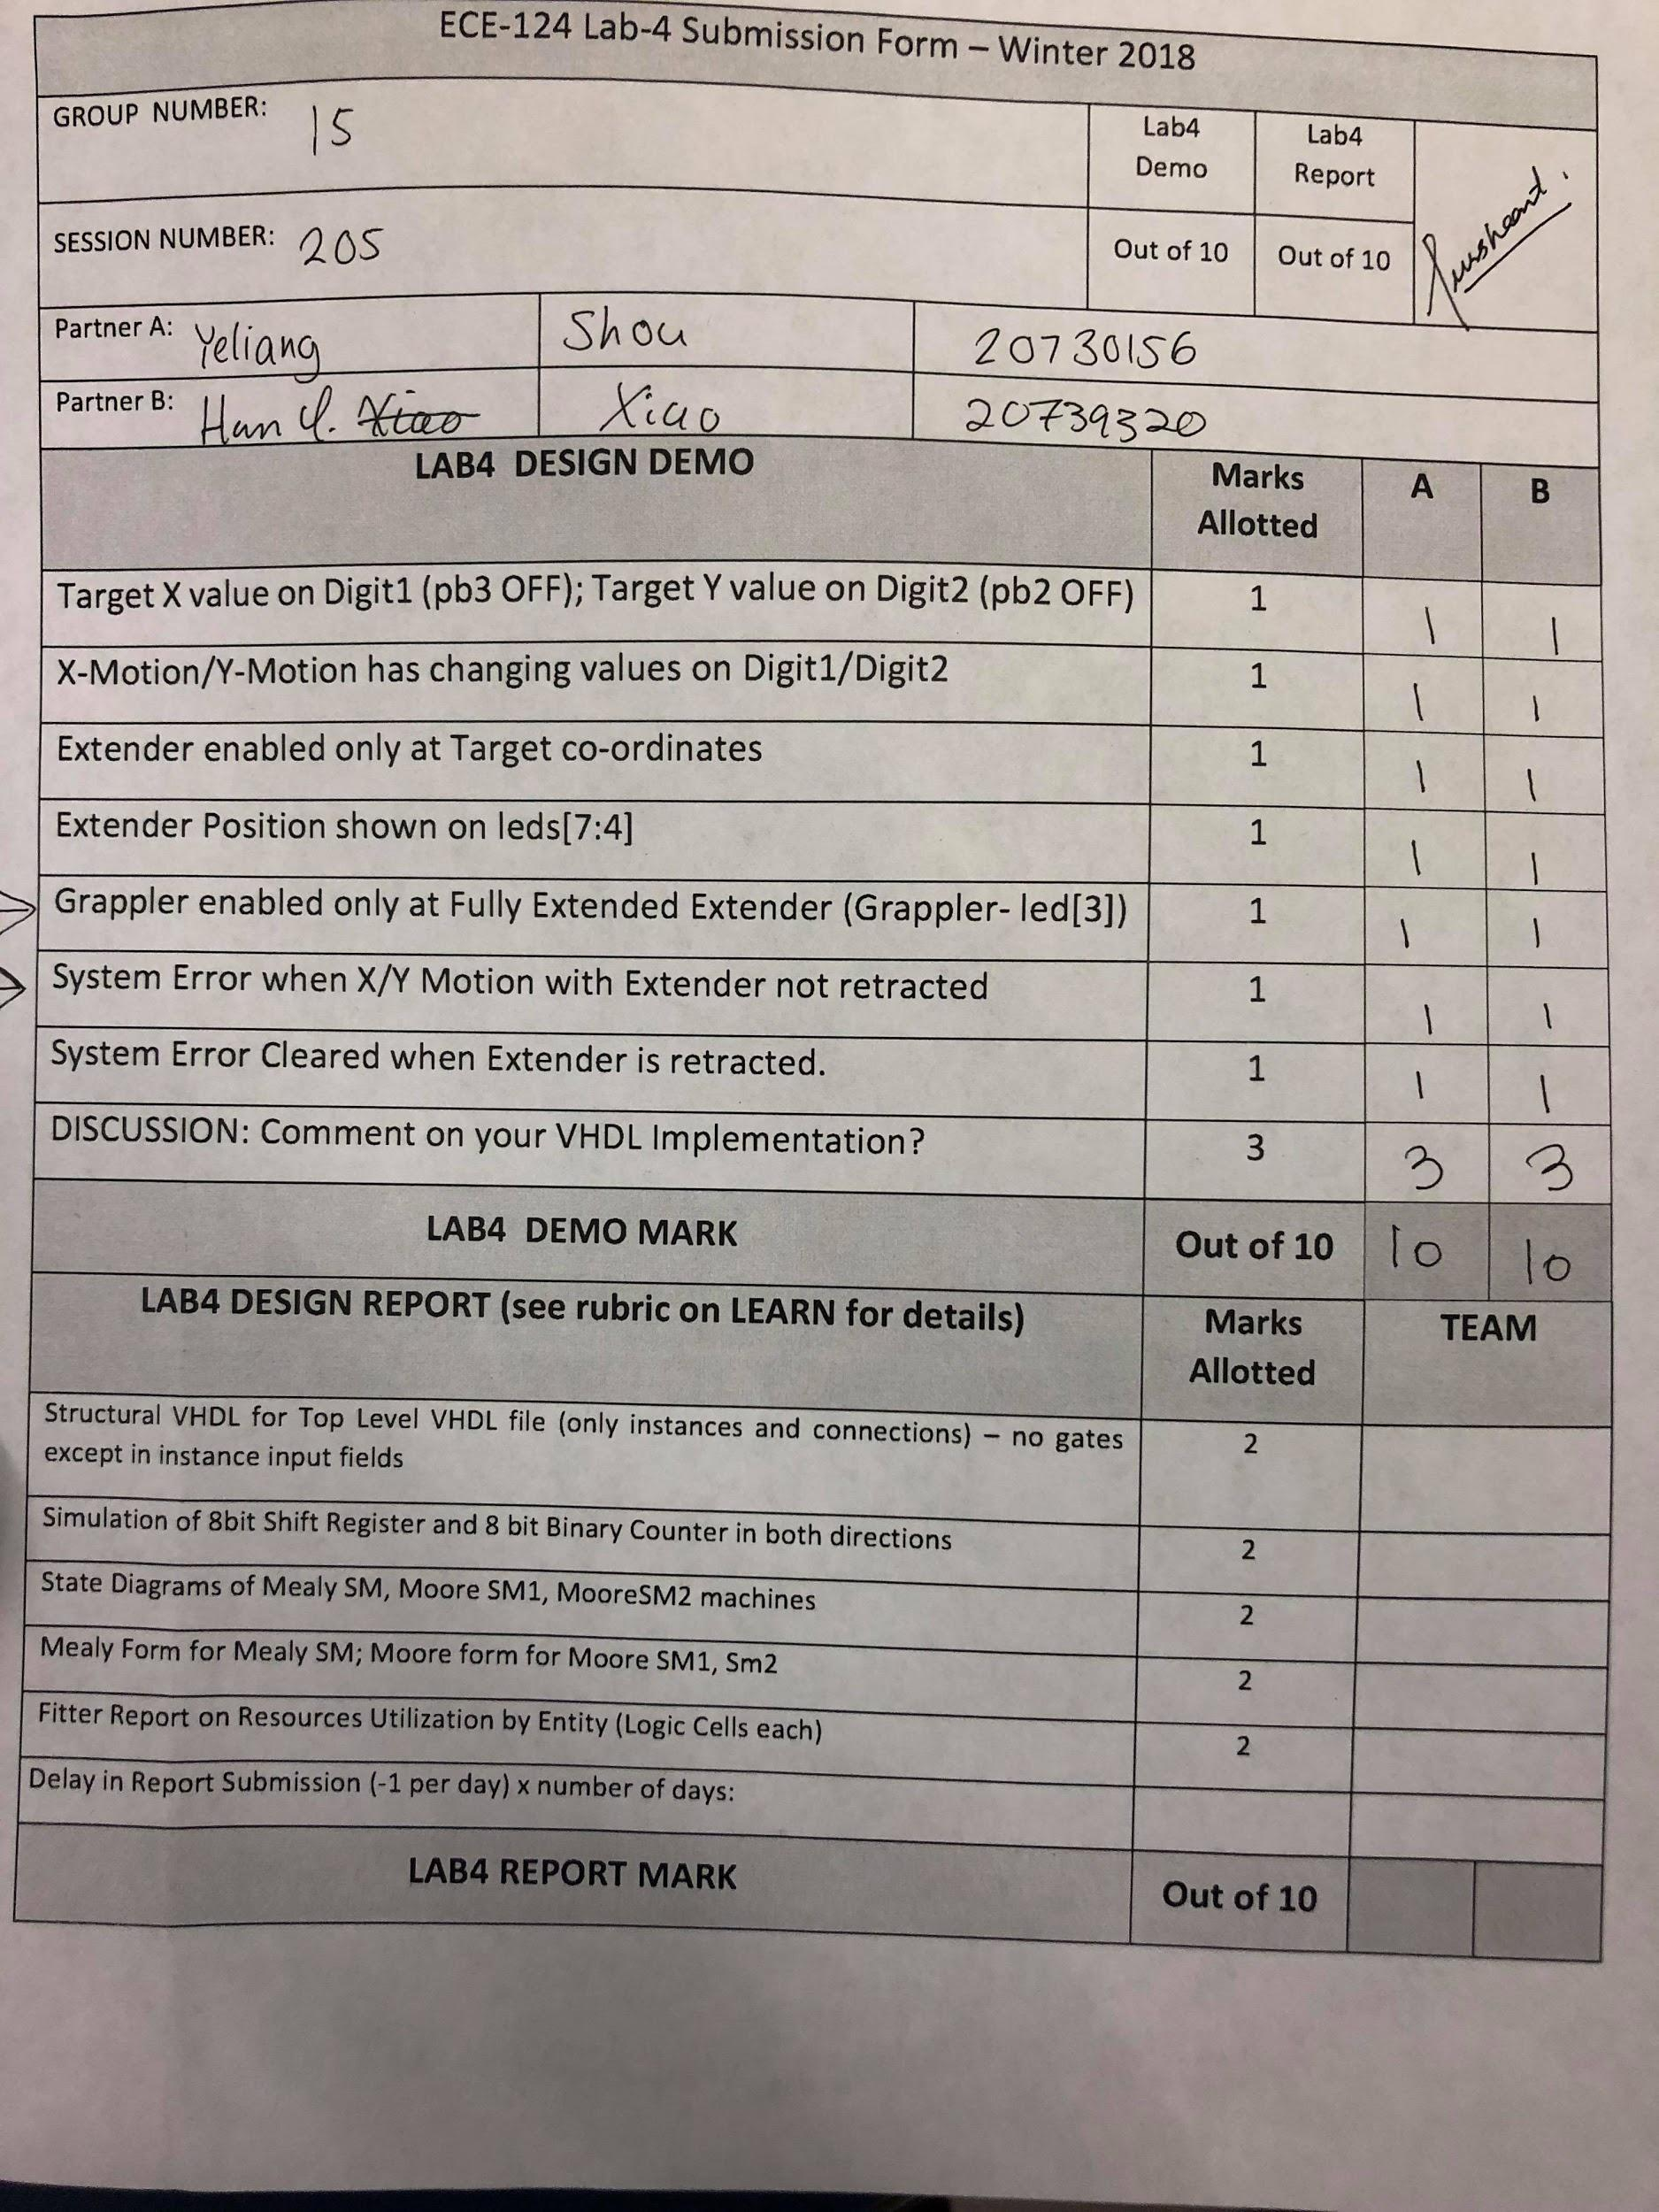

**Function Simulation for the Bidirectional Shift Register**

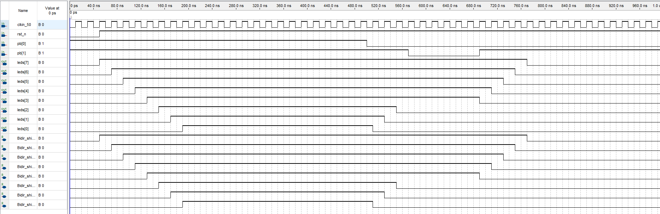

**Functional Simulation for the Up/Down Binary Counter**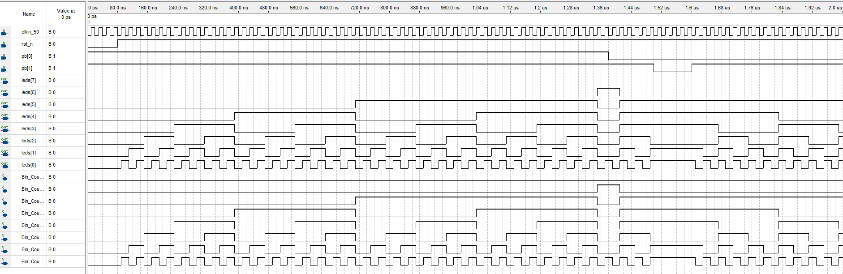

**Structural VHDL Top Level File**

*Entity Declaration*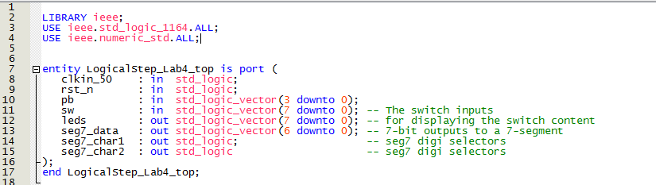

*Component Declarations*

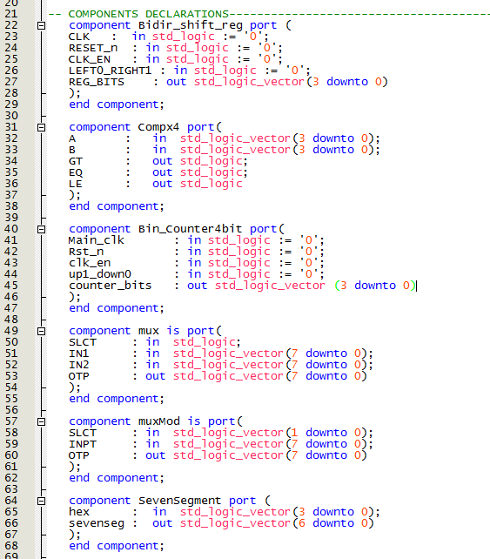

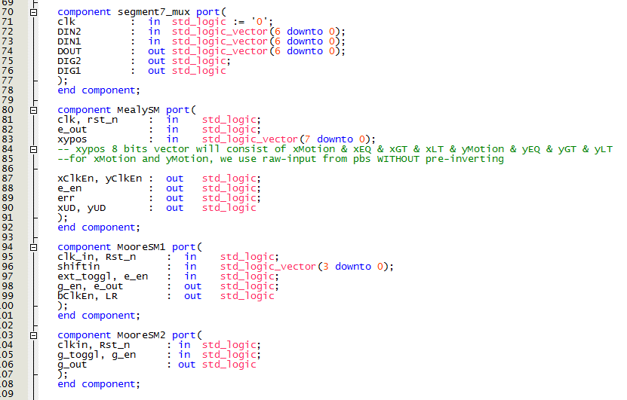

* Component declarations including:  
  1) 4-Bit Magnitude Comparator 2) Seven-Segment Decoder  
  3) Seg7_Mux 4) Bidirectional 4-bit Shift Register  
  5) Binary 4-bit up/down Counter 6) Mealy State Machine   
  7) Moore State Machine 8) All multiplexers

*All Signal Declarations*

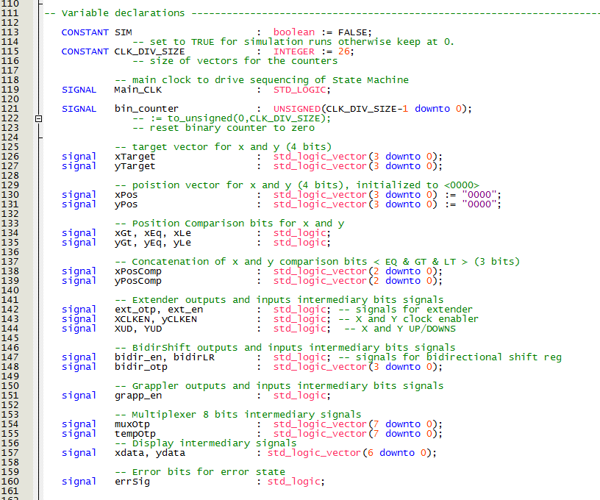

All signals in the top file are declared here.

*Architecture*

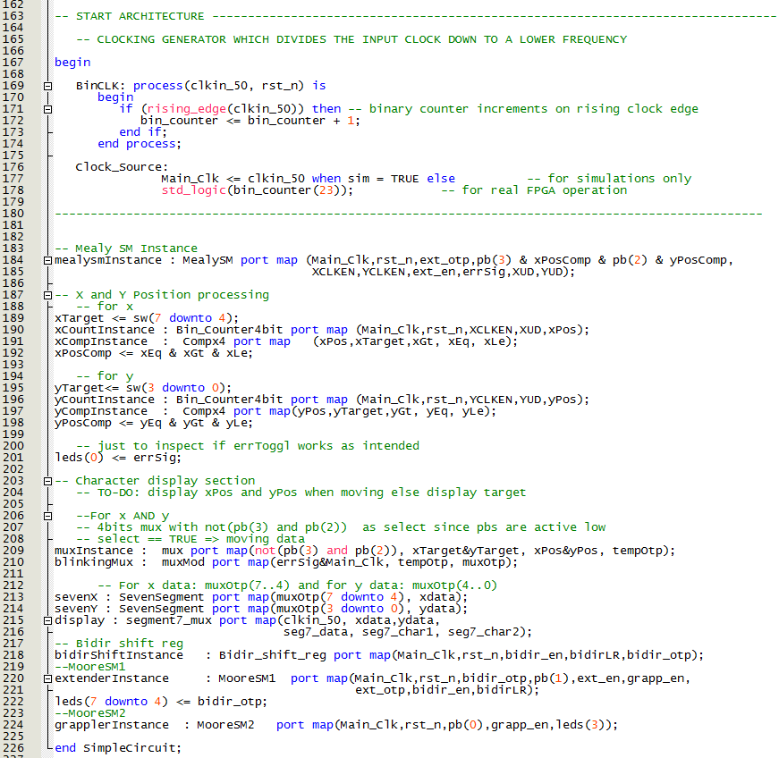

The architecture section in this VHDL file. This includes all the instances used in the program.

**Mealy SM State Diagram**

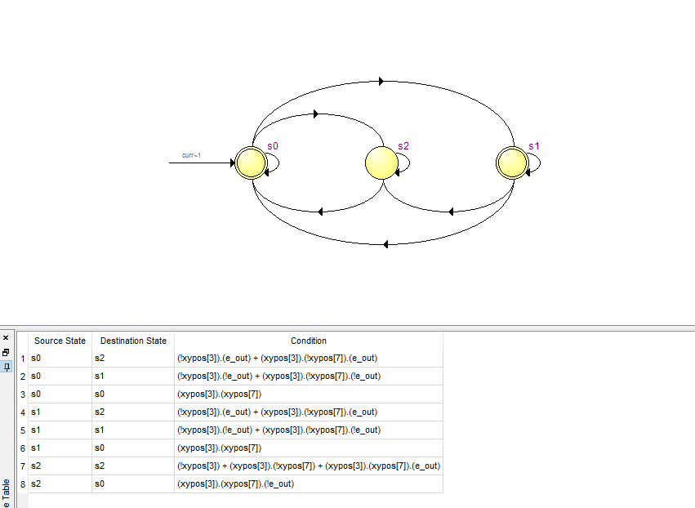

**Moore SM State Diagram 1**

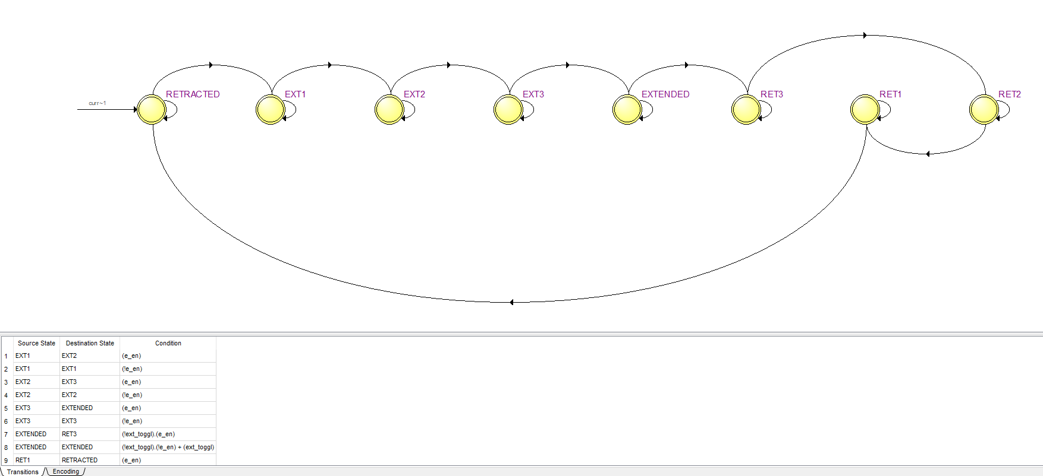

**Moore SM State Diagram 2**

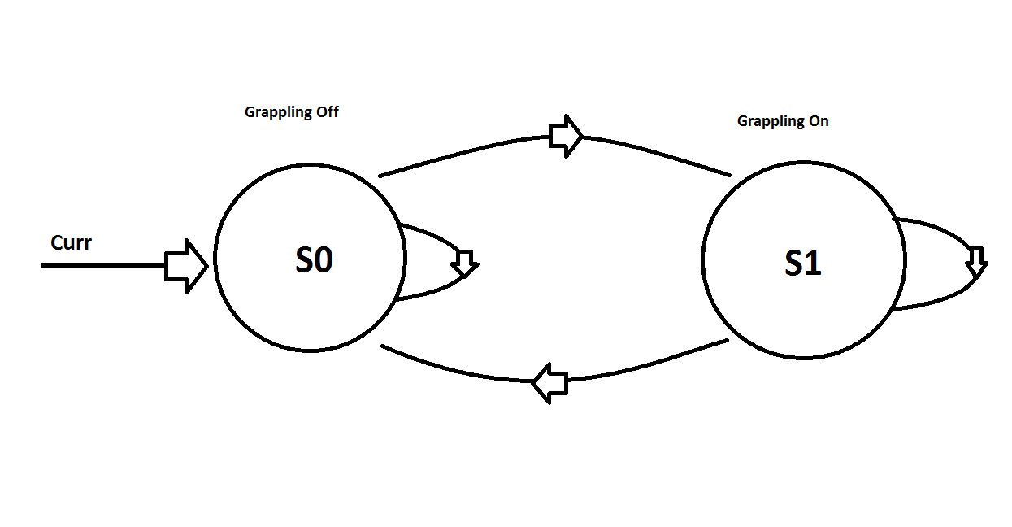

**Mealy State Machine (x/y position controller)**

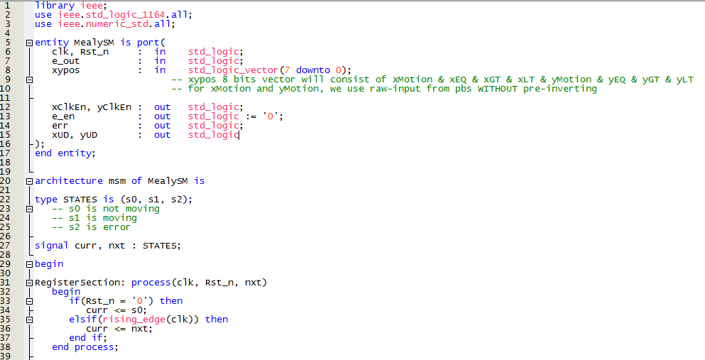

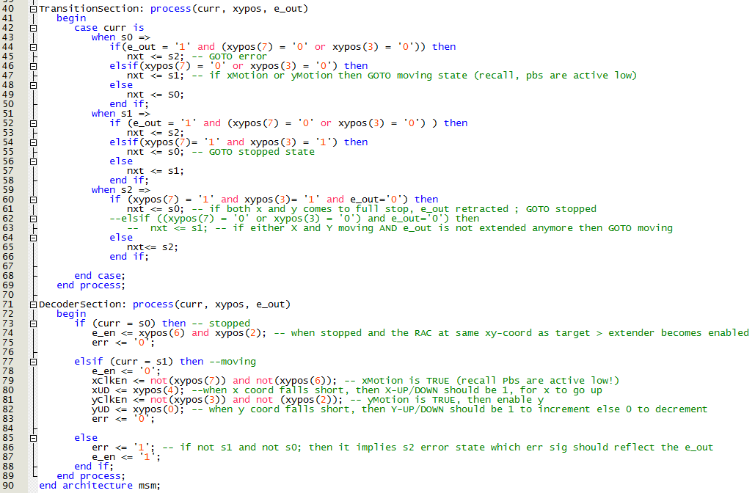

Code for the Mealy state machine is as shown above. We used 3 different states consisting of: The state when our xy position is not moving, when the position is moving towards the target xy position, and an error state when we try to move when the RAC is extended.

The register section is clocked by the rising edge of Main_Clk.  
The transition sections lets us change states according to inputs from comparators, push-buttons[3:2] and extender controller.

Finally the decoder section is of Mealy form, driven by both current state and input values.

**Moore State Machine 1 (extender controller)**

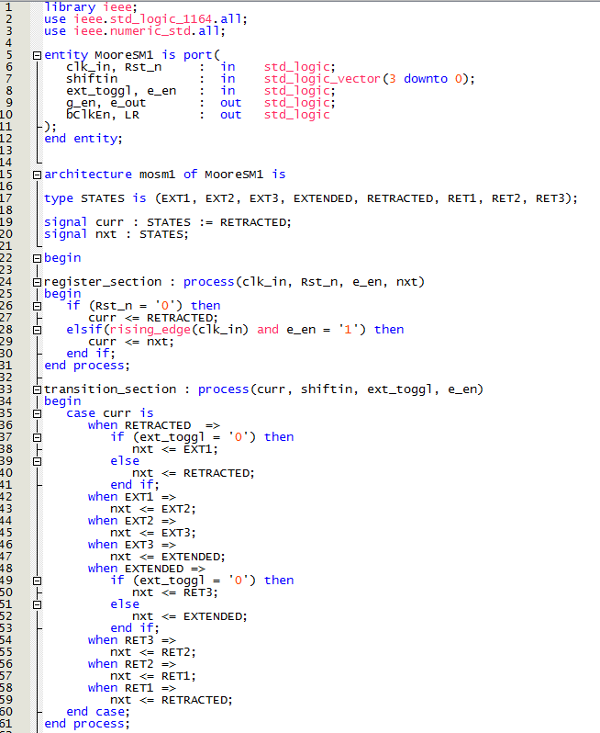

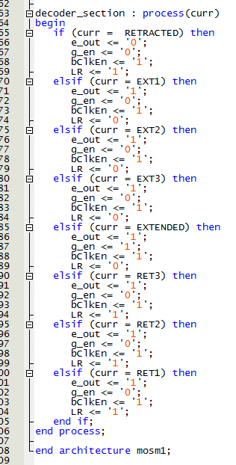

Code for the first Moore machine (the extender) as shown above. 8 different states were used to indicate the state of the extender.

The register section is clocked by the rising edge of Main_Clk.

The transition section allows the states to change states according to inputs received from the bidirectional shift register, extender_enable, and pb[1].

The decoder section is of Moore form, making the outputs only dependent on the current state.

**Moore State Machine 2 (grappler)**

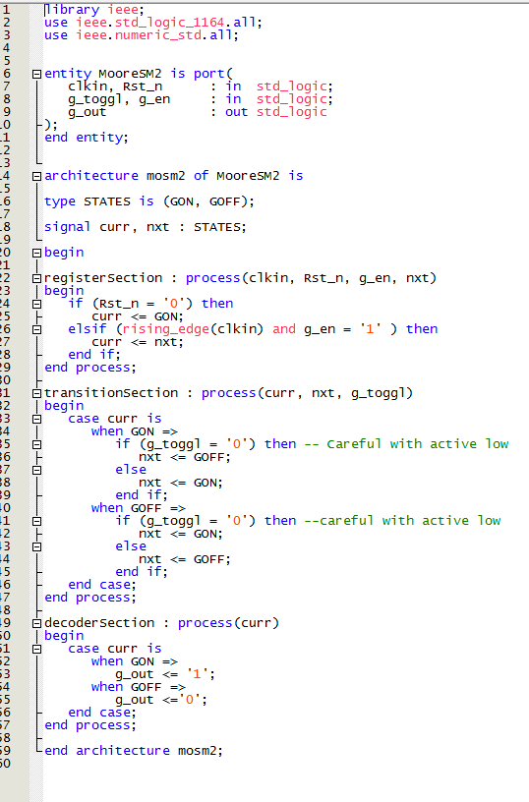

Code for the second Moore machine (grappler) as shown above.

The register section is clocked by the rising edge of Main_Clk.

The transition section allows the states to change states according to the inputs received from the grappler enable and pb[0]

The decoder section is of Moore form, making the outputs only dependent on the current state.

**Fitter Report on Resource Utilization by Entity**