Fire Technology

1

© 2013 Springer Science+Business Media New York. Manufactured in The United States

DOI: 10.1007/s10694-013-0336-7

Skin Burn Translation Model for Evaluating Hand Protection in Flash Fire Exposures

*Alexander Hummel* and Roger Barker, Textile Protection and Comfort Center, College of Textiles, North Carolina State University, 2401 Research Dr,*

*Raleigh, NC 27695-8301, USA*

*e-mail:* [*roger_barker@ncsu.edu*](mailto:roger_barker@ncsu.edu)

*Kevin Lyons, Department of Mechanical and Aerospace Engineering, North Carolina State University, Raleigh, NC, USA*

*e-mail:* [*lyons@eos.ncsu.edu*](mailto:lyons@eos.ncsu.edu)

Received: 17 August 2012/Accepted: 29 March 2013

*Abstract.* A model is described for use in translating measured heat flux to predict second and third degree hand burn injury in fire exposures. The model adapts a burn translation algorithm for estimating burn injuries used in established instrumented fire test manikin technologies. It facilitates more accurate prediction of burns to human hands by accounting for the cylindrical geometry of the fingers, bone tissue beneath the skin, and different skin thickness data that represents the different areas of the hand. A numerical modeling approach is used to demonstrate the response of the skin burn model for predicting hand burn injury in heat exposures encountered in fire manikin testing.

Keywords: Burn injury prediction modeling, Human skin burns, Flame protection, Thermal protection, Protective clothing, Instrumented manikin fire test systems

# Introduction

The PyroHands™ Fire Test System was developed to assess the thermal protective performance of gloves in flash fire exposures [1]. The PyroHands™ System, shown in Figure 1, consists of two anthropometrically accurate manikin hands that incorporate thirteen thermal sensors in right and left hand forms. There are three thermal sensors in each palm, three in each dorsum (or back of hand), four in each wrist, and one thermal sensor in each of the three middle-most fingers of each hand. This system is housed in a fire test chamber where four large propane gas burners are used to produce fire exposures that fully engulf the hand forms in flames at a calibrated average heat flux of 84 kW/m2 (2 cal/cm2s) incident to the surface of the hands. The severity of the fire exposure is adjusted by varying the duration of the incident flame exposure.

* Correspondence should be addressed to: Alexander Hummel, E-mail: [achummel@ncsu.edu](mailto:achummel@ncsu.edu)



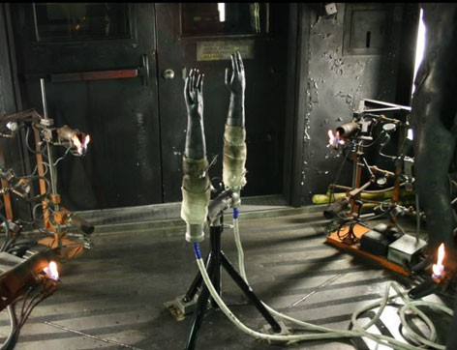

Figure 1. PyroHands™ system located in the fire test chamber at NC State University.

Development of the PyroHands™ system required creating a model to predict skin burn injury that is optimized to account for differences in tissue thickness in the hands and fingers and for the unique geometry of the fingers. The hand burn skin model needed to consider the effects of the bone layers beneath the skin on the heat transfer and burn injury in the hands.

# Skin Burn Injury Modeling

For the purposes of burn injury modeling, human skin can be considered as con- sisting of three distinct tissue layers, the epidermis, dermis, and subcutaneous. The epidermis, or outer skin layer, is composed of mostly dead cells that act as the protective barrier against moisture, ultra-violet radiation, and extreme heat. The dermis, or second layer of skin, contains the blood vessels, nerve endings, and other living tissues vital to healthy skin. The subcutaneous, or deepest skin layer, is made up of fat and connective tissue. Each of the three skin layers has its own unique thicknesses and thermo physical properties. In this regard, ASTM F 1930

[2] prescribes values for skin thickness and thermo physical properties for full scale manikin testing. However, since skin thickness varies from body region to body region, thickness values specific to the hands and fingers were needed for the PyroHands™ burn translation model. The skin thickness and thermo physical property values assumed for the hand are summarized in Tables 1 and 2.

Skin burns can be categorized into three levels of severity depending on the depth of thermal damage to skin tissue. First degree burns result in mild pain, skin redness, and are usually regarded as ‘‘minor’’ burns (such as sun burns). First degree burns are not considered in burn injury predictions based on instrumented fire test manikins because they are not life threatening. Second degree, or partial thickness burns, are produced when the dermis layer of skin tissue is damaged,

Table 1

Skin Thickness Values for the Hand [1, 9–15]

|  |  |  |  |
| --- | --- | --- | --- |
| Location | Epidermis (lm) | Dermis (lm) | Subcutaneous (lm) |
| ASTM F 1930 | 75 | 1,125 | 3,885 |
| Palm | 550 | 1,100 | 3,800 |
| Dorsum (back of hand) | 85 | 965 | 600 |
| Back of finger | 200 | 1,150 | 600 |
| Wrist | 80 | 1,100 | 3,800 |

Table 2

Thermo Physical Properties for the Layers of Skin Tissue and Bone [2, 16]

|  |  |  |
| --- | --- | --- |
| Layer | Thermal conductivity, k (W/m K) | Volumetric heat capacity, qC (kJ/m3 K) |
| Epidermis | 0.6055 | 4,255 |
| Dermis | 0.5745 | 4,245 |
| Subcutaneous | 0.3659 | 2,150 |
| Bone | 0.3000 | 2,619 |

resulting in skin blisters. Third degree burns, or full thickness burns, are produced when the subcutaneous tissue layer experiences thermal damage resulting in tissue destruction and scarring. Second and third degree burns are included in burn injury predictions because they represent tissue damage that requires immediate medical attention, and can potentially be fatal.

The algorithm used to estimate skin burn injury in the ASTM F 1930 fire test manikin standard is based on the Henriques integral method [3]. The Henriques integral method uses an Arrhenius equation to estimate the time required to achieve a second or third degree burn using surface heat flux histories as input to a model of human skin [2, 3]. The Henriques integral is expressed as follows:

X = Z Pe—DE dt (1)

RT

where, X = burn injury parameter (dimensionless), P = pre-exponential constant (1/s), DE = activation energy constant (J/kmol), R = universal gas constant (8,314.5 J/mol K), T = temperature at specified skin depth (K), t = time that T is above 44°C (s).

Using the Henriques integral, burn injury becomes a function of the time and temperature that skin tissue exceeds 44°C (317.15 K), which is the temperature at which tissue thermal damage occurs. Henriques [3] defined a second degree burn injury as X = 1 when applied to the skin depth equivalent to the junction between the epidermis and dermis skin tissue layers. Third degree burn injury is defined when X = 1 at a skin depth equivalent to the junction between the dermis and subcutaneous layers. The standard fire test manikin method (ASTM F 1930 [2]) specifies values for the constants P and DE/R from Eq. 1. The values for P

and DE/R are given in Table 3, which also shows how these constants change when the temperature of the skin is above 50°C.

The Henriques Integral predicts skin burn injury from the estimated tempera- ture at the epidermis/dermis and dermis/subcutaneous tissue junctions at a given time. These temperature values are found using a model that calculates heat trans- fer through skin tissue based on the heat flux incident on the surface of the skin.

## One-Dimensional Skin Burn Model

The one-dimensional, three-layer, skin model (Figure 2), is used for most full-size fire test manikins, including NCSU’s PyroMan™.

The heat flux data, collected by manikin sensors, is applied to the one-dimen- sional conductive heat transfer equation [4] as follows:

@T @2T

qC @t = k @x2 (2)

where, qC = volumetric heat capacity of skin (J/m3 K), T(x) = temperature of skin (K), x = depth into the skin (m), k = thermal conductivity of skin (W/m*K), t = exposure time (s).

Table 3

Constants for Calculation of Omega Using Henriques Burn Integral [2]

|  |  |  |  |
| --- | --- | --- | --- |
| Skin burn injury | Temperature range (oC) | P (1/s) | DE/R (K) |
| Second degree | 44 £ T £ 50 | 2.185 9 10124 | 93,534.9 |
|  | T > 50 | 1.823 9 1051 | 39,109.8 |
| Third degree | 44 £ T £ 50 | 4.322 9 1064 | 50,000 |
|  | T > 50 | 9.389 9 10104 | 80,000 |

**Heat Flux**

|  |
| --- |
| **Epidermis** |
| **Dermis** |
| **Subcutaneous** |

Figure 2. One-dimensional skin model showing surface heat flux and skin layers.

Equation 2 is solved numerically using a finite difference method [5] to estimate the temperature of the skin at any given time. The finite difference method sepa- rates the layers of skin into small finite segments, where the junctions between these segments are called nodes. The boundary and initial conditions defined by ASTM F 1930 [2] are applied to Eq. 2. The front boundary condition is the applied heat flux on the skin surface (either from heat flux sensors located on the fire test manikin or numerically created from previous experiments). The initial temperature profile of the skin increases linearly from the surface temperature of

32.5°C to the back surface temperature of 33.5°C. The back boundary of the one- dimensional skin model is held at a constant 33.5°C for every time step. This iso- thermal boundary condition becomes important if thickness of the subcutaneous layer is reduced too much, which is an important factor for the dorsum and finger regions of the hands.

The one-dimensional heat transfer model is suﬃcient for body regions where the radius is greater than 5.0 cm [2, 6]. However, the radius of the PyroHands™ finger is less than 1.0 cm. Since the effect on burn injury prediction for radii this small is not known, it was necessary to develop a cylindrical model of skin to esti- mate heat transfer in the human finger.

## Cylindrical Skin Burn Model

The cylindrical skin model uses a three-layer structure with the epidermis, dermis, and subcutaneous configured as a cylinder with a hollow core (Figure 3). In the case of a four-layer model, the hollow core is replaced by bone to increase the anatomically accuracy of the burn prediction.

**Heat Flux**

**Epidermis**

**Dermis**

**Subcutaneous**

Figure 3. Cylindrical skin model showing skin layers with a hollow core.

The heat flux equation for cylindrical conduction is [4]:

@T k @T @2T

qC @t = r dr + k @r2 (3)

where, qC = volumetric heat capacity of skin (J/m3 K), T(r) = temperature of skin (K), r = radius of the skin (m), k = thermal conductivity of skin (W/m*K), t = exposure time (s).

The cylindrical heat equation (Eq. 3) is similar to the one-dimensional heat

equation, with the singular difference being the k @T term. In full torso fire manikin

r

dr

tests, this term is assumed to be negligible, which is essentially true for radius val-

ues greater than 5.0 cm [6]. However, the human finger has a significantly smaller radius than the body regions previously assumed in fire test manikins. Therefore, an important aspect of defining the burn injury model for PyroHands™ system was to examine the effects that cylindrical coordinates have on burn injury predic- tion for radii less than 5.0 cm.

# Numerical Modeling

## Effects of Cylindrical Coordinates

A computer code was developed using MatLab® [7] to replicate the one-dimen- sional burn injury prediction algorithm. This code used cylindrical coordinates for heat conduction through the skin. The numerical routines use input heat flux data (i.e. ASTM standard profiles [2] and PyroHands™ sensor data) to calculates the maximum value of Omega (X). As described, X = 1 results in a second degree burn when applied at the epidermis/dermis junction and a third degree burn at the dermis/subcutaneous junction. Figures 4 and 5 represent the Omega value taken at the epidermis/dermis junction of second degree burns.

The ASTM F 1930 [2] Standard heat flux profiles (Table 4) were used to com- pare the different burn models (one-dimensional and cylindrical). This validation data set was defined by the work of Stoll and Greene [8], who exposed radiant heat fluxes to human subject forearms until they received a 2nd degree burn or ‘‘Threshold Blister.’’ Therefore, numerically, these heat flux values produce X = 1 ± 0.1 (at the epidermis/dermis junction) when applied to the surface of the one-dimensional skin model, for the specified time. These ASTM Standard profiles were applied to both the one-dimensional, or slab model, and cylindrical models to produce the omega values shown in Figures 4 and 5.

Figure 4 shows the numerical modeling results for the cylindrical and one- dimensional slab skin models when standard skin thickness values of 75 lm, 1,125 lm, and 3,885 lm are used. The burn injury (Omega) value is used as the y-axis instead of ‘‘time-to-burn’’ to highlight deviation from the 2nd degree burn of Omega = 1. When looking at Figure 4, an Omega value much greater than 1 will result in a faster time to burn and a higher skin temperature. The results of Figure 4 show that the cylindrical model is similar to the slab model burn injury prediction for radius value of 5 cm. This finding is consistent with the omission of

4.000

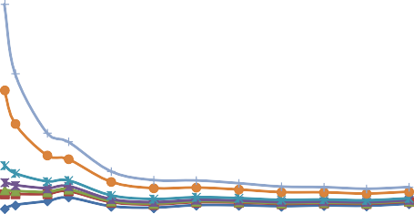

3.500

3.000

2.500

**Omega**

2.000

1.500

1.000

0.500

 Slab  Cylinder - 5cm  Cylinder - 4cm  Cylinder - 3cm  Cylinder - 2cm  Cylinder - 1cm

 Cylinder - 0.75cm

0.000

0 10000 20000 30000 40000 50000 60000 70000 80000

**Heat Flux (W/m^2)**

Figure 4. Omega values for the ASTM standard heat flux profiles showing the effects of cylindrical coordinates on standard skin thick- ness (calculated at depth of 75 lm).

1.000

0.900

0.800

0.700

0.600

**Omega**

0.500

0.400

0.300

0.200

0.100

0.000

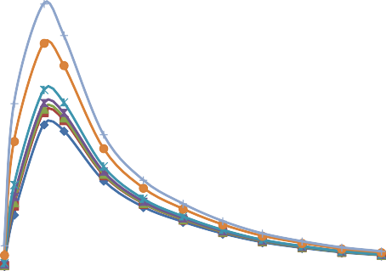

0 10000 20000 30000 40000 50000 60000 70000 80000

**Heat Flux (W/m^2)**

 Slab  Cylinder - 5cm  Cylinder - 4cm  Cylinder - 3cm  Cylinder - 2cm  Cylinder - 1cm

 Cylinder - 0.75cm

Figure 5. Omega values for the ASTM standard heat flux profiles showing the effects of cylindrical coordinates and variation in assumed cylinder radius (calculated at depth of 200 lm).

cylindrical coordinates for burn injury predictions using fire test manikins [2, 6]. Figure 4 also shows that as the radius of the cylinder decreases, the burn injury values begin to change, especially for the low intensity, long duration heat flux values. Therefore, when using standard ASTM thickness values, the addition of radius to the burn equation is significant for radii less than 5 cm. This is particu- larly important for the finger portion of PyroHands™, which features a radius less than or equal to 1 cm (0.39 in.).

The numerical modeling, illustrated in Figure 4, was replicated using skin thick- ness values specific to the back of the finger to produce the profile shown in

Table 4

Skin Model Validation Data Set from ASTM F 1930 [2]

Absorbed exposure heat flux (constant for the exposure)

|  |  |  |  |
| --- | --- | --- | --- |
| W/m2 | Cal/cm2 s | Exposure duration (s) | Required time step size (s) |
| 3,935 | 0.094 | 35.9 | 0.01 |
| 5,903 | 0.141 | 21.09 | 0.01 |
| 11,805 | 0.282 | 8.30 | 0.01 |
| 15,740 | 0.376 | 5.55 | 0.01 |
| 23,609 | 0.564 | 3.00 | 0.01 |
| 31,479 | 0.752 | 1.95 | 0.01 |
| 39,348 | 0.940 | 1.41 | 0.01 |
| 47,218 | 1.128 | 1.08 | 0.01 |
| 55,088 | 1.316 | 0.862 | 0.001 |
| 62,957 | 1.504 | 0.713 | 0.001 |
| 70,827 | 1.692 | 0.603 | 0.001 |
| 78,697 | 1.88 | 0.522 | 0.001 |

Figure 5. For the back of the finger, the epidermis and dermis tissue layers are thicker than the standard values, but have a significantly thinner subcutaneous layer (Table 1).

Figure 5 shows that, as the radius of the cylinder decreases, burn injury predic- tion deviates from values generated by the one-dimensional slab model. Due to the thicker epidermis, a second degree burn injury for both the one-dimensional slab and cylindrical skin models is not predicted (Omega values are less than 1). The pronounced reduction in predicted burn injury values for the low intensity, long duration heat fluxes is clearly shown.

Modeling of the three lowest intensity ASTM standard heat flux profiles (3,935, 5,903, and 11,805 W/m2) yielded the highest Omega values for standard skin thick- nesses (Figure 4). However, these values are significantly lower when using skin layer thickness values for the finger (Figure 5). The markedly lower Omega is a result of the thinner subcutaneous layer (600 lm) used in the skin model for finger skin. By reducing the subcutaneous layer, the isothermal condition of 33.5°C is moved closer to the two skin layer boundaries where burn injury is measured (epi- dermis/dermis and dermis/subcutaneous). The proximity of the isothermal bound- ary suppresses temperature rise in the deeper portions of the tissue which also suppresses burn injury. This is most evident for long duration heat exposures. The burn injury phenomena, shown in Figure 5, led to numerical experimentation using a four-layer model to determine the effect of adding bone underneath the subcutane- ous layer. The bone layer acts to insulate deep tissue layers from the isothermal boundary condition while also adding more anatomical accuracy to the model.

## Effects of Bone Tissue

A four-layer heat transfer model was developed that added a layer of bone to the back of the subcutaneous tissue layer of the skin model. The additional layer of

material was added to simulate the effect of the greater thermal insulation of bone tissue located beneath the deep tissue skin layers. The areas of the hands most affected by the presence of a bone layer are the dorsum (back of the hand) and the finger. Both of these areas have significantly thinner subcutaneous layers (600 lm) than the other regions of the body, including the rest of the hands (3,800 lm to 3,885 lm). Data in Table 2 show that the thermo physical properties of bone are similar to those of the subcutaneous layer, which are thermally insula- tive in nature.

The numerical model was modified to predict burn injury using finger, dorsum, and standard skin thickness values. Using the one-dimensional slab model, ASTM standard heat flux profiles were applied to show differences in second degree omega values with and without bone for three areas of the body (Figure 6).

Figure 6 shows that a significant drop in Omega is predicted for long duration heat flux exposure for both the dorsum and finger (600 lm subcutaneous layers) without the presence of a bone layer. When the bone layer is present, the Omega values do not have this precipitous drop. This finding indicates that the bone layer provides suﬃcient insulation to correct the suppression of burn injury due to the isothermal boundary. The standard skin thickness values show little difference between the three-layer and four-layer models. Figure 6 also shows how different skin thickness values impact the Omega values (predicted second degree burn injury). These differences will be discussed using burn profiles from actual Pyro- Hands™ tests in the following section.

The numerical comparison on effect of cylindrical coordinates using finger skin thickness values was repeated with the addition of a bone layer to the back of the subcutaneous. Figure 7 demonstrates that burn injury prediction varies greatly from the standard profile for cylinder radii less than 1 cm, similar to the results

2.000

1.800

1.600

1.400

1.200

**Omega**

1.000

0.800

0.600

0.400

0.200

0.000

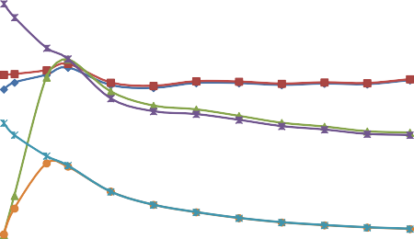

0 10000 20000 30000 40000 50000 60000 70000 80000

**Heat Flux (W/m^2)**

Standard w/out Bone Standard w/ Bone Dorsum w/out Bone Dorsum w/ Bone Finger w/out Bone Finger w/ Bone

Figure 6. Omega values for the ASTM standard heat flux profiles showing the effects of adding a bone layer to skin thickness values for standard skin thickness, dorsum, and finger (calculated at depth of 75 lm, 85 lm, and 200 lm, respectively).

3.000

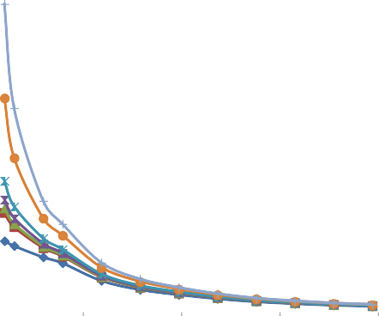

2.500

2.000

**Omega**

1.500

1.000

0.500

 Slab  Cylinder - 5cm  Cylinder - 4cm  Cylinder - 3cm  Cylinder - 2cm  Cylinder - 1cm  Cylinder - 0.75cm

0.000

0 20000 40000 60000 80000

**Heat Flux (W/m^2)**

Figure 7. Omega values for the ASTM standard heat flux profiles showing the effects of cylindrical coordinates on finger skin thickness with a bone layer (calculated at depth of 200 lm).

found in Figure 4. The presence of the bone layer eliminates the burn suppression shown in Figure 5.

## Effects of Skin Thickness

Numerical modeling was conducted using input data from heat flux profiles from PyroHands™ sensors obtained from actual tests. Data sets were chosen that pre- dicted second and third degree burn injury using the one-dimensional slab model with standard skin thickness values [2]. These two profiles were then applied to the numerical model for skin thickness with the values changed to reflect those of the four different regions of PyroHands™ (palm, dorsum, finger, and wrist). Cal- culations for the finger were derived using the cylindrical model, where the other regions used the one-dimensional slab model.

The difference in burn injury prediction for a second degree burn profile (from PyroHands™) with and without a bone layer is shown in Figure 8. These data indicate an insignificant difference in second degree omega values with a bone layer for the palm and wrist areas of the hand. However, a significant difference in the burn prediction is indicated for the finger and dorsum. These findings con- firm the experimental results shown in Figure 6. They also show the effects of the assumptions made about the variations in skin layer thickness over parts of the human hand and fingers.

Figure 9 presents omega values taken at the dermis/subcutaneous junction of skin when a third degree heat flux profile was applied. As with second degree burn predictions, the burn injury values for the palm and the wrist were similar with or without a layer of bone. However, there is a significant difference between the values, calculated with or without bone for the finger and dorsum. These

12.00

10.77

8.35 8.38

8.60 8.65

7.76

5.31

4.63

0.48 0.48

10.00

8.00

**Omega - 2nd Degree**

6.00

Without Bone Layer With Bone Layer

4.00

2.00

0.00

Standard Finger Dorsum Palm Wrist

Figure 8. Omega values for different skin thicknesses using second degree burn profile from PyroHands™ (calculated at epidermis depths located in Table 1).

3.00

2.51

1.13 1.18

0.83

0.01

0.00

0.19 0.20

1.06 1.10

2.50

2.00

**Omega - 3rd Degree**

1.50

Without Bone Layer  With Bone Layer

1.00

0.50

0.00

Standard Finger Dorsum Palm Wrist

Figure 9. Omega values for different skin thicknesses using third degree burn profile from PyroHands™ (calculated at epidermis depths located in Table 1).

differences exceed those shown in Figure 8. This result can be attributed to the proximity of the isothermal boundary temperature to the dermis/subcutaneous junction in comparison to the epidermis/dermis junction.

## Comparison of Burn Models for Whole Hands and Fingers

Graphics in Tables 5, 6, and 7 show second and third degree skin burn develop- ment as a function of time for different burn translation models. Each used the third degree incident heat flux profile as input data which is the same as that used in calculating Figure 9. The incident heat flux is assumed to be uniformly applied over all areas of the hands and fingers. In Tables 5, 6, and 7, yellow represents ‘‘No Burn,’’ red represents ‘‘2nd Degree Burn,’’ and purple represents ‘‘3rd Degree Burn.’’

Table 5 shows the time to burn when all of the segments of the hands are using the ASTM F 1930 [2] skin thickness values and one-dimensional heat transfer. This table shows that, using the standard model for this particular heat flux pro- file, the hands would receive a second degree burn at 4 s and a third degree burn at 32 s.

Table 6 shows the time to burn when hand skin thickness values (Table 1) are used. The additional bone layer is not added to the model and the cylindrical model for the finger is not used. These data show that the wrists, dorsum, and fin- gers receive a second degree burn at 4 s and that the palm receives a burn at 5.5 s. At 16 s, the wrist receives a third degree burn, where the other hand areas did not.

Table 7 shows hand burn predictions when skin thickness values specific to the hands (Table 2), are incorporated in a four-layer cylindrical model with a bone layer. When the same burn profile is applied to this hand model, the sec- ond degree burn times are the same as in Table 6. However, the main differ- ences occur for third degree burns, where the dorsum received this burn at 9 s, the wrists at 16 s, and the fingers at 17 s. The palms do not receive a third degree burn in this profile, which can be attributed to the very thick epidermis of this region.

Table 5

PyroHands™ Burn Development Using the ASTM F 1930 [2] Skin Burn Model for All Sections of the Hands (Color figure online)

Time interval (s)

Parameter 0 to 4 4 to 32 32 to 90

Standard skin thickness 3-layer skin

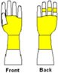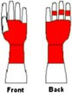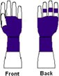1-D slab for all

Yellow = No Burn, Red = 2nd Degree Burn, Purple = 3rd Degree Burn

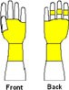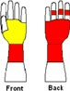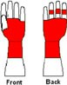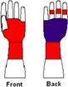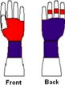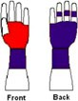

Table 6

PyroHands™ Burn Development Using Skin Burn Model with Hand Thickness values (Color figure online)

Time interval (s)

Parameters used 0 to 4 4 to 5.5 5.5 to 16 16 to 90

Hand skin thickness 3-layer skin model

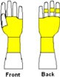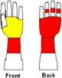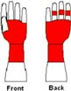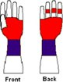1-D slab for all

Yellow = No Burn, Red = 2nd Degree Burn, Purple = 3rd Degree Burn

Table 7

PyroHands™ Burn Development Using Burn Four Layer Cylindrical Model with Hand Thickness Values and Bone Layer (Color figure online)

Time intervals (s)

Parameters 0 to 4 4 to 5.5 5.5 to 9 9 to 16 16 to 17 17 to 90

Hand skin thickness 4-layer skin Cylinder finger

Yellow = No Burn, Red = 2nd Degree Burn, Purple = 3rd Degree Burn

# Conclusions

Skin burn translation models have been developed that more accurately represent the tissue thickness and bone structure of the human hand and fingers than previ- ous skin burn injury models. Numerical modeling simulations show that these anatomically corrected models predict more severe burns for the back of the hands and fingers. This is because the three-layer, one-dimensional slab model used in standardized full scale manikin tests does not adjust for the thinner skin tissue values and/or bone structure of the hands and fingers. This model underes- timates hand burn injury to these critical areas. A four-layer cylindrical model has been described that accounts for the thinner skin tissue values and the thermal insulation of the bone tissue found in the back of the hands and fingers.

Additional research is needed to better understand the effects of skin thermo physical properties and other physiological factors, such as blood flow, on burn