Indian Journal of Fibre & Textile Research Vol. 42, March 2017, pp. 94-99

Effect of moisture and water on thermal protective performance of multilayered fabric assemblies for firefighters

Supriyo Chakraborty & V K Kotharia

Department of Textile Technology, Indian Institute of Technology, New Delhi 110 016, India

*Received 27 January 2015; revised received and accepted 3 June 2015*

Multilayered protective fabric assemblies comprising a Nomex III woven outer layer, Nomex nonwoven thermal liners and a modacrylic/cotton woven inner layer have been studied for heat protective performance. Effect of conditioning and presence of water on the outer layer fabric has been studied on heat protective performance, against radiant heat flux. It is observed that the radiative heat protective performance of firefighters’ protective clothing assembly can be improved in presence of a water tight barrier layer used just after the outer layer when the outer layer fabric is wet. Conditioning of the assembly in a particular environment can also significantly affect thermal protective performance.

**Keywords**: Externally added water, Impermeable barrier, Multilayered fabric, Nomex, Radiative heat protective performance, Thermal protection

# Introduction

In addition to the other hazards like toxic gases & chemicals, radioactive agents and biological agents, the oxygen deficient atmosphere, radiant heat and convective flames of different intensity are the most important hazards that a firefighter face during firefighting and related operations. Based on tolerance time to cause burn injury at different heat fluxes and air temperatures, firefighting environment can be classified in routine, hazardous and emergency categories1. Primary role of the protective clothing is to protect the person from such heat and flames. Firefighters’ protective clothing is designed to give protection from long term exposure at moderate heat fluxes and short term exposure to high heat fluxes. At the same time, protective clothing should be comfortable to wear under the normal working condition2.

During firefighting operations, the persons involved are exposed to hazards of steam being generated from the hose spray onto fires particularly in a closed and hot environment3. Firefighters also get wet during suppression of fire using hose lines, as large amount of water creates mist and splash back. Outer shell of the turnout gear is exposed first to the external environment. Though usually treated with water repellent finishes, outer shell will absorb and

——————

aCorresponding author.

E-mail: [iitkothari@gmail.com](mailto:iitkothari@gmail.com)

soak some amount of moisture and then tend to diffuse through the subsequent layers4. The other way of moisture accumulation in firefighter turnout clothing is due to sweating5, which gets accumulated in the inner layers. Water accumulated in turnout clothing in these ways is associated to the stored energy and steam burn phenomena. Effect of presence of moisture on protective performance of firefighter protective clothing in low-level radiant heat exposures has been studied by Barker *et al.*6 and it is found that with increasing added moisture to the protective clothing, the predicted burn time (s) at the specified heat flux decreases upto certain level of moisture content (20%) and then increases. In a study on thermal protective performance of firefighter gloves under radiant heat exposure and conductive/ compressive test, it was found that wet gloves resulted more protection in radiant heat, whereas in conductive/compressive tests wet gloves with moisture barrier showed more protection and less protection without moisture barier7. Stull8 have mentioned that insulation of protective clothing is affected by amount of moisture, location of moisture, construction of the clothing materials, intensity and duration of heat exposure etc.

In the present study, experiments have been carried out to observe the effect of preconditioning of multilayered clothing assembly, effect of added water on the outer layer fabric of a multilayered clothing assembly, and effect of presence of an impermeable

teflon barrier with added water on outer layer fabric on the radiant heat protective performance of the fabric assemblies. Front side of the fabric assemblies is exposed to a radiative heat flux, and temperature rise on the other side of the fabric was recorded with a copper calorimeter. Typical calorimetric traces, generated on exposure of the different fabric samples to radiant heat, have also been explained.

# Materials and Methods

Multilayered fabric assembly, used for the study, consists of a Nomex III (DuPont) woven outer shell fabric, two types of Nomex needle-punched nonwoven thermal liner and a modacrylic/cotton (60/40) woven innermost layer. Fundamental information of the fabrics is given in Table 1. Fabric thicknesses were measured on digital thickness tester at 0.2 gf/cm2 with an accuracy of 0.01 mm. Air permeability was measured on TEXTEST FX 3300 air permeability tester at 98 Pa. Fibre diameter of Nomex nonwoven thermal liners was observed and measured under Leica VZ 80 RC microscope at ×400 magnification.

Radiant heat flux of 10 kW/m2 intensity was set by adjusting the voltage variac. Combination of fabrics was exposed to that radiant heat of intensity

10 kW/m2 continuously till the temperature curve crosses the Stoll curve9. This evaluation has been done on a setup developed in our laboratory following the principles outlined in ASTM F 1939 (Standard test method for radiant heat resistance of flame resistant clothing materials with continuous heating). Schematic representation of the experimental setup is shown in Fig. 1. Experimental setup contains a vertically arranged bank of quartz heating tubes, fabric sample holder, copper calorimeter and a data acquisition system (ADAM) which record temperature data of copper plate with time. For comparing different samples cumulative heat per unit area of the sensor has been plotted along with Stoll criterion9,10. Stoll second degree burn injury curve is constructed based on the experimental work of Stoll

and Chianta10. Cumulative radiant heat exposure, (*Q*) is calculated using the following equation:

*Q*(J/cm2 )   *m**Cp* (Temp*final* Temp*initial*) … (1)

*A*

where *m* is the mass of copper calorimeter (g); *Cp*, the specific heat of copper [J/(g·ºC]; and *A*, the area of copper plate (cm2). The exposure time that satisfies Stoll criteria (J*/*cm2 = 5.0204 × *t* 0.2901) represents an approximate second-degree predicted burn injury point on continuous heating of the sample specimen without accounting for the energy remaining in the specimen (ASTM F 2702-08, Standard test method for radiant heat performance of flame resistant clothing materials with burn injury prediction). Two types of fabric combinations, such as

*i*

(i) Nomex woven fabric– Nomex nonwoven-1 – Modacrylic/cotton woven and (ii) Nomex woven fabric– Nomex nonwoven-2 – Modacrylic/cotton woven, were prepared and tested after conditioning in ambient atmosphere, completely dried and conditioned both at zero% RH and 100% RH. In this experiment, both the commercially sourced Nomex nonwoven thermal liners used in the middle layer were of the same areal density (~200gsm) but different thickness. In first experiment, fabric samples were conditioned in ambient atmosphere for 24 h

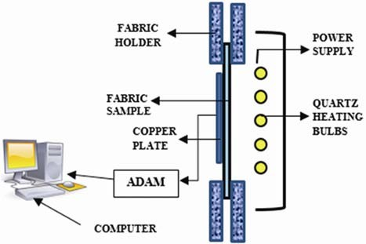

Fig. 1—Experimental set-up for evaluating radiative protective performance evaluation

Table 1—Basic physical properties of the fabrics

|  |  |  |  |  |  |  |
| --- | --- | --- | --- | --- | --- | --- |
| Fabric | Fibre | Construction | Bulk density ×103 | Areal | Thickness | Air permeability |
|  |  |  | g/m3 | density, g/m2 | mm | cm3/cm3/s |
| Woven outer layer | Nomex 93%  Kevlar 5%, Antistatic fibre 2% | Twill | 500 | 220 | 0.44 | 6.5 |
| Thermal liner-1 | Nomex | Needle punched | 47 | 200 | 4.24 | 102.0 |
| Thermal liner-2 | Nomex | Needle punched | 58 | 200 | 3.45 | 64.0 |
| Innermost layer | Modacrylic/cotton | Plain woven | 478 | 195 | 0.41 | 17.0 |

(RH ~55%, 29°C). Dry samples were obtained by oven drying the fabric combination at 100°C for 2 h and then kept in a desiccator containing di- phosphorous pentoxide (P2O5) for 24 h with the lid closed with gel. In another set, samples were conditioned for 24 h in a desiccator again at 100%RH with the desiccator pot containing water. All the samples were tested immediately after taking them out from the conditioning pots.

In the second set of experiment, water was applied in two different quantities, 40% (88 *l*/m2) and 80% (176 *l*/m2) of weight of the outer shell Nomex woven fabric. Water was applied to fabric by using a pipette drop wise and allowed to spread over the fabric. Combined wet sample was weighed to the correct predetermined value and tested immediately after correct weight was obtained. In third set a Teflon sheet (thickness, 0.25mm) was placed between outer shell and nonwoven thermal liner, and process of application of water was repeated followed by testing them to radiant heat exposure (10 kW/m2).

Differential Scanning Calorimeter (DSC) studies were done to see the effect of moisture and other thermo chemical reactions that may occur during thermal exposure of the protective clothing. For the possible temperature range (upto 300°C), no effect of thermochemical reactions were found to occur for Nomex samples as TGA analysis of Nomex fibres shows significant mass loss occurred only above 400°C. In DSC study, mass of two aluminium samples pans was determined on an electronic balance of 0.1 mg accuracy. Fabric samples were cut into small pieces (approx. 6-8 mg), filled in one pan and weighed accurately. From the DSC run (upto 300°C at 20°C/min heating rate) specific heat as a function of temperature was obtained by instrument software. In present study, DSC test of all the components of multiple layers was carried out on TA DSC Q2000 instrument.

# Results and Discussion

* 1. **Effect of Preconditioning**

Rise in temperature on the other side of the fabric was continuously measured using copper calorimeter as the combination of fabric sample was exposed to a heat flux of 10 kW/m2. Form the temperature data cumulative heat per unit area is plotted against time in seconds along with Stoll criteria. Figs 2 (a) and (b) show the effect of preconditioning of the fabric samples. During initial heating period (upto 50s), the

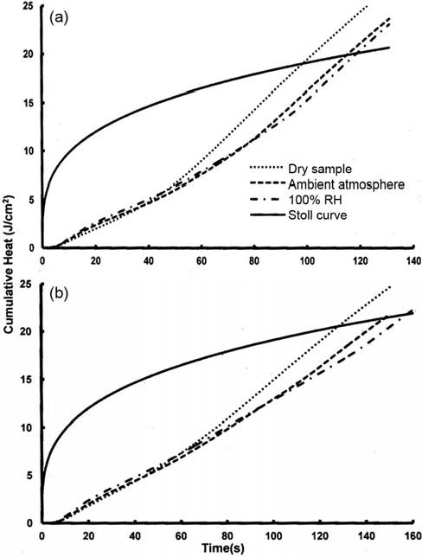

Fig. 2—Effect of conditioning on protective performance using

(a) 1st type and (b) 2nd type of Nomex nonwovens

curves are superposed and cannot be identified separately. After that initial seconds, samples conditioned at 100% RH or that conditioned in ambient atmosphere can be identified rising together and ultimately crosses Stoll curve almost at the same place. However, for the sample dried and conditioned at zero% RH, temperature rises faster and indicates a low burn injury time. It can also be observed that first fabric combination with Nomex fibre nonwoven of type-1 results low burn injury or protection time than the other.

Increase in burn injury time due to the presence of moisture can be observed and understood from the DSC studies of the fabric. In Fig. 3, specific heat has been shown as a function of temperature. These Nomex nonwoven samples were conditioned in laboratory at ~55% RH and 29°C for 24 h. After the DSC test, specific heat as a function of temperature is obtained by using TA universal analysis software. The hump observed is due to the presence of moisture in sample, which is centered at around 100°C spreading over a range of 50°C. Specific heat of Nomex fibres is approximately 1.260 J/(g·°C) or

0.30 cal/(g·°C) at 25°C. Increase in specific heat of conditioned fabric sample on evaporation can be estimated considering the moisture present in Nomex fabric (~4.5%) at 65% RH11, latent heat of evaporation of water (~2250 J/(g·°C) ) and temperature range over which evaporation takes place2. Thermal energy transfer to the fabric and copper calorimeter exposed to radiative heat and temperature can be predicted by solving the unsteady state heat equation with suitable boundary conditions. It has been found that due to the presence of moisture, specific heat of the clothing components increases as it can be observed from DSC studies (Fig. 3). As a result of increased specific heat capacity, rise in temprerature is delayed and it shifts towards right which means time available before burn injury increases.

* 1. **Effect of Added Water on Outer Shell Fabric**

During firefighting there are chances of getting wetted due to spray and splashes of water, pooled water or water drips. In Figs 4 (a) and (b) the effect of added water on the outer shell fabric during radiative heat protective performance testing can be observed. Three layered samples conditioned in ambient atmosphere show a typical temperature rise, resulting in a burn injury time of ~115s [Fig. 4(a)] and 148s [Fig. 4(b)]. Fabric combination with 40% added water on the outershell results in a much longer time to cross Stoll’s curve on continuous heating. Response of fabric combination with 80% added water on the outershell results a further delay in temperature rise. It can be observed that the nature of these two curves is similar. Both having a sharp temperature rise period followed by a flattening of the curve wherein very little temperature rise is observed followed by a regular temperature rise. Initial sharp temperature rise in case of the fabric with 80% added water on outer shell continues longer than the other fabric with less amount of added water. The flattening of the curve is attributed to the evaporation of water from the fabric. This causes minimal temperature rise of the fabric due to the phase change of water from liquid to vapour, and heat energy absorbed is utilised for evaporation. After the evaporation is complete, regular temperature rise of the fabric takes place. Starting of evaporation of water and its completion is not happening over a sharply defined time, rather it occurs gradually over a period of time. As water has large heat capacity, it stores thermal energy that can be get gradually released and absorbed by the

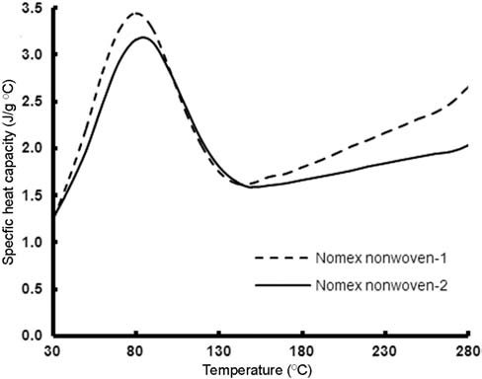

Fig. 3—DSC curve of Nomex nonwoven fabrics

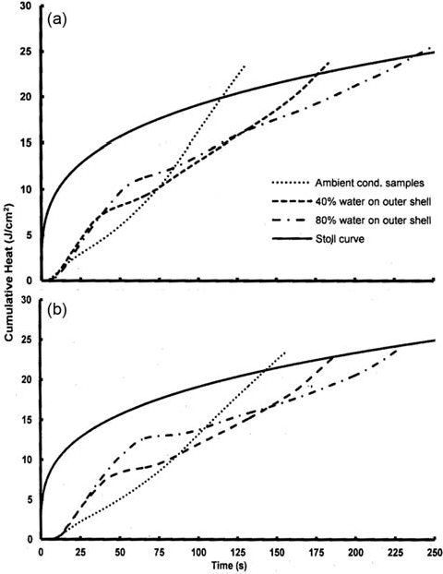

Fig. 4—Effect of water on outer shell using (a) 1st type and

(b) 2nd type of Nomex nonwovens (with added water on outer shell)

human skin to cause burn injuries even with the little damage of the fabrics.

When moisture content in fabric assembly is large, it increases thermal conductivity due to local moisture concentration. An increase in heat energy in an infinitesimal volume (including fibre, water and air) is equal to the contribution of conduction and radiation heat plus the heat evolved due to absorption of water

vapour inside a small porous fabric volume element12. Both specific heat and thermal conductivity are affected by the local moisture content and fibre volume fraction. In the present case, added water on the outer shell wicks and diffuses inside fabric layers and its effect is prominent in the experiment. Water moving inside the fabric increases thermal conductivity of the assembly and it is responsible for the sharp rise in temperature during initial heating, subsequent flattening can be explained by evaporation.

* 1. **Effect of Added Water on Outer Shell Fabric with Teflon Barrier**

In the third set of experiments additional impermeable Teflon barrier of 0.25 mm thickness was introduced after the outer shell cloth. The fabric layer combination becomes outer shell fabric – Teflon barrier – Nomex thermal liner (types 1 and 2) - modacrylic/cotton fabric. Same experimentation was repeated with addition of 40% and 80% water on the outer shell of the fabric. Cumulative thermal energy per unit area plotted for all the combinations are shown in Figs 5(a) and (b). It is observed by comparing radiant heat protective performance of earlier samples conditioned in ambient atmosphere (without added water), with that of the samples having an impermeable Teflon barrier (Figs 2, 4 and 5), that the later results in significant increase in protection time. Gain due to the use of Teflon barrier is particularly large in case of fabric combination where first type of Nomex nonwoven fabric is used. As it can be seen from air permeability values (Table 1), Nomex nonwoven (1st type) is much open in structure as compared to the nonwoven fabric (2nd type) and this is reflected in protection time (Figs 2 and 4). Disadvantage due to the openness in this case is compensated by the use of teflon film and an increase in protection time is observed [Fig. 5(a)]. It can be observed from Figs 4 and 5 that adding water on outer shell improves burn injury time to a limited extent but significant difference is observed in the initial heating periods. As teflon barrier does not allow water to diffuse or wick in to the inner layer, initial sharp increase in temperature that was observed in the other case, is absent here. Using impermeable barrier prevents wicking and diffusion of moisture and steam leaving thermal conductivity of the inner layers unaffected and ensures better insulation.

* 1. **Effect of Fibre Diameter**

Nomex nonwovens, used as insulating thermal liners, in these samples are of same basis weight, but

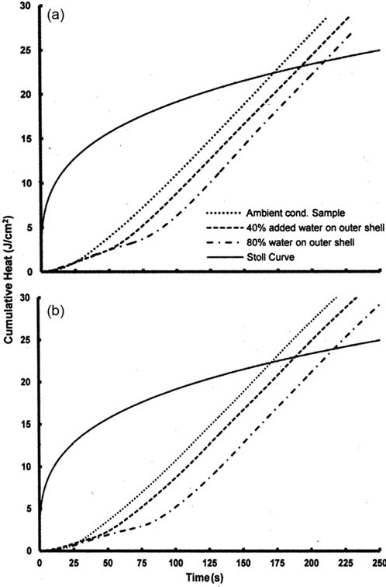

Fig. 5—Effect of water on outer shell using (a) 1st type and (b) 2nd type of Nomex nonwovens (with impermeable teflon barier)

their thicknesses are different. It is commonly known that the higher thickness gives better insulation, but in the present case it can be seen [Figs 2, 4 and 5] that the combinations of fabrics with type-2 Nomex nonwoven offer same or better protection / thermal insulation though its thickness is much less (~25% less) as compared to the other one. It can probably be explained from the diameter of the constituent fibres of the nonwoven samples. Nonwoven thermal liner of type-2 is made of fibres of average diameter ~ 14μm, whereas the fibre diameter of type-1 nonwoven is

~21μm*.* For the same areal density finer fibres cause more number of discontinuities, more contact points, greater tortuosity and greater resistance to heat flow. This is also reflected in air permeability of the type-2 nonwoven thermal liner which is much less (**Table** 1) than the other, and causes more difficulties for gases to diffuse through the fabric.

# Conclusion

Presence of moisture in the fabric assemblies causes the temperature trace to be shifted further and increase the burn injury time. Though the effect of different conditioning environment is little on protective performance of firefighter clothing assembly, pre-drying of fabric assembly reduces heat protective performance. In the case when no barrier is used after the outer shell fabric, externally added water tends to diffuse and wick inside the inner layers and increases fabric thermal conductivity, causing nonlinearity in the temperature curves. Presence of moisture or water to a definite amount can increase time of protection. However, too large amount of water can increase thermal conductivity and can cause an early burn injury. As water has large heat capacity stores thermal energy get gradually released and absorbed by skin to cause burn injuries even when little damage of the fabrics have taken place. At the same time, practical firefighting situation is unpredictable, and to what extent firefighter clothing becomes wet, cannot be said beforehand. Temperature dependent specific heat alone cannot explain nonlinear temperature traces obtained. Initial distribution of moisture, specific heat, thermal conductivity which depend on local moisture/water content, heat of evaporation, rate of diffusion in the fiber, air and water system need to be considered to explain this satisfactorily. Putting an impermeable

barrier causes an improvement in heat protective performance of fabric assemblies in all cases.

# References

1. Holcombe B V, *Fire Safety J*, 6(1983)129.
2. Torvi D A, *Heat Transfer in Thin Fibrous Materials Under High Heat Flux Conditions,* Ph D Thesis, University of Alberta, 1996.
3. Stull J O & Stull G G, Evolution of moisture barrier Use in PPE, <http://www.firerescue1.com/fire-products/Personal-> protective-equipment-ppe/articles/455083-Evolution-of- Moisture-Barrier-Use-in-PPE/ (accessed on 16/06/2013).
4. Stull J O & Stull G. G, Getting wet: Moisture effects on PPE performance, <http://www.firerescue1.com/fire-products/> gloves/articles/869460-Getting-wet-Moisture-effects-on- PPE-performance/ (accessed on 16/06/2013).
5. Barker R L, Deaton A S & Ross K A, *Fire Technol*, 47(3)(2011)549.
6. Barker R L, Guerth-Schacher C, Grimes R V & Hamouda H,

*Text Res J*, 76(2006)27.

1. Veghte J H, *Fire Technol*, 23.(4) (1987)313.
2. Stull J O, in *Performance of Protective Clothing: Issues and Priorities for the 21st Century,* 7 Vol*.*, edited by C N Nelson and N W Henry III (ASTM Special Technical Publication 1386), 2000, 557.
3. Stoll A M & Chianta M A, *Transactions—New York Acad Sci*, 33(7)(1971)649.
4. Stoll A M & Chianta M A, *Aerospace Med*, 41(1969)1232.
5. Bajaj P, in *Handbook of Technical Textiles*, edited by H R Horrocks and S C Anand (Woodhead Publishing, Cambridge), 2000, 231.
6. Prasad K, Twilley W & Lawson J R, Thermal Performance of Fire Fighters’ Protective Clothing. 1. Numerical Study of Transient Heat and Water Vapor Transfer, <http://fire.nist.gov/> bfrlpubs/fire02/PDF/f02077.pdf (accessed on 12/04/2014).