Clothing Air Gap Layers and Thermal Protective Performance in Single Layer Garmenty

Guowen Song*

*Department of Human Ecology, University of Alberta Edmonton, Alberta, Canada T6G 2N1*

ABSTRACT: A three-dimensional body scanning technique is used to measure the air gap layer distribution between different-sized protective garments and the body of a manikin used to evaluate garment thermal protective performance. The influence of fabric material and garment size on the manikin skin-clothing air gap layers existing in single layer thermally protective coveralls is analyzed. Protective performance of these garments is evaluated using the Manikin Thermal Protective Clothing Analysis System. Relationships between the burn patterns, measured on a flash fire manikin and measured manikin-garment air gap layers, are examined. The effects of thermally induced shrinkage as a result of flash fire exposure are discussed in comparisons between single layer protective coverall clothing made with heat resistant fabrics. An established numerical model is used to forecast the dimensions of skin-clothing air gap for optimum thermal protection.

KEY WORDS: air gap layers, three-dimensional body scanning, thermal protective clothing, flash fire manikin, protection, burn injury.

yThis paper was presented in Autex 2004 Conference on June 23, 2004 in Roubaix, France

*E-mail: [guowen.song@afhe.ualberta.ca](mailto:guowen.song@afhe.ualberta.ca)

Figures 1–13 appear in color online: [http://jit.sagepub.com](http://jit.sagepub.com/)

*JOURNAL OF INDUSTRIAL TEXTILES, Vol. 36, No. 3—January 2007* 193

1528-0837/07/03 0193–13 $10.00/0 DOI: 10.1177/1528083707069506

© 2007 SAGE Publications

# INTRODUCTION

IR ENTRAPPED BETWEEN a protective garment and the human body is a major factor determining the garment’s thermal protective insulation. Some bench-scale studies on air gap and its dimensions for protective and other clothing have been reported [1–5]. Due to the geometry of the human body, the size and the distribution of air gap layers are not evenly distributed. Thermally induced garment shrinkage during intense heat exposure can significantly reduce clothing size of air layers and, therefore, increase heat transfer to the skin [1]. Under flash fire conditions, the size of air layer between the heated garment and the skin/manikin body affects the energy transfer in the air layer. The mode of heat transfer between a heated fabric and the skin can be radiation, conduction, or convection. These modes of heat transfer in the air layers depend on the size of air gap layer and fire boundary conditions [2]. The stagnant air can be a good insulator, and if air is stagnant, its insulating value will increase as the width of the air gap layer increases. However, if the air layer becomes wide enough, natural convection may occur, which will increase the heat transfer across the air layer and may decrease its value as an insulator [3–5]. The air gap at which convection is initiated is termed the critical or optimal air gap. In this study, the air gap size and distribution of protective coveralls dressed in a thermal manikin were determined using a three-dimensional (3D) body scanning technique. The average air gap sizes at the locations where a burn prediction occurs were examined. An established numerical model of flash fire manikin test was used to predict clothing thermal protective performance [1]. Based on the fire characteristics of lab simulation in the manikin chamber, the critical air gap dimensions, which could provide the maximum insulation under flash fire conditions were obtained using

*A*

the numerical model analysis.

# AIR LAYERS BETWEEN PROTECTIVE GARMENTS AND MANIKIN

A 3D body scanning technology was applied to measure the air gap layers that exist between the different-sized coveralls (VF cooperation in ‘Deluxe’ style) and the manikin body. The air gap size and distribution are determined by superimposing the extracted data from the instrumented manikin with and without the protective coverall being tested (Figure 1). Coveralls in size 40, 42, and 44 made with 153 g/m2 Kevlar®/PBI fabric as well as 203 g/m2 Nomex®III fabric were measured in both pre-exposure and post-exposure.

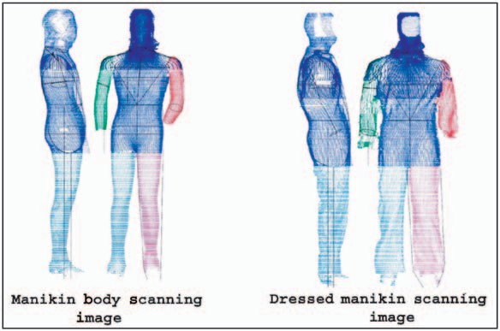

FIGURE 1. Body scanning image of dressed and undressed manikin.

# FLASH FIRE MANIKIN TEST

The flash fire manikin tests of protective coveralls were performed on the PyroMan® system (Figure 2), which utilizes a fully instrumented, life-sized manikin capable of measuring the performance of thermal protective clothing. The system uses a size 40 regular manikin made from a flame resistant polyester resin reinforced with fiberglass. The manikin is suspended from the ceiling of an 11 × 18 ft fire-resistant burn chamber and surrounded by eight industrial burners capable of producing a large volume, simulated, flash fire capable of fully engulfing the manikin in flames. The manikin is instrumented with 122 individual heat-flux sensors distributed over the surface of the body. In addition to measuring the heat transfer to the manikin with exposure of the test garment or protective clothing ensemble, these sensors also set the exposure level by directly exposing the manikin to the flames in a test without the garment. The test specimen is placed on the manikin at ambient atmospheric conditions and exposed to the flash fire simulation with controlled heat flux, duration, and flame distribution. The incident heat flux measured by the sensors, during and after exposure, is used to calculate the changing temperature of human tissue at two skin depths, one representing a second degree burn injury point and the other a third degree burn injury point. A computer system controls data acquisition, calculation of surface heat flux, calculates skin temperature distribution histories, and predicts the skin burn damage

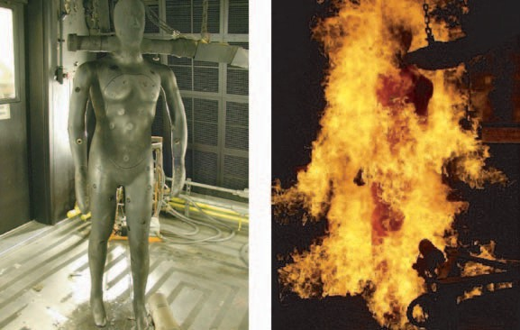

FIGURE 2. Instrumented flash fire manikin test system.

for each sensor location. The computer produces a full report of the test including a contour mapping of burn locations.

# RESULTS AND DISCUSSION

Two types of protective garments were selected to demonstrate the influence of air gap layers on thermal protective performance: 4.5 oz/yd2 Kevlar®/PBI coveralls of sizes 40, 42, and 44; and a 6.0 oz/yd2 Nomex®IIIA coverall of size 42. These coveralls are typical industrial thermal protective coveralls having standard pocketing in a ‘deluxe’ style. All garments used in this research were laundered five times using an industrial laundering procedure before manikin testing. This laundering procedure is similar to ASTM 1449-92, but for this research, both temperature and detergents were modified to the AATCC 135 requirements.

The Distribution of the Skin-clothing Air Layers

Figure 3 shows the relationship between body locations and the dimension of the skin/manikin-clothing air layers in size 40, 42, and 44 coveralls made with the Kevlar®/PBI fabric. These data show that the clothing air layers are not evenly distributed over the manikin body. In some locations, specifically the shoulder, knee, and upper back areas, the protective garment is close to the body; while in other locations, such as

25

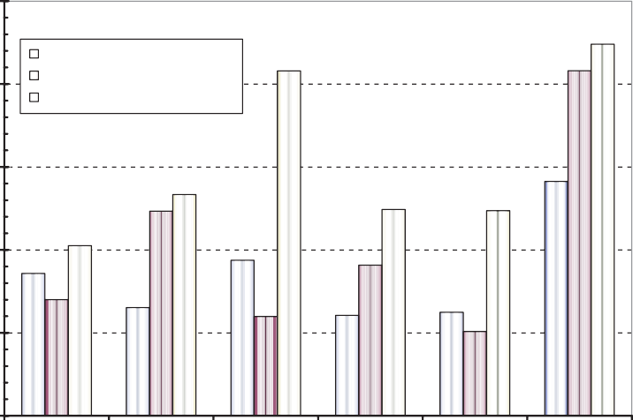

PBI/Kevlar coverall size 40 PBI/Kevlar coverall size 42 PBI/Kevlar coverall size 44

20

15

**Average air gap size (mm)**

10

5

0

Arm Front chest Rear chest Front abdomen Rear abdomen Leg

**Body area**

FIGURE 3. Distribution of air layers of a fire manikin dressed in 153 g/m2 Kevlar®/ PBI protective coveralls.

the waist and thigh areas, a larger insulating air space is present. Areas of the legs exhibit the largest air layers, while the least air space between the manikin and protective garment is found in the arm and back. The size of the protective garment affects the distribution of the air layers over the surface of the manikin (Figure 3).

Garment fabric drapability and stiffness also affect clothing air layers, since more flexible materials tend to conform to body contours. The different coverall (Nomex®IIIA and Kevlar®/PBI) with the same garment size (size 42) and pattern are examined and their air gap distributions are compared in Figure 4. It is shown that a Kevlar®/PBI protective coverall holds larger average air gap layers than a Nomex®IIIA protective coverall. This is mainly attributable to the differences in fabric stiffness.

Thermally induced fabric shrinkage can be a significant factor controlling the garment air layer dimensions. The air gap change was examined by comparing a post-exposure Nomex®IIIA coverall to an unexposed Nomex®IIIA coverall as shown in Figure 5. The Nomex®IIIA coverall (size 42, ‘deluxe’ style, 203 g/m2) shrinks significantly in a 4 s exposure to 2.00 cal/cm2 s heat, thereby reducing the insulating air layer, by 50% on average, and as much as 90% in areas around the legs of the manikin.

25

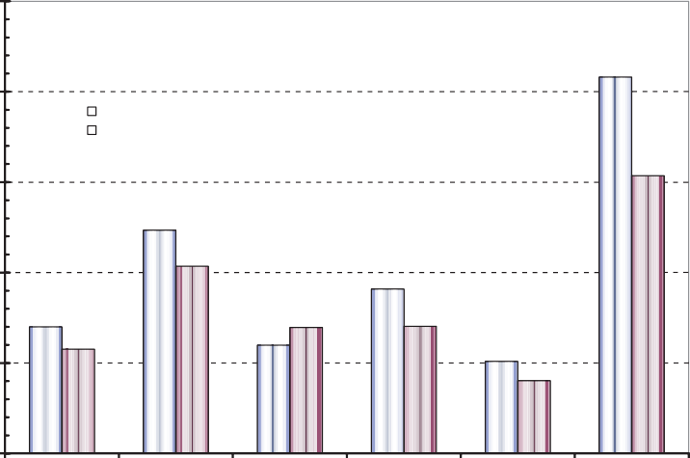

PBI/ Kevlar coverall size 42 Nomex coverall 42

20

15

**Average air gap size (mm)**

10

5

0

Arm Front chest Rear chest Front abdomen Rear abdomen Leg

**Body area**

FIGURE 4. Comparison of Kevlar®/PBI (153 g/m2) and Nomex® (203 g/m2) coveralls air gap distribution.

18

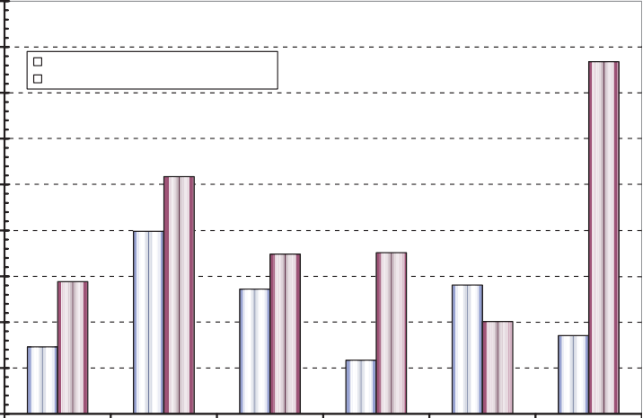

Post-exposed Nomex coverall 42 Nomex coverall 42

16

14

**Average air gap size (mm)**

12

10

8

6

4

2

0

Arm Front chest Rear chest Front abdomen Rear abdomen Leg

**Body area**

FIGURE 5. Comparison of post-exposed (4 s exposure) and nonexposed Nomex® coveralls.

Flash Fire Manikin Testing Results

These different-sized coveralls of Kevlar®/PBI and Nomex®IIIA were evaluated using the flash fire manikin testing system with 3 and 4 s exposures. Figures 6–9 show an expected increase in predicted burn injuries as the time of flash fire exposure increases from 3 to 4 s. These data also demonstrate a correlation between the manikin skin-clothing air gap dimensions and the predicted skin burn injuries. As expected, the areas with the thinnest insulating air gap received the highest predicted burn injury. In Figures 6–9, the dark areas (red) that indicate a second degree burn was predicted and the grey areas (pink) show a third degree skin burn.

*Numerical Model Predictions*

In order to investigate the effect of the air gap size on burn predictions and forecast the dimensions of manikin skin-clothing air gap for optimum thermal protection, a numerical model of manikin fire testing is used [1]. The model developed considers the entire manikin burning process as illustrated in Figure 10. Heat transfer through the fabric and air layers is computed in conduction/convection and radiation modes. A heat transfer

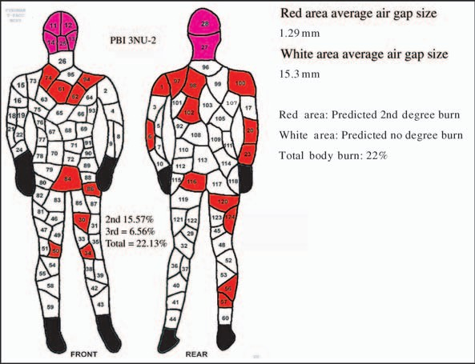

FIGURE 6. Kevlar®/PBI coverall (size 42, 4.5 oz/yd2) exposed to 3 s flash fire (2.0 cal/cm2s).

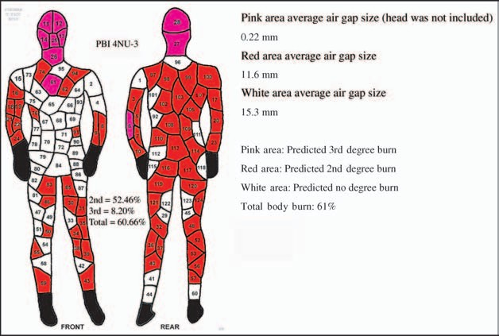

FIGURE 7. Kevlar®/PBI coverall (size 42, 4.5 oz/yd2) exposed to 4 s flash fire (2.0 cal/cm2s).

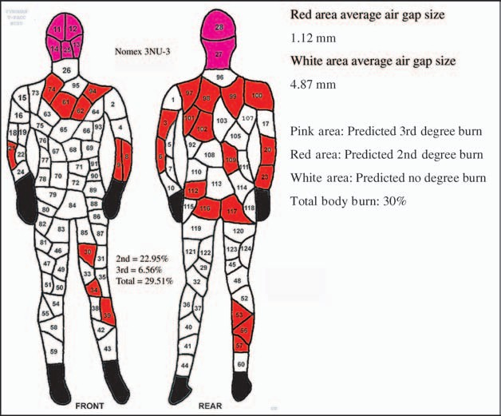

FIGURE 8. Nomex®IIIA coverall (size 42, 6.0 oz/yd2) exposed to 3 s lab simulated flash fire (2.0 cal/cm2s).

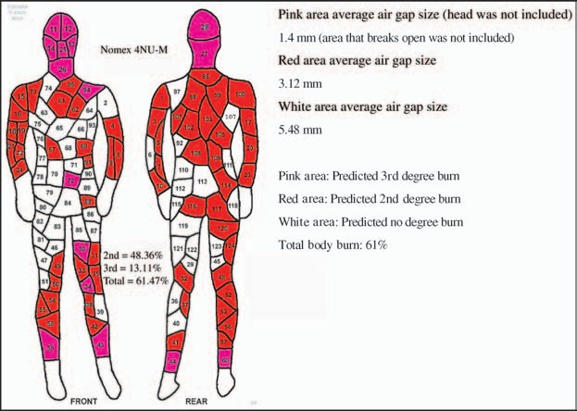

FIGURE 9. Nomex®IIIA coverall (size 42, 6.0 oz/yd2) exposed to 4 s lab simulated flash fire (2.0 cal/cm2s).

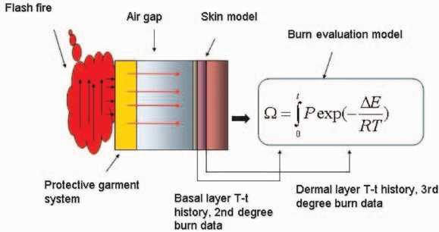

FIGURE 10. Elements of fabric air layer and burn evaluation model in the developed numerical model.

equation is applied in conjunction with a skin model to estimate the temperature profile in the basal and dermal layers of the skin. Based on these temperature profiles, second and third degree skin burn injuries can be predicted.

50,000

Air gap 0.01 mm Air gap 0.1 mm Air gap 0.64 mm Air gap 1.64 mm Air gap 3.5 mm Air gap 5.5 mm Air gap 7.5 mm Air gap 10 mm Air gap 14 mm Air gap 25 mm

45,000

40,000

35,000

30,000

Heat-flux (W/m2)

25,000

20,000

15,000

10,000

5000

0

0 1 2 3 4 5 6 7 8 9 10 11 12 13 14 15 16

Time (s)

FIGURE 11. Heat-flux profiles on skin surface with different air gaps for a 3 s exposure.

Under lab-simulated flash fire conditions, the flash fire numerical model predicts that the optimum air layer size is around 7–8 mm for a one layer protective garment. Larger than this air layer size, a heat transfer due to the form of natural convection can be initiated and consequently increase the amount of total energy to skin. Figure 11 exhibits the difference in the amount of total energy transferred to skin (heat-flux profile on skin surface) among different air gap layers with the same fire boundary condition. The energy transferred to skin decreased significantly as the air gap size increased from 0.01 to 7.0 mm. Beyond this range, however, increasing the air gap size shows no significant effect on the amount of total energy transferred to skin. This is due to the fact that the convection was initiated. When the air gap size is beyond the range of 7–8 mm, the model predicted that a convection current would occur, which could increase the heat transfer across the air space. Therefore, increase in the air gap size from 7–8 mm range will not help to provide the insulation value. As a matter of fact, the amount of energy transferred in different modes may change with different air gap sizes. At a smaller air gap (<3 mm), a large amount of energy is transferred through the air gap by conduction. At a larger air gap, (>7.5 mm) the convection initiates and the predominant form of energy transfer is the combination of radiation and convection. Additionally, the

25,000

20,000

15,000

Heat-flux (W/m2)

10,000

Fabric shrink started

From bottom to top

Shrinkage rate= 0 Shrinkage rate= 0.2 Shrinkage rate= 0.4 Shrinkage rate= 0.6 Shrinkage rate= 0.8 Shrinkage rate= 0.9 Shrinkage rate= 0.95

5000

0

0 2 4 6 8 10 12 14

Time (s)

FIGURE 12. Skin surface heat-flux increase at different shrinkage rate (7.5 mm air gap).

model predictions demonstrate that thermal shrinkage, as a result of exposures, significantly increased the heat transfer to skin (Figure 12).

The heat-flux profiles from heated fabric to the skin with different shrinkage rates were predicted as shown in Figure 12. The shrinkage rate indicates air gap size change during the exposure. The shrinkage was predicted to occur at about 2 s with an increased heat transfer profile as shrinkage rate increases. Therefore, garment shrinkage during exposure reduced the air gap layers and, as a result, the total energy transfer between the heated fabric and skin was enhanced significantly. Figure 13 examines the shrinkage effect on thermal protection performance using model predictions. The model computes two predictions with no shrinkage and with shrinkage of Nomex®IIIA coveralls (size 42, 203 g/m2) for 3 and 4 s flash fire exposure (2.0 cal/cm2 s). The results demonstrated that shrinkage during exposure could increase burn injuries significantly for both 3 and 4 s exposures.

# CONCLUSIONS

Air gaps existing in protective garments play a vital role in providing thermal insulation when exposed to flash fire conditions. The results of flash fire manikin tests demonstrated that the burn predictions occur in smaller air gap areas (locations). Under the lab simulated flash fire conditions,

60

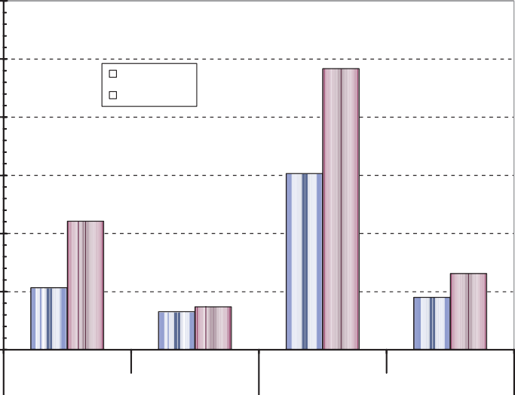

No shrinkage

Shrinkage

2nd degree

3rd degree

2nd degree

3rd degree

3 s exposure 4 s exposure

50

40

Predicted burn (%)

30

20

10

0

FIGURE 13. Model predictions for burn damage with and without shrinkage.

our numerical model predicts that the optimum air gap size is around 7– 8 mm for a particular type of one layer protective garment. Below this range, the insulating value will increase as the air gap size increases. Beyond this air gap dimension, however, we expected convection to occur. Consequently, increase in air gap size beyond 7–8 mm range are predicted to provide no increased insulation value. In addition, the garment shrinkage during exposure can potentially cause a significant decrease in the performance of thermal protective clothing.

# ACKNOWLEDGMENTS

The author would like to acknowledge Mike King in Textile/Clothing Technology Corporation (TC2) for help in conducting the three dimensional body scanning and Patirop Chitrphiromsri from the Department of Mechanical and Aerospace Engineering in North Carolina State University for help in programming and computation.

# REFERENCES

1. Song, G. and Barker, R. (2004). Thermal Protective Performance of Heat Resistant Garments in Flash Fire Exposures, *Textile Research Journal*, 74: 1033–1040.
2. Stoll, A.M., Chianta, M.A. and Munroe, L.R. (1964). Flame Contact Studies, Transactions of the ASME, *Journal of Heat Transfer*, 86: 449–456.
3. Rees, W.H. (1941). The Transmission of Heat Through Textile Fabrics,

*The Journal of the Textile Institute*, 32: T149–T166.

1. Morse, H.L., Thormpson, J.G. and Clark, K.J. (1973). Analysis of the Thermal Response of Protective Fabrics, Acurex Corporation, Aerotherm Division Report AFML-TR-73-17.
2. Cain, B. and Farnworth, B. (1986). Two New Techniques for Determining the Thermal Radiative Properties of Thin Fabrics, *Journal of Thermal Insulation*, 9: 301–323.

# NOTE

These data characterize the properties of materials or assemblies in response to thermal exposure under controlled laboratory conditions and should not be used to appraise the safety benefits or risks of materials, products, or assemblies under actual fire conditions. They are the results of specific laboratory exposures. Extrapolations to other types of heat exposures or different combinations of radiant, convective, and conductive assaults cannot be made. They are not presented to predict all types of field conditions where the nature of the thermal exposures can be physically complicated and unqualified. We wish to emphasize that it is not our intention to recommend, exclude, or predict the suitability of any commercial product for a particular end-use.

# BIOGRAPHY

Guowen Song is an assistant Professor in the Department of Human Ecology, University of Alberta. He received his PhD in Textile Engineering, Chemistry and Science at NC State in October 2002. Guowen’s research interests are in the areas of protective properties and comfort of textile materials and clothing. General research emphasis has been on characterizing, understand- ing, and modeling heat and moisture transfer in clothing systems in an effort to improve protective clothing performance. His research includes mate- rial response under various thermal hazards,

testing methodologies, heat transfer mechanism as well as the prediction of human skin burn injury.