The current issue and full text archive of this journal is available on Emerald Insight at:

[https://www.emerald.com/insight/0955-6222.htm](http://www.emerald.com/insight/0955-6222.htm)

A prediction method to evaluate thermal performance of protective clothing based on the correlation analysis of the bench scale and flame manikin tests

Chang Xu and Shifei Shen

*Department of Engineering Physics, Institute of Public Safety Research, Tsinghua University, Beijing, China, and*

Ming Fu and Yayun Li

*Hefei Institute for Public Safety Research, Tsinghua University, Hefei, China*

Abstract

Purpose – Bench scale and flame manikin tests are two typical methods to evaluate thermal protective performance (TPP) of fire protective clothing. However, flame manikin test is limited to be widely used for its complication and high cost. The purpose of this paper is to develop a method to evaluate the thermal performance of protective clothing from the bench scale test results and garment parameters, which predicts the body burn injuries without conducting flame manikin tests.

Design/methodology/approach – Bench scale and flame manikin tests’ data were collected from the previous research literature and then statistical analysis was performed to quantitatively investigate the correlations between the two test methods. Equations were established to predict the TPP values accounting for the effects of entrapped air gap and thermal shrinkage. Fitting analysis was conducted to analyze the relationship between the predicted TPP values and total burn injury. Finally, a method to predict total burn injury from the TPP values was proposed and validated.

Findings – The results showed that when the TPP value was predicted with the effects of air gap and thermal shrinkage considered, there was an approximate linear relationship between the predicted TPP values and total burn injury from the manikin test. Therefore, the prediction model of burn injury was developed based on the correlation analysis and verified with a generally good accuracy.

Originality/value – This paper presented a new prediction method to evaluate the thermal performance of protective clothing, which saved significant time and cost compared to the conventional methods. It can provide useful information for burn injury prediction of protective clothing.

Keywords Bench scale test, Flame manikin test, Protective clothing, Thermal protective performance, Air gap, Thermal shrinkage

Paper type Research paper

1. Introduction

Firefighter’s protective clothing is used with the characteristics of flame retardant, thermal isolation and stability (Barker, 2005). Bench scale and flame manikin tests are two typical methods to evaluate thermal protective performance (TPP) (Lee *et al.*, 2010). The bench scale test can provide thermal performance of fabrics, and the flame manikin test simulates a real fire exposure environment to get body burn percent and distribution when the manikin dressed in the garment. Although the full-scale flame manikin tests accounting for the effects

Thermal performance of

protective clothing

499

Received 14 February 2019

Revised 30 November 2019

Accepted 7 December 2019

This study was supported by the National Natural Science Foundation of China (Grant No. 51706123), Anhui Provincial Natural Science Foundation for Distinguished Young Scholars (Grant No. 1908085J22) and Science and Technology Major Project of Anhui Province (Grant No. 17030901016). The authors are deeply grateful to these supports.

International Journal of Clothing Science and Technology Vol. 32 No. 4, 2020

pp. 499-510

© Emerald Publishing Limited

0955-6222

DOI [10.1108/IJCST-02-2019-0017](https://doi.org/10.1108/IJCST-02-2019-0017)

IJCST 32,4

500

of the air gap, thermal shrinkage and design factors could provide more realistic thermal performance information of the fire protective clothing ensemble, it is limited to be used for its complication and high cost. While the bench scale test is more widely used as it is simpler, quicker and less costly.

There are some studies on the evaluation of the bench scale test to analyze the TPP of protective clothing (Shalev *et al.*, 1984; Torvi, 1998; Sawcyn, 2003; Song, 2007; Sawcyn *et al.*, 2009; Talukdar *et al.*, 2010; Mandal *et al.*, 2014; Udayraj *et al.*, 2017a, 2017b). It was shown that TPP was associated with the type and intensity of heat flux, fabric properties and air gap configuration (Shalev *et al.*, 1984; Udayraj *et al.*, 2017b; Mandal *et al.*, 2014). Fabrics with higher thickness and weight could provide more effective protection in flame and radiant exposure (Shalev *et al.*, 1984). Moreover, the air gap size between the fabric and sensor affected the modes of heat transfer (Sawcyn *et al.*, 2009). Energy mainly transferred through the air gaps by the conduction at a smaller size ( < 3 mm), and transferred by the combined radiation and conduction as the gap size increased. The convection occurred when the gap size was more than 7.5 mm, and the predominant form of energy transfer was the combination of radiation and convection (Song, 2007). Meanwhile, some prediction models have been developed to predict the thermal performance, which can be classified into the mathematical models, artificial neural network models and fitting models. Mathematical models had relatively high accuracy, but they were limited in practical applications due to their complexities (Sawcyn *et al.*, 2009; Torvi, 1998; Sawcyn, 2003; Talukdar *et al.*, 2010; Udayraj *et al.*, 2017a). The accuracy of the artificial neural network models were in dependence on the training model and the number of test data (Udayraj *et al.*, 2017c). The fitting models revealed the statistical regression relationships between the heat flux, fabric properties and TPP value (Mandal *et al.*, 2014).

Flame manikin test has also been investigated to analyze the effects of test conditions on burn injury prediction (Dale *et al.*, 1992; Crown *et al.*, 1998; Kim *et al.*, 2002; Song, 2003, 2007; Chitrphiromsri, 2005; Mercer *et al.*, 2008; Ghazy, 2011; Li *et al.*, 2013; Tian *et al.*, 2016). Total burn injury was found to be related with the exposure conditions (heat flux and exposure time), fabric properties (thickness, weight and thermal conductivity), human status (static and running), human posture (upright and knee bending) and garment size and design. It was demonstrated that the unevenly distributed air gap between the garment and manikin surface had a significant effect on the heat transfer (Kim *et al.*, 2002). Moreover, for some kinds of fabric materials like Nomex, thermal shrinkage was found to be severe during the exposure, which decreased the air gap size and greatly affected the heat transfer (Song, 2007). The garment style, closure system and seam type, which can be collectively called as the design factors, also had influences on the thermal performance (Crown *et al.*, 1998). A few numerical models (Song, 2003; Chitrphiromsri, 2005; Mercer *et al.*, 2008; Ghazy, 2011; Tian *et al.*, 2016) have been developed to simulate the heat transfer in protective clothing during flash fire. The effects of the air gap and thermophysical properties of fabrics were also quantitatively analyzed. However, the numerical models to predict total burn injury with a high accuracy in the three-dimensional scale were rather complicated.

The correlation between bench scale and flame manikin tests has been discussed (Pawar, 1995; Crown *et al.*, 2002; Lee *et al.*, 2002; Mah *et al.*, 2010; Wang *et al.*, 2015, 2016). Bench scale and manikin tests both provide effective criteria of thermal performance, with differences in several respects including the orientation of material in the flame, sensor for sample configuration and exposure duration (Pawar, 1995). It was observed that the sensor temperature in areas without air gaps and with small air gaps on the manikin had a good correlation with that of the bench scale test (Pawar, 1995; Lee *et al.*, 2002). Thermal shrinkage was found to be severe in the areas with a large air gap on the manikin, which significantly decreased the gap size and greatly affected the heat transfer (Wang *et al.*, 2016). However, bench scale test described in the NFPA 1971 (2013) and ISO 17492 (2003) can not capture the

shrinkage effect, the air gap size between the fabric and sensor is constant throughout the test process. Crown *et al.*, (2002) measured the TPP values by a new cylindrical bench scale device which could capture the shrinkage effect. During the measurement, the fabric specimens can shrink close to the sensor and may even contact the sensor. The tested TPP results was observed to correlate better with the total burn injury values than that of the conventional planar bench scale test results, suggesting that shrinkage effect should be taken into account when comparing the relationship between the bench scale and flame manikin test. Furthermore, the differences in air gaps due to the garment style and fit significantly affected the burn degree prediction for the manikin test (Mah *et al.*, 2010). The thermal shrinkage and the garment design, which were not available to be considered in the bench scale test, have great influence on the comparison of two test methods, especially with a large gap size. It is of great value to investigate the quantitatively correlation of the two test methods, which is helpful to predict thermal performance of protective clothing from the simpler bench scale test. However, the previous studies limited on analyzing the relationship by TPP values tested in the fixed air gap condition (Wang *et al.*, 2015), the effects of the uneven distribution air gap and thermal shrinkage were not included in the correlation analysis model.

This paper aims to develop a prediction method to evaluate thermal performance of protective clothing based on the quantitatively correlation analysis of the bench scale and flame manikin tests. The research findings can provide an insight into the correlation of bench scale and manikin tests and give some guidance to the test methods of protective clothing.

1. Methodology

The flow chart for developing a prediction method to evaluate thermal performance of protective clothing was shown in Figure 1. The data of thermal performance for the fabric and garment samples made of Nomex IIIA material were collected from the previous research literature. Details of fabric samples in the bench scale test were shown in Table I. The data in the flame manikin test were listed in Table II. Section 2.1, 2.2 briefly introduced the experimental setup and section 2.3 described the statistical analysis method.

* 1. *Bench scale test* Bench scale tests in the referenced literature (Li *et al.*, 2015; Wang *et al.*, 2015) were performed in accordance with NFPA 1971 (2013). Schematic of the TPP test apparatus was shown in Figure 2. It consisted of two Meker burners and a bank of nine quartz tubes, to provide a combined flame and radiant heat source. A copper calorimeter test sensor was used in place of human skin to monitor temperature, and a metal spacer was applied to set a specified air gap between the fabric and test sensor. The fire source was set as 84 kW/m2, with 50 percent radiative and 50 percent convective heat flux. The TPP value was calculated as the time to

Thermal performance of

protective clothing

501

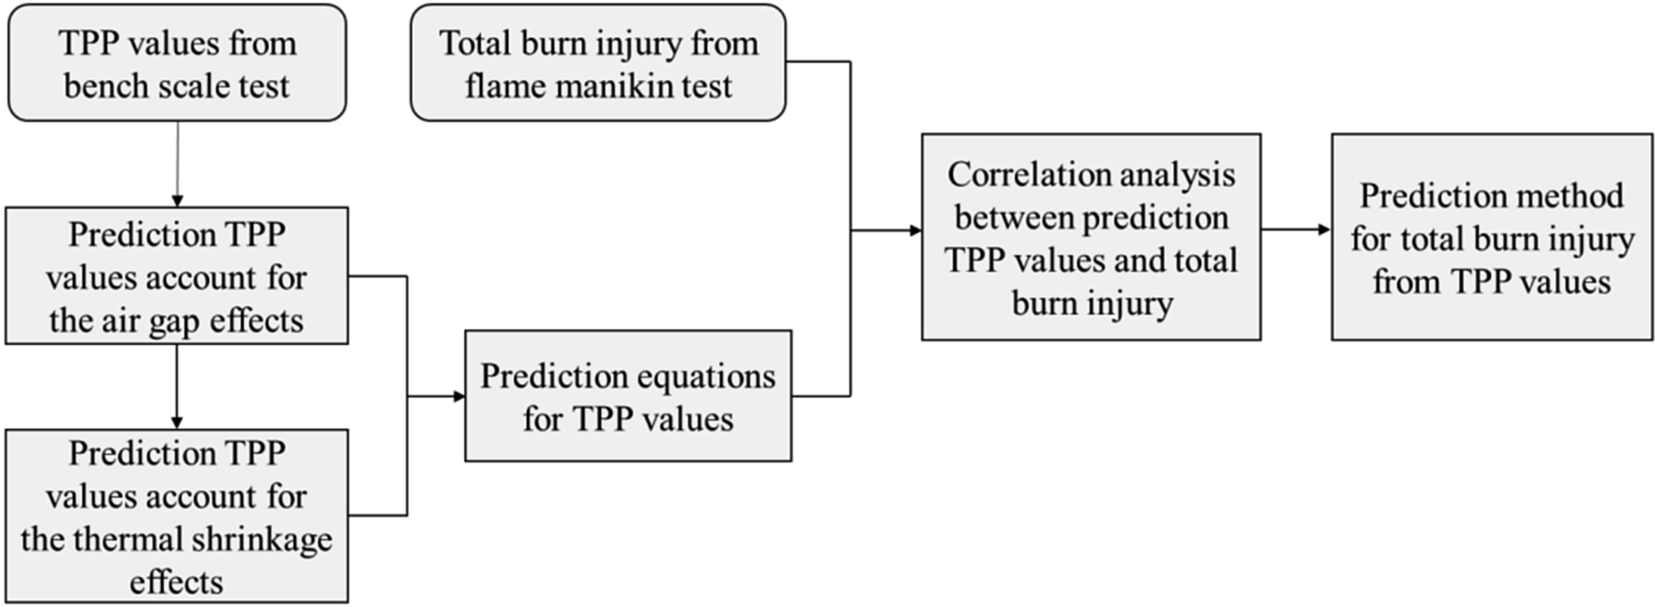Figure 1. Flow chart for developing a prediction method to evaluate thermal performance of protective clothing

|  |  |  |  |  |  |
| --- | --- | --- | --- | --- | --- |
| IJCST  32,4 | References | Gap size (mm) | Thickness (mm) | Weight (g/m2) | TPP (kJ/m2) |
|  | Li *et al.* (2015) | 0 | 0.55 | 150 | 380 |
|  |  | 3 | 0.55 | 150 | 475 |
|  |  | 6 | 0.55 | 150 | 545 |
|  |  | 9 | 0.55 | 150 | 610 |

|  |  |  |  |  |  |
| --- | --- | --- | --- | --- | --- |
| 12 | | | 0.55 | 150 | 630 |
| 502 |  | 15 | 0.55 | 150 | 608 |
|  |  | 18 | 0.55 | 150 | 670 |
|  |  | 21 | 0.55 | 150 | 675 |
|  |  | 24 | 0.55 | 150 | 670 |
|  |  | 0 | 0.63 | 210 | 400 |
|  |  | 3 | 0.63 | 210 | 595 |
|  |  | 6 | 0.63 | 210 | 645 |
|  |  | 9 | 0.63 | 210 | 655 |
|  |  | 12 | 0.63 | 210 | 680 |
|  |  | 15 | 0.63 | 210 | 725 |
|  |  | 18 | 0.63 | 210 | 730 |
|  |  | 21 | 0.63 | 210 | 740 |
|  |  | 24 | 0.63 | 210 | 760 |
|  | Wang *et al.* (2015) | 0 | 0.33 | 166 | 336 |
|  |  | 0 | 0.42 | 198 | 382.2 |
| Table I. |  | 0 | 0.52 | 250 | 445.2 |
| Details of fabric |  | 6.4 | 0.33 | 166 | 541.8 |
| samples in the bench |  | 6.4 | 0.42 | 198 | 609 |
| scale test |  | 6.4 | 0.52 | 250 | 680.4 |

Specification of

|  |  |  |  |  |  |  |  |  |
| --- | --- | --- | --- | --- | --- | --- | --- | --- |
| References | Garment code | Size | Thickness (mm) | Weight (g/m2) | Averaged air gap size (mm)  Before After  exposure exposure | | Averaged shrinkage rate(%) | Total burn injury (%) |
| Song (2003) | G1 | 42 | 0.8 | 203 | 11.56 | 4.62 | 60.03 | 60.67 |
| Li *et al.* | G2 | 34 | 0.63 | 210 | 9.49 | 6.07 | 36.05 | 68.00 |
| (2013) | G3 | 36 | 0.63 | 210 | 11.68 | 7.39 | 36.75 | 56.10 |
|  | G4 | 38 | 0.63 | 210 | 13.89 | 7.91 | 43.05 | 56.50 |
|  | G5 | 36 | 0.55 | 150 | 11.68 | 6.53 | 44.10 | 80.07 |
|  | G6 | 36 | 0.58 | 175 | 11.68 | 7.10 | 39.20 | 79.73 |
| Wang *et al.* | G7 | 42 | 0.33 | 166 | 25.00 | 14.86 | 40.58 | 59.30 |
| (2015) | G8 | 42 | 0.52 | 250 | 24.42 | 17.94 | 27.50 | 42.60 |
| Table II. | X1 | 42 | 0.42 | 198 | 24.42 | 11.66 | 52.25 | 70.50 |
| garment samples in the Wang (2016) | X2 | 42 | 0.53 | 200 | 25.20 | 5.99 | 76.24 | 63.74 |
| flame manikin test | X3 | 42 | 0.59 | 250 | 24.00 | 4.79 | 80.03 | 55.32 |

reach second degree burn multiplied by the heat flux intensity. The higher TPP value contributed to the better TPP and vice versa.

* 1. *Flame manikin test*

Flame manikin test in the referenced literature (Song, 2003; Li *et al.*, 2013; Wang *et al.*, 2015; Wang, 2015) were conducted in accordance with ASTM F1930 (2012) and ISO 13506 (2008). The flame manikin was designed to the 50th percentile male dimensions, and more than 120

Copper calorimeter



Air gap

Recoder

Thermal performance of

protective clothing

Fabric sample Metal spacer

Specimen holder

503

Water cooled shutter

Maker burner



Quartz tube bank

Figure 2.

Schematic of the TPP

test apparatus

heat flux sensors were evenly distributed over the manikin surface. The manikin with upright posture was placed in the center of the burn chamber, with 12 torch burners positioned around to produce a uniform laboratory simulation of a flash fire. The averaged incident heat flux was 84 kW/m2, which was the same as the bench scale test. The percent of burn injury area was calculated by the burn model of Henriques (1947). The air layer was determined by scanning the nude manikin and clothed manikin before and after exposure by a 3D scanner. Then the air gap size was calculated by superimposing the 3D images of clothed manikin over the nude manikin. More details of air gap measurement could be found in the publication of Song *et al.* (2003) and Wang *et al.* (2015). Moreover, a parameter *SR* defined by Wang *et al.* (2016) was used to represent the change rate of gap size,

*SR* = *Dg* — *Dg* 3100% (1)

'

*Dg*

Where *SR* is the change rate of gap size, *Dg* is the gap size before exposure (mm), and *Dg* is the gap size after exposure (mm).

'

According to Equation (1), the averaged shrinkage rate of the protective clothing can be calculated by the averaged air gap data before and after exposure.

* 1. *Statistical analysis*

First optimization software (7D-Soft High Technology Inc.) was used to determine the fitting parameters of TPP value prediction equation. Regression analysis was performed by Origin

8.0 to quantitatively analyze the correlation between the predicted TPP values and total burn injury area of the whole body. The significant level analysis was carried out with SPSS Version 17, and *p* < 0.05 was considered to indicate significant difference or correlation.

1. Results and discussion
   1. *Fitting analysis for the TPP values*

Mandal *et al.* (2014) proposed a regression model to predict the TPP value, with a positive correlation between the fabric weight and thermal insulation. Numerical models have shown an approximate exponential relationship between the air gap size and TPP value (Torvi, 1998; Sawcyn, 2003; Sawcyn *et al.*, 2009; Talukdar *et al.*, 2010; Udayraj *et al.*, 2017a). Based on these findings, the fitting analysis was conducted to predict the TPP values with the effects of air gap, as below,

32,4

504

*TPPag* = *a*3*Lf* + *b*3*Wf* + *c*3exp(*d*3*Dg*)+ *e* (2)

Where *TPPag* is the predicted TPP value accounts for the effect of air gap (kJ/m2). *Lf* is the fabric thickness (mm), *Wf* is the fabric weight (g/m2). *Dg* is the air gap size between the garment and manikin surface. *a*, *b*, *c*, *d* and *e* are the fitting coefficients, respectively.

The thermal performance data of fabric in Table I were used for the fitting analysis. The determination coefficient *R*2 and adjusted *R*2 value were applied to show the goodness of the fitting results. Fitting coefficients of Equation (2) were displayed in Table III. It was found that *R*2 and adjusted *R*2 value were all more than 0.975. Figure 3 illustrated that the predicted TPP values were in good agreement with the experimental data. Therefore, Equation (2) can be used to predict the TPP values with the air gap size between 0 and 24 mm for Nomex IIIA material.

* 1. *Effects of thermal shrinkage*

In the full-scale flame manikin test, thermal shrinkage was observed to be a dynamic process that occurred about 2 s later after the initiation of flash fire exposure (Wang *et al.*, 2015). The shrinkage rate differs in different areas of protective clothing, which depends on the heat flux, gap size, fabric material, exposure time and location (Li *et al.*, 2013). Thermal shrinkage reduced the air gap between the clothing and manikin surface, which increased the heat transfer and led a decrease of TPP (Song, 2007). Hence, by combining Equations (1) and (2), the predicted TPP values *TPPsr* (kJ/m2) with the effects of air gap and thermal shrinkage can be calculated as,

|  |  |  |  |  |  |  |
| --- | --- | --- | --- | --- | --- | --- |
| Table III. | Parameter | *a* | *b* | *c* | *d* | *e R*2 Adj*R*2 |
| Fitting analysis results  of the TPP values | Value | 148.0 | 1.068 | —317.8 | —0.1725 | 428.9 0.9797 0.9787 |

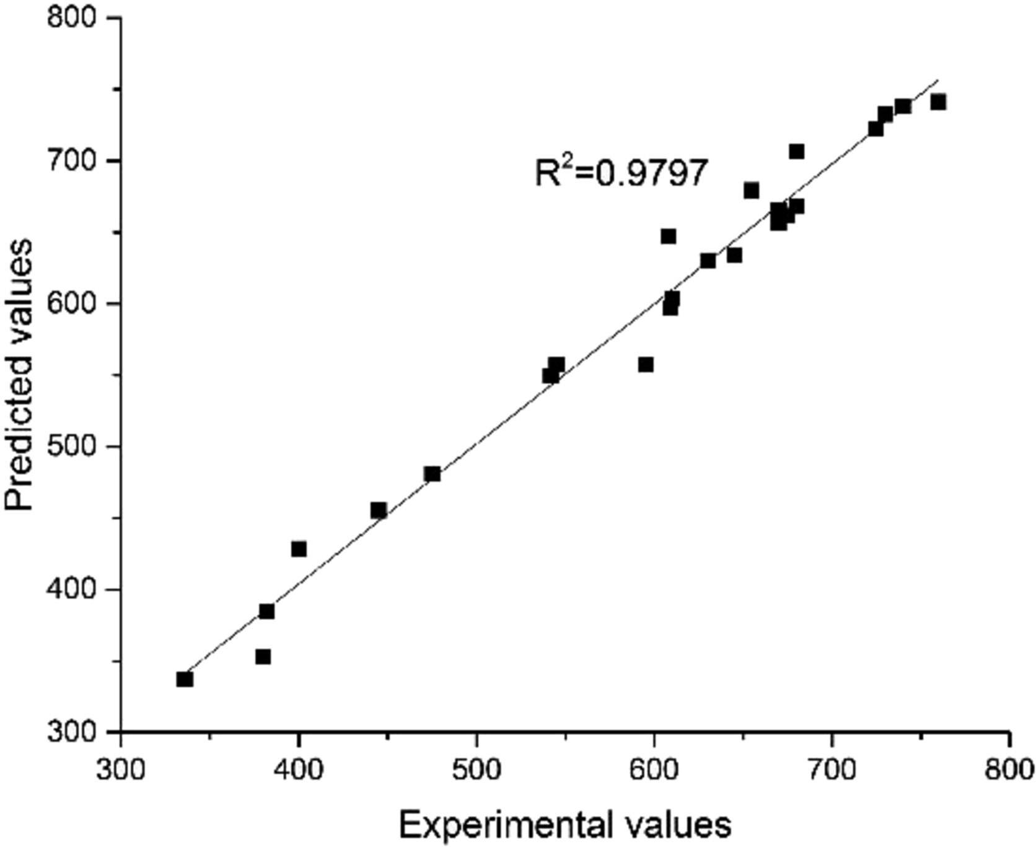Figure 3.

Plot of experimental and predicted TPP values

*TPPsr* = *a*3*Lf* + *b*3*Wf* + *c*3exp(*d*3*Dg*(1 — *SR*)) + *e* (3)

In order to represent the thermal performance of the garment ensemble by TPP values, fabric proprieties (fabric weight, thickness) and garment parameters (averaged air gap size and averaged shrinkage rate) were used to calculate the predicted TPP values by equation (2) and

(3). TPP values without air gap, with air gap before exposure and with air gap after exposure of G1–G8 were present in Table IV.

It was observed that the averaged shrinkage rate of G1–G8 were in the range of 27.5 percent–60.03 percent, with the averaged value of 40.91 percent. The garment with a large shrinkage rate suggested relatively low thermal dimensional stability of the fabric. The predicted TPP values before exposure were within the range of 628.22–768.52 kJ/m2 and decreased to be in the range of 567.56–758.59 kJ/m2 after exposure. It illustrated that there was a significant difference between the predicted TPP value before and after exposure (*p* < 0.001). The reduced TPP value caused by thermal shrinkage indicated a decrease of TPP, which should be considered when investigating the correlation between the bench scale and manikin tests.

* 1. *Correlation prediction between bench scale and manikin tests*

The predicted TPP values from the bench scale test and total body burn injuries from the manikin test were shown in Table IV and Table II, respectively. Both of them were two direct and effective criteria to represent the TPP. It is assumed that the fabric with a higher TPP value exhibited a lower result of total burn injury for the full-scale test.

The regression analysis was conducted to investigate the relationship between the predicted TPP values with the total body burn injury. Figure 4 showed the fitting results of the bench scale and flame manikin tests. It was observed from Figure 1(a) that correlation relationship between the predicted TPP value without air gap and total burn injury was weak (*R*2 5 0.349, *p* > 0.05). Similar results were also found in previous studies (Crown *et al.*, 2002; Wang *et al.*, 2015), the weak relationship may be partially attributed to the different air gap settings between the two test methods. In the flame manikin test, the fabric can freely shrink and the air gap size can be changed. While the fabric sample was fixed on the supporter and air gap size between the fabric and sensor was constant throughout the test process. Moreover, the air gap set in the bench scale test was not the realistic air gap size between the manikin surface and clothing. When the averaged air gap size of the garments before exposure was used to predict TPP values, it is found that the predicted TPP values had an approximate negative linear relationship with the total burn injury (*R*2 5 0.716, *p* < 0.01), seen in Figure 4(b). When thermal shrinkage was also considered, the correlation of the predicted TPP values after exposure and the total burn injury was shown in Figure 4(c). The value of *R*2

Thermal performance of

protective clothing

505

Predicted TPP value (kJ/m2)

|  |  |  |  |  |
| --- | --- | --- | --- | --- |
| Garment code | Without air gap | With air gap before exposure | With air gap after exposure |  |
| G1 | 446.39 | 720.96 | 621.00 |
| G2 | 428.71 | 684.71 | 634.98 |
| G3 | 428.71 | 704.16 | 657.68 |
| G4 | 428.71 | 717.59 | 665.34 |
| G5 | 352.77 | 628.22 | 567.56 |
| G6 | 383.92 | 659.37 | 608.39 | Table IV. |
| G7 | 337.30 | 650.85 | 630.61 | Predicted TPP values |
| G8 | 455.15 | 768.52 | 758.59 | of garment samples |

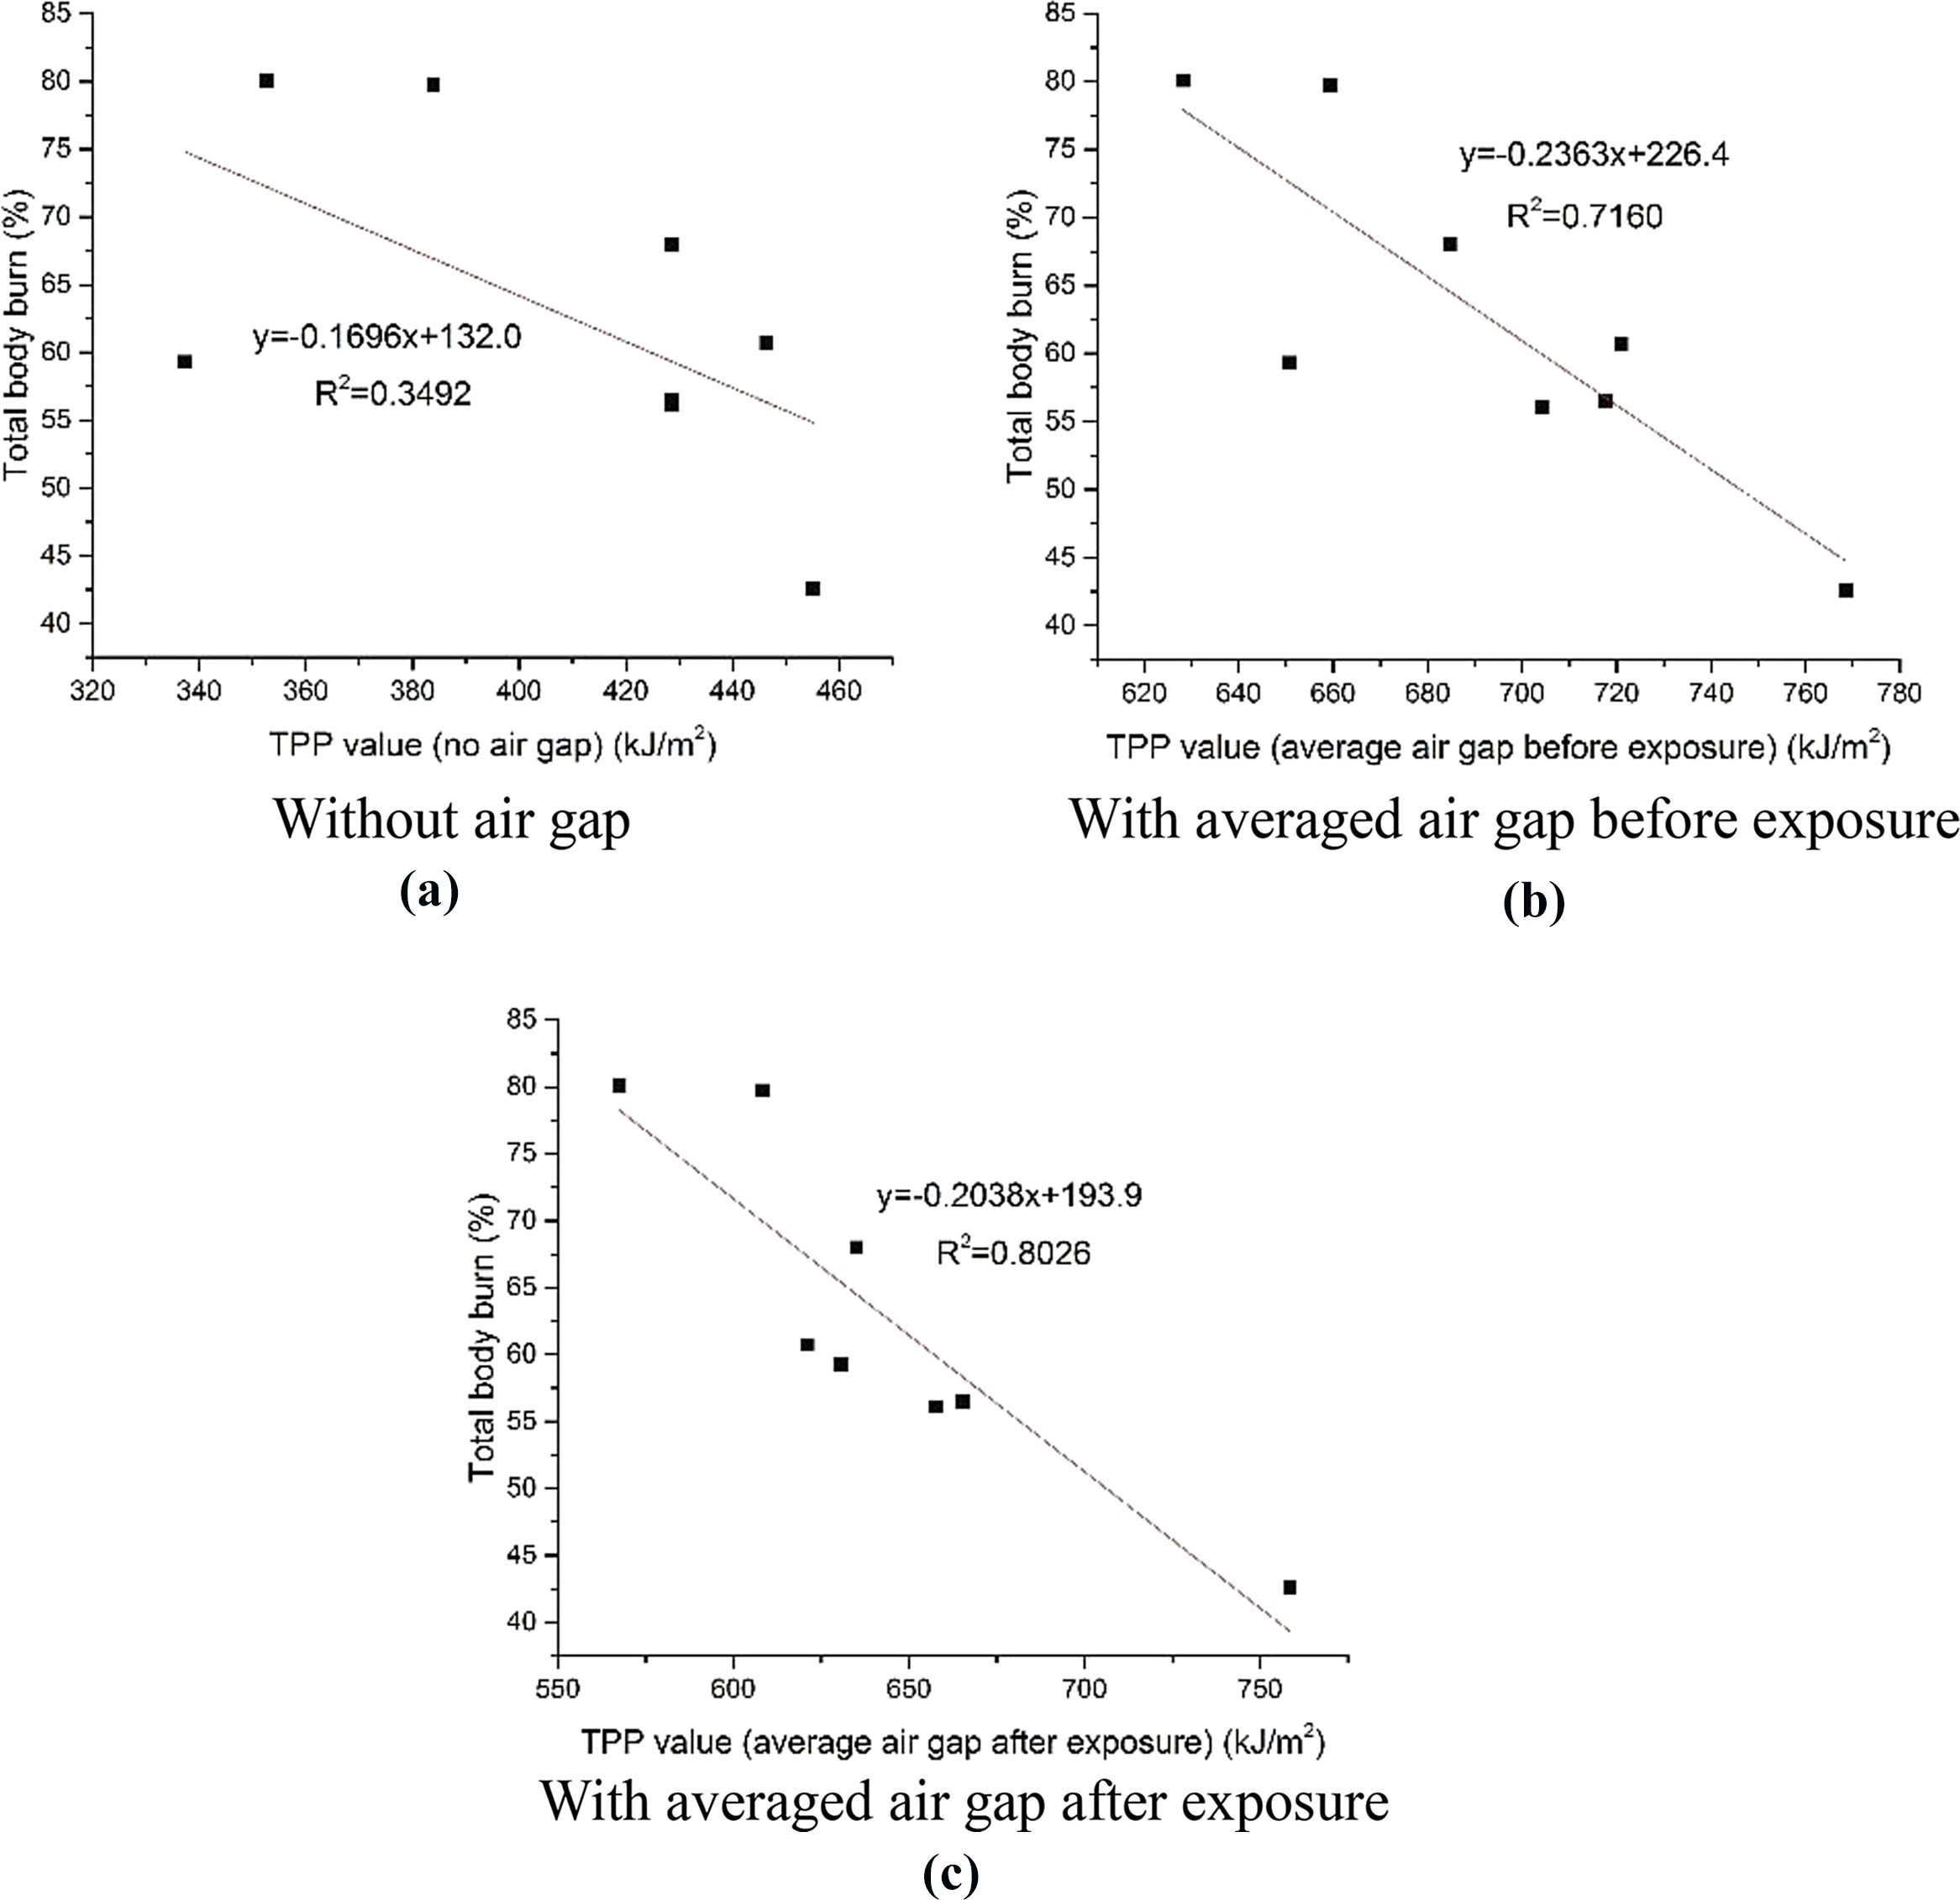32,4

506

Figure 4. Correlation between the bench scale and flame manikin tests

was 0.803, larger than that in Figure 4(b). It can be seen that the predicted TPP values considered the effects of air gap and thermal shrinkage had a generally good correlation with the total burn injury (*R*2 5 0.803, *p* < 0.005). Therefore, Equation (3) was proved to be effective to provide the thermal performance information for protective clothing made of Nomex IIIA fabric.

* 1. *Prediction method for the total burn injury from the TPP values*

The total burn injury in the flame manikin test can reflect the percent body burn under the exposure, but it is limited to be widely used for its complication and high cost. Therefore, it is efficient and time-saving if the full-scale result can be predicted based on the relatively simple bench scale test. A method was proposed and validated for predicting the total burn injury from the TPP values.

* + 1. *Prediction model for total burn injury.* It has been revealed from the above results that there was an approximate linear relation between the predicted TPP value and total body burn injury. Based on the correlation analysis, a linear equation to predict total burn injury was proposed as below,

*TBI*prediction = 1 — (*TPP*sr — *TPPc*)3*F* (4)

where *TBI*prediction is the predicted total burn injury in the manikin test. *TPP*sr is the predicted TPP value calculated from Equation (3).

*TPPc* is a statistical value obtained from the correlation analysis between the bench scale and flame manikin tests. In this study, for the garment made of Nomex IIIA fabric material, *TPPc* can be calculated from the regression equation in Figure 4(c). Assuming the total burn rate was 100 percent, and the *TPPc* was calculated to be 460.74 kJ/m2 by the linear equation. *TPPc* indicated the TPP value of protective clothing starting to protect human from burn injury.

*F* is a coefficient , it can be calculated from Equation (4) when *TBI*prediction was the real total burn injury value of the flame manikin test and *TPP*sr was calculated by the real experimental thermal shrinkage data in Table II. The value of *F* was affected by the factors such as garment design style, test environment and flame system. Table V showed the calculated values of *F* of G1–G8. The averaged *F* value can be used as a statistical value to conduct the method validation.

In summary, the process of the prediction method was to get fabric priorities of the garment first, then measuring the gap size between the garment and manikin surface by 3D scanning approach. Finally, the statistical data of *SR*, *TPPc* and *F* were used to predict total burn injury by Equation (3) and (4). It should be noted that the date of bench scale and flame manikin test was needed in the future to obtain more accurate statistical value.

* + 1. *Method validation.* In order to validate the accuracy of the prediction method garments G1–G8 and added garments X1–X3 were chosen. The details of garment X1–X3 were shown in Table II. The garment thermal shrinkage rate was simplified to be related with garment size in this validation. The averaged shrinkage rate of the garments with the same size were calculated and applied to predict *TPP*sr by Equation (3). The averaged *F* value of G1–G8 was calculated to be 2.02310–3, which was applied to predict total burn injury of garments by Equation (4).

Table VI showed the prediction results of the flame manikin test. It was found that the mean absolute error and mean relative error were 6.29 and 10.23 percent, respectively. It indicated that the predicted method had a generally good prediction precision. The absolute error of garments X1–X3 were in the range of 6.37–9.52 percent. It was a reasonable and acceptable error when predicting the total burn injury without conducting the flame manikin

Thermal performance of

protective clothing

507

|  |  |  |  |  |  |  |  |  |  |
| --- | --- | --- | --- | --- | --- | --- | --- | --- | --- |
| Garment code | G1 | G2 | G3 | G4 | G5 | G6 | G7 | G8 |  |
| *F* (310–3) | 2.45 | 1.84 | 2.23 | 2.13 | 1.87 | 1.37 | 2.40 | 1.93 | Table V.  Calculated values of *F* |

|  |  |  |  |  |
| --- | --- | --- | --- | --- |
| Garment code | Predicted total burn injury | Absolute error | Relative error |  |
| G1 | 65.79% | 5.12% | 8.44% |
| G2 | 65.15% | 2.85% | 4.19% |
| G3 | 61.82% | 5.72% | 10.19% |
| G4 | 59.08% | 2.58% | 4.57% |
| G5 | 77.00% | 3.07% | 3.83% |
| G6 | 70.77% | 8.96% | 11.23% |
| G7 | 70.69% | 11.39% | 19.22% |
| G8 | 47.31% | 4.71% | 11.05% |
| X1 | 61.62% | 8.88% | 12.59% | Table VI. |
| X2 | 57.37% | 6.37% | 10.00% | Prediction results of |
| X3 | 45.80% | 9.52% | 17.20% | total burn injury |

IJCST 32,4

508

test. This method can be used to provide thermal protection information for protective clothing.

It was noticed that G7 had the maximum error, which can be partially attributed to error of thermal shrinkage prediction. In addition, the error may come from the predicted *TPP*sr. In this study, only averaged air gap was applied to calculate the *TPP*sr. However, considering the uneven distribution of clothing and thermal shrinkage, the averaged gap size might not accurately represent the overall gap size. As clothing ensemble was divided into more than 120 areas based on the location of test sensor on the manikin surface, the *TPP*sr values in Equation (4) can be replaced by the averaged *TPP*sr values of more than 120 areas. It considered the fact that the growth rate of TPP gradually decreased with the gap size, which can more accurately predict the thermal performance (Li *et al.*, 2015).

In this study, the total burn injury prediction model was developed based on the available data of garment samples made of Nomex IIIA fabric material. The flame manikin test data in Table II were obtained by the “PyroMan™ system” and Donghua fire manikin, more data of air gap, fabric shrinkage and burn injury are needed to improve the applicability of the prediction method. A new flame manikin system is setting up in Tsinghua University. The contrast experiments will be conducted in the future study to improve the predicted accuracy and applicability.

1. Conclusion In this paper, a prediction method to evaluate thermal performance of protective clothing was developed, basing on the quantitatively investigation of the correlation between the bench scale and flame manikin tests. Fitting equations were established to predict the TPP values accounting for the air gap and thermal shrinkage. The results showed that there was an approximate linear relationship between the total burn injury and predicted TPP value when the effects of air gap and thermal shrinkage were considered. It indicated that air gap and thermal shrinkage of garment should not be ignored for TPP evaluation. A new method was proposed to predict total burn injury by the TPP values and garment statistical parameters. The validation showed that the predicted burn injury values were in generally good agreement with the experimental results. This method combines the advantages of both bench scale and flame manikin tests, to simply and quickly predict the total burn injury of garment ensemble. The research findings can provide an insight into the correlation analysis between bench scale and manikin tests, and give some useful suggestions to burn injury prediction of protective clothing.

References

ASTM (2012), *Standard Test Method for Evaluation of Flame Resistant Clothing for Protection against Fire Simulations Using an Instrumented Manikin*, Reference No. F1930-12, ASTM International, West Conshohocken.

Barker, R. (2005), *A Review of Gaps and Limitations in Test Methods for First Responder Protective Clothing and Equipment: A Final Report Presented to National Personal Protection Technology Laboratory*, National Institute for Occupational Safety and Health, Chapel Hill, NC.

Chitrphiromsri, P. (2005), “Modeling of thermal performance of firefighter protective clothing during the intense heat exposure”, PhD thesis, North Carolina State University, Raleigh.

Crown, E.M., Ackerman, M.Y., Dale, J.D. and Tan, Y.B. (1988), “Design and evaluation of thermal protective flightsuits. Part II: instrumented mannequin evaluation”, *Clothing and Textiles Research Journal*, Vol. 16, pp. 79-87.

Crown, E.M., Dale, J.D. and Bitner, E. (2002), “A comparative analysis of protocols for measuring heat transmission through flame resistant materials: capturing the effects of thermal shrinkage”, *Fire and Materials*, Vol. 26 Nos 4/5, pp. 207-213.