CS-57 Human–AI Data Annotation, Provenance, and Dataset Evaluation Platform
Final Report



Group Based 5703 Capstone Project

Group Members
- Michael Max (540559785)
- Parth (550620451)
- Jingwei Lin (520372766)
- Hanchen Wang (520374346)
- Yi Geng (520373453)
- Dishank Aswal (540870299)
- Kanishka Kathait (540870325)
- Tim Chung (550512950)

Contribution Statement
Our group CS-57, taking project titled "Human–AI Data Annotation, Provenance, and Dataset Evaluation Platform", with group members Michael Max, Parth, Jingwei Lin, Hanchen Wang, Yi Geng, Dishank Aswal, Kanishka Kathait and Tim Chung, would like to state the contributions that each group member has made for this project during this semester. Identifiers such as C2 name user stories in the backlog (Section 4.1.2).
Michael Max (540559785): Client liaison and minute-taker from Week 3 to Week 8: attended the first client meeting (19 August), recorded the client and team meetings, sent the Week-5 written update, arranged the first sprint check-in with the client (9 September), drafted Status Checking 1 and obtained the client's sign-off on it, and worked on the client feedback round for Status Checking 2. Designed and built the AI batch pipeline (story C2): the design documents, job tables, background worker, retry and dead-letter handling, run trigger and batch-progress view. Also replaced the fabricated AI output with an explicit failure (C3), and built versioned guidelines and policies (F2), the release gate (H3) and the release manifest (H2). Wrote ADRs 018, 020 and 021. Authored 14 merged pull requests and reviewed 4.
Parth (550620451): Moved the platform to PostgreSQL 18 while keeping SQLite working. Set up the two-database CI and the Docker Compose stack, and later hardened both and added the export-figure check (A4, H5). Built review justification and send-back (C5, E2), the blind independent second review with sampled cross-review, adjudicator independence (D7, D8, E3), state–history consistency (D2) and the provenance event record (F1). Wrote ADRs 010, 011 and 015. Authored 6 merged pull requests and reviewed 4, giving reproduction steps for each fault found.
Jingwei Lin (520372766): Set up the pull-request review workflow with Hanchen. Built role-based permissions and cross-project write guards (G1, G3), project review policies and their enforcement (B2, G2), the review target (D4), corrections (D3), reopening (D9), audit history (F4), the result shape (B3) and the production mode (C4). Evaluation work: the harness (I1), the casebook's growth to 57 cases (I2), the blind-then-reveal protocol (I4), the agreement coefficients and recorded model runs (I3) and the integrity checks (I5). Also built the dispute screens (E6), organisation identity and project archiving (J1, J4), the settlement of held disagreements, the interface clean-up and part of the handover sweep (K1). Wrote 11 of the 25 ADRs. Authored 29 merged pull requests and reviewed 27.
Hanchen Wang (520374346): Project manager. Wrote the backlog of user stories and the mission, tech-stack and roadmap specifications. Ran the Jira board, the contribution tracker, the weekly re-planning (including the re-plan of 1 October) and the client-facing backlog dashboard. Started the written client Q&A, presented progress and demonstrations at client meetings, and prepared Status Checking 3. Code: restored the test suites (A2), draft ownership and atomic submission (D5, D6), fixes to the work queues, the work panel and the submission chooser (D8, D4), answer versions (F3), the casebook structure and repeatable runs with a regression baseline (I2, I1), page-load performance (A6), retirement of the legacy escalation flow (A5) and the handover sweep (K1). Wrote ADR 009. Authored 16 merged pull requests and reviewed 42.
Yi Geng (520373453): Integrated the client's AI assistant prototype into Hej (C1), with custom task and label definitions. Raised the team's technical workflow questions with the client, took minutes, and opened the GitHub client-question issues on dispute scope and AI rework. Built per-task annotation surfaces (B8), record-based JSONL intake (B7), the dispute and adjudication record with automatic disputes (E1, E3, E4), the human fallback for a rejected AI first pass (E2), the Expert Gate and escalation postures (G2, E5), the item timeline (F5), the release screens (H6), the permission model (G1), the governance seed projects (A3) and model-stated confidence (C1). Wrote ADRs 004, 005, 013, 017, 023 and 025. Authored 14 merged pull requests and reviewed 23.
Dishank Aswal (540870299): Built status validation with correct conflict responses (G4, B5) and one completion rule for tasks and exports (B6). Also built the task lifecycle with its delete policy (B4), resubmission rules (D8), one authoritative answer per item (H4, which closed the last Critical inherited defect) and an expert's acceptance of a reviewer's correction (D3, E3). Authored 6 merged pull requests and reviewed 3.
Kanishka Kathait (540870325): Made dataset registration transactional (B5). Built the role-checked work-queue API and the available-work list (D8), the immutable release artefact (H1) and the evaluation findings record with its negative results (I5). Authored 5 merged pull requests and reviewed 3.
Tim Chung (550512950): Restored the organisation invitation flow (G5) and built the member-management screens with role choice at invitation and the invitee's acceptance (J3). Also built the project overview (J2) and organisation-scoped project creation (B1). Authored 5 merged pull requests and reviewed 2, including the review that found four defects in project archiving.
All group members agreed on the contributions listed on this statement by each group member.
Signatures:

Abstract
Supervised machine learning is only as trustworthy as its labels, yet most annotation tools keep little more than the final label, so a dataset often cannot show which guideline governed an answer, what an AI suggested, how a person responded or how disagreement was settled. For Arc Intelligence, team CS-57 extended Hej (Human Evaluation and Judgement), the client's annotation platform, into a governed, provenance-aware human–AI annotation system. The aim was not faster labelling but a dataset that can answer, for every item, how its label got there, and a platform that refuses to release data when it cannot.
The team inherited an immature codebase with 30 catalogued defects, six of them critical, such as finalised answers being overwritten and annotators approving their own work. In weekly Scrum sprints the eight members delivered 63 user stories around six pillars: Govern, Assist, Record, Adjudicate, Release and Evaluate. The platform records an append-only provenance event at every decision, keeps each person's and model's answer as its own version, treats a reviewer's correction as a proposal, and lets only an independent expert decide a dispute. A release gate reads recorded facts and refuses unreviewed, disputed or untraceable items before anything is created; a passing release is frozen with a manifest anyone can check without the platform. All 30 inherited defects were closed.
A casebook of 88 end-to-end cases, adversarial ones included, drives the real application programming interface (API) and is compared with a committed baseline in continuous integration; 87 pass and one is skipped by design, alongside 2,495 backend and 1,050 web tests. Recorded runs of two language models over 400 client records were accurate on news topics (84.5% and 92.5%) but confidently wrong on toxic comments, with recall of only 35% and 47% on the abusive class, so model confidence cannot justify skipping human review.
The project shows that label provenance can be enforced at the moment of decision and release made conditional on it. Its limits: the evaluation's people were scripted, the AI first pass and the release have been joined only in a manual run, and a complete record shows how a label was produced, not whether it is right.

Table of Contents
Contribution Statement i
Abstract iii
Table of Contents iv
1. Introduction 1
2. Related Literature 2
2.1 Literature Review 2
3. Project Problems 8
3.1 Project Aims & Objectives 8
3.2 Project Questions 9
3.3 Project Scope 10
4. Methodologies 11
4.1 Methods 12
4.2 Data Collection 14
4.3 Data Analysis 15
4.4 Deployment 16
4.5 Testing 16
5. Resources 17
5.1 Hardware & Software 17
5.2 Materials 18
5.3 Roles & Responsibilities 19
6. Milestones / Schedule 20
7. Results 23
7.1 The prototype system 23
7.2 Results by pillar 25
7.3 Quantitative results 30
7.4 Answers to the project questions 34
8. Discussion 36
8.1 Provenance captured at decision time 36
8.2 Release gates that cannot be satisfied by assertion 37
8.3 Independence and the separation of roles 38
8.4 Separating evaluation from production 39
8.5 The evaluation harness as a safety net for governance 39
8.6 Decisions the team made when the client delegated 40
8.7 Significance for the client and for dataset consumers 41
9. Limitations and Future Works 42
9.1 Limitations of the artefact 42
9.2 Limitations of the evidence 43
9.3 Limitations of the setting 44
9.4 Summary of future work 45
Acknowledgement of AI Use 47
References 48

Introduction
Most machine-learning systems are trained and tested on data that people have labelled: a news article sorted by topic, a comment marked as abusive or not, a region of an image outlined as a vehicle. Label quality sets a ceiling on everything built from the data. Errors in widely used benchmark test sets are common enough to change which model appears best (Northcutt et al., 2021), and practitioners report that data problems compound silently through later stages of a project (Sambasivan et al., 2021). Labelling is also increasingly shared between people and AI models: a model proposes a label and a person accepts, edits or overrides it, which lowers cost but raises a new question, namely whose judgement the final label represents.
These pressures have made the history of a label as important as the label. Researchers propose that every dataset be documented with how it was collected and labelled (Gebru et al., 2021) and that dataset development be held to the accountability of software (Hutchinson et al., 2021), and the European Union's Artificial Intelligence Act requires data governance covering the origin of data and preparation steps such as labelling (Regulation (EU) 2024/1689, 2024, art. 10). Documentation written after the fact, however, is only as reliable as the records it draws on: if the platform never recorded who reviewed an item, or what the AI suggested before the human answered, no later report can recover it.
The client, Arc Intelligence, operates Hej (Human Evaluation and Judgement), a platform for producing labelled datasets through annotation, review and expert adjudication. Its brief observes that annotation tools concentrate on the act of labelling, while what makes a dataset defensible happens around it, in sources, guideline versions, reviews, AI suggestions, disputes and releases. The goal was therefore not faster annotation but a platform where a released dataset can answer, for any item, "how did this label get here", and which refuses to release when it cannot. The team inherited a working but immature codebase, a web application and an API service developed by earlier teams without a consistent review process, in which an audit catalogued 30 defects. Six were critical and went to the heart of trust in the data: a finalised answer could be silently overwritten, an annotator could approve their own work, a finished item could be exported with two conflicting answers, and a reviewer's correction was lost.
The problem was not a missing feature but a missing guarantee: the platform could produce labels but could not defend them. The proposed solution was a governed, provenance-aware layer over the existing workflow, organised around the six pillars of the brief. Govern sets who may do what, through roles, capabilities and versioned guidelines and policies. Assist delivers AI suggestions through a replaceable model interface. Record captures each decision as it happens. Adjudicate keeps an annotator's label, a reviewer's decision and an expert's resolution distinct. Release produces frozen datasets with manifests behind a gate that checks recorded facts. Evaluate measures quality, the effect of AI on people and the integrity of the record under repeatable conditions. Text annotation was agreed as the committed path; image, audio and video were kept working but not extended.
The benefits are practical: a team using Hej can show, item by item, which guideline governed an answer, whether a person followed or overrode the AI, and why a disagreement ended as it did, and the release gate turns the promise "everything was reviewed" into a check that cannot be passed by assertion. The choice also has costs. Recording every decision adds refusals and friction, and a provenance record proves what happened, not that the judgement was right. Not doing the work, however, would leave every dataset produced on the platform exposed to labels that cannot be audited, AI influence that cannot be measured and exports that may contain answers no reviewer approved.
Chapter 2 reviews the literature and identifies the gap; Chapter 3 states the aims, questions and scope; Chapters 4 to 6 describe the methods, resources and schedule; Chapter 7 presents the results, Chapter 8 discusses them, and Chapter 9 sets out limitations and future work.

Related Literature
Each of the six pillars answers a problem that the literature on data annotation, human–AI decision-making, provenance and access control has documented. This chapter reviews those problems and shows how they shaped the platform's design.

Literature Review
The brief demands properties, such as provenance "captured as it happens", release gates that cannot be satisfied by assertion and measures of anchoring and automation bias, that come from different research communities, so the design needed to know which agreement measures are sound, what AI assistance does to annotators, what a provenance record must contain and what existing tools offer. The review covers five themes, preferring peer-reviewed work from natural language processing, human–computer interaction, machine learning accountability, databases and security, with a W3C standard, an EU regulation and vendor documentation where they define the topic. Foundational work on agreement, anchoring, access control and provenance (1960–2007) was kept because the platform implements it directly; work on large-language-model (LLM) assistance dates from 2021 to 2025. Every source was checked against its publisher's record.

Label quality is a property of the process
Early crowdsourcing work showed that non-expert labels can be useful if collected and combined with care: a few aggregated non-expert labels per item came close to expert quality on several language tasks (Snow et al., 2008), and relabelling noisy items improves both label quality and the models trained on them, though not in every case (Sheng et al., 2008). A label's reliability therefore depends on how it was produced and combined, information that is lost once only the final label is kept. The cost is real: Northcutt et al. (2021) estimated that the test sets of ten widely used benchmarks contain on average at least 3.3% label errors, enough to reverse some model rankings.
Agreement between annotators is the standard evidence that a labelling scheme is reliable, and the measure matters. Raw agreement ignores agreement expected by chance; Cohen's (1960) kappa corrects for chance between two coders, Fleiss (1971) extended it to many interchangeable raters, and Krippendorff's alpha handles any number of coders and missing answers (Hayes & Krippendorff, 2007). Artstein and Poesio (2008) showed that these coefficients rest on different assumptions, so the choice must fit how the data was produced. A second line of work questions whether disagreement should be removed at all: Aroyo and Welty (2015) called the single correct answer a myth, and Plank (2022) argued that treating human label variation as noise harms modelling and evaluation. The client adopted this view: disagreement is first-class data whose lineage must be kept, and an expert may resolve an item as genuinely ambiguous.

AI assistance and its effect on human judgement
Automating part of labelling is attractive. Gilardi et al. (2023) found that a general-purpose LLM outperformed crowd workers on several text-annotation tasks at a fraction of the cost; pre-annotation saved 13.9–21.5% of time per entity in clinical annotation without a significant fall in agreement (Lingren et al., 2014), and an AI-assisted labelling interface increased both speed and accuracy (Desmond et al., 2021). The same literature records the risk: pre-annotation can introduce systematic bias, especially when it is good enough to be trusted (Fort & Sagot, 2010).
Research on decision-making explains why. An initial value anchors later estimates even when people know it is arbitrary (Tversky & Kahneman, 1974), and people working with an automated aid both miss problems it did not flag and follow its wrong advice, errors that training does not reliably prevent (Parasuraman & Manzey, 2010). Explanations made people more likely to accept an AI's recommendation whether right or wrong (Bansal et al., 2021), and LLM labels improved annotators' accuracy when correct but reduced it when wrong (Wang et al., 2024). In a pre-registered study of LLM-assisted annotation on subjective tasks, suggestions did not make annotators faster but made them more confident, shifted labels towards the model's and inflated the model's measured performance when assisted labels were used as the reference (Schroeder et al., 2025).
Two consequences follow. If AI-assisted labels are used both to build a dataset and to judge the AI, the evaluation is circular unless the human's independent answer is kept apart from the suggestion. And the order of exposure matters: a design in which people decide before seeing the AI's recommendation, then may update, reduced over-reliance (Buçinca et al., 2021), which is in substance the blind-then-reveal protocol the client asked for. Finally, stated confidence is only useful if calibrated; modern neural networks are often overconfident, measured by the expected calibration error (ECE) (Guo et al., 2017).

Provenance and dataset accountability
Provenance is the record of where data came from and how it was derived. Buneman et al. (2001) distinguished "why" provenance (which sources justify a result) from "where" provenance (where a value was copied from), and the W3C PROV model generalised the idea as a graph of entities, activities and responsible agents (Moreau & Missier, 2013). For annotation the mapping is natural: items and answers are entities; annotating, reviewing and adjudicating are activities; and people, models and the platform's own rules are agents, which must be told apart if the record is to say whether a person or a model decided.
In machine learning, accountability work has focused on documentation: datasheets describe a dataset's motivation, composition, collection and labelling (Gebru et al., 2021), model cards do the same for models (Mitchell et al., 2019), and Hutchinson et al. (2021) argued that datasets should be developed with the discipline of the software lifecycle so that decisions can be audited. Data-centric AI treats collection and label quality as central problems (Whang et al., 2023), 92% of practitioners interviewed in high-stakes domains had experienced compounding "data cascades" (Sambasivan et al., 2021), and Article 10 of the EU AI Act requires data governance covering data origin and labelling (Regulation (EU) 2024/1689, 2024). The common limit is that this work describes what should be documented, not how the record is captured: a datasheet written after the dataset exists has nothing reliable to draw on if the platform did not record each decision. The brief closes this gap by requiring provenance "captured as it happens, not reconstructed afterwards".

Governance, separation of duties and immutable versions
Role-based access control assigns permissions to roles and supports separation of duties, under which no single person holds two conflicting responsibilities (Sandhu et al., 1996); Saltzer and Schroeder's (1975) principles add least privilege and complete mediation (every access is checked, not only the first). In annotation, separation of duties is a quality control as much as a security one: a reviewer approving their own answer, or an expert adjudicating a dispute they took part in, defeats the independence review is meant to provide, which is exactly what the inherited code allowed. Reproducibility also requires that what was released stays fixed; Bhardwaj et al. (2015) proposed dataset version control modelled on source control. For a labelling platform this applies twice: each answer should be a version that later work supersedes but never overwrites, and each release a frozen artefact checkable against a record of what it should contain.

Existing annotation tools
Mature tools exist for the labelling moment. Label Studio imports model predictions as read-only pre-annotations, which can be copied into a new annotation for the annotator to edit (Tkachenko et al., 2020–2025); its reviewer workflow and agreement reporting are part of the commercial edition (HumanSignal, n.d.). Prodigy places a model in the loop: annotators accept or reject its suggestions, and the model learns from those decisions to choose the next examples (Montani & Honnibal, 2017). CVAT pre-annotates images and video with pre-trained models, filtered by a confidence threshold (CVAT.ai Corporation, 2023), and doccano provides open-source text annotation (Nakayama et al., 2018). Amazon SageMaker Ground Truth combines several workers' answers into a single consolidated label and can label automatically the items on which its model is confident, sending the rest to people (Amazon Web Services, n.d.-a, n.d.-b).
These tools make labelling efficient, and several do so by merging human and machine contributions: consolidation turns several answers into one, and a pre-annotation copied into an annotation no longer says which parts the person changed. The client's brief required the opposite: an annotator's label, a reviewer's decision and an adjudicated judgement kept distinct, and a record of whether the human accepted, modified, rejected or replaced the AI's suggestion. In the documentation reviewed, none of these tools describes a release gate that reads recorded decisions and refuses unreviewed or untraceable items. The client's interest was the governed layer around annotation, not another annotation interface (Section 3.3).

Synthesis: the gap and how Hej addresses it
The literature agrees on three points. Label quality depends on process, so the process must be recorded. AI assistance changes human answers in measurable and sometimes harmful ways, so the platform must keep the human's independent judgement apart from the AI's suggestion if it is to measure that change. Documentation and regulation increasingly ask for the history of each label, yet they assume a record that tools do not keep. The gap is a platform that captures the provenance of each label at the point of decision, preserves the separate roles of model, annotator, reviewer and expert, enforces independence on the server, and makes release conditional on the record. Table 1 shows how specific findings informed the design decisions the team recorded in Hej's architecture decision records (ADRs).
Table 1. Findings from the literature and the Hej design decisions they informed
Theme | Finding | Design decision in Hej (ADR)
Agreement measures | Raw agreement is inflated by chance; coefficients rest on different assumptions (Artstein & Poesio, 2008; Hayes & Krippendorff, 2007) | Coefficient beside the raw rate: Fleiss' kappa for reviewers, Krippendorff's alpha over first independent answers; undefined shown as missing, never 0 or 1 (ADR 019)
Disagreement as data | Disagreement often reflects real ambiguity (Aroyo & Welty, 2015; Plank, 2022) | Disagreements and settlements are their own records; an expert may resolve an item as ambiguous and the release says so (ADR 020–022)
Anchoring, automation bias, deciding first | A suggestion seen first shifts answers and inflates measured model performance; deciding first reduces over-reliance (Tversky & Kahneman, 1974; Parasuraman & Manzey, 2010; Buçinca et al., 2021; Schroeder et al., 2025) | Blind-then-reveal protocol: blind verdict recorded before the suggestion, which sits in a table no other read reaches; reveal refused before the blind verdict; only first rounds measured (ADR 016)
Calibration | Model confidence is often miscalibrated (Guo et al., 2017) | Confidence stored as stated or as none, never as 0; ECE and Brier score from recorded runs (ADR 019, 025)
Provenance | Provenance links results to sources, activities and agents (Buneman et al., 2001; Moreau & Missier, 2013) | Append-only event at each decision naming a person, model or platform actor; updates and deletions refused (ADR 015)
Accountability | Datasets need auditable records of how they were made (Gebru et al., 2021; Hutchinson et al., 2021) | Each release carries a manifest of items, chosen answers, versions and event chains, checkable without the platform (ADR 021)
Separation of duties, least privilege | Conflicting duties must not meet in one person; each role holds only what it needs (Sandhu et al., 1996; Saltzer & Schroeder, 1975) | No adjudication by anyone involved in the item (ADR 011); a correction is a proposal (ADR 012); administrators cannot judge (ADR 023)
Versioning and immutability | Datasets need version history like source code (Bhardwaj et al., 2015) | Every answer is a version, at most one authoritative (ADR 009); guidelines and policies versioned (ADR 018); the gate reads only recorded decisions (ADR 020)

Two findings in the literature also mark the limits of what such a platform can claim. A provenance record shows how a label was produced, not whether it is correct; Northcutt et al. (2021) found errors in datasets produced by careful processes. And measuring the effect of AI on annotators needs real annotators: the platform can provide the protocol and the measures, but the effect itself is an empirical question. Both limits return in Chapter 9.

Project Problems

Project Aims & Objectives
The project's aims follow the six pillars of the client's brief, grouped by the guarantee each provides:
- Aim 1 — A defensible dataset (Record, Release). Every released label can be traced to the source, guideline and policy versions, AI suggestion, human response, reviews and adjudication that produced it, and a release that cannot be traced is refused.
- Aim 2 — Trustworthy judgement (Govern, Adjudicate). Roles carry only the authority they need, no one judges their own work, and the contributions of annotator, reviewer and expert remain distinct.
- Aim 3 — Accountable AI assistance (Assist, Evaluate). AI suggestions come through a replaceable interface, a failure is never disguised as a suggestion, and the effect of AI on quality and on human judgement can be measured under repeatable conditions.
- Aim 4 — A platform that can be proven and maintained. The inherited defects are closed, and every guarantee above is backed by automated evidence that runs on each change.
Table 2 lists the objectives that operationalise these aims. O1 to O4 are the scope agreed with the client in week 4; O5 to O7 were added when the brief and the client's answers in weeks 6 to 8 showed that provenance, gated releases and the evaluation harness were required (Chapter 6); O8 runs through both.
Table 2. Project objectives, the aims they serve and how completion is measured
Objective | Aim | How completion is measured
O1 Complete the core workflow (project, policy, task, items, AI first pass, review, cross-review, dispute, adjudication, finalised item) on the provided text data | 2, 3 | Casebook cases carry a real AG News record through every stage; the workflow is shown on real screens
O2 Integrate the web application with the annotation and AI services through a typed model interface | 3 | Live and scripted models interchangeable without workflow change; a failed call recorded as a failure
O3 Enforce governance on the server: roles, capabilities, review policies, independence | 2 | Permission suites and cases show refusals of self-approval, self-adjudication and cross-project writes
O4 Validate and correct the contracts between web, API and AI services | 2, 4 | Results checked against the task's output shape on submission; web type checks and tests pass in CI
O5 Record provenance as it happens, with versioned sources, guidelines and policies | 1 | An event for every decision; versions cited by every answer; an integrity check of every released item
O6 Produce immutable releases with manifests, gated before they exist | 1 | Refusals with a reason per item that create nothing; a release rebuildable from its manifest alone
O7 Build an evaluation harness and a casebook of 40–60 end-to-end cases, adversarial ones included | 3, 4 | Case count and category coverage; agreement, accuracy, calibration and blind-then-reveal measures; baseline compared in CI
O8 Close the inherited defects inside the features that depend on them | 4 | All six Critical defects closed; any other closed or left open with an argued decision

Project Questions
The brief and the first meetings described symptoms: an inherited codebase with serious defects, a workflow that worked only part of the way, and AI suggestions with no measure of their effect. They share one underlying problem: the platform produced labels but could not defend them. Nothing linked an exported label to the decisions behind it, the record could be rewritten, reviewers were not guaranteed to be independent, and nothing stood between an unchecked dataset and its release. The project therefore addressed five questions, answered in Section 7.4 and discussed in Chapter 8.
- RQ1 — Traceability. Can a released dataset answer, for every item it contains, how its label got there (source and guideline version, AI suggestion, the human response to it, each review, dispute and adjudication, each with an actor and a time) from a record captured at each decision rather than reconstructed afterwards?
- RQ2 — Gated and checkable release. Can the platform refuse to create a release when that answer cannot be given (because items are unreviewed, disputed, missing provenance or without an authoritative answer) using only recorded facts and never an operator's assertion; and can anyone check a release against its manifest without the platform?
- RQ3 — Governed judgement. Can the server enforce governance so that no one approves, settles or adjudicates work they took part in, so that roles carry only the authority they need, and so that the annotator's label, the reviewer's decision or correction and the adjudicated resolution remain distinct records rather than a single "final answer"?
- RQ4 — Measured AI assistance. Can AI suggestions be supplied through a replaceable, typed interface that never disguises a failure as a suggestion, and can both the quality of those suggestions (accuracy and calibration) and their effect on human judgement (keeping or revising one's own answer) be measured under repeatable conditions?
- RQ5 — Proof rather than demonstration. Can these properties be shown by repeatable, adversarial, end-to-end evidence that runs through the real API and guards against regression, while the inherited defects are closed inside the features that depend on them, within one semester?
RQ1 and RQ2 correspond to Aim 1, RQ3 to Aim 2, RQ4 to Aim 3 and RQ5 to Aim 4. These five questions refine the two project questions set in the proposal. Q1, "How can a platform integrate human–AI annotation while keeping decisions transparent and governed?", is answered through RQ1 (each decision traceable), RQ3 (who may decide, and independence) and RQ4 (AI assistance integrated behind a replaceable interface). Q2, "How can automated validation and evaluation ensure the quality, integrity and reproducibility of AI-assisted datasets?", is answered through RQ2 (validation before release), RQ4 (measured AI quality) and RQ5 (repeatable, automated evidence). RQ4 therefore serves both.

Project Scope
In scope. The six pillars as they apply to text annotation: organisation, role and permission management; versioned guidelines and project policies, with source versions recorded for each item; the two production modes, human-first and AI-first; blind-then-reveal as an evaluation protocol, a separate task setting rather than a third mode, as the client specified on 21 September and confirmed on 14 October; review, independent cross-review, disputes and expert adjudication; the provenance record and item history; frozen, gated releases with manifests; and the evaluation harness with its quality, collaboration and integrity measures. Import of the client's JSON Lines (JSONL) datasets, one source record per item, was added at the client's request in week 7.
Modality. Text was agreed in week 4 as the committed path, as the highest-value and highest-confidence route in the time available. Image, audio and video had to keep working, and the schemas admit them, but they were not taken through the full set of guarantees.
Out of scope, following the brief's non-goals: rebuilding the annotation interface or integrating a tool such as Label Studio; training or fine-tuning models; a universal ontology or general workflow builder; formal privacy or legal compliance claims; marketplace, trust, billing and payout features; and a workflow for requesting that a finalised item be reopened, which the client allowed to be deferred (only the task owner reopens directly). The client's reference ("gold") labels were kept out of the platform: measures that need them are computed by the evaluation harness, so evaluation-only data never reaches annotators or models.
Inherited defects and working constraints. At week 4 the client directed the team not to spend one to two weeks clearing the 30 catalogued defects first, but to fix each defect when the feature under construction depends on it. The team made that traceable: each defect was linked to its user story and closed by that story's work, with a regression test where possible, and closing all six Critical defects was a success criterion in its own right. Features that already worked, the interface style and authentication were stable by default; replacing one needed a written justification agreed at review, and significant decisions were recorded as ADRs.

Methodologies
Three conditions shaped the methods: a large scope for eight part-time members, an inherited codebase that had to be changed without breaking it, and requirements the client clarified as features reached them. Each choice below is described with what it bought and what it cost; Table 3 summarises.

Methods

Life cycle: Scrum in weekly sprints
The team followed Scrum (Schwaber & Sutherland, 2020), adapted to a semester: seven sprints (W6–W11 and one for the mid-semester break, 1–7 October), each producing merged, reviewed work on main. From 19 September a sprint ran from Thursday to Wednesday, so that it closed after the Wednesday-evening client meeting and the client's feedback shaped the next plan; the client acted, in effect, as product owner. The project manager kept the backlog and ran the weekly planning meeting, where finished tickets were checked against main before new work came in.
Estimation used units rather than hours: one unit is two to three backlog subtasks, and each member carried 1.5–3.5 units a week, so members with different timetables shared one scale (a check on 18 September found a median of 2.5 subtasks per planned unit). Weekly sprints limited how long a misunderstanding could last, at the price of planning overhead every week.

Requirements as user stories with acceptance criteria
The agreed scope was broken into user stories ("As a … I want … because …") with numbered acceptance criteria, subtasks, a priority and the inherited defects each closes (Cohn, 2004). Stories are named by epic letter and number (for example D5, the fifth story of epic D, Review and Cross-Validation). The backlog began with 59 stories in 11 epics (A–K) and grew to 63 as client answers and a performance investigation added B7, B8, D9 and A6. Stories were delivered through Jira tickets, so a story could span sprints; the board finished with 104 tickets, all Done. Stories gave the client a backlog he could read and a checkable meaning of "complete", but had to be re-scoped when an answer changed their meaning: the decision of 17 September that work is self-served from queues, not assigned, rewrote the work-queue story while it was being built.

Definition of Done, code review and the defect policy
A story was done only when it could be demonstrated in the running application, shipped its tests in the same change, had a test that fails on the old code for any linked inherited defect (checked by reverting the fix), updated the documentation of changed states or contracts, and was reviewed by a member other than its author. The third condition applies Feathers' (2004) advice for legacy code: pin behaviour with a test before changing it, so a fix proves it closed the defect rather than moved it.
All changes went through GitHub pull requests. Of the 95 merged, 83 carry a formal GitHub review by a non-author and 93 have a non-author review when the reviewer of record in the contribution tracker is counted; the other two (#3 and #15) only merged main into a personal branch. Review found real faults: the work-queue API returned a server error for every non-empty queue until review fixed it, and the authoritative-answer and AI-rework changes went through three and five rounds of requested changes. It also spread knowledge of each change across the team, which Bacchelli and Bird (2013) found as important as finding defects. Its costs were that it was a team rule rather than a setting, since branch protection was not available on the repository's GitHub plan, and that three members carried most of the review load.
The client set the defect policy: instead of a clean-up sprint for the 30 inherited defects, a defect was fixed when the feature being built depended on it, treating technical debt as something repaid where it blocks value (Kruchten et al., 2012). Feature work started a week earlier while some defects stayed open longer; the last Critical one closed on 16 October, and all 30 were closed on main by the end of the build.

Specifications, decision records and client questions
Three standing specifications described the product: the mission (pillars, success criteria, risks), the tech stack (architecture, testing rules) and the roadmap (each sprint's tickets, owners and exit checks, a story counting as complete only when its code on main met the Definition of Done). They also briefed the coding assistants members used (see Acknowledgement of AI Use). Significant design choices were recorded as architecture decision records (Nygard, 2011); 25 are on main, most written in the pull request that implements them, giving reviewers and the client the reasons at the cost of writing time.
Questions the team could not settle went to the client in writing: two rounds in a shared document (answered 21 and 24 September), then GitHub issues labelled QA from 3 October. Answers were written into the affected stories and ADRs the same day. Waiting could hold a story (the dispute work paused for about a week, 3–9 October), so the roadmap gave each blocked group a fallback, and from 7 October the client asked the team to settle remaining questions as its own design. Re-planning happened weekly and once in depth: on 1 October W11 became the last build sprint and the provenance record moved from W11 to W9, because the W10 release gate reads it. The chain from provenance through the release gate and manifest to the integrity checks was planned as a critical path (Kelley & Walker, 1959), and each status report's risk register named an owner and a trigger per risk (Boehm, 1991).

Implications of the chosen methods
Table 3. Methods chosen, the reason for each, and their observed consequences
Method | Why it was chosen | Consequence observed
Weekly Scrum sprints closing after the client meeting | Requirements were partly unknown; weekly client contact | Client answers reached the backlog within a week; planning overhead every week
Load measured in units (two to three subtasks) | Members' available hours differed | One scale for eight people; under-estimates visible as subtask surplus
User stories with acceptance criteria | A backlog the client can read and check | 59 grew to 63 stories as answers arrived; stories re-scoped mid-build
Definition of Done with a failing test on old code | Inherited code with 30 known defects | Each fix proven, not assumed; slower first merges
Non-author review of pull requests (team rule) | Inherited history had overwritten changes | Defects caught before main; review load concentrated on three members
Defects fixed only on the critical path | Client's direction at kick-off | Feature work started earlier; last Critical defect closed in W10
Standing specifications and ADRs | Shared design for eight members and their tools | 25 recorded decisions; upkeep when decisions were amended
Written client questions (document, then GitHub issues) | Verbal answers were being lost | A durable record; stories occasionally paused for an answer

Data Collection
The client's dataset package, prepared by another student group, holds subsets of eleven public datasets in four modalities. Text has four, each of 200 items: AG News (topic classification), Civil Comments (moderation), Few-NERD (named entities) and SemEval-2010 Task 8 (relations); image, audio and video subsets hold about 200 files each. Each record carries a stable reference (such as ag_news:train:0000), the item text and reference labels. AG News and Civil Comments were used throughout.
Intake. Record-based intake (story B7, ADR 005) splits a JSON, JSONL or CSV file into one item per record. The uploader first chooses an input projection, the fields an annotator and the AI may see, so reference labels stay out of the annotation input (client answer R1-1); the upload is validated and committed in one request, so a malformed file creates nothing.
Evaluation data. A 56-record gold subset, stratified with a fixed seed, is committed for tests and CI; a full run reads all 400 AG News and Civil Comments records from the package at run time. Model output was collected by running the platform's own pre-annotator once per model and recording every reply: Llama 3 through Ollama (15 October) and DeepSeek Flash (19 October).
Requirements data came from the brief, the scoping workshop of 26 August, minuted weekly client meetings, 22 questions answered in September and three GitHub QA issues; operational data was collected as needed, such as the page-load profiling that created story A6.

Data Analysis
The brief asks for quality, collaboration and integrity to be measured, never reduced to one unexplained score; results are in Chapter 7.
Agreement. Reviewer agreement is Fleiss' kappa (Fleiss, 1971) over the two independent reviews of a sampled submission; annotator agreement is nominal Krippendorff's alpha, which allows items with different numbers of answers (Krippendorff, 2018). Alpha counts only each annotator's first independent answer, since a rework or an answer given after seeing the AI's or a colleague's raises agreement for reasons that are not the annotators' own (Artstein & Poesio, 2008). The raw rate is reported beside each coefficient, and an undefined coefficient is reported as missing with its reason (ADR 019).
AI suggestion quality. Recorded replies are replayed through the platform as an AI-first task, accepted by a reviewer through the API, and joined with gold outside the platform. Measures are accuracy, per-class precision, recall and F1 with macro-F1, and calibration: the expected calibration error over five confidence bins (Guo et al., 2017) and the Brier score (Brier, 1950).
Effect of AI on people. In the blind-then-reveal protocol (story I4, ADR 016) an annotator records a blind verdict, sees the AI's suggestion, then submits a final answer, each stage stored separately. Against gold the platform computes anchoring, automation bias (a right blind verdict switched to a wrong AI), benefit (the reverse), adoption of confidently wrong suggestions and the change in correctness.
Integrity and regression. A verify command reads any database read-only and checks roles (each step allowed to its actor at the time, and independent of their own work), provenance (a complete event chain for every released item; Moreau & Missier, 2013) and releases (each rebuilt byte for byte from its manifest). Every casebook run is compared case by case with a committed baseline, and a case that newly fails, skips or disappears is a regression. The team's own progress was analysed weekly by reconciling the Jira board, the contribution tracker and main, the code deciding where they disagreed.

Deployment
The client had not chosen a production host, so Hej was not deployed to a public server. It is handed over as the main branch of the private repository USYD-CS-Capstone/hej by 1 November 2026 and runs natively (npm install, uv sync, PostgreSQL 18, then npm run dev:all) or with Docker Compose, which starts PostgreSQL, the API and the web application in one command. Configuration lives in one file made from the committed .env.example; no credential has a default in code, and without a database setting the API stops with an error naming what to set. init_data.py --reset rebuilds a database with eleven demonstration accounts covering every role and ten test projects, four of them one governance posture each on real dataset records.
PostgreSQL 18 is the default because concurrent annotators and a background AI worker need concurrent writers, as the client endorsed at the second status check; SQLite remains for quick local runs and tests. The application creates its schema and development databases are reset after a schema change, so the absence of migrations is a limitation for production (Section 9.3). Updates follow the build process: a branch, a pull request, non-author review and CI; a merge to main is the release.

Testing
A behaviour counted as delivered only when an automated test showed it working through the path a user takes. Four layers apply this; their results on the final code are reported once, in Section 7.3.1.
Backend tests (pytest), 154 files run in parallel with a fresh database per test. Because many inherited defects were authorisation faults, permission suites use real users and roles in a real database rather than mocks, and provenance suites check that each decision writes its event in the same transaction and that events cannot be edited.
End-to-end casebook. The harness (ADR 006) runs each case through the real HTTP API in a fresh database; every actor logs in with their own account and holds only their declared role, and the AI is scripted at the model interface so a "confidently wrong AI" is wrong the same way every time. A case is a TOML file naming its category, the defects or criteria it protects, its steps (which may require a refusal) and the expected outcome. Every fixed bug adds a regression case, and a case whose feature does not exist yet states the outcome owed and is skipped rather than written to match wrong behaviour.
Web tests (Vitest) test components and pages with jsdom and Testing Library, with type checking and ESLint. No test drives a real browser; multi-user behaviour was checked by scripted manual walkthroughs.
Continuous integration. GitHub Actions runs on every ready pull request: the backend suite and casebook on SQLite, a check that each adversarial category has a case, and the web tests, type check and lint. After each merge to main the backend suite and casebook also run on PostgreSQL 18 with sessions in the Australia/Sydney time zone, to expose date faults a UTC server hides. Inherited defects were fixed test-first (Beck, 2003): tests that fail before and pass after, checked by reverting. With the baseline and two-database CI, every merge became a small, checked release candidate, close to continuous delivery (Humble & Farley, 2010).

Resources

Hardware & Software
Platforms. Hej is a web application. The server side (API, database and optional AI worker) runs on any 64-bit machine with Python 3.14 and PostgreSQL 18, or any host with Docker Compose; members developed on their own laptops and CI runs on Ubuntu Linux. Users need only a current web browser; local models need a machine able to run Ollama, hosted models an API key. Table 4 lists the software and why each part was used.
Table 4. Software used to build and run Hej (versions from package.json, pyproject.toml, the Dockerfiles and compose.yaml on main)
Layer | Technology | Why it was used
Web application | Next.js 16 (App Router), React 19, TypeScript 5.9, Tailwind CSS 4 | Inherited stack; its UI style is a surface the brief protects
API | FastAPI on Uvicorn, Python 3.14, Pydantic 2 | Inherited; typed schemas match the typed web client
Data | SQLAlchemy 2, psycopg 3; PostgreSQL 18 (default, CI) and SQLite (local, unit tests) | One data layer for both databases; concurrent writers for annotators and the AI worker
Authentication | JWT (PyJWT), bcrypt password hashes | Inherited; a stable surface
AI integration | openai SDK behind one JsonCompletionClient: OpenAI, DeepSeek, Qwen, Doubao, Groq, local Ollama | Providers chosen per task without changing the workflow
Build and run | npm workspaces with Turborepo 2; uv; Docker Compose | One repository, locked dependencies, same stack on any host
Testing and CI | pytest with xdist; Vitest 3, jsdom, Testing Library; ESLint 9; GitHub Actions | Parallel backend tests, component-level web tests, every change checked

Team tooling. The team used GitHub for code, pull requests, reviews, client-question issues and Pages (the client-facing backlog dashboard), and a Jira Scrum board with sprints and story points. A shared Google Sheet served as the contribution tracker, a shared document held the first rounds of client questions, and Zoom hosted the weekly client meetings. Members also used generative AI coding assistants under the conditions in the Acknowledgement of AI Use.

Materials
The materials were the client's brief, which defines the six pillars, the adversarial categories and the deliverables; the inherited hej repository, whose week13 branch the client confirmed as the baseline on 26 August, with the client's AI annotation prototype and the catalogue of 30 defects; the dataset package of Section 4.2; members' own API keys and a local Ollama installation, with recorded model replies committed so evaluation reruns need no key; and the inherited design documents, the unit's templates and the client's recorded answers.

Roles & Responsibilities
Every member was a developer who built full stories, front end and back end, and reviewed other members' work. Table 5 lists the further roles each member held over the semester and the areas they owned. The counts are pull requests merged into the repository (95 in all). A review counts if the member submitted a GitHub review or is the tracker's reviewer of record; one pull request can have several reviewers.
Table 5. Semester-long roles and responsibilities
Member | Roles | Main responsibilities (stories) | PRs authored / reviewed
Michael Max | Client liaison and minute-taker (Weeks 3–8); developer | Status Checking 1 and client sign-offs; AI batch pipeline (C2), AI failure handling (C3); versioned guidelines (F2); release gate and manifest (H3, H2) | 14 / 4
Parth | Infrastructure lead; developer | PostgreSQL 18, CI and Docker (A4, H5); independent second review and adjudicator independence (D7, D8, E3); state–history consistency (D2); provenance record (F1) | 6 / 4
Jingwei Lin | Evaluation lead; governance developer; reviewer | Permissions and policies (G1–G3, B2); review corrections and reopening (D3, D4, D9); evaluation harness and measures (I1–I5); dispute screens (E6); projects (J1, J4) | 29 / 27
Hanchen Wang | Project manager; developer; reviewer | Backlog, specifications, board, tracker, weekly re-planning, client reporting and demonstrations; drafts and submission (D5, D6, D8); answer versions (F3); casebook structure and baseline (I1, I2); performance (A6); handover (A5, K1) | 16 / 42
Yi Geng | AI integration lead; dispute developer; reviewer | AI prototype integration and confidence (C1); intake and annotation surfaces (B7, B8); disputes and adjudication (E1–E5); Expert Gate and permission model (G2, G1); item timeline and release screens (F5, H6) | 14 / 23
Dishank Aswal | Developer (task model and export) | Status validation (G4, B5); completion rule (B6); task lifecycle (B4); authoritative answer (H4); accepted corrections (D3) | 6 / 3
Kanishka Kathait | Developer (queues and release) | Transactional registration (B5); work-queue API and list (D8); release artefact (H1); evaluation findings record (I5) | 5 / 3
Tim Chung | Developer (organisations) | Invitations (G5); member management (J3); project overview (J2); organisation-scoped project creation (B1) | 5 / 2

Milestones / Schedule
The schedule was planned at Status Checking 1 in Week 4 as an indicative weekly plan, to be refined. Table 6 gives the actual timeline by teaching week (from Week 8 a sprint straddles two teaching weeks, and each row lists the sprint that starts in it), Figure 1 sets the actual work against the plan, and Table 7 explains each deviation.
Table 6. Actual milestones, tasks and reporting by teaching week (PRs = pull requests merged in the sprint)
Week (dates) | Sprint | Tasks and milestones | Reporting and client contact | PRs
1–3 (3–23 Aug) | — | Team formed; repository and dataset access; codebase study | First client meeting, 19 Aug | —
4 (24–30 Aug) | — | Scope agreed (text first); baseline branch merged; client's defect policy | Kick-off and Status Checking 1, 26 Aug | —
5 (31 Aug–6 Sep) | — | Backlog of 59 stories; board and tracker; audit of 30 defects; review workflow; Proposal | Written update, 6 Sep | 3
6 (7–13 Sep) | W6 | Draft ownership, roles, cross-project guards, explicit AI failure, legacy review writes retired | Client meeting 9 Sep | 6
7 (14–20 Sep) | W7 (14–23 Sep) | Finalised-item guard (Critical defect 2), atomic submission, AI worker, PostgreSQL 18 and two-database CI, project policy, queue API | Client meeting 16 Sep; written round 1 answered 21 Sep | 18
8 (21–27 Sep) | W8 (24–30 Sep) | Review target, task lifecycle, JSONL intake; three stories added | Status Checking 2, 23 Sep; round 2 answered 24 Sep | 7
Break (28 Sep–4 Oct) | Break (1–7 Oct) | Evaluation harness and casebook; answer versions; reopening; blind second review; page load 2,969 to about 560 ms; re-plan of 1 Oct | Questions move to GitHub issues, 3 Oct; client meeting 7 Oct | 15
9 (5–11 Oct) | W9 (8–14 Oct) | Disputes and adjudication, corrections, dispute screens, regression baseline, casebook to 57 cases | Progress Report; client meeting 14 Oct | 12
10 (12–18 Oct) | W10 (15–21 Oct) | Provenance record, authoritative answer (last Critical defect), release artefact, gate and manifest, versioned guidelines, agreement and calibration, blind-then-reveal, Expert Gate, integrity checks | CI blocked by billing 16–20 Oct | 19
11 (19–25 Oct) | W11 (22–28 Oct) | Findings record, permission model, governance seed projects, CI hardening, model-stated confidence, handover sweep; last PR 26 Oct | Client demonstration, 21 Oct | 15
12–13 (26 Oct–8 Nov) | — | Demonstration video, slides, handover by 1 Nov; final report | Status Checking 3, 28 Oct; presentation; submission | —

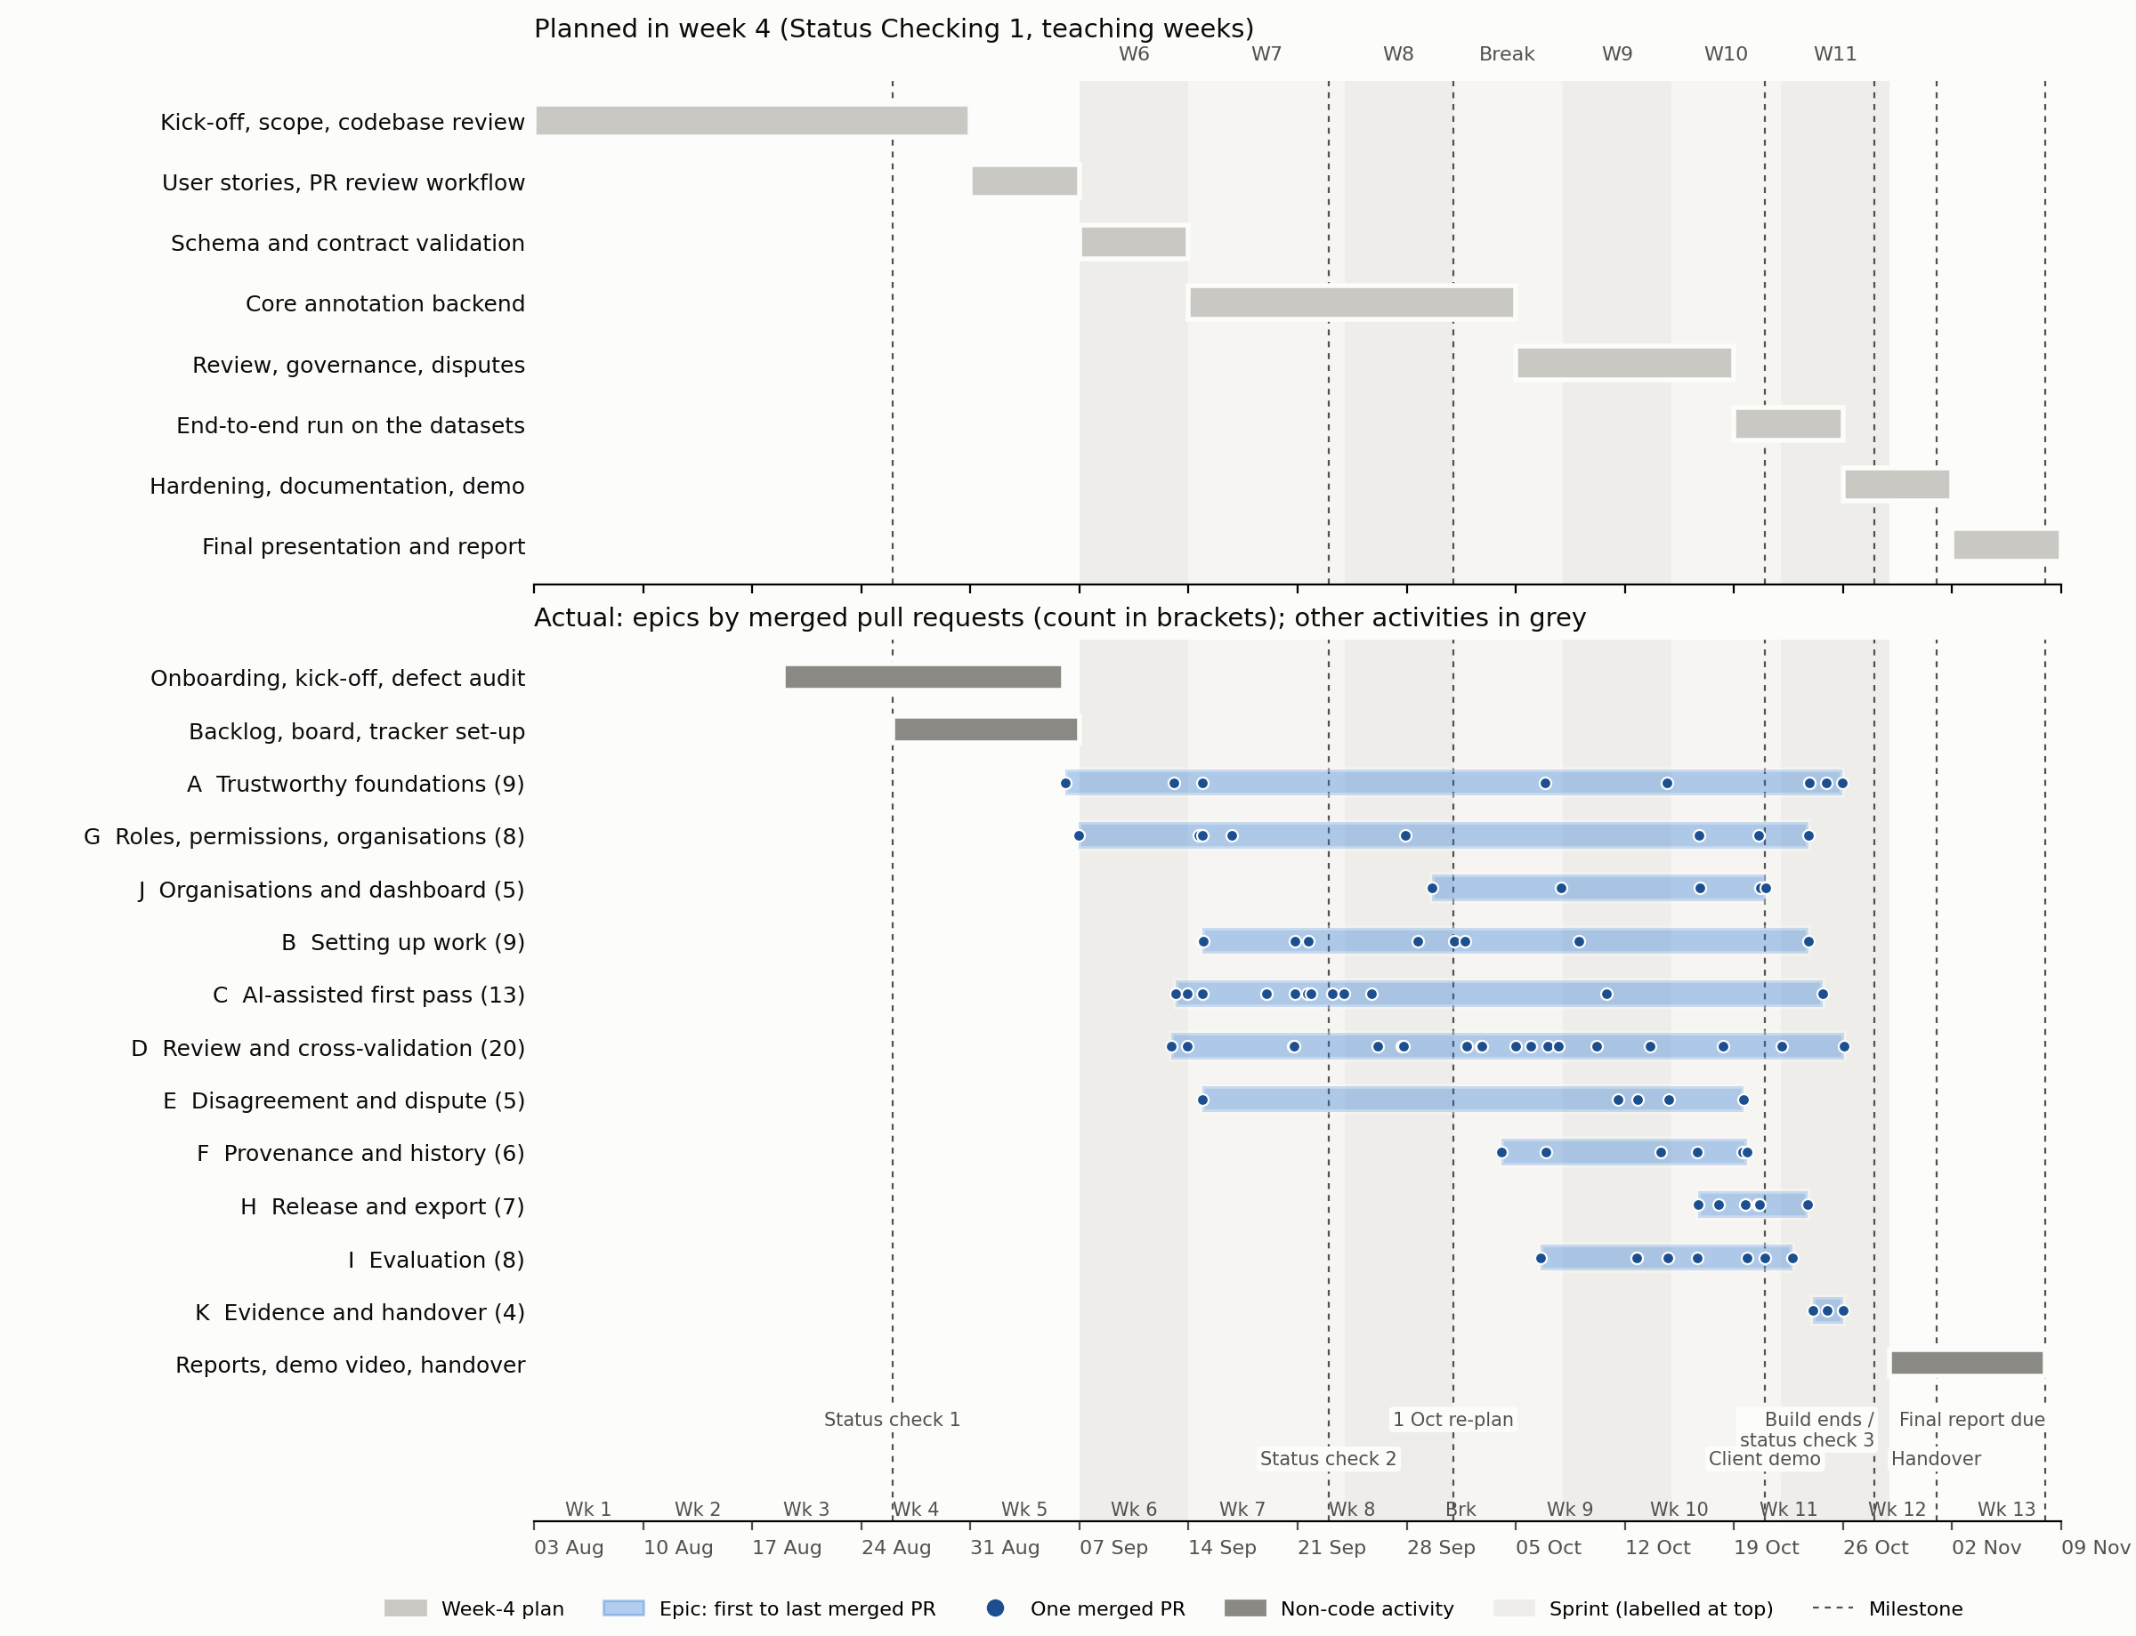
Figure 1. Planned (Week 4) and actual timeline. Top: the Week-4 plan by teaching week. Bottom: each epic from its first to its last merged pull request, one dot per merge (a pull request touching several epics appears in each), with non-code activities in grey; sprints are shaded and milestones dashed.
The fixed dates held: the status checks, the proposal and the progress report were delivered in their weeks, and build work ended on 28 October as re-planned. Within those dates the order changed: core annotation and governance work started in Week 6, one to four weeks early, and ran in parallel rather than as planned phases, while provenance, release and evaluation, added after Week 4, were compressed into the break and Weeks 9–11.
Table 7. Deviations from the Week-4 plan and their reasons
Planned (Week 4) | Actual | Reason and effect
Week 6: separate schema and contract validation | Replaced; each mismatch fixed inside the story that needed it | A standalone review would have found faults without the use that tests them; contract fixes shipped with their tests
Weeks 7–8: core backend; Weeks 9–10: review, governance, disputes | Both began in W6 and ran in parallel; disputes finished in W9–W10 | The client's defect policy put governance faults on the critical path at once; dispute work paused about a week (3–9 Oct) on an open question
Not planned: provenance, versioned guidelines, gated releases, evaluation | Added at Status Checking 2; built from the break to W11 | The brief and client answers confirmed them as required; they became the heaviest weeks
Provenance record in W11 (plan of 24 Sep) | Moved to W9 on 1 Oct; merged 16 Oct | The W10 release gate must read provenance; the earlier order could not finish
Evaluation harness late in the semester | Break sprint (1–7 Oct), with no other feature work planned | Status Checking 2 found evaluation at zero; the break gave it a week clear of feature work
Week 11: end-to-end run on the datasets as one event | Continuous: seeded projects and casebook cases on real AG News and Civil Comments records | Intake (B7) was brought forward to W8, so real records were available from October
Week 12: hardening, documentation, demo | W11 made the last build sprint; 29 Oct–1 Nov for reports and the demonstration | Re-plan of 1 Oct: no sprint after 28 Oct, so W11 was kept light to absorb carry-over
Stories K1–K4 (evidence and handover) | Set aside 14 Sep, reopened 25 Oct and completed by 26 Oct | Delivery of the platform came first; the ADRs and the findings record were written during the build, leaving the handover sweep and the demonstration
59 stories at the start | 63 stories, all complete | Client answers (24 Sep) added B7, B8, D9; profiling added A6 (4 Oct)

Delivery was steady but uneven: W8 merged 7 pull requests while large reviews were open and the break merged 15 as that queue cleared. The last pull request merged on 26 October, two days before build work ended, so nothing was carried over.

Results
This chapter describes the prototype (Section 7.1), the six pillars with the rules the server enforces (Section 7.2), the quantitative results (Section 7.3) and an answer to each project question (Section 7.4). Unless a source is named, every figure was measured by the team on 26 October 2026 on main of USYD-CS-Capstone/hej at commit 6951781, in a clean checkout on Windows 11 (Python 3.14.7, Node 22.23.2). Tests ran on in-memory SQLite and screenshots were taken from the running application on a freshly seeded database. No live model was called: AI answers came from the casebook's scripted client and from model replies recorded earlier and committed to the repository.

The prototype system
What was built. Hej is a web platform in which an organisation runs annotation projects whose output it can defend. Its architecture is shown in Figure 2. People work through a Next.js web application, which calls a FastAPI service over JSON with a bearer token. The service is a modular monolith: the routes for each pillar call a shared service layer, and every governance rule (who may act, on what, and when) is checked there rather than in the browser. Data is held in PostgreSQL 18 in CI and production configuration, with SQLite as an explicit fallback for local work. AI suggestions are produced either inline when a task is activated or by a separate worker process that claims queued items, and every provider is reached through one typed interface, JsonCompletionClient (the stack is listed in Section 5.1). The evaluation harness sits beside the API: it drives the real routes in process and can open any database read-only to check its integrity; continuous integration is described in Section 4.5.
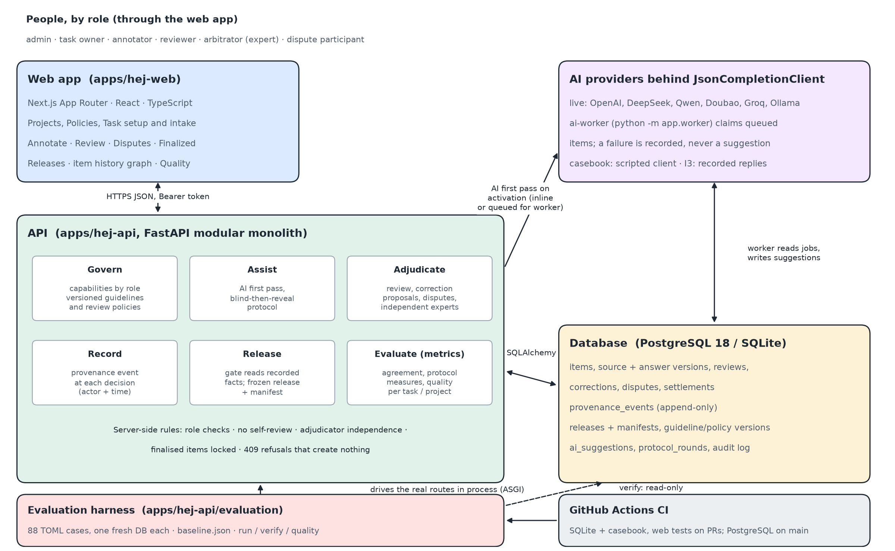
Figure 2. Architecture of the Hej prototype. The six pillars are services inside one API; the evaluation harness drives the same routes in process and checks any database read-only.
What it does, end to end. A task owner creates a project under one of four governance postures (Standard, Dual sign-off, Expert-gated, Arbitration-ready), creates a task with its own labels and guideline, and registers items, for example from a JSON Lines file with one source record per item. On activation the task runs human-first or AI-first. Annotators take items from self-served queues; reviewers accept, adjust, reject or escalate; a split between reviewers is held, settled by an independent reviewer or opened as a dispute, depending on the posture; an expert decides disputes and, under the Expert Gate, confirms every item. A finalised item has one authoritative answer or is resolved as ambiguous, and a release freezes a task's finalised items with a manifest.
How it was shown to the client. The client saw the working application at the weekly meetings; on 21 October, for example, the team demonstrated "who decides", "what gets released" and "what we can measure" live on seeded databases. That feedback changed the product: after the client observed that an administrator may lack the domain expertise to judge the work, administrators lost every judging capability (ADR 023), and cases EV-131 and EV-132 now prove that administrators and task owners can run and release work but cannot judge it.

Results by pillar

Govern
Six organisation roles (admin, task owner, annotator, reviewer, arbitrator, who acts as the expert, and dispute participant) map onto nine capabilities grouped by the authority they need: governing, configuring, overseeing, releasing and the four judging capabilities (annotate, review, dispute, adjudicate). Administrators and task owners configure, oversee and release but cannot judge (ADR 023). Guidelines and review policies are versioned: an edit creates a new version, new work follows it, and each answer records the versions it was given under (ADR 018). Each project's overview states the rules in force in plain language rather than as configuration flags.
The rules are enforced by the API, not by hiding buttons: in the walkthrough, an annotator who opened an item's Review tab received the server's refusal for want of the reviewer role. Permission suites call the routes as real users, and casebook cases prove each refusal end to end (Section 7.3.1).

Assist
AI assistance has two production modes, human-first and AI-first, and one evaluation protocol, blind-then-reveal, kept as a separate task setting on the client's instruction (ADR 016). In AI-first mode the model's answer is submitted as the item's first answer under the model's own identity (provider, model and the version the provider reports), never under a person's account, and goes to an ordinary human review (ADR 009). A failed model call is recorded as an AI failure and never turned into a suggestion; this closed inherited defect 20, and cases EV-002 and EV-107 prove it.
Under blind-then-reveal (Figure 3) an annotator commits a verdict, a confidence and a rationale before the AI's suggestion can be seen; the blind verdict is then locked. The suggestion lives in its own table that no other read of answers can reach, so it is withheld by construction; a test sweeps every GET route as every role and finds no part of it before the reveal. The final answer is an ordinary submission that is reviewed and released like any other, so the three stages (blind verdict, AI suggestion, final answer) remain distinct records.
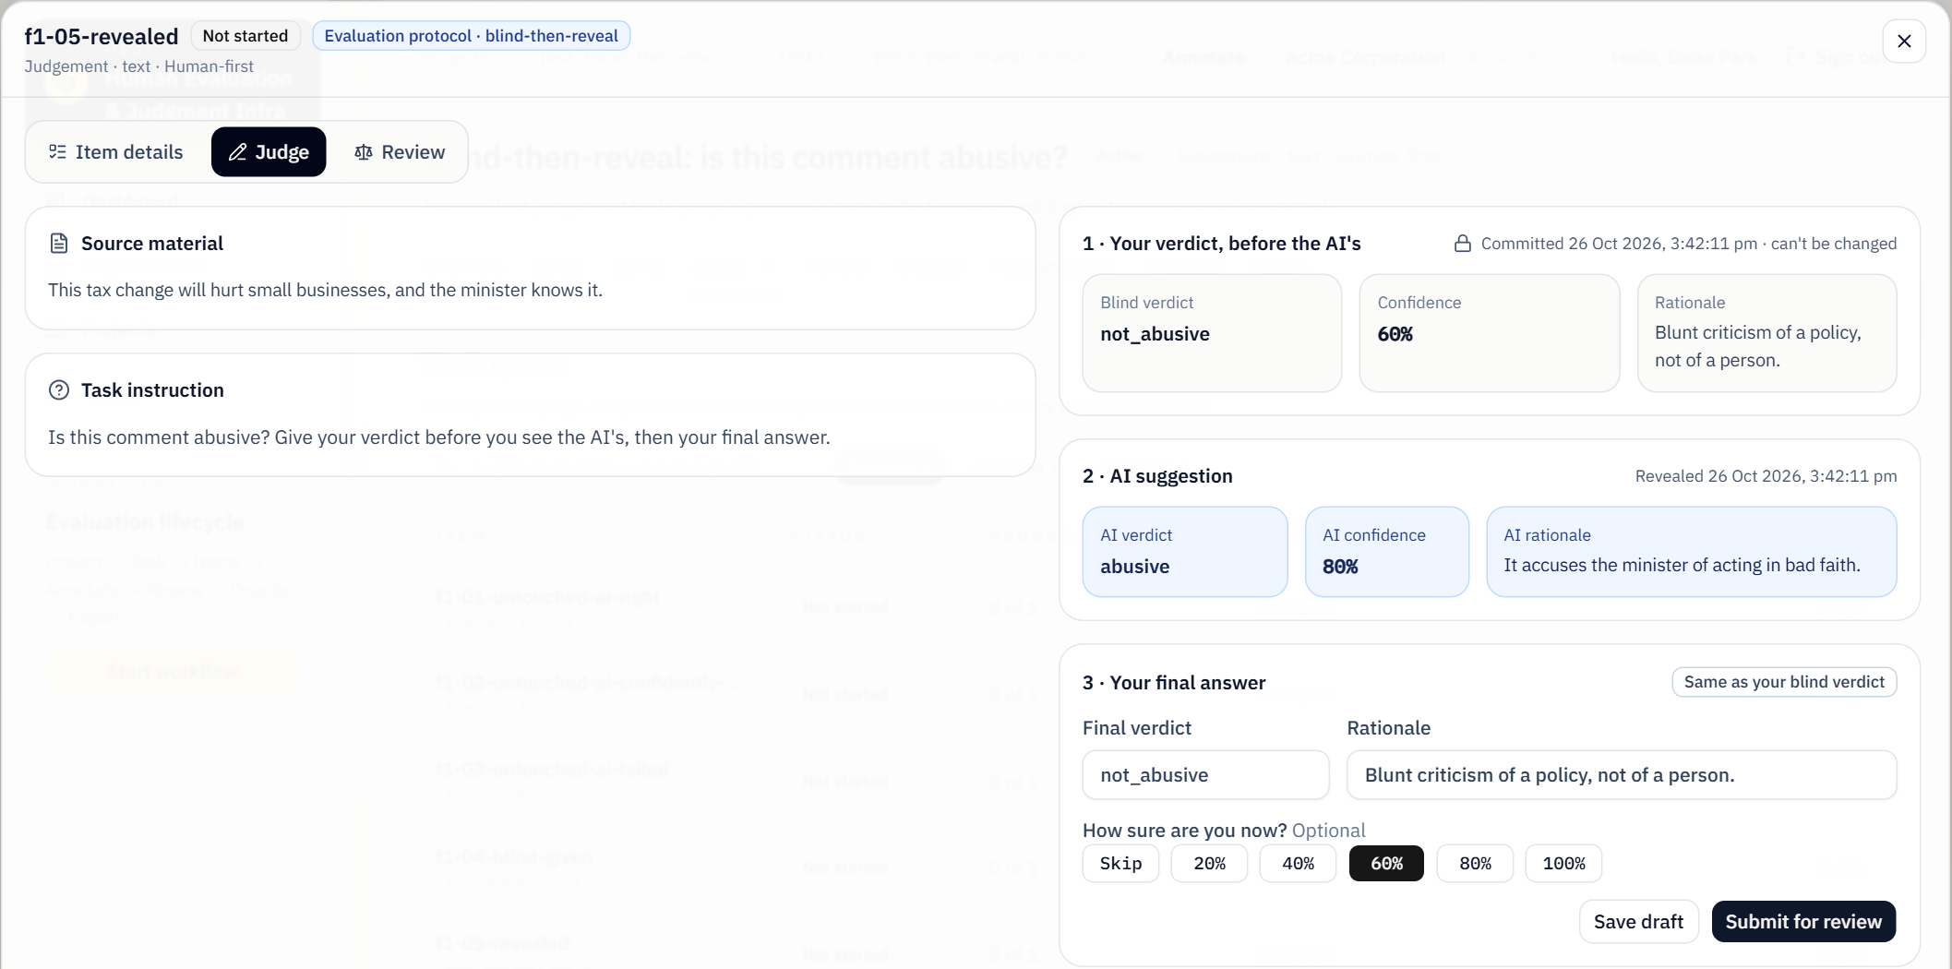
Figure 3. The blind-then-reveal protocol from the annotator's side. Stage 1 (the blind verdict) is committed and locked before stage 2 (the AI's suggestion) is revealed; stage 3 is the final answer.

Record
Provenance is written at the moment of each decision, not rebuilt from logs. An event is added to provenance_events inside the same transaction as the decision, from source registration through review, dispute, adjudication, settlement and reopening to release (ADR 015). Each event names its actor as a person, an AI model or the platform, and database triggers on SQLite and PostgreSQL refuse any update or deletion. Figure 4 shows the history graph of a real AG News record, ag_news:train:0150, after the walkthrough: the task owner registered the source, an annotator answered "World", one reviewer accepted and another rejected, the platform itself opened a dispute because the reviewers disagreed, and an expert accepted the answer with a written justification.
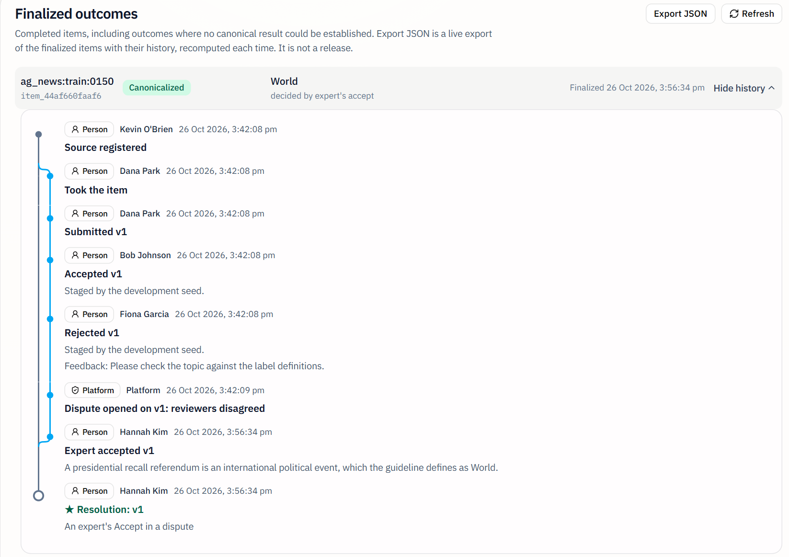
Figure 4. History graph of a finalised AG News item. Each step carries its actor kind (person or platform), the person's name and the time; the expert's justification is part of the record.

Adjudicate
The platform keeps the annotator's label, the reviewer's decision and the expert's resolution as separate records. A reviewer's correction is a proposal: it is stored as the reviewer's own version beside the answer, is never counted as a submission or an approval, and becomes the answer only if the annotator adopts it in a resubmission (which is reviewed again) or an expert accepts it in a dispute (ADR 012). The annotator sees it as "a suggestion to consider", while their own answer stays as submitted.
Disagreement is handled at two levels: a dispute concerns one submitted answer and its reviews (ADR 013), and a reconciliation chooses between several accepted answers, which the Expert Gate reuses to require an expert's confirmation of every item (ADR 017). One shared server rule enforces independence: nobody may adjudicate an item they annotated, reviewed, corrected, disputed or routed, administrators included, and the check returns 403 before any write (ADR 011). Under Standard and Dual sign-off a held split may instead be settled by an independent reviewer; under Arbitration-ready and the Expert Gate it must go to an expert (ADR 022). An expert's decision (Accept, Return or Reject) is final, and an item may be resolved as ambiguous. Figure 5 shows the expert's view of the platform-opened dispute traced in Figure 4, with both reviewers' decisions and justifications beside the disputed answer.
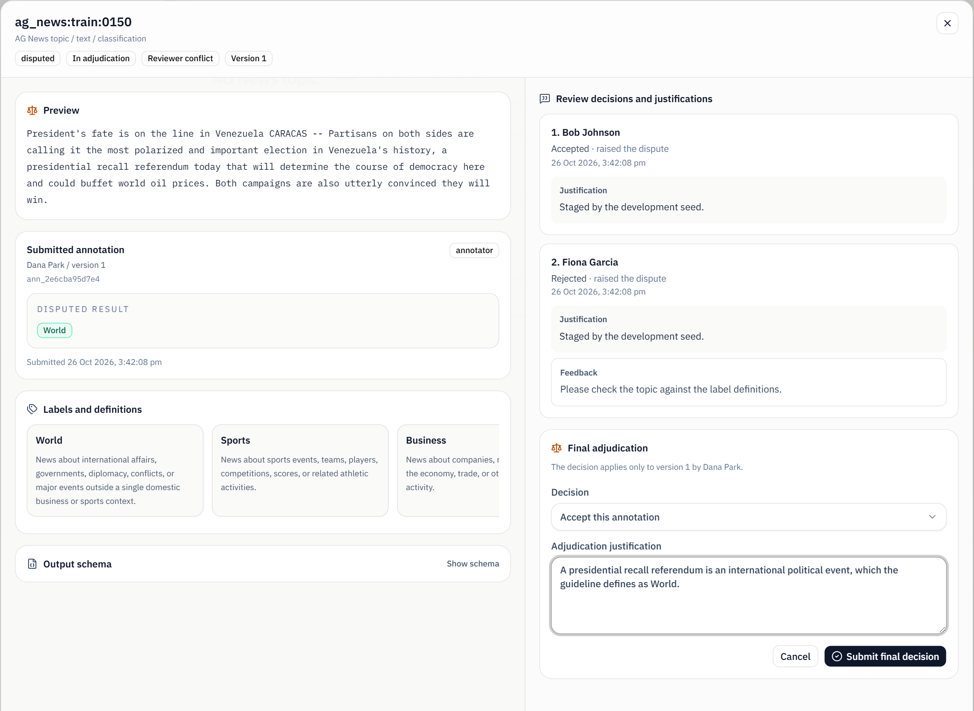
Figure 5. An expert adjudicating a dispute the platform opened when two reviewers disagreed, on a real AG News record. The decision applies to one named answer version and needs a justification.

Release
A release is gated before it exists. The gate reads only recorded facts and refuses for five reasons: an item not finalised (unreviewed), an open dispute or held disagreement (disputed), an answer superseded by later work (superseded), a finalised item with no authoritative answer (no_authoritative_answer), and a decision with no provenance event (incomplete_provenance). A refusal is an HTTP 409 that lists every failing item once with all its reasons and creates nothing (ADR 020). Figure 6 shows the refusal the task owner received when releasing a task in which nine of twelve items were still in work.
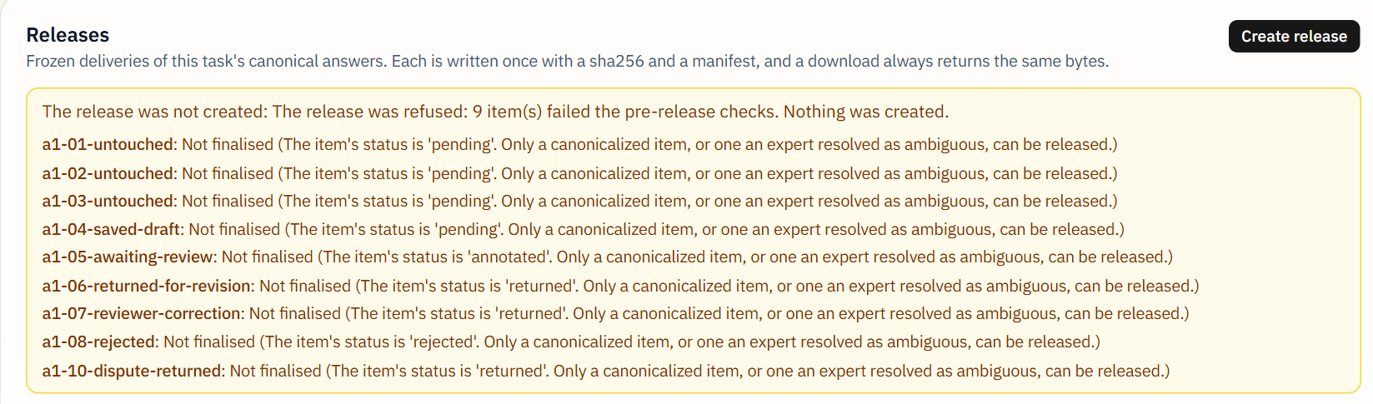
Figure 6. A refused release. The gate lists each failing item with its reason; no release, artefact or event was created.
A release that passes is frozen: its artefact (JSON Lines, one line per authoritative answer) and its manifest are written once, each with its SHA-256 hash, and every later download returns the same bytes. The manifest lists every item with its resolution, the guideline and policy versions in force, and its chain of provenance event identifiers, so anyone holding the two files can check the release with standard tools and without the platform (ADR 021). Figure 7 shows the release created during the walkthrough on the seeded completed task: three authoritative items, and three checks shown by the application, namely that the artefact and the manifest each hash to their recorded value and that the artefact agrees with its manifest line by line.
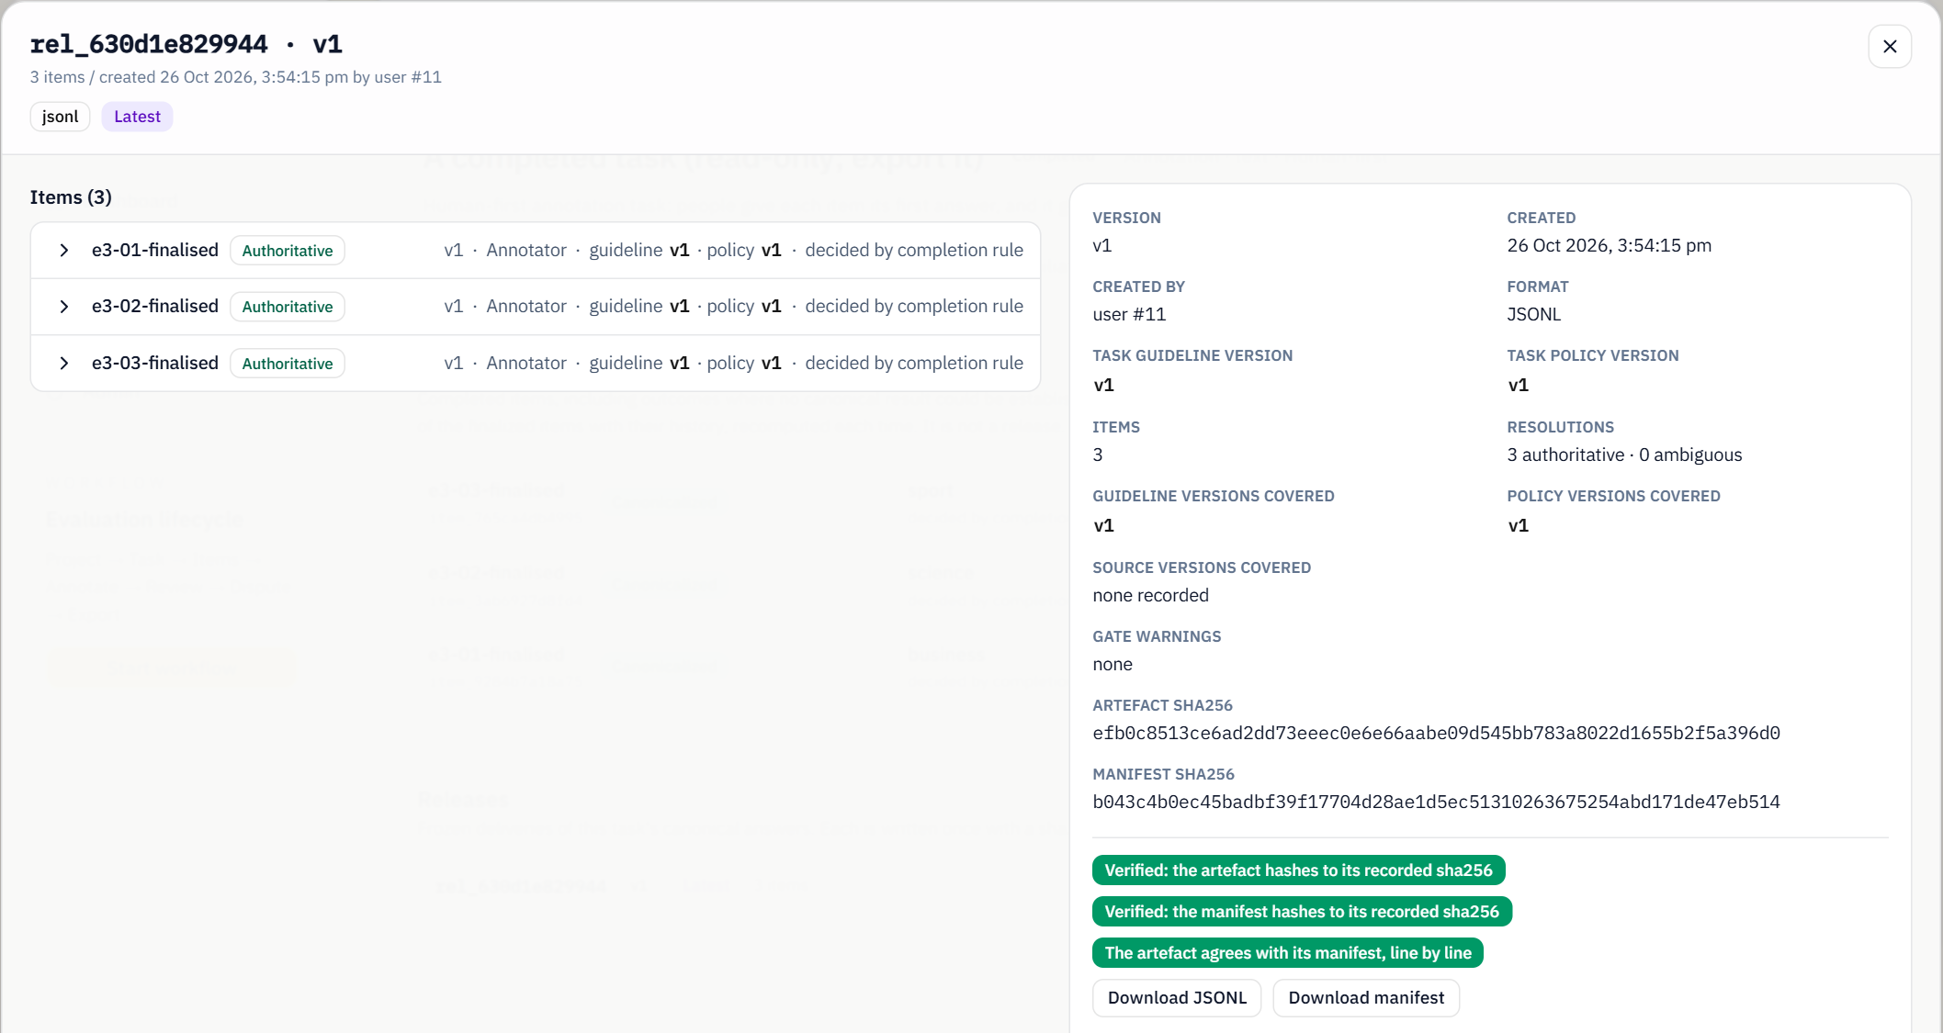
Figure 7. A frozen release and its manifest. Hashes and versions are recorded at creation; the application shows the three checks.
The manifest in Figure 7 reports "source versions covered: none recorded" because this task was seeded as already completed; tasks registered through intake record a source version on every answer, and the manual run reported in Section 7.4 carries one.

Evaluate
The evaluation harness (Sections 4.3 and 4.5) gives the client three instruments: a casebook of end-to-end cases compared with a committed baseline, a quality command that replays a recorded model run through the platform and scores it against gold labels that never enter the platform (ADR 019), and a verify command that checks any database's record of roles, provenance and releases without trusting the API. Their results follow in Section 7.3.

Quantitative results

Tests and casebook
Table 8 lists the automated checks run on 26 October; every one passed. These are the report's reference figures for testing (the README on main still shows older counts from 23 October).
Table 8. Automated checks on main at 6951781, 26 October 2026
Check (command) | Result
Backend suite, SQLite (uv run --locked pytest -q -n auto, 154 test files) | 2,495 passed, 62 skipped (PostgreSQL-only), 188 subtests passed; 140.5 s
Casebook against the committed baseline (evaluation run --baseline evaluation/baseline.json --exact) | 88 cases: 87 passed, 0 failed, 1 skipped (EV-018); all 88 verdicts unchanged; exit 0
Coverage (evaluation list --coverage) | 9 of 9 adversarial categories have a case, 8 of 9 have one that runs; 16 of 16 owed protections covered; exit 0
Web suite (npm run test:web, Vitest) | 110 files, 1,050 tests passed; 29.3 s
Integrity check of the seeded database (evaluation verify) | 20 tasks checked (provenance, releases, roles): nothing found; the same after the walkthrough's adjudications and release

The brief asked for 40 to 60 cases; the casebook holds 88, of which 23 sit in the brief's nine adversarial categories and the rest cover the ordinary workflow, policies and regressions. The one skipped case, EV-018, waits for source versions that can change; since a skipped case proves nothing, coverage counts runnable cases separately. The 16 "owed protections" are the eleven defects and five story criteria the casebook committed to cover.

Model quality and agreement
To measure real models, two models answered the 400 AG News and Civil Comments records once and their replies were committed (ADR 019). Table 9 gives the figures re-computed on 26 October by replaying the recordings through the platform as AI-first tasks, each answer accepted by a scripted reviewer and scored against gold.
Table 9. Recorded-model quality against gold labels (one recorded run per model; replayed 26 October 2026)
Model | Dataset (records) | Accuracy | Macro-F1 | ECE (5 bins) | Brier | Recall on the hardest class
llama3 (Ollama) | AG News (200) | 84.5% (169/200) | 0.845 | 0.008 (0.043 by stated value) | 0.125 | Sci/Tech 0.74
llama3 (Ollama) | Civil Comments (200) | 65.5% (131/200) | 0.620 | 0.270 | 0.283 | abusive 0.35
DeepSeek V4.1 Flash | AG News (200) | 92.5% (185/200) | 0.925 | 0.040 | 0.069 | Sci/Tech 0.86
DeepSeek V4.1 Flash | Civil Comments (199 answered, 1 failed) | 69.8% (139/199) | 0.682 | 0.225 | 0.236 | abusive 0.47

The figures agree with the team's findings record, and the committed 28-record subsets reproduce the pipeline from the repository alone (llama3: 89.3% on AG News and 57.1% on Civil Comments; DeepSeek: 96.4% and 71.4%). Two results matter most. First, both models are good at news topics and poor at moderation: they miss most abusive comments (recall 0.35 and 0.47) while stating confidence of 0.8 or more, so their confidence is not evidence that a human review can be skipped on that task. Second, the five-bin calibration error flatters llama3 on AG News (0.008), because the model only ever states 0.8, 0.9 or 1.0 and every answer falls into one bin; computed per stated value it is 0.043. One DeepSeek reply of 400 was malformed JSON and was correctly recorded as a failure, not an answer.
The agreement coefficients and blind-then-reveal measures were exercised on the casebook's scripted people: reviewer kappa was computed in 10 cases and annotator alpha in 9, and in six more the coefficient was reported as undefined with its reason rather than as 0 or 1. Their values are fixed by the scripts, and the harness labels them "a pipeline demonstration, not a finding": they show that the stages are recorded and the arithmetic is right, not how real annotators behave.

Integrity checks
On the seeded database verify found nothing in 20 tasks, before and after the walkthrough added two expert decisions and a release. Tamper cases show the checks bite: each alters an honest run past the API and the check names the item, whether a review event deleted with the database owner's rights (EV-117), an approval by someone without the role (EV-119), a self-review (EV-120), a changed author (EV-121) or a deleted release event (EV-123); without the owner's rights the database refuses the deletion (EV-118). All passed.

Performance (story A6)
On 4 October a team investigation found that opening the Annotate page of a 200-item task sent 404 API requests and ran 6,882 SQL statements, taking 2,969 ms on a PostgreSQL 18 test bed. No single statement was slow; the page fetched each item's drafts separately, twice, and every read of the item list ran a repair that wrote to the database. Story A6 replaced the per-item reads with one batched read (PR #54: from 405 requests and 3,390 ms to 7 requests and 571 ms on the bed at that date) and made reads never write (PR #98: the item-list read fell from 26 to 16 statements, and a project page from 13 requests to 6). The request count no longer grows with the task: on main at 6951781 the running application sent 15 API requests per Annotate-page load for both a 12-item and a 42-item task.

Inherited defects
Table 10 summarises how the 30 inherited defects, six of them Critical, were closed, each inside the story whose feature depended on it.
Table 10. The 30 inherited defects and how they were closed ("case" is a casebook case that fails on the old behaviour)
# | Defect | Severity | Closed by (story; evidence)
2 | Finalised annotation silently overwritten | Critical | D5; PR #19, case EV-041
4 | Finalised item exports conflicting answers | Critical | H4; PR #66, cases EV-068, EV-069
5 | Reviewer corrections not saved | Critical | D3; PR #58, case EV-070
6 | Drafts have no ownership enforcement | Critical | D6; case EV-027
7 | Annotators can approve their own work | Critical | D1; PRs #45, #53; cases EV-001, 021–023, 063, 115, 124
8 | Legacy review API rewrites approval history | Critical | D2; routes retired (#6) and removed (#102); unit tests
3, 9, 10 | Wrong annotator's work shown to reviewer; cross-project write bypass; invalid statuses saved | High | D4, G3, G4; PRs #34, #14, #9; case EV-046
11, 16, 29 | Non-atomic submission and registration; intake conflict as server error | High / Medium | D5, B5; PRs #23, #11, #9; cases EV-047, EV-048
15, 20 | Dispute send-back missing; AI failure produced fake annotations | High | E2, C3; cases EV-040, EV-061, EV-002, EV-107
17, 18 | Invitations broken; pending invitations unreachable | High | G5; PR #16
19, 27, 28, 30 | Completion and export disagree; impossible status in export rule; task stuck in draft; undeletable task or project | High / Low / Medium | B6, B4; one eligibility rule; PR #41 task lifecycle
12–14, 25, 26 | Frontend typecheck and test failures; export tests not running; vacuous or misleading tests | High / Low | A2; commit e0e642ac (PR #2); tests re-run 26 Oct
21, 22 | Audit actor always "user"; duplicated escalation entries | Medium | F4; PRs #57, #68
23, 24 | .env ignored; database reset broken | Medium / High | A3; PR #10
1 | Live API key hardcoded in source | Medium | A4; key removed from code; provider refuses it (HTTP 401)

All 30 are closed on main, the six Critical ones included; the last Critical defect, number 4, closed with PR #66 on 16 October. Two closures deserve a word. Defects 25 and 26, a frontend test that did not test what it claimed and a misleading backend test set-up, were fixed in the test-suite restoration (story A2, commit e0e642ac, merged in PR #2), and their tests pass on main at 6951781. For defect 1, the Gemini key was removed from the code in September, and a provider check on 26 October found that the Gemini API refuses the committed key (HTTP 401), so it no longer grants access, although it remains in the repository's history.

Delivery
All 63 user stories in the eleven epics are complete, and all 104 Jira tickets are Done. GitHub lists 95 merged pull requests and none open (26 October). Of the 95, 83 carry a formal GitHub review by a member other than the author, and 93 have a non-author review when reviews recorded in the contribution tracker are counted; the remaining two (#3 and #15) merged main into personal branches. Because main is not branch-protected, review was a team rule rather than a setting GitHub enforced (Section 4.1.3). The repository holds 25 ADRs and a findings record that reports negative results alongside positive ones.

Expected outcomes
Table 11 sets the outcomes agreed with the client in week 4, and those added afterwards, against what was delivered. The team's final status check rates all of them achieved; the last column gives the basis.
Table 11. Expected outcomes and their status at the end of the build (week 11)
Expected outcome | Status | Evidence
1. A functional, integrated platform running the end-to-end workflow | Achieved | Setup to release through the web and API (Sections 7.1–7.2)
2. Clear interfaces between components, open to extension | Achieved | One typed model interface for six providers; per-task output schemas checked on submission; four media types
3. A governance framework that supports the workflow reliably | Achieved | Six roles, nine capabilities, four postures; server-side refusals proven by cases
4. The workflow demonstrated on the provided dataset | Achieved on the agreed text path | Seeded projects on real AG News and Civil Comments records; EV-100, EV-101
5. Supported by appropriate documentation | Achieved | 25 ADRs, findings record with negative results, setup runbooks, handover ticket map
Added: provenance captured at each decision | Achieved | Append-only events; versions on every answer (Figure 4)
Added: immutable, gated releases with manifests | Achieved | Five-reason gate; rebuildable manifest (Figures 6–7, EV-122)
Added: evaluation harness and a casebook of 40–60 cases | Achieved, exceeded | 88 cases with CI baseline; quality and integrity checks

Answers to the project questions
RQ1 — Traceability: answered yes, for work done since the provenance record existed. Every decision writes an event in its own transaction, naming a person, model or platform actor and a time, and the database refuses to change one (ADR 015); each answer records its source, guideline and policy versions (ADR 018), and an AI answer its model and version (ADR 009). EV-101 carries a real AG News record from intake through review, cross-review, dispute and adjudication to a release and reads every stage back from it; verify found every released item's history complete on the seeded database. The answer has a stated boundary: work created before the event record went live on 16 October has no events and is exempt from the completeness check by team decision (ADR 020, decision 3), and source versions are recorded but cannot yet change.
RQ2 — Gated and checkable release: answered yes. The gate refuses for five reasons, each read from a recorded fact; no request field lets an operator declare an item reviewed, and a refusal creates nothing (Figure 6; EV-015, EV-016, EV-017). A passing release is frozen with a manifest from which anyone can rebuild it byte for byte (EV-122), and tampering with the record afterwards is detected (EV-117 to EV-123). One condition was deliberately softened: an answer given under a guideline or policy version that has since been replaced produces a warning, not a refusal, because refusing would block every task whose guideline changed during the work (ADR 020, decision 2).
RQ3 — Governed judgement: answered yes. The server refuses self-approval, self-settlement and self-adjudication, administrators included, through one shared independence rule applied both to the queues and to the decision itself (ADR 011, ADR 022); administrators and task owners hold no judging capability (ADR 023, EV-131, EV-132). Annotator answers, reviewer corrections and expert resolutions are separate records with their own authors, and a correction never becomes the answer without a second person (ADR 012). The six Critical defects, four of which were failures of exactly these rules (defects 2, 5, 6 and 7), are closed with regression cases.
RQ4 — Measured AI assistance: answered yes for the platform's capability; the human effect remains unmeasured. Every provider sits behind one typed interface, interchangeable with the scripted client and with recorded replies, and a failure is never presented as a suggestion (EV-002, EV-107). Model quality was measured on all 400 client records for two models, with accuracy, macro-F1, ECE and Brier score (Table 9). The blind-then-reveal protocol records the blind verdict, the suggestion and the final answer as distinct stages and computes anchoring, automation bias, benefit and correctness change. These people-side measures have so far been computed only on scripted participants, so the project shows that the platform can measure the effect of AI on annotators, not what that effect is.
RQ5 — Proof rather than demonstration: answered yes, with one gap. The guarantees are backed by 88 end-to-end cases run through the real API with real roles and compared with a committed baseline in CI, with the test suites of Table 8; all 30 inherited defects were closed inside the stories that needed them, and all 63 stories were delivered in eight build weeks. The gap is the full journey in one automated run: the AI first pass (seven AI-assisted cases and the replay of 400 recorded replies) and the release (EV-100, EV-101) are proven separately, and no automated case takes an AI-first item to a release. The joined journey was run once by hand on 26 October on main at 6951781 (local SQLite): record 1 of the client's AG News file was imported into an AI-assisted task, DeepSeek Flash's recorded reply (Business, confidence 0.99) became its first answer, a reviewer accepted it, and the finalised item was exported and released (release rel_04cccad3788a), its manifest pointing to the item's chain of five provenance events. A manual run shows that the pieces join; it does not guard against regression.

Discussion
This chapter asks what the results mean for the client and for dataset consumers, how they address the gap identified in Section 2.1.6, what the negative results teach, and what the team's own design decisions cost.

Provenance captured at decision time
The literature reviewed in Chapter 2 agrees that a label's reliability depends on how it was produced (Sheng et al., 2008; Snow et al., 2008), and the accountability literature asks dataset creators to document that process (Gebru et al., 2021; Hutchinson et al., 2021). What it leaves open is where that documentation comes from. A datasheet written after the fact can only be as good as the records its author can find, and in the inherited platform those records were a generic activity log in which the actor was always "user" and corrections were not saved at all. The result for RQ1 changes the source of the evidence. Because each event is written inside the transaction of the decision it describes, an event cannot exist without its decision, and a decision cannot be committed without its event. Because the database refuses updates and deletions, the record cannot be quietly edited afterwards, and the casebook proves that a deletion with ordinary rights fails (EV-118) and that a deletion with the owner's rights is detected (EV-117).
For the client, documentation becomes a query rather than a writing task. The history graph in Figure 4 is drawn from the same events that a release manifest points to, so "how did this label get here?" has one answer, whether a task owner asks it on screen or a consumer asks it of a downloaded release. The record also separates kinds of agency, as the W3C PROV model recommends (Moreau & Missier, 2013): the dispute in Figure 4 was opened by the platform applying the project's rule, not by a person, and a model's answer belongs to the model and its version. When a dataset is questioned, "the platform applied the policy in force" and "a reviewer chose to escalate" call for different remedies.
The cost is that history cannot be reconstructed for earlier work. The team chose not to fabricate events for work from before 16 October and exempted it from the release check (ADR 020): backfilled events would look like evidence but be inferred, exactly what the brief's "captured as it happens, not reconstructed afterwards" rules out. The exemption is keyed to each item's earliest event, not a date in code, so it cannot silently widen.

Release gates that cannot be satisfied by assertion
Most annotation tools treat export as a view of current data, and several consolidate several workers' answers into one label (Amazon Web Services, n.d.-a), which is efficient but discards who disagreed and why. The inherited Hej did the same: "export" was a status computed on the fly, and a finalised item could export conflicting answers (defect 4). The result for RQ2 is significant less because a release can be refused than because of what the refusal is based on. Each of the five reasons is computed from rows the workflow itself wrote: the item's status, open dispute and disagreement records, answer versions and provenance events. There is no field through which an operator can declare that review has happened, so the only way to make a release pass is to do the work that the gate checks for. In governance terms, this applies the principle of complete mediation (Saltzer & Schroeder, 1975) to the dataset itself: a release is checked against the record at the moment it is made, not trusted because of earlier steps.
The manifest extends that trust beyond the platform: a consumer, auditor or regulator holding a release and its manifest can recompute the hashes and check every line without access to Hej (EV-122). Article 10 of the EU AI Act asks for data governance covering the origin of data and labelling (Regulation (EU) 2024/1689, 2024), and a manifest naming, per item, the versions in force and the chain of decisions is the kind of evidence such governance needs; no legal compliance is claimed.
The gate also makes a trade-off visible. Treating an answer under a superseded guideline as a warning (ADR 020) lets a release mix guideline versions; the alternative would block every long-running task whose guideline was revised, and because the manifest lists each item's versions, the judgement about mixed versions moves to the consumer with the evidence attached.

Independence and the separation of roles
Separation of duties and least privilege are long-established access-control principles (Sandhu et al., 1996; Saltzer & Schroeder, 1975). The inherited code had role checks but did not apply them to the relationships that matter in annotation: an annotator could approve their own work (defect 7), drafts had no owner (defect 6), and the team's review of 13 September found that an administrator could escalate and then finalise their own item. The result for RQ3 is that independence is defined by participation, not by role. The same rule, which asks whether a person annotated, reviewed, corrected, disputed or routed the item, is used by the queues to decide what to offer and by the decision routes to refuse, so a person cannot reach a forbidden decision by a different screen or by calling the API directly. Because the team chose not to assign work to named people (Section 8.6), independence could not be encoded as "the assigned reviewer"; it had to be a property of every query, and the casebook tests it from both sides.
Treating a reviewer's correction as a proposal rather than an edit is the clearest example of keeping roles distinct. A reviewer who rewrites an answer is acting as a second annotator whom nobody reviews. Under ADR 012 the correction is recorded as the reviewer's own version and becomes the answer only through a second person, either the annotator who adopts it (and whose resubmission is reviewed again) or an independent expert. This keeps the three contributions the brief distinguishes (annotator's label, reviewer's decision, canonical judgement) as three records, and it keeps disagreement as data, in line with the argument that disagreement often reflects real ambiguity rather than error (Aroyo & Welty, 2015; Plank, 2022): an expert may resolve an item as ambiguous, and the release lists it as such rather than forcing a winner.
With administrators and task owners unable to judge (ADR 023), every judgement on a released item was made by someone who held a judging role and was independent of the work, and verify can check that claim afterwards on any database.

Separating evaluation from production
The literature on AI assistance shows that suggestions change human answers, sometimes for the worse (Fort & Sagot, 2010; Parasuraman & Manzey, 2010), and that labels collected with assistance can inflate the measured performance of the model that assisted (Schroeder et al., 2025). A platform that only stores the final answer cannot tell an annotator who agreed with the AI from one who was persuaded by it. The blind-then-reveal protocol answers this by recording the annotator's own verdict before the suggestion is visible, which is the design Buçinca et al. (2021) found reduced over-reliance. The team's contribution is in how it is enforced: the suggestion is stored where no read of answers can reach it, so the protocol does not depend on every screen remembering to hide it, and a route sweep test checks that none does.
Keeping the protocol as a separate setting from the production mode, as the client asked, also separates two questions that are easily confused: how a dataset is produced and how the effect of AI on its producers is measured. A client can run production in AI-first mode for speed and run a blind-then-reveal task on a sample to estimate how much the suggestions move people. The recorded-model results show why that matters. Both models were confident and wrong on abusive comments, the class where review matters most (recall 0.35 and 0.47 at stated confidence of 0.8 or more). The calibration literature warns that model confidence is often miscalibrated (Guo et al., 2017), and these figures show it on the client's own data: on a moderation task, an AI-first workflow that let confident answers through with a light review would be likely to pass exactly the errors it most needed to catch. The platform does not skip review on confidence, and the findings record states this as a residual risk rather than a solved problem (Section 9.1).

The evaluation harness as a safety net for governance
Governance rules fail quietly: an independence check that stops applying after a refactor raises no error, it only makes a dataset less defensible than it claims. The casebook turns each rule into a case that must keep passing through the real API, and the committed baseline makes any change in a verdict visible in the pull request that caused it; a skip counts as a regression, so a rule cannot be hidden by switching its case off. The evaluation work also caught its own faults before merge, among them a replay that matched model replies to the wrong record when texts repeated, annotator agreement inflated by answers that were not independent, and a missing confidence stored as 0 (evaluation findings, §3). Each would have produced plausible but wrong figures.
The same discipline applied to the inherited defects. Closing each defect inside the story that needed it, with a test that fails on the old code, meant the team never had to choose between features and fixes, and the defects most damaging to the brief (overwritten finalised answers, unsaved corrections, self-approval, conflicting exports) were fixed in the stories that built the guarantees they had broken. The client's week-4 direction to prioritise features over a clean-up phase was thus compatible with closing all 30.

Decisions the team made when the client delegated
From early October the client asked the team to decide several open design questions itself rather than wait for answers. These decisions shaped the results and carry costs, which Table 12 makes explicit.
Table 12. Design decisions taken by the team, the alternative rejected and the cost accepted
Decision (record) | Alternative rejected | Why | Cost accepted
Work before the event record is exempt from the provenance check (ADR 020) | Backfill events, or refuse older work | Inferred events would be fabricated evidence | Early work released on weaker evidence
An answer under a superseded guideline or policy is a warning (ADR 020) | Refuse it | Refusal blocks any task whose guideline changed mid-work | A release may mix versions; the manifest says which
Two levels: disputes about one answer, reconciliation between accepted answers (ADR 013, 017) | One "escalation" for both | The inherited model let an expert accept one answer while finalising the whole item | Two record types to learn
A held split may be settled by an independent reviewer unless the posture requires an expert (ADR 022) | Always send splits to an expert | Makes the four postures differ, as the client's answer R2-8 asked | Settlement is a lighter check
No assignment: self-served, role-checked queues (client, 17 September) | Assign items to named people | The client's choice | Independence and load live in queue queries
History graph for finalised items, for task owners and administrators (story F5, narrowed) | A graph of every item for every role | Only complete histories, within the time available | Other roles and open items have no graph
A rejected AI first pass goes to a person; AI-assisted tasks have one annotator (team, 14 October) | Retry the model automatically | A person stays responsible for the replacement | No automatic second attempt

Every decision favours a record that can be checked over a workflow that is easier to use, consistent with the brief's statement that the goal is not faster annotation, and each is written down with its alternative and cost, so the client can reverse it knowing what it protected.

Significance for the client and for dataset consumers
For Arc Intelligence, the result is a platform whose central claim can be checked. The brief asked for a dataset that can say, for any item, how its label got there, and a platform that refuses to release when it cannot. Both properties are enforced in code, proven by cases on every change, and checkable on any database by a command that trusts only the stored record. The client can therefore promise its customers not that its annotators are careful, but that each delivered label carries a checked history.
For a dataset consumer, the significance lies in what arrives with the data: which items were decided by rule, by an expert or resolved as ambiguous, under which versions, through which chain of events. Section 2.1.6 identified the gap as a platform that captures provenance at the point of decision, keeps the roles distinct, enforces independence on the server and makes release conditional on the record; the results show that such a platform can be built on an existing workflow in one semester. They also mark the boundary of the contribution: a complete and checked record shows how a label was produced, not whether it is right. Careful processes still produce label errors (Northcutt et al., 2021), and the recorded-model results show where a careless use of AI would add them. The platform's contribution is to make those errors traceable and the process that produced them open to measurement.

Limitations and Future Works
The limitations concern the artefact, the evidence offered for it and the setting in which it was built. Each comes with future work tied to the code, case or story it concerns and a priority: P1 should precede production use, P2 strengthens a claim this report makes, P3 is an extension. Table 13 summarises them.

Limitations of the artefact
The AI first pass and the release are not yet joined in one automated run. The brief's first success criterion is the full journey on realistic data. EV-100 and EV-101 reach a release on a human-first task, the AI-assisted cases stop before release, and the demonstration video shows the two separately; the joined journey was run once by hand (Section 7.4), but a manual run is not a regression test. Future work (P1): one casebook case taking an AI-first task on a gold record through review, dispute, adjudication, release and verify; the harness already has every step.
Text is the only modality demonstrated end to end. As agreed at week 4, image, audio and video were kept working but not taken through the full set of guarantees. One gap was found in review on 24 October and confirmed in the code on main: on a judgement task over images, the default surface asks the AI for bounding boxes (app/core/annotation_types.py), but the web work panel offers a person only a verdict and a rationale, so the two sides answer different questions. Future work (P2): decide whether a person on such a task draws boxes or judges the AI's boxes, align the schema preset and the panel, and add one casebook case per modality that reaches a release.
Source versions are recorded but cannot change. Every answer records the source version it was made on, but intake always writes version 1 and nothing registers a new version, so EV-018 ("a new source version does not rewrite or reopen a finalised answer") is the casebook's only skipped case and the source_changed adversarial category has no running case. Future work (P2): add source re-registration that creates a new version, let the task owner decide whether affected items are reopened (the decision EV-018 already assumes), and un-skip EV-018.
Work before 16 October is exempt from the provenance check, and early releases cannot be rebuilt. This is a deliberate limit (Section 8.1), but older databases verify on weaker evidence and pre-manifest releases cannot be rebuilt. Future work (P3): mark exempt items in each manifest, and start production from a fresh database so the exemption never applies.
Roles are organisation-wide. Project-scoped role assignments exist in the data model but grant nothing, so nobody can be a reviewer on one project only. Future work (P2): honour project-scoped grants in the capability check and in verify together, so platform and auditor keep one definition of authority.
There is no assignment of work, by design. Self-served queues keep independence in the queries but cannot balance load or direct a hard item to a particular expert. Future work (P3): optional assignment as a filter on the existing queues, so it can only narrow what the independence rules allow.
No extra check is forced where the model is known to be confidently wrong. Every AI answer is reviewed (EV-110 shows a confidently wrong suggestion caught in review), but nothing raises the review requirement where recorded results show the model to be unreliable, as on Civil Comments. Future work (P2): a policy rule requiring dual sign-off or the Expert Gate for AI-first answers when measured recall or calibration falls below a threshold.
Smaller known gaps. A correction to a bare multi-label answer is stored as text rather than in the multi-label shape. Future work (P3): fix the correction builder and add a case.

Limitations of the evidence
People in the evaluation are scripted. All agreement, human-accuracy and blind-then-reveal figures come from scripted participants, so RQ4 is answered for the platform's capability only. Future work (P1 for any claim about annotators): a small within-subject study on the seeded blind-then-reveal task with annotators outside the team, measuring how often a reveal turns a right blind verdict into a wrong final answer, reported with sample sizes.
One recorded run per model, on two text datasets. Each model's figures come from one recorded sample (re-recording the 56-record subset changed 10 answers), so no variance estimate exists and no provider was evaluated live at scale. Future work (P2): several recordings per model with bootstrap confidence intervals, and a scheduled live run outside CI.
No test drives a browser. The web tests run in CI on every ready pull request, but no automated test clicks through the running application, so faults in how screens and API fit together are found by people. The screenshots in Chapter 7 were taken by a browser automation script, which shows the journey can be driven this way. Future work (P1): a browser smoke test of log-in, answer, review, adjudication and release on the seeded database, run on merges to main.
Performance was measured for one user on one machine. The A6 measurements used one user at a time on a 200-item task with API and database on one machine; contention was not measured, and the dashboard's reads still grow with the number of projects. Future work (P2): a concurrent load test on PostgreSQL in a deployment-like configuration, with targets set before measuring.
An invalidated key remains in the history. The API key behind defect 1 was removed from the code and the provider now refuses it, but it is still readable in the repository's history, and the repository cannot show when it stopped working. Future work (P3): record the provider check in the findings record (a correction is pending), and treat any committed secret as compromised at once, revoking it rather than relying on its removal from the code.

Limitations of the setting
There is no production deployment. The platform has not been hosted for real users, and development databases are disposable: a schema change is applied by resetting and re-seeding, because the code creates tables but does not migrate data, which is acceptable for a prototype but not for a client's records. Future work (P1): versioned schema migrations before any production use, then a hosted deployment with backups and secret management.
Review before merge is held by team rule. main is not branch-protected, because protection was not available on the repository's GitHub plan, so the review recorded on 93 of the 95 merged pull requests (Section 4.1.3) was a team rule that GitHub did not enforce. Future work (P1): move the repository to a plan or organisation setting that allows protection, require the CI checks and one non-author approval, and forbid direct pushes.
Time and inherited debt. About eight build weeks, an inherited codebase with 30 defects and scope added after week 4 (provenance, gated releases, the evaluation harness) explain what was kept narrow (the history graph for finalised items only, text as the only end-to-end modality) and the late arrival of release work (16–20 October). The ADRs and findings record let the next team start from these choices rather than rediscover them.

Summary of future work
Table 13. Limitations and future work, by priority
Priority | Limitation | Future work
P1 | AI first pass and release not joined in one automated run | One casebook case from AI-first intake to a verified release
P1 | No production deployment; disposable databases | Versioned schema migrations, then hosted deployment
P1 | main not branch-protected | Required checks and non-author approval enforced by GitHub
P1 | No browser-driven test | Browser smoke test of the main journey on merges to main
P1 | Scripted participants only | Within-subject blind-then-reveal study with real annotators
P2 | Source versions cannot change | Source re-registration; un-skip EV-018
P2 | Text the only end-to-end modality; image judgement mismatch | Decide the image judgement surface; one case per modality to release
P2 | One recorded sample per model | Repeated recordings with confidence intervals; scheduled live runs
P2 | Single-user performance evidence | Concurrent load test on PostgreSQL
P2 | Roles organisation-wide | Honour project-scoped grants in API and verify
P2 | No stronger review where the model is known unreliable | Policy rule raising review on low measured recall or calibration
P3 | Pre-provenance work exempt | Mark exempt items in manifests; start production fresh
P3 | No assignment | Optional assignment as a filter on the existing queues
P3 | Multi-label correction shape | Fix the correction builder; add a case
P3 | Invalidated key still in history | Record the provider check; revoke committed secrets at once

The P1 items share one theme: each turns something demonstrated or asserted into something enforced, the same move the project made for datasets.

Acknowledgement of AI Use
The team used generative AI tools during the project, as the client's brief and the University's policy permit, under one rule: a tool may add capacity but never replaces judgement, and the member who submits AI-assisted work must be able to explain and defend every line of it without referring to the tool.
The tools used were Claude (including the Claude Code coding assistant) and ChatGPT. Members used them to clarify concepts and unfamiliar code, to suggest and check implementation and tests, and to improve the wording of documents. All code went through the same pull-request review by another member as hand-written code, and the casebook and test suites applied to it unchanged. The project manager also used Claude Code for:
- drafting and maintaining the specifications and the weekly plans;
- synchronising the board, the contribution tracker and the client-facing backlog;
- supporting code reviews by reading diffs and reproducing reported faults;
- drafting status reports and demonstration scripts.
Every output was checked against the code on main and edited before use.
This report was drafted with AI assistance. Drafts of its chapters were produced with Claude Code from the team's own records (code, specifications, minutes, tracker and board), and the team reviewed, corrected and approved the final text. All decisions, results and interpretations are the team's own. The University's separate AI statement form is submitted with this report.

References
Amazon Web Services. (n.d.-a). Annotation consolidation. Amazon SageMaker AI Developer Guide. Retrieved October 26, 2026, from https://docs.aws.amazon.com/sagemaker/latest/dg/sms-annotation-consolidation.html
Amazon Web Services. (n.d.-b). Automate data labeling. Amazon SageMaker AI Developer Guide. Retrieved October 26, 2026, from https://docs.aws.amazon.com/sagemaker/latest/dg/sms-automated-labeling.html
Aroyo, L., & Welty, C. (2015). Truth is a lie: Crowd truth and the seven myths of human annotation. AI Magazine, 36(1), 15–24. https://doi.org/10.1609/aimag.v36i1.2564
Artstein, R., & Poesio, M. (2008). Inter-coder agreement for computational linguistics. Computational Linguistics, 34(4), 555–596. https://doi.org/10.1162/coli.07-034-R2
Bacchelli, A., & Bird, C. (2013). Expectations, outcomes, and challenges of modern code review. In Proceedings of the 35th International Conference on Software Engineering (ICSE 2013) (pp. 712–721). IEEE. https://doi.org/10.1109/ICSE.2013.6606617
Bansal, G., Wu, T., Zhou, J., Fok, R., Nushi, B., Kamar, E., Ribeiro, M. T., & Weld, D. (2021). Does the whole exceed its parts? The effect of AI explanations on complementary team performance. In Proceedings of the 2021 CHI Conference on Human Factors in Computing Systems (pp. 1–16). ACM. https://doi.org/10.1145/3411764.3445717
Beck, K. (2003). Test-driven development: By example. Addison-Wesley.
Bhardwaj, A., Bhattacherjee, S., Chavan, A., Deshpande, A., Elmore, A. J., Madden, S., & Parameswaran, A. (2015). DataHub: Collaborative data science & dataset version management at scale. In Proceedings of the 7th Biennial Conference on Innovative Data Systems Research (CIDR 2015). https://arxiv.org/abs/1409.0798
Boehm, B. W. (1991). Software risk management: Principles and practices. IEEE Software, 8(1), 32–41. https://doi.org/10.1109/52.62930
Brier, G. W. (1950). Verification of forecasts expressed in terms of probability. Monthly Weather Review, 78(1), 1–3. https://doi.org/10.1175/1520-0493(1950)078<0001:VOFEIT>2.0.CO;2
Buçinca, Z., Malaya, M. B., & Gajos, K. Z. (2021). To trust or to think: Cognitive forcing functions can reduce overreliance on AI in AI-assisted decision-making. Proceedings of the ACM on Human-Computer Interaction, 5(CSCW1), Article 188. https://doi.org/10.1145/3449287
Buneman, P., Khanna, S., & Tan, W.-C. (2001). Why and where: A characterization of data provenance. In J. Van den Bussche & V. Vianu (Eds.), Database theory — ICDT 2001 (Lecture Notes in Computer Science, Vol. 1973, pp. 316–330). Springer. https://doi.org/10.1007/3-540-44503-X_20
Cohen, J. (1960). A coefficient of agreement for nominal scales. Educational and Psychological Measurement, 20(1), 37–46. https://doi.org/10.1177/001316446002000104
Cohn, M. (2004). User stories applied: For agile software development. Addison-Wesley.
CVAT.ai Corporation. (2023). Computer Vision Annotation Tool (CVAT) (Version 2.8.1) [Computer software]. Zenodo. https://doi.org/10.5281/zenodo.10072446
Desmond, M., Muller, M., Ashktorab, Z., Dugan, C., Duesterwald, E., Brimijoin, K., Finegan-Dollak, C., Brachman, M., Sharma, A., Joshi, N. N., & Pan, Q. (2021). Increasing the speed and accuracy of data labeling through an AI assisted interface. In Proceedings of the 26th International Conference on Intelligent User Interfaces (pp. 392–401). ACM. https://doi.org/10.1145/3397481.3450698
Feathers, M. C. (2004). Working effectively with legacy code. Prentice Hall.
Fleiss, J. L. (1971). Measuring nominal scale agreement among many raters. Psychological Bulletin, 76(5), 378–382. https://doi.org/10.1037/h0031619
Fort, K., & Sagot, B. (2010). Influence of pre-annotation on POS-tagged corpus development. In Proceedings of the Fourth Linguistic Annotation Workshop (pp. 56–63). Association for Computational Linguistics. https://aclanthology.org/W10-1807/
Gebru, T., Morgenstern, J., Vecchione, B., Vaughan, J. W., Wallach, H., Daumé III, H., & Crawford, K. (2021). Datasheets for datasets. Communications of the ACM, 64(12), 86–92. https://doi.org/10.1145/3458723
Gilardi, F., Alizadeh, M., & Kubli, M. (2023). ChatGPT outperforms crowd workers for text-annotation tasks. Proceedings of the National Academy of Sciences, 120(30), Article e2305016120. https://doi.org/10.1073/pnas.2305016120
Guo, C., Pleiss, G., Sun, Y., & Weinberger, K. Q. (2017). On calibration of modern neural networks. In Proceedings of the 34th International Conference on Machine Learning (Proceedings of Machine Learning Research, Vol. 70, pp. 1321–1330). https://proceedings.mlr.press/v70/guo17a.html
Hayes, A. F., & Krippendorff, K. (2007). Answering the call for a standard reliability measure for coding data. Communication Methods and Measures, 1(1), 77–89. https://doi.org/10.1080/19312450709336664
HumanSignal. (n.d.). Review annotations in Label Studio. Label Studio Documentation. Retrieved October 26, 2026, from https://docs.humansignal.com/guide/quality
Humble, J., & Farley, D. (2010). Continuous delivery: Reliable software releases through build, test, and deployment automation. Addison-Wesley.
Hutchinson, B., Smart, A., Hanna, A., Denton, E., Greer, C., Kjartansson, O., Barnes, P., & Mitchell, M. (2021). Towards accountability for machine learning datasets: Practices from software engineering and infrastructure. In Proceedings of the 2021 ACM Conference on Fairness, Accountability, and Transparency (pp. 560–575). ACM. https://doi.org/10.1145/3442188.3445918
Kelley, J. E., & Walker, M. R. (1959). Critical-path planning and scheduling. In Papers presented at the Eastern Joint IRE-AIEE-ACM Computer Conference (pp. 160–173). ACM. https://doi.org/10.1145/1460299.1460318
Krippendorff, K. (2018). Content analysis: An introduction to its methodology (4th ed.). SAGE Publications.
Kruchten, P., Nord, R. L., & Ozkaya, I. (2012). Technical debt: From metaphor to theory and practice. IEEE Software, 29(6), 18–21. https://doi.org/10.1109/MS.2012.167
Lingren, T., Deleger, L., Molnar, K., Zhai, H., Meinzen-Derr, J., Kaiser, M., Stoutenborough, L., Li, Q., & Solti, I. (2014). Evaluating the impact of pre-annotation on annotation speed and potential bias: Natural language processing gold standard development for clinical named entity recognition in clinical trial announcements. Journal of the American Medical Informatics Association, 21(3), 406–413. https://doi.org/10.1136/amiajnl-2013-001837
Mitchell, M., Wu, S., Zaldivar, A., Barnes, P., Vasserman, L., Hutchinson, B., Spitzer, E., Raji, I. D., & Gebru, T. (2019). Model cards for model reporting. In Proceedings of the Conference on Fairness, Accountability, and Transparency (pp. 220–229). ACM. https://doi.org/10.1145/3287560.3287596
Montani, I., & Honnibal, M. (2017, August 4). Prodigy: A new tool for radically efficient machine teaching. Explosion. https://explosion.ai/blog/prodigy-annotation-tool-active-learning
Moreau, L., & Missier, P. (Eds.). (2013). PROV-DM: The PROV data model (W3C Recommendation). World Wide Web Consortium. https://www.w3.org/TR/2013/REC-prov-dm-20130430/
Nakayama, H., Kubo, T., Kamura, J., Taniguchi, Y., & Liang, X. (2018). doccano: Text annotation tool for human [Computer software]. https://github.com/doccano/doccano
Northcutt, C. G., Athalye, A., & Mueller, J. (2021). Pervasive label errors in test sets destabilize machine learning benchmarks. In Proceedings of the Neural Information Processing Systems Track on Datasets and Benchmarks (Vol. 1). https://datasets-benchmarks-proceedings.neurips.cc/paper/2021/hash/f2217062e9a397a1dca429e7d70bc6ca-Abstract-round1.html
Nygard, M. (2011, November 15). Documenting architecture decisions. Cognitect. https://cognitect.com/blog/2011/11/15/documenting-architecture-decisions
Parasuraman, R., & Manzey, D. H. (2010). Complacency and bias in human use of automation: An attentional integration. Human Factors, 52(3), 381–410. https://doi.org/10.1177/0018720810376055
Plank, B. (2022). The "problem" of human label variation: On ground truth in data, modeling and evaluation. In Proceedings of the 2022 Conference on Empirical Methods in Natural Language Processing (pp. 10671–10682). Association for Computational Linguistics. https://doi.org/10.18653/v1/2022.emnlp-main.731
Regulation (EU) 2024/1689 of the European Parliament and of the Council of 13 June 2024 laying down harmonised rules on artificial intelligence (Artificial Intelligence Act). (2024). Official Journal of the European Union, L 2024/1689. http://data.europa.eu/eli/reg/2024/1689/oj
Saltzer, J. H., & Schroeder, M. D. (1975). The protection of information in computer systems. Proceedings of the IEEE, 63(9), 1278–1308. https://doi.org/10.1109/PROC.1975.9939
Sambasivan, N., Kapania, S., Highfill, H., Akrong, D., Paritosh, P., & Aroyo, L. M. (2021). "Everyone wants to do the model work, not the data work": Data cascades in high-stakes AI. In Proceedings of the 2021 CHI Conference on Human Factors in Computing Systems (pp. 1–15). ACM. https://doi.org/10.1145/3411764.3445518
Sandhu, R. S., Coyne, E. J., Feinstein, H. L., & Youman, C. E. (1996). Role-based access control models. Computer, 29(2), 38–47. https://doi.org/10.1109/2.485845
Schroeder, H., Roy, D., & Kabbara, J. (2025). Just put a human in the loop? Investigating LLM-assisted annotation for subjective tasks. In Findings of the Association for Computational Linguistics: ACL 2025 (pp. 25771–25795). Association for Computational Linguistics. https://doi.org/10.18653/v1/2025.findings-acl.1323
Schwaber, K., & Sutherland, J. (2020). The Scrum guide. https://scrumguides.org/scrum-guide.html
Sheng, V. S., Provost, F., & Ipeirotis, P. G. (2008). Get another label? Improving data quality and data mining using multiple, noisy labelers. In Proceedings of the 14th ACM SIGKDD International Conference on Knowledge Discovery and Data Mining (pp. 614–622). ACM. https://doi.org/10.1145/1401890.1401965
Snow, R., O'Connor, B., Jurafsky, D., & Ng, A. Y. (2008). Cheap and fast—but is it good? Evaluating non-expert annotations for natural language tasks. In Proceedings of the 2008 Conference on Empirical Methods in Natural Language Processing (pp. 254–263). Association for Computational Linguistics. https://aclanthology.org/D08-1027/
Tkachenko, M., Malyuk, M., Holmanyuk, A., & Liubimov, N. (2020–2025). Label Studio: Data labeling software [Computer software]. https://github.com/HumanSignal/label-studio
Tversky, A., & Kahneman, D. (1974). Judgment under uncertainty: Heuristics and biases. Science, 185(4157), 1124–1131. https://doi.org/10.1126/science.185.4157.1124
Wang, X., Kim, H., Rahman, S., Mitra, K., & Miao, Z. (2024). Human-LLM collaborative annotation through effective verification of LLM labels. In Proceedings of the 2024 CHI Conference on Human Factors in Computing Systems (pp. 1–21). ACM. https://doi.org/10.1145/3613904.3641960
Whang, S. E., Roh, Y., Song, H., & Lee, J.-G. (2023). Data collection and quality challenges in deep learning: A data-centric AI perspective. The VLDB Journal, 32(4), 791–813. https://doi.org/10.1007/s00778-022-00775-9

