METEOROLOGICAL SERVICE CO. OF SCSOJSC GUANGDONG METEOROLOGICAL OBSERVATO GUANGDONG METEOROLOGICAL OBSERVATORY NO.6 FUJIN ROAD YUEXIU, GUANGZHOU GUANGDONG, CHINA 510080 PHONE: +86 20 87751755 EMAIL: [nymsc@tom.com](mailto:nymsc@tom.com)

RY



TO: ENI CHINA B.V.

ATTN: Mr. OPERATIONS MANAGER

Subject: MARINE WEATHER FORECAST FOR LOCATION HZ25-10-1 21°15'15''N 115°09'33''E

Base Time: 27/02:00 L.T. Dec 2018; Issued Time: 27/04:00 L.T. Dec 2018

Dominant weather situation:

The band of clouds now covering north part of the S.C.S. areas will thin out gradually.An intense winter monsoon will reach the region in the latter part of this week. Temperatures will fall significantly over the region and it will be windy. The weather will be cold with rain early next week.

TC WARNING:

AT 27/02:00 L.T.THE LOW PRESSURE AREA 1002HPA OVER THE SEA TO EAST OF THE PHILIPPINES WAS LOCATED NEAR 10.4N 129.9E. THE MOVEMENT IS TOWARDS WLY 10KTS.

**Elemental Forecast**

|  |  |  |  |  |  |  |  |  |  |  |  |  |  |  |  |  |
| --- | --- | --- | --- | --- | --- | --- | --- | --- | --- | --- | --- | --- | --- | --- | --- | --- |
| **Date** | **WINDS(KTS)** | | | | | | **WIND WAVES (M)** | | | | **SWELL** | | | **COMB** | **WEATHER** | |
| **Dir** | **Ws** | **Ws** | **Wg** | **Ws** | **Wg** | **Dir** | **H** | **Hmax** | **PER** | **Dir** | **H** | **PER** | **HT** | **T2m** | **VIS** |
| **10m** | **50m** | **50m** | **100m** | **100m** |
| 12-27 08 | 39 | 26 | 31 | 41 | 34 | 44 | 39 | 2.6 | 3.3 | 5 | 54 | 54 | 6 | 3.2 | 21.9 | 10 |
| 12-27 14 | 35 | 27 | 32 | 42 | 35 | 45 | 35 | 2.8 | 3.5 | 5 | 50 | 50 | 6 | 3.4 | 21.6 | 26 |
| 12-27 20 | 32 | 29 | 35 | 45 | 38 | 48 | 32 | 3.2 | 4 | 6 | 47 | 47 | 7 | 3.9 | 21.3 | 26 |
| 12-28 02 | 32 | 32 | 38 | 48 | 42 | 55 | 32 | 3.7 | 4.9 | 6 | 47 | 47 | 7 | 4.5 | 21.1 | 12 |
| 12-28 08 | 39 | 34 | 41 | 53 | 44 | 57 | 39 | 3.9 | 5.4 | 6 | 54 | 54 | 7 | 4.8 | 20.7 | 12 |
| 12-28 14 | 39 | 35 | 42 | 55 | 46 | 61 | 39 | 4 | 5.6 | 7 | 54 | 54 | 8 | 4.9 | 21.6 | 20 |
| 12-28 20 | 39 | 36 | 43 | 55 | 47 | 62 | 39 | 4.4 | 5.8 | 7 | 54 | 54 | 8 | 5.4 | 19.8 | 20 |
| 12-29 02 | 40 | 33 | 40 | 52 | 44 | 57 | 40 | 3.8 | 5.1 | 6 | 55 | 55 | 7 | 4.6 | 21.1 | 10 |
| 12-29 08 | 41 | 34 | 41 | 53 | 44 | 57 | 41 | 3.9 | 5.4 | 6 | 56 | 56 | 7 | 4.8 | 18.8 | 10 |
| 12-29 14 | 41 | 32 | 38 | 48 | 42 | 55 | 41 | 3.7 | 4.9 | 6 | 56 | 56 | 7 | 4.5 | 19.3 | 20 |
| 12-29 20 | 47 | 34 | 42 | 55 | 45 | 60 | 47 | 3.9 | 5.4 | 6 | 62 | 62 | 7 | 4.8 | 19.0 | 20 |
| 12-30 02 | 44 | 33 | 39 | 50 | 43 | 55 | 44 | 3.8 | 5.1 | 6 | 59 | 59 | 7 | 4.6 | 18.7 | 10 |
| 12-30 08 | 37 | 31 | 38 | 48 | 41 | 53 | 37 | 3.5 | 4.6 | 6 | 52 | 52 | 7 | 4.3 | 19.3 | 10 |
| 12-30 14 | 50 | 30 | 36 | 46 | 39 | 50 | 50 | 3.3 | 4.3 | 6 | 65 | 65 | 7 | 4 | 19.4 | 14 |
| 12-30 20 | 54 | 33 | 40 | 52 | 43 | 55 | 54 | 3.8 | 5.1 | 6 | 69 | 69 | 7 | 4.6 | 19.0 | 14 |
| 12-31 02 | 62 | 30 | 36 | 46 | 39 | 50 | 62 | 3.3 | 4.3 | 6 | 77 | 77 | 7 | 4 | 18.8 | 10 |
| 12-31 08 | 49 | 30 | 37 | 47 | 40 | 52 | 49 | 3.3 | 4.3 | 6 | 64 | 64 | 7 | 4 | 18.8 | 7 |
| 12-31 14 | 56 | 29 | 36 | 46 | 39 | 50 | 56 | 3.2 | 4 | 6 | 71 | 71 | 7 | 3.9 | 18.7 | 20 |
| 12-31 20 | 48 | 31 | 37 | 47 | 40 | 52 | 48 | 3.5 | 4.6 | 6 | 63 | 63 | 7 | 4.3 | 19.9 | 14 |
|  | | | | | | | | | | | | | | | | |

|  |  |  |  |  |  |  |  |  |  |  |  |  |  |  |  |  |
| --- | --- | --- | --- | --- | --- | --- | --- | --- | --- | --- | --- | --- | --- | --- | --- | --- |
| 01-01 02 | 43 | 29 | 35 | 45 | 38 | 48 | 43 | 3.2 | 4 | 6 | 58 | 58 | 7 | 3.9 | 19.9 | 7 |
| 01-01 08 | 51 | 29 | 35 | 45 | 38 | 48 | 51 | 3.2 | 4 | 6 | 66 | 66 | 7 | 3.9 | 19.8 | 5 |

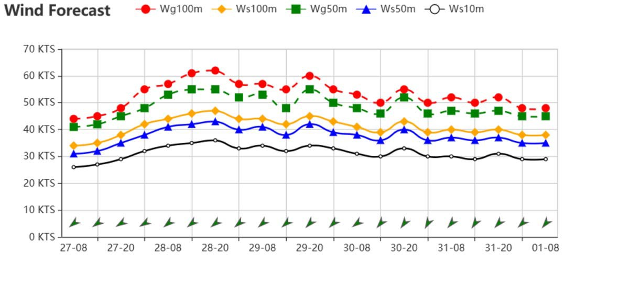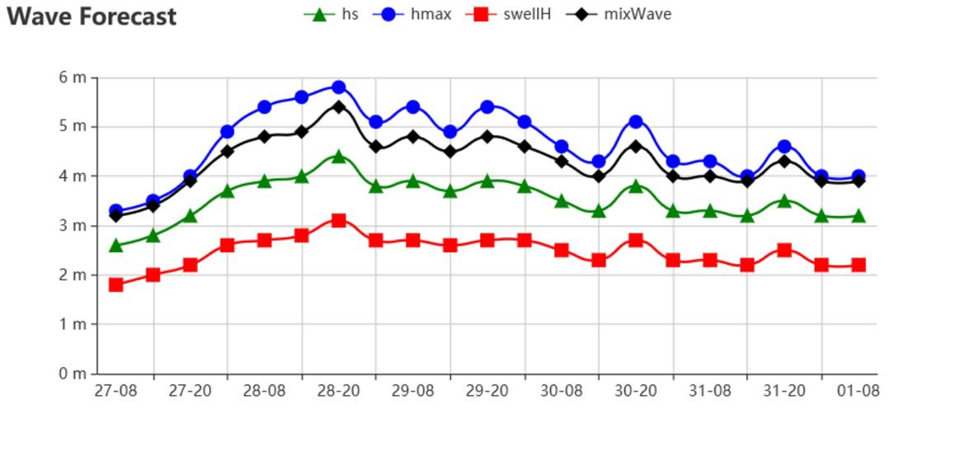

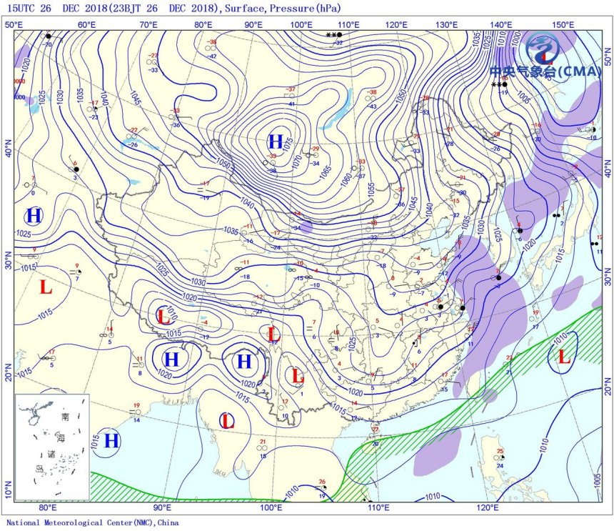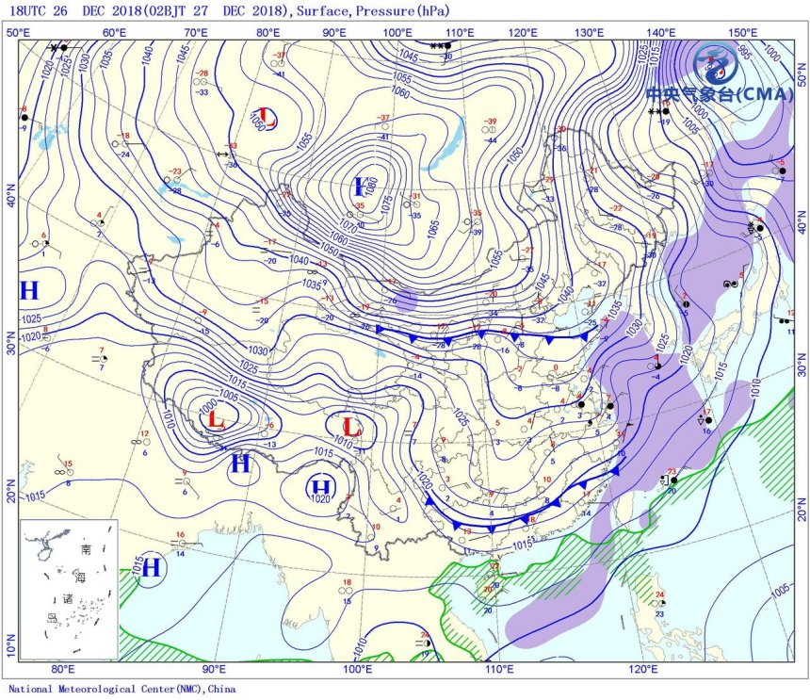

＼

｀

N·o