Project 1 Report -- Air Quality

Hunter Anciaux
CIVE202 Spring 2026
3 February 2026

Table of Contents
Introduction 3
Background Information 3
Objectives 3
Scope of Work 4
Methods 4
Discussion of Results 6
Sources 11

Table of Figures
Figure 1 - This table shows the values of the top 5 mean and median locations for PM2.5. 6
Figure 2 - This table shows the top 5 locations in terms of highest average value of PM10.0. 7
Figure 3 - This table shows the top 5 values for mean VOCs. 7
Figure 4 - This table shows the top 5 values for median VOCs. 8
Figure 5 - This table shows the average values for the three main parameters of air quality sorted by the temperature ranges given by the client. 9
Figure 6 - This table shows the average PM2.5, PM10.0, and VOC values for the 3 humidity ranges. 9
Figure 7 - This table shows the average values for the three parameters based on the altitude bins. 9

Introduction
The University of Nebraska Medical Center started a program in collaboration with PurpleAir to monitor air quality throughout the state. Since they are not experts in air quality analysis, they enlisted the help of engineers in understanding the data.

Background Information
When studying air quality, it is important to understand what is actually being examined to determine whether the AQI is “good” or “bad”. Three of the main contaminant types that are being examined in this report are PM2.5, PM10.0, and VOC. PM2.5, or particulate matter of diameter 2.5 micrometers or less, are small airborne particles that can be harmful if inhaled. Due to their microscopic size, they can easily enter the bloodstream if inhaled. PM10.0 are particles with a diameter of around 10.0 µm. These particles are also considered harmful and can lodge themselves deep in the lungs (US EPA₁ 2023), though they are less likely to enter the bloodstream and therefore have a much higher threshold to be considered hazardous. VOCs are volatile organic compounds, which are carbon-based gases that are emitted from various sources and could cause an array of health effects (EPA₂ 2024). PM2.5 and PM10.0 are measured in multiple ways, whether that be with electronic sensors or the use of filters that contain holes of a set size that only allow certain particles through (PurpleAir 2024).

Objectives
There are multiple objectives of this report. The client wanted to know the top five locations that were highest in mean and median PM2.5, PM10.0, and VOCs. They also wanted to know where and when the maximum values for each of those 3 indicators occurred. They also inquired about the effect of temperature, humidity, and altitude on air quality readings. Finally, they wanted to know if and if so how many days where the air pollutant values exceeded the values set for “unhealthy for sensitive groups” (Client prompt).

Scope of Work
Coding Tasks
The data needs to be imported as a CSV into the coding environment. A dataframe will then be made to make the data more useable. It can then be filtered by location to find the specific sites where the extreme values that the clients are looking for exist. The data can then also be filtered by humidity and temperature to reach the desired bins that they want to examine. Obtaining the dates and locations associated with all these data points is also important in this project. More specifics on coding strategies will be included later in the “Methods” section.

Research
The values of PM10.0 and PM2.5 that are considered unhealthy for sensitive groups must be found prior to the start of this project so that those thresholds can be used to filter the data appropriately. Potential causes of the unhealthy air can also be found before this both to better understand why these extreme zones appear and where they might be to aid in narrowing down the search.

Deliverables
The raw python code and its annotations will be sent to the client. The CSV with the raw data will also be sent. Finally, the report containing the findings of this task that show what the client asked for will be sent.

Methods
Initially, the data will be imported into the coding environment Jupyter Notebooks. The package Pandas, which aids in data analysis, will be imported and heavily utilized throughout. The data will then be made into a dataframe deemed “air_data”, so it is easier to interact with and perform analytical tasks on. Different steps will then be taken for each task.

Task 1: Finding the top five locations with the highest mean and median concentrations of PM2.5, PM10.0, and VOCs.
The following was done for each of the three parameters: Initially, the data was sorted by sensor name per the request of the client using the “.groupby()” function. Next, the “.agg()” function was used to compute the mean and median values for the columns containing the values for PM2.5, PM10.0, and VOC. This new dataset containing these values was then sorted with the “.sort_values()” function to list them from greatest to smallest. Finally, the “.head()” function was used to collect the top five values from each of the new datasets for the three parameters.

Task 2: Finding when and where the maximum values of PM2.5, PM10.0, and VOCs occurred.
To find the maximum values for each of the three parameters, the functions “.idxmax()” and “.loc()” were used (Microsoft Copilot). This way the location of the maximum value in each of the columns was found and the corresponding date and location could be collected, as it showed the entire row that the maximum value occurred at.

Task 3: Determining if humidity and temperature had a significant effect on air quality.
The client gave the parameters for the categories for both temperature and humidity. For humidity, “Low” was considered anything under 50%, “High” was 50-80%, and “Very high” was above 80%. For temperature, “Below freezing” was understandably below 32ºF, “Cool” was 32-50ºF, “Warm” was 50-70ºF, and “Hot” was above 70ºF. To place the humidities and temperatures into bins, functions were made that went through and determined whether the values met the minimum threshold, then the next and so on until they were all placed in one category. The “.apply()” function was used to apply the other functions that were made to their corresponding columns. The word descriptors were generated and then added to their own columns.
Next, the data was grouped by the new columns containing the descriptors using “.groupby()”. Then, the mean could be taken of each group to show the average value of PM2.5, PM10.0, and VOC in each group for humidity and temperature.
A “bonus task” asking about altitude levels was also in the client request. Because specific level steps were not given, the altitudes were arbitrarily sorted into 3 bins of “Low” (<2000ft), “Medium” (2000 – 3000ft), and “High” (>3000 ft). Then the same process was followed to delineate, group, and calculate the desired values.
Task 4: Determining if there have been any AQI health risks.
First, the thresholds for what constitutes as a health risk had to be found. For PM2.5, it is a value greater than 35.5 µg/m³. For PM10.0, it is 155 µg/m³ (AQI). These are the values that the EPA deems to be “unhealthy for sensitive groups” and therefore is the health hazard that UNMC is inquiring about.
To find the dates and locations of these unhealthy events, a new dataset was created for both PM2.5 and PM10.0. This one was created by filtering through the “air_data” dataset created at the beginning to find where PM2.5 and PM 10.0 were greater than 35.5 and 155, respectively. A second new dataset was created that filtered out only sensor name (which contains the location), date, and the value given that was greater than the health risk threshold.
The client wants to also know some potential causes or reasons for the unhealthy events, and this will be accomplished through some research.

Discussion of Results
Task 1:
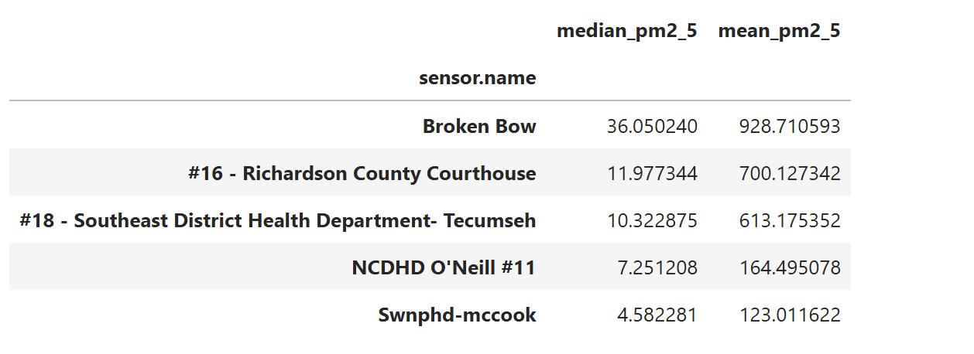
Figure 1 - This table shows the values of the top 5 mean and median locations for PM2.5.
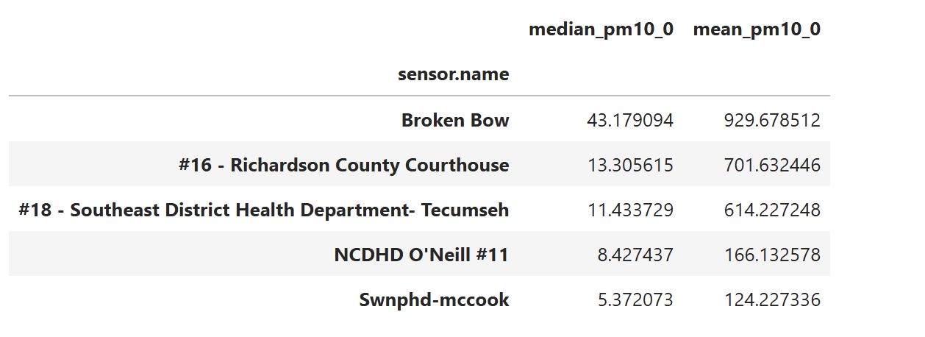
Figure 2 - This table shows the top 5 locations in terms of highest average value of PM10.0.
The data relating to the particulate matter was very similar. The top five mean and median locations were all the same for both PM2.5 and PM10.0, with Broken Bow being a significant leader in both mean and median for both sizes of particle. The data was sorted by both mean and median, but only one table is shown for each as they were identical for both PMs. There is a striking difference between the mean and median values. This is likely due to an extended period where the PM values exceeded 3000. The median for PM2_5 in Broken Bow is still above the unhealthy range, though.

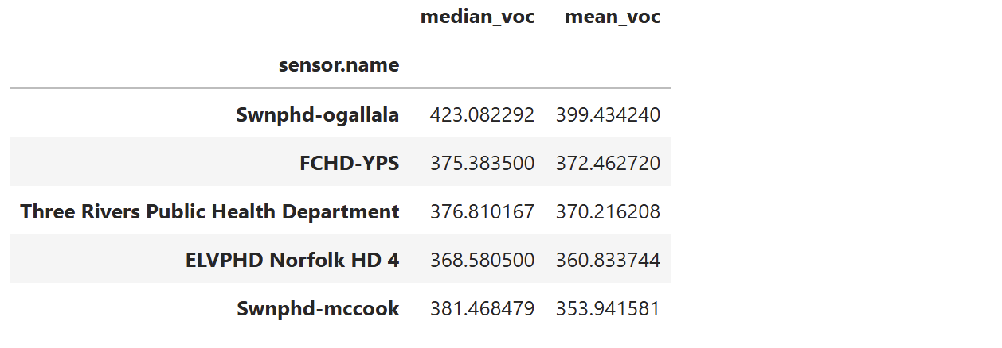
Figure 3 - This table shows the top 5 values for mean VOCs.

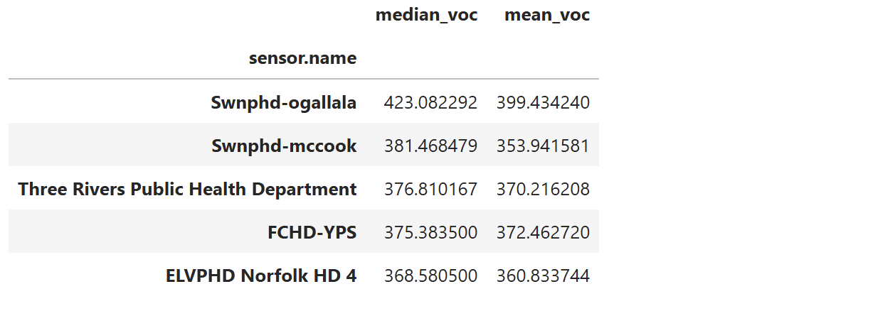
Figure 4 - This table shows the top 5 values for median VOCs.

Unlike the PMs, the VOCs had different top five lists for mean and median VOC concentration. Ogallala was the highest for both and Three Rivers stayed at three in each, but there was movement in the rest. The mean and median values for the VOCs are much closer than they were for the PMs.

Task 2:
The maximum PM2.5 came in at 3782.82 µm/m³. It occurred on February 18, 2025, at sensor #16 - Richardson County Courthouse. The maximum value of PM10_0 was 3784.68, occurring on the same day in the same place. The only reason that could be found for this is a phenomenon called winter temperature inversion, where a layer of cold air is trapped toward the ground and prevents vertical air mixing, holding air pollutants toward the Earth’s surface and causing poor air quality (National Library of Medicine).

The maximum VOC came in at 1209.93 on June 24, 2024, in Ogallala. This may be due to the Ogallala groundwater contamination superfund site (EPA₃). With large amounts of chemicals found in the groundwater, they eventually vaporize and move into the air. In June 2024, PCE was found in the basement of a duplex in Ogallala. VOC evaporation from contaminated groundwater is accelerated by the heat, so this occurring in June lines up.

Task 3:
Temperature Level: | Average PM2.5 | Average PM10.0 | Average VOC
Below Freezing | 273.698560 | 276.080794 | 257.628626
Cool | 143.167452 | 144.593363 | 288.558923
Warm | 85.914999 | 86.834046 | 255.179179
Hot | 70.145543 | 71.821037 | 282.145818
Figure 5 - This table shows the average values for the three main parameters of air quality sorted by the temperature ranges given by the client.
The temperature seemed to have quite a significant impact on the particulate matter. The mean descends the warmer it gets for both sizes of PM. This again is likely due to the winter temperature inversion effect. It has little to no effect on the gaseous VOCs in the air, or at least no conclusion can be drawn from this data.

Humidity | Average PM2.5 | Average PM10.0 | Average VOC
Low | 76.513935 | 77.880520 | 279.329347
High | 80.874444 | 82.561133 | 252.664069
Very High | 533.786399 | 536.520850 | 19.395555
Figure 6 - This table shows the average PM2.5, PM10.0, and VOC values for the 3 humidity ranges.
There does appear to be some correlation between the humidity and all three of the parameters. The particulate matter concentration increases with humidity, though the spike is far more drastic from high to very high than from low to high. This is likely caused by a large single event rather than a trend. The VOC concentrations have the inverse effect, decreasing with humidity, with the same giant leap (though this time downward) from high to very high.

Altitude | Average PM2.5 | Average PM10.0 | Average VOC
Low | 91.964518 | 93.593349 | 252.218398
Medium | 162.633015 | 164.001230 | 282.205860
High | 7.856594 | 8.999231 | 324.971952
Figure 7 - This table shows the average values for the three parameters based on the altitude bins.
The particulate matter seems to spike in the mid-range of altitude while almost completely dropping off in the higher ranges. VOCs seem to have a positive correlation with altitude, increasing as altitude increases.

Task 4:
There were 520 days where it would be considered “unsafe for sensitive groups” over the research period, so to list the date and location of them all would not be feasible. Events that are likely to cause poor air quality in the state of Nebraska include wildfires from other states and Canada, vehicle emissions, tire and break wear-down, and controlled agricultural burnoffs (IQAir). Agricultural practices tend to kick up a large amount of particles into the air while also using a significant amount of chemicals, both of which contribute respectively to increased PM2.5/10.0 and VOC concentrations.

Sources
In order of appearance:
EPA₁:
United States Environmental Protection Agency. (2023, July 11). Particulate matter (PM) basics. United States Environmental Protection Agency. https://www.epa.gov/pm-pollution/particulate-matter-pm-basics
‌
EPA₂:
United States Environmental Protection Agency. (2024, August 13). Volatile Organic Compounds’ Impact on Indoor Air Quality | US EPA. US EPA. https://www.epa.gov/indoor-air-quality-iaq/volatile-organic-compounds-impact-indoor-air-quality
‌
PurpleAir:
How is Particulate Matter (PM) Measured? (2024, October 3). PurpleAir. Berryman, Kieran. https://www2.purpleair.com/blogs/blog-home/how-is-pm-measured?srsltid=AfmBOorrK1FjO5e2TdI4JiANIMHTkJX4KwDs1xekVPMfuB41ZuGJ8Iwn
‌
Client Prompt:
UNMC. (n.d.). Project #1: Organizing and Summarizing Air Quality Data [Review of Project #1: Organizing and Summarizing Air Quality Data]. Retrieved February 2, 2026, from https://uofnebraska-my.sharepoint.com/:w:/g/personal/37381171_nebraska_edu/IQBfy_AZo5lLS5HIIfZOqeY-AaYaVP8j_fgfmkvOFHreEvQ?e=PJ5PwX

Copilot:
Microsoft Copilot. (n.d.). Microsoft Copilot: Your AI Companion. Retrieved February 2, 2026, from https://copilot.microsoft.com/

AQI:
(2018, September). Technical Assistance Document for the Reporting of Daily Air Quality – the Air Quality Index (AQI [Review of Technical Assistance Document for the Reporting of Daily Air Quality – the Air Quality Index (AQI]. AQI; US EPA. https://uofnebraska-my.sharepoint.com/personal/37381171_nebraska_edu/_layouts/15/onedrive.aspx?id=%2Fpersonal%2F37381171%5Fnebraska%5Fedu%2FDocuments%2FTeaching%2FCIVE%20202%2FSpring%202026%2FProject%20%231%2FEPA%20Air%20Quality%20Index%20Document%2Epdf&parent=%2Fpersonal%2F37381171%5Fnebraska%5Fedu%2FDocuments%2FTeaching%2FCIVE%20202%2FSpring%202026%2FProject%20%231&ga=1
‌
National Library of Medicine:
Beard, J. D., Beck, C., Graham, R., Packham, S. C., Traphagan, M., Giles, R. T., & Morgan, J. G. (2012). Winter Temperature Inversions and Emergency Department Visits for Asthma in Salt Lake County, Utah, 2003–2008. Environmental Health Perspectives, 120(10), 1385–1390. https://doi.org/10.1289/ehp.1104349
‌
EPA₃:
US EPA, OSRTI. (2026). OGALLALA GROUND WATER CONTAMINATION | Superfund Site Profile | Superfund Site Information | US EPA. Epa.gov. https://cumulis.epa.gov/supercpad/SiteProfiles/index.cfm?fuseaction=second.contams&id=0702287
‌IQAir:
Nebraska Air Quality Index (AQI) and USA Air Pollution | IQAir. (n.d.). Www.iqair.com. https://www.iqair.com/us/usa/nebraska
‌

