CIVE 202 Project 2 – Concrete Automation

Nay Law Htoo, Hunter Anciaux, Abdi Aden

24 February 2026

Table of Contents
Background 3
Methods 3
Results 5
Discussion 7
Sources 9

Figure 1 - This table shows the concrete weight summary for 47B concrete. 5
Figure 2 - This table shows the concrete weight summary for 47BR concrete. 6
Figure 3 - This table shows the concrete weight summary for 47B-HE concrete. 6
Figure 4 - This table shows the concrete weight summary for SF concrete. 7

Background
The focus of the project was to bring an existing Excel sheet that was used for calculating concrete mix design weight charts into a Python format. The calculations were to be moved from the offline Excel environment into the online Python code. Having it in a Python format makes the process easier to implement into a web-based setting while also making the process more transparent and repeatable.

Methods
Initially we must access the original Excel sheet containing the mix design calculations. This will be the basis of the Python code, as the code will try to replicate the format of the Excel sheet. The cells that originally contained the inputs in the sheet were kept as labels for the Python code.
A few constants that would be widely used throughout were defined at the beginning, including the unit weight of a cubic foot of water (62.4 lb/ft³) and the conversion from cubic yards to cubic feet (27).
Next, the variables that needed to be defined by functions were created.
Water Weight (Q):
The water weight function required the parameters of weight of cement (A), weight of fly ash (B), weight of silica fume (C), weight of other SCM (D), and the target water to cement ratio (E). To calculate the water weight (Q), parameters A, B, C, and D were added, and this quantity was multiplied by E.
Cement Volume (R):
The cement volume function needed two parameters: weight of cement (A) and specific gravity of cement (J). To get the volume, parameter A was divided by the quantity of J multiplied by the unit weight of water.
Fly Ash Volume (S), Silica Fume Volume (T), Other SCM Volume (U):
These three functions followed a very similar layout to the cement volume, where their respective weights B, C, and D were divided by their respective specific gravities K, L, and M multiplied by the water unit weight.
Air Volume (V):
The air volume function took only one parameter, air content (F). It divided this value by 100 and then multiplied this quantity by the conversion from cubic feet to yards.
Water Volume (W):
The water volume function also only took one parameter, the previously calculated water weight (Q) and divided this value by the unit weight of water.
Aggregate Volume (X):
This function took 6 parameters, the volumes of cement (R), fly ash (S), silica fume (T), other SCM (U), air (V), and water (W). The aggregate volume X was calculated by taking the cubic foot conversion of 27 and subtracting each of the parameters.
Fine (Y), Course (Z), and Other (AA) Aggregate Weight:
Each of these functions worked practically the same. They required 3 parameters: each respective percentage of that aggregate G, H, I, the 3 respective specific gravities N, O, P, and the aggregate volume X in each. To calculate the weights, the target percent values (G, H, I) were divided by 100. This value was then multiplied by the specific gravities (N, O, P), X, and the unit weight of water.
Finally, these functions were compiled into one location. The values that are variable and need to be fed into the code by the user were requested using input, so that entering the values was quick and easy. The project name and class of concrete are also input-able parameters. Using the values, the created functions could calculate the requested information and present it in a weight chart.

Results
Four different mix designs were tested using the new Python mix design code, 47B, 47BR, 47B-HE, and SF. These mixes came from the NDOR document provided by the client.

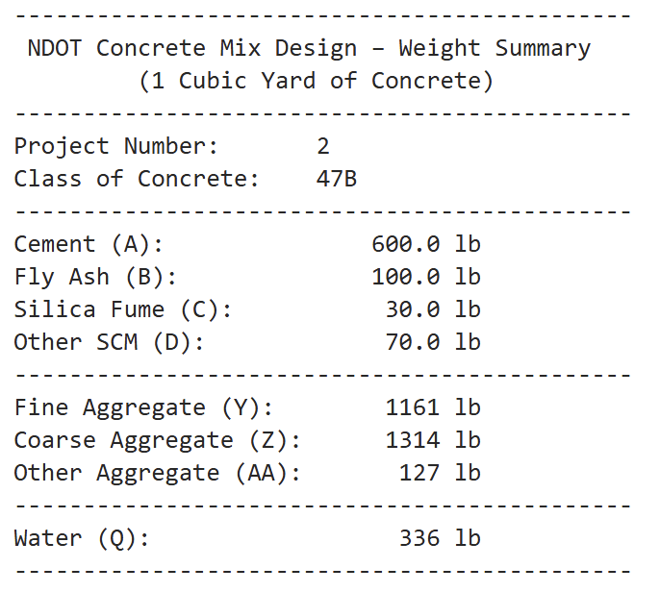
Figure 1 - This table shows the concrete weight summary for 47B concrete.

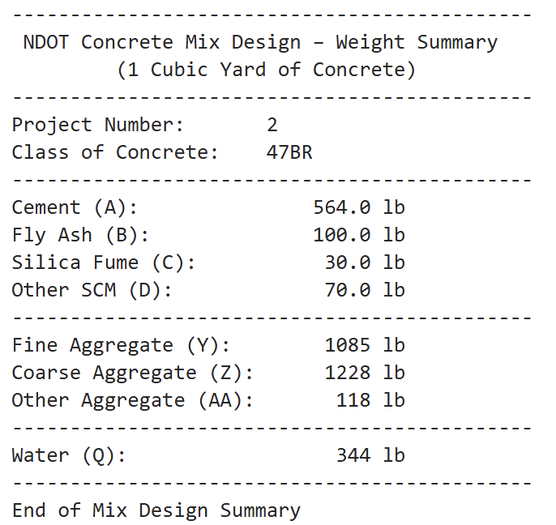
Figure 2 - This table shows the concrete weight summary for 47BR concrete.
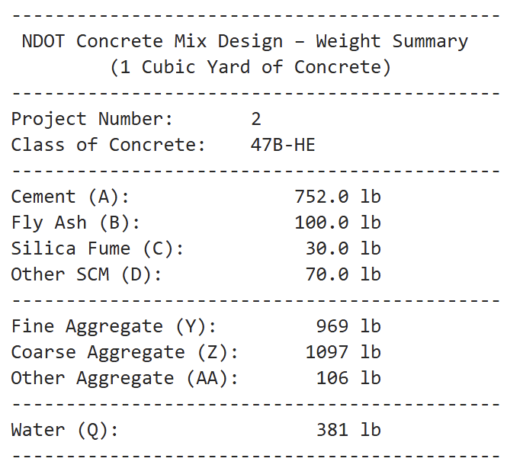
Figure 3 - This table shows the concrete weight summary for 47B-HE concrete.
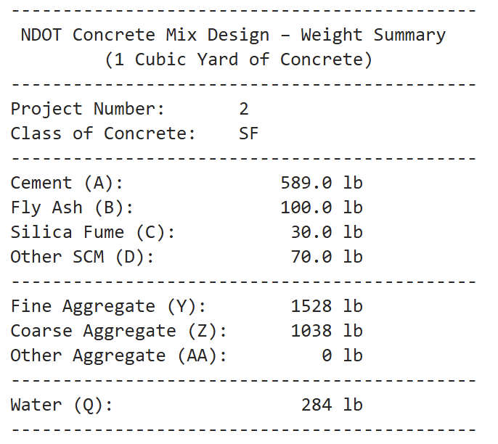

Figure 4 - This table shows the concrete weight summary for SF concrete.

Discussion
The values for the cement weight (A) and ranges for the aggregate target percentages and air percent were obtained from the source. The remaining values were given in class. The 47B-HE concrete had a significantly higher cement weight per cubic yard than the rest of the mixes (NDOR 2017). The three 47B concretes all had similar ratios of fine, coarse, and other aggregate while the SF concrete had more fine than coarse and did not contain any of the other. The SF concrete had the lowest water weight, almost 100 pounds lighter than 47B-HE which had the maximum value for this parameter.
Class 47B concrete is typically used in set structures like bridge supports that require high durability (NDOR 2002). 47BR is a revised version of the 47B that is meant to optimize the use of local aggregates in the mix and is used in roadways (NDOR 2017). 47B-HE is used for projects that require the concrete to have high early strength (NYDOT 2010). It is meant to be denser (hence the much higher cement weight per cubic yard). It also is meant to integrate local aggregates to help with cost while being exceptionally strong. Finally, SF concrete is used in applications that require resistance to elements, like chemicals or marine structures (Euclid 2018).
The 4 scenarios outputs are all different and based on their inputs, and have been documented as markdowns. This code is automated and has been verified by comparing the output of the NDOT mix design from Excel. This code produced the same answers as the Excel mix design when the same inputs were entered. This code outputs 1 cubic yard of concrete chart, including the materials used, and a result for sanity check between 3,700 and 3,950 lb is the "Sane Zone" for Nebraska concrete. Since this code produces a number within this range, it proves that the X, Y, and Z volume equations are working perfectly and that the mix is safe to build. This validates that the code is working properly.

Sources
Optimized Aggregates Gradations for Portland Cement Concrete Mix Designs Evaluation. (n.d.). Retrieved February 23, 2026, from https://dot.nebraska.gov/media/3isfdv45/final-report-p336.pdf
‌
Standard Specifications for Highway Construction 2017 Edition. (n.d.). https://dot.nebraska.gov/media/g4qp4y0d/2017-specbook.pdf
‌
STATE OF NEBRASKA DEPARTMENT OF ROADS ADDENDUM NO. 3 AND ELECTRONIC BIDDING SYSTEM. (2002). http://www.nebraskatransportation.org/letting/c-let-020314/f07ad303.pdf
‌
ITEM 555.01010004 -HIGH EARLY STRENGTH (HES) CEMENT CONCRETE FOR FULL DEPTH SLAB REPAIR, CONCRETE PARAPET REPAIR, AND LONGITUDINAL JOINT REPAIR. (2010). https://www.dot.ny.gov/spec-repository-us/555.01010004.pdf
‌
TUF-STRAND SF - Euclid Chemical. (2018). Euclidchemical.com. https://www.euclidchemical.com/products/concrete-fibers/synthetic-macrofibers/tuf-strand-sf/
‌

