Project 5 – Continued Risk and Hazard Assessment

Elizabeth Wiggins, Hunter Anciaux

CIVE 202

8 May 2026

Table of Contents
Introduction 3
Methods 3
Discussion of Results 8
Conclusion 18
References 19

Figure 1 - Average wind speed by longitude in the Gulf of Mexico region 8
Figure 2 - Average NRI hurricane risk by population 9
Figure 3 - Average NRI hurricane risk by state 10
Figure 4 - Wind speed at each data point 11
Figure 5 – Pressure along hurricane paths 12
Figure 6 - Percentage of mobile homes by state 13
Figure 7 - Total uninsured population by state 14
Figure 8 - Total population 65 and older by state 15
Figure 9 - NRI hurricane risk score by census tract 16
Figure 10 - Hurricane risk intensity by generated categories 17

Introduction
  - Project Background
Risk Averse, LLC is looking for a complete analysis of a specific natural hazard across six states in the same region. This project will provide the analysis of hurricane patterns in Alabama, Florida, Georgia, Louisiana, Mississippi, and Texas by utilizing python code to generate plots that are clear and descriptive of the data that they represent. The natural hazard and census data featured in the following graphs is sourced from NRI Census Tract and SVI datasets for the given states.
  - Scope of Work
The goal of the project is to analyze the risk of a specific natural hazard, hurricanes, among 6 different states, Texas, Louisiana, Mississippi, Alabama, Georgia, and Florida, and the impact of the hazard. The analysis is to consist of a comparison of how the risk of hurricanes vary across these 6 different states, a report of any trends that occurred in the data, what these trends may indicate about the region, and a discussion of how this natural hazard has impacted the communities of these areas.
Tasks to accomplish the project goal include extracting and organizing the SVI data, preliminary research, examining and evaluating the risk, plotting data, and reporting the data.
Project deliverables include the following: raw data files used in the python code file, the coding file used to generate the solution, scope of work, Gantt chart, engineering timesheet, annotated code document, a link to the Github repository with all project files, and the written report stating the results and findings of the project.

Methods
Task 0 – Setting up coding environment and importing data:
The coding for this project was done using Python within the Jupyter environment. Seven packages were imported for this project: NumPy, Pandas, GeoPandas, MatPlotLib’s pyplot, patches, and colors, and Seaborn.
The SVI and FEMA CSVs were imported using Pandas’ read_csv function. The shapefiles for the NRI data and the US state borders were imported with GeoPandas’ read_file tool.

Task 1 – Data management and cleaning:
- NRI data:
The census tracts dataset required a few steps to get it to a useful place. First, all of the states and territories beside Texas, Louisiana, Mississippi, Alabama, Georgia, and Florida were added to a list. A new dataset was made that excluded all of those states and territories. Next, using to_crs, the coordinate reference system was set to ESRI:102003, which is standard for maps displaying the contiguous US. The nulls in this dataset were represented with the value -9999, and these were replaced with NaN with the replace feature.
- FEMA data
The FEMA dataset was made into a GeoDataFrame using its longitude and latitude to place the data points in space. It was then set to the same CRS as the state outline shapefile. Then, using GeoPandas’ special join feature, the FEMA hurricane path CSV was joined with the state border shapefile.
- SVI data
To merge the SVI dataset with the state outline shapefile, first a shared column had to be found. The ST_ABBR column was suitable. Because it was called STUSPS in the shapefile, a column called STUPSPS was created in the SVI dataset matching its ST_ABBR column. The two were then merged on STUSPS using Pandas’ merge feature.
Task 2 – Setting up data for plotting and graphing:
- Binned data:
The first set of bins was the longitude in the FEMA dataset. They were created using Pandas’ cut tool and ranged from -120 to -70. The binned data 1 set grouped the FEMA set by the new binned column and found the mean of the wind speed in each range.
The second binned set was done to the NRI dataset. It also used the cut feature to make bins of population ranged from 0 to 31 000. The second binned set was made the same way as the first, by grouping by the new population bins column and finding the average of the NRI hurricane risk score in each bin.
The third bin set was made simply by grouping the NRI set by state and then finding the average hurricane risk within each state.
- Categorical data function:
The NRI hurricane risk score (0-100) was divided, somewhat arbitrarily, into 8 levels of intensity. A function was made that assigned the value into one of these categories. If it was a null, it returned ‘No Data’. Otherwise, a value below 15 returned marginal, 15 to 29 was slight, 30 to 45 was moderate, 45 to 60 was high, 60 to 75 very high, 90 to 95 was extreme, and 96 to 100 was egregious. This function was run on the hurricane risk score column and the result was placed in a new column.
A color was assigned to each level of intensity. The color scheme was based off weather radar, going from greens to yellow, orange, red, then pinks. A new column was added containing the hex code for each risk category’s corresponding color.
Using Pandas’ categorical tool, the levels of intensity were given an order to avoid being placed alphabetically and then they were sorted by that order.

Task 3 – Creating bar plots:
First, the graph style was set to dark grid using Seaborn.
- Plotting average wind speed by longitude range:
A 12x6 figure was created for this graph. Then, the first set of binned data was graphed with MatPlotLib’s plot feature, setting the kind of graph to bar. The colors, labels, and title were customized for better visualization and understanding.
- Plotting average NRI hurricane risk score by population:
This plot was made nearly identically to the first, just using the second set of binned data rather than the first.
- Plotting average NRI hurricane risk score by state.
A 12x6 figure was also created for this plot. Unlike the others, however, this graph was created using Seaborn. This was done because it made more sense to display the states in the order they appear in geographically rather than alphabetically, and Seaborn makes ordering the bars much easier. An argument called ‘order’ within Seaborn’s barplot feature allows one to make a list to order the bars. The rest of the graph was customized and labeled in a similar way.

Task 4 – Plotting FEMA hurricane path data:
- Wind speed:
A variable ‘ax’ was created that was the figure size. Then, the dataset created from the special join between the FEMA set and the state borders was plotted using MatPlotLib’s plot feature. The column containing the wind speeds was set as the column argument. The x and y limits of the graph were set at -107 to -75 and 20 to 37, respectively. These values represented the window of longitudes and latitudes that were to be displayed. The color and labels were customized, and what resulted was a map displaying the desired states and the gulf area with points scattered throughout, colored based on their wind speed.
- Pressure:
This was done in a very similar fashion to the first graph. The column containing pressures was used and for this one the color scale was inversed, as lower pressures means higher hurricane risk. The legend was also given a logarithmic scale from MatPlotLib.colors so that the pressures could be more easily visualized, as their values were all somewhat high numerically.

Task 5 – Choropleth plotting statewide SVI data:
- State population:
The data in the merged SVI and state outline was aggregated by state to combine each census tract’s data into one state. This one was aggregated by population. It was graphed with the plot feature. This graph used the logarithmic scale bar.
- Percentage of mobile homes by state:
This was done in a very similar way to the last. This time, however, it wasn’t a sum like the previous, but rather a weighted average of the percentages. This was then plotted using the same function. This plot used the typical linear scale.
- Total uninsured population by state:
Again, this was very similar, especially to the first. It was again a sum, it was plotted using the same tool and this one also used the logarithmic scale from MatPlotLib.colors.
- Total 65+ population by state:
Very similar yet again, aggregated by the over 65 column, plotted using plot feature, and also utilized the logarithmic scale.

Task 6 – Graphing NRI risk level with choropleth and categorically:
- NRI census tract data:
This graph was made by using the finalized, cleaned version of the NRI census tract dataset that also included a shapefile for plotting the US. The column for this graph was the hurricane risk score.
- Categorical hurricane risk:
For this graph, a legend handle variable had to be made. This was done by using a for loop and going through the list of risk intensities with MatPlotLib.patches’ Patch feature in order to ensure they were graphed correctly and not in alphabetical order. The column containing the risk intensities’ colors was graphed and the label was customized using the legend handle variable.

Discussion of Results
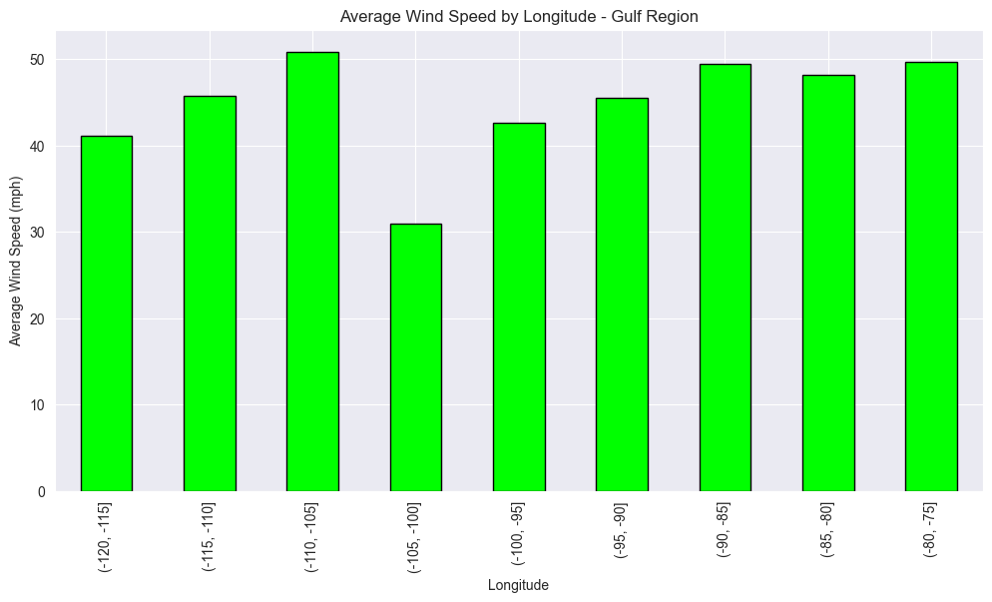
Figure 1 - Average wind speed by longitude in the Gulf of Mexico region
This bar graph shows the average wind speed within each longitudinal point. There does not appear to be any strong correlation until the -105 to -75 region, where it steadily increases in that span. This range was selected because it is the approximate span of the observed states. It appears that the range around Florida is quite high risk and may be worth increased monitoring. Potential bias in this graph could stem from the fact that there are not an equal amount of data points in each range, so some hold more weight in the average than others. This could skew data if a unusually weak or strong system existed in a region without a lot of data.

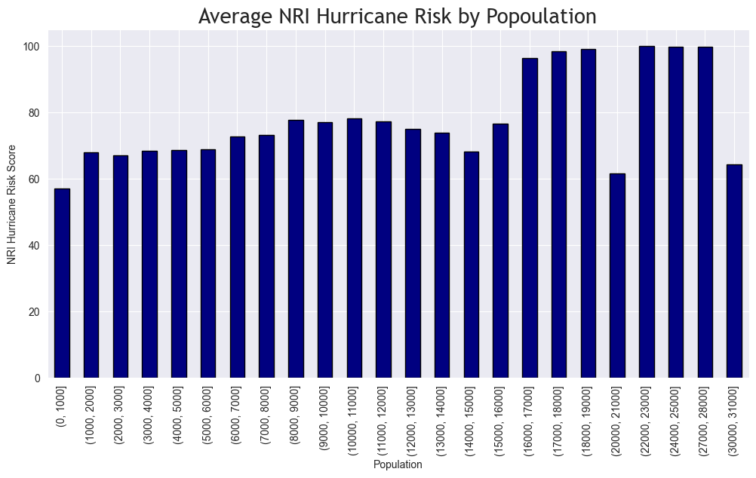
Figure 2 - Average NRI hurricane risk by population
This bar chart displays the average risk within each 1000-person population range. It does appear to have somewhat of a positive correlation in that the lowest average is in the lowest population, and the highest points are all far to the right. This makes sense in that there is more risk of harm to people in areas where more people live. Some bias that could interfere with the accuracy of this table is that generally more people live near the coast, where hurricanes are much more prevalent. Therefore, it is possible that this trend could be due to correlation rather than causation.

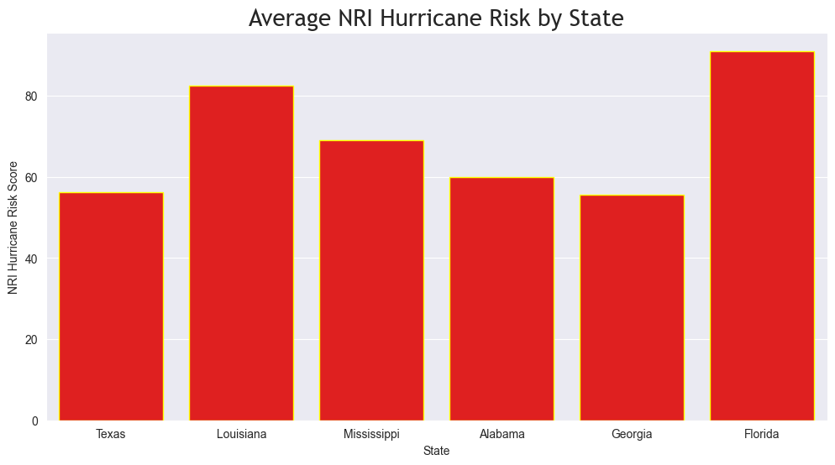
Figure 3 - Average NRI hurricane risk by state
This bar chart shows the average NRI hurricane risk score in each of the six observed states. It can be determined from the graph that Florida has the highest average hurricane risk of the six, while Georgia is the lowest. Geographically, this does make sense as Georgia is the most inland of the six while Florida has the most coastline. Therefore, Florida would be the likely candidate for increased hazard focus and potential funding.

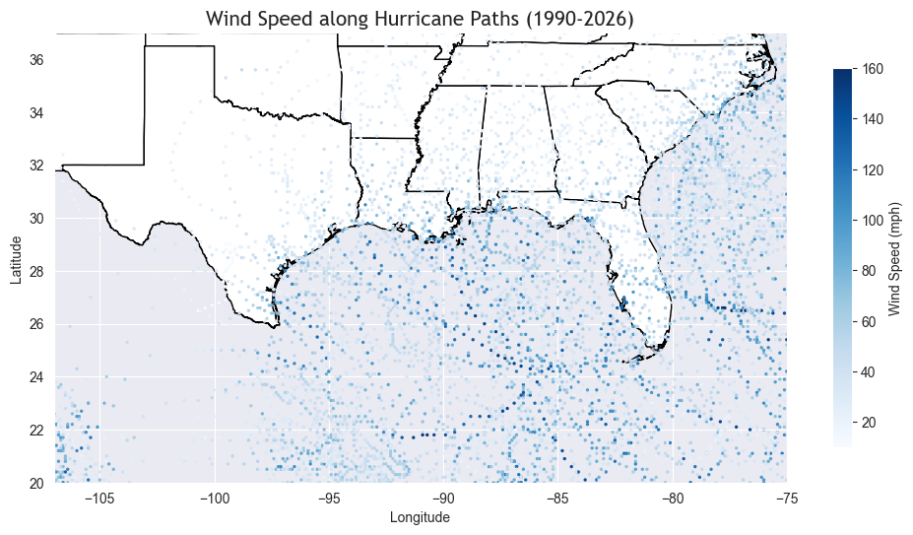
Figure 4 - Wind speed at each data point
This map shows the wind speed at each collected data point along the FEMA hurricane paths. The highest wind speeds appear to exist closer to the middle of the gulf. There are a significant number of data points that exist within the states of interest, primarily in Florida, but also densely in Louisiana and coastal Texas. Florida and Louisiana have darker points, indicating higher winds, meaning that they could both require additional assistance due to more damaging winds. A potential source of bias could be the number and location of data points, in that some data could be missed or skewed due to when they chose to record the information.

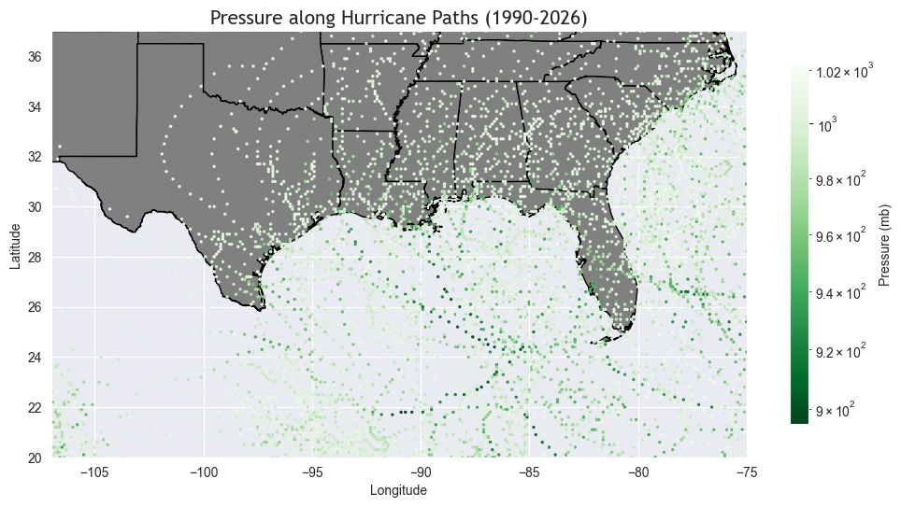
Figure 5 – Pressure along hurricane paths
The map in Figure 5 shows the pressure in millibars, along the 6 states as recorded at each data point in the FEMA dataset from 1990 to the present. The pressure can be seen at its highest in the center of the Gulf between the Southernmost points of Texas and Florida. From this point the pressure seems to reduce the as the points move toward the coastal states and further North. This indicates that the coastal areas face the highest amount of pressure.

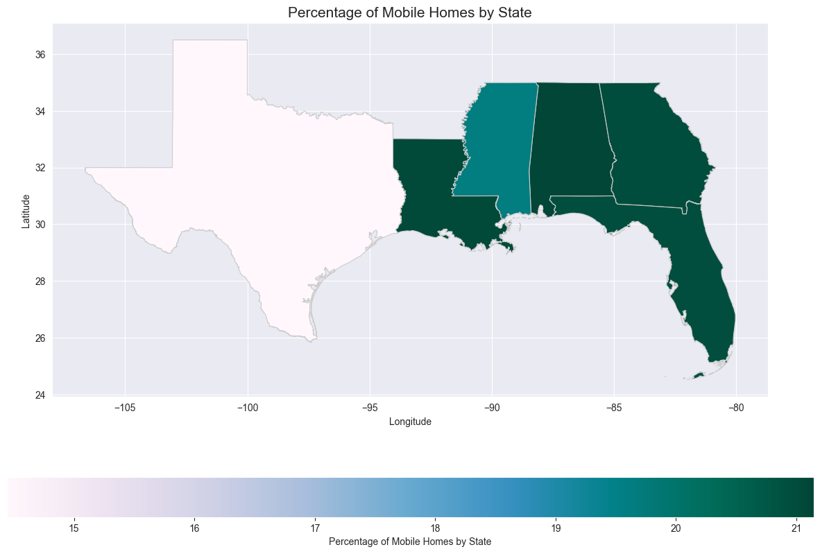
Figure 6 - Percentage of mobile homes by state
This map displays the percentage of total homes that are classified as mobile homes in each state. This could mean trailers, RVs, etc. These types of structures are at a greater risk of damage from hurricane winds and flooding, and the people who live in them don’t have basements to hide out in. Texas has a significantly lower percentage than the other states, so this graphic is of little concern there. The others, however, have quite high rates, with Alabama being over 21%. This could warrant some more interest, since this means that over a fifth of their populations live in homes that serve little comparative protection to this hazard.
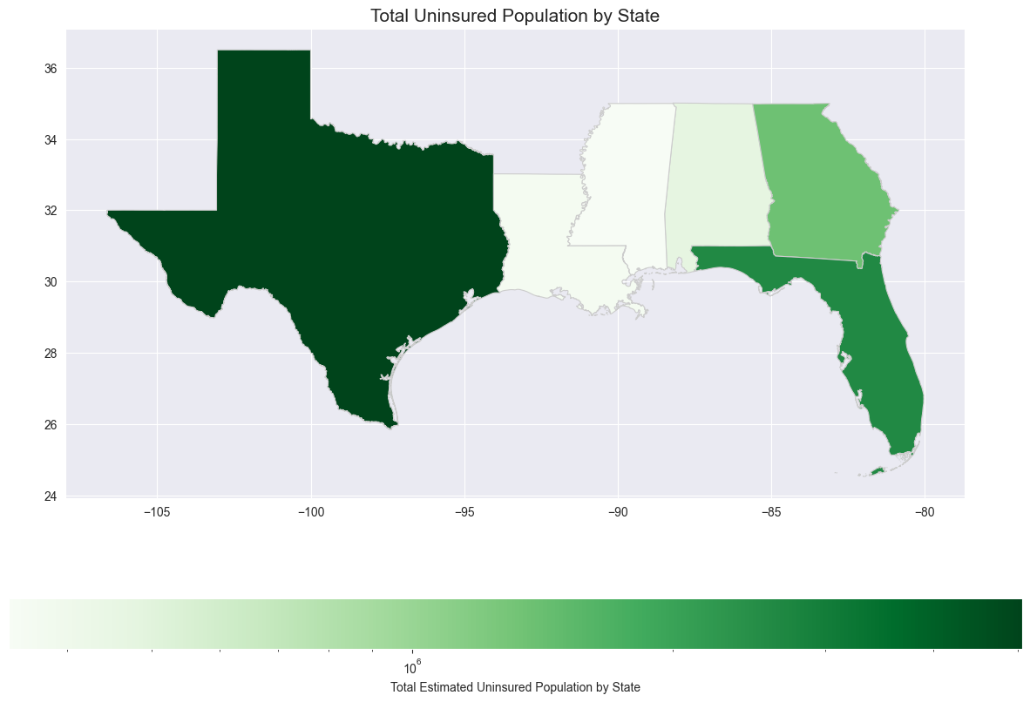
Figure 7 - Total uninsured population by state
The map seen in figure 7 portrays the total amount of the population without insurance in each state. This figure does indicate some bias in the code as the uninsured population in each state will be skewed so that the states with a much larger population will resultantly have a much larger number of uninsured people as well. While this graph does properly depict the number of people in each state that would be impacted negatively by hurricane damage due to their lack of insurance, a more representative graph to compare the proportion of the uninsured population within each state without bias would be to graph the percent of the population instead of the total population.

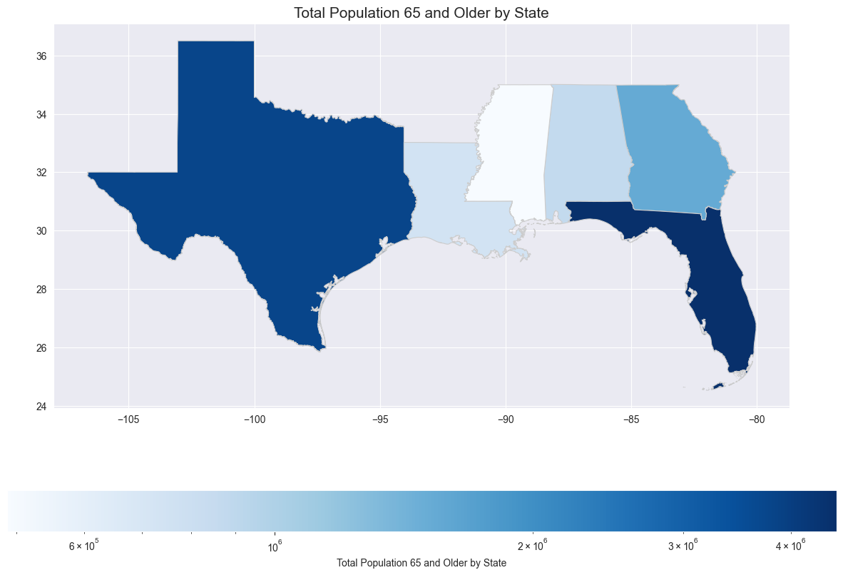
Figure 8 - Total population 65 and older by state
This map shows the total population of people in each of the observed states that are 65 years of age and older. Unsurprisingly, Florida has the highest number of this demographic. They would likely be more impacted by an event like this in that they are typically less physically abled than most.

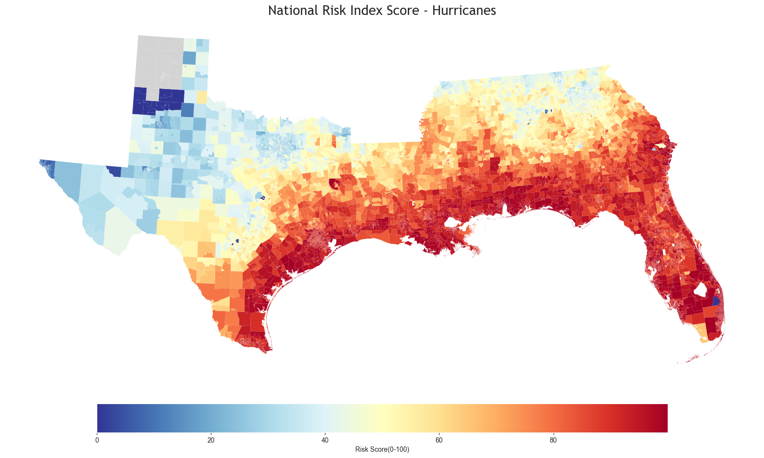
Figure 9 - NRI hurricane risk score by census tract
This map displays the NRI’s hurricane risk value from 0 to 100 in each of the census tracts. It appears that, somewhat predictably, the closer a region is to the coast, the higher the risk for hurricanes is at that location. That is not always the case, as there are some higher ones in the Texas panhandle, as well as a very low risk tract in Southern Florida. For aid purposes, this could mean focusing more on the extreme coastal areas, including less populated areas, to ensure that they can adequately prepare for these events and react to them should they happen.

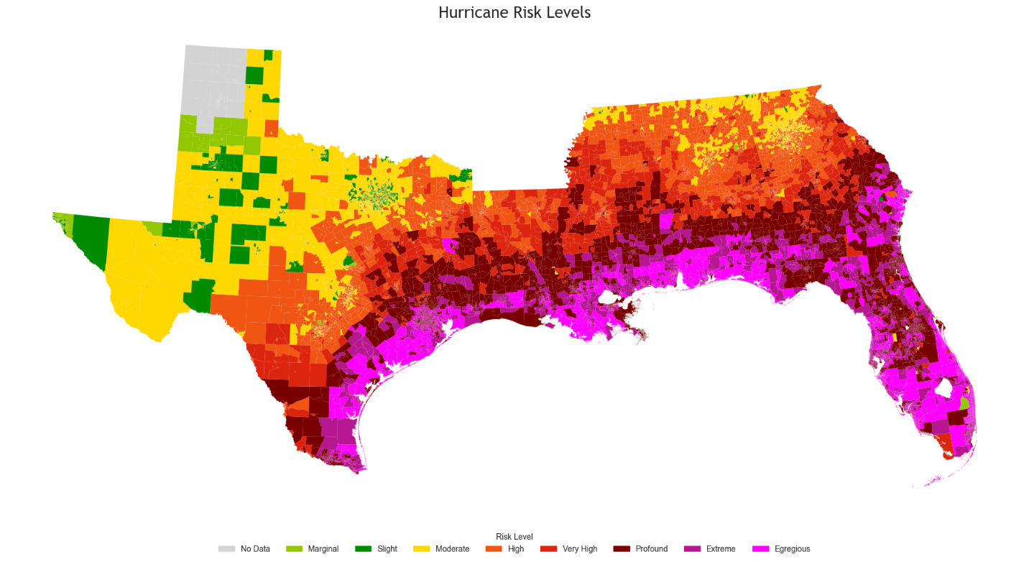
Figure 10 - Hurricane risk intensity by generated categories
This map displays the eight hurricane risk intensity levels that were created in the coding section. The most severe category, egregious (96-100), appears to exist quite extensively throughout the more coastal areas. Florida appears to have the highest ratio of census tracts with the most intense risk. In Northern Texas, there was not data related to hurricane risk, likely due to little historical precedent of this hazard in that region. The bias from this graph would come from the way that the risk levels were delineated.

Conclusion
This project aimed to further analyze hurricane risk throughout Texas, Louisiana, Mississippi, Alabama, Georgia, and Florida. Specifically, it wanted to find any connections between risk and population and geography. This was to gather information regarding potential risk and response to hazards in this area. Of the six states, it is quite evident that Florida is the most heavily impacted. It consistently had higher risk scores, while also having high rates of mobile homes and people over the age of 65. It also appears that higher population areas generally have higher hurricane risk scores, whether it be from correlation or causation, so this should be taken into consideration as well. Anywhere along the coast is generally going to have the highest risk of hurricanes, so managing this hazard in those areas is important.

References
Centers for Disease Control and Prevention. (n.d.). SVI data & documentation download. Centers for Disease Control and Prevention. https://www.atsdr.cdc.gov/place-health/php/svi/svi-data-documentation-download.html
National risk index for natural hazards | fema.gov. FEMA. (n.d.). https://www.fema.gov/flood-maps/products-tools/national-risk-index
Bureau, U. C. (2024, October 30). Cartographic boundary files - shapefile. Census.gov. https://www.census.gov/geographies/mapping-files/time-series/geo/carto-boundary-file.html

