ECOVAT Heat Demand Prediction

1. **House model**

The objective of this model is simulating what is the inside temperature of a single space house.

**Building energy simulation methods**

Building energy simulation is a vast field of research that started in the late ’50s and that is still highly active nowadays. Building energy simulations are mainly used to help to make design decisions, to analyze current designs and to forecast future building energy use. Building energy modeling methods can mainly be divided into three categories:

* White box model (physics-base)
* Black box model (data-driven)
* Grey box (hybrid)

White box model is based on the equations related to the fundamental laws of energy and mass balance and heat transfer. White box models can be differentiated in two types, distributed parameter models and lumped parameter models. Lumped parameter models simplify the description of distributed physical systems into discrete entities that approximate the behavior of a distributed system. The advantage of using lumped models is the decrease on simulation time (Ramallo-González et al.). White box model is of special interest for the design phase as they are used to predict and analyses the performance of the building envelope and building systems.

Black box models are based on the statistical relation between input and output system values. The statistical relation between input and output is based on actual data. The relation between the parameters can differ based on the amount of data and the method used to analyze the relation. Currently, there is a large and active field of research about statistical models that are used on black box models (Coacley et al.). Black box models are of special interest when there is a large amount of actual input and output data available.

Grey box model is a hybrid model form that aim to combine the advantages of both systems. In order to use them it is necessary to implement some equations and it is also required to have actual data of inputs and outputs.

**White box lumped model: RC network**

The objective of the house model for this project is to serve as test environment for a heat pump model, what means that the house model is intended as a tool to help taking building systems design decisions. The house heating needs calculation model implemented for this project is a white box lumped model. Specifically, it is a RC network model consisting of resistances (R) and capacities (C). The RC network model is based on electrical systems analogy. The simulation of thermodynamic systems characterizing building elements as resistances or capacities allows to simplify the model while maintaining a high simulation results accuracy (Bagheri et al., Bacher et al.).

There are several types of RC models, the most common being 3R4C models and 3R2C models which are applied on the outer and internal wall. For the simulation of simple house buildings 3R2C models perform as accurate as more complex 3R4C models (Fraisse et al. ). Considering that one of the objectives for this project is to obtain a fast but accurate simulation of a simple dwelling the 3R2C network model appeared as starting point. In the 3R2C model two indoor temperature nodes in the dwelling with capacities (usually an air and a wall temperature) and a well-known outdoor temperature are present. Between these 3 temperature nodes 3 heat transfer resistances are present. However, the direct heat transfer between the inner walls and the outdoor air is low. Moreover, uncertainties are present about heat transfer coefficients between walls and indoor air, different indoor temperatures in the house rooms and the ground temperature which deviates from the outdoor temperature. In addition, occupancy behaviour varies strongly. For that reason, we have made a further simplification to a 2R2C model. In section 4 it is shown that this dwelling model delivers a reliable annual energy consumption.

The dwelling model has been developed making use of Matlab/Simulink. In the Simulink model it is possible to define the dwelling characteristics, the dwelling use data and the climate data. With some of this information the model resistances and capacities are built on a Matlab script. The resistances and capacities values are used during the year energy simulation.

In sections 3.1 to 3.3 the information provided to make the simulation is presented. In section 3.4 it is explained how the 2R2C network model has been build. The Matlab script can be found in the appendix I.

**Dwelling characteristics information**

The dwelling characteristics considered in order to define the model resistances and capacities are presented in figure 1. The ventilation rate n in ach (air changes per hour) is based on a mechanical ventilation rate of 150 m3/h for kitchen, toilet and bathroom) by regulations.

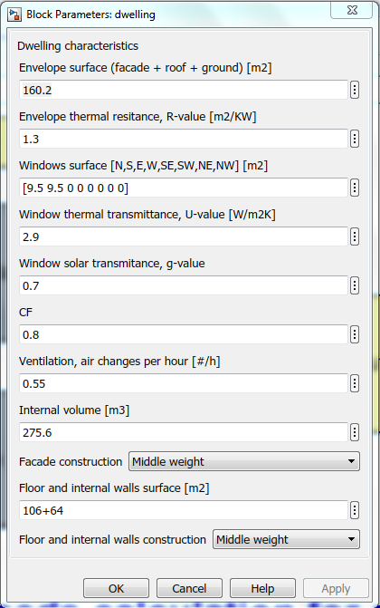

Figure 1. Dwelling characteristics model information.

**Dwelling use data**

The dwelling use data define the schedule to be used to calculate the dwelling internal heat and the thermostat set-points. The thermostat signal is communicated to the heat pump model. The information uses to define the dwelling use is presented in Figure 2.

**Climate data**

The hourly data about the outdoor temperature and the solar radiation is extracted from the NEN5060:2018 norm. This norm defines a typical meteorological year using the Finkelstein-Schafer statistical method with the climate data of 20 years period (1996-2015). The meteorological data used by the norm is updated once every 5 years.

The typical meteorological year data is the one to be used when calculating the typical energy use of the heating installation. The NEN norm offers also three other hourly climate datasets, each one with a different percentual deviation from the typical meteorological year: 1%, 3% and 5%. These data sets are to be used when analyzing the response of the heating installation under more extreme climate conditions. This is usually done for design installation purposes. The total energy use calculated with these other datasets will not give a reliable value for calculating the typical energy use.  In figure 3 it is shown that is it possible to choose between the four different NEN climate datasets.

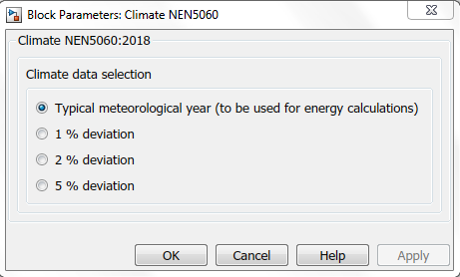

Figure 3. Climate data selection

In a pre-process the global incident radiant is calculated for North, South, East, West, North-West, North-East, South-West and South-East orientations of the façade in Matlab. The model from Perez is applied for the exchange. In this model the irradiation is split into a direct and diffuse terms.

Appendix II shows the applied files.

**Dwelling model**

The 2R2C structure implemented in the Simulink model is shown in Figure 4.

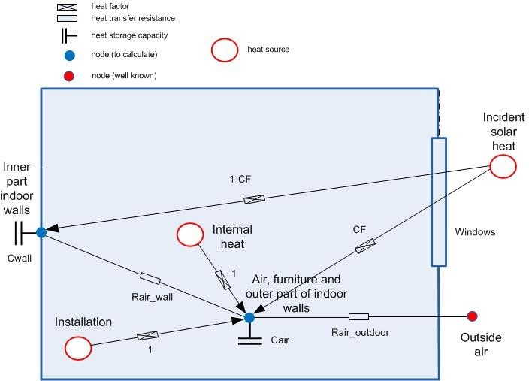

Figure 4. Schematic of the dwelling model

There are two capacities Cair and Cwall and two resistances Rair_wall and Rair_outdoor. The incident solar heat is divided between Cwall and Cair by the convection factor CF. It is assumed that both internal heat (lighting, occupancy and electric devices) and supplied heat (installation) are fully released at the air node.

 It is assumed that furniture and the surface part of the walls have the same temperature as the air and the wall mass is divided between the air and wall mass. Thus, the capacity of the air node consists of the air capacity, furniture capacity and capacity of a part of the walls. Appendix I presents the coefficients in the dwelling model. In the resistance Rair_outdoor the influence of heat transmission through the outdoor walls and natural ventilation is considered.

For the air and wall nodes the following energy balances can be set up:

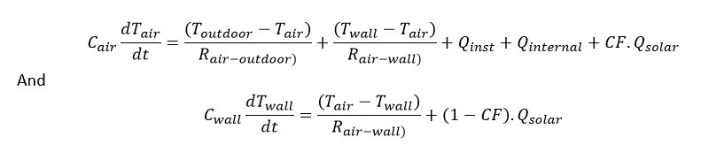

Qsolar is the incident solar radiation:

C:\Users\TrungNguyen\AppData\Local\Microsoft\Windows\INetCache\Content.MSO\B4BC97D8.tmp

With      qsolar=solar radiation on the outdoor walls [W/m2]

               g = g value of the glass (=ZTA in dutch) [0..1]

These equations are implemented as differential equations in Simulink in a so-called State-Space block. See Figure 5.

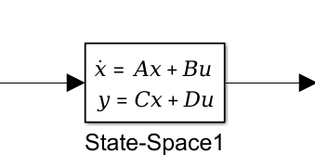

Figure 5. State Space block.

Wherein x and y are a vector containing the air and wall temperatures and u is a vector containing Toutdoor, Qinst, Qinternal and Qsolar. The coefficients in the matrices A, B, C and C are calculated from the R’s and C’s. See line numbers 45 to 52 of the ‘init_dwelling’ script in the Annex.

In the dwelling model Qinst is proposed to be well-known.  Qinst is estimated by the control block in the installation model of the Simulink model.

**Model results verification**

In order to test the model, we have used the data from the document *Voorbeeldwoningen 2011 Bestaande bouw* published by Agentschap NL. We have run the model for a detached house building build between 1975 and 1991 and for row house building build between 1975 and 1991.For the detached house the model calculates a sum of the yearly energy needs of 10545 kWh. The document *Voorbeeldwoningen 2011*gives a calculated energy use for heating and hot water of 1542 m3 gas. The average gas consumption of hot tap water on a Dutch household is 300 m3gas. We assume a combustion (under) value ho=35.2 MJ/m3 gas. Taking into consideration a heating system efficiency of 0.9, the energy need is 10843 kWh.

C:\Users\TrungNguyen\AppData\Local\Microsoft\Windows\INetCache\Content.MSO\AF88B6A4.tmp

For the row house the model calculates a sum of the yearly energy needs of 19776 kWh. The sidewalls have been considered as adiabatic walls. The document *Voorbeeldwoningen 2011*gives a calculated energy use for heating and hot water of 2616 m3 gas. The average gas consumption of hot tap water on a Dutch household is 300 m3gas. Taking into consideration a heating system efficiency of 0.9, the energy need is 20219 kWh.

C:\Users\TrungNguyen\AppData\Local\Microsoft\Windows\INetCache\Content.MSO\B2DCE852.tmp

The results give an indication that the model is on the right result range.

More verification result can be seen below

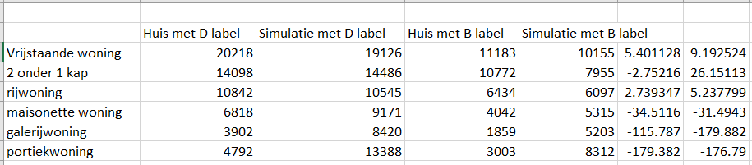

**Type of model**

It is a white model programmed in Matlab/Simulink. In order to calculate the inside temperature of the house the model considers five heat flow.

1. Transmission
2. Ventilation
3. Solar Gains
4. Internal Heat Gains
5. Heating/Cooling

The model also considers the mass of the air inside the house and the mass of the walls.

House characteristics data

The document *Voorbeeldwoningen 2011 Bestaande bouw* published by Agentschap NL will be used as a reference to determine the house characteristics. The document makes a classification of the house stock per construction type (7) and year of construction (4 time periods).

**Construction type**

1. Detached house (*vrijstaande woning*)
2. Semi-detached house (*2 onder 1 kap woning*)
3. Terraced house (*rijwoning*)
4. Apartment block own access (*maisonnettewoning*)
5. Apartment horizontal shared access (*galerijwoning*)
6. Apartment block vertical shared access (*portiekwoning*)
7. Apartment block in general (*flatwoningen (overig))*

Year of construction

1. Build before 1964
2. Build between 1965 and 1974
3. Build between 1975 and 1991
4. Build between 1992 and 2005

For the first model we will use the data of a detached house building build between 1975 and 1991. In the following models we can use also data from another house's typology.

We can use the energy consumption sum presented in the report as the first validation mechanism for this model. In the following model development, we should look for the possibility to validate the model with the use of real data.

**Climate data**

NEN 5060:2008 nl(Hygrothermische eigenschappen van gebouwen -Referentieklimaatgegevens), will be used as the climate data for the simulations. It is good to consider that there is a new NEN5060 on the making, what can imply some changes on the results of the simulation.  NEN 5060:2018 also has been used.

**Internal heat gains data**

There is no reference document about the internal heat gains for dwelling in the Netherlands. We can consider that there are two people living in the house with an average working schedule.

**Control mechanism**

The heating will be controlled by a thermostat. The indoor temperature of the house is based on recommendation given on the ISSO publication *Kleintje Binnenklimaat.*The indoor temperature should be maintained at a minimum of 20 degrees.

We could consider taking cooling into account in the following models.

**Heating energy needs and minimum heating capacity**

The graph and table below have been created making use of the row house model as presented in the word document “HHS simplified dwelling heating needs calculation model 2018-20-8 (row house)”. Appendix A

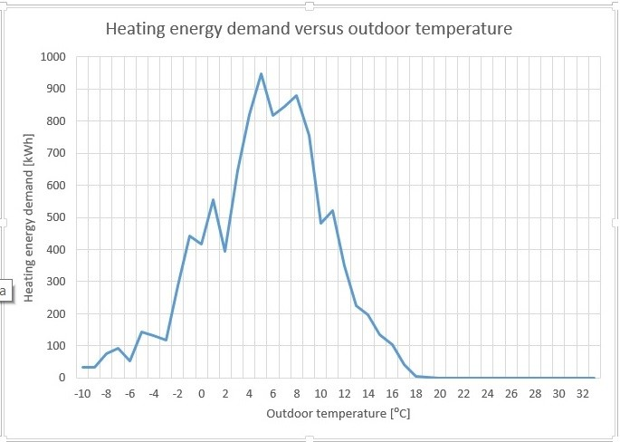

Figure 1:  Year heating demands

In order to get an estimation of the minimum heating power capacity needed to maintain a specific indoor temperature the whole year we have set the model thermostat at a constant temperature day and night.

|  |  |
| --- | --- |
| **Indoor temperature [⁰C]** | **Minimum heating power capacity [W]** |
| **18** | 6041 |
| **19** | 6335 |
| **20** | 6474 |
| **21** | 6704 |
| **22** | 6972 |
| **23** | 7144 |
| **24** | 7366 |
|  |  |

Minimum heating power capacity needed to maintain a specific indoor temperature the whole year.

From the simulation in figure 1 the energy for the whole year has highest demanded on temperature from 5 to 9-degree Celsius.

1. **Heat demand model base on machine learning.**

This is the summarize report of the minor project students from big data module.

There are 2 datasets had been used. One of these datasets was delivered by a member of HAN. It contains the weekly heat production of a house with a heat pump and a gas heating. This dataset would provide the information about the heat demand, the output of the model. The other dataset used was the weather data of the closest weather station (Instituut, 2019). This dataset would provide the inputs to the model, consisting of the average weekly temperature, the average weekly windspeed, the average weekly sunshine duration the overall sum of sunshine duration, the average hourly precipitation and the sum of precipitation per week. This data was gained from hourly values provided by the Dutch weather service.

The heat production data was manually cleaned to get rid of outliers, measurement errors and other unwanted values. Dimensions of each column were checked, gaps filled and intervals between data checked for uniformity. As the heat production was given as an accumulative sum, the heat production per week needed to be extracted.

The data was split to 70% for training and 30% for testing.

As the NN was doing classification in the assignment, the evaluation had to be changed as well. New error metrics for this prediction model had to be established. Mean absolute Error, mean absolute relative error and mean absolute percentage error are a few to name.

**NN MATLAB toolbox**

The NN MATLAB toolbox for neural fitting was applied to the data. This toolbox applies a 2-layer feed-forward network with sigmoid hidden neurons and linear output neurons (Figure 9).

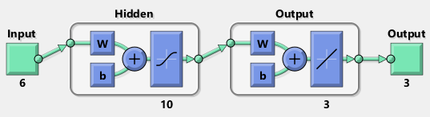

Figure 9: NN as used by the neural fitting toolbox

This network is then fed with the x_train and y_train previously generated for the manual implementation of the NN (Figure 10).

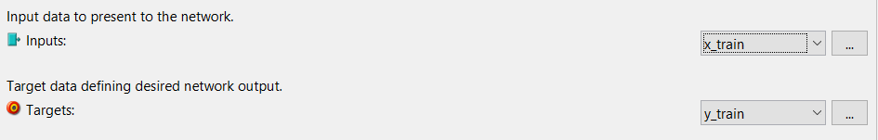

Figure 10: Input to NN

The training data set is then split up into training- test- and validation- set (Figure 11). This splitting cannot be reduced to zero. As it is a toolbox function, the validation and test dataset were part of the overall training algorithm, so the values were not changed. This data splitting is unconnected to the initial splitting between test and validation set. Here the training data set is internally split up by the toolbox.

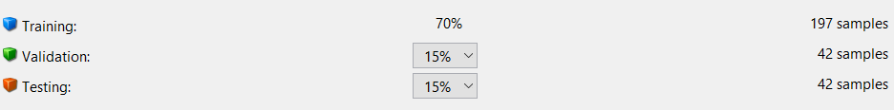

Figure 11: Training data vs Validation and Testing data ratio

For the hidden layer 10 neurons are chosen as in the first attempt with the self-made NN (Figure 12).



Figure 12: Hidden layer size

The NNtraintool automatically determines the right amount of iterations.

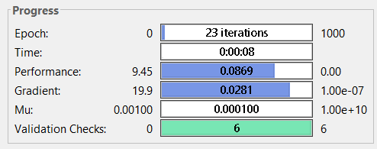

Figure 13: Progress report after training

From the validation performance (Figure 14), it can be clearly seen, that the NN is being trained quickly. By the validation performance it is determined, that at epoch 17 the NN delivers best performance so training can be stopped.

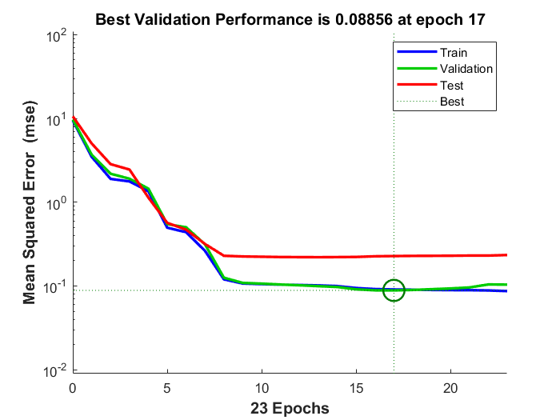

Figure 14: Validation Performance

The toolbox already delivers its own quality measures (Figure 15). The MSE (Mean Squared Error) measures the average of the squares of the errors—that is, the average squared difference between the estimated values and what is estimated. The closer the MSE is to zero, the better the fit. As the MSE is very low here, there seems to be a good fit with the data.

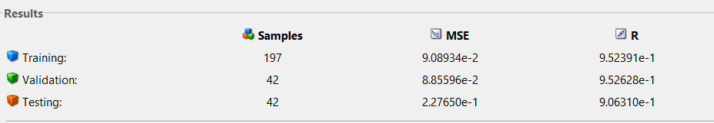

Figure 15: Error metrics

The trained network can then be fed again with the training data set (Figure 16). A good fit with the training data can be already observed here.

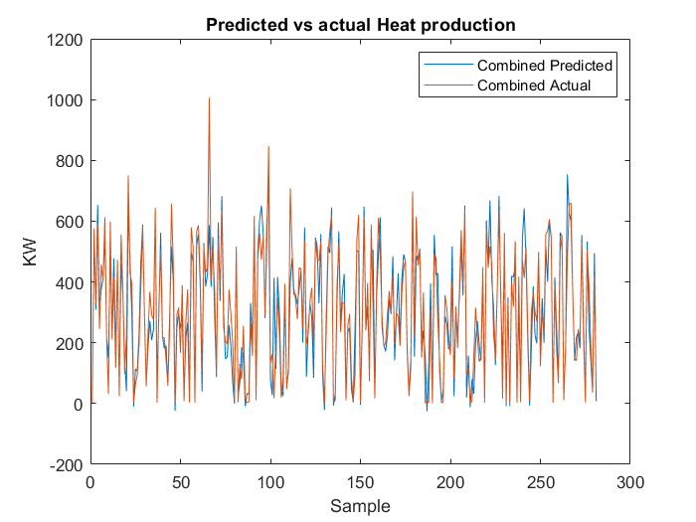

Figure 16: Combined heat production predicted vs actual – Train data

When feeding the NN with the test data, a relatively good prediction can be seen (Figure 17).

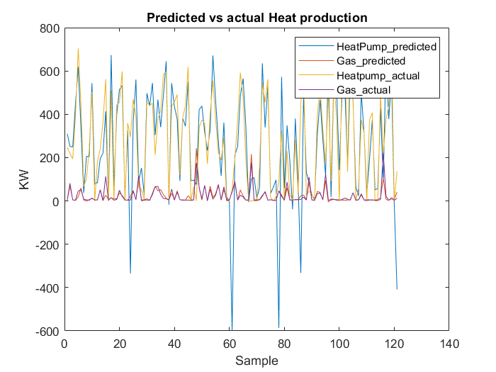

Figure 17: Predicted vs actual Heat production - Test data

There are a few big outliers giving negative heat production for the heat pump (Figure 17).

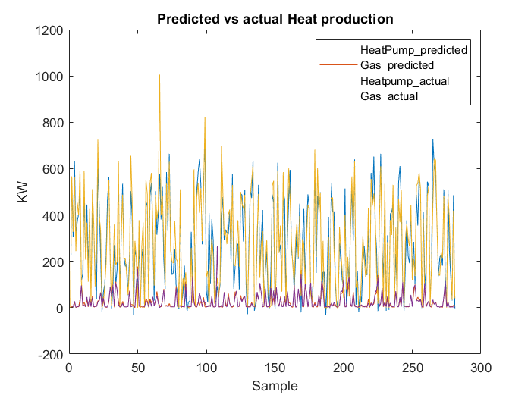

Figure 18: Predicted vs actual Heat production - Training data

This behavior cannot be spotted on the training data (Figure 18) and was never observed for previous training attempts.

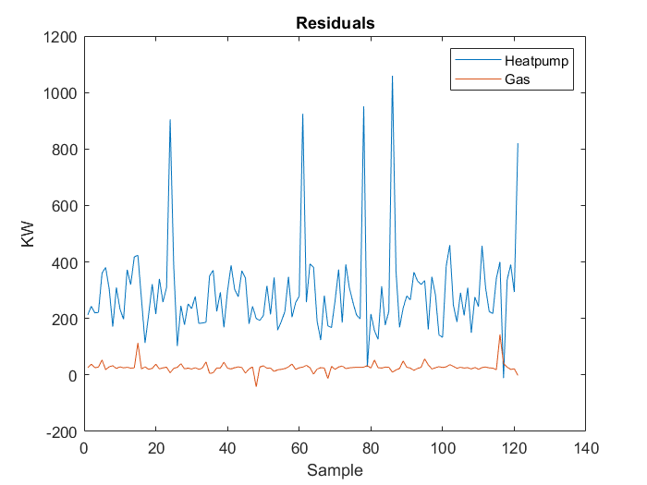

Figure 19: Residuals - Test Data

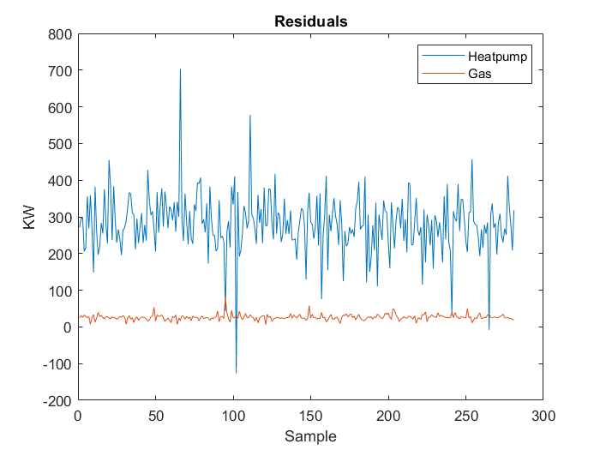

Figure 20: Residuals - Training Data

The residuals both for training (Figure 20) as well as for test data (Figure 19) are roughly in the same range.

It can be assumed, that the negative outliers in the heating prediction of the test set are simply the result of a bad seed.

The MSE (mean squared error) can be found in the following table.

Table 2:MSE(norm)-nftool

|  |  |  |
| --- | --- | --- |
| **MSE (norm)** | **Training Data** | **Test Data** |
| Heat pump | 0.144817 | 0.593376 |
| Gas | 0.044751 | 0.218106 |
| Combined | 0.136688 | 0.586856 |

**Regression MATLAB toolbox**

The regression SVM toolbox in MATLAB was employed. Using the regression model through SVM (Gaussian kernel) function, the root mean square error (RMSE) is very small and so are the other error metrics. A 5-fold cross validation is used to validate the model (Figure 21).

Cross validation is also called a rotation estimation. It’s very easy to see how accurately the predictive model will perform in practical settings. The data is divided into 5 portions of test data sets and training data sets for each iteration. The same test set is not used for all iterations. This testing is just an internal metric of the toolbox and can be seen as part of the training algorithm. It is independent of the initial splitting into test and training data. The cross validation is purely run on the training data. This cross validation is part of the toolbox and can’t be removed.

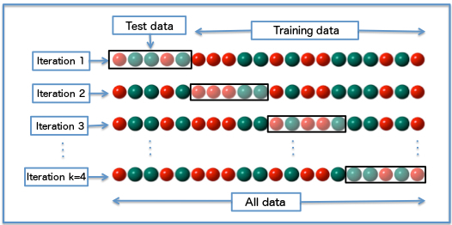

Figure 21: k-fold cross validation

The error metrics RMSE, R-Squared, MSE and MAE as given by the toolbox are observed and all of them are small (Figure 22).

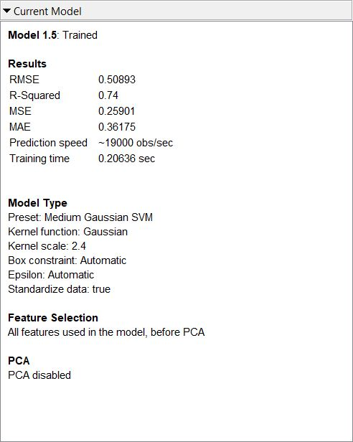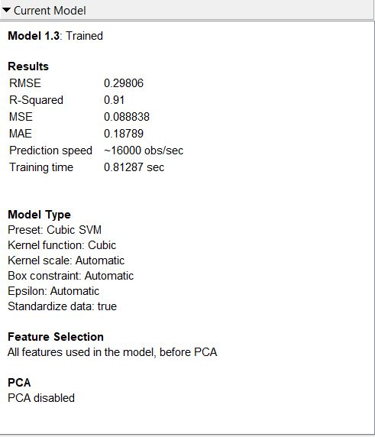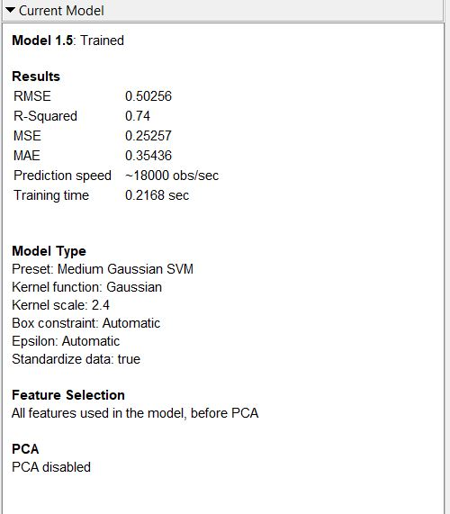

Figure 22: Error metrics and parameters for Heat pump (left), Gas (middle) and combined (right)

In the graph below (Figure 23), the graph corresponds to the **actual** heat production and the **predicted** heat production as given by the toolbox. It can be seen here that there is a good correlation between the output (heat demand) and the temperature (x-axis, column_1).

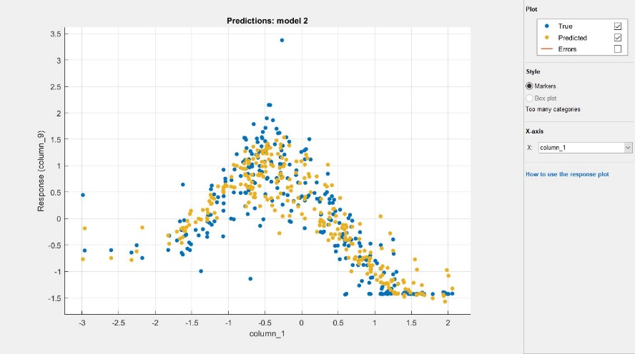

Figure 23: Predicted vs actual heat demand based on temperature

The graph below (Figure 24) shows the fit of the actual and predicted responses as given by the toolbox. The linear graph is the ideal fit. The closer the points are to each other and the ideal line, better the fit. As can be seen, it’s a good prediction model.

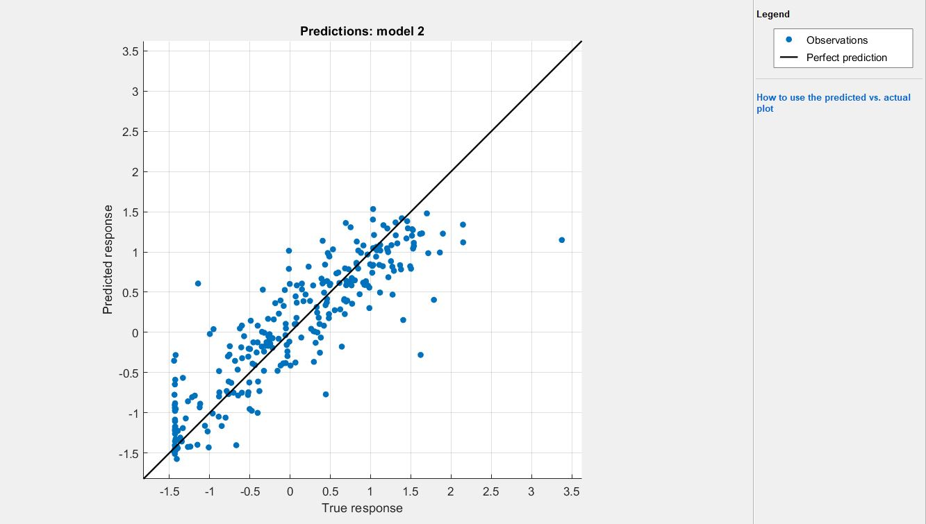

Figure 24: Fit of normalised predicted and actual outputs of heat demand

The graph below (Figure 25) shows the residuals as given by the toolbox with respect to the predicted response. For the normalised values that range between -1.5 and 1.5, the residuals are lower for the lower end and increases with an increase in normalised values.

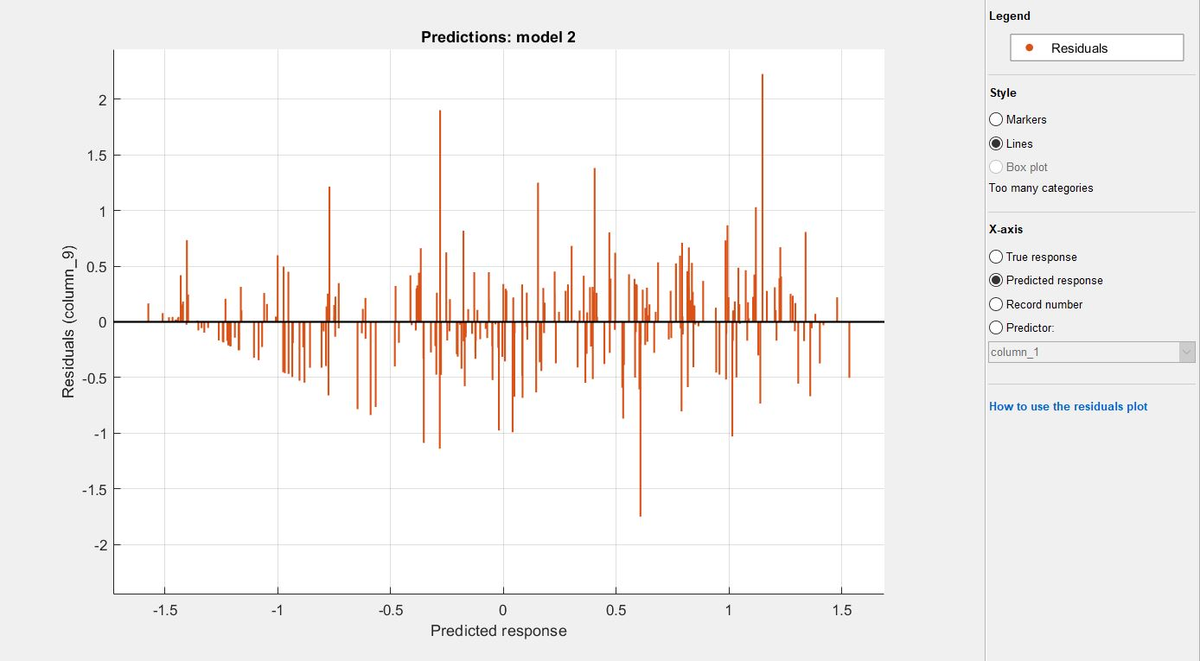

Figure 25: Residuals for predicted heat demand

When feeding the model with the training data, a good fit can be already observed for the combined output (Figure 26).

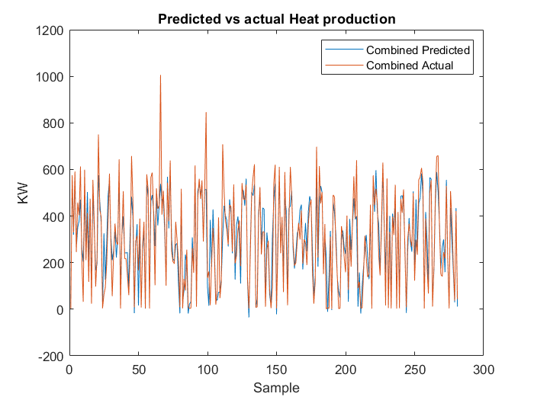

Figure 26: SVM - combined heat production predicted vs actual output- Train Data

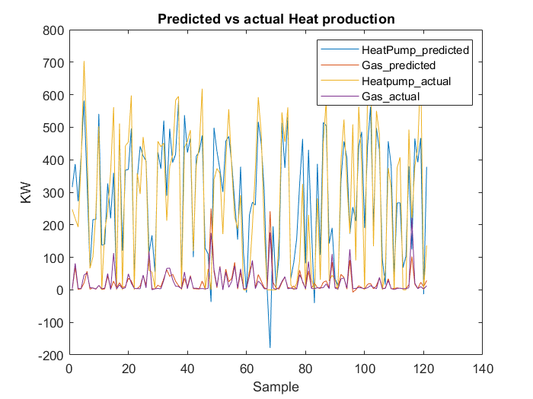

Figure 27: SVM - Predicted Heat production vs actual Heat production -Test Data

The predictions on the test data match the expected values well, especially the prediction of Gas Heat production (Figure 27). The match with the training set does not show any significant unexpected predictions (Figure 28).

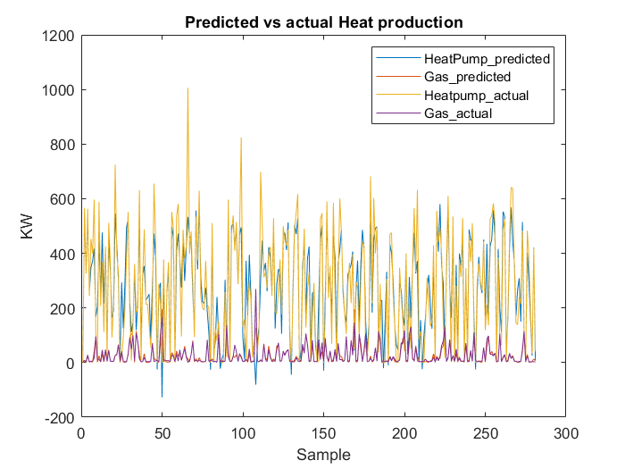

Figure 28:SVM - Predicted Heat production vs actual Heat production -Training Data

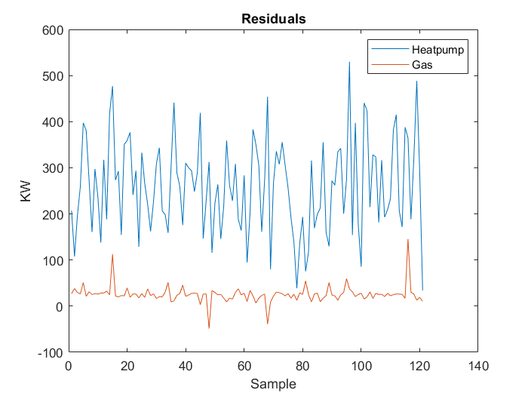

Figure 29: SVM- Residuals -Test Data

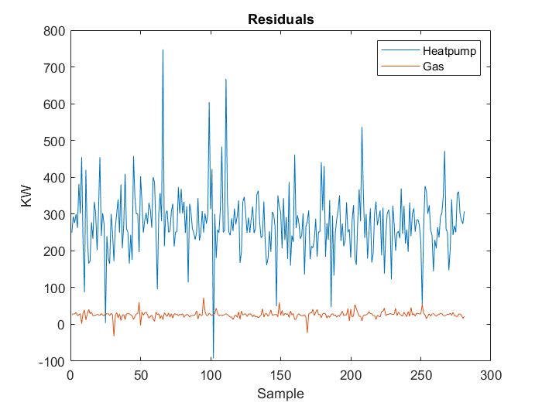

Figure 30: SVM - Residuals - Training Data

The residuals for both training (Figure 30) and test data (Figure 29) lie within the same range.

Below, the MSE table can be found.

Table 3: MSE(norm)-SVM (regression toolbox)

|  |  |  |
| --- | --- | --- |
| **MSE (norm)** | **Training Data** | **Test Data** |
| Heat pump | 0.178197 | 0.238478 |
| Gas | 0.060874 | 0.249772 |
| Combined | 0.167937 | 0.245215 |

**Retrain the physical model using machine learning.**

In this chapter the model in chapter 1 have been reused to extract a heat demand from the house and applied a nonlinear machine learning technique (Levenberg-Marquardt backpropagation) with the help from Matlab toolbox.

The input data is from NEN5060, the heat demand output come from Simulink model in chapter 1. The data again has been split up into training- test- and validation- set.

The result with zoom in has been shows on the picture below, the prediction fit nicely with the heat demand from Simulink model.

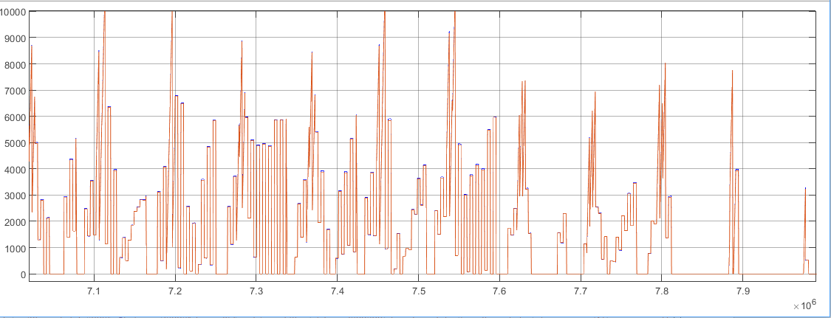

1. **Conclusion**

From the Simulation results it could be seen, that the data gives enough information for prediction. An improvement on the dataset would provide better results with any prediction method.

The SVM with the regression toolbox can find a correlation in the data, especially with the temperature input. The MSE for the SVM are even better than the ones of the neural network generated with the toolbox. Also, the MSE on the test data is best for the SVM generated with the regression toolbox. Although it needs training for each output individually, the SVM gives the best predictions.

References

AgenschapNL (2011) Voorbeeldwoningen 2011 Bestaande bouw, Agenschap NL, Sittard, the Netherlands.

Bacher P., Madsen H. (2011) Identifying suitable models for the heat dynamics of buildings, Energy and Buildings, 43-11, pp. 1511-1522.

Bagheri A., Feldheim V. and Ioakimidis C. S. (2018) On the Evolution and Application of the ThermalNetwork Method for Energy Assessments in Buildings, Energies, 11, pp. 890.

Coakley D., Raftery P. and Keane M. (2014), A review of methods to match building energy simulation models to measured data, Renewable and Sustainable Energy Reviews, 37, pp.123-141.

Fraisse G., Viardot C., Lafabrie O. and Achard G. (2002) Development of a simplified and accurate building model based on electrical analogy, Energy and Buildings, 34-10, pp. 1017-1031.

Koninklijk Nederlands Normalisatie‐instituut (2018) NEN5060:2018, Hygrothermal performance of buildings ‐ Climatic reference data.

Ramallo-González A.P., Eames M.E. and Coley D. A. (2013) Lumped parameter models for building thermal modelling: An analytic approach to simplifying complex multi-layered constructions, Energy and Buildings, 60, pp. 174-184.

**Appendix I. Code Initialization file ‘init_dwelling’**

1 % Initialization Dwelling

2 % 3 September 2018 (cleaned version from 10 July 2018)

3 % Arie Taal, Baldiri Salcedo HHS

4

5

6 %% Predefined variables

7

8 rho_air=1.20; % density air in [kg/m3]

9 c_air=1005; % specific heat capacity air [J/kgK]

10 alpha_i_facade=8;

11 alpha_e_facade=23;

12 alpha_internal_mass=8;

13

14 %% Variables from Simulink model, dwelling mask

15

16 % Floor and internal walls construction.

17 % It is possible to choose between light, middle or heavy weight construction

18

19 if N_internal_mass==1 % Light weight construction

20

21 c_internal_mass=840; % Specific heat capacity construction [J/kgK]

22 th_internal_mass=0.1; % Construction thickness [m]

23 rho_internal_mass=500; % Density construction in [kg/m3]

24

25 elseif N_internal_mass==2 % Middle weight construction

26

27 c_internal_mass=840; % Specific heat capacity construction [J/kgK]

28 th_internal_mass=0.1; % Construction thickness [m]

29 rho_internal_mass=1000; % Density construction in [kg/m3]

30

31 else % Heavy weight construction

32

33 c_internal_mass=840; % Specific heat capacity construction [J/kgK]

34 th_internal_mass=0.2; % Construction thickness [m]

35 rho_internal_mass=2500; % Density construction in [kg/m3]

36 end

37

38 Aglass=sum(glass); % Sum of all glass surfaces [m2]

39 V_internal_mass=A_internal_mass*th_internal_mass; % Volume floor and internal walls

construction [m3]

40 qV=(n*V_dwelling)/3600; % Ventilation, volume air flow [m3/s]

41 qm=qV*rho_air; % Ventilation, mass air flow [kg/s]

42

43 %% Dwelling temperatures calculation

44

45 % Calculation of the resistances

46 Rair_wall=1/(A_internal_mass*alpha_internal_mass); % Resistance indoor air-wall

47 U=1/(1/alpha_i_facade+Rc_facade+1/alpha_e_facade); % U-value indoor air-facade

48 Rair_outdoor=1/(A_facade*U+Aglass*Uglass+qm*c_air); % Resitance indoor air-outdoor air

49

50 % Calculation of the capacities

51 Cair=rho_internal_mass*c_internal_mass*V_internal_mass/2+ rho_air*c_air*V_dwelling; % Capacity indoor air + walls

52 Cwall=rho_internal_mass*c_internal_mass*V_internal_mass/2% Capacity walls

53

54 % State space equations

55 % dTair/dt=a11.Tair+a12.Twall+b11.Toutdoor+b12.Qinst+b13.Qinternal+b14.Qsolar

56 % dTwall/dt=a21.Tair+a22.Twall+b21.Toutdoor+b22.Qinst+b23.Qinternal+b24.Qsolar

57

58 % Calculation of the matrix elements

59 a11=-1/(Rair_wall*Cair)-1/(Rair_outdoor*Cair);

60 a12=1/(Rair_wall*Cair);

61 a21=1/(Rair_wall*Cwall);

62 a22=-1/(Rair_wall*Cwall);

63

64 b11=1/(Rair_outdoor*Cair); % Toutdoor

65 b12=1/Cair; % Q installation

66 b13=1/Cair; % Q internal heat gains

67 b14=CF/Cair; % Q solar radiation

68

69 b21=0; % Toutdoor

70 b22=0; % Q installation

71 b23=0; % Q internal heat gains

72 b24=(1-CF)/Cwall % Q solar radiation

73

74 % Calculation of the matrices

75 A=[a11 a12 ; a21 a22];

76 B=[b11 b12 b13 b14 ; b21 b22 b23 b24];

77 C=[1 0 ; 0 1 ]; % dummy T=T

78 D=[0 0 0 0; 0 0 0 0]; % dummy

**Appendix II. Codes m-files for calculation solar irradiation on inclined surfaces**

1. Exchange_NEN5060_3.m

1 % Exchange_NEN5060_3.m

2 %

3 % Exchange of NEN5060 data in climate files for Matlab/ Simulink

4 %

5 % Exchange of NEN5060_2008 data in Excel format to a mat-file with irradiation

6 % for irradiation on S, SW, W, NW, N, NE, E, SE and horizontal

7 % and Toutdoor

8 % Irradiation can be used for solar irradiation on windows

9 % version September 17th 2018

10 % by Arie Taal THUAS (The Hague University of Applied Sciences)

11

12 rground=0; % ground reflection is ignored

13 for k=1:4

14

15 if k==1

16 [NUM,TXT,RAW]=xlsread('NEN5060-A2.xls',1); % this file is part of NEN 5060 2008

17 elseif k==2

18 [NUM,TXT,RAW]=xlsread('NEN5060-B2.xls',1);

19 elseif k==3

20 [NUM,TXT,RAW]=xlsread('NEN5060-B2.xls',2);

21 else

22 [NUM,TXT,RAW]=xlsread('NEN5060-B2.xls',3);

23 end

24

25 t=((1:8760)'-1)*3600;

26 dom=NUM(:,3); % day of month

27 hod=NUM(:,4); % hour of day

28 qglob_hor=NUM(:,5);

29 qdiff_hor=NUM(:,6);

30 qdir_hor=NUM(:,7);

31 qdir_nor=NUM(:,8);

32 Toutdoor=NUM(:,9)/10;

33 phioutdoor=NUM(:,10);

34 xoutdoor=NUM(:,11)/10;

35 pdamp=NUM(:,12);

36 vwind=NUM(:,13)/10; % at 10 m height

37 dirwind=NUM(:,14);

38 cloud=NUM(:,15)/10;

39 rain=NUM(:,16)/10;

40

41 for j=1:9

42 if j<9

43 gamma=45*(j-1);

44 beta=90;

45 else

46 gamma=90;

47 beta=0;

48 end

49 for i=1:8760

50 E(i,j)=qsun(t(i),qdiff_hor(i),qdir_nor(i),gamma,beta,rground);

51 end

52 end

53 qsunS=horzcat(t,E(:,1));

54 qsunSW=horzcat(t,E(:,2));

55 qsunW=horzcat(t,E(:,3));

56 qsunNW=horzcat(t,E(:,4));

57 qsunN=horzcat(t,E(:,5));

58 qsunNE=horzcat(t,E(:,6));

59 qsunE=horzcat(t,E(:,7));

60 qsunSE=horzcat(t,E(:,8));

61 qsunhor=horzcat(t,E(:,9));

62 Tout=horzcat(t,Toutdoor);

63 phiout=horzcat(t,phioutdoor);

64 xout=horzcat(t,xoutdoor);

65 pout=horzcat(t,pdamp);

66 vout=horzcat(t,vwind);

67 dirvout=horzcat(t,dirwind);

68 cloudout=horzcat(t,cloud);

69 rainout=horzcat(t,rain);

70

71 if k==1

72 save NEN5060_A2 t Tout qsunS qsunSW qsunW qsunNW qsunN qsunNE qsunE qsunSE ...

73 qsunhor Tout phiout xout pout vout dirvout cloudout rainout

74 elseif k==2

75 save NEN5060_B2_1 t Tout qsunS qsunSW qsunW qsunNW qsunN qsunNE qsunE qsunSE ...

76 qsunhor Tout phiout xout pout vout dirvout cloudout rainout

77 elseif k==3

78 save NEN5060_B2_2 t Tout qsunS qsunSW qsunW qsunNW qsunN qsunNE qsunE qsunSE ...

79 qsunhor Tout phiout xout pout vout dirvout cloudout rainout

80 elseif k==4

81 save NEN5060_B2_3 t Tout qsunS qsunSW qsunW qsunNW qsunN qsunNE qsunE qsunSE ...

82 qsunhor Tout phiout xout pout vout dirvout cloudout rainout

83 end

84 end