Description of CurrClust – The Currency Clusterer Application

András Horváth, April 24, 2017

# Background

The volume of currency markets has a daily value nearly five trillion US dollars. The currency exchange rates reflect the economic balance between countries. Trend in exchange rates of a currency is used to evaluate the economic status of a country and widely used as indicators for investment strategies. However, currencies are priced against each other, and neither of them can be regarded as a standard; all the currencies are constantly exposed to fluctuating economic situations. On the foreign exchange market, not only a pair of currencies are traded but the whole market. To get more precise data, we should look at the whole landscape. A possible solution for this problem is to consider all the major currencies and plot the changes in the exchange rates in a multidimensional space. Instead of focusing on individual currency pairs, we can find those which are bound more strongly and set up a tree of relationships.

An approach to determine the similarity between currencies is calculating the correlation between them. Keksina et al. measured the Pearson correlation coefficient between several pair of currencies. The coefficients were applied for average-linkage cluster analysis and a minimum spanning tree was created [1]. This analysis reveals if the value of different currencies are affected by similar economic circumstances and if their exchange rates change similarly.

From clustered currencies, indicators can be extracted about foreign exchange market either to describe trends or to catch impulses [2]. Unbiased indicators are useful tools for those who seek investment in any currencies or for foreign currency traders. Using such tools allows the investor to rely on more exact data than intuitions and helps to plan more successful investment strategies.

# Description of the application

CurrClust, the web application presented here determines the distance between currencies and performs an average-linkage cluster analysis [3]. The data are obtained from the database of the European Central Bank (ECB) consisting historical exchange rates for 33 currencies [4]. To access data within the application, the API from fixer.io [5] was used from where exchange rates can be obtained in json format. The application was written in R using the Shiny package and RStudio.

Instead of using correlations, the change of exchange rates between two time points are used for distance calculation. Therefore, this approach requires less resources and allows short computation time. The changes in exchange rates are regarded as vectors in a space of all currencies. Distances are determined as the cosine (angular) distances between the vectors. In the currency space, neither vectors can be identical since each currency have zero-length vector in its own space. The similarity is therefore determined by the exchange rates with other currencies.

The application performs an average-linkage hierarchical clustering on the distance matrix obtained from cosine distances. The user can subsequently pick up a currency to view the most similar currencies.

# Example of use

On January 15, 2015, The Swiss National Bank decided to end its cap on Swiss Franc. This event was called as “Frankenschock” since it caused turbulence on foreign exchange market [6]. CurrClust was run on the time interval: the day before the “Frankenschock”, January 15, 2015 and a few days later, January 24, 2105. As seen on the clustogram below, the Swiss Franc sharply separated from the rest of the clusters (Figure 1).

**Figure 1.** *Clustogram of the change in currency exchange rates before and after the “Frankenschock” (January 15, 2015)*

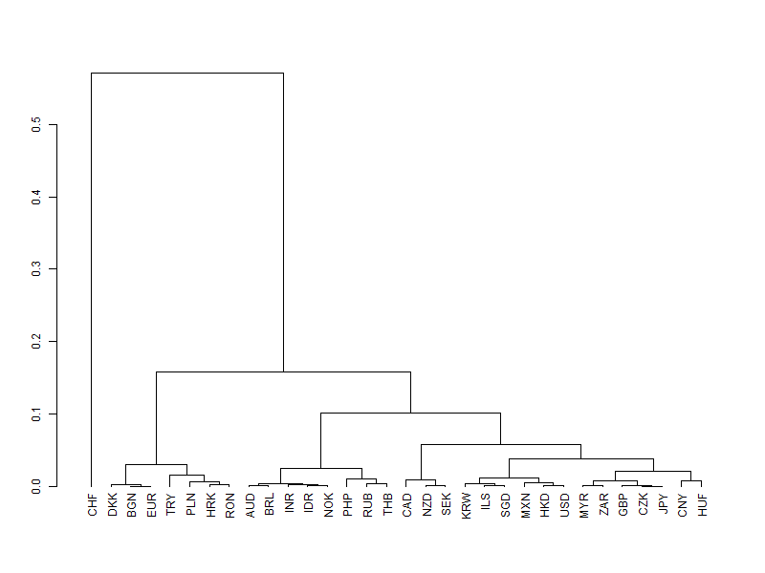

If we look at the most similar currencies to the Swiss Franc in this period, we can see that neither of them has the distance value less than 0.4. After such an event, you might want to find a suitable investment in some currencies: if you want to avoid the negative interest rates of the Swiss Franc, you may choose a currency which is most similar to it. As seen on the list of most similar currencies, your choice might be the Norwegian Krone (Table 1). Though the “Frankenschock” had a strong effect on the foreign currency market, it had the least impact on the Norwegian currency.

**Table 1.** *Most similar currencies to Swiss Franc during the event “Frankenschock”*

|  |  |  |
| --- | --- | --- |
| **Rank** | **Currency** | **Distance** |
| 1 | Norwegian Krone (NOK) | 0.4135439 |
| 2 | Indonesian Rupiah (IDR) | 0.4139164 |
| 3 | Indian Rupee (INR) | 0.4154081 |
| 4 | Brazil Real (BRL) | 0.4167193 |
| 5 | Australian Dollar (AUD) | 0.4173824 |

# Further developmental goals

* Other data sources can be used to obtain exchange rates. However, these data sources may not be freely accessible.
* Instead of the two endpoint vectors of a time interval, correlation coefficients can be used to determine distances. However, the analysis of a whole-time series would require more data processing including smoothing via moving average or phase synchronization. This approach would require more computational resource on the server side, therefore server development would be required.
* Indicators will be developed which can be useful for prediction. For example, a measure will be introduced which finds the largest momentum in the fluctuations of exchange rates to find the optimal choice for investment.

# References

1. Topology of the correlation networks among major currencies using hierarchical structure methods; Mustafa Keskina, Bayram Devirenb and Yusuf Kocakaplanc; Physica A: Statistical Mechanics and its Applications; Volume 390, Issue 4, 15 February 2011, Pages 719–730
2. THEORETICAL BASIS OF BUILDING CLUSTER INDICATORS FOR FOREX; Simeon Semenych; Metatrader, 2007; <https://www.mql5.com/en/articles/1464>
3. <https://stat.ethz.ch/R-manual/R-devel/library/stats/html/hclust.html>
4. <http://www.ecb.europa.eu/stats/policy_and_exchange_rates/euro_reference_exchange_rates/html/index.en.html>
5. <https://github.com/hakanensari/fixer-io>
6. <http://www.swissinfo.ch/eng/business/strong-franc_counting-the-cost-of--frankenshock-/41882280>