# Request Throttling by Custom Key

In this hands-on exercise, service requests are throttled by a custom key – such as an IP Address or any HTTP header value.

1. Go to policy editor of **getProduct** operation of Products service.
2. Add the “Limit call rate per key” policy to the inbound section of the service as shown below.

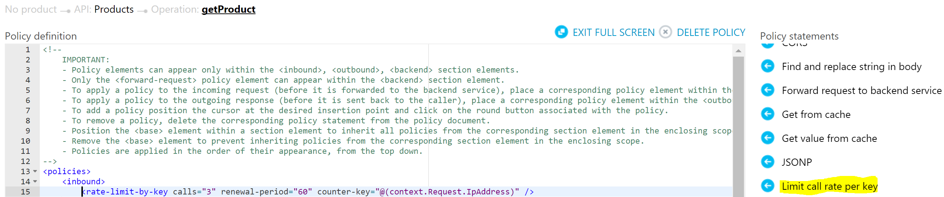

Alternatively copy the code in the attached file to the beginning of in the inbound section of the policy.



1. The above policy ensures that the service can be accessed by an IP address only 3 times within a 60 second period.
2. Access the Products service (<https://pgecommerce.azure-api.net/products/47400656109>) 3 times within a minute and note that it returns results.
3. Access the service 4th time within a minute and note that it returns a HTTP 429 error code as shown below.

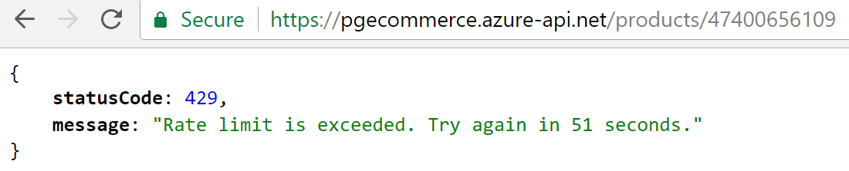

1. Comment out or delete the policy that was just configured – this is in preparation for the remaining hands-on.

# References

* Protect API with rate limits – <https://docs.microsoft.com/en-us/azure/api-management/api-management-howto-product-with-rules>
* Advanced Request Throttling – <https://docs.microsoft.com/en-us/azure/api-management/api-management-sample-flexible-throttling>