Create a new drupal module
20 Mei 2015
11:44

- Create a folder under ..\sites\all\modules. Example: ..\sites\all\modules\first
- Open 'first" folder then create two files, "first.info" and "first.module", also "first.test" (optional)
- Open file "first.info" and write code as follows:

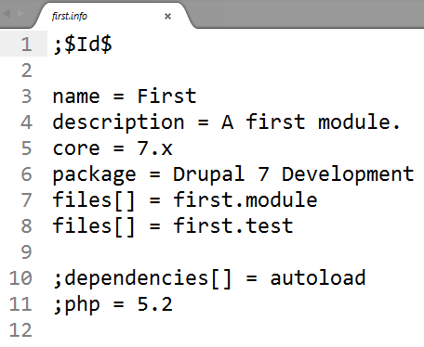

;$Id$ > this code must be like that
name = First
description =
core = 7.x //version of drupal
package = Drupal 7 Development
files[] = first.module
files[] = first.test

line 10 & 11 are ignored

- Open "first.module" and write code as follows:

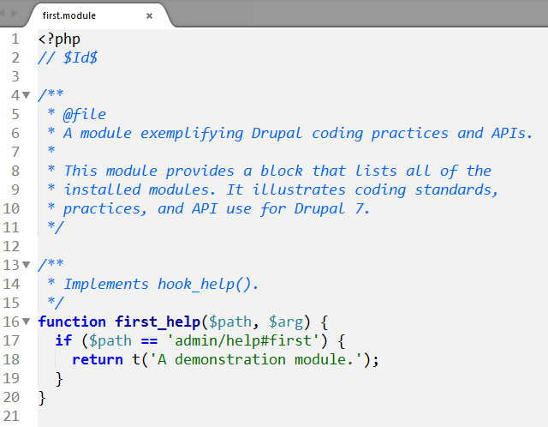
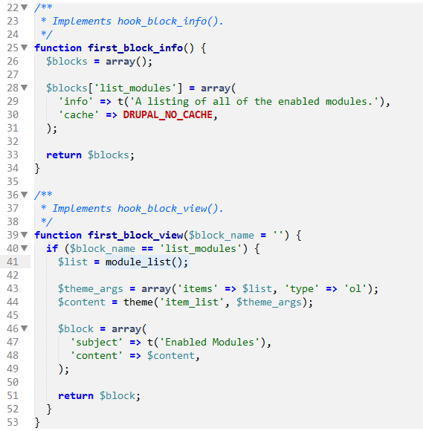

To enable & show the "first" module
- login as administrator
- click menu Modules, you will see "First" module in the bottom of list under "Drupal 7 Development" group.
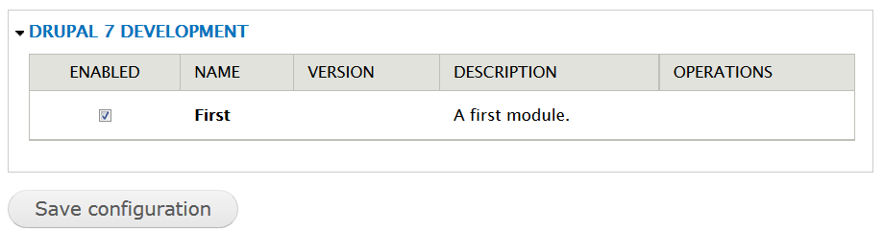

to activate "First" module, tick/checked in the "ENABLE" column, as shown in the picture above. Then click button "Save confuguration".

- to show First Module: go to "Structure" menu > click "Blocks", screen will display list block as follow:
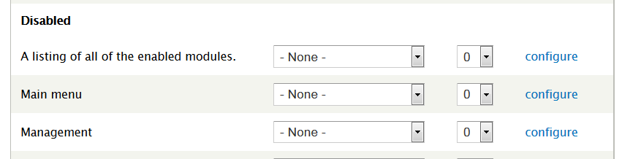

then select location where the First module (block) will be displayed, example : "sidebar second" then click "Save Block" button.

another good example can be download from "Example" Project drupal development: https://www.drupal.org/project/examples
extract under ".\site\all\modules" folder.

