Introduction
25 Februari 2015
11:10

CLIENT’S PROBLEM STATEMENT
I need to have you develop a website system which enables me to create, edit, delete as many web pages as possible with easy to administrate dashboard. Website system should also have ability to protect some of web pages to show to only accessible users. Additionaly, I will also need ability to manage widgets that apears on sidebar areas of website. Abilty to change the theme of website at anytime.

ANALYSIS OF CLIENT’S PROBLEM STATEMENT
Based on problem statement of client, we need to develop a complete content management system which enables the client to manage website.
  - Management of Webpages Content. (Main Requirment of Client)
  - Access control on content
  - Widgets at sidebar of website.
  - Theming/Templating capability

OUR APROACH OF DEVELOPING CMS
We will use object-oriented programing(OOP) techniques to develop this CMS. Object-oriented programing helps to create stable, modular and manageble code.

When an architect creates a building, he will make sure to have is base. Every building in the world stands on its base.

Likewise we need to have a base of our CMS.The rest of CMS will be stand upon that base. So, in short we have four modules and one base.

CMS Modules
  - Webpages Content Management (This is the module for the Main Requirement of Client)
  - Access Control
  - Widgets Management
  - Templating/Theming Management
  - CMS Base

The Base of website will contain objects which will be common for all of the modules like accessing database. Since “Access Control” module has functionality which will be required by all of other modules so instead of putting it seperately. It should be part of Base of our CMS.

So “Access Control” module should be merged into Base of CMS. Now 5 CMS modules have striped to 4 modules which are as fellows.

CMS Modules Revised
  - Webpages Content Management (This is the module for the Main Requirement of Client)
  - Widgets Management
  - Templating/Theming Management
  - CMS Base

Below is the abstract diagram of our current CMS structure.

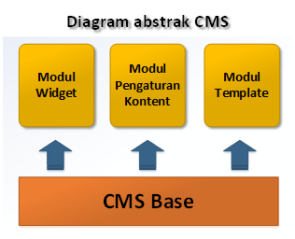
BASIC ARCHITECTURE of CMS system

In the next post, We will start coding.

Using GIT to maintance a project in github.com

  - Create freee ACOOUNT at http://github.com, ex: 'handaga', link of our project is http://github.com/handaga

  - Create 'NEW REPOSITORY' as our project location, name it as 'mycms'
  - Install git software, that can download from this link http://www.git-scm.com/
  - Run 'Git-Bash'
  - From Git-Bash (interface), Goto Folder where you save your project in local system,
'$ cd /c/wamp/www '
  - CLONE / copy 'master ' project from github.com, using this command:
'$ git clone https://github.com/handaga/mycms'
…
$ git clone https://github.com/handaga/mycms
Cloning into 'mycms'...
remote: Counting objects: 3, done.
remote: Total 3 (delta 0), reused 0 (delta 0), pack-reused 0
Unpacking objects: 100% (3/3), done.
Checking connectivity... done.
….

  - Go to /c/wamp/www/mycms folder.
'$ cd mycms'
  - copy all of your source code inside subfolder 'mycms', then add to the project using this command
$git add index.php
$git add includes
$git add includes/cmsBase.php
$git add includes/cmsApplications.php
$git add includes/cmsWidget.php
$git add includes/templateFunctions.php
  - do first commit using this command
'$git commit -m "My First Commit"
  - Update our new project to github.com, using this command
$git remote -v (to check remote location)
$git push origin master

NEXT:

Before coding create following directories and files:

Step 1:
Create a folder in www (wamp) or htdocs (xampp) directory of your system. Lets name this folder as “mycms”.

Step 2:
Create another folder inside “mycms” folder and name it “includes” ("mycms/includes")

Step 3:
Create a php file in “mycms” folder. Name it “index.php”. Let it be empty for now.

Step 4:
Create another php file in “mycms/includes/” folder and name it “cmsBase.php”.

Step 5:
Open file “cmsBase.php” and write following code in it.

<?php
class CmsBase{
// Anything here will
// be accessible to all
// of the CMS.
}

After creating Base of CMS, Now we have to create other base classes for other modules of our CMS.

Step 6:
Create a new file in “mycms/includes/” folder with name “cmsApplication.php”.

Step 7:
Open file “cmsApplication.php” and write following code in it.

<?php
require_once('cmsBase.php');
class CmsApplication extends CmsBase{
//Anything here will be accessible in
//main functionality of CMS
}

“CmsApplication” class will be the base class of entire CMS main functionality like displaying “Web pages content”.

Step 8:
Create a new file in “mycms/includes/” folder with name “cmsWidget.php”.

Step 9:
Open file “cmsWidget.php” and write following code in it.

<?php
require_once('cmsBase.php');
class CmsWidget extends CmsBase {
//Anything here will be accessible
// in widget functionality of CMS
}

Step 10:
Create a new file in “mycms/includes/” folder with name “templateFunctions.php”

Step 11:
Open file “templateFunctions.php” and write following code in it.

<?php
require_once('cmsBase.php');
class TemplateFunctions extends CmsBase{
//All CMS template management
//related functions will be here.
}

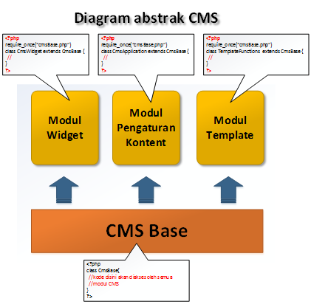

This is the skeleton structure of PHP CMS which we are developing for beginers

