CMS Application
25 Februari 2015
11:25
Hello Everybody, This is the third part of PHP CMS Development from scratch. In previous post, we have created 4 php classes
- CmsBase
- CmsApplication (extends CmsBase)
- CmsWidget (extends CmsBase)
- TemplateFunctions (extends CmsBase)

Now, we are going to define interactions of user with our Cms application. For now user needs two interactions first is to add content and view content. See below the diagram of user interaction with Cms Application.
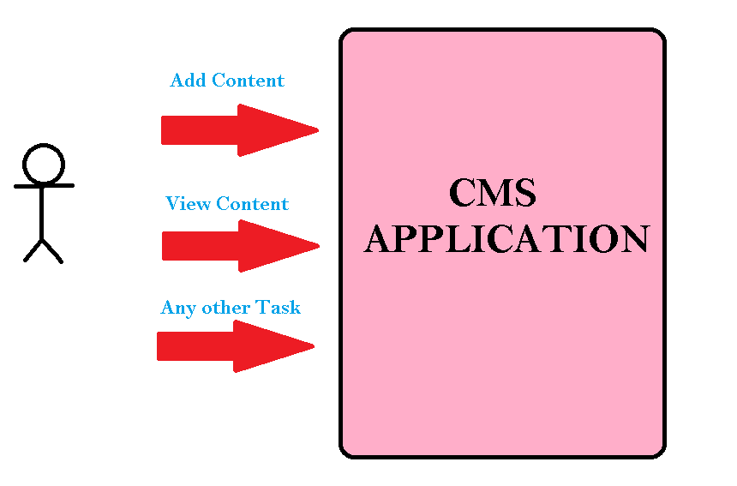
Now open file “mycms/includes/cmsApplication.php” and type into it the following code.

<?php
require_once('cmsBase.php');
class CmsApplication extends CmsBase{
//here we can write as many functions as we want and
//thosefunctions will be called by user directly.

function addcontent()
{
echo 'here add content functionality will takes place';
}

function viewcontent()
{
echo 'here view content functionality will takes place';
}

function anyothertask()
{
echo 'this is another task here can be written a complete php program against that task';
}
}

Now we have to create an object of class “CmsApplication” in file “mycms/index.php” and call its various function based of query string passed in browser.

Open “mycms/index.php” file and type following code into it.

<?php
require_once('includes/cmsApplication.php');
$app=new CmsApplication();
if(isset($_REQUEST['task']))
{
$task=$_REQUEST['task'];
switch($task)
{
case 'addcontent':$app->addcontent();break;
case 'anyothertask':$app->anyothertask();break;
default: $app->viewcontent();break;
}
}
else
{
//if no query string has passed then by default interaction should be view content
$app->viewcontent();
}

Now open browser and type following in url field of browser
- “http://localhost/mycms/index.php” outputs “here view content functionality will takes place”
- “http://localhost/mycms/index.php?task=addcontent” outputs “here add content functionality will takes place”
- “http://localhost/mycms/index.php?task=viewcontent” outputs “here view content functionality will takes place”
- “http://localhost/mycms/index.php?task=anyothertask” outputs “this is another task here can be written a complete php program against that task”

You can see all those outputs are coming from CmsApplication class functions which are maped by 'index.php' file.

For now it is simple php echo statement which outputs text. There can be written a complete processing against each task. For example when user types “http://localhost/mycms/index.php?task=addcontent” , CmsApplication class’ function “addcontent()” is being called.

In the body of that function instead of just echoing text there can be call to database to update database. There can be email sent or There can be run a full-fledge php application.

As you can see there is just a simple output in browser without any template, so in the next session, we will be doing some template work. We will enable our cms to have templating capability.

In previous lesson, we have created possible user interactions/tasks with CMS Application by defining methods in CmsApplication class for each interaction. As many of you already know that Modern CMS enable users to use templates of their own taste. So, we are going to do exactly same for our own CMS.
I am sorry for late post, in fact I had too much busy schedule for last two months anyways its now relaxed. Let’s proceed our journey of CMS development from Scratch.

- Create a new folder ‘mycms/templates’
- Create another folder ‘mycms/templates/default/’
- Create an html file ‘mycms/templates/default/index.html’
- Create a css file ‘mycms/templates/default/css/style.css’

Lets write some HTML for our template in index.html file.

<html>
<head>
<title>This is default template of MyCMS</title>
<link type='text/css' rel='stylesheet' href='css/style.css' />
</head>
<body>
<div class="wrapper">
<div class="header">MyCMS</div>
<div class='clear'></div>
<div class="sidebar">
this is sidebar
<br><br><br><br><br><br><br>
</div>
<div class='content'>
There goes the main content of our cms
<br><br><br><br><br>
</div>
<div class='clear'></div>
<div class="footer">
this is footer text
</div>
</div>
</body>
</html>

Now open file ‘mycms/templates/default/index.html’ directly in your browser, it would output following.
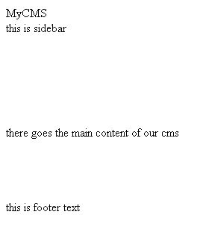
Template without Style

As you can see it is just plain text. This is because we haven’t write style in ‘mycms/templates/default/css/style.css’ file. Now lets write some style of above html.

Open the file ‘mycms/templates/default/css/style.css’ and write following code in it.

.wrapper{width:900px;}
.header{
border:1px solid grey;
background-color:black;
color:white;
font-weight:bold;
font-size:35px;
padding:35px 10px;
}
.sidebar{
width: 170px;
float:left;
padding:5px;
border:1px solid black;
overflow:hidden;
}
.content{
width: 706px;
float: right;
padding: 5px;
}

.footer{
text-align: center;
background: black;
color: white;
padding: 21px 3px;
}
.clear{clear:both;}
Now open up ‘mycms/templates/default/index.html’ file and you will see following.

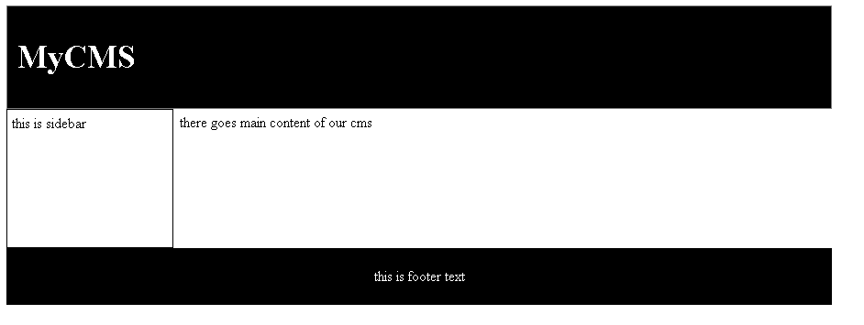
Template with Stylesheet

