php-API-for Android
12 Mei 2015
8:43

Convert movies.json to became php script (as API)

- Create database, (phpmyadmin), example: "movies"
- Create php file to handle, REQUEST from client, apply CRUD operation, produce JSON file as OUTPUT {using function json_encode($OUTPUT) ].

Structure of database from "movies.json" file:

{
"title": "District 9",
"image": "http://10.0.2.2/android/images/2.jpg",
"rating": 8,
"releaseYear": 2009,
"genre": ["Action", "Sci-Fi", "Thriller"]
},

Create 3 Tabel:

- MOVIE: (movieid int PRIMARY_KEY AI, title varchar(50), image_location varchar(100), rating int, releaseYear int )
- GENRE: (genreid int PRIMARY_KEY AI, genre VARCHAR(50))
- GENMOVIE: (gmid int PRIMARY_KEY AI, movieid int, genreid)

Movie table creation

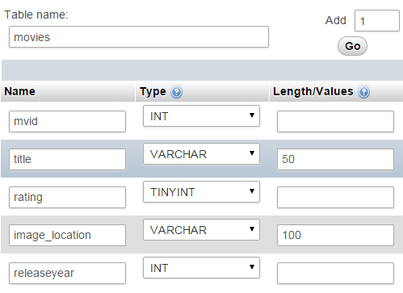

GENRE Tabe;
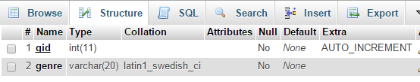

SQL command to read movie data with genre:

read movie with mvid=1 tabel :
"Select * from movies where mvid=1"

Read genre of movie with mvid=1;
" select genre.genre from genre, genmovie
where genmovie.mvid = 1 and
genre.gid = genmovie.gid"

SQL command to create list of movie
with genre inside

"Select * from movies"
for every movie:
select genre.genre, movies.title from genre, genmovie, movies
where genmovie.mvid = movies.mvid and
genre.gid = genmovie.gid

Create php file from
http://10.0.2.2/android/movies.json

- create new php file and save in ..\android folder, example: mives.php;
- code :

<?php
$servername = "localhost";
$username = "root";
$password = ""; //no password
$dbname = "movies";

// Create connection
$conn = new mysqli($servername, $username, $password, $dbname);
// Check connection
if ($conn->connect_error) {
//stop here
die("Connection failed: " . $conn->connect_error);
}

$sql = "SELECT * FROM movies";
$result = $conn->query($sql);

$movies = [];
if ($result->num_rows > 0) {
// output data of each row
while($row = $result->fetch_assoc()) {
$movies[] = $row;
}

echo json_encode($movies);
} else {
echo "0 results";
}
$conn->close();
?>

download php code from http://www.androidhive.info
for another example (Login & registeration using mySQL & SQLite database).

