Login & registration using PHP, MySQL, & SQLite
19 Mei 2015
8:52

Algorithm:
- android: send request (name="user" & password="pass") to server
- server: receive request from client, proceed to validate username & pasword (using PHP script).
- user validation: php will start to connect with DB server (MySQL) then send SQL command to check status of user. ("select * from user_table where username="user" AND password="pass"), if there is a row result from that query, mean user is valid, else create response "USER is invalid" then stop.
- If user Valid: server will send data/profile of user to client (response), and flag that indicate user is valid.
- Android: will create new row (INSERT command) and save profile of user in the local database (SQLite) as SESSION. note: if user logout this data will be deleted (delete COMMAND).

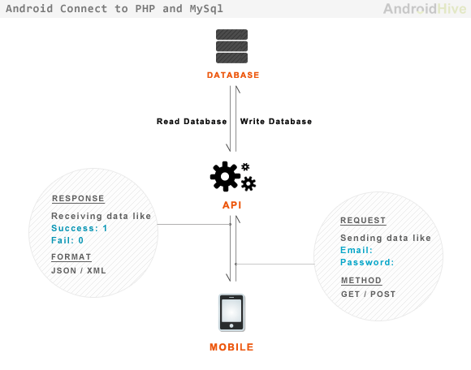

Example project download from this link:
http://www.androidhive.info/2012/01/android-login-and-registration-with-php-mysql-and-sqlite/

note:

modify IP address for targetr server :
src\info.androidhive.loginandregistration\AppConfig.java

change android (4.2.2) type with your android type (4>)

if there is problem with "style.xml", then delete all style.xml in folder \res\values*

WEB SERVER using old version, to change with new version:
- Modify mysql SQL command with mysqli
or install old wamp/xammp one.

