ListView dengan Image (Volley)
17 Maret 2015
8:28

Contoh tampilan ListView yang akan dibuat

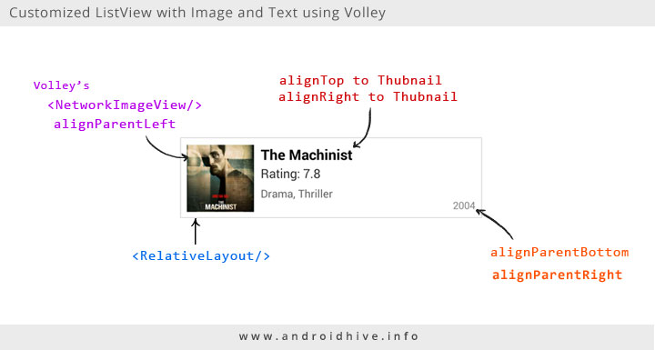

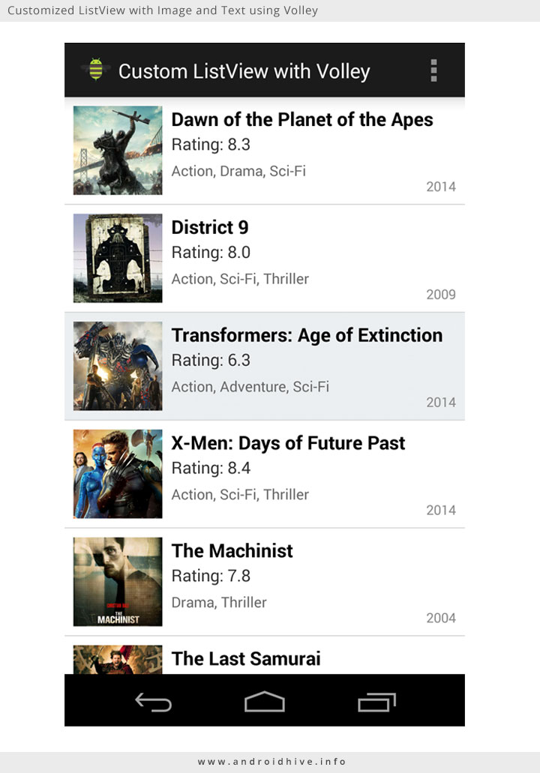

What is Volley?

Android volley is a networking library was introduced to make networking calls much easier, faster without writing tons of code. By default all the volley network calls works asynchronously, so we don’t have to worry about using asynctask anymore.
Volley comes with lot of features. Some of them are
1. Request queuing and prioritization
2. Effective request cache and memory management
(very good to handle image data)
3. Extensibility and customization of the library to our needs
4. Cancelling the requests

Check this link:
http://www.androidhive.info/2014/05/android-working-with-volley-library-1/

Download:
http://api.androidhive.info/volley/volley.jar
then put the Volley.jar file inside folder ../libs

/libs/volley.jar

SEVER SETTING:
download this file and save in your local webserver (XAMP/WAMP)
http://api.androidhive.info/json/movies.json

example:
C:\wamp\www\android\movies.json

DOWNLOAD IMAGES (15 images) from this link
http://api.androidhive.info/json/movies/1.jpg
http://api.androidhive.info/json/movies/2.jpg
http://api.androidhive.info/json/movies/3.jpg
… until
http://api.androidhive.info/json/movies/15.jpg

and save in your local web server like this:

C:\wamp\www\android\images\1.jpg
C:\wamp\www\android\images\2.jpg
C:\wamp\www\android\images\3.jpg
…… until
C:\wamp\www\android\images\15.jpg

then modify link image inside the movies.json file
example:

from:
"image": "http://api.androidhive.info/json/movies/1.jpg"

to
"image": "http://[your ip server]/android/images/1.jpg"

Makesure you have already run your local web server
check this link:

http://localhost/android/movies.json

--------

Once the project is created paste the volley.jar in libs folder.
Create four packages named adapter, app, model and util.

Open colors.xml under res/values and add below colors. If you don’t see colors.xml file, create a new file and add these color values.

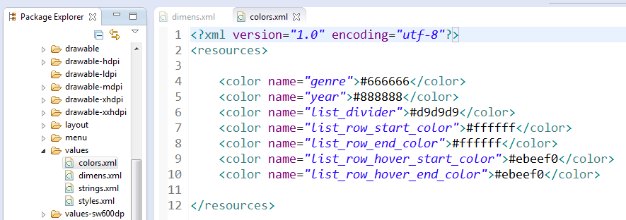

Also add below dimensions in dimens.xml file located under res/values.

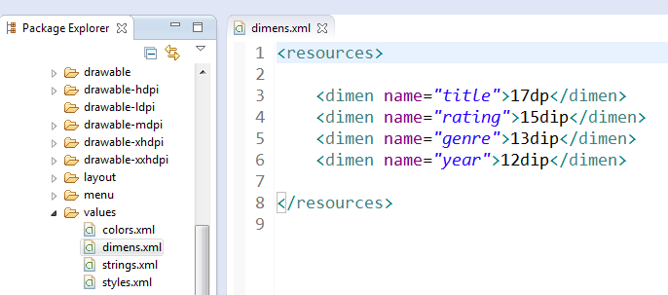

Create
list_row_bg.xml,
list_row_bg_hover.xml and
list_row_selector.xml
with below respective codes under res/drawable folder. If you don’t see drawable folder under res, create a new folder and name it as drawable.

list_row_bg.xml:
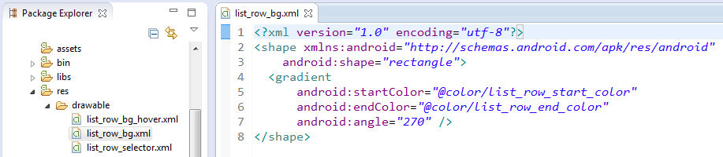

list_row_bg_hover.xml:
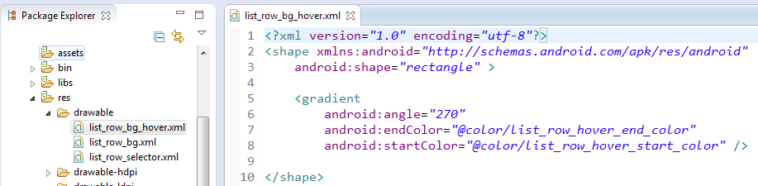

list_row_selector.xml:
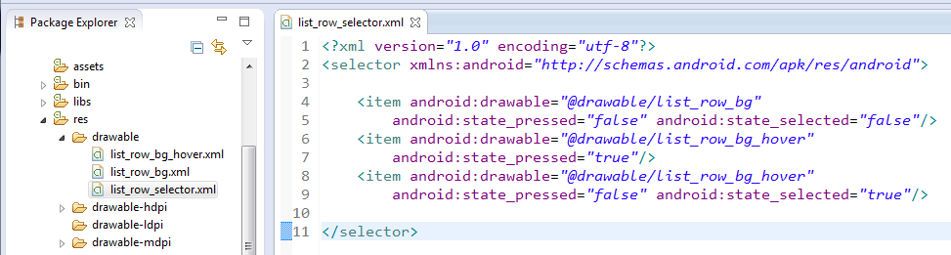

Now open your layout file of main activity (in my case activity_main.xml) and add a ListView element.

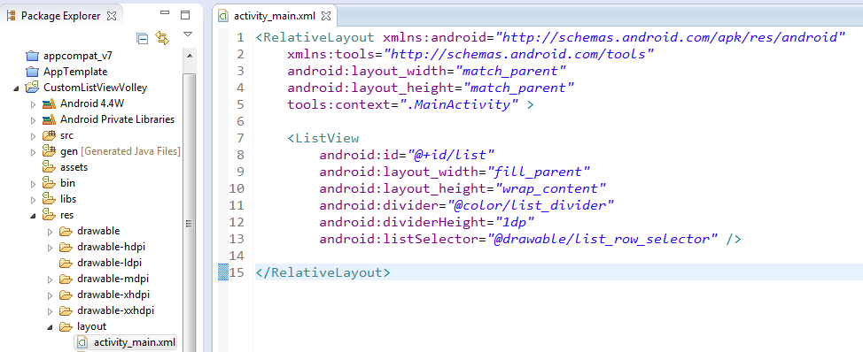

We need to create another layout file for list view row. This is the main design component in this project as we define actual custom list design here. I am naming this file as list_row.xml
[show file here]

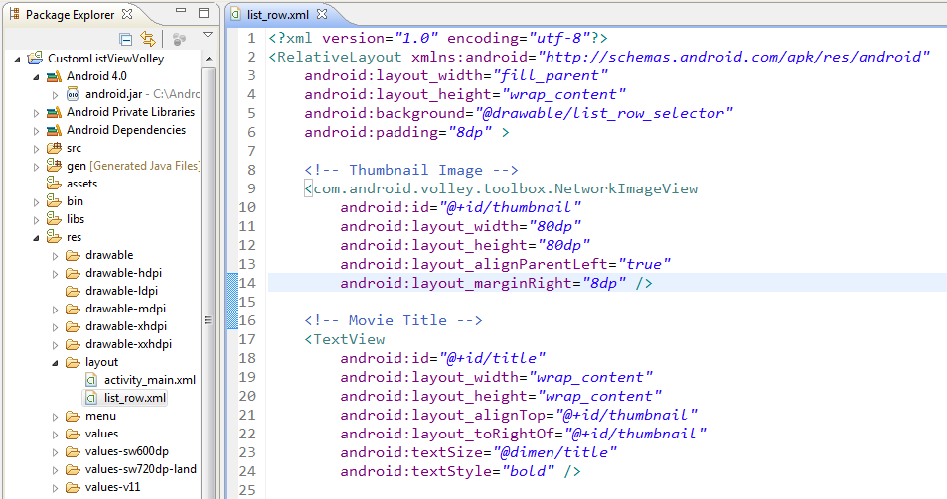
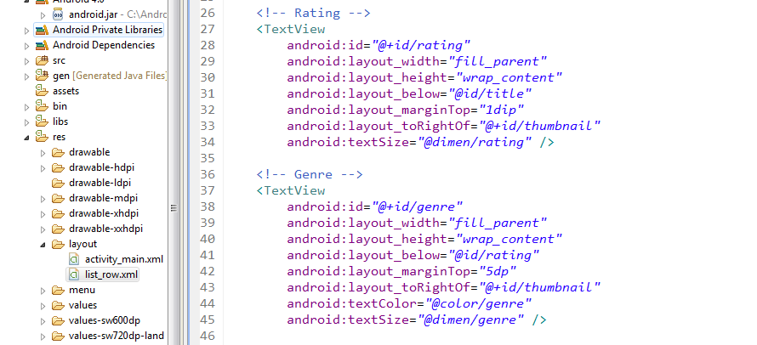
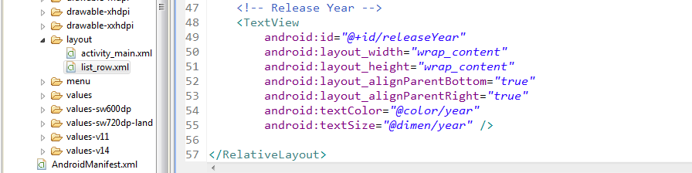

Here we completed the design part. Let’s move to java part.

Create LruBitmapCache.java under util package.
This class takes care of caching images on disk.

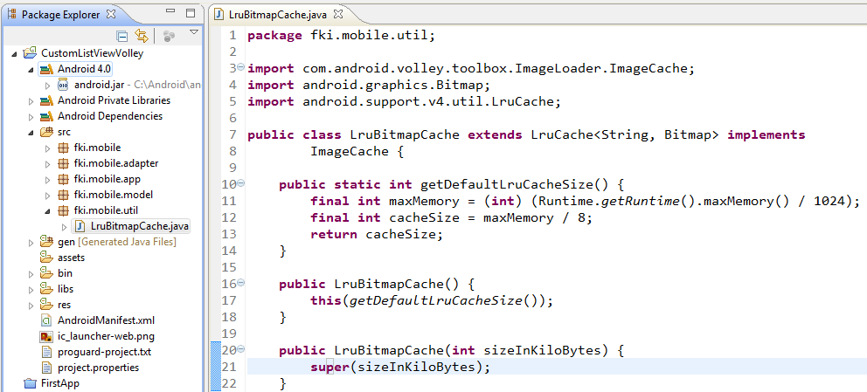
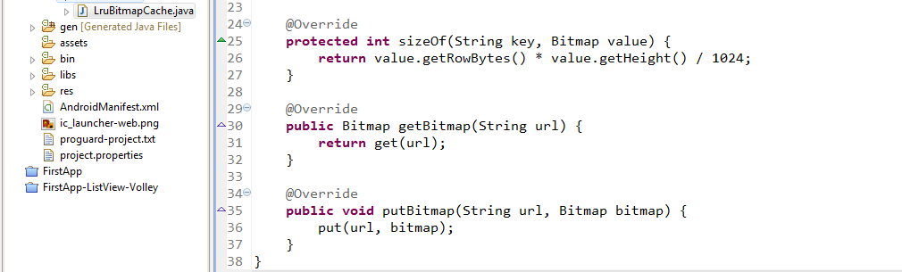

Create AppController.java under app package. This class is a singleton class which initializes core objects of volley library.

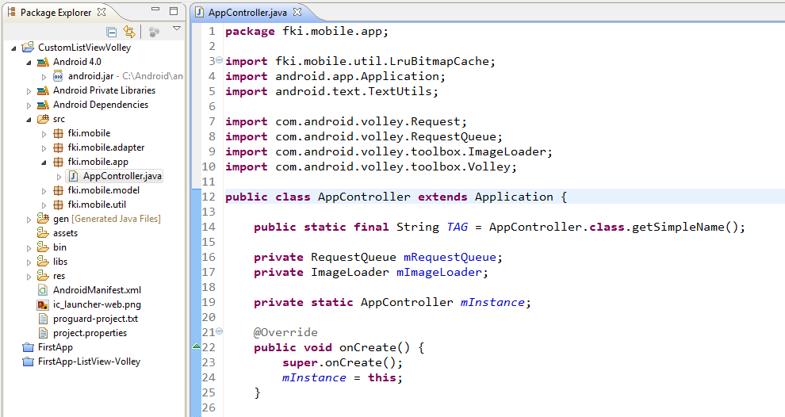
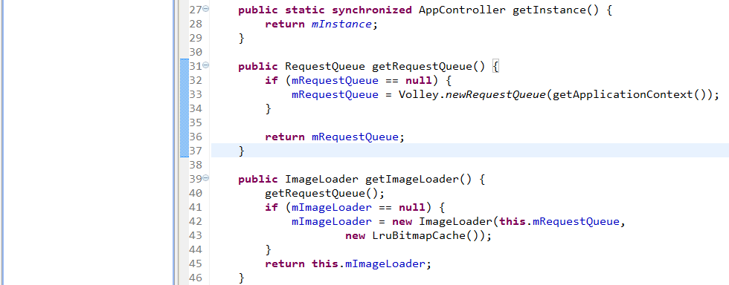
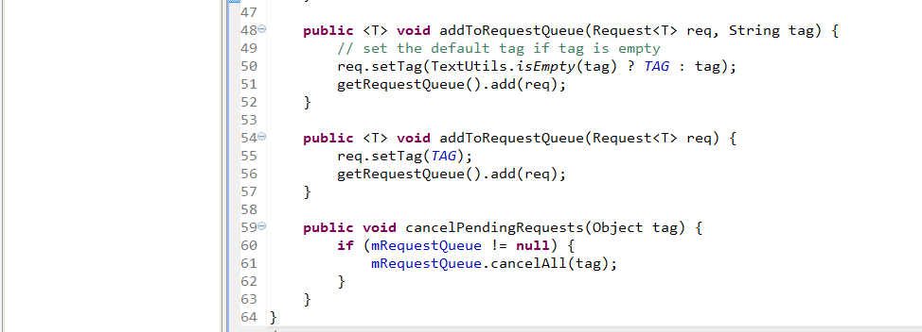

Now add the AppController.java class in AndroidManifest.xml to your <application> tag using name property to execute this class on application start. Also add INTERNET permission as we are going to make network calls.

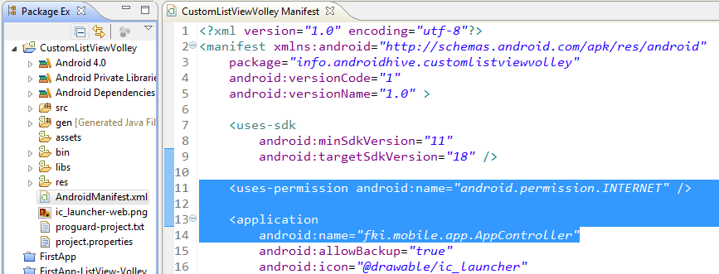
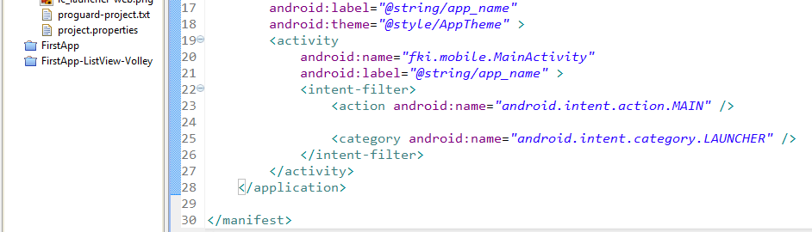

Now create Movie.java under model package. This model class will be used to provide movie objects data to list view after parsing the json.

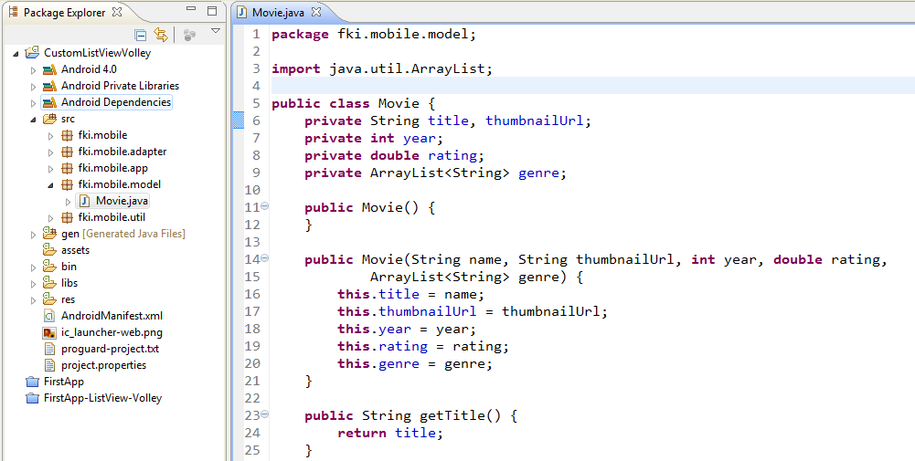
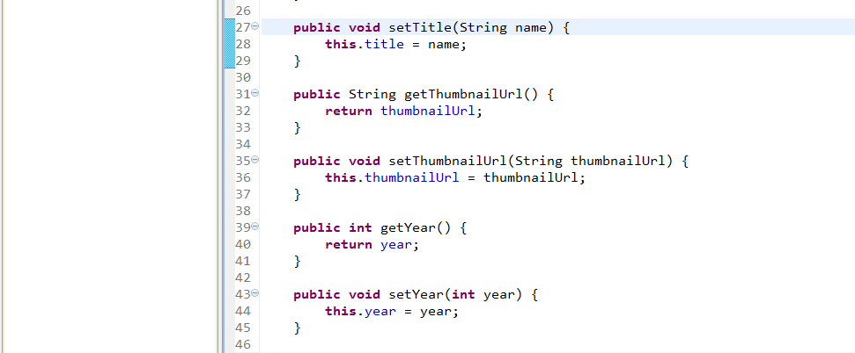
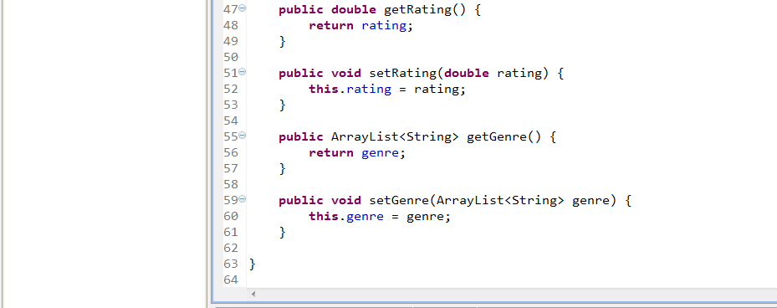

Create a class named CustomListAdapter.java with below code. This is a custom list adapter class which provides data to list view. In other words it renders the layout_row.xml in list by pre-filling appropriate information.

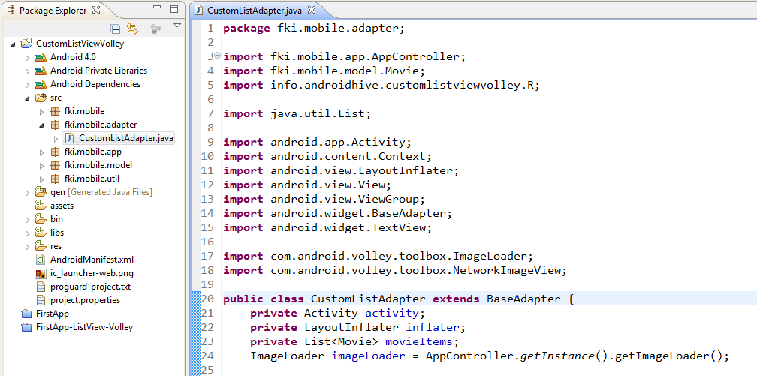
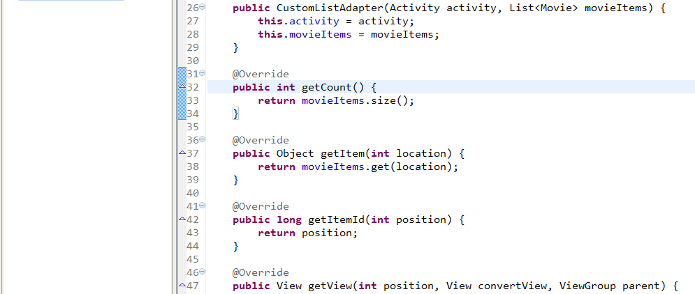
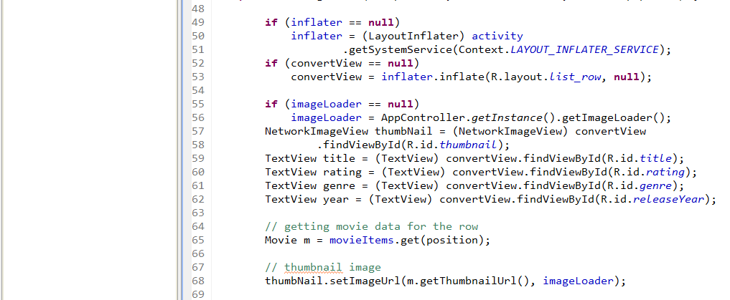
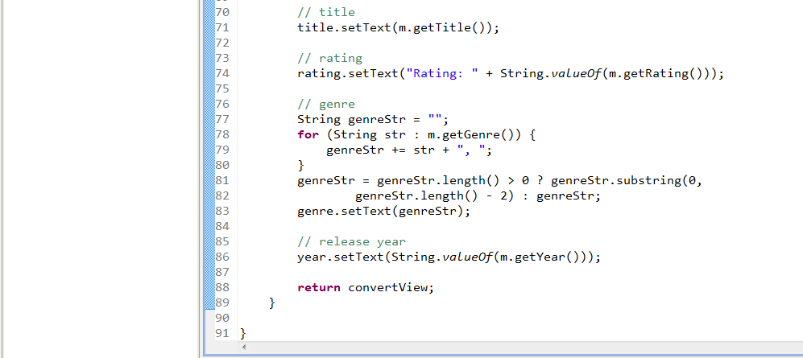

Now open your main activity class (MainActivity.java) and do the below changes. Here I created volley’s JsonArrayRequest to get the json from url. Upon parsing the json, I stored all the json data into an ArrayList as Movie objects. Finally I called notifyDataSetChanged() on CustomListAdapter instance to render the list view with updated information.

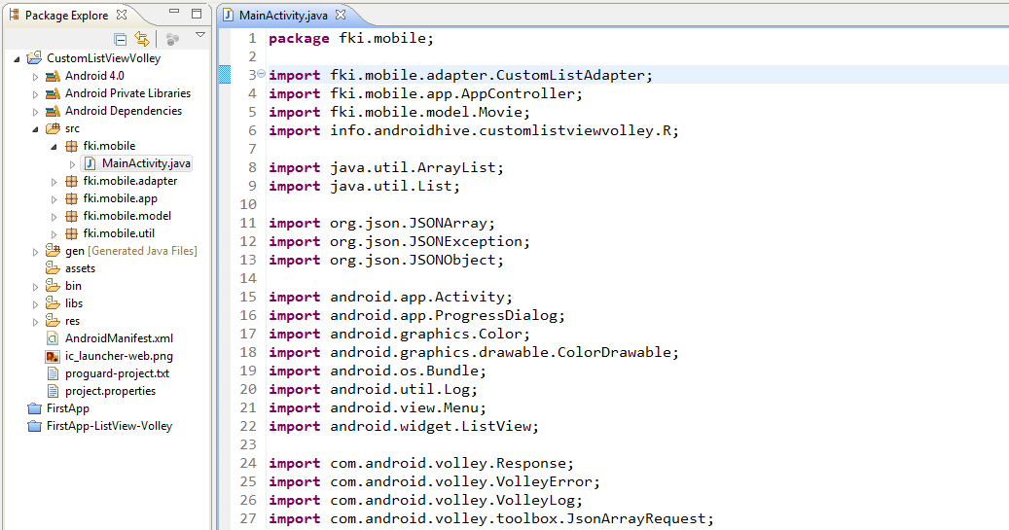
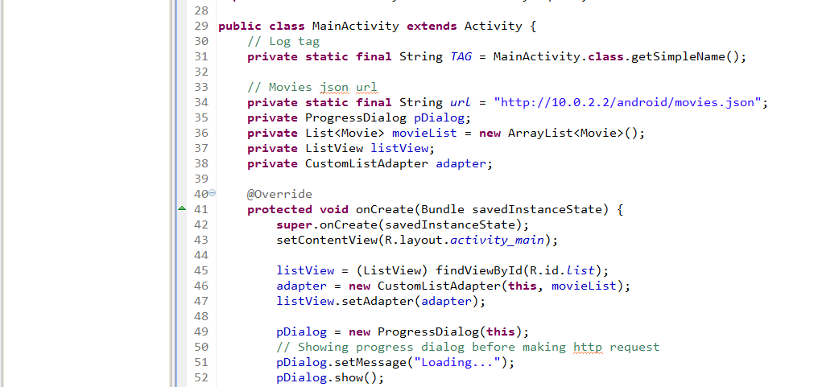
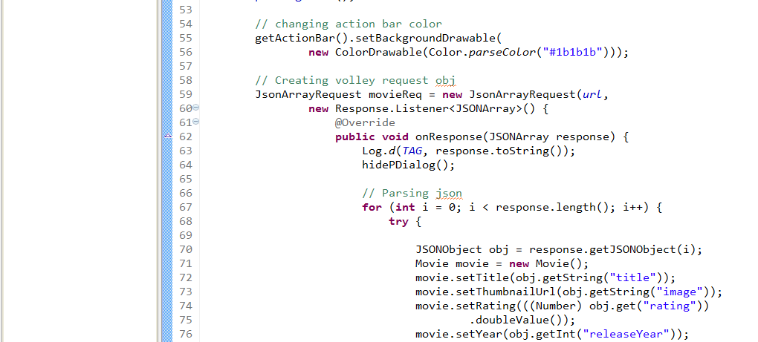
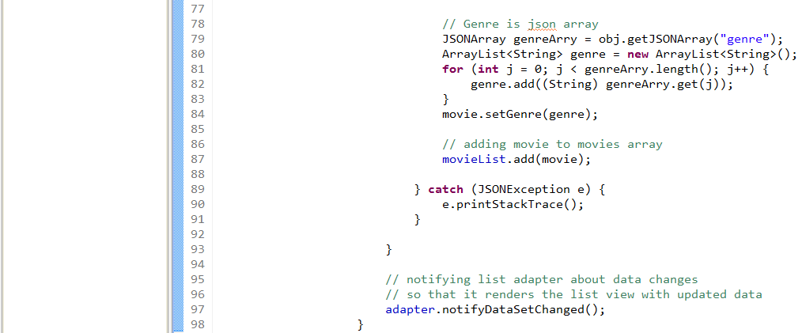
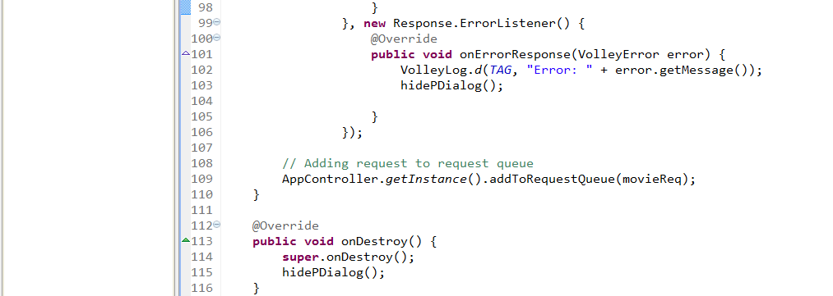
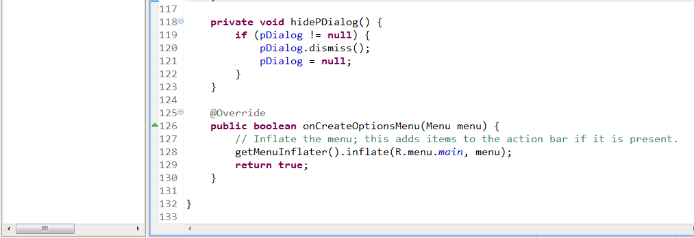

RESULT:

