Diac
23 May 2017
7:59

Diac Tutorial
The DIode AC switch, or Diac for short, is another solid state, three-layer, two-junction semiconductor device but unlike the transistor the Diac has no base connection making it a two terminal device, labelled A1 and A2.
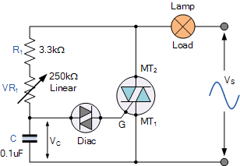

Diac’s have no control or amplification but act much like a bidirectional switching diode as they can conduct current from either polarity of a suitable AC voltage supply.
In our tutorial about SCR’s and Triacs, we saw that in ON-OFF switching applications, these devices could be triggered by simple circuits producing steady state gate currents as shown.
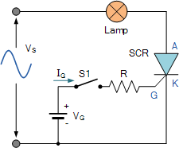
When switch, S1 is open no gate current flows and the lamp is “OFF”. When switch S1 is closed, gate current IGflows and the SCR conducts on the positive half cycles only as it is operating in quadrant Ι.
We remember also that once gated “ON”, the SCR will only switch “OFF” again when its supply voltage falls to a values such that its Anode current, IA is less than the value of its holding current, IH.
If we wish to control the mean value of the lamp current, rather than just switch it “ON” or “OFF”, we could apply a short pulse of gate current at a pre-set trigger point to allow conduction of the SCR to occur over part of the half-cycle only. Then the mean value of the lamp current would be varied by changing the delay time, T between the start of the cycle and the trigger point. This method is known commonly as “phase control”.
But to achieve phase control, two things are needed. One is a variable phase shift circuit (usually an RC passive circuit), and two, some form of trigger circuit or device that can produce the required gate pulse when the delayed waveform reaches a certain level. One such solid state semiconductor device that is designed to produce these gate pulses is the Diac.
The diac is constructed like a transistor but has no base connection allowing it to be connected into a circuit in either polarity. Diacs are primarily used as trigger devices in phase-triggering and variable power control applications because a diac helps provide a sharper and more instant trigger pulse (as opposed to a steadily rising ramp voltage) which is used to turn “ON” the main switching device.
The diac symbol and the voltage-current characteristics curves of the diac are given below.
Diac Symbol and I-V Characteristics
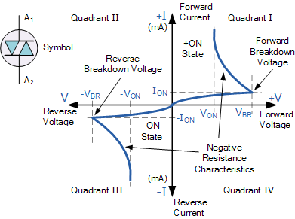

We can see from the above diac I-V characteristics curves that the diac blocks the flow of current in both directions until the applied voltage is greater than VBR, at which point breakdown of the device occurs and the diac conducts heavily in a similar way to the zener diode passing a sudden pulse of voltage. This VBR point is called the Diacs breakdown voltage or breakover voltage.
In an ordinary zener diode the voltage across it would remain constant as the current increased. However, in the diac the transistor action causes the voltage to reduce as the current increases. Once in the conducting state, the resistance of the diac falls to a very low value allowing a relatively large value of current to flow. For most commonly available diacs such as the ST2 or DB3, their breakdown voltage typically ranges from about ±25 to 35 volts. Higher breakover voltage ratings are available, for example 40 volts for the DB4 diac.
This action gives the diac the characteristic of a negative resistance as shown above. As the diac is a symmetrical device, it therefore has the same characteristic for both positive and negative voltages and it is this negative resistance action that makes the Diac suitable as a triggering device for SCR’s or triacs.
Diac Applications
As stated above, the diac is commonly used as a solid state triggering device for other semiconductor switching devices, mainly SCR’s and triacs. Triacs are widely used in applications such as lamp dimmers and motor speed controllers and as such the diac is used in conjunction with the triac to provide full-wave control of the AC supply as shown.
Diac AC Phase Control
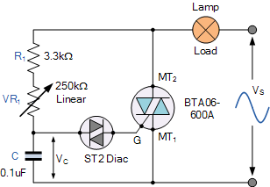

As the AC supply voltage increases at the beginning of the cycle, capacitor, C is charged through the series combination of the fixed resistor, R1 and the potentiometer, VR1 and the voltage across its plates increases. When the charging voltage reaches the breakover voltage of the diac (about 30 V for the ST2), the diac breaks down and the capacitor discharges through the diac, producing a sudden pulse of current, which fires the triac into conduction. The phase angle at which the triac is triggered can be varied using VR1, which controls the charging rate of the capacitor.
Once the triac has been fired into conduction, it is maintained in its “ON” state by the load current flowing through it, while the voltage across the resistor–capacitor combination is limited by the “ON” voltage of the triac and is maintained until the end of the present half-cycle of the AC supply.
At the end of the half cycle the supply voltage falls to zero, reducing the current through the triac below its holding current, IH turning it “OFF” and the diac stops conduction. The supply voltage then enters its next half-cycle, the capacitor voltage again begins to rise (this time in the opposite direction) and the cycle of firing the triac repeats over again.
Triac Conduction Waveform
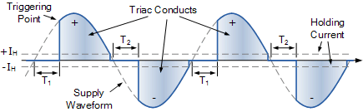

Then we have seen that the Diac is a very useful device which can be used to trigger triacs and because of its negative resistance characteristics this allows it to switch “ON” rapidly once a certain applied voltage level is reached. However, this means that whenever we want to use a triac for AC power control we will need a separate diac as well. Fortunately for us, some bright spark somewhere replaced the individual diac and triac with a single switching device called a Quadrac.
The Quadrac
The Quadrac is basically a diac and triac fabricated together within a single package and as such are also known as “internally triggered triacs”. This all in one bi-directional device is gate controlled using either polarity of the main terminal voltage which means it can be used in full-wave phase-control applications such as heater controls, lamp dimmers, and AC motor speed control, etc.
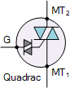
Like the triac, quadracs are a three-terminal semiconductor switching device labelled MT2 for main terminal one (usually the anode), MT1 for main terminal two (usually the cathode) and G for the gate terminal.
The quadrac is available in a variety of package types depending upon their voltage and current switching requirements with the TO-220 package being the most common as it is designed to be an exact replacement for most triac devices.
Diac Tutorial Summary
In this diac tutorial we have seen that the diac such as the ST2 or DB3 is a two-terminal voltage blocking device that can conduct in either direction. Diacs posses negative resistance characteristics which allows them to switch “ON” rapidly once a certain applied voltage level is reached.
Since the diac is a bidirectional device, when paired with the BTAxx-600A or IRT80 series of switching triacs it makes it useful as a triggering device in phase control and general AC circuits such as light dimmers and motor speed controls.
Quadracs are simply triacs with an internally connected diac. As with triacs, quadracs are bidirectional AC switches which are gate controlled for either polarity of main terminal voltage.

