IGBT
23 May 2017
7:57

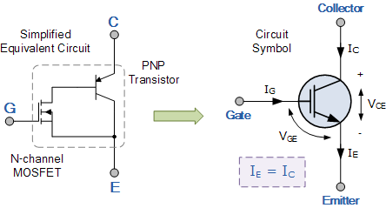
Insulated Gate Bipolar Transistor
The Insulated Gate Bipolar Transistor also called an IGBT for short, is something of a cross between a conventional Bipolar Junction Transistor, (BJT) and a Field Effect Transistor, (MOSFET) making it ideal as a semiconductor switching device.

The IGBT transistor takes the best parts of these two types of transistors, the high input impedance and high switching speeds of a MOSFET with the low saturation voltage of a bipolar transistor, and combines them together to produce another type of transistor switching device that is capable of handling large collector-emitter currents with virtually zero gate current drive.
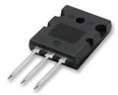
Typical IGBT
The Insulated Gate Bipolar Transistor, (IGBT) combines the insulated gate (hence the first part of its name) technology of the MOSFET with the output performance characteristics of a conventional bipolar transistor, (hence the second part of its name). The result of this hybrid combination is that the “IGBT Transistor” has the output switching and conduction characteristics of a bipolar transistor but is voltage-controlled like a MOSFET.
IGBTs are mainly used in power electronics applications, such as inverters, converters and power supplies, were the demands of the solid state switching device are not fully met by power bipolars and power MOSFETs. High-current and high-voltage bipolars are available, but their switching speeds are slow, while power MOSFETs may have higher switching speeds, but high-voltage and high-current devices are expensive and hard to achieve.
The advantage gained by the insulated gate bipolar transistor device over a BJT or MOSFET is that it offers greater power gain than the standard bipolar type transistor combined with the higher voltage operation and lower input losses of the MOSFET. In effect it is an FET integrated with a bipolar transistor in a form of Darlington type configuration as shown.
Related Products: Diodes, Transistors and Thyristors | IGBT Chip | IGBT Module
Insulated Gate Bipolar Transistor
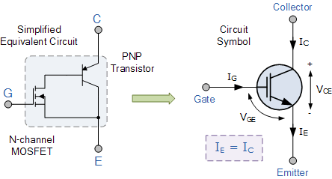
We can see that the insulated gate bipolar transistor is a three terminal, transconductance device that combines an insulated gate N-channel MOSFET input with a PNP bipolar transistor output connected in a type of Darlington configuration. As a result the terminals are labelled as: Collector, Emitter and Gate. Two of its terminals (C-E) are associated with the conductance path which passes current, while its third terminal (G) controls the device.
The amount of amplification achieved by the insulated gate bipolar transistor is a ratio between its output signal and its input signal. For a conventional bipolar junction transistor, (BJT) the amount of gain is approximately equal to the ratio of the output current to the input current, called Beta.
For a metal oxide semiconductor field effect transistor or MOSFET, there is no input current as the gate is isolated from the main current carrying channel. Therefore, an FET’s gain is equal to the ratio of output current change to input voltage change, making it a transconductance device and this is also true of the IGBT. Then we can treat the IGBT as a power BJT whose base current is provided by a MOSFET.
The Insulated Gate Bipolar Transistor can be used in small signal amplifier circuits in much the same way as the BJT or MOSFET type transistors. But as the IGBT combines the low conduction loss of a BJT with the high switching speed of a power MOSFET an optimal solid state switch exists which is ideal for use in power electronics applications.
Also, the IGBT has a much lower “on-state” resistance, RON than an equivalent MOSFET. This means that the I2R drop across the bipolar output structure for a given switching current is much lower. The forward blocking operation of the IGBT transistor is identical to a power MOSFET.
When used as static controlled switch, the insulated gate bipolar transistor has voltage and current ratings similar to that of the bipolar transistor. However, the presence of an isolated gate in an IGBT makes it a lot simpler to drive than the BJT as much less drive power is needed.
An insulated gate bipolar transistor is simply turned “ON” or “OFF” by activating and deactivating its Gate terminal. Applying a positive input voltage signal across the Gate and the Emitter will keep the device in its “ON” state, while making the input gate signal zero or slightly negative will cause it to turn “OFF” in much the same way as a bipolar transistor or eMOSFET. Another advantage of the IGBT is that it has a much lower on-state channel resistance than a standard MOSFET.
IGBT Characteristics
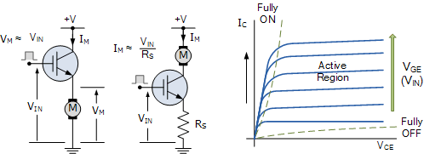
Because the IGBT is a voltage-controlled device, it only requires a small voltage on the Gate to maintain conduction through the device unlike BJT’s which require that the Base current is continuously supplied in a sufficient enough quantity to maintain saturation.
Also the IGBT is a unidirectional device, meaning it can only switch current in the “forward direction”, that is from Collector to Emitter unlike MOSFET’s which have bi-directional current switching capabilities (controlled in the forward direction and uncontrolled in the reverse direction).
The principal of operation and Gate drive circuits for the insulated gate bipolar transistor are very similar to that of the N-channel power MOSFET. The basic difference is that the resistance offered by the main conducting channel when current flows through the device in its “ON” state is very much smaller in the IGBT. Because of this, the current ratings are much higher when compared with an equivalent power MOSFET.
The main advantages of using the Insulated Gate Bipolar Transistor over other types of transistor devices are its high voltage capability, low ON-resistance, ease of drive, relatively fast switching speeds and combined with zero gate drive current makes it a good choice for moderate speed, high voltage applications such as in pulse-width modulated (PWM), variable speed control, switch-mode power supplies or solar powered DC-AC inverter and frequency converter applications operating in the hundreds of kilohertz range.
A general comparison between BJT’s, MOSFET’s and IGBT’s is given in the following table.
IGBT Comparison Table
Device  Characteristic | Power  Bipolar | Power  MOSFET | IGBT
Voltage Rating | High <1kV | High <1kV | Very High >1kV
Current Rating | High <500A | Low <200A | High >500A
Input Drive | Current, hFE  20-200 | Voltage, VGS  3-10V | Voltage, VGE  4-8V
Input Impedance | Low | High | High
Output Impedance | Low | Medium | Low
Switching Speed | Slow (uS) | Fast (nS) | Medium
Cost | Low | Medium | High
We have seen that the Insulated Gate Bipolar Transistor is semiconductor switching device that has the output characteristics of a bipolar junction transistor, BJT, but is controlled like a metal oxide field effect transistor, MOSFET.
One of the main advantages of the IGBT transistor is the simplicity by which it can be driven “ON” by applying a positive gate voltage, or switched “OFF” by making the gate signal zero or slightly negative allowing it to be used in a variety of switching applications. It can also be driven in its linear active region for use in power amplifiers.
With its lower on-state resistance and conduction losses as well as its ability to switch high voltages at high frequencies without damage makes the Insulated Gate Bipolar Transistor ideal for driving inductive loads such as coil windings, electromagnets and DC motors.

