SMPS
23 May 2017
8:00

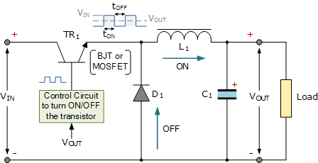
Switch Mode Power Supply
Linear voltage IC regulators have been the basis of power supply designs for many years as they are very good at supplying a continuous fixed voltage output and are generally much less expensive and easier to use than regulator circuits made from discrete components.

The most popular linear and fixed output voltage regulator types are by far the 78… positive output voltage series, and the 79… negative output voltage series. These two types of complementary voltage regulators produce a precise and stable voltage output ranging from about 5 volts up to about 24 volts for use in many electronic circuits.
There is a wide range of these three-terminal fixed voltage regulators available each with its own built-in voltage regulation and current limiting circuits. This allows us to create a whole host of different power supply rails and outputs, either single or dual supply, suitable for most electronic circuits and applications. There are even variable voltage linear regulators available as well providing an output voltage which is continually variable from just above zero to a few volts below its maximum voltage output.
Most d.c. power supplies comprise of a large and heavy step-down mains transformer, diode rectification, either full-wave or half-wave, a filter circuit to remove any ripple content from the rectified d.c. producing a suitably smooth d.c. voltage, and some form of voltage regulator or stabiliser circuit, either linear or switching to ensure the correct regulation of the power supplies output voltage under varying load conditions. Then a typical d.c. power supply would look something like this:
Typical DC Power Supply
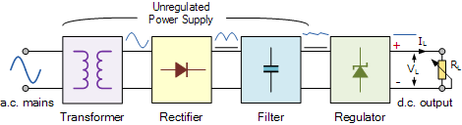

These typical power supply designs contain a large mains transformer (which also provides isolation between the input and output) and a dissipative series regulator circuit. The regulator circuit could consist of a single zener diode or a three-terminal linear series regulator to produce the required output voltage. The advantage of a linear regulator is that the power supply circuit only needs an input capacitor, output capacitor and some feedback resistors to set the output voltage.
Linear voltage regulators produce a regulated DC output by placing a continuously conducting transistor in series between the input and the output operating it in its linear region (hence the name) of its current-voltage (i-v) characteristics. Thus the transistor acts more like a variable resistance which continually adjusts itself to whatever value is needed to maintain the correct output voltage. Consider this simple series pass transistor regulator circuit below:
Series Transistor Regulator Circuit
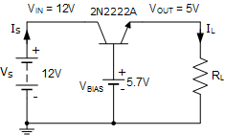
Here this simple emitter-follower regulator circuit consists of a single NPN transistor and a DC biasing voltage to set the required output voltage. As an emitter follower circuit has unity voltage gain, applying a suitable biasing voltage to the transistors base, a stabilised output is obtained from the emitter terminal.
Since a transistor provides current gain, the output load current will be much higher than the base current and higher still if a Darlington transistor arrangement is used.
Also, providing that the input voltage is sufficiently high enough to get the desired output voltage, the output voltage is controlled by the transistors base voltage and in this example is given as 5.7 volts to produce a 5 volt output to the load as approximately 0.7 volts is dropped across the transistor between the base and emitter terminals. Then depending upon the value of the base voltage, any value of emitter output voltage can be obtained.
While this simple series regulator circuit will work, the downside to this is that the series transistor is continually biased in its linear region dissipating power in the form of heat as a result of its VxI product, since all the load current must pass through the series transistor, resulting in poor efficiency, wasted power and continuous heat generation.
Also, one of the disadvantages that series voltage regulators have is that, their maximum continuous output current rating is limited to just a few amperes or so, so are generally used in applications where low power outputs are required. When higher output voltage or current power supplies are required, the normal practice is to use a switching regulator commonly known as a switch-mode power supply to convert the mains voltage into whatever higher power output is required.
Switch Mode Power Supplies, or SMPS, are becoming common place and have replaced in most cases the traditional linear ac-to-dc power supplies as a way to cut power consumption, reduce heat dissipation, as well as size and weight. Switch-mode power supplies can now be found in most PC’s, power amplifiers, TV’s, dc motor drives, etc., and just about anything that requires a highly efficient supply as switch-mode power supplies are increasingly becoming a much more mature technology.
By definition, a switch mode power supply (SMPS) is a type of power supply that uses semiconductor switching techniques, rather than standard linear methods to provide the required output voltage. The basic switching converter consists of a power switching stage and a control circuit. The power switching stage performs the power conversion from the circuits input voltage, VIN to its output voltage, VOUT which includes output filtering.
The major advantage of the switch mode power supply is its higher efficiency, compared to standard linear regulators, and this is achieved by internally switching a transistor (or power MOSFET) between its “ON” state (saturated) and its “OFF” state (cut-off), both of which produces lower power dissipation. This means that when the switching transistor is fully “ON” and conducting current, the voltage drop across it is at its minimal value, and when the transistor is fully “OFF” there is no current flow through it. So the transistor is acting like an ideal switch.
As a result, unlike linear regulators which only offer step-down voltage regulation, a switch mode power supply, can offer step-down, step-up and negation of the input voltage using one or more of the three basic switch mode circuit topologies: Buck, Boost and Buck-Boost. This refers to how the transistor switch, inductor, and smoothing capacitor are connected within the basic circuit.
Buck Switch Mode Power Supply
The Buck switching regulator is a type of switch mode power supply circuit that is designed to efficiently reduce DC voltage from a higher voltage to a lower one, that is it subtracts or “Bucks” the supply voltage, thereby reducing the voltage available at the output terminals without changing the polarity. In other words, the buck switching regulator is a step-down regulator circuit, so for example a buck converter can convert say, +12 volts to +5 volts.
The buck switching regulator is a DC-to-DC converter and one of the simplest and most popular type of switching regulator. When used within a switch mode power supply configuration, the buck switching regulator uses a series transistor or power MOSFET (ideally an insulated gate bipolar transistor, or IGBT) as its main switching device as shown below.
The Buck Switching Regulator

We can see that the basic circuit configuration for a buck converter is a series transistor switch, TR1 with an associated drive circuit that keeps the output voltage as close to the desired level as possible, a diode, D1, an inductor, L1 and a smoothing capacitor, C1. The buck converter has two operating modes, depending on if the switching transistor TR1 is turned “ON” or “OFF”.
When the transistor is biased “ON” (switch closed), diode D1 becomes reverse biased and the input voltage, VIN causes a current to flow through the inductor to the connected load at the output, charging up the capacitor, C1. As a changing current flows through the inductor coil, it produces a back-emf which opposes the flow of current, according to Faraday’s law, until it reaches a steady state creating a magnetic field around the inductor, L1. This situation continues indefinitely as long as TR1 is closed.
When transistor TR1 is turned “OFF” (switch open) by the controlling circuitry, the input voltage is instantly disconnected from the emitter circuit causing the magnetic field around the inductor to collapse inducing a reverse voltage across the inductor. This reverse voltage causes the diode to become forward biased, so the stored energy in the inductors magnetic field forces current to continue to flow through the load in the same direction, and return back through diode.
Then the inductor, L1 returns its stored energy back to the load acting like a source and supplying current until all the inductor’s energy is returned to the circuit or until the transistor switch closes again, whichever comes first. At the same time the capacitor also discharges supplying current to the load. The combination of the inductor and capacitor forms an LC filter smoothing out any ripple created by the switching action of the transistor.
Therefore, when the transistor solid state switch is closed, current is supplied from the supply, and when the transistor switch is open, current is supplied by the inductor. Note that the current flowing through the inductor is always in the same direction, either directly from the supply or via the diode but obviously at different times within the switching cycle.
As the transistor switch is being continuously closed and opened, the average output voltage value will therefore be related to the duty cycle, D which is defined as the conduction time of the transistor switch during one full switching cycle. If VIN is the supply voltage, and the “ON” and “OFF” times for the transistor switch are defined as: tON and tOFF, then the output voltage VOUT is given as:
Buck Converter Duty Cycle


The buck converters duty cycle can also be defined as:
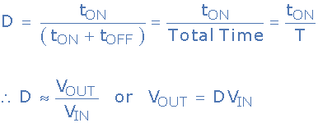

So the larger the duty cycle, the higher the average DC output voltage from the switch mode power supply. From this we can also see that the output voltage will always be lower than the input voltage since the duty cycle, D can never reach one (unity) resulting in a step-down voltage regulator. Voltage regulation is obtained by varying the duty cycle and with high switching speeds, up to 200kHz, smaller components can be used thereby greatly reducing a switch mode power supply’s size and weight.
Another advantage of the buck converter is that the inductor-capacitor (LC) arrangement provides very good filtering of the inductor current. Ideally the buck converter should be operated in a continuous switching mode so that the inductor current never falls to zero. With ideal components, that is zero voltage drop and switching losses in the “ON” state, the ideal buck converter could have efficiencies as high as 100%.
As well as the step-down buck switching regulator for the basic design of a switch mode power supply, there is another operation of the fundamental switching regulator that acts as a step-up voltage regulator called the Boost Converter.
Boost Switch Mode Power Supply
The Boost switching regulator is another type of switch mode power supply circuit. It has the same types of components as the previous buck converter, but this time in different positions. The boost converter is designed to increase a DC voltage from a lower voltage to a higher one, that is it adds too or “Boosts” the supply voltage, thereby increasing the available voltage at the output terminals without changing the polarity. In other words, the boost switching regulator is a step-up regulator circuit, so for example a boost converter can convert say, +5 volts to +12 volts.
We saw previously that the buck switching regulator uses a series switching transistor within its basic design. The difference with the design of the boost switching regulator is that it uses a parallel connected switching transistor to control the output voltage from the switch mode power supply. As the transistor switch is effectively connected in parallel with the output, electrical energy only passes through the inductor to the load when the transistor is biased “OFF” (switch open) as shown.
The Boost Switching Regulator
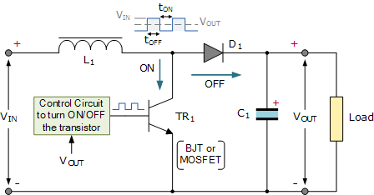

In the Boost Converter circuit, when the transistor switch is fully-on, electrical energy from the supply, VIN passes through the inductor and transistor switch and back to the supply. As a result, none of it passes to the output as the saturated transistor switch effectively creates a short-circuit to the output. This increases the current flowing through the inductor as it has a shorter inner path to travel back to the supply. Meanwhile, diode D1 becomes reverse biased as its anode is connected to ground via the transistor switch with the voltage level on the output remaining fairly constant as the capacitor starts to discharge through the load.
When the transistor is switched fully-off, the input supply is now connected to the output via the series connected inductor and diode. As the inductor field decreases the induced energy stored in the inductor is pushed to the output by VIN, through the now forward biased diode. The result of all this is that the induced voltage across the inductor L1 reverses and adds to the voltage of the input supply increasing the total output voltage as it now becomes, VIN + VL.
Current from the smoothing capacitor, C1 which was used to supply the load when the transistor switch was closed, is now returned to the capacitor by the input supply via the diode. Then the current supplied to the capacitor is the diode current, which will always be ON or OFF as the diode is continually switched between forward and reverse status by the switching actions of transistor. Then the smoothing capacitor must be sufficiently large enough to produce a smooth steady output.
As the induced voltage across the inductor L1 is negative, it adds to the source voltage, VIN forcing the inductor current into the load. The boost converters steady state output voltage is given by:
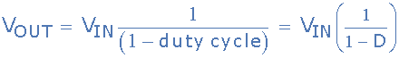

As with the previous buck converter, the output voltage from the boost converter depends upon the input voltage and duty cycle. Therefore, by controlling the duty cycle, output regulation is achieved. Not also that this equation is independent of the value of the inductor, the load current, and the output capacitor.
We have seen above that the basic operation of a non-isolated switch mode power supply circuit can use either a buck converter or boost converter configuration depending upon whether we require a step-down (buck) or step-up (boost) output voltage. While buck converters may be the more common SMPS switching configuration, boost converters are commonly used in capacitive circuit applications such as battery chargers, photo-flashes, strobe flashes, etc, because the capacitor supplies all of the load current while the switch is closed.
But we can also combine these two basic switching topologies into a single non-isolating switching regulator circuit called unsurprisingly, a Buck-Boost Converter.
Buck-Boost Switching Regulator
The Buck-Boost switching regulator is a combination of the buck converter and the boost converter that produces an inverted (negative) output voltage which can be greater or less than the input voltage based on the duty cycle. The buck-boost converter is a variation of the boost converter circuit in which the inverting converter only delivers the energy stored by the inductor, L1, into the load. The basic buck-boost switch mode power supply circuit is given below.
The Buck-Boost Switching Regulator
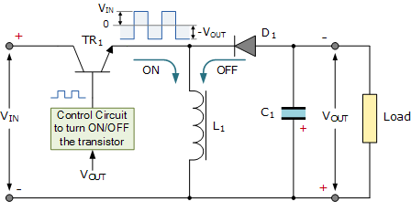

When the transistor switch, TR1, is switched fully-on (closed), the voltage across the inductor is equal to the supply voltage so the inductor stores energy from the input supply. No current is delivered to the connected load at the output because diode, D1, is reverse biased. When the transistor switch is fully-off (open), the diode becomes forward biased and the energy previously stored in the inductor is transferred to the load.
In other words, when the switch is “ON”, energy is delivered into the inductor by the DC supply (via the switch), and none to the output, and when the switch is “OFF”, the voltage across the inductor reverses as the inductor now becomes a source of energy so the energy stored previously in the inductor is switched to the output (through the diode), and none comes directly from the input DC source. So the voltage dropped across the load when the switching transistor is “OFF” is equal to the inductor voltage.
The result is that the magnitude of the inverted output voltage can be greater or smaller (or equal to) the magnitude of the input voltage based on the duty cycle. For example, a positive-to-negative buck-boost converter can convert 5 volts to 12 volts (step-up) or 12 volts to 5 volts (step-down).
The buck-boost switching regulators steady state output voltage, VOUT is given as:
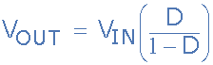

Then the buck-boost regulator gets its name from producing an output voltage that can be higher (like a boost power stage) or lower (like a buck power stage) in magnitude than the input voltage. However, the output voltage is opposite in polarity from the input voltage.
Switch Mode Power Supply Summary
The modern switch mode power supply, or SMPS, uses solid-state switches to convert an unregulated DC input voltage to a regulated and smooth DC output voltage at different voltage levels. The input supply can be a true DC voltage from a battery or solar panel, or a rectified DC voltage from an AC supply using a diode bridge along with some additional capacitive filtering.
In many power control applications, the power transistor, MOSFET or IGFET, is operated in its switching mode were it is repeatedly turned “ON” and “OFF” at high speed. The main advantage of this is that the power efficiency of the regulator can be quite high because the transistor is either fully-on and conducting (saturated) or full-off (cut-off).
There are several types of DC-to-DC converter (as opposed to a DC-to-AC converter which is an inverter) configurations available, with the three basic switching power supply topologies looked at here being the Buck, Boost, and the Buck-Boost switching regulators. All three of these topologies are non-isolated, that is their input and output voltages share a common ground line.
Each switching regulator design has its own unique properties with regards to the steady-state duty cycles, relationship between the input and output current, and the output voltage ripple produced by the solid-state switch action. Another important property of these switch mode power supply topologies is the frequency response of the switching action to the output voltage.
Regulation of the output voltage is achieved by the percentage control of the time that the switching transistor is in the “ON” state compared to the total ON/OFF time. This ratio is called the duty cycle and by varying the duty cycle, (D the magnitude of the output voltage, VOUT can be controlled.
The use of a single inductor and diode as well as fast switching solid-state switches capable of operating at switching frequencies in the kilohertz range, within the switch mode power supply design, allows for the size and weight of the power supply to be greatly reduced. This is because there would be no large and heavy step-down (or step-up) voltage mains transformers within their design. However, if isolation is required between the input and output terminals, a transformer must be included before the converter.
The two most popular non-isolated switching configurations are the buck (subtractive) and the boost (additive) converters.
The buck converter is a type of switch-mode power supply that is designed to convert electrical energy from one voltage to a lower one. The buck converter operates with a series connected switching transistor. As the duty cycle, D < 1, the output voltage of the buck is always smaller than the input voltage, VIN.
The boost converter is a type of switch-mode power supply that is designed to convert electrical energy from one voltage to a higher one. The boost converter operates with a parallel connected switching transistor which results in a direct current path between VIN and VOUT via the inductor, L1 and diode, D1. This means there is no protection against short-circuits on the output.
By varying the duty cycle, (D) of a boost converter, the output voltage can be controlled and with D < 1, the DC output from the boost converter is greater than input voltage VINas a consequence of the inductors self-induced voltage.
Also, the output smoothing capacitors in Switch-mode Power Supplies is assumed to be very large, which results in a constant output voltage from the switch mode supply during the transistors switching action.

