Triac
23 May 2017
7:56

Triac Tutorial
In the previous tutorial we looked at the construction and operation of the Silicon Controlled Rectifier more commonly known as a Thyristor.
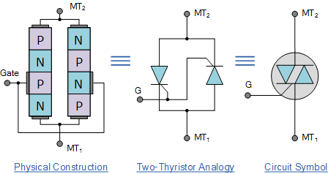

Being a solid state device, thyristors can be used to control lamps, motors, or heaters etc. However, one of the problems of using a thyristor for controlling such circuits is that like a diode, the “thyristor” is a unidirectional device, meaning that it passes current in one direction only, from Anode to Cathode.
For DC switching circuits this “one-way” switching characteristic may be acceptable as once triggered all the DC power is delivered straight to the load. But in sinusoidal AC switching circuits, this unidirectional switching may be a problem as it only conducts during one half of the cycle (like a half-wave rectifier) when the Anode is positive irrespective of whatever the Gate signal is doing. Then for AC operation only half the power is delivered to the load by a thyristor.
In order to obtain full-wave power control we could connect a single thyristor inside a full-wave bridge rectifier which triggers on each positive half-wave, or to connect two thyristors together in inverse parallel (back-to-back) as shown below but this increases both the complexity and number of components used in the switching circuit.
Thyristor Configurations
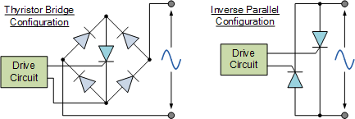

There is however, another type of semiconductor device called a “Triode AC Switch” or Triac for short which is also a member of the thyristor family that be used as a solid state power switching device but more importantly it is a “bidirectional” device. In other words, a Triac can be triggered into conduction by both positive and negative voltages applied to its Anode and with both positive and negative trigger pulses applied to its Gate terminal making it a two-quadrant switching Gate controlled device.
A Triac behaves just like two conventional thyristors connected together in inverse parallel (back-to-back) with respect to each other and because of this arrangement the two thyristors share a common Gate terminal all within a single three-terminal package.
Since a triac conducts in both directions of a sinusoidal waveform, the concept of an Anode terminal and a Cathode terminal used to identify the main power terminals of a thyristor are replaced with identifications of: MT1, for Main Terminal 1 and MT2 for Main Terminal 2 with the Gate terminal G referenced the same.
In most AC switching applications, the triac gate terminal is associated with the MT1terminal, similar to the gate-cathode relationship of the thyristor or the base-emitter relationship of the transistor. The construction, P-N doping and schematic symbol used to represent a Triac is given below.
Triac Symbol and Construction

We now know that a “triac” is a 4-layer, PNPN in the positive direction and a NPNP in the negative direction, three-terminal bidirectional device that blocks current in its “OFF” state acting like an open-circuit switch, but unlike a conventional thyristor, the triac can conduct current in either direction when triggered by a single gate pulse. Then a triac has four possible triggering modes of operation as follows.
  - Ι + Mode = MT2 current positive (+ve), Gate current positive (+ve)
  - Ι – Mode = MT2 current positive (+ve), Gate current negative (-ve)
  - ΙΙΙ + Mode = MT2 current negative (-ve), Gate current positive (+ve)
  - ΙΙΙ – Mode = MT2 current negative (-ve), Gate current negative (-ve)
And these four modes in which a triac can be operated are shown using the triacs I-V characteristics curves.
Triac I-V Characteristics Curves
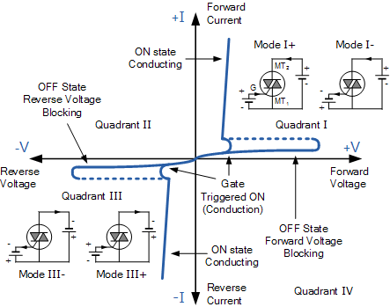

In Quadrant Ι, the triac is usually triggered into conduction by a positive gate current, labelled above as mode Ι+. But it can also be triggered by a negative gate current, mode Ι–. Similarly, in Quadrant ΙΙΙ, triggering with a negative gate current, –ΙG is also common, mode ΙΙΙ– along with mode ΙΙΙ+. Modes Ι– and ΙΙΙ+ are, however, less sensitive configurations requiring a greater gate current to cause triggering than the more common triac triggering modes of Ι+ and ΙΙΙ–.
Also, just like silicon controlled rectifiers (SCR’s), triac’s also require a minimum holding current IH to maintain conduction at the waveforms cross over point. Then even though the two thyristors are combined into one single triac device, they still exhibit individual electrical characteristics such as different breakdown voltages, holding currents and trigger voltage levels exactly the same as we would expect from a single SCR device.
Triac Applications
The Triac is most commonly used semiconductor device for switching and power control of AC systems as the triac can be switched “ON” by either a positive or negative Gate pulse, regardless of the polarity of the AC supply at that time. This makes the triac ideal to control a lamp or AC motor load with a very basic triac switching circuit given below.
Triac Switching Circuit
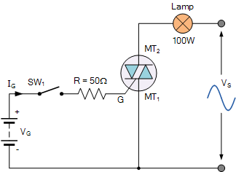

The circuit above shows a simple DC triggered triac power switching circuit. With switch SW1 open, no current flows into the Gate of the triac and the lamp is therefore “OFF”. When SW1 is closed, Gate current is applied to the triac from the battery supply VG via resistor R and the triac is driven into full conduction acting like a closed switch and full power is drawn by the lamp from the sinusoidal supply.
As the battery supplies a positive Gate current to the triac whenever switch SW1 is closed, the triac is therefore continually gated in modes Ι+ and ΙΙΙ+ regardless of the polarity of terminal MT2.
Of course, the problem with this simple triac switching circuit is that we would require an additional positive or negative Gate supply to trigger the triac into conduction. But we can also trigger the triac using the actual AC supply voltage itself as the gate triggering voltage. Consider the circuit below.
Triac Switching Circuit
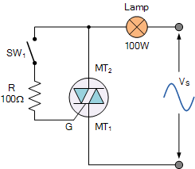

The circuit shows a triac used as a simple static AC power switch providing an “ON”-“OFF” function similar in operation to the previous DC circuit. When switch SW1 is open, the triac acts as an open switch and the lamp passes zero current. When SW1 is closed the triac is gated “ON” via current limiting resistor R and self-latches shortly after the start of each half-cycle, thus switching full power to the lamp load.
As the supply is sinusoidal AC, the triac automatically unlatches at the end of each AC half-cycle as the instantaneous supply voltage and thus the load current briefly falls to zero but re-latches again using the opposite thyristor half on the next half cycle as long as the switch remains closed. This type of switching control is generally called full-wave control due to the fact that both halves of the sine wave are being controlled.
As the triac is effectively two back-to-back connected SCR’s, we can take this triac switching circuit further by modifying how the gate is triggered as shown below.
Modified Triac Switching Circuit
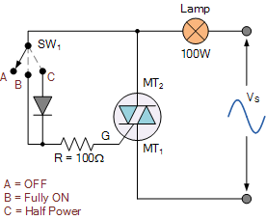

As above, if switch SW1 is open at position A, there is no gate current and the lamp is “OFF”. If the switch is moved to position B gate current flows at every half cycle the same as before and full power is drawn by the lamp as the triac operates in modes Ι+and ΙΙΙ–.
However this time when the switch is connected to position C, the diode will prevent the triggering of the gate when MT2 is negative as the diode is reverse biased. Thus the triac only conducts on the positive half-cycles operating in mode I+ only and the lamp will light at half power. Then depending upon the position of the switch the load is Off, at Half Power or Fully ON.
Triac Phase Control
Another common type of triac switching circuit uses phase control to vary the amount of voltage, and therefore power applied to a load, in this case a motor, for both the positive and negative halves of the input waveform. This type of AC motor speed control gives a fully variable and linear control because the voltage can be adjusted from zero to the full applied voltage as shown.
Triac Phase Control
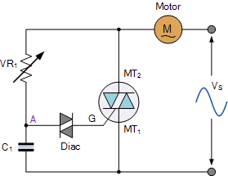

This basic phase triggering circuit uses the triac in series with the motor across an AC sinusoidal supply. The variable resistor, VR1 is used to control the amount of phase shift on the gate of the triac which in turn controls the amount of voltage applied to the motor by turning it ON at different times during the AC cycle.
The triac’s triggering voltage is derived from the VR1 – C1 combination via the Diac (The diac is a bidirectional semiconductor device that helps provide a sharp trigger current pulse to fully turn-ON the triac).
At the start of each cycle, C1 charges up via the variable resistor, VR1. This continues until the voltage across C1 is sufficient to trigger the diac into conduction which in turn allows capacitor, C1 to discharge into the gate of the triac turning it “ON”.
Once the triac is triggered into conduction and saturates, it effectively shorts out the gate triggering phase control circuit connected in parallel across it and the triac takes control for the remainder of the half-cycle.
As we have seen above, the triac turns-OFF automatically at the end of the half-cycle and the VR1 – C1 triggering process starts again on the next half cycle.
However, because the triac requires differing amounts of gate current in each switching mode of operation, for example Ι+ and ΙΙΙ–, a triac is therefore asymmetrical meaning that it may not trigger at the exact same point for each positive and negative half cycle.
This simple triac speed control circuit is suitable for not only AC motor speed control but for lamp dimmers and electrical heater control and in fact is very similar to a triac light dimmer used in many homes. However, a commercial triac dimmer should not be used as a motor speed controller as generally triac light dimmers are intended to be used with resistive loads only such as incandescent lamps.
Then we can end this Triac Tutorial by summarising its main points as follows:
  - A “Triac” is another 4-layer, 3-terminal thyristor device similar to the SCR.
  - The Triac can be triggered into conduction in either direction.
  - There are four possible triggering modes for a Triac, of which 2 are preferred.
Electrical AC power control using a Triac is extremely effective when used properly to control resistive type loads such as incandescent lamps, heaters or small universal motors commonly found in portable power tools and small appliances.
But please remember that these devices can be used and attached directly to the mains AC power source so circuit testing should be done when the power control device is disconnected from the mains power supply. Please remember safety first!.

