OS Server
04 Maret 2016
9:44
OS?

Real Time OS
Normal OS

OS Server?
OS that run on SERVER machine to serve some service

What kind of Service?

DNS
http
mail
ftp
chating

References:
Linux server Book
Windows Server Book
check in this link
http://it-ebooks.info
to find the ebook

Assignment:
List all of features in the linux server (Ubuntu) and Windows Server.

Upload your work to http://github.com/[NIM]/OSS

Tools:
VirtualBox (to create Virtual Server & virtual Network)

LabVirtual-1 : try to setup web server using Linux server.

WWW (World Wide Web) Operation
WWW works on client- server approach. Following steps explains how the web works:
- User enters the URL (Universal Resources Locator) (say, http://www.tutorialspoint.com) of the web page in the address bar of web browser.
- Then browser requests the Domain Name Server for the IP address corresponding to www.tutorialspoint.com.
- After receiving IP address, browser sends the request for web page to the web server using HTTP protocol which specifies the way the browser and web server communicates.
- Then web server receives request using HTTP protocol and checks its search for the requested web page. If found it returns it back to the web browser and close the HTTP connection.
- Now the web browser receives the web page, It interprets it and display the contents of web page in web browser’s window.

====================
- User memasukan URL (browser atau command line, menggunakan domain)
- Browser meminta IP Address yang dimiliki oleh domain yang terdapat pada URL, kepada DNS server yang tercatat dalam konfigurasi network.
- Setelah menerima IP Address dari DNS server, kemudian browser meminta halaman web kepada web server menggunakan protokol HTTP. (default halaman adalah index.html)
- Web server menerima permintaan (request) dari browser dan memeriksa halaman web yang diminta. Jika ditemukan halaman web yang diminta oleh browser, web server akan mengirimkan balik ke browser melalui komunikasi HTTP.
- Browser menerima halaman web yang diminta, menterjemahkan dan menampilkan isi halaman web dalam windows browser.

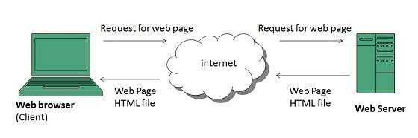

Overview
Web server is a computer where the web content is stored. Basically web server is used to host the web sites but there exists other web servers also such as gaming, storage, FTP, email etc.
Web site is collection of web pages whileweb server is a software that respond to the request for web resources.
Web Server Working
Web server respond to the client request in either of the following two ways:
- Sending the file to the client associated with the requested URL.
- Generating response by invoking a script and communicating with database

--------------------------
Web server : sebuah komputer yang digunakan untuk menyimpan dokumen web. Biasanya digunakan untuk hosting web site. Tetapi saat ini web server juga digunakan sebagai server untuk GAME, Remote STORAGE, FTP, Email dll.

Cara kerja Web server:
web server akan menjawab permintaan dari client menggunakan dua cara sbb:
- Mengirimkan file yag diminta oleh client seperti yang tertulis dalam URL. (web statis)
- Memjawab browser dengan cara memanggil sebuah SCRIPT dan berkomunikasi dengan basis data, untuk membuat dokumen HTML.

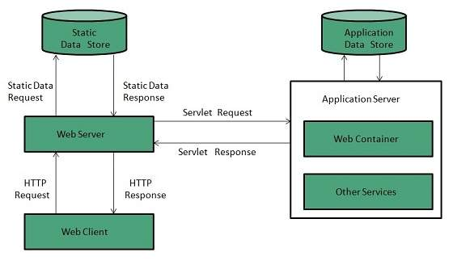

Web server

Apache HTTP server
- open source,
- can run in many platform (linux, windows, mac os etc.)
- almost 60% web server in the world using this Apache http server.
IIS
lighthttpd
Sun java
jigsaw

Node.js ( Javascript Web Server)

Konfigurasi apache web server yang penting:

Lokasi file :
../apache/conf/http.conf

Item konfigurasi utama:

ServerRoot "C:/xampp/apache"
ServerName localhost:80
Listen 80
# Listen 127.0.0.1:80

# mengatur akses ke direktory
# direktory berikut BOLEH di kases dari internet
DocumentRoot "C:/xampp/htdocs"
<Directory "C:/xampp/htdocs">
Options Indexes FollowSymLinks Includes ExecCGI
AllowOverride All
Require all granted
</Directory>

Contoh konfigurasi Virtual Host

<Directory "C:/Users/bana/Desktop/zakat.org">
Options Indexes FollowSymLinks Includes ExecCGI
AllowOverride All
Require all granted
</Directory>

<VirtualHost *:80>
# ServerAdmin webmaster@dummy-host2.example.com
DocumentRoot "C:/Users/bana/Desktop/zakat.org"
ServerName zakat.org
# ErrorLog "logs/host_01.log"
# CustomLog "logs/dummy-host2.example.com-access.log" common
</VirtualHost>

<Directory "C:/Users/bana/Desktop/devExtreme">
Options Indexes FollowSymLinks Includes ExecCGI
AllowOverride All
Require all granted
</Directory>
<VirtualHost *:80>
DocumentRoot "C:/Users/bana/Desktop/devExtreme"
ServerName my.dextreme
</VirtualHost>

<Directory "C:\Users\bana\Desktop\parkir\server_parkir">
Options Indexes FollowSymLinks Includes ExecCGI
AllowOverride All
Require all granted
</Directory>
<VirtualHost *:80>
DocumentRoot "C:\Users\bana\Desktop\parkir\server_parkir"
ServerName my.parkir
</VirtualHost>

Note:
untuk Network Harus ada DNS Server
untuk localhost: harus mendaftarkan semua nama host di dalam file /windows/system32/drivers/etc/hosts

contoh
my.dextreme 127.0.0.1
my.parkir 127.0.0.1
zakat.org 127.0.0.1

