RPC & SOAP
02 May 2017
15:47

RPC:

RPC services quite literally call procedures (i.e., functions) remotely. These types of
API will typically have a single endpoint, so all requests are made to the same URL.
Each request will include the name of the function to call, and may include some
parameters to pass to it.

SOAP:

SOAP was once an acronym for Simple Object Access Protocol; however, this has
been dropped and now it is just “SOAP.” SOAP is an RPC-style service that communi‐
cates over a very tightly specified format of XML. Since SOAP is well-specified when
it follows WSDL conventions, little work is needed to implement it in an application,
or to integrate against it; PHP has a really excellent set of SOAP libraries for both cli‐
ent and server (php_soap.dll php extention)

How to activate the library:
- Check php.ini file then make sure line "extension=php_soap.dll" active (no semicolon in front of "extension=php_soap.dll")
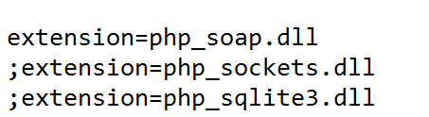
- Another check using "phpinfo()", there must be line about SOAP, as follow
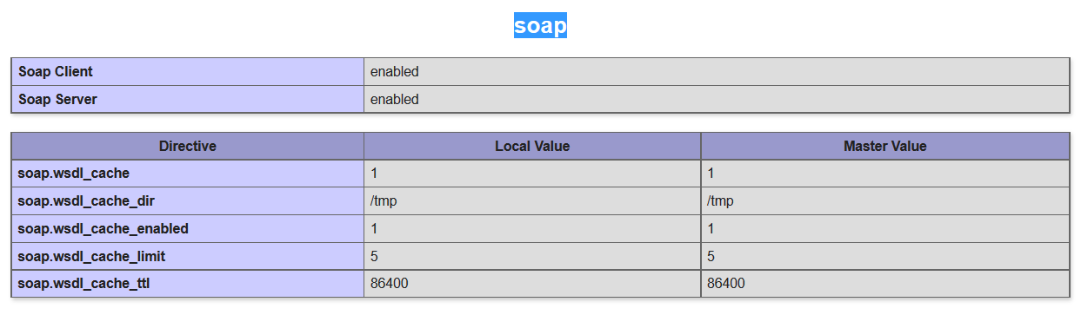

- Next we can use SoapServer and SoapClient function in php script. (complete code see this link http://github.com/handaga/ , look for sistem-informasi-terdistribusi-2017)

Wsdl (Web services Description Language):
It describes the location of a particular service, the data types that are used in it, and the methods, parameters, and return values that are available.

Wsdl is not compulsery, but very usefull for user. We can create wsdl file manualy but that way is very borring. There is an easy way to create wsdl using php library name "php2wsdl".

Create wsdl:
- Download composer from http://composer.org
- Create file "composer.json" then write this script, as follow:
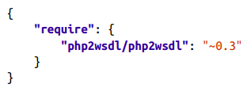

- Open command prompt, goto working directory, then execute this command:
"C:\xampp\htdocs\ws> composer install"
Afer finished installation, there is one new folder call "vendor", create by composer to save all php library. All library that need by our library ("php2wsdl") will be downloaded automatically by composer. That way we need "composer".

- Create file to generate "wsdl", for example:

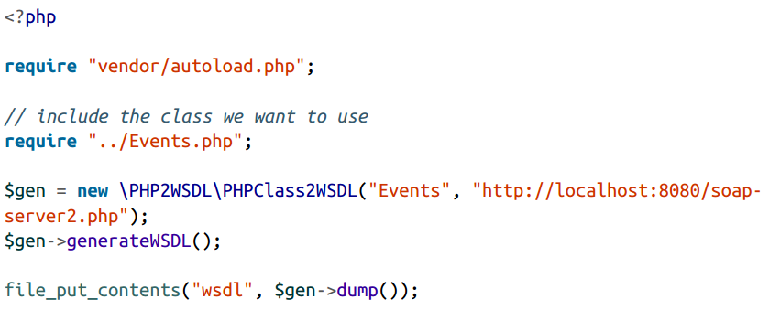

We can use "SOAPUI" (https://www.soapui.org) to analys the content of wsdl file, so display list of procedure & parameters will be created more easy.

