Diode Application
04 April 2015
14:07

The Signal Diode

The semiconductor Signal Diode is a small non-linear semiconductor devices generally used in electronic circuits, where small currents or high frequencies are involved such as in radio, television and digital logic circuits. The signal diode which is also sometimes known by its older name of the Point Contact Diode or the Glass Passivated Diode, are physically very small in size compared to their larger Power Diode cousins.
Generally, the PN junction of a small Signal Diode is encapsulated in glass to protect the PN junction, and usually have a red or black band at one end of their body to help identify which end is the cathode terminal. The most widely used of all the glass encapsulated signal diodes is the very common 1N4148 and its equivalent 1N914 signal diode.
Small signal and switching diodes have much lower power and current ratings, around 150mA, 500mW maximum compared to rectifier diodes, but they can function better in high frequency applications or in clipping and switching applications that deal with short-duration pulse waveforms.
The characteristics of a signal point contact diode are different for both germanium and silicon types and are given as:
- 1. Germanium Signal Diodes – These have a low reverse resistance value giving a lower forward volt drop across the junction, typically only about 0.2-0.3v, but have a higher forward resistance value because of their small junction area.
- 2. Silicon Signal Diodes – These have a very high value of reverse resistance and give a forward volt drop of about 0.6-0.7v across the junction. They have fairly low values of forward resistance giving them high peak values of forward current and reverse voltage.
The electronic symbol given for any type of diode is that of an arrow with a bar or line at its end and this is illustrated below along with the Steady State V-I Characteristics Curve.

Silicon Diode V-I Characteristic Curve
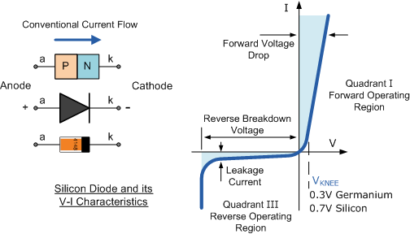

The arrow always points in the direction of conventional current flow through the diode meaning that the diode will only conduct if a positive supply is connected to the Anode, ( a ) terminal and a negative supply is connected to the Cathode ( k ) terminal thus only allowing current to flow through it in one direction only, acting more like a one way electrical valve, ( Forward Biased Condition ).
However, we know from the previous tutorial that if we connect the external energy source in the other direction the diode will block any current flowing through it and instead will act like an open switch, ( Reversed Biased Condition ) as shown below.

Forward and Reversed Biased Diode

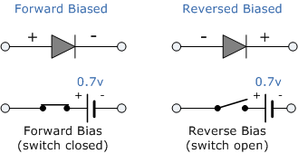

Then we can say that an ideal small signal diode conducts current in one direction ( forward-conducting ) and blocks current in the other direction ( reverse-blocking ). Signal Diodes are used in a wide variety of applications such as a switch in rectifiers, limiters, snubbers or in wave-shaping circuits.

Signal Diode Parameters
Signal Diodes are manufactured in a range of voltage and current ratings and care must be taken when choosing a diode for a certain application. There are a bewildering array of static characteristics associated with the humble signal diode but the more important ones are.

1. Maximum Forward Current
The Maximum Forward Current ( I_{F(max)} ) is as its name implies the maximum forward current allowed to flow through the device. When the diode is conducting in the forward bias condition, it has a very small “ON” resistance across the PN junction and therefore, power is dissipated across this junction ( Ohm´s Law ) in the form of heat.
Then, exceeding its ( I_{F(max)} ) value will cause more heat to be generated across the junction and the diode will fail due to thermal overload, usually with destructive consequences. When operating diodes around their maximum current ratings it is always best to provide additional cooling to dissipate the heat produced by the diode.
For example, our small 1N4148 signal diode has a maximum current rating of about 150mA with a power dissipation of 500mW at 25ºC. Then a resistor must be used in series with the diode to limit the forward current, ( I_{F(max)} ) through it to below this value.

2. Peak Inverse Voltage
The Peak Inverse Voltage (PIV) or Maximum Reverse Voltage ( V_{R(max)} ), is the maximum allowable Reverse operating voltage that can be applied across the diode without reverse breakdown and damage occurring to the device. This rating therefore, is usually less than the “avalanche breakdown” level on the reverse bias characteristic curve. Typical values of V_{R(max)} range from a few volts to thousands of volts and must be considered when replacing a diode.

The peak inverse voltage is an important parameter and is mainly used for rectifying diodes in AC rectifier circuits with reference to the amplitude of the voltage were the sinusoidal waveform changes from a positive to a negative value on each and every cycle.

3. Total Power Dissipation
Signal diodes have a Total Power Dissipation, ( P_{D(max)} ) rating. This rating is the maximum possible power dissipation of the diode when it is forward biased (conducting). When current flows through the signal diode the biasing of the PN junction is not perfect and offers some resistance to the flow of current resulting in power being dissipated (lost) in the diode in the form of heat.
As small signal diodes are non-linear devices the resistance of the PN junction is not constant, it is a dynamic property then we cannot use Ohms Law to define the power in terms of current and resistance or voltage and resistance as we can for resistors. Then to find the power that will be dissipated by the diode we must multiply the voltage drop across it times the current flowing through it: P_{D} = VxI

4. Maximum Operating Temperature
The Maximum Operating Temperature actually relates to the Junction Temperature ( T_{J} ) of the diode and is related to maximum power dissipation. It is the maximum temperature allowable before the structure of the diode deteriorates and is expressed in units of degrees centigrade per Watt, ( ºC/W ).
This value is linked closely to the maximum forward current of the device so that at this value the temperature of the junction is not exceeded. However, the maximum forward current will also depend upon the ambient temperature in which the device is operating so the maximum forward current is usually quoted for two or more ambient temperature values such as 25ºC or 70ºC.
Then there are three main parameters that must be considered when either selecting or replacing a
signal diode and these are:
- • The Reverse Voltage Rating
- • The Forward Current Rating
- • The Forward Power Dissipation Rating

Signal Diode Arrays
When space is limited, or matching pairs of switching signal diodes are required, diode arrays can be very useful. They generally consist of low capacitance high speed silicon diodes such as the 1N4148 connected together in multiple diode packages called an array for use in switching and clamping in digital circuits. They are encased in single inline packages (SIP) containing 4 or more diodes connected internally to give either an individual isolated array, common cathode, (CC), or a common anode, (CA) configuration as shown.

Signal Diode Arrays
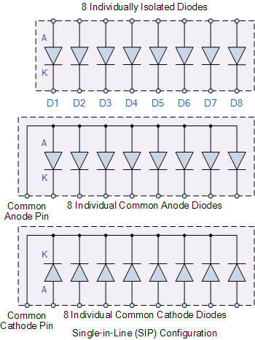

Signal diode arrays can also be used in digital and computer circuits to protect high speed data lines or other input/output parallel ports against electrostatic discharge, (ESD) and voltage transients. By connecting two diodes in series across the supply rails with the data line connected to their junction as shown, any unwanted transients are quickly dissipated and as the signal diodes are available in 8-fold arrays they can protect eight data lines in a single package.
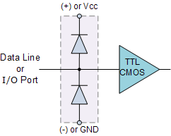
CPU Data Line Protection
Signal diode arrays can also be used to connect together diodes in either series or parallel combinations to form voltage regulator or voltage reducing type circuits or even to produce a known fixed reference voltage.
We know that the forward volt drop across a silicon diode is about 0.7v and by connecting together a number of diodes in series the total voltage drop will be the sum of the individual voltage drops of each diode.
However, when signal diodes are connected together in series, the current will be the same for each diode so the maximum forward current must not be exceeded.

Connecting Signal Diodes in Series
Another application for the small signal diode is to create a regulated voltage supply. Diodes are connected together in series to provide a constant DC voltage across the diode combination. The output voltage across the diodes remains constant in spite of changes in the load current drawn from the series combination or changes in the DC power supply voltage that feeds them. Consider the circuit below.

Signal Diodes in Series
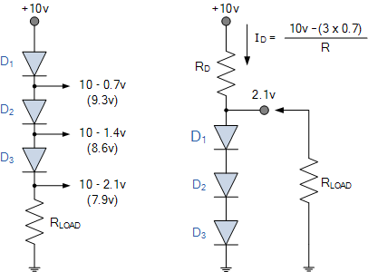

As the forward voltage drop across a silicon diode is almost constant at about 0.7v, while the current through it varies by relatively large amounts, a forward-biased signal diode can make a simple voltage regulating circuit. The individual voltage drops across each diode are subtracted from the supply voltage to leave a certain voltage potential across the load resistor, and in our simple example above this is given as 10v – ( 3 x 0.7v ) = 7.9v.
This is because each diode has a junction resistance relating to the small signal current flowing through it and the three signal diodes in series will have three times the value of this resistance, along with the load resistance R, forms a voltage divider across the supply.
By adding more diodes in series a greater voltage reduction will occur. Also series connected diodes can be placed in parallel with the load resistor to act as a voltage regulating circuit. Here the voltage applied to the load resistor will be 3 x 0.7v = 2.1v. We can of course produce the same constant voltage source using a single Zener Diode. Resistor, R_{D} is used to prevent excessive current flowing through the diodes if the load is removed.

Freewheel Diodes
Signal diodes can also be used in a variety of clamping, protection and wave shaping circuits with the most common form of clamping diode circuit being one which uses a diode connected in parallel with a coil or inductive load to prevent damage to the delicate switching circuit by suppressing the voltage spikes and/or transients that are generated when the load is suddenly turned “OFF”. This type of diode is generally known as a “Free-wheeling Diode”, “Flywheel Diode” or Freewheel diode as it is more commonly called.
The Freewheel diode is used to protect solid state switches such as power transistors and MOSFET’s from damage by reverse battery protection as well as protection from highly inductive loads such as relay coils or motors, and an example of its connection is shown below.

Use of the Freewheel Diode
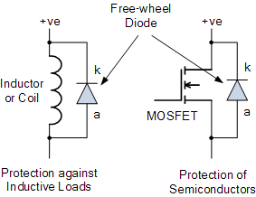
Modern fast switching, power semiconductor devices require fast switching diodes such as free wheeling diodes to protect them form inductive loads such as motor coils or relay windings. Every time the switching device above is turned “ON”, the freewheel diode changes from a conducting state to a blocking state as it becomes reversed biased.
However, when the device rapidly turns “OFF”, the diode becomes forward biased and the collapse of the energy stored in the coil causes a current to flow through the freewheel diode. Without the protection of the freewheel diode high di/dt currents would occur causing a high voltage spike or transient to flow around the circuit possibly damaging the switching device.
Previously, the operating speed of the semiconductor switching device, either transistor, MOSFET, IGBT or digital has been impaired by the addition of a freewheel diode across the inductive load with Schottky and Zener diodes being used instead in some applications. But during the past few years however, freewheel diodes had regained importance due mainly to their improved reverse-recovery characteristics and the use of super fast semiconductor materials capable at operating at high switching frequencies.
Other types of specialized diodes not included here are Photo-Diodes, PIN Diodes, Tunnel Diodes and Schottky Barrier Diodes. By adding more PN junctions to the basic two layer diode structure other types of semiconductor devices can be made. For example a three layer semiconductor device becomes a Transistor, a four layer semiconductor device becomes a Thyristor or Silicon Controlled Rectifier and five layer devices known as Triac’s are also available.
In the next tutorial about diodes, we will look at the large signal diode sometimes called the Power Diode. Power diodes are silicon diodes designed for use in high-voltage, high-current mains rectification circuits.

The Power Diode
In the previous tutorials we saw that a semiconductor signal diode will only conduct current in one direction from its anode to its cathode (forward direction), but not in the reverse direction acting a bit like an electrical one way valve. A widely used application of this feature is in the conversion of an alternating voltage ( AC ) into a continuous voltage ( DC ). In other words, Rectification.
But small signal diodes can also be used as Rectifiers in low-power, low current (less than 1-amp) rectifiers or applications, but were larger forward bias currents or higher reverse bias blocking voltages are involved the PN junction of a small signal diode would eventually overheat and melt so larger more robust Power Diodes are used instead.
The power semiconductor diode, known simply as the Power Diode, has a much larger PN junction area compared to its smaller signal diode cousin, resulting in a high forward current capability of up to several hundred amps (KA) and a reverse blocking voltage of up to several thousand volts (KV).
Since the power diode has a large PN junction, it is not suitable for high frequency applications above 1MHz, but special and expensive high frequency, high current diodes are available. For high frequency rectifier applications Schottky Diodes are generally used because of their short reverse recovery time and low voltage drop in their forward bias condition.
Power diodes provide uncontrolled rectification of power and are used in applications such as battery charging and DC power supplies as well as AC rectifiers and inverters. Due to their high current and voltage characteristics they can also be used as free-wheeling diodes and snubber networks.
Power diodes are designed to have a forward “ON” resistance of fractions of an Ohm while their reverse blocking resistance is in the mega-Ohms range. Some of the larger value power diodes are designed to be “stud mounted” onto heatsinks reducing their thermal resistance to between 0.1 to 1ºC/Watt.
If an alternating voltage is applied across a power diode, during the positive half cycle the diode will conduct passing current and during the negative half cycle the diode will not conduct blocking the flow of current. Then conduction through the power diode only occurs during the positive half cycle and is therefore unidirectional i.e. DC as shown.

Power Diode Rectifier
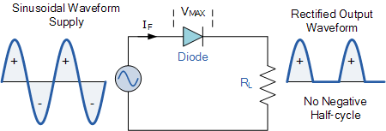

Power diodes can be used individually as above or connected together to produce a variety of rectifier circuits such as “Half-Wave”, “Full-Wave” or as “Bridge Rectifiers”. Each type of rectifier circuit can be classed as either uncontrolled, half-controlled or fully controlled were an uncontrolled rectifier uses only power diodes, a fully controlled rectifier uses thyristors (SCRs) and a half controlled rectifier is a mixture of both diodes and thyristors.
The most commonly used individual power diode for basic electronics applications is the general purpose 1N400x Series Glass Passivated type rectifying diode with standard ratings of continuous forward rectified current of 1.0 amp and reverse blocking voltage ratings from 50v for the 1N4001 up to 1000v for the 1N4007, with the small 1N4007GP being the most popular for general purpose mains voltage rectification.

Half Wave Rectification
A rectifier is a circuit which converts the Alternating Current (AC) input power into a Direct Current (DC) output power. The input power supply may be either a single-phase or a multi-phase supply with the simplest of all the rectifier circuits being that of the Half Wave Rectifier.
The power diode in a half wave rectifier circuit passes just one half of each complete sine wave of the AC supply in order to convert it into a DC supply. Then this type of circuit is called a “half-wave” rectifier because it passes only half of the incoming AC power supply as shown below.

Half Wave Rectifier Circuit
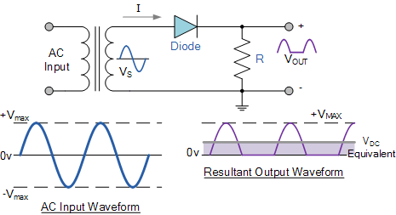

During each “positive” half cycle of the AC sine wave, the diode is forward biased as the anode is positive with respect to the cathode resulting in current flowing through the diode.
Since the DC load is resistive (resistor, R), the current flowing in the load resistor is therefore proportional to the voltage (Ohm´s Law), and the voltage across the load resistor will therefore be the same as the supply voltage, Vs (minus Vf), that is the “DC” voltage across the load is sinusoidal for the first half cycle only so Vout = Vs.
During each “negative” half cycle of the AC sinusoidal input waveform, the diode is reverse biased as the anode is negative with respect to the cathode. Therefore, NO current flows through the diode or circuit. Then in the negative half cycle of the supply, no current flows in the load resistor as no voltage appears across it so therefore, Vout = 0.
The current on the DC side of the circuit flows in one direction only making the circuit Unidirectional. As the load resistor receives from the diode a positive half of the waveform, zero volts, a positive half of the waveform, zero volts, etc, the value of this irregular voltage would be equal in value to an equivalent DC voltage of 0.318 x Vmax of the input sinusoidal waveform or 0.45 x Vrms of the input sinusoidal waveform.
Then the equivalent DC voltage, V_{DC} across the load resistor is calculated as follows.
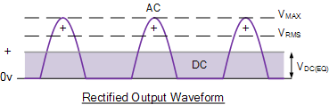

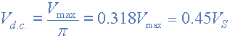
Where V_{max} is the maximum or peak voltage value of the AC sinusoidal supply, and V_{S} is the RMS (Root Mean Squared) value of the supply.

Power Diode Example No1
Calculate the voltage across V_{DC} and the current I_{DC}, flowing through a 100Ω resistor connected to a 240 Vrms single phase half-wave rectifier as shown above. Also calculate the DC power consumed by the load.

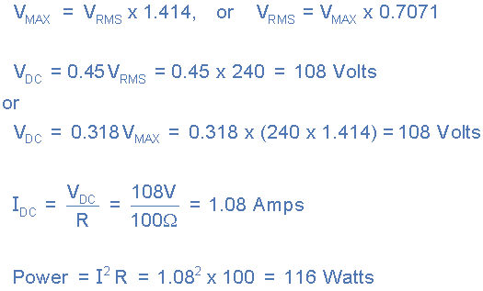

During the rectification process the resultant output DC voltage and current are therefore both “ON” and “OFF” during every cycle. As the voltage across the load resistor is only present during the positive half of the cycle (50% of the input waveform), this results in a low average DC value being supplied to the load.
The variation of the rectified output waveform between this “ON” and “OFF” condition produces a waveform which has large amounts of “ripple” which is an undesirable feature. The resultant DC ripple has a frequency that is equal to that of the AC supply frequency.
Very often when rectifying an alternating voltage we wish to produce a “steady” and continuous DC voltage free from any voltage variations or ripple. One way of doing this is to connect a large value Capacitor across the output voltage terminals in parallel with the load resistor as shown below. This type of capacitor is known commonly as a “Reservoir” or Smoothing Capacitor.

Half-wave Rectifier with Smoothing Capacitor

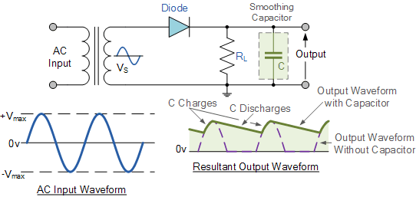

When rectification is used to provide a direct voltage ( DC ) power supply from an alternating ( AC ) source, the amount of ripple voltage can be further reduced by using larger value capacitors but there are limits both on cost and size to the types of smoothing capacitors used.
For a given capacitor value, a greater load current (smaller load resistance) will discharge the capacitor more quickly ( RC Time Constant ) and so increases the ripple obtained. Then for single phase, half-wave rectifier circuit using a power diode it is not very practical to try and reduce the ripple voltage by capacitor smoothing alone. In this instance it would be more practical to use “Full-wave Rectification” instead.
In practice, the half-wave rectifier is used most often in low-power applications because of their major disadvantages being. The output amplitude is less than the input amplitude, there is no output during the negative half cycle so half the power is wasted and the output is pulsed DC resulting in excessive ripple. To overcome these disadvantages a number of Power Diode are connected together to produce a Full Wave Rectifier as discussed in the next tutorial.

The Full Wave Rectifier
In the previous Power Diodes tutorial we discussed ways of reducing the ripple or voltage variations on a direct DC voltage by connecting capacitors across the load resistance. While this method may be suitable for low power applications it is unsuitable to applications which need a “steady and smooth” DC supply voltage. One method to improve on this is to use every half-cycle of the input voltage instead of every other half-cycle. The circuit which allows us to do this is called a Full Wave Rectifier.
Like the half wave circuit, a Full Wave Rectifier Circuit produces an output voltage or current which is purely DC or has some specified DC component. Full wave rectifiers have some fundamental advantages over their half wave rectifier counterparts. The average (DC) output voltage is higher than for half wave, the output of the full wave rectifier has much less ripple than that of the half wave rectifier producing a smoother output waveform.
In a Full Wave Rectifier circuit two diodes are now used, one for each half of the cycle. A multiple winding transformer is used whose secondary winding is split equally into two halves with a common centre tapped connection, (C). This configuration results in each diode conducting in turn when its anode terminal is positive with respect to the transformer centre point C producing an output during both half-cycles, twice that for the half wave rectifier so it is 100% efficient as shown below.

Full Wave Rectifier Circuit
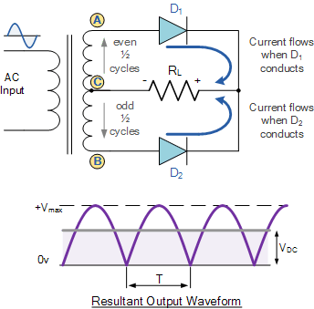

The full wave rectifier circuit consists of two power diodes connected to a single load resistance (R_{L}) with each diode taking it in turn to supply current to the load. When point A of the transformer is positive with respect to point C, diode D₁ conducts in the forward direction as indicated by the arrows.
When point B is positive (in the negative half of the cycle) with respect to point C, diode D₂ conducts in the forward direction and the current flowing through resistor R is in the same direction for both half-cycles. As the output voltage across the resistor R is the phasor sum of the two waveforms combined, this type of full wave rectifier circuit is also known as a “bi-phase” circuit.
As the spaces between each half-wave developed by each diode is now being filled in by the other diode the average DC output voltage across the load resistor is now double that of the single half-wave rectifier circuit and is about 0.637V_{max} of the peak voltage, assuming no losses.

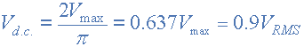

Where: V_{MAX} is the maximum peak value in one half of the secondary winding and V_{RMS} is the rms value.
The peak voltage of the output waveform is the same as before for the half-wave rectifier provided each half of the transformer windings have the same rms voltage value. To obtain a different DC voltage output different transformer ratios can be used. The main disadvantage of this type of full wave rectifier circuit is that a larger transformer for a given power output is required with two separate but identical secondary windings making this type of full wave rectifying circuit costly compared to the “Full Wave Bridge Rectifier” circuit equivalent.

The Full Wave Bridge Rectifier
Another type of circuit that produces the same output waveform as the full wave rectifier circuit above, is that of the Full Wave Bridge Rectifier. This type of single phase rectifier uses four individual rectifying diodes connected in a closed loop “bridge” configuration to produce the desired output. The main advantage of this bridge circuit is that it does not require a special centre tapped transformer, thereby reducing its size and cost. The single secondary winding is connected to one side of the diode bridge network and the load to the other side as shown below.

The Diode Bridge Rectifier
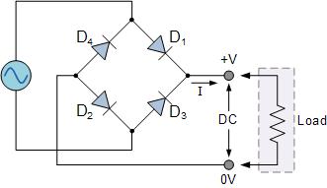

The four diodes labelled D₁ to D₄ are arranged in “series pairs” with only two diodes conducting current during each half cycle. During the positive half cycle of the supply, diodes D1 and D2 conduct in series while diodes D3 and D4 are reverse biased and the current flows through the load as shown below.
The Positive Half-cycle
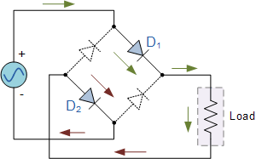

During the negative half cycle of the supply, diodes D3 and D4 conduct in series, but diodes D1 and D2 switch “OFF” as they are now reverse biased. The current flowing through the load is the same direction as before.

The Negative Half-cycle
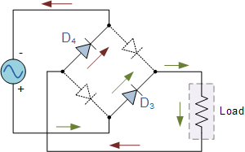

As the current flowing through the load is unidirectional, so the voltage developed across the load is also unidirectional the same as for the previous two diode full-wave rectifier, therefore the average DC voltage across the load is 0.637V_{max}.
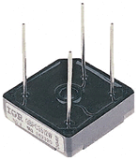
Typical Bridge Rectifier

However in reality, during each half cycle the current flows through two diodes instead of just one so the amplitude of the output voltage is two voltage drops ( 2 x 0.7 = 1.4V ) less than the input V_{MAX} amplitude. The ripple frequency is now twice the supply frequency (e.g. 100Hz for a 50Hz supply or 120Hz for a 60Hz supply.)
Although we can use four individual power diodes to make a full wave bridge rectifier, pre-made bridge rectifier components are available “off-the-shelf” in a range of different voltage and current sizes that can be soldered directly into a PCB circuit board or be connected by spade connectors.
The image to the right shows a typical single phase bridge rectifier with one corner cut off. This cut-off corner indicates that the terminal nearest to the corner is the positive or +ve output terminal or lead with the opposite (diagonal) lead being the negative or -ve output lead. The other two connecting leads are for the input alternating voltage from a transformer secondary winding.

The Smoothing Capacitor
We saw in the previous section that the single phase half-wave rectifier produces an output wave every half cycle and that it was not practical to use this type of circuit to produce a steady DC supply. The full-wave bridge rectifier however, gives us a greater mean DC value (0.637 Vmax) with less superimposed ripple while the output waveform is twice that of the frequency of the input supply frequency. We can therefore increase its average DC output level even higher by connecting a suitable smoothing capacitor across the output of the bridge circuit as shown below.

Full-wave Rectifier with Smoothing Capacitor

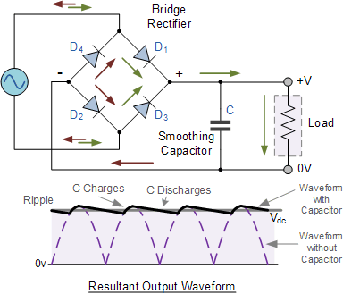

The smoothing capacitor converts the full-wave rippled output of the rectifier into a smooth DC output voltage. Generally for DC power supply circuits the smoothing capacitor is an Aluminium Electrolytic type that has a capacitance value of 100uF or more with repeated DC voltage pulses from the rectifier charging up the capacitor to peak voltage.
However, their are two important parameters to consider when choosing a suitable smoothing capacitor and these are its Working Voltage, which must be higher than the no-load output value of the rectifier and its Capacitance Value, which determines the amount of ripple that will appear superimposed on top of the DC voltage.
Too low a capacitance value and the capacitor has little effect on the output waveform. But if the smoothing capacitor is sufficiently large enough (parallel capacitors can be used) and the load current is not too large, the output voltage will be almost as smooth as pure DC. As a general rule of thumb, we are looking to have a ripple voltage of less than 100mV peak to peak.
The maximum ripple voltage present for a Full Wave Rectifier circuit is not only determined by the value of the smoothing capacitor but by the frequency and load current, and is calculated as:

Bridge Rectifier Ripple Voltage



Where: I is the DC load current in amps, ƒ is the frequency of the ripple or twice the input frequency in Hertz, and C is the capacitance in Farads.
The main advantages of a full-wave bridge rectifier is that it has a smaller AC ripple value for a given load and a smaller reservoir or smoothing capacitor than an equivalent half-wave rectifier. Therefore, the fundamental frequency of the ripple voltage is twice that of the AC supply frequency (100Hz) where for the half-wave rectifier it is exactly equal to the supply frequency (50Hz).
The amount of ripple voltage that is superimposed on top of the DC supply voltage by the diodes can be virtually eliminated by adding a much improved π-filter (pi-filter) to the output terminals of the bridge rectifier. This type of low-pass filter consists of two smoothing capacitors, usually of the same value and a choke or inductance across them to introduce a high impedance path to the alternating ripple component
Another more practical and cheaper alternative is to use an off the shelf 3-terminal voltage regulator IC, such as a LM78xx (where “xx” stands for the output voltage rating) for a positive output voltage or its inverse equivalent the LM79xx for a negative output voltage which can reduce the ripple by more than 70dB (Datasheet) while delivering a constant output current of over 1 amp.
In the next tutorial about diodes, we will look at the Zener Diode which takes advantage of its reverse breakdown voltage characteristic to produce a constant and fixed output voltage across itself.

Diode Clipping Circuits
The Diode Clipper, also known as a Diode Limiter, is a wave shaping circuit that takes an input waveform and clips or cuts off its top half, bottom half or both halves together to produce an output waveform that resembles a flattened version of the input. For example, the half-wave rectifier is a clipper circuit, since all voltages below zero are eliminated.
But Diode Clipping Circuits can be used a variety of applications to modify an input waveform using signal and Schottky diodes or to provide over-voltage protection using Zener Diodes to ensure that the output voltage never exceeds a certain level protecting the circuit from high voltage spikes. Then diode clipping circuits can be used in voltage limiting applications.
We saw in the Signal Diodes tutorial that when a diode is forward biased it allows current to pass through itself clamping the voltage. When the diode is reverse biased, no current flows through it and the voltage across its terminals is unaffected, and this is the basic operation of the diode clipping circuit.
Although the input voltage to diode clipping circuits can have any waveform shape, we will assume here that the input voltage is sinusoidal. Consider the circuits below.

Positive Diode Clipping Circuits
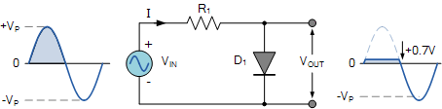

In this diode clipping circuit, the diode is forward biased (anode more positive than cathode) during the positive half cycle of the sinusoidal input waveform. For the diode to become forward biased, it must have the input voltage magnitude greater than +0.7 volts (0.3 volts for a germanium diode).
When this happens the diodes begins to conduct and holds the voltage across itself constant at 0.7V until the sinusoidal waveform falls below this value. Thus the output voltage which is taken across the diode can never exceed 0.7 volts during the positive half cycle.
During the negative half cycle, the diode is reverse biased (cathode more positive than anode) blocking current flow through itself and as a result has no effect on the negative half of the sinusoidal voltage which passes to the load unaltered. Then the diode limits the positive half of the input waveform and is known as a positive clipper circuit.

Negative Diode Clipping Circuits
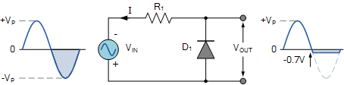

Here the reverse is true. The diode is forward biased during the negative half cycle of the sinusoidal waveform and limits or clips it to -0.7 volts while allowing the positive half cycle to pass unaltered when reverse biased. As the diode limits the negative half cycle of the input voltage it is therefore called a negative clipper circuit.

Clipping of Both Half Cycles
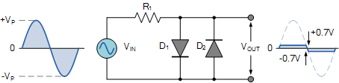

If we connected two diodes in inverse parallel as shown, then both the positive and negative half cycles would be clipped as diode D₁ clips the positive half cycle of the sinusoidal input waveform while diode D₂ clips the negative half cycle. Then diode clipping circuits can be used to clip the positive half cycle, the negative half cycle or both.
For ideal diodes the output waveform above would be zero. However, due to the forward bias voltage drop across the diodes the actual clipping point occurs at +0.7 volts and -0.7 volts respectively. But we can increase this ±0.7V threshold to any value we want up to the maximum value, (V_{PEAK}) of the sinusoidal waveform either by connecting together more diodes in series creating multiples of 0.7 volts, or by adding a voltage bias to the diodes.

Biased Diode Clipping Circuits
To produce diode clipping circuits for voltage waveforms at different levels, a bias voltage, V_{BIAS} is added in series with the diode as shown. The voltage across the series combination must be greater than V_{BIAS} + 0.7V before the diode becomes sufficiently forward biased to conduct. For example, if the V_{BIAS} level is set at 4.0 volts, then the sinusoidal voltage at the diode’s anode terminal must be greater than 4.0 + 0.7 = 4.7 volts for it to become forward biased. Any anode voltage levels above this bias point are clipped off.

Positive Bias Diode Clipping
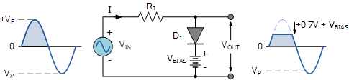

Likewise, by reversing the diode and the battery bias voltage, when a diode conducts the negative half cycle of the output waveform is held to a level -V_{BIAS} - 0.7V as shown.

Negative Bias Diode Clipping
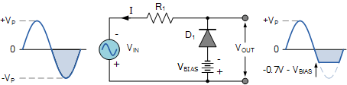

A variable diode clipping or diode limiting level can be achieved by varying the bias voltage of the diodes. If both the positive and the negative half cycles are to be clipped, then two biased clipping diodes are used. But for both positive and negative diode clipping, the bias voltage need not be the same. The positive bias voltage could be at one level, for example 4 volts, and the negative bias voltage at another, for example 6 volts as shown.

Diode Clipping of Different Bias levels
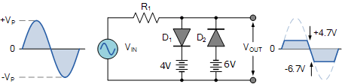

When the voltage of the positive half cycle reaches +4.7 V, diode D₁ conducts and limits the waveform at +4.7 V. Diode D₂ does not conduct until the voltage reaches –6.7 V. Therefore, all positive voltages above +4.7 V and negative voltages below –6.7 V are automatically clipped.

The advantage of biased diode clipping circuits is that it prevents the output signal from exceeding preset voltage limits for both half cycles of the input waveform, which could be an input from a noisy sensor or the positive and negative supply rails of a power supply.
If the diode clipping levels are set too low or the input waveform is too great then the elimination of both waveform peaks could end up with a square-wave shaped waveform.

Zener Diode Clipping Circuits

The use of a bias voltage means that the amount of the voltage waveform that is clipped off can be accurately controlled. But one of the main disadvantages of using voltage biased diode clipping circuits, is that they need an additional emf battery source which may or may not be a problem.
One easy way of creating biased diode clipping circuits without the need for an additional emf supply is to use Zener Diodes.
As we know, the zener diode is a another type of diode that has been specially manufactured to operate in its reverse biased breakdown region and as such can be used for voltage regulation or zener diode clipping applications. In the forward region, the zener acts just like an ordinary silicon diode with a forward voltage drop of 0.7V (700mV) when conducting, the same as above.
However, in the reverse bias region, the voltage is blocked until the zener diodes breakdown voltage is reached. At this point, the reverse current through the zener increases sharply but the zener voltage, V_{Z} across the device remains constant even if the zener current, I_{Z} varies.
Then we can put this zener action to good effect by using them for clipping a waveform as shown.

Zener Diode Clipping

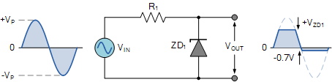

The zener diode is acting like a biased diode clipping circuit with the bias voltage being equal to the zener breakdown voltage. In this circuit during the positive half of the waveform the zener diode is reverse biased so the waveform is clipped at the zener voltage, V_{ZD1}. During the negative half cycle the zener acts like a normal diode with its usual 0.7V junction value.
We can develop this idea further by using the zener diodes reverse-voltage characteristics to clip both halves of a waveform using series connected back-to-back zener diodes as shown.

Full-wave Zener Diode Clipping
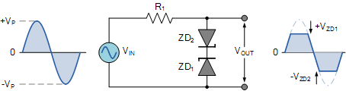

The output waveform from full wave zener diode clipping circuits resembles that of the previous voltage biased diode clipping circuit. The output waveform will be clipped at the zener voltage plus the 0.7V forward volt drop of the other diode. So for example, the positive half cycle will be clipped at the sum of zener diode, ZD1 plus 0.7V from ZD2 and vice versa for the negative half cycle.
Zener diodes are manufactured with a wide range of voltages and can be used to give different voltage references on each half cycle, the same as above. Zener diodes are available with zener breakdown voltages, V_{Z} ranging from 2.4 to 33 volts, with a typical tolerance of 1 or 5%. Note that once conducting in the reverse breakdown region, full current will flow through the zener diode so a suitable current limiting resistor, R1 must be chosen.

Diode Clipping Summary
As well as being used as rectifiers, diodes can also be used to clip the top, or bottom, or both of a waveform at a particular dc level and pass it to the output without distortion,. In or examples above we have assumed that the waveform is sinusoidal but in theory any shaped input waveform can be used.
Diode Clipping Circuits are used to eliminate amplitude noise or voltage spikes, voltage regulation or to produce new waveforms from an existing signal such as squaring off the peaks of a sinusoidal waveform to obtain a rectangular waveform as seen above.
The most common application of a “diode clipping” is as a flywheel or free-wheeling diode connected in parallel across an inductive load to protect the switching transistor form reverse voltage transients.

Bypass Diodes in Solar Panels
Bypass Diodes which in electronics we know as free-wheeling diodes, are wired in parallel with individual solar cells or panels, to provide a current path around them in the event that a cell or panel becomes faulty or open-circuited. This allows a series (called a string) of connected cells or panels to continue supplying power at a reduced voltage rather than no power at all.

Bypass diodes are connected in reverse bias between a solar cells (or panel) positive and negative output terminals and has no effect on its output. Ideally there would be one bypass diode for each solar cell, but this can be rather expensive so generally one diode is used per small group of series cells.
A “solar panel” is constructed using individual solar cells, and solar cells are made from layers of silicon semiconductor materials. One layer of silicon is treated with a substance to create an excess of electrons. This becomes the negative or N-type layer. The other layer is treated to create a deficiency of electrons, and becomes the positive or P-type layer similar to transistors and diodes.
When assembled together with conductors, this silicon arrangement becomes a light-sensitive PN-junction semiconductor. In fact Photovoltaic Solar Cells or PV’s as they are more commonly called, are no more than big, flat photo sensitive diodes.
Photovoltaic solar cells convert the photon light around the PN-junction directly into electricity without any moving or mechanical parts. PV cells produce energy from sunlight, not from heat. In fact, they are most efficient when they are cold!.
When exposed to sunlight (or other intense light source), the voltage produced by a single solar cell is about 0.58 volts DC, with the current flow (amps) being proportional to the light energy (photons). In most photovoltaic cells, the voltage is nearly constant, and the current is proportional to the size of the cell and the intensity of the light.

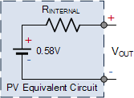

The equivalent circuit of a PV, shown on the left, is that of a battery with a series internal resistance, R_{INTERNAL}, similar to any other conventional battery. However, due to variations in internal resistance, the cell voltage and therefore available current will vary between photovoltaic cells of equivalent size and structure, connected to the same load, and under the same light source so this must be accounted for in the solar panel assemblies you buy.
The silicon wafer of the photovoltaic solar cell that faces the sunlight consist of the electrical contacts and is coated with an anti-reflective coating that helps absorb the sunlight more efficiently. Electrical contacts provide the connection between the semiconductor material and the external electrical load, such as a light bulb or battery.
When sunlight shines on a photovoltaic cell, photons of light strike the surface of the semiconductor material and liberate electrons from their atomic bonds. During manufacture certain doping chemicals are added to the semiconductors composition to help to establish a path for the freed electrons. These paths creates a flow of electrons forming an electrical current which starts to flow over the surface of the photovoltaic solar cell.
Metallic strips are placed across the surface of a photovoltaic cell to collect the electrons which form the positive (+) connection of the cell. The back of the cell, the side away from the incoming sunlight consists of a layer of aluminium or molybdenum metal which forms the negative (-) connection to the cell. Then a photovoltaic solar cell has two electrical connections, one positive, on the top, and one negative, at the bottom as shown.

Photovoltaic Solar Cell Construction
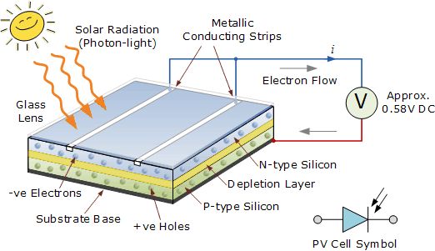

The type of solar power produced by a photovoltaic solar cell is DC the same as from a battery. Most photovoltaic solar cells produce a “no load” open circuit voltage of about 0.5 to 0.6 volts when there is no external circuit connected. This output voltage ( V_{OUT} ) depends very much on the load current ( I ) demands of the PV cell.
For example on very cloudy or dull day the current demand would be low and so the cell could provide the full output voltage, but at a reduced output current. But as the current demand of the load increases a brighter light (solar radiation) is needed at the junction to maintain a full output voltage, V_{OUT}.
However, there is a physical limit to the maximum current that a single photovoltaic solar cell can provide no matter how intense or bright the suns radiation is. This is called the maximum deliverable current and is symbolised as I_{MAX}.
The I_{MAX} value of a single photovoltaic solar cell depends upon the size or surface area of the cell (especially the PN-junction), the amount of direct sunlight hitting the cell, its efficiency of converting this solar power into a current and of course the type of semiconductor material that the cell is manufactured from either silicon, gallium arsenide, cadmium sulphide or cadmium telluride etc.
So when selecting blocking diodes or bypass diodes to connect to solar cells or panels, this maximum current value, I_{MAX} needs to be taken into account.

Diodes in Photovoltaic Array

The PN-junction diode acts like solid state one way electrical valve that only allows electrical current to flow through themselves in one direction only. The advantage of this is that diodes can be used to block the flow of electric current from other parts of an electrical solar circuit. When used with a photovoltaic solar panel, these types of silicon diodes are generally referred to as Blocking Diodes.
Bypass Diodes are used in parallel with either a single or a number of photovoltaic solar cells to prevent the current(s) flowing from good, well-exposed to sunlight solar cells overheating and burning out weaker or partially shaded solar cells by providing a current path around the bad cell. Blocking diodes are used differently than bypass diodes.
Bypass diodes in solar panels are connected in “parallel” with a photovoltaic cell or panel to shunt the current around it, whereas blocking diodes are connected in “series” with the PV panels to prevent current flowing back into them. Blocking diodes are therefore different than bypass diodes although in most cases the diode is physically the same, but they are installed differently and serve a different purpose. Consider our photovoltaic solar array below.

Bypass Diodes in Photovoltaic Arrays

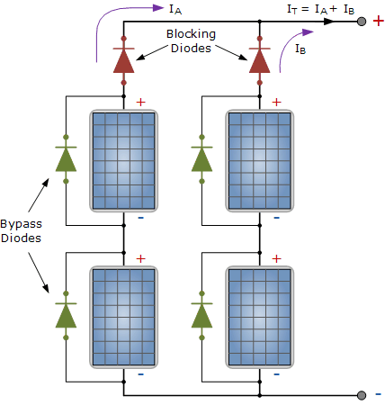

As we said earlier, diodes are devices that allow current to flow in one direction only. The diodes coloured green above are “bypass diodes”, one in parallel with each solar panel to provide a low resistance path. Bypass diodes in solar panels and arrays need to be able to safely carry this short circuit current.

The two diodes coloured red are referred to as the “blocking diodes”, one in series with each series branch. Blocking diodes are different than bypass diodes, but in most cases the two diodes are physically the same. However they are installed differently and serves a different purpose.
These blocking diodes, also called a series diode or isolation diode, ensure that the electrical current only flows in one direction “OUT” of the series array to the external load, controller or batteries.
The reason for this is to prevent the current generated by the other parallel connected PV panels in the same array flowing back through a weaker (shaded) network and also to prevent the fully charged batteries from discharging or draining back through the array at night. So when multiple solar panels are connected in parallel, blocking diodes should be used in each parallel connected branch.
Generally speaking, blocking diodes are used in PV arrays when there are two or more parallel branches or there is a possibility that some of the array will become partially shaded during the day as the sun moves across the sky. The size and type of blocking diode used depends upon the type of photovoltaic array.
Two types of diodes are available as bypass diodes in solar panels and arrays: the PN-junction silicon diode and the Schottky barrier diode. Both are available with a wide range of current ratings. The Schottky barrier diode has a much lower forward voltage drop of about 0.4 volts as opposed to the PN diodes 0.7 volt drop for a silicon device.
This lower voltage drop allows a savings of one full PV cell in each series branch of the solar array therefore, the array is more efficient since less power is dissipated in the blocking diode. Most manufacturers include both blocking diodes and bypass diodes in their solar panels simplifying the design.

