Kirchoffs Circuit Law
02 April 2015
9:15
Kirchoffs Circuit Law

We saw in the Resistors tutorial that a single equivalent resistance, ( R_{T} ) can be found when two or more resistors are connected together in either series, parallel or combinations of both, and that these circuits obey Ohm’s Law.

However, sometimes in complex circuits such as bridge or T networks, we can not simply use Ohm’s Law alone to find the voltages or currents circulating within the circuit. For these types of calculations we need certain rules which allow us to obtain the circuit equations and for this we can use Kirchoffs Circuit Law.

In 1845, a German physicist, Gustav Kirchoff developed a pair or set of rules or laws which deal with the conservation of current and energy within Electrical Circuits. These two rules are commonly known as: Kirchoffs Circuit Laws with one of Kirchoffs laws dealing with the current flowing around a closed circuit, Kirchoffs Current Law, (KCL) while the other law deals with the voltage sources present in a closed circuit, Kirchoffs Voltage Law, (KVL).

Kirchoffs First Law – The Current Law, (KCL)

Kirchoffs Current Law or KCL, states that the “total current or charge entering a junction or node is exactly equal to the charge leaving the node as it has no other place to go except to leave, as no charge is lost within the node“. In other words the algebraic sum of ALL the currents entering and leaving a node must be equal to zero, I_{(exiting)} + I_{(entering)} = 0. This idea by Kirchoff is commonly known as the Conservation of Charge.

Kirchoffs Current Law
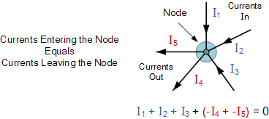

Here, the 3 currents entering the node, I₁, I₂, I₃ are all positive in value and the 2 currents leaving the node, I₄ and I₅ are negative in value. Then this means we can also rewrite the equation as;
I₁ + I₂ + I₃ – I₄ – I₅ = 0
The term Node in an electrical circuit generally refers to a connection or junction of two or more current carrying paths or elements such as cables and components. Also for current to flow either in or out of a node a closed circuit path must exist. We can use Kirchoff’s current law when analysing parallel circuits.

Kirchoffs Second Law – The Voltage Law, (KVL)

Kirchoffs Voltage Law or KVL, states that “in any closed loop network, the total voltage around the loop is equal to the sum of all the voltage drops within the same loop” which is also equal to zero. In other words the algebraic sum of all voltages within the loop must be equal to zero. This idea by Kirchoff is known as the Conservation of Energy.

Kirchoffs Voltage Law

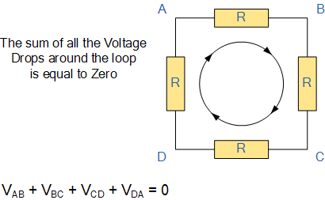

Starting at any point in the loop continue in the same direction noting the direction of all the voltage drops, either positive or negative, and returning back to the same starting point. It is important to maintain the same direction either clockwise or anti-clockwise or the final voltage sum will not be equal to zero. We can use Kirchoff’s voltage law when analysing series circuits.
When analysing either DC circuits or AC circuits using Kirchoffs Circuit Laws a number of definitions and terminologies are used to describe the parts of the circuit being analysed such as: node, paths, branches, loops and meshes. These terms are used frequently in circuit analysis so it is important to understand them.

Common DC Circuit Theory Terms:

- • Circuit – a circuit is a closed loop conducting path in which an electrical current flows.
- • Path – a single line of connecting elements or sources.
- • Node – a node is a junction, connection or terminal within a circuit were two or more circuit elements are connected or joined together giving a connection point between two or more branches. A node is indicated by a dot.
- • Branch – a branch is a single or group of components such as resistors or a source which are connected between two nodes.
- • Loop – a loop is a simple closed path in a circuit in which no circuit element or node is encountered more than once.
- • Mesh – a mesh is a single open loop that does not have a closed path. There are no components inside a mesh.

Note that:

Components are said to be connected in Series if the same current flows through component.
Components are said to be connected in Parallel if the same voltage is applied across them.

A Typical DC Circuit

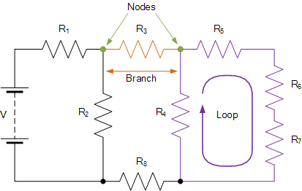

Kirchoffs Circuit Law Example No1
Find the current flowing in the 40Ω Resistor, R₃

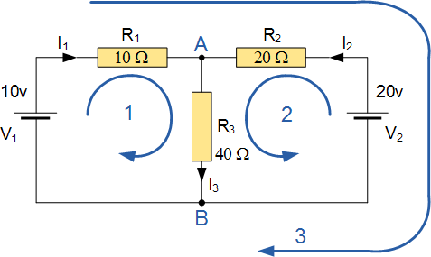

The circuit has 3 branches, 2 nodes (A and B) and 2 independent loops.
Using Kirchoffs Current Law, KCL the equations are given as;
At node A : I₁ + I₂ = I₃
At node B : I₃ = I₁ + I₂

Using Kirchoffs Voltage Law, KVL the equations are given as;
Loop 1 is given as : 10 = R₁ x I₁ + R₃ x I₃ = 10I₁ + 40I₃
Loop 2 is given as : 20 = R₂ x I₂ + R₃ x I₃ = 20I₂ + 40I₃
Loop 3 is given as : 10 – 20 = 10I₁ – 20I₂
As I₃ is the sum of I₁ + I₂ we can rewrite the equations as;
Eq. No 1 : 10 = 10I₁ + 40(I₁ + I₂) = 50I₁ + 40I₂
Eq. No 2 : 20 = 20I₂ + 40(I₁ + I₂) = 40I₁ + 60I₂
We now have two “Simultaneous Equations” that can be reduced to give us the values of I₁ and I₂
Substitution of I₁ in terms of I₂ gives us the value of I₁ as -0.143 Amps
Substitution of I₂ in terms of I₁ gives us the value of I₂ as +0.429 Amps
As : I₃ = I₁ + I₂
The current flowing in resistor R₃ is given as : -0.143 + 0.429 = 0.286 Amps
and the voltage across the resistor R₃ is given as : 0.286 x 40 = 11.44 volts
The negative sign for I₁ means that the direction of current flow initially chosen was wrong, but never the less still valid. In fact, the 20v battery is charging the 10v battery.

Application of Kirchoffs Circuit Laws

These two laws enable the Currents and Voltages in a circuit to be found, ie, the circuit is said to be “Analysed”, and the basic procedure for using Kirchoff’s Circuit Laws is as follows:
- 1. Assume all voltages and resistances are given. ( If not label them V1, V2,… R1, R2, etc. )
- 2. Label each branch with a branch current. ( I1, I2, I3 etc. )
- 3. Find Kirchoff’s first law equations for each node.
- 4. Find Kirchoff’s second law equations for each of the independent loops of the circuit.
- 5. Use Linear simultaneous equations as required to find the unknown currents.
As well as using Kirchoffs Circuit Law to calculate the various voltages and currents circulating around a linear circuit, we can also use loop analysis to calculate the currents in each independent loop which helps to reduce the amount of mathematics required by using just Kirchoff's laws. In the next tutorial about DC Theory we will look at Mesh Current Analysis to do just that.

From <http://www.electronics-tutorials.ws/dccircuits/dcp_4.html>

