11 Juni 2015
9:46

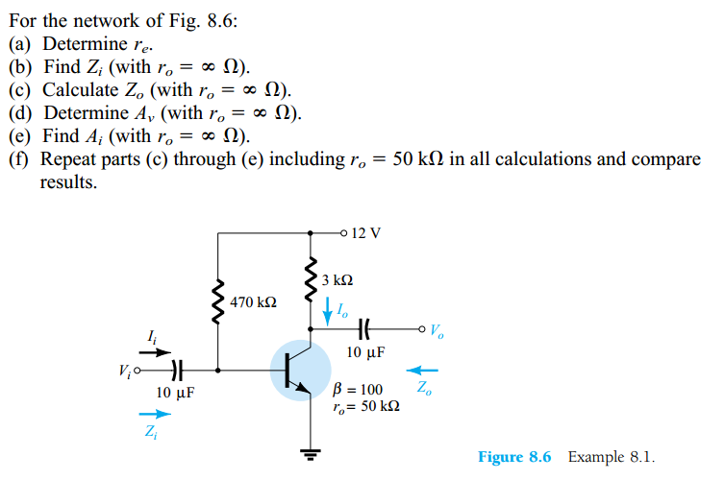

Kisi-kisi Final Exam:

Bias BJT circuit (all configuration, CC, CB, CE)
R_{E} stabilizer
BJT modelling ( re = 26 mV/I_{E})
BJT amplifier (calculate Zi, Zo, Av, & Ai),
table summary page 383)

