 | Universitas Muhammadiyah Surakarta  Jl. A. Yani Tromol Pos I Pabelan Kartasura Telp (0271)717417, 719483 Fax. (0271)715448 Surakarta 57102

UJIAN TENGAH SEMESTER GANJIL 2017/2018
MID SEMESTER EXAM OF ODD SEMESTER
FAKULTAS/FACULTY : TEKNIK/ENGINEERING
JURUSAN/DEPARTMENT : Teknik Elektro/Electronic Engineering
Mata Uji - Course | Mobile Computing | Hari / Tanggal – Day/Date
Smt./Klas - Class | 7/I | Jam ke - Session
Penguji - Examiner | Dr. Ir. Bana Handaga, MT | Waktu - Duration | 90 menit

CLOSE BOOK

- What top tree mobile phone in the world? And descript the difeerent between theme? (20%)
- What type of sofware tools used to developt android application? Descript what type of language programming on that tool? (20%)
- Descript how to prepare the computer to run android studio? (what software compiler must be on the computer before android studio and how to setup) (20%)
- See figure 1, descript the five main components in the android operating system! (20%)
- List all of resources that may uses in android application and explaint the resource is for what? (20%)

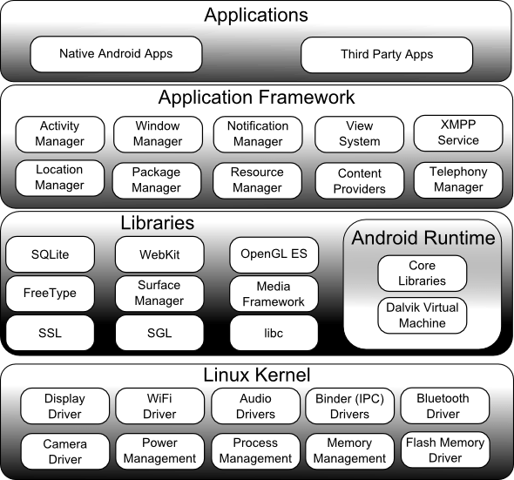
Figure 1. Android architecture

