 | Universitas Muhammadiyah Surakarta  Jl. A. Yani Tromol Pos I Pabelan Kartasura Telp (0271)717417, 719483 Fax. (0271)715448 Surakarta 57102

UJIAN TENGAH SEMESTER GANJIL 2017/2018
MID SEMESTER EXAM OF ODD SEMESTER
FAKULTAS/FACULTY : TEKNIK/ENGINEERING
JURUSAN/DEPARTMENT : Teknik Elektro/Electronic Engineering
Mata Uji - Course | Elektronika Analog Lanjut | Hari / Tanggal – Day/Date
Smt./Klas - Class | 3/i | Jam ke - Session
Penguji - Examiner | Dr. Ir. Bana Handaga, MT | Waktu - Duration | 90 menit

CLOSE BOOK

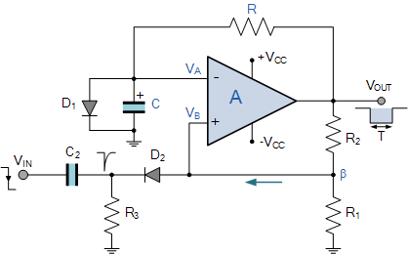  Figure-01 | 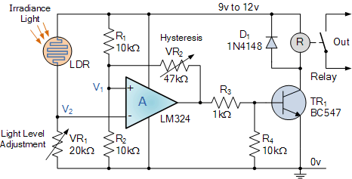  Figure-02

- Descript the four ideal characteristics of an operational amplifier? (25%)
- Design an inverting ampplifier which have voltage gain 40dB? How much phase shifted on output signal as compare with input signal? (25%)
- See Figure-01, what the name of that circuit? How the circuit work? If the formula to calculate time constant is T = RC * ln (1 + R1/R2), calculate the T of that circuit in second! Draw the output signal (25%)
- See Figure-02, analys how the circuit work? What is the main function of OpAmp there? What the condition which can cause the relay to become active? (25%)

