Mobile Computing
14 September 2017
14:33

Communication (communication system of mobile phone, GSM)
Hardware (How to build mobile phone)
Software (How to create app on mobile phone)

Android
Windows phone
Iphone

Reference:
Available at http://gen.lib.rus.ec
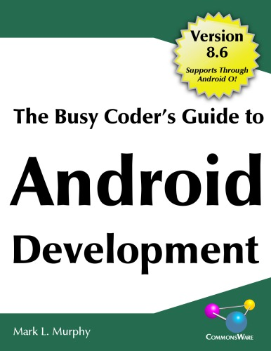
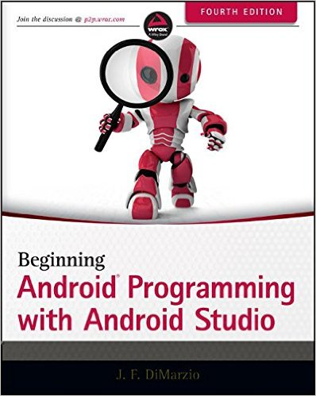

Internet Resource:
https://www.tutorialspoint.com//android_online_training/android_manifest_xml.asp
https://www.androidhive.info

