Minggu-02
10 September 2016
18:19

Chapter-1
Architecture & Organization

- Architecture is those attributes visible to the programmer
  - Instruction set, number of bits used for data representation, I/O mechanisms, addressing techniques.
  - e.g. Is there a multiply instruction?
- Organization is how features are implemented
  - Control signals, interfaces, memory technology.
  - e.g. Is there a hardware multiply unit or is it done by repeated addition?

- All Intel x86 family share the same basic architecture
- The IBM System/370 family share the same basic architecture

- This gives code compatibility
  - At least backwards
- Organization differs between different versions
Structure & Function
- Structure is the way in which components relate to each other
- Function is the operation of individual components as part of the structure
Function
- All computer functions are:
  - Data processing
  - Data storage
  - Data movement
  - Control
Functional View of Computer

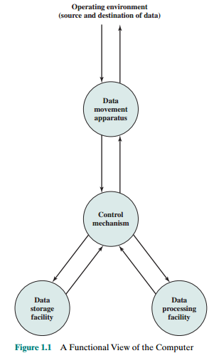

- The computer, of course, must be able to process data
- It is also essential that a computer store data. Thus, there is at least a short-term data storage function. Equally important, the computer performs a long-term data storage function .
- The computer must be able to move data between itself and the outside world.
- Finally, there must be control of these three functions.

Operations (a) Data movement
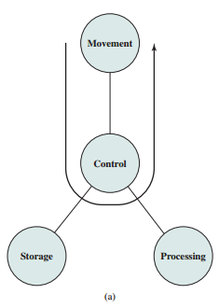

Operations (b) Storage

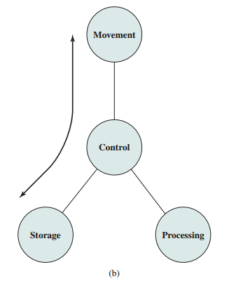

Operation (c) Processing from/to storage

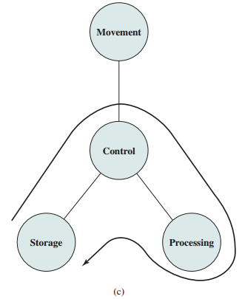

Operation (d)
Processing from storage to I/O

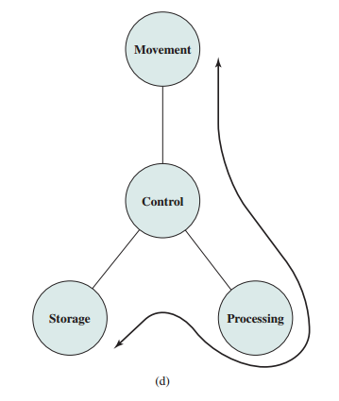

Structure - Top Level

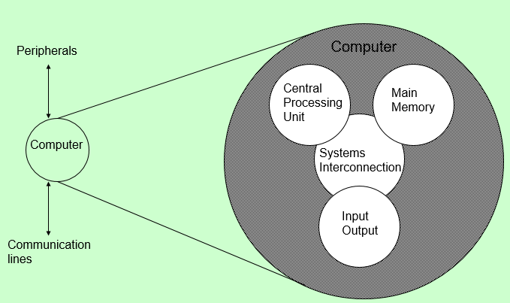

There are four main structural components:
- Central processing unit (CPU): Controls the operation of the computer and performs its data processing functions; often simply referred to as processor.
- Main memory: Stores data.
- I/O: Moves data between the computer and its external environment.
- System interconnection: Some mechanism that provides for communication among CPU, main memory, and I/O. A common example of system interconnection is by means of a system bus, consisting of a number of conducting wires to which all the other components attach.

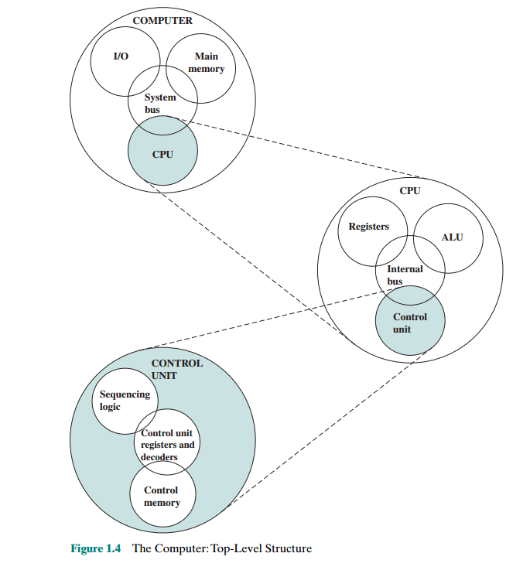
However, for our purposes, the most interesting and in some ways the most complex component is the CPU. Its major structural components are as follows:

- Control unit: Controls the operation of the CPU and hence the computer.
- Arithmetic and logic unit (ALU): Performs the computer’s data processing functions.
- Registers: Provides storage internal to the CPU.
- CPU interconnection: Some mechanism that provides for communication among the control unit, ALU, and registers.

Chapter 2
Computer Evolution and Performance

ENIAC
Background
- Electronic Numerical Integrator And Computer
- Eckert (student) and Mauchly (Prof)
- University of Pennsylvania
- Trajectory tables for weapons
- Started 1943
- Finished 1946
- Too late for war effort
- Used until 1955
Details
- Decimal (not binary)
- 20 accumulators of 10 digits
- Programmed manually by switches
- 18,000 vacuum tubes
- 30 tons
- 15,000 square feet
- 140 kW power consumption
- 5,000 additions per second

