
Version 2.0

Chapter 2

MSA Network Architecture
Architecture Blueprints
MSA Reference Architecture Kit

Microsoft Confidential. © 2003 Microsoft Corporation. All rights reserved. These materials are confidential to and maintained as a trade secret by Microsoft Corporation. Information in these materials is restricted to Microsoft authorized recipients only. Any use, distribution or public discussion of, and any feedback to, these materials is subject to the terms of the attached license. By providing any feedback on these materials to Microsoft, you agree to the terms of that license. If the license agreement has been removed, review the terms at http://www.microsoft.com/licensing/specs/agrmt02.asp before using these materials.

Abstract
This chapter of the Microsoft® Systems Architecture (MSA) version 2.0 Architecture Blueprints guide provides a detailed discussion of the design process for creating an enterprise network architecture. The discussion includes examples as well as advantages and disadvantages for each of the network design options. The design process is then applied to the MSA scenarios to document the additional considerations that may be required to help the reader utilize the guidance for their own design.

Information in this document, including URL and other Internet Web site references, is subject to change without notice. The entire risk of the use or the results of the use of this document remains with the user.
Unless otherwise noted, the example companies, organizations, products, domain names, email addresses, logos, people, places and events depicted herein are fictitious, and no association with any real company, organization, product, domain name, email address, logo, person, place or event is intended or should be inferred.
Complying with all applicable copyright laws is the responsibility of the user. Without limiting the rights under copyright, no part of this document may be reproduced, stored in or introduced into a retrieval system, or transmitted in any form or by any means (electronic, mechanical, photocopying, recording, or otherwise), or for any purpose, without the express written permission of Microsoft Corporation.
Microsoft may have patents, patent applications, trademarks, copyrights, or other intellectual property rights covering subject matter in this document. Except as expressly provided in any written license agreement from Microsoft, the furnishing of this document does not give you any license to these patents, trademarks, copyrights, or other intellectual property.
© 2003 Microsoft Corporation. All rights reserved.
Microsoft, Active Directory, Windows, and Windows NT are either registered trademarks or trademarks of Microsoft Corporation in the United States and/or other countries.
The names of actual companies and products mentioned herein may be the trademarks of their respective owners.
Microsoft Corporation • One Microsoft Way • Redmond, WA 98052-6399 • USA 00

Table of Contents
Version 2.0 1
Chapter 2 1
MSA Network Architecture 1
Introduction 1
Who Should Read This Chapter 1
MSA Enterprise Design 2
Business Need 2
Architecture Definition 3
Local Area Network (LAN) Segments 4
Physical Network Segments on L2 Switches 4
VLAN Network Segments on L2 Switches 5
VLAN Network Segments on L3 Switches 6
Wide Area Networks 7
Connectivity Roles 9
Switching and Routing 9
Load Balancing 9
Firewall Services 10
Remote Access Services 11
WAN Connectivity Services 11
WAN Connectivity Technologies 13
Wireless Technologies 13
Wireless Personal Area Networks (WPAN) 13
Wireless Local Area Networks (WLAN) 14
Wireless Wide Area Networks (WWAN) 14
Enterprise Security Policy 14
Architecture Design 15
Design Example: Wingtip Toys 16
Business Need 16
Technical Requirements 16
Desired Outcome 17
Design Inputs 17
Security Zone Definitions 17
Tier Definitions and Required Tier Communication 18
Required Host Communication Performance and Availability 21
Zone and Tier Communication Restrictions 22
Defining the Network Roles 24
Defining Network Segments 26
Network Segment Requirements and Purpose 27
Physical or Logical Network Segments 27
Assigning LAN Connectivity Devices 32
Device Classes 32
Device Consolidation 32
Grouping the Roles 35
Assigning WAN Connectivity Devices 37
Remote Access Device 37
Connecting a Remote Client to the Enterprise Network 37
Designing an IP Addressing Scheme 42
Logical Design 45
Architecture Dependencies 46
Availability 47
Security 48
Multihoming 49
Design Options—Multihoming Servers for Security 49
Wingtip Toys Design Choice 50
Security Lockdowns 50
Access Control Lists 50
Wingtip Toys Design Choice 50
Service Account(s) 51
Network Authentication 51
Wingtip Toys Design Choice 51
Network Encryption 51
Scalability 52
Manageability 52
Management Process Models 52
Role-based Administration 53
Management Capabilities 53
Network Management Services 54
System Administration 54
Design Option—Integrated or Dedicated Management Networks 54
Performance 56
Supportability 56
Consolidation 56
Same Role Consolidation 57
Different Role Consolidation 57
Interoperability 57
Best Practices 58
Standards and Guidelines 58
CDC Design Considerations 59
Business Need 59
Architecture Design 59
Technical Requirements 60
Desired Outcome 60
Design Inputs 60
Security Zone Definitions 60
Tier Definitions and Required Tier Communication 62
Required Host Communication Performance and Availability 67
Zone and Tier Communications Restrictions 67
Defining the Network Roles 68
Defining Network Segments 71
Assigning LAN Connectivity Devices 74
Grouping the Roles 74
Assigning WAN Connectivity Devices 76
Client Connectivity Method 76
Client Encryption Mechanism 76
Designing an IP Addressing Scheme 77
Selecting a Network Class and Subnets 77
Logical Design 77
Security 78
Multihoming 78
Security Lockdowns 79
Access Control Lists 79
Network Authentication 79
Network Encryption 79
Manageability 80
SBO Design Considerations 81
Architecture Design 81
Technical Requirements 81
Desired Outcome 81
Design Inputs 82
Security Zone Definitions 82
Tier Definitions and Required Tier Communications 82
Required Host Communication Performance and Availability 83
Defining the Network Roles 83
Defining Network Segments 84
Assigning LAN Connectivity Devices 85
Grouping the Roles 85
Logical Design 85
Security 86
Manageability 86
Summary 87

Introduction
There are five defined solution architectures in Microsoft® Systems Architecture (MSA) 2.0. These architectures are:
- Network
- Storage
- Application Infrastructure
- Management
- Security
This chapter of the Architecture Blueprints guide discusses network technologies and addresses the process of planning and designing a network architecture for an enterprise organization.
The sections in this chapter provide different levels of guidance. At the enterprise level, the guidance deals with the entire organization's architecture; this guidance is the appropriate starting point for any process, as it addresses the most far-reaching planning issues encountered by enterprise architects. The subsequent sections provide guidance that is specific to each of the MSA 2.0 scenarios. These scenarios are outlined in the MSA–A Program Overview document and a further level of detail is provided in the "Introduction to MSA Architecture Blueprints" chapter of this guide.
Who Should Read This Chapter
This chapter is written for those who are involved in the planning and design of a computer network infrastructure. Consultants, system architects, and information technology (IT) professionals who are responsible for the planning stages of application or infrastructure development across multiple projects will benefit from the information in this chapter; others who would likely benefit include:
- Architects and planners who are responsible for driving the architecture efforts for their organizations.
- Business analysts and decision makers (BDMs) who have critical business objectives and requirements that need IT support.
- MCS and partner consultants who need knowledge transfer tools for enterprise customers and partners.

MSA Enterprise Design
This section provides guidance for the network architecture design requirements of an enterprise organization. This guidance can be customized to meet the requirements of most enterprise projects that require a network architecture.
MSA has defined the following components of the overall network architecture:
- Router devices
- Switch devices
- Load balancing devices
- Firewall devices
- Virtual Private Network (VPN) devices
This chapter addresses the design issues that affect, and are affected by, these components. However, for purposes of the rest of the MSA guidance, the first three components are grouped into a common “Network Devices” chapter while firewall and VPN devices are covered in separate chapters. For specific design information on these components, refer to the following chapters in the Service Blueprints guide:
- Network Devices
- Firewall Services
- Remote Access Services

Note: Unless otherwise stated, this chapter uses the term "device" to refer to either a server that provides a network connectivity service (including the ability to run additional applications) or a dedicated item of network equipment.

Business Need
Technology architecture is the foundation upon which an organization can effectively deliver mission-critical services to its employees, partners, and customers. To deliver the services at the appropriate level, business requirements and technical constraints such as security, cost, and service availability must be considered. A well-implemented technology infrastructure can help resolve many of the challenges faced by IT professionals who need to provide effective delivery of these services in order to contribute to the success of an organization and give it competitive advantage. Network architecture is a fundamental aspect of the technology infrastructure.
At a high level, the requirements for network architecture in an organization can be summarized as follows:
Users need to connect to IT services efficiently, reliably, and securely. In addition, the devices providing the services also need to connect to other devices in the organization in an efficient, reliable, and secure manner.
Architecture Definition
The MSA network architecture combines a number of technology solutions into a complex environment that provides highly available, secure, scalable, manageable, and reliable services. The network devices within the architecture operate at various layers of the Open Systems Interconnect (OSI) model; therefore, the reader of this chapter is expected to be familiar with the structure of this model.

Note: Background information on the OSI model can be obtained from a number of sources, including Microsoft Knowledge Base Article 103884 titled “The OSI Model's Seven Layers Defined and Functions Explained.” A fundamental aspect of the networking functions as expressed in this chapter is the understanding of the OSI layer 2, "data link" and OSI layer 3, "network" layers.

Enterprise-level network architectures generally consist of a mix of the following technologies and elements:
- Local area network (LAN) segments: In this chapter, a network segment is defined as two or more devices that communicate with each other at OSI layer 2 (L2) using L2 LAN connectivity devices (described later) with no routing at L3 between them. Network segments may be physical or logical; if the segments are logical, they are referred to as virtual local area networks (VLANs). LANs are created by connecting either multiple network hosts through an L2 LAN connectivity device or multiple network segments using an L3 LAN connectivity device. In the case of a LAN, the wires and the L2 and L3 LAN connectivity devices are typically owned by the organization. The connectivity speeds between hosts and devices on network segments or between network segments on a LAN are typically 10 megabits per second (Mbps) or higher.
- Wide area networks (WANs): WANs are formed by joining one or more LANs through WAN devices and technologies (described later). When connected together, an organization’s centralized facilities and branch offices are commonly referred to as a WAN. The wired connectivity between network segments is typically owned by telephone carriers. The endpoint WAN connectivity devices are generally owned by the organization, but the devices in between are usually owned by telephone carriers. The connectivity speeds between network segments on a WAN are often less than 10 Mbps. In many cases, connection speeds range from 64 Kilobits per second (Kbps) to 1.54 Mbps (commonly referred to as a “T1” line).
- LAN connectivity devices: Devices that provide connectivity at L2 or L3 for LANs or between multiple LANs are:
- L2 LAN connectivity devices: For purposes of this chapter, the primary function of these devices is simply to efficiently move data packets at L2 between hosts or devices on the same network segment. A switch (described later) typically provides this functionality.
- L3 LAN connectivity devices: For purposes of this chapter, the primary function of these devices is to move data packets at L3 between multiple network segments. Routers or load balancing devices typically provide this functionality through their use and support of the TCP/IP protocol suite. (TCP/IP has been used for many years and is the communications “language” of the Internet. Almost every network-connected device in use today can use TCP/IP to communicate with other devices.) In addition, firewall devices and remote access devices provide the functionality to control the flow of traffic based on security rules.
- WAN connectivity devices and technologies: These devices and technologies provide functionality for connecting remote clients or branch offices to an organization’s data center, connecting a hosted Internet data center to the organization’s main data center, and connecting to partner networks.
- Network protocols: A number of network communication protocols are used in enterprise networks. Therefore, it is an important part of the overall architecture plan to define which protocols are required.
- Enterprise security policy: A network architecture should incorporate features to ensure the integrity and availability of the data traffic that it supports. For example, it should control which TCP/UDP ports are allowed for communication between devices on the network. Enterprise security policy will dictate the issues that affect the design of the network architecture.
The following sections provide details of these technologies and elements.
Local Area Network (LAN) Segments
As mentioned earlier, a network segment is defined as two or more devices that communicate with each other through an L2 LAN connectivity device with no routing devices between them at L3. The network segment may be virtual or physical.
Physical Network Segments on L2 Switches
An illustration of a physical network segment is provided in the following figure.
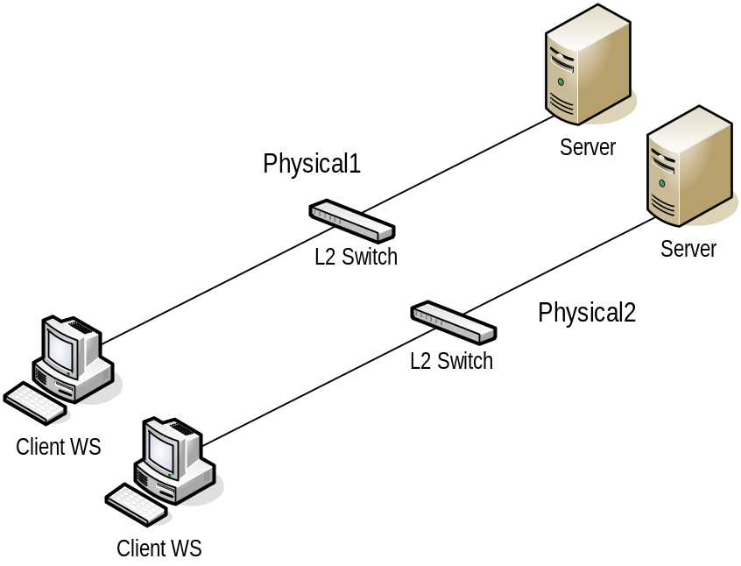
Figure 1. Physical Network Segments on L2 Switches
In this figure, there are two physical network segments—Physical1 and Physical2. The clients and servers cannot communicate from one segment to another unless a network cable connects the switches. If the switches were connected, this configuration would be considered as one physical network segment and could be referred to collectively as a LAN.
VLAN Network Segments on L2 Switches
Virtual network segments cannot be created on all switches, but typically can be created on higher-end switches; they are commonly referred to as virtual local area networks (VLANs). A VLAN is a set of ports that share the same broadcast traffic. The address resolution protocol (ARP), which is the L2 resolution protocol, relies on broadcast traffic. Therefore, all VLANs are technically L2 VLANs. Some switches can also route traffic between VLANs; when this happens, the term L3 VLAN is frequently used. When the term L2 VLAN is used, it means that no other segments are routed to or from it at L3. When the term L3 VLAN is used, it typically means that it is an L2 VLAN and other L2 VLANs are routed to or from it within the switch. The following figure illustrates a single switch with two VLANs named Virtual1 and Virtual2.
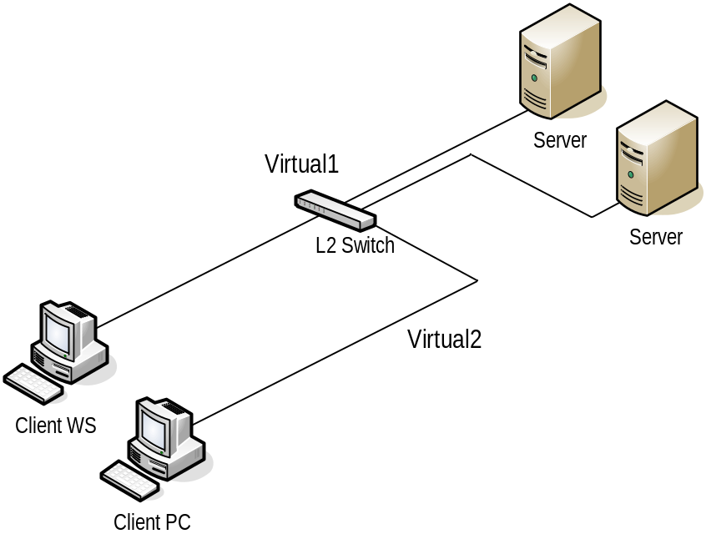
Figure 2. Virtual Network Segments on L2 Switches, or VLANs
This figure illustrates two logically separate network segments that are physically on the same switch. These segments are logically two separate LANs that cannot communicate with each other because they do not have the same broadcast domain. If traffic needs to flow between these LANs, a configuration change could be made to the switch. Once this is done and the two separate VLANs are joined together, they would be referred to as a single VLAN. L2 switches are fundamentally multiport bridges that forward network packets (frames) based on their destination Media Access Control (MAC) address without any knowledge of the actual network protocol being used.
Some switches can route at L3 between network segments. L3 switches have many characteristics of conventional routers and forward datagrams based on their network layer addressing (IP address, for example). L3 switches provide better scalability and overall network simplification than L2 switches because traffic can be isolated at L3 in addition to L2. Switches that support this functionality have routing functionality built into them to provide routing of packets between VLANs. The VLANs themselves have no knowledge of the protocol running across them.

Note: Routing packets at L3 between segments involves more processing at the switch than simply moving packets between devices on an L2 segment, which can result in some performance degradation in the maximum achievable throughput between two segments on some L3 devices.

VLAN Network Segments on L3 Switches
The following figure illustrates how an L3 switch may be used to route between VLANs.
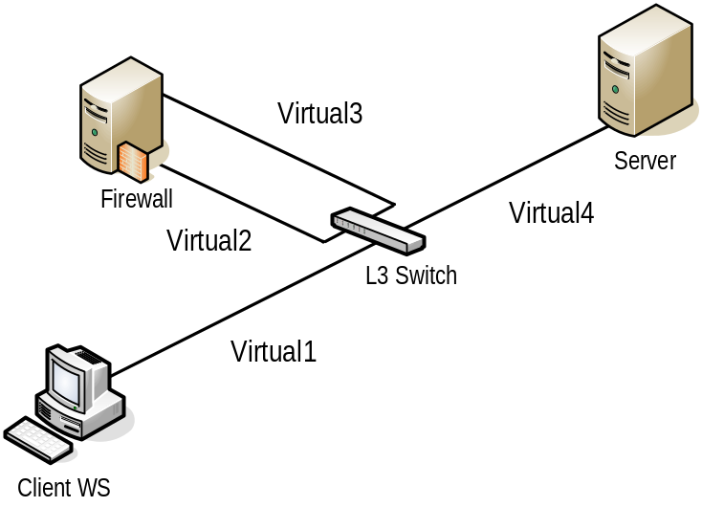
Figure 3. Virtual Network Segments on L3 Switches
This figure contains four VLANs. Virtual1 connects the client to the switch (in this example the switch is the “default gateway” for the client because the switch is capable of routing at L3 between VLANs). Virtual2 is a dedicated VLAN connecting the switch and the external interface of the firewall server. The firewall processes packets based on filtering rules (discussed later in this chapter and in the “Firewall Services” chapter of the Service Blueprints guide), and if the requirements of the rules are satisfied, the firewall relays the request out of its internal interface attached to the Virtual3 VLAN. The switch then processes this traffic, and if the request satisfies additional access control list (ACL) filters applied to the VLAN (if such filtering has been implemented), the request is routed to the Virtual4 VLAN. The server also uses the switch as its “default gateway.” In this configuration, each VLAN could be called a LAN. In addition, all four VLANs could collectively be called a LAN.
The trade-offs around implementing physical versus logical network segments and routing between them are covered in the “Architecture Design” section later in this chapter.
Wide Area Networks
A WAN is one or more LANs connected over a large geographical area by public or leased communication links. Generally, WAN links between LANs provide less data throughput than LANs because of a number of factors, including:
- The subscriber cost of the connection: High bandwidth connections can be extremely expensive, and most organizations consider a slower, more economical connection to be more appropriate.
- Bandwidth sharing: A number of WAN links will share the same carrier network. Despite the use of complex routing algorithms by the carrier service providers, there remains a potential for bottlenecks.
- Protocol and connection limitations: Some WAN protocols offer restricted bandwidth by design, which is often due to limitations of the physical technologies used (for example, cable types).
The following figure depicts a WAN formed by connecting three LANs in an organization.
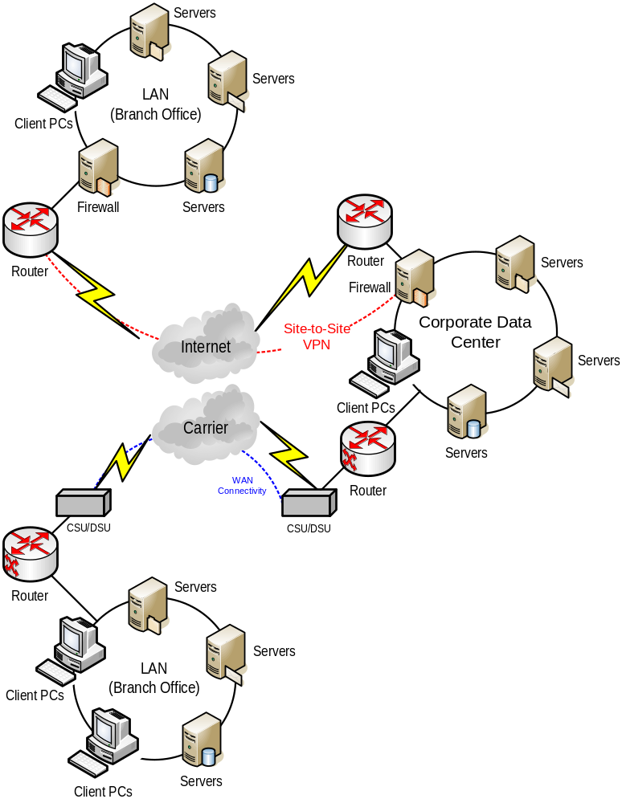
Figure 4. Wide Area Network (WAN)

Note: A WAN that is within a 25-mile geographic radius is sometimes referred to as a Metropolitan Area Network (MAN). This term is not in common use and will therefore not be used elsewhere in this chapter.

Connectivity Roles
There are a number of roles that must be performed to provide connectivity within an enterprise network. These roles are:
- Switching and routing
- Load balancing
- Firewall protection
- Remote access
- WAN connectivity
It is important to make a distinction here between the logical "role,” which is a requirement of the network, and the physical "device" that can fulfill the requirement. In many cases, the enterprise-level device used for a role may have the capability to perform other roles as well. Understanding the basic difference between these roles and the devices that perform them is key to defining the network architecture.
Switching and Routing
In simple terms, the role of switching is to provide efficient movement of packets from one device to another at L2 of the OSI model. Devices that perform the L2 switching role can learn destination MAC addresses (where packets are being sent) by monitoring network traffic. Once this knowledge is gained, these devices can send specific packets to the port that connects to the network adapter with a specific MAC address (unlike hubs that send every packet to all the ports).
Many enterprise-level switches have the capability to route packets at L3 between segments, and are therefore capable of performing the routing role. This role intelligently moves data packets from one network segment to another based on L3 addresses. Devices that perform the routing role also exchange information with other routers on the network to determine the most efficient path from one device to another. The routing role can be fulfilled by dedicated router devices or by hybrid devices that can perform additional roles such as switching, firewall services, or remote access services. For further details about switches and routers, refer to the "Network Devices" chapter of the Service Blueprints guide.
Load Balancing
Load balancing facilitates horizontal clustering, where multiple servers are configured to perform the same function on the network. The load balancing functionality may be provided by software or a hardware device in one of two ways:
- Distributed: This form of load balancing is accomplished by running software on each node of a cluster that allows the nodes to process requests in a distributed manner. With this mechanism, each node in the cluster receives every packet destined for the cluster. The software uses an algorithm to determine which node will process the request. Because each node is running the load balancing software, and each node is using the same algorithm, every node knows which node will process each request. The other nodes simply drop the request.
- Routed: This form of load balancing is accomplished by using a centralized device that receives every inbound packet destined for a cluster and determines which host in the cluster to send the packet to. No other nodes in the cluster receive the packet. The determination may be based on a number of criteria—such as a 50/50 split, least busy node, or a variety of other algorithms—depending on the solution adopted.
For further details on load balancers and distributed versus routed load balancing mechanisms, refer to the "Network Devices" chapter of the Service Blueprints guide.
Firewall Services
The firewall services role involves controlling the flow of traffic between network segments using L3 addresses in order to meet security requirements. Although this role is usually dedicated to a specialized device (particularly when it addresses the boundary between the internal network and the Internet), hosts running software firewall solutions and other hybrid devices are becoming increasingly capable of providing the required firewall services in addition to such other roles as switching and routing. The security requirements are met by creating rule sets that allow the device performing the firewall services role to determine which traffic is allowed to pass or, conversely, which traffic is not allowed. Most firewalls have an "implicit deny" rule. This means that if a rule to allow the request does not exist, then the request is implicitly denied.
The "implicit deny" rule is useful as a starting point; however, it is a best practice to explicitly deny traffic that you do not want to allow because this provides a clearer picture of the complete security configuration. The following table shows what a typical rule set looks like.

Source IP Address | Destination IP Address | Action | Port | Protocol
Any | 208.217.184.6 | Allow | 80 | TCP
Any | 10.1.0.5 | Deny | 25 | TCP
Table 1. Example Firewall Rule
In this example, TCP port 80 (HTTP) traffic is allowed to a Web server with the address 208.217.184.6 from any source IP address.
Devices that perform the firewall services role can usually provide one or more of the following types of functionality:
- Network adapter input filter inspection
- Static packet filters
- Network address translation (NAT)
- Stateful inspection
- Circuit-level inspection
- Proxy firewall
- Application layer filtering
Not all servers or devices that perform the firewall services role provide all types of functionality. For a detailed explanation of the differences in functionality, refer to the "Firewall Services" chapter of the Service Blueprints guide.
Remote Access Services
The remote access services role provides endpoint connectivity to remote clients or offices. The devices that perform this role generally also perform the routing and firewall services roles for all L3 traffic between the main network and the remote client or site. Client and branch office connectivity requirements vary somewhat; considerations include:
- Clients typically connect using modems or broadband connections. Modem connections may be made directly into the enterprise (with the enterprise providing modem pools for dial-in access) or through VPN tunnels. VPN tunnels are encrypted communications made over public lines (such as the Internet). The “Architectural Design” section in this chapter details the pros and cons of different connectivity approaches.
- Branch offices typically connect to enterprise facilities over leased lines or lines connected to the Internet. In the latter case, VPN tunnels are typically used. Remote access services are covered later in this chapter; for further details, refer to the "Remote Access Services" chapter of the Service Blueprints guide.
WAN Connectivity Services
WAN technologies usually function at the lower three layers of the OSI reference model—the physical, data link, and network layers. In general, an organization leases WAN services from a telecommunications carrier such as a local exchange carrier or an inter-exchange carrier. Very remote locations may be connected by using a satellite-based service or by deploying an optical fiber-based connection.
WAN Connectivity Devices
A WAN connectivity device may perform one or more roles on the network, including routing and switching. Numerous types of devices can fulfill the WAN connectivity role. These devices include:
- Analog modem: An analog modem converts digital information into analog signals (audible sound) so that they can be transmitted over voice-grade telecommunication lines. The figure below depicts an analog modem-to-modem connection through a WAN.
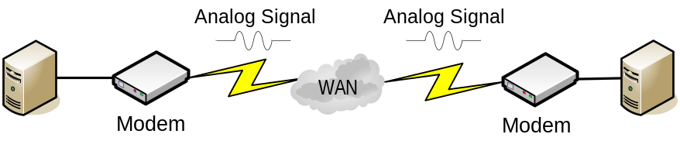
Figure 5. Analog Modem Connection
- Digital modem: An Integrated Services Digital Network (ISDN) modem connects the ISDN Basic Rate Interface (BRI) to other interfaces. A terminal adapter is called an ISDN modem, even though it does not convert digital information into analog signals, because it uses telephone wires in a similar way to a modem. It would be more accurate to refer to digital modems as WAN routers. They are called modems because the marketplace recognizes a modem as any device that connects a user to the Internet. Other types of digital modems are cable modems and the devices used to connect to digital subscriber lines (DSL) and asymmetric digital subscriber lines (ADSL). The following figure depicts a typical ISDN connection.
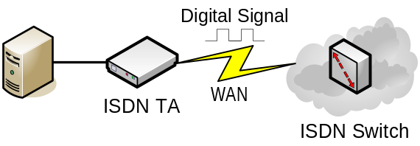
Figure 6. Digital Modem Connection
- Channel service unit/digital service unit (CSU/DSU): A CSU/DSU connects a router to a digital circuit like T1, digital data service (DDS), or Frame Relay. The CSU/DSU packages digital data into a format suitable for the particular digital transmission line being serviced. The following figure depicts a typical CSU/DSU in a WAN.
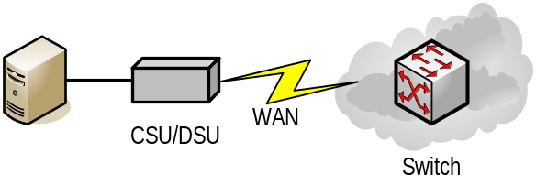
Figure 7. CSU/DSU
- WAN switch: A WAN switch is a multipart internetworking device used in carrier networks. These devices operate at L2 of the OSI model and switch traffic such as Frame Relay, SMDS, and X.25. The following figure depicts a typical WAN switched configuration.
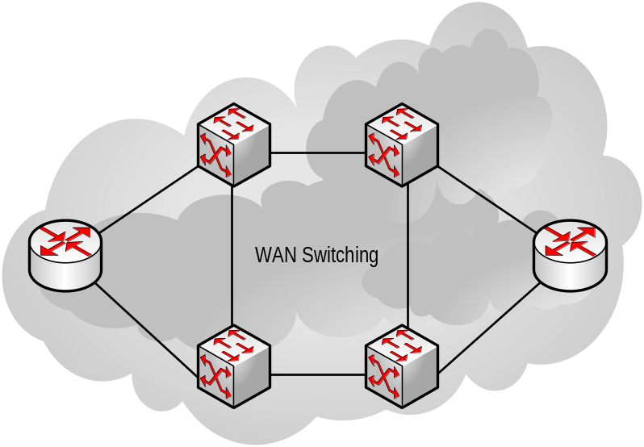
Figure 8. WAN Switching
WAN Connectivity Technologies
WAN connectivity technologies include circuit-switched services such as ISDN and modem connections, packet-switched services like Frame Relay, and connections that typically use a form of synchronous data link control (SDLC) or High-level Data Link Control (HDLC) protocols. WAN technologies extend networking beyond the LAN border to the edge of the carrier’s network. The boundary of each LAN may be a router, bridge, access server, or other form of data terminal equipment (DTE) that connects through a WAN device to the carrier’s network.
There are a number of resources available on creating WAN designs; however, a detailed discussion of the topic is beyond the scope of this chapter. A discussion of the interoperability issues is included in the "Network Devices" chapter of the Service Blueprints guide.
Wireless Technologies
Many organizations have started using wireless networking. The following three basic types of wireless networking technologies meet the requirements of distinct areas of networking:
- Wireless personal area networks (WPAN)
- Wireless local area networks (WLAN)
- Wireless wide area networks (WWAN)
The following section explains each of these areas and how the wireless technologies address the needs of each area.
Wireless Personal Area Networks (WPAN)
WPAN technologies are designed to allow users to establish ad hoc wireless communications between personal devices such as PDAs, cellular phones, or laptops. Generally these devices are designed to communicate in an area of a few meters, an area referred to as a personal operating space (POS). Currently, the two key WPAN technologies are infrared and Bluetooth. Infrared light interfaces have been around for many years and provide basic point-to-point connectivity up to a range of approximately one meter. The primary standard for this technology is Infrared Data Association (IrDA), which was devised by a group of device manufacturers to allow different devices to communicate. Bluetooth is a more recent addition to WPAN; it uses radio waves to transmit data to a distance of up to approximately 10 meters. Unlike IrDA, Bluetooth transmission can pass through objects such as pockets, briefcases, and even walls. This technology is primarily used to provide point-to-point connections, however the specification allows up to seven simultaneous connections to be established and maintained by a single device. The Bluetooth standard is managed by the Bluetooth Special Interest Group (SIG), a non-profit trade association. For more details on Bluetooth, refer to the following URL:
www.bluetooth.com
The IEEE (Institute of Electrical and Electronics Engineers) working group has established a standard for the development of WPAN technologies. The key goals of the 802.15.1 standard are low complexity, low power consumption, interoperability, and coexistence with 802.11 networks. For more information on this topic, refer to the following URL:
www.ieee802.org/15
Wireless Local Area Networks (WLAN)
WLAN technologies enable wireless network connections within a private area, such as a company office or building, or in a public area such as an airport or shop. WLANs are generally used to supplement an existing wired LAN environment, providing an extra level of flexibility for the WLAN users at the cost of network speed. However, with the development of high speed WLAN, WLAN is starting to be used to replace wired solutions especially in “hotdesk” environments and green field sites.
The primary standard for WLAN is 802.11, which is also managed by an IEEE working group. There have been a number of updates to the original 802.11 standard, which specifies a data transfer rate of up to 2 Mbps. 802.11b was widely adopted and specifies a data transfer rate of up to 11 Mbps. 802.11a, which specifies data transfer at a maximum rate of 54 Mbps, is growing in popularity. For more information on the 802.11 standards, refer to the following URL:
grouper.ieee.org/groups/802/11/index.html
Wireless Wide Area Networks (WWAN)
WWAN technologies are designed to enable wireless connections over public or private networks that are distributed over large geographical areas, such as cities or countries. The WWAN technologies, currently available, are collectively known as second generation (2G) technologies (first generation was analog cellular) and include global system for mobile communications (GSM), code division multiple access (CDMA), and time division multiple access (TDMA). The connectivity speed for these networks ranges from 9.6 Kbps for GSM networks to 115 Kbps for General Packet Radio Service (GPRS). These limited connection speeds have, for the most part, restricted the adoption of these technologies to cellular phones and PDAs.
However, third generation (3G) technologies that provide greater bandwidth (up to 2 Mbps for fixed locations) are becoming available. The significant increase in connection speed should lead to a much wider adoption of the technology. The International Telecommunication Union (ITU) is responsible for the development of 3G and its standards. For information on 3G standards and technologies, refer to the following URL:
www.itu.int/home/imt.html
Enterprise Security Policy
No network architecture design should be started without input from the security team within the organization. The organization’s security requirements in the form of an enterprise security policy are a significant factor in any network design. Oftentimes, security teams define security zones to facilitate the application of a number of security policies.
Security zones are logical entities created around groups of the organization’s resources. Security personnel can define security restrictions on the resources within a zone and on the permissible network communication between zones. This chapter will address security zones only in relation to the impact they have on the network architecture design. Further details on defining security zones can be found in the "MSA Security Architecture" chapter of this guide.
At the network layer, a security zone encompasses devices that the security team within the organization has determined require some form of L3 access control to or from devices in other security zones. In this chapter we will use the example of a security zone design created for a fictitious company called Wingtip Toys, details of which are provided in the next section.
Architecture Design
Network architecture is designed to achieve the following objectives:
- Provide reliable and efficient movement of data packets from a source device to a destination device.
- Comply with the organizational security policy.
These objectives may seem contradictory (the purpose of the first is to move data packets from place to place in the most reliable and efficient manner, and the purpose of the second is to restrict the types of traffic that can flow from one device to another), but the two are inextricably tied when designing a network architecture. Therefore, it is imperative that the network designer obtain the following information from the security administrator and administrators of each tier within the organization before embarking on a network architecture design:
- Security zone definitions: It is important to understand which tier, and therefore which security zone, the host should be a member of. A tier is a logical entity, comprised of one or more hosts or devices that provide similar functionality; a security zone is a logical entity encompassing one or more tiers. A zone can contain other security zones, be a member of other security zones, or span other security zones. It is a good practice to gather the information on tier membership in a planning worksheet as a part of the planning process; an example of this is shown later in this chapter. Information on creating an organizational security policy can be found in the "MSA Security Architecture" chapter of this guide, along with sample policies. Security information is obtained from the security administrator within the organization.
- Security zone restrictions data: The protocols that are allowed to move between the zones that have been defined for the organization. This information is obtained from the security administrator within the organization.
- Required tier communications data: Detailed information about which tiers need to communicate with which others, what TCP and UDP ports are required, and which protocols are used. This information must be gathered from the administrators of each of the tiers in the organization.
- Required host communication performance and availability data: Detailed information about the acceptable latency levels, availability requirements, and bandwidth needs between each of the source and destination hosts. This information must be gathered into a worksheet from the administrators of each of the tiers in the organization.
Once this information has been collected, you can begin the process of designing the network architecture to meet the identified requirements by using the technologies described earlier in this chapter.
Design Example: Wingtip Toys
The network architecture design process may be straightforward or complex, depending on the scenario requirements. The “Wingtip Toys” example has been created to illustrate steps in the assessment and design process for network architecture. For more information about this example, refer to the "MSA Security Architecture" chapter of this guide.
Business Need
Wingtip Toys is a relatively new company. It already has some IT infrastructure in place and plans to deploy several new services in the organization. Wingtip Toys plans to connect to the Internet soon and to provide the following Internet-based services to clients:
- A public-facing Web site that serves static Web content, such as information on the history of Wingtip Toys.
- A public-facing Domain Name System (DNS) server that helps Internet clients to find the Web site of Wingtip Toys.
In addition, it wants to add the following services for its internal employees:
- A database server for client applications.
- Microsoft Windows® Server 2003 Active Directory® domain controllers and DNS servers for name resolution within the organization.
Wingtip Toys has had very informal security practices up to this point because it was not connected to the Internet. It seeks to improve these practices before making the Internet-based services available to employees and clients.
Technical Requirements
Wingtip Toys plans to redesign its network to mitigate the security risks that may exist for the new services. While the Web site and internal client applications require specific security, storage, hardware, software, management, and networking modifications, this chapter covers just the specific requirements pertaining to networking and associated security considerations.
Desired Outcome
A secure implementation of their public-facing Web site as well as the database and infrastructure servers to support their internal client application.

Note: The examples provided in the remaining part of this section are not intended to illustrate all of Wingtip Toy’s needs but rather to provide examples that illustrate the specific points being addressed.

Once the requirements have been defined, it is possible to walk through the design steps and generate the required information. Once these steps are complete, the network architecture can be designed and implemented.
Design Inputs
Before starting the design process, the network designer needs to gather a great deal of information from the security team and the various application (or project) teams. The following sections provide relevant examples to illustrate the information gathering and design process.
Security Zone Definitions
Security zones are defined in organizations for a variety of reasons. For details on zone definition criteria, refer to the “MSA Security Architecture" chapter of this guide.
The network designer typically designs a network to satisfy the actions allowed between various security zones in an organization rather than defining the zones themselves. The Wingtip Toys security team defined the security zones and the permissible protocol traffic between them; the following figure illustrates the security zones they defined.
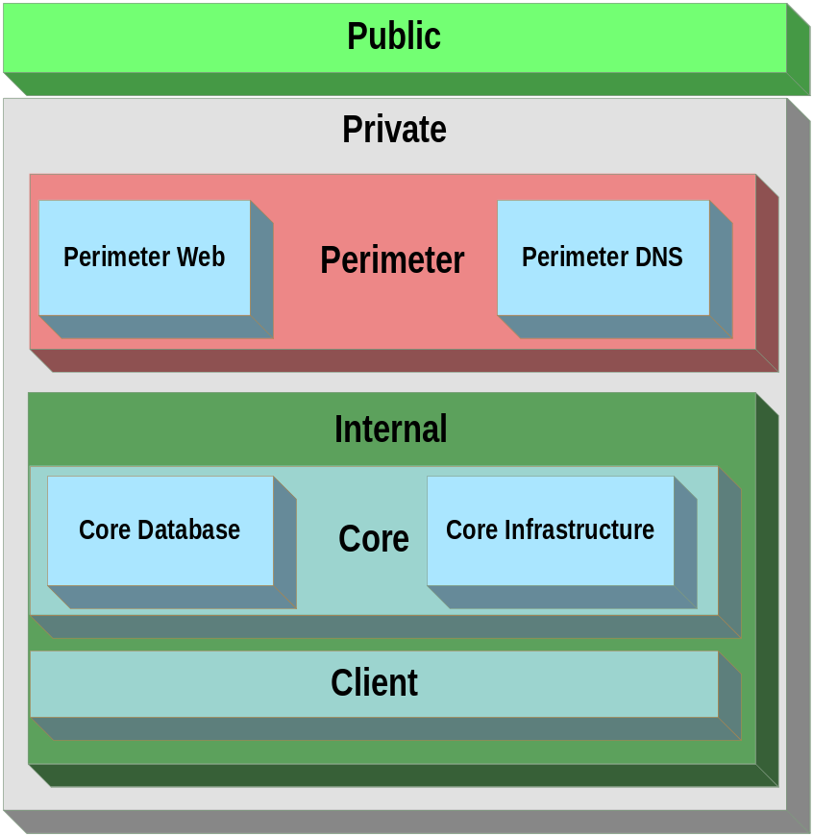
Figure 9. Example Security Zones for Wingtip Toys
Tier Definitions and Required Tier Communication
Defining tiers and required tier communications is iterative in nature. The hosts have to be defined, as well as the tier(s) to which they belong. As the purpose of each host is understood, it is possible to form a tier structure to accommodate the various tasks being performed. Where a host fails to fit into an existing tier, a new tier can be created in the plan. This process requires many hours of discussion, planning, consolidation, and compromise, but the importance of getting it right must not be underestimated.
The following table shows the tiers that were defined for the Wingtip Toys example, the hosts that are part of each tier, and which security zone each tier is in.

Tier | Tier Description | Services and Hosts It Contains | Member of Security zone | Load Balancing Functional Requirements
Perimeter Web | Web services available to the public | Web servers | Perimeter Web | Source IP/SS/URL persistence, SSL termination/Offloading, downstream service availability awareness
Perimeter DNS | DNS services available to the public for queries | DNS servers | Perimeter DNS | Session persistence
Perimeter VPN | Provides remote access for Internet-based clients | VPN servers | Perimeter VPN | None*
Core Database | Microsoft® SQL Server™ for internal clients | Database servers | Core Database | None*
Core Active Directory | Active Directory for internal use | Domain controllers | Core Infrastructure | None
Core DNS | DNS services for internal name resolution | DNS servers | Core Infrastructure | None
Client | Client access devices | Desktops, laptops | Client | None
Table 2. Example Tier Definitions for Wingtip Toys

* Note: These servers are clustered for failover and not for load balancing; therefore, they have no impact on the network design. If multiple server hosts need to be clustered together to present themselves as one host to the network, the service administrator should specify the type of load balancing required. For further details, refer to the “Load Balancers” subsection of the “Service Definition” section in this chapter.

Defining the number and requirements of these hosts requires an intimate knowledge of the network client and server applications. The resulting worksheet is likely to be extremely large, but it will provide vital information that will enable the network architecture design to meet the organization’s requirements.
At this point in the planning, the required interfaces to the tiers can be defined and hosts assigned to the tiers. An example of how this data might look in the Wingtip Toys example is provided in the following table. Note that all ports are explicitly denied unless specified in the table.

Source Zone | Destination Zone/NIC | Port# | Protocol | TCP/UDP | Purpose
Internet Client Access
Public | Perimeter Web/1 | 80 | HTTP | TCP | To allow non-encrypted Internet client interaction with the Wingtip Toys public Web site.
Public | Perimeter Web/1 | 443 | HTTPS | TCP | To allow encrypted Internet client interaction with the Wingtip Toys public Web site.
Public | Perimeter DNS/1 | 53 | DNS | UDP | To allow Internet clients to look up the IP address of the Wingtip Toys public Web server.
Public | Perimeter VPN/1 | 500 | PPTP | UDP | To allow public client workstations to securely connect to the Wingtip Toys internal network remotely.
Internal Client Access
Client | Core Active Directory | 135 | RPC End Point Mapper | TCP/UDP | To allow clients to log on to Active Directory and get Group Policy.
Client | Core Active Directory | 1024-65535 | RPC | TCP | To allow clients to log on to Active Directory and get Group Policy.
Client | Core Active Directory | 88 | Kerberos | TCP/UDP | To allow clients to log on to Active Directory and get Group Policy.
Client | Core Active Directory | 389 | LDAP | TCP | To allow clients to log on to Active Directory and get Group Policy.
Client | Core Active Directory | 3268 | LDAP | TCP | To allow clients to log on to Active Directory and get Group Policy.
Client | Core Active Directory | 3269 | LDAP/SSL | TCP | To allow clients to log on to Active Directory and get Group Policy.
Client | Core Active Directory | 445 | CIFS | TCP/UDP | To allow clients to log on to Active Directory and get Group Policy.
Client | Core Active Directory | 53 | DNS | TCP/UDP | To allow Internal clients to look up internal IP addresses.
Client | Core Active Directory | 123 | NTP | UDP | To allow clients to log on to Active Directory and get Group Policy.
Client | Core Active Directory | 3389 | RDP | TCP | To allow administrators to remotely administer the servers through Terminal Services.
Client | Core DNS | 3389 | RDP | TCP | To allow administrators to remotely administer the servers through Terminal Services.
Client | Core Database | 3389 | RDP | TCP | To allow administrators to remotely administer the servers through Terminal Services.
Client | Perimeter DNS | 3389 | RDP | TCP | To allow administrators to remotely administer the servers through Terminal Services.
Client | Perimeter Web | 3389 | RDP | TCP | To allow administrators to remotely administer the servers through Terminal Services.
Client | Core Database | 1433 | Microsoft SQL Server Monitor | TCP | To allow clients to use the internal database servers.
Client | Core Database | 1434 | Microsoft SQL Server Monitor | TCP | To allow clients to use the internal database servers.
Table 3. Example Zone/Tier Communications for Wingtip Toys

Note: The source host or network adapter is provided so that if the host has multiple adapters, separate rules can be specified for each interface.

Required Host Communication Performance and Availability
After listing the hosts and servers in the organization as shown in the previous table, the next step is to obtain the network performance and availability requirements for each.
Obtaining detailed performance information may require the gathering of relevant performance data from application lab tests, which can be a long and tedious process. However, planning for the network requirements becomes little more than an educated guess if a designer does not have this information.
The minimum acceptable availability data provides an indication of the acceptable level of downtime for the application or service communications. It is important for the individual specifying this value to understand that this is downtime for the network communications and not the server, device, or the application itself. The figures for these components will be addressed in the relevant chapters of the Service Blueprints guide. This availability value can be specified in a number of ways; the following table provides a number of availability levels for the application or service providers to choose from.

Note: The availability value specified here will have a direct and exponential impact on the cost of implementation. Ensure that the specified value is correctly justified and verified.

9s Rating | Percentage Uptime | Annual Downtime
2 | 99.000 | 3 days, 15 hours, 36 minutes
3 | 99.900 | 8 hours, 46 minutes
4 | 99.990 | 53 minutes
5 | 99.999 | 5 minutes
Table 4. Availability Summary for Wingtip Toys
The following table illustrates the availability information for the Wingtip Toys scenario.

Source Zone or Tier | Destination Tier/NIC | Peak Bandwidth Requirements | Average Bandwidth Requirements | Maximum Latency | Minimum Acceptable 9s Rating
Internet Client Access
Public | Perimeter Web/1 | 7 MBps | 2 MBps | 100 ms | 5
Public | Perimeter DNS/1 | 1 MBps | 500 KBps | 100 ms | 5
Internal Client Access
Internal | Internal DNS/1 | 5 KBps | 1 KBps | 100 ms | 3
Internal | Internal Active Directory/1 | 5 MBps | 1 MBps | 100 ms | 3
Internal | Core Database/1 | 10 MBps | 2 MBps | 100 ms | 3
Table 5. Required Host Communication Performance and Availability for Wingtip Toys

Note: The term "Latency" in the table above is used in the context of the delay from the time the user makes a request until the time he/she receives the data. This delay may be due to a number of factors that are outside the control of the network, such as delays due to slow workstations. The figures quoted here are intended to reflect the delay due to network issues only.

Zone and Tier Communication Restrictions
At this point in the process it is possible to create a network; however, if you were to do so, the network would not necessarily provide the required level of security for the organization. Before the next step can be taken, it is essential to analyze the security requirements for each application and evaluate them against the enterprise security requirements.
It is the security team that creates the zone and tier restrictions because they are responsible for the overall security of the network. In reality, this process will be iterative because the requirements are evaluated by the security team to ensure that no unnecessary security risks are exposed. Details of this security process are provided in the "MSA Security Architecture" chapter of this guide.
An example of the information required by the network designers from the Wingtip Toys security team is shown in the following table; note that everything except what is in the table is explicitly denied, and that "tier" or "zone" is used to differentiate in cases where a zone and tier have the same name.

Source Zone or Tier | Destination Zone or Tier | Allowed Communication or Restrictions
Public | Perimeter | A device must control traffic between these two zones. The device must provide application layer proxy services between these two zones. It must be a dedicated physical device that performs no other function and does not provide this function for any other zone.
Public | Perimeter Web Zone | TCP ports 80 and 443 only.
Public | Perimeter DNS Zone | UDP port 53 only.
Public | Core | Internet Protocol security (IPSec) encrypted traffic between client and server endpoint (VPN). Two-factor authentication (smart card) to endpoint is also required before gaining access to any resources, which facilitates remote users and branch offices connecting to the organization securely over the Internet.
Client | Core Infrastructure | Any TCP or UDP ports. (Wingtip Toys does not limit traffic to the tiers in this zone due to the rules that would be required and since critical data is not stored on them).
Perimeter | Internal | A device must control traffic between these two zones; at a minimum, it must provide stateful packet inspection between them. It must also be a dedicated physical device that performs no other functions and does not provide this function for any other zone.
Client | Core Database Zone | TCP ports 1433 and 1434 only.
Core Active Directory | Core DNS | Any TCP or UDP ports (Wingtip Toys does not limit traffic between tiers in this zone due to the rules that would be required and since critical data is not stored on them).
Client | Perimeter | TCP port 3389 (for remote administration through Terminal Services).
Client | Core | TCP port 3389 (for remote administration through Terminal Services).
Table 6. Example Zone and Tier Communication Restrictions for Wingtip Toys
Once the allowed zone or tier communications have been defined by the security team, this information is used to form the complete zone and tier plan by the network design team. The tiers and security zones can now be mapped into one plan to complete the picture. The following figure provides an example of the tier and zone mappings for Wingtip Toys.
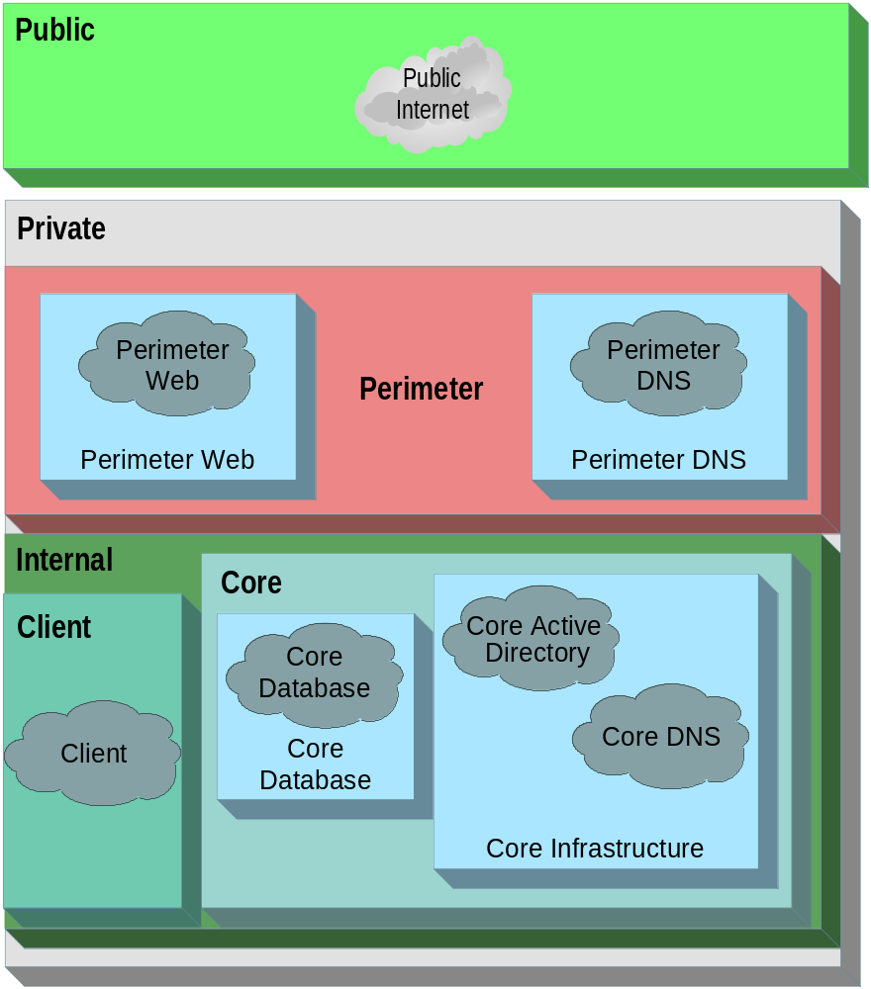
Figure 10. Example Tier and Zone Mappings for Wingtip Toys
Defining the Network Roles
Once the network tiers and zones have been defined, the process of matching a network role to each network segment needs to be completed. It is important to understand at this point in the design that you are not defining a physical device, but the type of activity that will occur across each boundary in order to meet the security, performance, and connectivity requirements. The roles identified provide one or more of the following classes of functions:
- Connectivity
- Security
- Load balancing
Using the Wingtip Toys information, it is possible to identify the roles in the following table for the network architecture.

Source | Destination | Role  Required | Role ID | Reason
Public Zone | Private Zone | Switching and Routing | Border Routing | To provide connectivity between the two zones.
Private Zone | Perimeter Zone | Firewall services | Perimeter Firewall services | To comply with enterprise security policy.
Within Perimeter Zone |  | Switching and Routing | Perimeter Switching | To provide connectivity.
Perimeter Web Tier |  | Load Balancing | Perimeter Web Tier Load Balancing | To load balance the perimeter Web servers.
Perimeter DNS Tier |  | Load Balancing | Perimeter DNS Tier Load Balancing | To load balance the perimeter DNS servers.
Perimeter Zone | Internal Zone | Firewall Service | Internal Firewall services | To comply with enterprise security policy.
Internal Zone | Client Tier and Zone and Core Zone | Switching and Routing | Internal Switching | To provide connectivity.
Table 7. Wingtip Toys Network Roles
Defining network roles requires a detailed understanding of the capabilities of various devices that could perform the roles in the network design. For example, a firewall service has been identified at two places in the Wingtip Toys design; such a determination can only be made if you have a detailed understanding of the functions of a device. In this manner, it is possible to take a list of required functions from the security team and allocate a device for each function that is capable of performing that function in the network design. For a detailed explanation of the functions of all the network devices, refer to the relevant devices’ chapters of the Service Blueprints guide in this documentation kit.
Once network roles have been defined, a logical diagram can be generated. For the Wingtip Toys example, the output from this step is shown in the following figure.
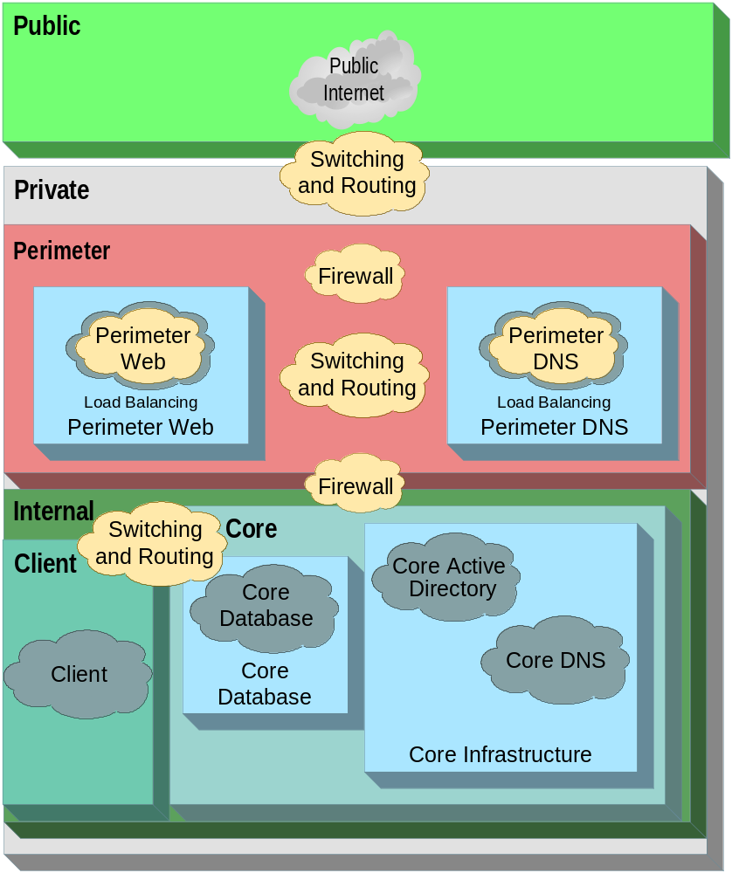
Figure 11. Example Network Roles for Wingtip Toys
Once the network role information has been gathered, the next step is to define the network segments that will be needed to fulfill the requirements of the security zones, tiers, and hosts identified so far.
Defining Network Segments
When determining the network segments that should exist in an environment, perform the following actions:
- State the purpose of each proposed network segment and determine the hosts and server roles that will be on it.
- Determine whether the proposed network segments should be physical or logical.
The following section discusses the issues involved in making these determinations.
Network Segment Requirements and Purpose
Network segments are typically created to control the flow of traffic between hosts on different segments for the following reasons:
- Connectivity: To provide basic communications.
- Performance: To improve performance by providing broadcast traffic containment.
- Security: To control the flow of traffic between segments at layer 3.
An enterprise organization is likely to have a network segmentation design that uses segments for all these reasons. In addition to defining the number of networks segments, this step also requires decisions on where to use physical and logical segments. The following section provides information on making these design choices.
Physical or Logical Network Segments
Network segments may be either physical or logical (VLANs) in the design. This section presents the advantages and disadvantages of each design option along with an example that shows how network segments should be defined.
Design Option 1—Physical Network Segments
If a physical implementation is being considered, the following advantages and disadvantages should be understood.
Advantages
Advantages of defining physical network segments include:
- Security: Because each network segment is separated from another network segment with no physical connectivity between them, the devices that provide connectivity for hosts on physical network segments are not susceptible to a hacker breaching one device and gaining access to any logical network managed by the device.
- Expense: Purchasing multiple physical devices is generally less expensive than buying a single device that permits logical network configuration.
- Simpler setup: No configuration is required to set up the segments; they are created simply by plugging the devices together.
- No firmware updates required: Because the firmware of the physical devices is so much simpler, they are less likely to require firmware updates.
Disadvantages
Disadvantages of defining physical network segments include:
- More physical devices to manage: With more physical devices to keep track of, the ongoing management costs are higher. This is especially true when a highly available solution is required.
- Difficult to reconfigure: If the network topology changes, the process of "replugging" the physical devices is slower due to the requirement for physical cabling changes.
Design Option 2—Logical Network Segments
Using logical network segments has the following advantages and disadvantages.
Advantages
Advantages of defining logical network segments include:
- Flexible configuration: Configuration is manageable, although this requires people in the organization with the requisite skills to do this.
- Fewer physical devices to manage: With fewer devices to track and manage, the ongoing management is likely to be simpler.
Disadvantages
Disadvantages of defining logical network segments include:
- Security: Because all the logical network segments are on the same physical device, all segments are at risk if the device is breached by an intruder.
- Complex setup: Logical devices generally require a complex configuration process before they can be used. Physical devices, however, require only that the correct cables be plugged in.
- Higher skill set requirements: Logical devices require specialized skills to administer; for an organization to configure and support these devices in house, time and money will have to be invested in training the support staff.
- Higher startup cost: The initial cost of devices that support logical network segments is typically higher than the devices that support only physical network segments.
Based on the information provided in the Wingtip Toys example and the tables generated so far, it is possible to define a network segmentation design that fulfills the identified requirements. The following figure shows how the Wingtip Toys network design looks at this point in the design process.
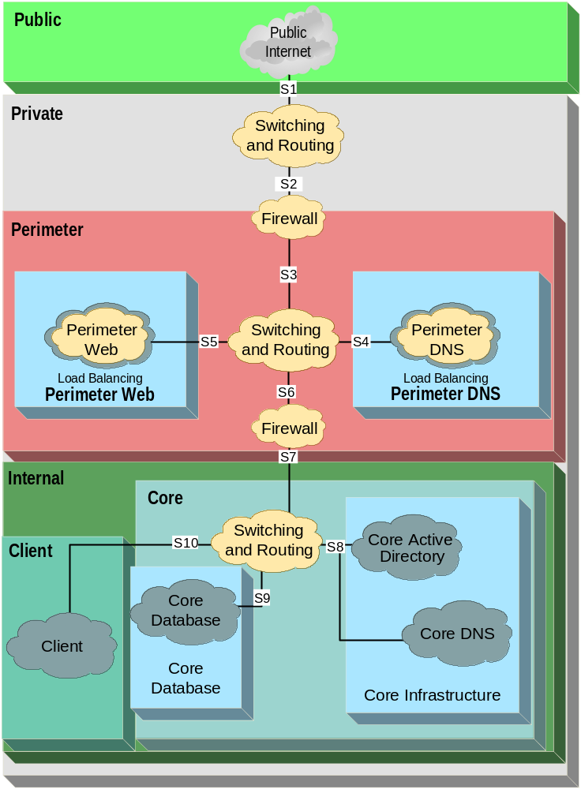
Figure 12. Example Zones, Tiers, Roles, and Segments for Wingtip Toys
The following table summarizes why the different segments in the example were created and how they operate.

Segment ID | Purpose | Physical or Logical | Destination Segments | Reason for Creation
S1 | Connectivity | Physical. This connection is from the Internet to a Wingtip Toys edge device, so a physical segment is necessary. | S2 only | So that traffic can be routed between the Wingtip Toys network and the Internet, the company’s enterprise security policy required a device to provide both the Perimeter Firewall services role and the application layer proxy firewall function between the Public and Private zones. Wingtip Toys did implement a device that performed these functions, which required the creation of S2. However, the company decided it wanted a separate, dedicated device optimized for routing the connection of its network to the Internet (instead of using the device that performed the Perimeter Firewall services role). This solution offered higher performance and enabled the company to plan for potential future growth through adding more segments on the device performing the Border Routing role.
S2 | Connectivity and Security | Logical. It is between two devices that Wingtip Toys owns, and the company wants to minimize the number of devices to manage in its environment. | S3 only | See reason for S1.
S3 | Connectivity and Security | Logical. It is between two devices that Wingtip Toys owns, and the company wants to minimize the number of devices to manage in its environment. | S2, S4, and S5 | To allow traffic to flow from the device that performs the Border Routing role to the device that performs the Perimeter Firewall services role. In addition, to allow traffic to flow from the device performing the Perimeter Firewall services role to the Perimeter DNS and Perimeter Web tiers through the device that performs the Perimeter Switching role. The Wingtip Toys enterprise security policy mandated that the physical device that performed the Perimeter Firewall services role perform the application layer proxy firewall function to control traffic between the Public and Private security zones. In addition, the company’s enterprise security policy mandated that the device that performs the Internal Switching role must be a physically separate device from the device that performs the Perimeter Switching role.
S4 | Security | Logical. It is between two devices that Wingtip Toys owns, and the company wants to minimize the number of devices to manage in its environment. | S3 and S6 | To allow the flow of traffic between the device that performs the Perimeter Firewall services role and the Perimeter DNS tier, as well as to allow devices in the Client zone to connect to the servers in the Perimeter DNS tier to remotely administer these servers.
S5 | Security | Logical. It is between two devices that Wingtip Toys owns, and the company wants to minimize the number of devices to manage in its environment. | S3 and S6 | To allow traffic to flow between the device that performs the Perimeter Firewall services function and the Perimeter Web tier as well as to allow devices in the Client zone to connect to the servers in the Perimeter Web tier to remotely administer these servers.
S6 | Security or Connectivity | Logical. It is between two devices that Wingtip Toys owns, and the company wants to minimize the number of devices to manage in its environment. | S4, S5, and S7 | To allow traffic to flow between the device that performs the Perimeter Switching role and the device that performs the Internal Firewall services role. All servers in the Perimeter DNS and Perimeter Web tiers route traffic through the device that performs the Perimeter Routing and Switching role if they need to communicate with clients in the Client zone. (Clients in the Client zone might connect to these servers to perform remote administration.) The Wingtip Toys enterprise security policy mandated that a device that performs at least the stateful packet inspection firewall function control network traffic between the Perimeter and Internal Zones. In addition, it mandated that the device that performs the Internal Firewall services role be a dedicated device for this purpose, and physically separate from the device that performs the Perimeter Firewall services role.
S7 | Security or Connectivity | Logical. It is between 2 devices that Wingtip Toys owns, and the company wants to minimize the number of devices to manage in its environment. | S6-10 | To allow traffic to flow between the device performing the Internal Firewall Services role and the device that performs the Internal Switching role. Note that the Wingtip Toys enterprise security policy mandated that the device that performs the Internal Switching role must be a physically separate device from the device that performs the Perimeter Switching function.
S8 | Connectivity | Logical. It is between two devices that Wingtip Toys owns, and the company wants to minimize the number of devices to manage in its environment. | S7 and S10 | To allow traffic to flow between the device that performs the Internal Switching role and the tiers in the Core Infrastructure zone as well as to allow traffic to flow between the Client zone and the Core Infrastructure tier.
S9 | Security | Logical. It is between two devices that Wingtip Toys owns, and the company wants to minimize the number of devices to manage in its environment. | S7 and S10 | To allow traffic to flow between the device that performs the Internal Switching role and the Core Database tier as well as to allow traffic to flow between the Client zone and the Core Database tier.
S10 | Security | Logical. It is between two devices that Wingtip Toys owns, and the company wants to minimize the number of devices to manage in its environment. | S7-S9 | To allow traffic to flow between the internal clients and the tiers in the Core Database, Core Infrastructure, Perimeter DNS, and Perimeter Web zones.
Table 8. Example Network Segmentation Information for Wingtip Toys
Assigning LAN Connectivity Devices
Once the network segments have been determined, the next step is to assign these segments to the network devices capable of supporting the required roles between each segment.
At this point in the design process, it should be clear what roles are required and at which points in the logical design they are needed. Therefore, the next step is to identify the physical devices capable of supporting the network requirements.
Device Classes
Network designers need to understand the features and functionality of each network device. One method of simplifying this is to provide a classification guide that helps group the wide range of devices available in the marketplace into a more manageable list. For a grouping done on a device-by-device basis, refer to the relevant device’s chapter of the Service Blueprints guide in this documentation kit.
Device Consolidation
When allocating roles to physical hosts or devices, you need to determine how many physical devices are required. More simply, you need to decide whether a number of devices are preferred over a single multi-function device. The decision faced by the network designers at Wingtip Toys can help illuminate this issue.
Based on the information gathered so far in the example design process, the Wingtip Toys designers have a requirement for the following seven roles:
- Border Routing: The role between the Public and Private zones (segments S1 and S2).
- External Firewall services: The role between segments S2 and S3.
- Web Load Balancing: The role between hosts in the Public Web tier.
- DNS Load Balancing: The role between hosts in the Public DNS tier.
- Perimeter Switching: The role in the Perimeter zone that controls traffic flow between segments S3, S4, S5, and S6.
- Internal Firewall services: The role that provides connectivity between segments S6 and S7.
- Internal Switching: The role that manages segments S7, S8, S9, and S10.
The next design decision is whether these roles are to be fulfilled by multiple physical devices or a single device.
Design Option 1—Consolidate Using Multifunction Devices
It is possible to assign multiple roles or, in some cases, all roles within a network to a single multifunction device. There are too many permutations of this consolidation for a detailed comparison; however, the general advantages and disadvantages of this approach are as follows:
Advantages
Advantages of consolidating various roles into a single multifunction device include:
- Flexibility: Because a multifunction device provides all the required functions in a single device, there is little need to change the physical wiring; a change can be made by simply reconfiguring the software of the device to modify the behavior of the ports.
- Manageability: A single device makes the ongoing management process simpler, as there are fewer physical devices to manage.
- Hardware cost: The cost of separate devices to perform specific roles may be higher than a single device performing multiple roles. However, this device is likely to be significantly more expensive than any other single device.
Disadvantages
Disadvantages of consolidating various roles into a single multifunction device include:
- Security: The single biggest disadvantage with this approach is security. Because a single device touches many areas of the network, a breach could potentially expose all the network segments. No matter how small this risk appears to be, for some it might be too big a risk to take. In addition, individuals in the organization administer different roles; the device may not be able to provide fine-grained administration of separate roles by separate individuals.
- Initial startup cost: Generally, these multifunction devices are more expensive to purchase and set up than a number of single function devices. In addition, the practicality of running all the cables back to a single point in the building may prove difficult to achieve.
- Complexity: The configuration of a device of this complexity is not a simple process; an error in the setup may result in a serious security breach. Therefore, specially trained consultants typically configure these devices based on the customer's requirements.
- Lower Performance: Because a single device performs all the functions, the performance of one function is likely to be affected by the load occurring through another function on the device. It is difficult, at times impossible, to scale one function separately from another when the organization requires it.
- Low Availability: If one role were to fail, it could potentially have an impact on the availability of the other roles being performed by the device.
Design Option 2—Use Different Specialized Devices
An alternative to the single device option is to use a number of specialized devices that provide for a more focused role on the network. This option includes the following advantages and disadvantages.
Advantages
Advantages of using different specialized devices for each role include:
- Security: Physically separate devices always provide more security than logically separate devices. In logically separate devices, an attacker may breach one role and potentially impact other roles provided by the device. When roles are provided by separate physical devices, the attacker must breach every device individually. In addition, if different administrators perform different roles in the organization, this approach is more conducive to separate administration, whereas a multifunction device may not provide for this fine-grained administrative control. This type of approach is in line with the defense-in-depth strategy. For more details on this strategy, refer to the "MSA Security Architecture” chapter of this guide.
- Performance: The overall performance of a device that is optimized to provide a specific role is generally greater than the performance provided by a multipurpose device that provides the same role along with other roles.
- Physical flexibility: Use of multiple devices provides greater flexibility in the positioning of devices in the enterprise environment. In addition, there is a wider variety of specialized devices available compared to that of the high end multifunction devices. This means that there is greater competition in the marketplace for the specialized devices, which typically leads to greater benefits for the customers.
Disadvantages
Disadvantages of using different specialized devices for each role include:
- Operating cost: The operating cost of running multiple specialized devices is higher than that for a single multifunction device. Each device has its own operating system, firmware, and management requirements, which add to the total cost for operating each device.
- Availability: If the organization implements redundant devices to provide the roles and to meet the availability requirements, there are more devices to duplicate. The final point to consider when making this decision is whether it is better to "put all your eggs in one basket." The outcome of this discussion is largely a matter of opinion because each argument has an equal counter argument. For example, if a single device were to fail, the whole network would be affected; however, a multiple device design is more likely to fail because it introduces more points of failure into the network. Which is a better option—a rare large-scale failure or more frequent small-scale failures?
- Ultimately, the decision has to be made by the design team. (It should also be noted that the decision will significantly affect the nature of the network design from this point on.)
Grouping the Roles
If your design team chooses not to use multifunction devices for the network roles, it does not necessarily mean that there will be a one-to-one mapping between the role and the device. There may still be areas where an element of consolidation makes sense. The Wingtip Toys example helps illustrate this point.
So far the Wingtip Toys design has identified seven roles in the network: Border Routing, Perimeter Firewall services, Perimeter Web Load Balancing, Perimeter DNS Load Balancing, Perimeter Switching, Internal Firewall services, and Internal Switching. Grouping of similar roles can consolidate the roles into a smaller list as follows:
- Border Routing
- External and Internal Firewall services
- Perimeter and Internal Switching
- Perimeter Web and DNS Load Balancing
It is possible for an L3 switch to perform the role of a border router; therefore the roles listing can be further consolidated as follows:
- Border Routing, Perimeter and Internal Switching
- External and Internal Firewall services
- Perimeter Web and DNS Load Balancing
The following section provides details of these specialized areas and discusses the advantages and disadvantages of physically consolidating them.
Design Option 1—Assign a Single Device to Each Consolidated Role
Use of a device that is capable of supporting an area of specialization for all the roles of that type identified on the network makes it possible to consolidate the physical devices required to perform the desired network roles into a single device. This design approach has the following advantages and disadvantages.
Advantages
Advantages of assigning a single device to each consolidated role include:
- Single point of setup and configuration: The single device focuses all setup and configuration into a single point.
- Lower TCO and startup costs: A single device is likely to be a more economic option during the deployment as well as the operations phase of the project.
Disadvantages
Disadvantages of assigning a single device to each consolidated role include:
- Security risk: If the device is compromised in a security attack, it may be possible to gain access to all the segments controlled by the device. This could provide a direct route from the Public to the Internal security zone. This risk can be minimized if the device is correctly configured; however, it still is a concern that needs to be understood.
- Complex configuration: The device controls a large number of VLANs, thus the setup and configuration are complex. In addition, because the device spans the Wingtip Toys internal and perimeter zones, a rigorous round of security testing should be undertaken to ensure that a “no configuration” error does not lead to a security breach.
Design Option 2—Assign Physically Distributed Devices to Each Consolidated Role
This option uses a physical device that is capable of supporting a single role requirement. The advantages and disadvantages of this design approach are as follows.
Advantage
The advantage of using this design is that when physically distributed devices are assigned to each consolidated role, a distinct physical divide is created between the devices that makes them secure.
Disadvantages
Disadvantages of assigning physically distributed devices to each consolidated role include:
- Purchase cost: Buying multiple devices that are capable of supporting fewer network role requirements is likely to be more expensive than buying a single device that supports all the roles.
- Management overhead: Multiple devices provide a higher ongoing management overhead than a single device.
In the Wingtip Toys example, designers of network architecture chose option two for all network roles because it provided the required level of physical security as defined by their security team. The company uses a defense-in-depth strategy, which mandates a requirement for physical layers to be provided between each of the connectivity roles identified for the design. This meant that the Border Routing role was assigned as a single specialized device, as were the other roles of Perimeter Firewall services, Perimeter Switching and Routing, Internal Firewall Services, and Internal Switching and Routing.
Assigning WAN Connectivity Devices
The process of assigning WAN connectivity can be treated either as an extension to the overall network design or as a completely independent process that simply integrates into the overall design. The following section discuses the technologies and design issues that WAN connectivity introduces into the network design process.
Remote Access Device
A remote access device is a network device or server that can authenticate the client host and user before routing packets. These devices generally can also perform firewall functions.
Remote access devices have the following two basic functions in the network architecture:
- Allow employees who work away from the office or business partners to connect securely to the enterprise network over public networks such as the Internet. For a secure connection, the data traversing the connection (especially over the public network) should be encrypted between the client and the remote access device at the enterprise, where it is decrypted and routed as required.
- Allow remote facilities (branch offices or business partner sites) to connect securely to the enterprise network over public networks.
The methods that can be used to make the remote connections vary, and there are a number of options that need to be considered before the design can be completed. The following bullet points highlight three steps that need to be taken during the design process:
- Determine client connection network type.
- Determine client connectivity method.
- Determine the client encryption mechanism.
In addition to these items, the remote office connectivity type must be determined if a site-to-site link is to be implemented for a remote office from a central site.
Connecting a Remote Client to the Enterprise Network
A number of options exist to connect a remote client to the enterprise network in terms of the network type, the connectivity device, and the connectivity method. These options are detailed in the following sections.
Design Options—Remote Client Connection Network Type
The network types available for connecting to an enterprise network, together with their advantages and disadvantages, are described in this section.

Note: The term “client” in this section refers both to an individual and to a remote office because the only major difference between the two in design terms is the cost. For example, it is quite possible for a remote worker to have a higher bandwidth requirement than a small remote office; however, it is typically more difficult to justify the higher cost of a leased line to a single employee than to support a number of users at the remote office.

Design Option 1—Private Network
Use of a private network for client connections offers the following advantages and disadvantages.
Advantages
Advantages of using a private network include:
- Point-to-point connection: A client can connect directly to the organization, which assures the reliability and privacy of the connection.
- Guaranteed performance: Because a private network ensures that only the data required for a particular client’s connection travels on the wire, performance of this connection is more predictable and may come with service guarantees.
- Proven technology: Private network technology is well established and dependable.
Disadvantages
Disadvantages of using a private network include:
- Implementation costs: Additional skills and equipment are required to support private networks. It may be expensive to provide private circuits and equipment to all remote access clients.
- Security risk: Although a private network offers some protection against eavesdropping, it should not be considered a secure connection because traffic is not encrypted. Additional equipment is required to provide encryption to traffic.
Design Option 2—Public Network
Use of a public network for client connections offers the following advantages and disadvantages.
Advantage
The primary advantage of a public network is that it is more cost effective because an Internet service provider (ISP) connection costs less than a direct connection.
Disadvantages
Disadvantages of using a public network include:
- Reliability: Service reliability can be an issue because the equipment being used is not owned by the enterprise or the ISP.
- Network performance: The data traveling between a client and the central site shares bandwidth with a public network, therefore performance of the connection is not generally guaranteed. A Quality of Service network can help protect the minimum bandwidth; however, this solution is more expensive and is not available universally.
Design Options—Client Connectivity Method
The connectivity devices that are available for connecting to an enterprise network, together with their advantages and disadvantages, are described in this section:
Design Option 1—Analog Modem
Use of a modem as a client connectivity device offers the following advantages and disadvantages.
Advantages
Advantages of using an analog modem include:
- Inexpensive: Modems are now a low cost consumer item. Generally, all new computers come with a pre-installed modem.
- Location-independent: A modem connection can be made wherever there is a suitable analog connection point.
Disadvantages
Disadvantages of using an analog modem include:
- Inflexible connection: With a single line connection, a user is unable to use the line for other purposes (such as voice calls) while online.
- Slow connection speed: The connection is limited to modem speeds, which can be up to 56 Kbps depending on line quality and telephone infrastructure. Limited bandwidth may restrict the number of applications that can be used during connection.
Design Option 2—ISDN Modem
Use of an ISDN modem for client connectivity offers the following advantages and disadvantages.
Advantages
Advantages of using an ISDN modem include:
- Faster than an analog modem: Faster speed allows for the use of more applications across the connection.
- Keeps phone line open: ISDN provides two lines, one of which can be used for voice calls even while you are online.
Disadvantages
Disadvantages of using an ISDN modem include:
- Special configuration required: A private ISDN interface circuit must be connected directly to the internal network along with additional security and access controls, unless ISDN is provided through an ISP.
- Cost is higher: ISDN connections are more expensive than analog connections in terms of the equipment and connection charges.
- Limited availability: Availability of ISDN is limited, whereas analog lines are widely available.
Design Option 3—Broadband Connection
Use of a broadband (ADSL or cable) router as a client connectivity device offers the following advantages and disadvantages.
Advantages
Advantages of using a broadband connection include:
- High bandwidth, “always on” connection: ADSL and cable provide high speed data connectivity that is up to 10 times faster than an analog modem. User experience may be similar to using an office network.
- Multipurpose line: Both cable and ADSL are able to provide additional functions, such as voice and media services, by using the same communications line and equipment.
- More flexible: Faster speed allows for the use of more applications across the connection.
Disadvantages
Disadvantages of using a broadband connection include:
- Availability: Broadband has not yet been comprehensively deployed, although it is rapidly expanding.
- Impact on organization’s network: Additional network capacity may be required to support higher bandwidth client connections.
Design Option 4—Leased Line
Use of a high speed dedicated leased line, such as a T1 or frame relay circuit, for client connectivity offers the following advantages and disadvantages.
Advantages
Advantages of using a leased line include:
- Reliability: Because this is the traditional way of linking two sites, it is a proven technology whose speed can be as high as necessary. This is an “always on” connection between two sites.
- More flexible communications: Faster speed allows for the use of more applications across the connection. User experience can be similar to using an office network.
Disadvantages
Disadvantages of using a leased line include:
- Lower speed on lower cost lines: Committed information rate (CIR) speed may be lower than that of a broadband connection. For example, the CIR on a 64k leased line will be significantly lower than that of the cheaper ADSL or cable connection.
- Higher cost for equivalent speed: Leased circuits are more expensive than all previous options. Charges for usage beyond CIR can also be high.
- Increased complexity: Leased lines may require additional devices to act as routers for client network and will require additional installation and setup.
Wingtip Toys has a requirement to support remote users but not remote sites. The design team therefore chose to support three of the four connection types; the leased line option was determined to be too expensive for a single client’s needs.
The choice of which option to use for each client was based on the decision tree shown in the following figure.
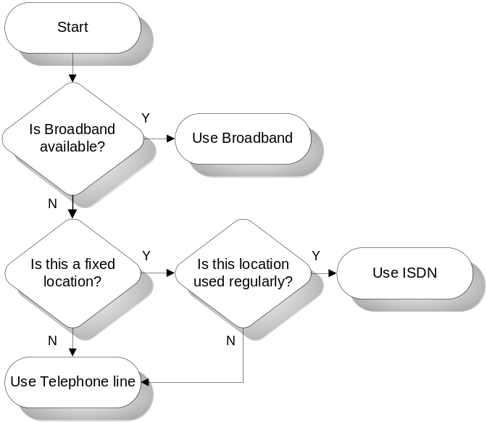
Figure 13. Example WAN Connectivity Decision Tree for Wingtip Toys
Design Options—Client Encryption Mechanism
The mechanisms used to provide a secure client connection to an enterprise network, together with their advantages and disadvantages, are described in this section.
Design Option 1—Client Connects to ISP, ISP Encrypts to Enterprise
When a client connects to an ISP and the ISP provides an encrypted connection to the enterprise, the following advantages and disadvantages apply.
Advantages
Advantages of this option include:
- ISP supports connection: The ISP maintains and supports all VPN-related equipment and provides support for client VPN issues.
- Single connection: Multiple VPN tunnels can be carried on a single network connection to the organization, the only limitation is the available network bandwidth.
Disadvantages
Disadvantages of this option include:
- Infrastructure impacts: The organization is required to set up an infrastructure to support user account maintenance (such as deleting, adding, enforcing password security). It may also need to install a Remote Authentication Dial-in User Service (RADIUS) server to interface with the ISP. Moreover, its clients may require additional VPN client software.
- Security: The ISP needs to be trusted with the security of the VPN tunnel.
- Cost: Tiered ISP bandwidth charges can be high, making this an expensive option.
Design Option 2—Client Initiates VPN Connection, Organization Hosts VPN Endpoint
When a client initiates a VPN connection and the organization hosts the connection endpoint, the following advantages and disadvantages apply.
Advantages
The advantage of this option is that the organization has control over VPN equipment, local control over user access, and additional control over remote access policies.
Disadvantages
Disadvantages of this option include:
- Support overheads: Additional support is required for equipment and users.
- Setup Cost: The organization will need to invest in the equipment to support the clients' VPN requirements.
The best option for the Wingtip Toys example is determined to be option 2, where the VPN tunnel stretches from the remote client to a connection point within the organization. The reason for this choice is that the company was able to use the VPN capabilities of Windows Server 2003 to gain maximum control over the clients’ security through the use of user groups in Active Directory.
Designing an IP Addressing Scheme
Choosing the right IP addressing scheme for an environment is critical to a successful network design. It is important to consider both manageability and future growth plans and to achieve a balance between the two considerations. Selecting an IP addressing scheme typically involves determining the following:
- Which version of IP standards to use: version 4 (v4) or version 6 (v6).
- If using IPv4, determine which network class to use.
- Whether to use public or private addresses.
Choosing the IP Version to Use
Most organizations today use IPv4. This version has been considered the IP standard for many years and is therefore a proven technology. However, IPv4 was never designed to support the numbers or types of devices it is now used for—not only computers and networking devices but even handheld PCs and mobile phones now use IP. IPv6 is currently being reviewed as a replacement for the IPv4 standard. IPv6 provides for a much larger address space than was ever possible with IPv4, and it offers better support for the services required. However, while many organizations may migrate to IPv6 some day, most are content to remain with IPv4 presently. A migration to IPv6 will be a major undertaking for most organizations, and the fact that facilities such as private addressing (covered later) and NAT exist to overcome the limitations of IPv4, at least for the time being, makes migration somewhat unattractive. Details of IPv6 are provided in Request for Comments (RFC) 1752.
The following options list the advantages and disadvantages of using IPv4 or IPv6 for the deployment of a new network.
Design Option 1—Use IPv4 for IP Addressing
IPv4 offers the following advantages and disadvantages.
Advantage
The advantage of using IPv4 is that it is a universally adopted, supported, and proven technology.
Disadvantage
The disadvantage of using IPv4 is that the maximum number of IP addresses it can support (10 billion) is insufficient, given the proliferation of devices and hosts that require addresses.
Design Option 2—Use IPv6 for IP Addressing
IPv6 offers the following advantages and disadvantages.
Advantages
Advantages of using IPv6 include:
- Increased IP address pool: The additional length of the IPv6 address over IPv4 (128-bit rather than 32-bit) offers a vastly increased pool of addresses.
- Simplified header: IPv6 offers a simplified header format to reduce the network overhead and increase network performance.
- Better support to services: An example of the better support that IPv6 offers to services is the pre-allocation of network resources to support time-dependent services.
Disadvantage
The disadvantage of using IPv6 is that it is not yet universally supported or widely implemented; therefore, limited support is available at this time.
For detailed information on the configuration of IPv6 in Windows Server 2003, Enterprise Edition, refer to the Microsoft Knowledge Base Article 325449 titled “HOW TO: Install and Configure IP Version 6 in Windows Server 2003 Enterprise Server” at the following URL:
support.microsoft.com/?id=325449

Note: Many router and switch vendors are beginning to support IPv6. Windows Server 2003 also supports the use of IPv6, although it is not exposed through the user interface (UI).

The Wingtip Toys network designers chose to use IPv4 addressing on their network because they were familiar with it and all their devices supported it. They currently have no need for IPv6 and do not want to introduce something unfamiliar into their environment.
Choosing Between Public or Private IP Addresses
In the current IPv4 address space, all public Class A and Class B address spaces are effectively taken and many organizations require more IP addresses than Class C address spaces can provide (254 usable addresses per address space). To solve this problem, the Internet Engineering Task Force (IETF) has reserved a Class A, Class B, and Class C address space for private usage, though servers connected directly to the Internet must have a routable IP address that comes from the public range of addresses.
Given the constraints on addressing, organizations typically use a mixture of public and private addresses to meet their IP addressing needs. The following design options detail when and where public or private addresses might be used.
Design Option 1—Public Addresses
Use of public IP addresses offers the following advantages and disadvantages.
Advantages
The advantage of this option is that public IP addresses provide direct access to the Internet. These addresses are routable through the Internet and are required on hosts that are directly connected to the Internet.
Disadvantages
Disadvantages of public IP addresses include:
- Limited availability: Very few public IP addresses are available from the Internet Assigned Numbers Authority (IANA).
- Direct access from the Internet: Public IP addresses make the host they’re assigned to directly accessible from other hosts connected to the Internet. This can be a security risk if not appropriately mitigated.
Design Option 2—Private Addresses
Use of private IP addresses offers the following advantages and disadvantages.
Advantages
Advantages of private IP addresses include:
- Scalable addressing: A private address scheme can accommodate a number of hosts and plans for growth in the organization.
- Increased security: Because a host with a private IP address is not directly accessible from the Internet, the risks of eavesdropping or unauthorized access are lower.
Disadvantages
A host with a private IP address is not directly routable onto the Internet. However, hosts can still connect outbound to the Internet through NAT.
The way network addresses were allocated in the Wingtip Toys example can help illustrate the outcome of this process. The following table details where public and private IP addresses were used.

Network Segment# | Public or Private | Why was the choice made?
S1 | Public | Border router needs to be accessible by a public address for Internet connectivity.
S2 | Public | Perimeter firewall needs to be accessible by a public address and is attached to the border router.
S3 | Private | No direct routing to the Internet was necessary for these devices because they connect to the Internet through a NAT device (firewall). Private addressing was sufficient.
S4 | Private | Private segment with no need for direct public addressability.
S5 | Private | Private segment with no need for direct public addressability.
S6 | Private | Private segment with no need for direct public addressability.
S7 | Private | Private segment with no need for direct public addressability.
S8 | Private | Private segment with no need for direct public addressability.
S9 | Private | Private segment with no need for direct public addressability.
S10 | Private | Private segment with no need for direct public addressability.
Table 9. Example Address Allocation Information for Wingtip Toys
Selecting a Network Class and Subnets
If a decision is made to use IPv4 and you have decided whether to use private or public addresses, then you need to make the class and subnet decisions to define the IP address space for the organization.
For details on network classes and how to choose the appropriate subnet mask for an organization, refer to the “Subnet Masks and Custom Subnetting” section in the “Determining Network Connectivity Strategies" chapter at the following URL:
www.microsoft.com/technet/prodtechnol/windows2000serv/reskit/deploy/part2/chapt-7.asp

Note: The referenced article discusses Windows 2000 Server and not Windows Server 2003, but at this level of design there are no differences in the choices that need to be made for the network.

In the Wingtip Toys example, Class C was assigned in all the segments because this provided more than an adequate number of addresses for each network segment in their design.
Logical Design
The previous sections defined and discussed the architectural elements of the network, the available design choices, and the processes that can be applied to produce a network architecture. The next step is to define an environment that can be used by the organization to meet its requirements.
The following figure illustrates how the devices and concepts of design (covered in the “Architecture Design” section) come together to provide the required functionality. The figure presents how the logical design of the Wingtip Toys network should look at this stage.
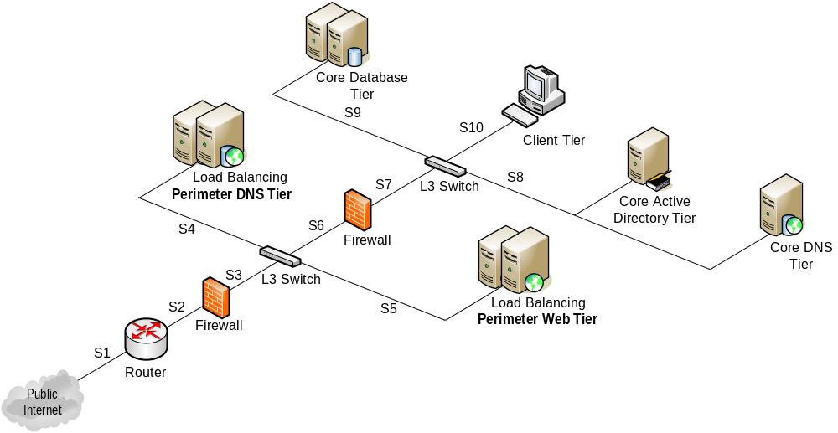
Figure 14. Example Logical Design for Wingtip Toys
The following figure illustrates the logical design focusing on the IP addressing scheme used in the Wingtip Toys example.
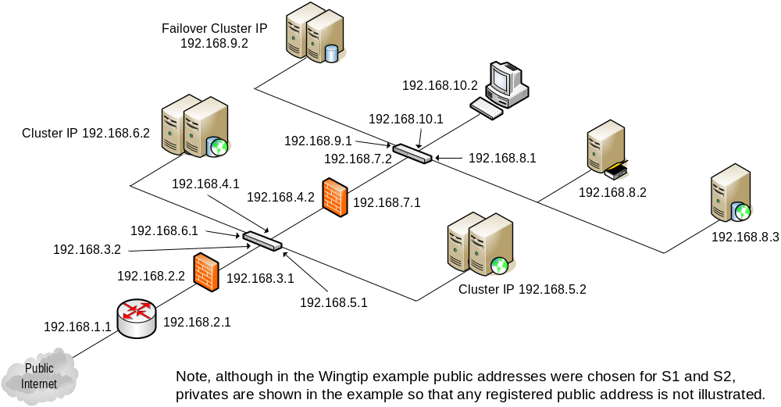
Figure 15. Example Logical Design with IP Addresses for Wingtip Toys
Architecture Dependencies
Network architecture exists to provide reliable, scalable, and available network connectivity at the physical and logical levels to satisfy the enterprise communication requirements. To ensure that a suitable level of network service is provided to applications, the network architecture depends on the security architecture, which imposes both structural (in terms of devices) and logical (in terms of configuration) requirements.
In some cases there may be a dependency on the management architecture—for example, if the management architecture defines a requirement for a separate network for traffic management.
Availability
Availability of the network architecture is dictated by the availability requirements of applications that make use of it. It is neither possible nor economical to guarantee 100 percent availability across the network. Rather, it is necessary to determine availability levels for each device that makes up the network architecture, based on the specific requirements of the applications the device must support.
Typical redundancy mechanisms used to provide high availability of network devices include:
- Redundant components: The devices themselves can be designed to provide redundancy by using multiple components internally.
- Active/active or active/passive clustering: When using clustering mechanisms, two network devices of each type may be implemented within the architecture to provide high availability at the network level.
- Hot-standby devices or servers: Redundant routers, switches, and firewalls could be implemented to maintain availability throughout the network. In this scenario, there is no single device in the design that can cause a site failure. If a firewall fails, a backup firewall is manually brought online. If one switch fails (and is used in conjunction with network adapter teaming as described previously), another switch takes on the full load until the first one is repaired or replaced.
- Network adapter teaming for hosts: Network adapter teaming provides two network adapter ports for a single host. Each port is connected to a physically separate switch, and the switches use a redundancy protocol (the protocol used depends upon the vendor equipment being used). Additionally, the driver for the network adapter at the host end manages the ports as one logical device. If a network adapter port fails, the host continues to communicate through its surviving port, and if a switch fails, all hosts continue to communicate through the network adapter connected to the surviving switch.
It is important to note the concept of “no single point of failure.” When determining availability requirements for the network architecture, it is important to analyze the chain of devices from the client to the application it communicates with. All devices between these two endpoints need to be highly available, as does the application software; otherwise, the application cannot be considered highly available. However, if the mean time between failures (MTBF) of each device in the communication path is considered, it may be that availability levels can still be achieved even if there is no redundancy for some devices.
Consider the following example. A client on a LAN requires access to a file server, which it does through switch "A," router "B," and another switch "C."
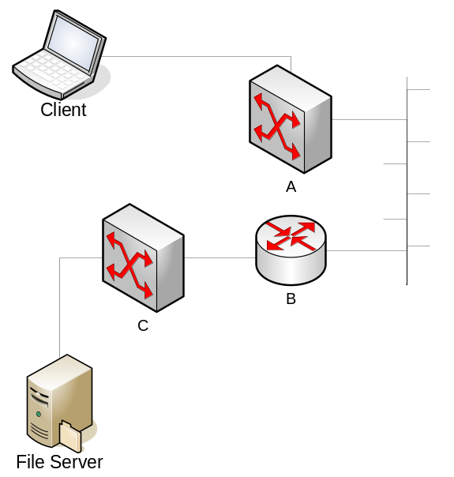
Figure 16. Availability Example
The service level agreement (SLA) provided to clients for this service requires 99.99 percent availability, which works out to approximately 53 minutes of acceptable downtime per year. There is no constraint on when the downtime can take place.
This means that the total downtime for five physical devices, all software, operating systems, and interconnecting cables cannot exceed 53 minutes per year. When the maintenance outages for requirements such as software and firmware upgrades, patches, and backups are taken into account, it is easy to see that the 53 minutes allocated for downtime could be used up quite quickly.
When calculating the required availability levels in an organization, tedious analysis of projected maintenance downtime as well as MTBF analysis for each component needs to be done to determine which high-availability mechanisms (if any) should be used in the design of the network architecture. It is also important to ensure that any SLAs that are entered into have availability figures that are feasible to implement.
Availability mechanisms that could be implemented for servers and devices are detailed in the respective devices’ chapters of the Service Blueprints guide in this documentation kit.
Security
As mentioned previously in this chapter, network architecture design takes into account the organization’s security requirements as much as it does performance requirements. Security zones should be defined by the organization's security personnel and adhered to when designing the network architecture.
Multihoming
Servers in the enterprise architecture may contain multiple network adapters for a variety of reasons. For example, there may be a need to separate traffic to Internet clients from traffic bound for other internal servers, either for performance reasons (that is, both types of traffic might overwhelm one network adapter but can be handled well by two) or for security reasons. Multihoming of servers is the use of multiple network adapters on the same server, or using multiple IP addresses on the same server (which may be used with one or multiple network adapters). In this section, multihoming will refer only to the use of multiple network adapters (which implies the use of multiple IP addresses).
Design Options—Multihoming Servers for Security
The following design options detail the advantages and disadvantages of multihoming and single-homing.
Design Option 1—Multihoming
Multihoming of servers offers the following advantages and disadvantages.
Advantages
Advantages of multihoming include:
- Improved performance: Multihoming allows for separation of traffic, such as the separation of management traffic (generated by backup/restore and remote administration functions, for example) from the network adapter used for communication with the Internet.
- More granular security: Multihoming allows each interface to be connected to a separate network segment and facilitates TCP/IP port filtering on each of the hosts’ interfaces.
Disadvantages
Disadvantages of multihoming include:
- More complexity: Multihoming complicates the network design by adding wires, interfaces, routing entries, and ports that need to be configured and managed.
- Added expense: Multihoming adds more cost through the requirement for additional network adapters, wires, and switch ports.
Design Option 2—Single-homing
Single-homing offers the following advantages and disadvantages.
Advantages
Advantages of single-homing include:
- Reduced cost: Single-homing is less expensive than multihoming because fewer network adapters, switch ports, and wires are required.
- Simpler management: Single-homing is easier to manage than multihoming because fewer network adapters, routing entries, switch ports, and wires are required.
Disadvantages
Single-homing is less flexible because the network administrator cannot isolate traffic to one or the other network adapter for performance or security reasons.
Wingtip Toys Design Choice
Wingtip Toys decided to use single-homing for the servers in its Perimeter zone in order to decrease complexity, even though it required them to have Terminal Services as well as other ports listening on the servers. They determined that the potential security risk did not outweigh the added complexity and switch ports required for multihoming, primarily because of the other security policies they had implemented.
Security Lockdowns
The equipment used to implement network architecture should provide a variety of lockdown functionality because these devices control the flow of information within an organization and to the Internet. All devices that comprise the network architecture should provide the following capabilities:
- At a minimum, username and password-based authentication for remote administrators.
- Optimally, encrypted communications for administration and monitoring purposes should be allowed.
Access Control Lists
Access control lists (ACLs) can be maintained from host to host or from network segment to network segment. The use of ACLs on the network devices makes it possible to control which data can travel to which LANs and VLANs.

Note: Switch ACLs typically provide static port filters. A firewall device can provide additional functionality; therefore, switch ACLs are not typically used in place of a firewall, but rather, in addition to firewalls for additional security and defense in depth.

Wingtip Toys Design Choice
Based on the information provided in the Wingtip Toys example, it was decided to implement ACLs between network segments (to ease administration) rather than between hosts.
Service Account(s)
When using servers to provide some of the functionality required by the network architecture, service accounts on the servers should all be local accounts (rather than domain accounts). Account naming and passwords should follow password guidelines as defined by the organization's security policy. For further information on password guidelines, refer to the "MSA Security Architecture" chapter of this guide.
Network Authentication
Network authentication is the process of ensuring that users attempting to connect to the network infrastructure are who they claim to be before allowing them access to the network. This function is commonly used in a network where one or more of the following scenarios are present:
- It is difficult to control physical access to network points.
- Network clients connecting remotely to a network through a remote access service, such as VPN.
- A wireless connectivity solution is being used.
Technologies such as smart cards, IPSec, Internet Authentication Server (IAS) and, in wireless scenarios, 802.1x authentication can all play a role in this process. For more information on these technologies, refer the following resources:
- For information on IPSec, refer the following URL:
www.microsoft.com/technet/prodtechnol/winxppro/proddocs/sag_ipsectopnode.asp
- For information on authentication in remote access scenarios, refer to the “Remote Access Services” chapter of the Service Blueprints guide.
- For information on the 802.1x authentication in wireless networks, refer the following URL:
www.microsoft.com/technet/prodtechnol/windowsserver2003/proddocs/entserver
/understanding_8021x.asp
Wingtip Toys Design Choice
Because the Wingtip Toys example does not require a wireless solution and the physical port security was not an issue, no network authentication solution was used for the main network infrastructure. However, authentication was used as part of the remote access because remote access was required.
Network Encryption
Encryption of data traffic within the network provides protection from malicious capturing and deciphering of data frames. The traditional encryption methods are Data Encryption Standard (DES) and 3DES, which are a part of the IPSec suite, or Microsoft Point-to-Point Encryption (MPPE) for point-to-point tunneling protocol (PPTP).
For more detailed information on this subject, refer to the “Encryption 101” section in Chapter 9 of the Mastering Network Security book published by Sybex, Inc. This book is available at the following URL:
www.microsoft.com/technet/security/prodtech/network/authen.asp
Scalability
When implementing network architecture, intelligent networking devices should be used to allow network administrators to scale the network as the data center and network bandwidth requirements grow. Sophisticated network devices include intelligent routing and packet filtering that allow for the efficient moving of packets, often at near wire speeds. Network devices and servers should be able to accommodate port speeds from 10 Mbps to 10 Gbps as network throughput requirements dictate in the environment. Modular switches can be used to enable the addition of more ports to accommodate devices and servers as they are added to the environment.
For details on scalability options for different classes of servers and devices, refer to the relevant devices chapters in the Service Blueprints guide.
Manageability
Management priorities in the enterprise have led to the acceleration and deepening of relationships between business needs and network operations. A primary goal of network managers is the mapping of network infrastructure components to business processes, together with the need to refocus the development of management metrics and event processing rules to address SLAs based on business priorities. The basic goals of network management are to:
- Improve the quality of services.
- Lower the cost of ownership.
- Reduce risks.
An organization requires well constructed, flexible, and business-oriented processes to manage its environment. Management of the environment includes administration, problem resolution, and proactive development of the infrastructure to minimize problems. Management also includes the determination of SLAs and verification that the service quality objectives are being met.
Management Process Models
In the absence of well-defined management processes, the adoption of a reference model for management can help accelerate the process for building and standardizing management processes. The MSA 2.0 guidance references two main models that are accepted broadly throughout the IT industry. These are the IT Infrastructure Library (ITIL) and Microsoft Operations Framework (MOF). These reference models provide a basis for developing enterprise-quality capabilities. For more information on the use of MOF in MSA, refer to the "MSA Management Architecture" chapter of this guide. Additional information on MOF is available at the following URL:
www.microsoft.com/mof
The processes defined in MOF that are the basis for network operations relate to the management of problems, change, planning, and assets. These processes are critical to an organization's ability to fix problems, make changes to the infrastructure, plan new implementations or upgrades, and track infrastructure assets. Addressing these goals includes the adoption of management processes, definition of management roles, and building of management capabilities.
Role-based Administration
It is likely that a number of individuals in an organization administer the different devices and servers that comprise the network architecture. In addition, different individuals may manage different functions of each device or server.
For a detailed list of IT and operations roles, together with mappings between MOF and MSF roles, refer to the “Microsoft Solutions Framework (MSF) IT Occupation Taxonomy” document, which is available from the MSF resource library at the following URL:
www.microsoft.com/technet/itsolutions/tandp/innsol/msfrl/
Management Capabilities
The IT Management Process Maturity model defines different levels of maturity in an organization's management processes. The following table from a Gartner article dated February 6, 2003 by Debra Curtis titled "Network Management for the Real-Time Enterprise" describes these levels.

Level | IT Management Process Maturity | Management Processes Implemented
4 | Value | IT or business metric linkage
3 | Service | Capacity planning, and service-level management
2 | Proactive | Performance, change, problem, configuration, and availability management; automation and job scheduling
1 | Reactive | Event up and down, console, trouble ticket, backup, topology, and inventory
0 | Chaotic | Multiple help desks, nonexistent IT operations, and user call notification
Table 10. IT Management Process Maturity Model
Many organizations deal well with the reactive processes of managing a service. Frequently, however, organizations fail to implement proactive management of networks as a service and therefore fail to achieve the greatest management value associated with full integration of the business priorities and IT.
Network Management Services
As defined earlier, the processes and maturity of network management drives the design of management services for a network. The primary tools used are network and server management tools, which provide the resources for proactively determining network performance, collection of events, and reporting or notification of the network.
There are many different products available to fulfill this service function. To provide centralized monitoring and service control, network and server management tools should be integrated with the monitoring and alerting services implemented in an organization's management architecture.
System Administration
Each of the devices and servers that comprise the network architecture should have the capability of being managed remotely and securely over the network. Security policies in place in an organization may require local administration rather than administration over the network. However, secure remote administration capabilities are generally recommended.
Management of the network should be secure; securing the management consoles includes physically protecting the network devices, using complex and long passwords, and protecting the network paths used for management. Use of technologies like RADIUS and Secure Shell (SSH) provides some of the solutions to the problem of securing management. Other solutions to this problem include the requirement of encrypted sessions and isolated management networks. Isolating management may include physically separating interfaces for device management from all other general routed network traffic and restricting management traffic between hosts on the network. If management is over general network paths, encryption of management traffic is highly recommended.
Management options vary depending on the devices chosen by an organization. At some point in the design process a decision should be made on whether to standardize on any management protocols. Typically, network devices include support for a number of the following management protocols:
- Telnet
- Secure Shell (SSH)
- Hypertext Transfer Protocol/Secure Hypertext Transfer Protocol (HTTP/HTTPS)
- File Transfer Protocol/Trivial File Transfer Protocol (FTP/TFTP)
- Syslog
- Simple Network Management Protocol (SNMP)
Design Option—Integrated or Dedicated Management Networks
As mentioned earlier, a network architecture design incorporates the organizational security policies. Frequently, an access control mechanism is between the Internet and internal users. At L3 and below, this is usually implemented as a sort of firewall mechanism with TCP and/or UDP port filters in place. While this approach facilitates higher levels of security with regard to how traffic is allowed to flow through the network architecture, it often causes problems when typical management tasks such as remote administration and backup/restore procedures need to be carried out. Many organizations implement separate or dedicated management networks to support their management needs; however, controls are still required to meet security objectives.
The following section summarizes the advantages and disadvantages of dedicated and integrated management network options. Keep in mind that regardless of the option chosen, the ports required by the management tools in the environment need to be available to allow the flow of management data through the environment.
Design Option 1—Dedicated Management Network
A separate or dedicated management network offers the following advantages and disadvantages.
Advantages
A dedicated management network provides a clear management boundary through the use of dedicated interfaces and networks to separate the traffic required for management functions.
Disadvantages
Disadvantages of a dedicated management network include:
- Management overhead: The management network itself becomes an additional network that needs to be managed.
- Security risk: Depending on the configuration, dedicated management could potentially bypass firewalls and other control mechanisms in the environment and cause security risks.
Design Option 2—Integrated Management Network
Use of a management network that shares the same facilities as the enterprise network offers the following advantages and disadvantages.
Advantages
An integrated management network eases management because there are fewer networks, ports, and routing tables to manage.
Disadvantages
Disadvantages of an integrated management network include:
- Potential network congestion: Some management functions can generate a large amount of network traffic. If these functions are performed on the same LAN as the clients accessing the servers, network latency and client delays can result.
- Less fault tolerance: If the primary network goes down, it becomes difficult to route management and configuration information to diagnose and fix the problem.
Performance
Designing network architecture for the highest available performance entails evaluating the following elements:
- Device speed: The speed of a device based on its function (that is, how fast can packets be routed or filtered).
- Network speed: The speed of the network interfaces and connectivity devices or server ports (for example, 100 Mbps or 1 Gbps).
- Filtering: The type of filtering being performed on packets (the inspection of packets above level 3 of the OSI model) determines the CPU power that is required. The higher the level of filtering that is performed, the greater the likelihood that performance will degrade. If needed, additional CPU resources should be added to bring the performance back to desired levels.
- Encryption: When encryption is used—for example, on VPN devices—the network traffic performance degrades. If this overhead proves to be too great and the network performance falls below an acceptable level, additional CPU resources should be added to the devices performing encryption to help bring performance back to desired levels.
- Number of devices: The latency introduced into the overall performance of the network increases with an increase in the number of devices.
Supportability
A key element of the network architecture that is often forgotten is supportability. Each device you introduce into the network environment will have an overhead attached to it that increases the overall TCO of the architecture. Specifying and purchasing devices that are designed to minimize the ongoing overhead will help keep the TCO as low as possible.
The methods by which supportability can be enhanced include:
- Remote administration tools.
- Centrally manageable remote firmware updates.
- High level of support with industry standards.
- Integration with enterprise-class management solutions.
Consolidation
In a growing organization, a variety of network devices proliferate; switches appear on every floor and in every server closet, some are managed while others remain unmanaged, some are 10 Mbps switches and others are higher speeds, and so on. Many organizations pursue standardization and consolidation efforts across the board to avoid chaos in their network infrastructure. At a high level, this process can be thought of as falling into distinct consolidation types, two of which are discussed in the following section.
Same Role Consolidation
This type of consolidation focuses on collapsing devices into fewer and physically more capable devices that can perform the same role with fewer points of failure. A switch device is a likely candidate for this type of consolidation. Low end unmanaged switches may be removed and replaced with a higher end managed switch. In addition, over time, advances in CPU and network adapter speeds have provided us with the ability to consolidate other more complex network roles such as routers, firewalls, and VPN devices (remote access servers).
Different Role Consolidation
Over time, convergence has blurred the lines between the different devices or server types that comprise network architecture. For example, many router devices and high end switches can perform firewall functions, and many such devices or servers can also provide VPN services to the network. Consolidation of multiple components to these multifunction devices or servers can decrease the number of devices that need to be managed in the environment, potentially decreasing the TCO for the enterprise. Companies may choose to pursue this route, although several considerations are involved in doing so, including:
- Administration: Different people may administer the different devices/servers in the organization. It may not be feasible to break up the administration of multifunction devices in a manner that is conducive to organizational structures.
- Higher attack surface: When combining functionality for many “edge” devices (devices connected directly to the Internet), the security threat is increased because the device is now vulnerable to multiple kinds of attacks.
- Reduced optimization options: For example, if VPN functionality were combined with a router, the ability to scale the service independently would be lost. VPN functionality requires encryption, which uses CPU cycles that would then be taken away from routing, potentially degrading routing performance. If the two different functionalities are on two separate devices, their unique performance requirements could be optimized separately.
Interoperability
Elements of the network architecture must interoperate with each other and with other architectural building blocks of the infrastructure. Interoperability must exist between the following levels:
- Physical: Network hardware must work with other networking equipment; for example, it must fit a standard equipment rack. Voltage requirements also need to be taken into account.
- Connectivity: Network hardware needs to provide suitable connectivity to match other network elements. For example, it needs to support twisted pair or fiber connections. Treatment of wired and wireless network equipment should also be considered.
- Protocol: Both L2 and L3 protocols need to be supported. Interoperability among network device vendors is generally very high. Almost all vendors who manufacture enterprise-class routers and switches adhere to industry standards published by IETF, which include configuration information and standards such as the Routing Information Protocol (RIP). Many of the RFCs that have been published over the years have been adopted as standards that hardware and software vendors use to develop their products.
- Management: Network hardware and software need to interoperate at a management level so that they can be monitored, remotely configured, and operated as economically as possible. Consider the management implications of using equipment from multiple vendors instead of obtaining the entire routing infrastructure from one vendor. Typically, the benefits of unifying on a small set of management tools and methodologies lead enterprise customers to use one vendor wherever possible.
Best Practices
In addition to the best practices highlighted throughout this chapter, the following best practices should be adhered to:
- Security-led design: When designing network architecture, it is vital that security is designed in from the start; each network device or server should be evaluated from the perspectives of its value to the enterprise and the security risk.
- Document requirements: Documenting the design process, in a manner similar to the method shown in the Wingtip Toys example, will help provide the kind of information required to make a successful architecture design.
Standards and Guidelines
The design of the network architecture itself adheres to the OSI model and the TCP/IP protocol. For details of the standards and guidelines to which routers, switches, load balancers, firewalls, remote access devices, and servers should adhere, refer to their respective chapters of the Service Blueprints guide in this documentation kit.

CDC Design Considerations
This section provides a summary of the design process for the network architecture of the MSA CDC scenario. The CDC scenario is the first of several projects required by the Contoso enterprise to meet its business requirements.
Business Need
Contoso is an established organization. It already has an IT infrastructure in place and plans to deploy new services in the organization to meet its growing requirements. Contoso would like to develop a standard infrastructure by creating an architectural blueprint that would be followed by future design projects to quickly integrate new technologies and acquisitions into their existing business environment. It also plans to expand its reliance on the Internet and provide Internet-based services to clients. Examples of these services include:
- A Web presence that delivers Web services for external and internal clients such as:
- Brochure and business information.
- Web-based secure e-mail access.
- Consumer information for partners and customers.
- VPN to facilitate the following types of communications:
- Partner B2B communications (Extranet).
- Internal employee remote access (Intranet).
- Connections between branch offices and the corporate network traversing the public network (Internet).
Contoso wants to add the following services to support a growing business:
- A unified directory service that supports centralized management, single sign on, and information auditing capabilities.
- Secure LAN connectivity options for both wireless and wired communications.
- Data storage for line of business applications.
- A public key encryption infrastructure.
- Messaging and collaboration tools.
Security practices at Contoso became fragmented because of rapid growth, acquisitions, and changing technologies. Now the company needs to improve these practices before providing additional Internet-based services to employees, partners, and clients to protect their customers and themselves against Internet-based and internal threats.
Architecture Design
The following sections illustrate how the process followed for the MSA CDC scenario. To obtain the complete picture of the design process, it is important to have an understanding of the documentation provided in the MSA 2.0 Planning Guide in the MSA Implementation Kit, specifically the “Introduction to MSA Planning Guide” and “Network Devices” chapters. The result of the design process in the case of the MSA CDC scenario was a fully functional environment that was planned, built, and tested in the MSA Test labs.
Technical Requirements
The MSA CDC network designers want to ensure that security mechanisms are implemented at appropriate layers of the technical architecture to minimize the risk of attack to its resources. The architecture blueprint must satisfy the following requirements:
- All services are highly available.
- Network services, including communications that traverse the Internet, are secure from end to end.
- All network communications not explicitly allowed are denied.
- All services use a central authentication mechanism.
- All applications are authenticated and auditable.
- Centralized management capability.
- Service health monitoring to prevent costly downtime.
- Data integrity is guaranteed and uncompromised from end to end.
Desired Outcome
Contoso requires that the final infrastructure meets the technical requirements and adheres to the security policies presented in the “MSA Security Architecture” chapter of this guide.

Note: The examples provided in the remainder of this section are not intended to illustrate all Contoso needs but rather to provide examples that illustrate the points being addressed.

Having defined the business need and the technical requirements, the necessary inputs for the network architecture design were needed before the design could be implemented and tested.
Design Inputs
Before starting the design process, the MSA network designers had to gather a great deal of information from the security team and the various application (or project) teams. The following section provides a relevant example of this information for the CDC scenario.
Security Zone Definitions
The MSA security team defined the security zones and the permissible protocol traffic between them. The following figure illustrates the security zones that were defined for the CDC scenario.
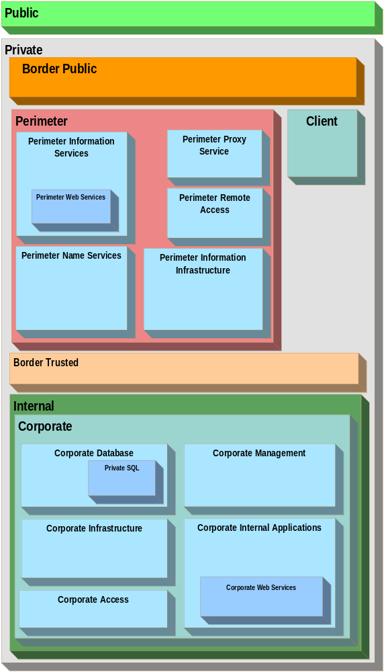
Figure 17. Security Zones for the MSA CDC Scenario
The process for defining these security zones is provided in the “MSA Security Architecture” chapter of this guide.
Tier Definitions and Required Tier Communication
The next phase in the design process is to define the network tiers and the network communications that are required by the services and applications planned for the infrastructure. The following table lists the tiers that were defined for the MSA CDC scenario. For a detailed breakdown of what services and hosts are deployed within each tier as well as the load balancing details for each, refer to Appendix 1.1 in the “Introduction to MSA Planning Guide” chapter of the MSA Implementation Kit.

Tier | Tier Description
Firewall (Public) | External interface on the border firewall between Public and the Border Public zone.
Firewall (Public) | Internal interface on the border firewall between Border Public and the Perimeter Information Services and Perimeter Name Services zone.
Firewall (Semi-trusted) | Border firewall between Public and Perimeter Remote Access zone.
Firewall (Semi-trusted) | Border firewall between Public and Perimeter Proxy Services zone.
Perimeter Application | Application servers for public access.
Perimeter Web | Web services available to the public.
Perimeter DNS | DNS services available to the public for queries.
Perimeter Directory | Domain controller and directory services available to the public.
Perimeter Backup | Backup services available for public.
Perimeter Management | Management services available for public.
External Proxies | Proxy and recursive DNS services for outbound client traffic.
VPN | VPN services for client and site-to-site connections.
Internal SQL | Microsoft SQL Server for internal clients.
SQL | Microsoft SQL Server for perimeter and internal access.
Internal Directory | Active Directory for internal use.
Internal Access | IAS services for RADIUS authentication of VPN clients.
Internal Proxy | Proxy services for internal use.
File and Print | File and print services for internal use.
Internal Name Services | DNS and WINS services for internal name resolution.
Internal Backup | Backup services for internal use.
Internal Management | Management services for internal use.
Internal Applications | Application services for internal use.
Internal Web | Web services for internal use.
Branch Office | Corporate remote offices.
Client | Client access devices.
Table 11. Tier Definition Summary for the MSA CDC Scenario
Once the tiers and zones have been identified, the security administrator can determine which tiers are members of which zones. The following figure illustrates the result of this exercise for the MSA CDC scenario.
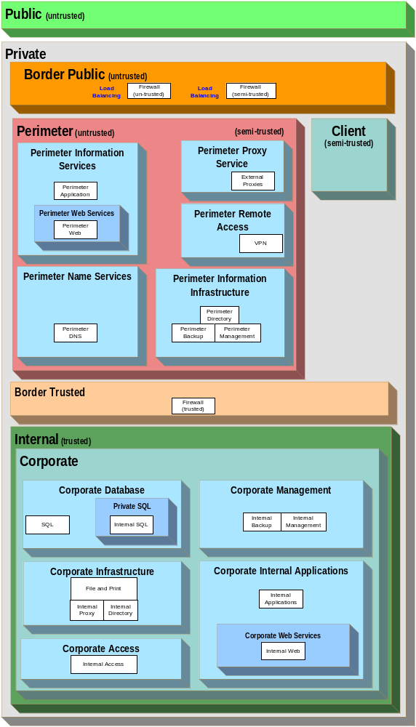
Figure 18. Tier and Zone Structure for the MSA CDC Scenario
In the MSA CDC scenario, certain applications have dedicated ports (ports 57901-59750) for remote procedure calls (RPCs); firewall rules were created to allow traffic on these TCP ports.
The following table is a compilation of a set of commonly allowed ports and protocols that were applied in the MSA CDC design. To retain the brevity of the table structure, the communication relationships will refer only to sets of common protocols instead of detailing each one.

Note: The table lists only the well known port for each protocol; however, in certain situations, the customer could select custom ports if a certain application or service needs to support them explicitly. The port range above 1024 can be used dynamically by specific applications which may not work properly when traversing firewalls or filtering devices. All TCP or UDP ports are explicitly denied unless specified in the table.

Port# or Service | TCP/UDP | Protocol | Purpose
53 | UDP | DNS | To allow DNS name query traffic.
88 | TCP/UDP | Kerberos | To allow clients to log on to Active Directory and get Group Policy or Kerberos.
123 | UDP | NTP | To allow clients to log on to Active Directory and get Group Policy or NTP traffic.
135 | TCP/UDP | RPC Endpoint Mapper | To allow clients to log on to Active Directory and get Group Policy or RPC traffic.
137 | TCP/UDP | NetBIOS NS | To allow WINS registration traffic over NetBIOS Name Server.
138 | TCP | NetBIOS DGM | To allow clients to log on to Active Directory and get Group Policy or Netlogon traffic over NetBIOS datagram service.
139 | TCP | NetBIOS SSN | To allow remote Event Viewer traffic over NetBIOS session service.
389 | TCP/UDP | LDAP | To allow clients to log on to Active Directory and get Group Policy or LDAP traffic.
445 | TCP/UDP | CIFS | To allow clients to log on to Active Directory and get Group Policy or SMB.
3389 | TCP | RDP | To allow administrators to remotely administer the servers through Terminal Services or Remote Desktop Connection.
57901 57902 | TCP | RPC | Statically defined RPC client ports to facilitate Active Directory services.
57903 | TCP | RPC | Fixed port for allowing Windows NT® 4.0 Directory Service traffic.
57904 | TCP | RPC | Fixed port for allowing Netlogon traffic.
57905 | TCP | RPC | Statically defined RPC client port to facilitate Active Directory services.
Table 12. Common Protocols Set
The next step in the process is to provide a detailed listing of the ports that are allowed to communicate with each zone or between zones within the network. On multihomed hosts, it is important to capture the exact number of network adapters so that the designer knows which interface to apply the security policy to and where the interface is connected to the internal or external facing networks. The following figure illustrates this concept.
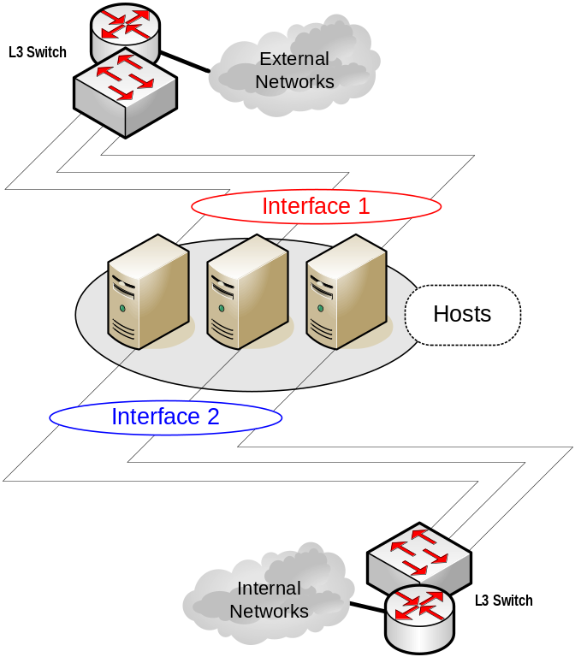
Figure 19. Multihomed Hosts Network Adapter Identification
An example of the level of detail required was given in Table 3 earlier in this chapter. Due to the detailed nature of this list, the exact data can only be provided as part of a specific instantiation and has therefore been provided in the MSA Implementation Kit. For the exact details of this list for the MSA CDC scenario, refer to Appendix 1.2 in the “Introduction to MSA Planning Guide” chapter of the MSA Implementation Kit.
Enforcing the traffic filters can be accomplished through various means. Typically, traffic filters are configured at VLAN level because VLANs can be used to segment the network logically into security zones and provide a more consistent security model where hosts that share common traffic restrictions are grouped into the same VLAN. If the VLAN design is already implemented and it is difficult to re-address hosts and create new VLANs, filter rules that pertain only to specific hosts (instead of a whole VLAN) can be applied.
Filters can be enforced in the following ways (in order of preference):
- Firewall rule at a VLAN or subnet level.
- Router ACL at a VLAN or subnet level.
- Firewall rule at a host level.
- Router ACL at a host level.
- Host rule on a specific interface.
Required Host Communication Performance and Availability
After listing the hosts and servers and their communication requirements, the next step is to obtain the network performance and availability requirements for each zone or tier.
In the MSA CDC scenario, the required level of uptime for services in the perimeter zone when accessed from the public zone was rated at 5 (99.999) because any downtime in these services could lead to a direct loss of revenue. The availability of the internal client zones was rated at 3 (99.9) because the users based in the clients security zone were not directly generating revenue for the organization.
The following table illustrates an example of some of the availability requirements for the MSA CDC scenario. In reality, obtaining this information for all network services in advance is extremely difficult because much of this information becomes available only once the systems are in place and network monitoring produces a useable baseline.

Source Zone or Tier | Destination Tier | Peak Bandwidth Requirements | Average Bandwidth Requirements | Maximum Latency Tolerated | Minimum Acceptable 9s Rating
Internet Client Access
Public | Perimeter Web, Perimeter Application | 7 Mbps | 2 Mbps | 100 ms | 5
Public | Perimeter DNS | 1 Mbps | 500 Kbps | 100 ms | 5
Internal Client Access
Client | Internal Name Services | 5 Kbps | 1 Kbps | 100 ms | 3
Client | Internal Directory, Internal Proxy | 5 Mbps | 1 Mbps | 100 ms | 3
Client | Internal SQL | 10 Mbps | 2 Mbps | 100 ms | 3
Table 13. Required Host Communication Performance and Availability Example for the MSA CDC Scenario
Zone and Tier Communications Restrictions
At this point in the design process, the restrictions that need to be in place between the security zones and network tiers must be evaluated. As stated in the Wingtip Toys example, this is an iterative process that requires the security and network design teams to compare each service and application requirement against the security risks that the requirement may introduce. For information on the final permitted communications, refer to the “MSA Security Architecture” chapter of this guide.
Defining the Network Roles
The next activity in the MSA CDC design process is the task of matching a network role to each network segment. The roles identified by the design team provide one or more of the following classes of functions:
- Connectivity (switching and routing)
- Security (firewall services)
- Load balancing
Using the MSA CDC scenario information, it was possible to identify requirements for a number of network roles. The following table lists these network roles for the MSA CDC network architecture.

Source | Destination | Network Role Required | Network Role ID | Reason
Public Zone | Private Zone | Routing and Switching | Border Routing | To provide connectivity between the two zones.
Private Zone | Perimeter Zone | Firewall services | Perimeter Firewall services (untrusted) | To comply with enterprise security policy.
Private Zone | Client Zone | Firewall services | Perimeter Firewall services (semi-trusted) | To comply with enterprise security policy.
Within Perimeter Zone |  | Routing and Switching | Perimeter Switching | To provide connectivity.
Perimeters Remote Access Tier |  | Load Balancing | Perimeter Remote Access Tier Load Balancing | To load balance the perimeter remote access (VPN) servers.
Perimeters Proxy Tier |  | Load Balancing | Perimeter Proxy Tier Load Balancing | To load balance the perimeter proxy servers.
Perimeter Application Tier |  | Load Balancing | Perimeter Application Tier Load Balancing | To load balance the perimeter Web servers.
Perimeter Web Tier |  | Load Balancing | Perimeter Web Tier Load Balancing | To load balance the perimeter Web servers.
Perimeter DNS Tier |  | Load Balancing | Perimeter DNS Tier Load Balancing | To load balance the perimeter DNS servers.
Within Client Zone |  | Routing and Switching | Client Switching | To provide connectivity.
Perimeter Zone and Client Zone | Internal Zone | Firewall Service | Internal Firewall services (trusted) | To comply with enterprise security policy.
Internal Zone | Corporate Zone | Switching and Routing | Internal Switching | To provide connectivity.
Corporate Proxy Tier |  | Load Balancing | Corporate Proxy Tier Load Balancing | To load balance the corporate proxy servers.
Corporate Application Tier |  | Load Balancing | Corporate Application Tier Load Balancing | To load balance the corporate Web servers.
Corporate Web Tier |  | Load Balancing | Corporate Web Tier Load Balancing | To load balance the corporate Web servers.
Corporate Data Tier |  | Load Balancing | Corporate Data Tier Load Balancing | To load balance the corporate read-only database servers.
Table 14. CDC Network Roles
After defining the network roles, a logical diagram can be created. The following figure shows the logical diagram for the MSA CDC scenario.
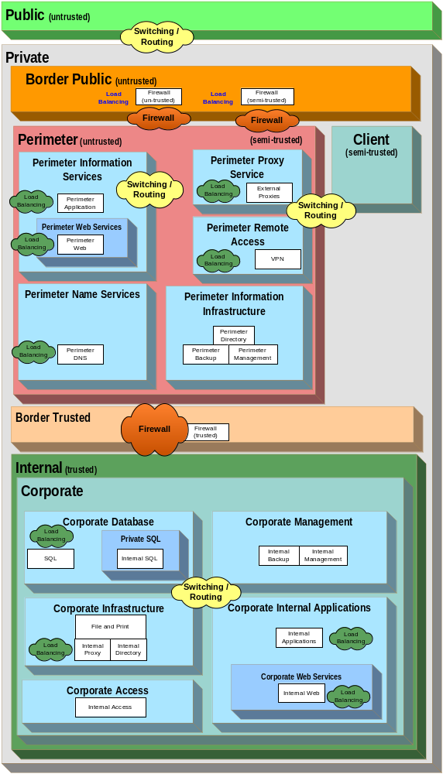
Figure 20. Network Roles for the MSA CDC Scenario
Defining Network Segments
Once the network roles have been added to the design, the next step is to define the network segments that are needed to fulfill the needs of the identified security zones, tiers, and hosts.
In the MSA CDC design, each security zone was represented by an individual segment or VLAN, except in those situations where it was considered impractical. The following table lists these situations.

Zones Sharing a VLAN or Segment | Segment # | Reason for Not Segmenting Into Separate VLANs
Perimeter Proxy Service, Perimeter Remote Access | 9 | Both zones are protected by the semi-trusted border firewall service, so the security risk is deemed very low.
Corporate Infrastructure, Corporate Access | 17 | The security risk is mitigated by the trusted firewall employing host-based security rules.
Table 15. Zone and Segment Security Explanations
All networking segments in the MSA CDC network design were logical VLANs except the segments that connected the edge network to the perimeter bastion hosts. This approach was taken to comply with the security requirement of having distinct physical network devices supporting edge connectivity. Additional security was achieved by placing the perimeter aggregate switches behind bastion hosts to prevent direct communication between these switches and the border routers. VLANs were chosen elsewhere because of their flexibility, manageability, and rich features. The following figure illustrates this concept.
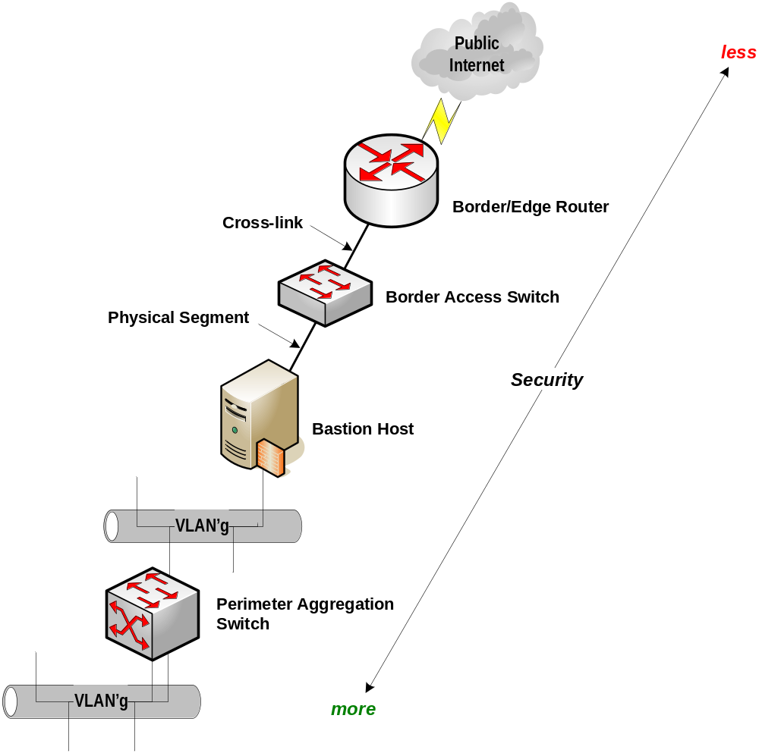
Figure 21. MSA CDC Network Segmentation Example
The following figure shows how the network design in the MSA CDC scenario looked at this point in the design process.
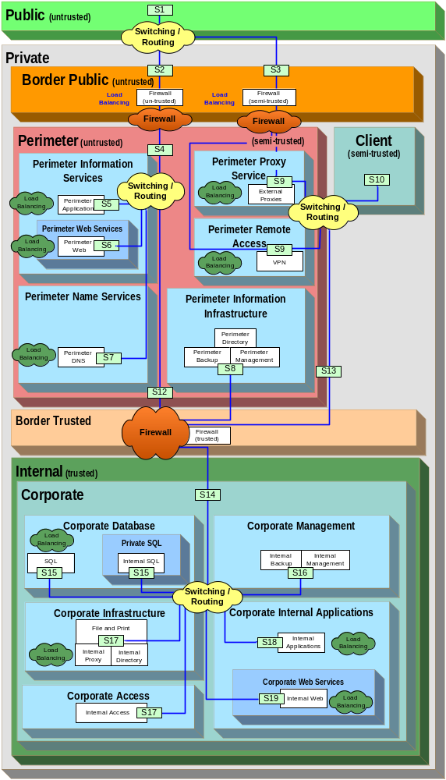
Figure 22. Zones, Tiers, Roles, and Segments for the MSA CDC Scenario
The reasons behind these design decisions are closely tied to the specific requirements of the particular scenario. To ensure that these reasons can be explained in the correct context, a detailed breakdown and explanation of the segments and the exact reasons for their creation is provided as a table in Appendix 1.3 in the “Introduction to MSA Planning Guide” chapter of the MSA Implementation Kit.
Assigning LAN Connectivity Devices
Having determined the network segments, the next step is to assign the segments to the network devices that would be capable of supporting the required roles between each segment. Up to this point in the design process, the references to network roles were as logical entities, which allowed the network designers to focus on the actual design requirements without having to figure out which physical device can (or cannot) support the role.
From this point on, the designers had to work with device specifications and manufacturers to determine which combination of physical devices would best serve the organization’s needs. To help in this process, the “Network Devices” chapter of the Services Blueprints guide provides a classification system for many network devices. This system allows a designer to reference a particular class of device without having to specify the particular model of device until the completed design is in place.
Grouping the Roles
So far the MSA CDC scenario design has identified the following roles in the network:
- Border Routing
- Perimeter Firewall services (untrusted)
- Perimeter Firewall services (semi-trusted)
- Perimeter Switching
- Perimeter Remote Access Load Balancing
- Perimeter Proxy Load Balancing
- Perimeter Application Tier Load Balancing
- Perimeter Web Tier Load Balancing
- Perimeter DNS Tier Load Balancing
- Client Switching
- Internal Firewall services (trusted)
- Internal Switching
- Corporate Proxy Tier Load Balancing
- Corporate Application Tier Load Balancing
- Corporate Web Tier Load Balancing
- Corporate Data Tier Load Balancing
Mapping the groups of similar network roles to various network devices consolidates the roles into a smaller list as follows:
- A border router device can provide for the Border Routing role.
- A switch placed in the perimeter can provide for the Perimeter Switching roles.
- An additional switch placed in the perimeter can provide for the Client Switching role; this role was not consolidated with the Perimeter Switching role due to the security requirement of separating untrusted and trusted network traffic. This switch could be considered a core access switch aggregating all client switching and routing.
- A switch placed in the internal zone can provide for the Internal and Corporate Switching roles.
- Bastion host servers could be used to provide for the necessary additional security requirements of physical separation between the zones and tiers to augment these devices.

Note: For information on mapping the groups of similar network roles to various network devices, refer to the “Network Devices” chapter of the Service Blueprints guide.

It was possible for the L3 switches that were being considered for the design to perform the roles of load balancer and firewall; therefore, the roles listing can be further consolidated to the following network devices:
- The border router would provide the Border Routing role.
- The perimeter switch would aggregate the following roles:
- Perimeter Switching
- Perimeter Remote Access Load Balancing
- Perimeter Proxy Load Balancing
- Perimeter Application Tier Load Balancing
- Perimeter Web Tier Load Balancing
- Perimeter DNS Tier Load Balancing
- The core switch would provide the Client Switching role because the traffic type is semi-trusted.
- The internal switch would aggregate the following roles:
- Internal Firewall services (trusted)
- Internal Switching
- Internal Proxy Load Balancing
- Corporate Proxy Tier Load Balancing
- Corporate Application Tier Load Balancing
- Corporate Web Tier Load Balancing
- Corporate Data Tier Load Balancing
- The Bastion host servers would provide the following roles because the security architecture requires physical device separation between the Border and Perimeter zones:
- Perimeter Firewall services (untrusted)
- Perimeter Firewall services (semi-trusted)
In the MSA CDC, the designers of the network architecture decided to use physically distributed devices for all network roles because such a design provided the required level of physical security as defined by the MSA security team. The scenario designers adopted the defense-in-depth strategy, which mandates that physical layers be provided between each of the connectivity roles identified for the design. To fulfill this requirement, the Border Routing role was assigned as a single specialized device, as were the other roles of Border Firewall services, Perimeter Switching and Routing, and Internal Switching and Routing.
Assigning WAN Connectivity Devices
The process of assigning WAN connectivity can be treated either as an extension to the overall network design or as a completely independent process that simply integrates into the overall design.
The MSA CDC design needed to support remote users, and the design team decided to use a leased line; its cost could be justified by the bandwidth requirements and the line's reliability.
Client Connectivity Method
The remote clients for the MSA CDC scenario are expected to use a variety of connection methods, including standard dial-up and DSL. All the connection types are made directly to an ISP, and a VPN connection is then used to connect securely to the company network. The main benefit of this approach is that it gives the MSA CDC clients the flexibility of using whatever connection method is most convenient for them without creating complexity in the network design.
Client Encryption Mechanism
The option of having clients connect to an ISP and then initiate a direct VPN connection to a termination point within the organization was selected by the designers of the CDC scenario. This choice was made so that the design could use the capabilities of Windows Server 2003 to gain maximum control over clients’ security through the use of VPN encryption, user groups in Active Directory, and through the VPN security schema. More detailed information on VPN is provided in the "Remote Access Services" chapter of the Service Blueprints guide in this documentation kit.
Designing an IP Addressing Scheme
The MSA CDC network designers selected IPv4 with a mix of public and private addressing.
The exact options selected for each network segment are provided in Appendix 1.4 in the “Introduction to MSA Planning Guide” chapter of the MSA Implementation Kit.
Selecting a Network Class and Subnets
In the MSA CDC design, a mix of classes was used for all private addressing: Class A was assigned to specific internal networks, Class B was assigned to the client network, and Class C was assigned to specific perimeter networks. Each private address class is compliant with RFC 1918.
Different classes were assigned to segments to make the different functions (perimeter, client, and internal) obvious and to ensure availability of an adequate number of host addresses.
Logical Design
At this point in the MSA CDC design process, a diagram was created to illustrate the complete logical network design. The following figure illustrates how the devices and concepts of design (covered in the “Architecture Design” section in this chapter) come together to provide the required functionality.
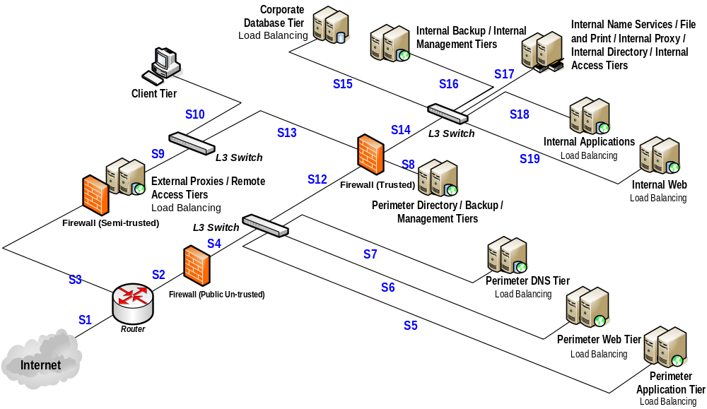
Figure 23. Logical Design for the MSA CDC Scenario
This figure represents the logical design of the MSA CDC network as it should look at this stage of the design process.
Security
This section provides information about the design decisions that were directly related to the MSA CDC security requirements.
Multihoming
It was decided to use multihoming for some key servers in the Perimeter zone in order to increase the security of the design.
The following table lists the servers that were multihomed in this design.

Servers | Why Was the Choice Made?
Firewall (public) | To provide separate network interfaces for applying security rules and routing.
Firewall (semi-trusted) | To provide separate network interfaces for applying security rules and routing.
Perimeter Proxy | To provide separate network interfaces for applying security rules and routing.
Perimeter Remote Access | To provide separate network interfaces for applying security rules and routing.
Perimeter Application | To provide separate network interfaces for applying security ACLs, to provide separation between perimeter and internal communications, and to allow the front interface to provide load balancing.
Perimeter Web | To provide separate network interfaces for applying security ACLs, to provide separation between perimeter and Internal communications, and to allow front interface for load balancing.
Perimeter DNS | To provide separate network interfaces for applying security ACLs, to provide separation between perimeter and Internal communications, and to allow front interface for load balancing.
Perimeter Management | To provide bastion host type security between the L3 front VLAN and the L2 management segment.
Internal Management | To provide bastion host type security between the L3 front VLAN and the L2 management segment.
Internal Data | For network performance, separating front and back end communications, and to allow the front interface to provide load balancing where necessary.
Table 16. Multihomed Computers in the MSA CDC Scenario
By allowing the servers to be directly attached to dual networks, internal filtering can be applied to restrict traffic forwarding. In fact, this was a key requirement for the servers performing a Perimeter Firewall network role.
The following table lists the remaining servers in the Perimeter zone that did not require multihoming.

Servers | Why Was the Choice Made?
Perimeter Directory and Backup | Service only requires one network interface and can be secured through VLAN or host-based ACLs.
Internal Deployment and Backup, and Storage Management
Internal Directory, DNS, WINS, MSP, Proxy, Certificate, Radius, File and Print
Table 17. Single-homed Servers in the MSA CDC Scenario
The MSA CDC security team determined that the potential security risk did not outweigh the added complexity and requirement of switch ports for multihoming these servers, primarily because of the other security policies that had been implemented.
Security Lockdowns
The various devices that make up the network infrastructure need to provide lockdown functionality because these devices control the flow of information within the organization and to the Internet.
Access Control Lists
Based on the information provided during the design process, it was determined that ACLs should be implemented at the network segment (VLAN) level as well as the individual host level. Although implementing ACLs only at the VLAN level eases administration and assists in troubleshooting for some shared segments, this option would have required the creation of individual VLANs for each host to achieve the same level of granularity. However, this option would significantly increase the number of VLANs that would be required and therefore the complexity of the whole network design.
The MSA CDC network design uses ACLs at the switch and router level as well as firewall rules to enforce traffic filtering. A detailed description of the ACL configuration as used in the MSA CDC scenario is provided in ConfigurationMatrix.xls, a file that is included in the Deployment Kit of the MSA Implementation Kit.
Network Authentication
The MSA CDC design does not use 802.1x wireless technology, which would have made the use of network authentication mandatory to maintain network security. The MSA CDC design used a number of mechanisms to maintain the security of the current wired infrastructure. It was decided by the MSA design team that the security benefits of using network authentication did not warrant the extra time and effort involved in implementing it; it was envisaged that a network authentication method could be implemented once a wireless element is added to the MSA infrastructure.
Network Encryption
The MSA CDC designers determined that all VPN traffic entering the network infrastructure should be encrypted with 3DES. The use of PPTP VPNs using 128-bit MPPE encryption was also evaluated, but the 3DES encryption mechanism provided the best encryption method available for IPSec and L2TP VPNs.
Manageability
The major design decision concerning manageability in the MSA CDC scenario's network architecture was how to handle the management traffic that would be required in the organization. The discussion of this issue focused on whether to use an integrated or dedicated management network.
The ultimate choice in the MSA CDC scenario was to use separate management switches to provide dedicated L2 segments for out-of-band management of network storage and computing devices. Management servers residing in the internal security zone have the authority to manage all internal hosts as well as perimeter management servers, and the perimeter management servers have the authority to manage perimeter hosts. Out-of-band management is provided by specific network adapter hardware in the servers. This design provided the most flexibility while still adhering to the security requirements of the organization.

SBO Design Considerations
This section provides a summary of the network architecture design process for the MSA Satellite Branch Office (SBO) scenario.
Architecture Design
The following sections illustrate how the process followed for the MSA SBO scenario. To obtain the complete picture of the design process, it is important to have an understanding of the documentation provided in the MSA 2.0 Planning Guide in the MSA Implementation Kit, specifically the “Introduction to MSA Planning Guide” and “Network Devices” chapters. The result of the design process in the case of the MSA SBO scenario was a fully functional environment that was planned, built, and tested in the MSA Test labs.
Technical Requirements
The MSA SBO network designers wanted to ensure that security mechanisms were implemented at appropriate layers of the technical architecture to minimize the risk of attack to its resources. The architecture blueprint must satisfy the following requirements:
- The SBO sites must take advantage of all services from the CDC site.
- No servers need to be deployed in the SBO site.
- The networking services do not need to be highly available.
- Network services must be secure end-to-end, including communications that traverse the Internet.
- All network communications that are not explicitly allowed must be denied.
- All services must use the CDC central authentication mechanism.
- SBO sites must be centrally managed by staff at the CDC site.
Desired Outcome
Contoso requires the final infrastructure to meet the technical requirements and adhere to the security policies presented in the “MSA Security Architecture” chapter of this guide.

Note: The examples provided in the remainder of this section are not intended to illustrate all Contoso needs but rather to provide examples that illustrate the points being addressed.

Having defined the technical requirements, the necessary inputs for the network architecture design were needed before the design could be implemented and tested.
Design Inputs
Before starting the design process, the MSA network designers had to gather information from the security team and the various application (or project) teams. The following section provides an example of this information for the SBO scenario.
Security Zone Definitions
The MSA security team defined the security zones and the permissible protocol traffic between them. The following figure illustrates the security zones that were defined for the SBO scenario.
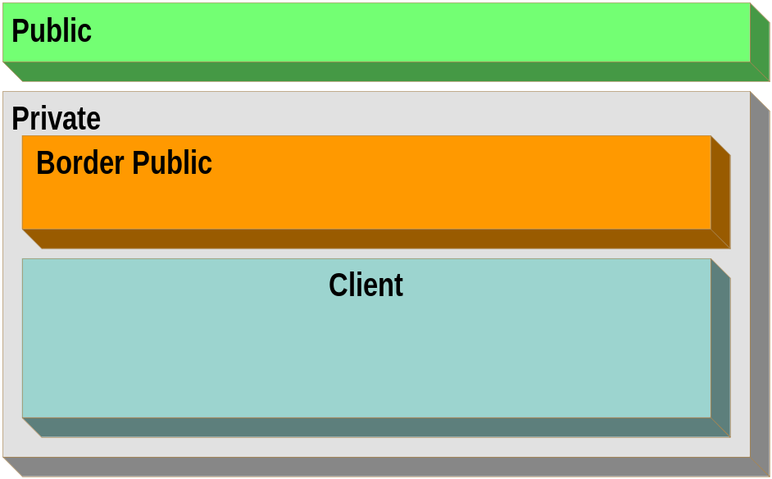
Figure 24. Security Zones for the MSA SBO Scenario
The process for defining these security zones is provided in the “MSA Security Architecture” chapter of this guide.
Tier Definitions and Required Tier Communications
The next phase in the design process is to define the network tiers and the network communications that are required by the services and applications planned for the infrastructure. The following table lists the tiers that were defined for the MSA SBO scenario.

Tier | Tier Description
Firewall (untrusted) | External interface on the border firewall between Public and the Border Public zones.
Firewall (untrusted) | Internal interface on the border firewall between Border Public and the Perimeter Information Services and Perimeter Name Services zone.
VPN | VPN services for site-to-site connections to the CDC.
Client | Client access devices.
Table 18. Tier Definition Summary for the MSA SBO Scenario
Once the tiers and zones have been identified, the security administrator can determine which tiers are members of which zones. The following figure illustrates the result of this exercise for the MSA SBO scenario.
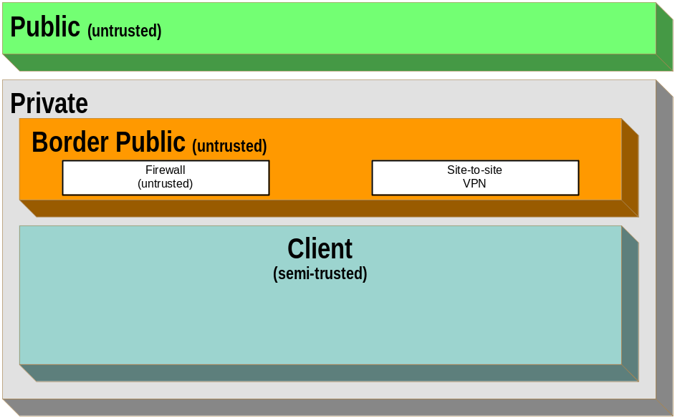
Figure 25. Tier and Zone Structure for the MSA SBO Scenario
Required Host Communication Performance and Availability
The MSA SBO site was designed to take advantage of all CDC services through a site-to-site VPN across a business-class DSL connection. A Cisco 1751 router with firewall and VPN functionality was selected for its reliability, although there was no requirement for high availability.
For more information on the site-to-site VPN connection, refer to the “Network Devices” and “Remote Access Services” chapters of the MSA 2.0 Planning Guide.
Defining the Network Roles
The MSA SBO design team matched a network role to each network segment. The roles provided the following classes of functions:
- Connectivity (switching and routing)
- Security (firewall services)
Using the MSA SBO scenario information, it was possible to identify requirements for other network roles. The following table lists these network roles for the MSA SBO network architecture.

Source | Destination | Network Role Required | Network Role ID | Reason
Public Zone | Private Zone | Routing and Switching | Border Routing | To provide connectivity between the two zones.
Private Zone | Client Zone | Firewall services | Perimeter Firewall services (semi-trusted) | To comply with enterprise security policy.
Table 19. SBO Network Roles
After defining the network roles, a logical diagram can be created. The following figure shows the logical diagram for the MSA SBO scenario.
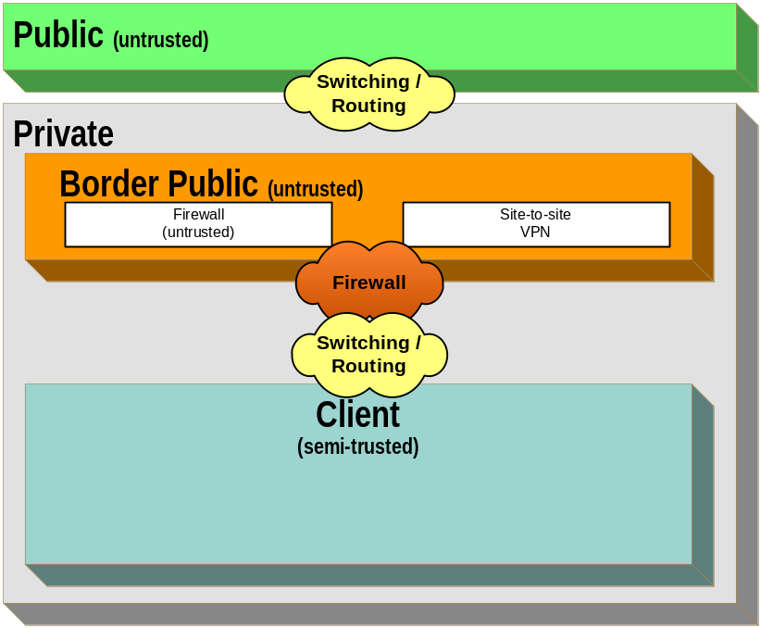
Figure 26. Network Roles for the MSA SBO Scenario
Defining Network Segments
Once the network roles were added to the design, the next step was to define the network segments that were needed to fulfill the needs of the identified security zones, tiers, and hosts. For the MSA SBO design only one VLAN was needed.
The reasons for these design decisions are closely tied to the specific requirements of the particular scenario. To ensure that these reasons can be explained in the correct context, a detailed breakdown and explanation of the segments and the exact reasons for their creation is provided as a table in Appendix 1.3 in the “Introduction to MSA Planning Guide” chapter in the MSA Implementation Kit.
Assigning LAN Connectivity Devices
Having determined the network segments, the next step was to assign the segments to the network devices that would be capable of supporting the required roles between each segment. Up to this point in the design process, the references to network roles were as logical entities, which allowed the network designers to focus on the actual design requirements without having to figure out which physical device can (or cannot) support the role.
From this point on, the designers had to work with device specifications and manufacturers to determine which combination of physical devices would best serve the organization’s needs. To help in this process, the “Network Devices” chapter of the Service Blueprints guide provides a classification system for many network devices. This system allows a designer to reference a particular class of devices without having to specify the particular model of a device until the completed design is in place.
Grouping the Roles
So far, the MSA SBO scenario design has identified the following roles in the network:
- Border Routing
- Border Firewall services (untrusted)
- Client Switching
It was possible for the Cisco 1751 router device that was being considered for the design to perform the roles of border router and firewall; therefore, the roles listing can be consolidated to the following network devices:
- The border router would provide the Border Routing and Firewall role.
- The separate client access switch would provide the Client Switching role.

Note: For information on mapping the groups of similar network roles to various network devices, refer to the “Network Devices” chapter of the Service Blueprints guide.

Logical Design
At this point in the MSA SBO design process, a diagram was created to illustrate the complete logical network design. The following figure illustrates how the devices and concepts of design (covered in the “Architecture Design” section in this chapter) provide the required functionality. This figure represents the logical design of the MSA SBO scenario.
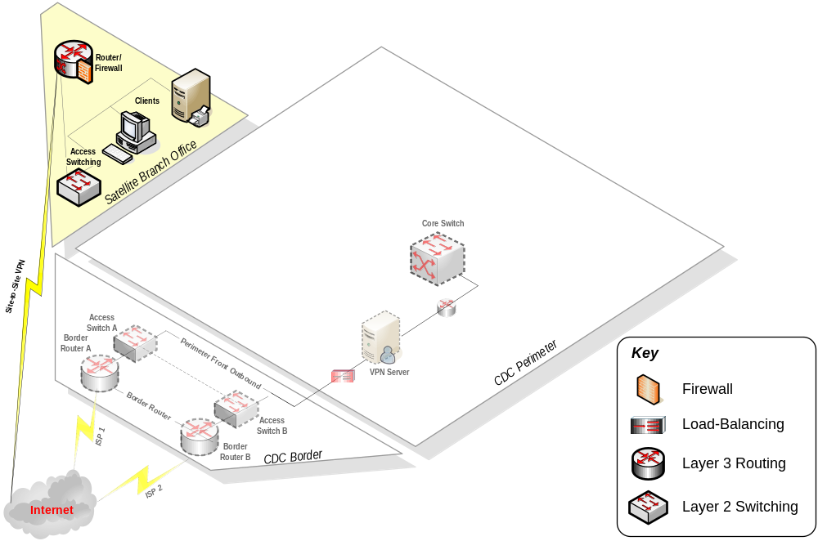
Figure 27. Logical Design for the MSA SBO Scenario
Security
For the SBO network security requirements, please refer to the “MSA Security Architecture” chapter of this guide and the “Remote Access” and “Network Devices” chapters of the MSA 2.0 Planning Guide.
Manageability
The major design decision concerning manageability in the MSA SBO scenario's network architecture was how to handle the management traffic that would be required in the organization.
The ultimate choice in the MSA SBO scenario was to centralize and aggregate all network management functions to the CDC network management system. Management servers residing in the CDC perimeter security zone have the authority to manage all SBO networks. This design provided the most flexibility while still adhering to the security requirements of the organization.

Summary
It is important to understand that there are many ways to design even the simplest of network architectures; it is not a precise art. The information presented in this chapter is designed to provide insights and examples to help you complete a network architecture design that fits your needs.
The introduction of the simple Wingtip Toys scenario provided fictional data to illustrate the process that was followed in the MSA 2.0 network architecture design; the entire process was then followed by the MSA design team to develop the CDC and SBO scenarios in the MSA Test labs. The design processes are documented in the "CDC Network Architecture Design" and “SBO Network Architecture Design” sections of this chapter, which also discuss the detailed design decisions by including samples of the data generated in the actual CDC and SBO design processes. All data generated by the design team is provided in the MSA Implementation Kit; the reason for this separation is that this data will usually be unique to each instantiation and therefore only relevant in the context of a specific implementation.
The design is based on a combination of the specific requirements, environment, budgets, and preferences of the organization’s design team. There is no single "right" answer, only one that meets an organization’s requirements in a timely and affordable manner.
Once the architectural design is in place, there are many device-specific factors that can affect the selection of physical devices to fulfill the network architecture requirements. These factors and the corresponding design decisions are covered in detail in the "Network Devices," "Firewall Services," and "Remote Access Services" chapters of the MSA 2.0 Planning Guide in the MSA Implementation Kit for the design that was implemented in the MSA Test labs.

