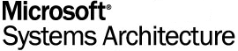
Version 2.0

Chapter 6
MSA Security Architecture
Architecture Blueprints
MSA Reference Architecture Kit

Microsoft Confidential. © 2003 Microsoft Corporation. All rights reserved. These materials are confidential to and maintained as a trade secret by Microsoft Corporation. Information in these materials is restricted to Microsoft authorized recipients only. Any use, distribution or public discussion of, and any feedback to, these materials is subject to the terms of the attached license. By providing any feedback on these materials to Microsoft, you agree to the terms of that license. If the license agreement has been removed, review the terms at http://www.microsoft.com/licensing/specs/agrmt02.asp before using these materials.

Abstract
This chapter of the Microsoft® Systems Architecture (MSA) version 2.0 Architecture Blueprints guide discusses the security architecture for an enterprise organization. The chapter outlines the business requirements, vulnerability assessment processes, and architectural considerations for the design and deployment of a secure enterprise infrastructure to support the services detailed in the MSA 2.0 guidance.

Information in this document, including URL and other Internet Web site references, is subject to change without notice. The entire risk of the use or the results of the use of this document remains with the user.
Unless otherwise noted, the example companies, organizations, products, domain names, email addresses, logos, people, places and events depicted herein are fictitious, and no association with any real company, organization, product, domain name, email address, logo, person, place or event is intended or should be inferred.
This is a preliminary document and may be changed substantially prior to final commercial release.
This document is provided for informational purposes only and Microsoft makes no warranties, either express or implied, in this document. Information in this document, including URL and other Internet Web site references, is subject to change without notice. The entire risk of the use or the results of the use of this document remains with the user.
© 2003 Microsoft Corporation. All rights reserved.
Microsoft, Active Directory, Microsoft Press, MSDN, and Windows are either registered trademarks or trademarks of Microsoft Corporation in the United States and/or other countries.
The names of actual companies and products mentioned herein may be the trademarks of their respective owners.
Microsoft Corporation • One Microsoft Way • Redmond, WA 98052-6399 • USA 00

Table of Contents
Introduction 1
Who Should Read This Chapter 1
MSA Enterprise Design 2
Business Need 2
Architecture Definition 3
Assets Defined 3
Data Assets 3
Tier Assets 4
People 4
Process 5
Asset Assessment and Valuation 5
Security Risk Identification 7
Security Risk Analysis 13
Security Risk Remediation and Development 14
Technology 17
Architecture Design 19
Design Example: Wingtip Toys 19
Business Need 19
Technical Requirements 20
Desired Outcome 20
Process 20
Asset Assessment and Valuation 20
Security Risk Identification 24
Security Risk Analysis 28
Security Risk Remediation and Development 29
Technology 38
Manageability 39
Role-based Administration 40
System Administration 41
Performance 42
Supportability 42
Consolidation 42
Interoperability 43
Standards and Guidelines 43
CDC Design Considerations 44
Architecture Design 44
Technical Requirements 44
Desired Outcome 44
Process 45
Asset Assessment and Valuation 45
Security Risk Identification 51
Security Zone Definitions and Restrictions 52
Services Worksheet—Service Consumer Information 63
VLAN Segmentation Matrix 67
Network Security Matrix 69
Industry Standard Security and Network Settings 72
SBO Design Considerations 73
Architecture Design 73
Technical Requirements 73
Desired Outcome 73
Process 73
Asset Assessment and Valuation 74
Security Risk Identification 75
Security Zone Definitions and Restrictions 75
VLAN Segmentation and Security Matrix 78
Industry Standard Security and Network Settings 79
Summary 80
References 81

Introduction
There are five defined solution architectures in Microsoft® Systems Architecture (MSA) 2.0. These architectures are:
- Network
- Storage
- Application Infrastructure
- Management
- Security
This chapter of the Architecture Blueprints guide discusses the security architecture, which outlines the business requirements, vulnerability assessment processes, and architectural considerations for the design and deployment of a secure enterprise infrastructure to support the services detailed in the MSA 2.0 guidance.
The sections in this chapter provide different levels of guidance. At the enterprise level, the guidance deals with the entire organization’s architecture. This guidance is an appropriate starting point because it addresses the most far-reaching planning issues encountered by enterprise architects. The subsequent sections provide guidance that is specific to each of the MSA 2.0 scenarios. These scenarios are outlined in the MSA—A Program Overview document, and a further level of detail is provided in the "Introduction to MSA Architecture Blueprints" chapter of this guide.
Who Should Read This Chapter
This chapter is written for enterprise architects working in the area of infrastructure and system security. Other audiences may find the guide useful in understanding the scope, capabilities, and impact of an enterprise-class security architecture.
MSA Enterprise Design
The security considerations facing enterprise organizations and their IT (information technology) systems are considerable, with many design issues to be studied and resolved. In order to address security design issues appropriately, however, security architecture must first be looked at from a business need perspective.
Business Need
Business is becoming increasingly Internet-enabled. As the number of organizations doing business electronically increases, information becomes more readily accessible both lawfully and (potentially) unlawfully. The growth in business-to-business (B2B) e-commerce has escalated the need for protection of information assets. The increasing dependence on information systems and services makes organizations more vulnerable to external security threats. In addition, the current trend of distributed computing has diluted the effectiveness of centralized data protection and control. The complex interconnections between public and private networks and the global allocation and delivery of information resources only add to the difficulties. Even though much has been done to ensure the security of systems and the data they contain, the number of attacks aimed at compromising information technology (IT) systems and data has grown exponentially in recent years.
The objective of IT security is to protect valuable or sensitive information while making it readily available to authorized users. Attacks on IT systems and data are usually attempts to compromise the systems, steal or alter information, or impede an organization’s ability to do business by hindering its infrastructure in some way. Potential consequences of poor security include:
- Deletion or alteration of information: An attacker might delete an organization’s customer files or deface its Web site.
- Information theft or fraud: An attacker might steal credit card details, personnel records, or other unique information to impersonate someone or otherwise defraud the information’s rightful owner.
- Disruption of normal business operations: An attacker can launch a denial-of-service attack, making it nearly impossible for legitimate users to access an organization’s Web site or computer systems.
- Damage to reputation: An attacker could use an organization’s computer systems to launch an attack on other sites, potentially labeling the owner of the first system as an “offender.”
Technologies and intelligence in the area of security are evolving continuously, but so are the vulnerabilities and threats that organizations face. This chapter provides guidance for each of the MSA 2.0 scenarios; even though the guidance might not fit your organization’s situation exactly, it is presented in a form that will allow you to tailor the information to meet your specific business requirements.
Architecture Definition
An enterprise-class infrastructure should conform to the appropriate standards; prevalent standards in the field of security are British Standard 7799 and its successor, the International Organization for Standardization (ISO) Standard 17799. Organizations typically create enterprise security policies to conform to such standards. Enterprise security policy is used to specify the necessary requirements for people, processes, and technologies to ensure that organizational information assets are used appropriately and by authorized individuals only.
People, processes, and technologies are interdependent, and the potential for a security breach increases with a deficiency in any of these elements. For more information on writing comprehensive enterprise security policies, refer to the "Application Security Best Practices at Microsoft" document at the following Web site:
www.microsoft.com/technet/itsolutions/msit/security/appsecbp.asp
Before considering how security operates in terms of people, process, and technology, it is important to define the assets that security architecture is designed to protect.
Assets Defined
Security architectures are designed to protect the assets of an organization, where assets are defined as resources that provide value to the organization. While there are many types of assets, this chapter focuses on only two types of IT assets: data and tiers.
Data Assets
Data, or information, is the heart of an organization, and it must be protected from internal and external threats. Security architecture is designed to protect the confidentiality, integrity, and availability of information.
- Confidentiality: An organization may have information that requires protection from unauthorized disclosure, such as personal information or proprietary business information. Confidentiality ensures that such information is accessible only to authorized users by enforcing the necessary level of secrecy at each stage of data processing and preventing unauthorized disclosure. A consistent level of confidentiality should be maintained while data resides on the system, on the tiers within the network as it is transmitted, and once it reaches its destination.
- Integrity: An organization may have information that must be protected from unauthorized, unanticipated, or unintentional modification, such as census information, economic indicators, and financial transaction data. Integrity is ensured by safeguarding the accuracy and completeness of information and processing methods so that unauthorized modification of data is prevented.
- Availability: An organization may provide services or have information that must be available on a timely basis to meet mission-critical requirements or to avoid substantial losses. Examples include safety systems, life support systems, and consistent network connectivity services. Availability ensures reliable and timely access to data and resources for authorized individuals.
Tier Assets
A tier is defined as a logical entity comprised of one or more hosts or devices that provide similar functionality and which may be addressed as a single host by other hosts, devices, and users. Host and device are defined as follows:
- Host: A multi-purpose computing device that runs an operating system and, typically, applications. Hosts are usually referred to as workstations or servers.
- Device: A computing device that is configured and optimized to perform a single or limited number of function(s). Devices run an operating system, but typically do not run applications. A good example of a device is a managed network switch or router.
For example, a tier could be a single host serving a Web site called www.wingtiptoys.com, or it could consist of multiple clustered hosts serving the same Web site. This concept is illustrated in the following figure.
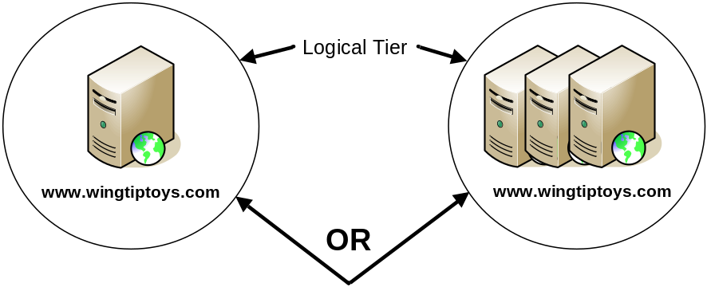
Figure 1. Single or Multiple Hosts in a Tier
In the figure, the single Web server with the IP address 208.217.184.180 and the grouping of Web servers with IP address 208.217.184.180 are both defined as tiers. However, a tier does not always equate to one IP address; it may answer to many IP addresses. A tier may be any number of hosts, not just one or three as in the example. In fact, a tier may not consist of hosts at all; it might instead consist only of devices. An illustration of this concept appears later in this chapter in a discussion on port filtering devices used as a remediation mechanism for specific risks, where traffic rules are illustrated at a tier level rather than a host or device level.

Note: Tier is used in place of host or device, unless one of these terms is specifically being referred to, in the remainder of this chapter.

People
Security is the responsibility of every person in the organization, although the organization must first define its security policies and how they apply to individuals. Users of the system then need to adhere to the security policies so that they do not breach the protection that has been put in place. People-related security principles include:
- The security administration personnel must be able to write effective policies that protect the organization’s data.
- Administrators who carry out the day-to-day IT administration tasks such as managing the hosts that contain protected data must be knowledgeable about how to protect the systems.
- People in the organization who use the organization’s data must be knowledgeable about the organization’s security policies and responsible for their own applications. In addition, users must be aware of changes in policies and be held accountable for abiding by the enterprise security policies.
- Appropriate mechanisms should be in place to ensure that internal staff and other application users have access only to the data they need and are authorized to access.
- Administrators must have the ability to audit and log information access to enable accurate validation of security policy adherence.
Process
The MSA team recommends and has used the Security Risk Management Discipline (SRMD) provided in Chapter 3 of the Securing Microsoft Windows 2000 Server solution guide. The following four steps (out of the nine steps identified in SRMD) apply directly to the security architecture planning process used in MSA 2.0:
- Asset Assessment and Valuation
- Security Risk Identification
- Security Risk Analysis
- Security Risk Remediation and Development
The following sections give a description of these steps, along with their inputs and outputs.
Asset Assessment and Valuation
The purpose of the Asset Assessment and Valuation step is to identify the assets in the organization that, if misused, could adversely affect the business.
Inputs
Primarily, this step consists of activities that perform the following services:
Asset Identification
Identifying assets can be very easy or very difficult, depending on the procurement processes followed and the asset tracking mechanisms used in the organization.
The first step in identifying assets is to classify the types of data maintained in the organization. For example, hardware devices often contain the configuration data of the device only, which has only a certain amount of value. Hosts and devices typically contain similar information in addition to data about customers and employees, which obviously has a different level of value altogether.
Assets also include trade secrets, intellectual property, and patents, all of which could significantly affect an organization’s worth if compromised.
Asset Valuation
Once assets have been identified, it is important to determine each asset’s value or monetary worth in the following terms:
- Physical Value: An asset's physical value is determined by defining:
- Hardware costs
- Software costs
- Support costs
- Replacement costs
- Business Value: The business value of data may be based on the data’s contribution to the overall financial goals of the organization or the value of the data to an external person or organization. Generally, this value is very difficult to quantify. The value should provide, in relative terms, the effect of loss of the data as compared to the loss of other assets. Often, the value of the data far surpasses the value of the hardware on which it is stored. In addition, this value may include the cost of replacing or repairing the damage caused by the loss of the asset.
- Indirect Value: This value may be the most difficult to quantify. It is the value that the organization stands to lose through negative publicity, lawsuits, or loss of business if the asset is lost or compromised. An example of this is when an organization’s reputation or brand is discredited through malicious public exposure of customer private data.
- Competitive Value: This is the value of the data to a competitor and is also difficult to quantify. It should reflect the monetary value that an external agent would be willing to pay for the actual data contained in the asset.
Asset value is a monetary figure used to compute loss expectancies for an asset. It is the sum of the above four values.
Asset Prioritization
Identifying assets is a qualitative process. The overall benefits to the business goals of the organization should be kept in mind when determining the potential value of the assets in each tier, which helps define an asset priority (AP) for each tier and data type so that efforts can be focused on the highest priority items first. Primary factors to consider include:
- Financial value of the asset.
- Cost to build the asset.
- Cost to protect the asset.
- Cost to support the asset.
- Cost to recover the asset.
- Value of the asset to competition.
Outputs
The outputs of the Asset Assessment and Valuation step are:
- Data Classification List: A listing of different classifications of data that will be contained in tiers within an organization.
- Tier Identification List: A listing of the different tiers identified for deployment.
- Asset Valuation List: A listing of value of assets to the organization computed using multiple metrics.
- Asset Prioritization List: A listing of the prioritized assets in the organization. Once assets have been identified, valued, and prioritized based on the importance of the assets to the organization, risks to those assets need to be identified.
Security Risk Identification
The purpose of the Security Risk Identification step is to identify the assets in the organization that may be compromised, the threats that exist to these assets, the likelihood of the threat damaging the asset, and the effect of damage to the asset. The following terms are used in this step:
- Threat: A potential danger, normally a person, thing, or event, that may compromise an asset.
- Threat Agent: The form of the threat, such as a hacker, intruder, or natural event like a hurricane.
- Vulnerability: The software, hardware, or procedural weaknesses that are potential points of attack by the threat, including the probability of the attack being successful.
- Exploit: The method used by a threat agent to expose vulnerability.
- Risk: A quantifiable representation of a combination of asset, threat, vulnerability, and exploit. It is the impact that the combination could potentially have on the organization.
Inputs
The inputs for the Security Risk Identification step include gathering available knowledge of threats, creating a list of current exploit methods and techniques, and analyzing system and policy vulnerabilities that could be exploited to cause harm to the organization’s assets. The following activities are performed as part of this step.
Threat Analysis
Systems administrators usually identify threats to their respective systems, which helps security administrators identify various vulnerabilities that may be exploited in an attack. It is important that administrators update their knowledge in this area on a continual basis, because potential attackers are always devising newer methods, tools, and techniques for circumventing security.
Vulnerability Assessment
When determining its security needs, an organization must assess its vulnerabilities in relation to known threats. This assessment entails identification of different types of assets as well as the potential damage to them.
- Determining Possible Damage from an Attack: Possible damage to assets in your organization can range from minor host or device malfunctions to catastrophic data loss. If possible, use a test or lab environment to assess the potential damage that might result from different types of attacks because not all attacks cause the same type or amount of damage. This assessment also tests the security policies and procedures to help determine their strengths and weaknesses. These tests include:
- A simulation of an e-mail virus attack in a lab system followed by an analysis to determine the damage caused and potential recovery procedures required.
- A test to determine whether employees are susceptible to attackers who attempt to acquire a user name and password from an unsuspecting employee.
- A drill or simulation of a data center disaster to measure the loss of production time and the time needed to recover.
- A simulation of a specific malicious attack to measure the time required to recover a computer. This time factor can then be multiplied by the number of computers infected in the system to ascertain the amount of downtime or loss of productivity.
- Determining Vulnerabilities to Attacks: If vulnerabilities to a specific attack are discovered, current security policies and controls can be altered or new ones implemented to minimize them. Penetration tests can help determine existing vulnerabilities that are specific to certain types of attacks, threats, and methods.
Security Risk Statement Qualification
A security risk statement is an expression of the relationship between the existing security state of the organization and consequences of a potential but unrealized security threat. The first part of the security risk statement is called "the condition," which provides the description of an existing state or potential threat that may cause some harm. The second part of the risk statement is called the "consequence," which describes an undesirable loss of confidentiality, integrity, and availability to an asset as defined in the "Business Need" section.
The following steps are involved in qualifying risk statements:
- Define Risk Statements: When making security risk statements, each possibility should be addressed separately and specific consequences of each risk should be described. If there are multiple consequences, the risk statement may be too broad and require further refining. Each risk statement must have a condition that leads to a consequence. The security risk statement should be in the following form:
IF a Threat Agent uses a tool, technique, or method to exploit Vulnerability, THEN a loss of (confidentiality, integrity, existence, or availability) to an Asset may result in an impact.
- Determine Layer Applicability: Risks can apply to one or more “layers” of the IT environment, as shown in the following figure.
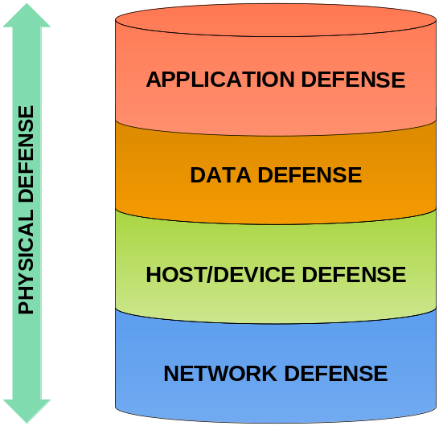
Figure 2. Security Defense Layers
These layers can be defined in whatever way makes sense for the organization.
For purposes of this discussion, the risks and layers in the figure are defined as follows:
- Physical: Risks at the physical layer arise from an attacker having physical access to the asset. The primary concerns at this layer are that the attacker may physically damage or steal the asset and the value it contains.
- Network: Risks at the network layer arise from an attacker having access to local and wide area networks and the tiers connected by them. The primary risks at this layer revolve around the available TCP/UDP ports throughout the network.
- Host/Device: This is the layer for which vendors typically package their service packs and hotfixes. Risks at this layer arise from attackers gaining access by listening to TCP/UDP ports, where they can execute a variety of attacks against the systems software running on the layer itself (buffer overflows, for example). The primary concerns at this layer are access to the binaries that comprise the operating system or access to the host through vulnerabilities in the operating system's listening services.
- Data: Risks at the data layer arise from an attacker gaining access to configuration data, organization data, or any data that is unique to the device or the organization. For example, binary files of the operating system are not considered data but the contents of a registry in a server running Microsoft Windows® Server 2003 are considered data because it contains unique information about the server. The primary concerns at this layer are access to tier-based data; such access might be facilitated by vulnerabilities present in the host/device or application layers.
- Application: Risks at the application layer arise from an attacker gaining access to running applications, which are defined as any executable code packaged outside of an operating system. They may be commercial off-the-shelf (COTS) applications such as e-mail or Web server applications, applications developed in house, Trojan programs, or spyware. The primary concerns at this layer are access to the binaries that comprise the application, access to the host through vulnerabilities in the application's listening services, or the inappropriate gathering of specific data from the system to pass on to someone who can use it for their own purposes.
- Determine Criticality Factors: The criticality factor (CF) is a measure of the damage that a particular attack can cause to an asset by exploiting the vulnerability in question. A particular vulnerability may have several different exploits that could be used to attack the asset, and each exploit may have different effects on the target computer. Therefore, this may require some research to evaluate the potential exploits for each of the vulnerabilities. The criticality factor should be measured on a scale of 1 to 10, where 1 indicates very little impact from an exploit and 10 indicates a large amount of irrevocable damage to an asset from an exploit.
- Determine Effort to Exploit Identified Vulnerabilities: The effort (E) is the amount of work, knowledge, or experience that an attacker would need to make use of a particular exploit. The level of effort to make use of a specific exploit should be measured by the simplicity of the attack. There is a wide variety of malicious attackers, ranging from “script kiddies” who have little knowledge about how or why attacks work (but who know what tools can help them gain information) to serious hackers who have a deep technical understanding of security issues and can overcome the security measures of computer systems to gain unauthorized access. The effort of a specific exploit should be measured on the same scale as the criticality factor, which is 1 to 10 (where 1 indicates that very little skill is required to use a particular exploit and 10 indicates that the skills of a seasoned security programmer would be required).
- Determine Vulnerability Factors: The vulnerability factor (VF) is the measure of susceptibility to a particular form of attack. The vulnerability factor of an asset should also be measured on the 1 to 10 scale, where 1 indicates that a particular asset is not susceptible to the vulnerability and 10 indicates that the asset is extremely susceptible to the vulnerability.
Security Risk Statement Quantification
Security risk statement quantification is a process by which a more precise expression of a risk statement can be made in order to facilitate the prioritization of risks to assets. This process is illustrated in the following figure.
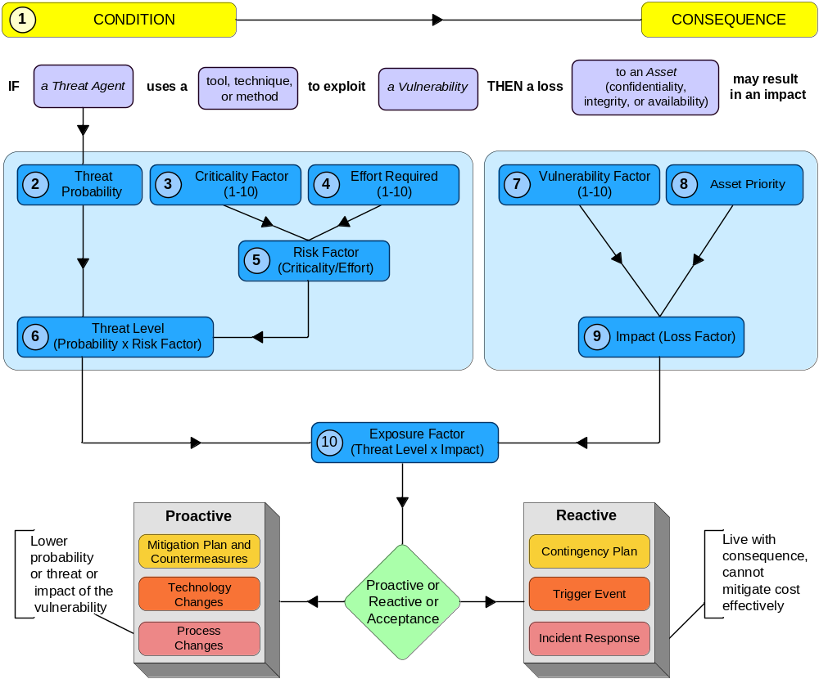
Figure 3. Risk Statement Quantification Process
The following steps provide details for each part of the process illustrated in the preceding figure:
- Start with a risk statement defined as a part of the Risk Statement Qualification explained earlier.
- Using the Threat Analysis process detailed previously, assign a threat probability (TP) to the threat using a 0—100 scale (0 percent lowest—100 percent highest). The threat probability is the probability of a possible threat agent entering your environment.
- Assign a criticality factor (CF) using a 1—10 scale (1 lowest—10 highest). The criticality factor is the level of potential exploit of the threat to an asset.
- Rank the effort (E) using a 1—10 scale (1 lowest—10 highest). The effort is the amount of expertise required for an attacker to make use of a particular exploit.
- Determine the risk factor (RF). This is the criticality factor divided by the effort.
- Determine the threat frequency level using the formula (TP × RF).
- Rank the vulnerability factor (VF) using a 1—10 scale (1 lowest—10 highest). The vulnerability factor (VF) is a measure of susceptibility to a particular form of attack.
- Identify the asset priority (AP) as defined in the Asset Assessment and Valuation step of the SRMD process.
- Determine the impact factor (IF) using the formula (VF × AP).
- Determine the exposure factor (EF) using the formula (Threat Frequency Level × Impact Factor divided by 1,000). The exposure factor is expressed as a percentage.
Though this is a tedious process, it should ideally be completed for each asset at each of the layers defined previously. This information enables an organization to prioritize the risks it wants to mitigate.
Outputs
The outputs of the Security Risk Identification step are:
Known Threats and Exploits List
The known threats and exploits list needs to be updated over time. New threats and exploits should be added and old ones deleted as they lose applicability.
Vulnerability Assessment List
The vulnerability assessment list needs to be updated over time. New vulnerabilities need to be added and the old ones removed as they are mitigated with improved security features and updated software or firmware.
Risk Assessment Sheets
For each identified risk, create a separate risk assessment sheet that contains the following details:
- Risk Statement
- Layer Applicability
- Criticality Factor
- Effort
- Vulnerability Factor
Risk Assessment Summary
The output of the Security Risk Identification step is a clear and explicit statement of the security risks, documented as the security issues list. It is recommended that the Risk Assessment Summary be maintained in a tabular form for each layer to provide easy viewing of the relevant information. It includes:
- Threat
- Threat Probability (TP)
- Exploit
- Criticality Factor (CF)
- Vulnerability
- Vulnerability Factor (VF)
- Asset
- Asset Priority (AP)
The Risk Assessment Summary is the main input for the next step of the SRMD process.
Security Risk Analysis
Once the risks in the organization are defined, they are analyzed to determine which assets should be secured against which threats.
Inputs
The inputs for the Security Risk Analysis step are:
Security Risk Probability
This input is the probability that the situation described in the risk condition portion of the security risk statement will actually occur. A risk statement may include factors outside the scope of your organization as defined in the first half of the security risk statement:
"IF a Threat Agent uses a tool, technique, or method to exploit Vulnerability…"
This is the condition part of the risk statement. Certain types of threats may not exploit known vulnerabilities, especially when the threat is a natural disaster.
The use of a numerical value is desirable for ranking risks, as it provides a method to consistently communicate the risk. If the security risk probability is zero, then the threat does not pose a security risk. If the probability is 100 percent, then the security risk is a certainty and may be a known issue.
Probabilities are notoriously difficult to estimate and apply. Industry or enterprise risk databases may be helpful in providing known probability estimates based on samples of large numbers of projects.
Security Risk Impact
Security risk impact is an estimate of the severity of loss due to the adverse effects on the assets or the magnitude of a loss resulting from an asset losing confidentiality, integrity, or availability. It should be a direct measure of the security consequence as defined in the second half of the security risk statement:
"…THEN a loss of (confidentiality, integrity, or availability) to an Asset may result in an impact."
Loss of an asset may be measured either in financial terms or on a subjective measurement scale. If the security risk impact is expressed in financial terms, the use of this value to quantify the magnitude of loss or opportunity cost has the advantage of being familiar to business sponsors. The financial impact might be long term costs in operations and support or loss of market share, or it may be short term costs in additional work or opportunity cost. In other situations, a subjective scale from 1 to 10 is more appropriate for measuring security risk impact.
Security Risk Exposure
Security risk exposure is a single numeric estimate that measures the overall security risk to the assets, including information expressing the likelihood of actual loss and magnitude of the potential loss. The security team uses the magnitude of risk exposure to rank security issues. In the simplest form of quantitative risk analysis, risk exposure is calculated by multiplying risk probability and risk impact.
Outputs
Security risk analysis provides a prioritized security action list to guide your team in security risk planning activities. Detailed security risk information—including conditions, context, root causes, and the metrics used for prioritization (probability, impact, and exposure)—are often recorded for each risk in the form of a risk statement, which is described in detail later in this chapter.
Master Security Risk Prioritization List
The Master Security Risk Prioritization list is a compilation of all the security risk assessment information. It is a living document that forms the basis for the ongoing security risk management process and should be kept up-to-date throughout the IT life cycle phases of planning, building, deploying, and operating. This list and the Risk Assessment Summary (completed in the previous step) are the fundamental documents that support proactive or reactive risk management. These documents help security decision making by providing a basis for:
- Prioritizing efforts
- Identifying critical actions
- Highlighting dependencies
The Master Security Risk Prioritization list is the basic input for the next step in the process.
Security Risk Remediation and Development
Development of countermeasures and operational procedures is essential to the security strategy of your organization. Security risks can be proactively managed, either through a technology hardening process or by developing organization-wide policies.
The security strategy development process also includes development of systems, policies, and procedures for tracking and reporting unrealized security risks. These mechanisms help ensure that the preventive measures in the technology infrastructure are working and the new policies and procedures are effective.
The remediation development process documents the necessary architectural design policies that the implementation of different services must adhere to within the organization.
Inputs
The principal input to the Security Risk Remediation and Development step is each layer’s Security Risk Prioritization list created in the previous step. From this list, specific security mitigation plans are developed and implemented in the design and implementation of different services within the organization. Remediation development also requires that systems and processes be developed to monitor the triggers identified for executing the contingency plans.
Outputs
The outputs of the Security Risk Remediation and Development step are as follows.
Security Risk Mitigation Strategy Lists
The main output of this step is the remediation plan for each identified risk at each layer and for every asset. The remediation plan and the prioritized risks enable the organization to make smart decisions on which risks it wants to mitigate, when it wants to mitigate them, and how it will mitigate them. Most organizations do not mitigate every risk present in the environment for reasons such as:
- It costs money to implement additional products that need to be purchased.
- Manageability of an asset may become more complex. For example, if multiple mitigation strategies at multiple layers are implemented to protect an asset, the number of people needed in the organization to maintain the different settings in the respective technologies is likely to be higher, which would increase the possibility for human error and potentially increase the points of inconsistency in the steps and processes (lockdowns) needed to secure the asset.
- The usability of an asset decreases. Typically, the greater the number of lockdowns or processes implemented to secure an asset, the more complex and restrictive the asset is to use.

Note: Although an identified risk may have remediation plans for every layer, it is important to identify whether the remediation plan needs to be implemented at every layer. Some organizations implement remediation plans at one layer only, while others implement remediation plans at several or all layers. Implementing remediation plans at multiple layers to mitigate the same risk is typically referred to as the defense-in-depth strategy, which is explained in the next section.

Security Zone Definitions and Restrictions
Creation of security zones can help an organization implement mitigation strategies. Many organizations have a default set of security guidelines that they follow based on historical data of the organization or the industry as a whole. For example, almost every organization uses a firewall to prevent unauthorized access to servers behind the firewall by applying network traffic flow security rule sets. While a firewall can mitigate many defined security risks, organizations often do not go through the SRMD process to determine that they need one; it is just a generally accepted security design practice. Defining security zones can allow an organization to create default security restrictions/practices in the organization. Then, if it chooses to do so, it may go through the SRMD process for each risk identified. On the other hand, it may simply determine which pre-existing security zone would be appropriate for new application functionality (whether on an existing tier or a new tier), or go through the SRMD process and create a new security zone to address newly identified risks.
A security zone is a logical entity containing one or more tiers. A zone can contain other security zones, be a member of other security zones, or span other security zones. The purpose of a security zone is to provide a logical container so that policies for mitigation strategies can be defined and applied to the following areas:
- Tier restrictions within a zone
- Intra-zone communications
- Inter-zone tier communications
The definition of zones and tiers is typically a collaborative process in most organizations. Often new zones and tiers are created when additional applications or services are introduced into the environment. When this happens, the service administrator typically works with the security administrator to determine whether the new application or service will run on an existing tier. If it will, there is a potential for the tier restrictions and intra-zone and inter-zone tier communications to be modified. If it will run on a new tier, then the security administrator will determine if the tier can be placed in an existing security zone or if a new security zone needs to be created.
The security administrator typically works on these areas of the SRMD process with the service administrator to determine the unique vulnerabilities that are applicable and how they should be mitigated.
- Security Zone Definitions: Organizations can use the security zone concept to define mitigation strategies and policy, beginning with at least one security zone definition to contain assets that the organization controls. Organizations connected to the Internet have at least two security zones, as depicted in the following figure:
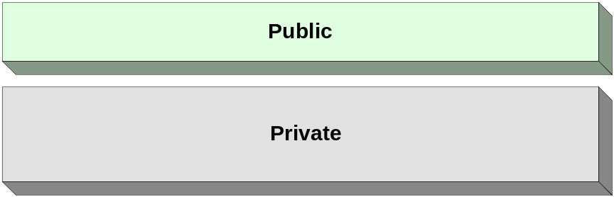
Figure 4. Minimum Security Zones
- Private: Contains assets controlled by the organization.
- Public: Contains assets not owned or managed by the organization.
Further zone definition is based on the needs of the organization.
- Security Zone Restrictions: Some common inter-zone restrictions are provided in the following table.

Source Zone | Destination Zone | Restrictions
Public | Private | A device that performs stateful packet inspection exists at the network layer between these two zones.
Public | Private | Only port 80 and 443 traffic is allowed to pass through the device that performs stateful packet inspection.
Public | N/A | If users send authentication credentials to any of the tiers in this zone, the tier must have an encrypted channel for sending/receiving the credentials.
Table 1. Common Zone Restrictions
Defense-in-Depth Strategy
Defense-in-depth is a multilayered approach that applies multiple strategies to protect resources from external and internal threats. Sometimes referred to as security-in-depth or multilayered security, defense-in-depth is a term used to describe the layering of security countermeasures to form a cohesive security environment. The deployment of a defense-in-depth strategy includes protective measures all the way from your external routers through to the location of your resources and at all points in between.
Deploying multiple layers of security helps ensure that if one layer is compromised, the other layers will provide the security needed to protect your resources. For example, compromising an organization’s firewall should not provide an attacker unfettered access to the organization’s most sensitive data. Ideally, each layer should provide different forms of countermeasures to prevent the same exploit method from being used at multiple layers.
Advantages of implementing defense-in-depth include:
- Protection of assets in the event of failure of prior layers. Prior layers may fail for multiple reasons, such as:
- The hosts or devices protecting the different layers are configured incorrectly, exposing security vulnerabilities.
- The software protecting the layer has an exploitable vulnerability.
- Multiple people typically administer the mechanisms for protecting different layers and there may be miscommunication between them.
Disadvantages of implementing defense-in-depth include:
- Potential for error: Suppose a network administrator implements a firewall to deny port access to a server and then the server administrator implements port filtering on the server to deny access to the same port. It is possible that one of the administrators might not configure something correctly or that a change might be carried out by only one of them and not the other.
- Redundancy: Some organizations believe that protection at certain layers should be performed only by certain administrators. This might prevent other administrators from implementing redundant remediation plans.
- Potential increase in actual cost: The organization may purchase products to protect specific layers and may not be able to justify the cost of protecting others.
When determining remediation strategies, it is critical to determine how many levels of remediation are desired for each identified risk. Defense-in-depth may be desirable for some assets and not for others.
Technology
A variety of technologies can assist an organization in mitigating security risks. The following figure illustrates some of the technologies available for mitigating risks at each of the layers identified earlier in this chapter.
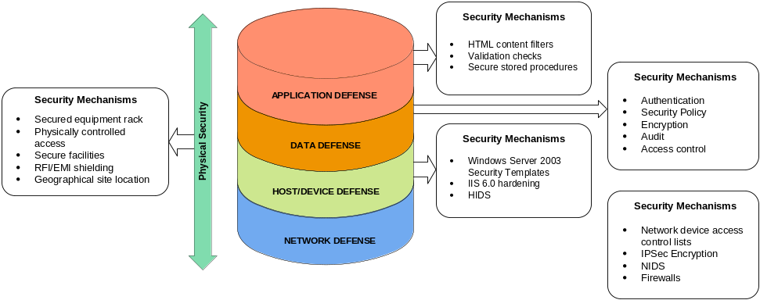
Figure 5. Risk Mitigation Technologies
There are a number of mechanisms available to assist in the mitigation of risks at each layer. Common examples of these mechanisms are listed in the following table.

Security Mechanism | Type of Risk Mitigation at Each Layer
Application Layer
HTML content filters | Identifies and takes action on unauthorized URL strings. For example, dropping them before they reach the application providing the Web server functionality.
Data Layer
Authentication | Denies access to resources to unknown persons.
Encryption | Mitigates the impact of packet “sniffing” on the network; might be implemented as secure sockets layer (SSL) encryption.
Host/Device (Tier) Layer
Internet Information Services (IIS) 6.0 Hardening | Provides additional security for IIS 6.0. Though not installed by default in Windows Server 2003, this optional lockdown incorporates security fixes from previous versions and is configured to provide minimal services by default as well as helping users to avoid common configuration mistakes.
Windows Server 2003 Security Templates | Prevents a variety of attacks against Active Directory®. An attack could be as simple as an attacker running a password dictionary attack to crack a user’s simple password or something more complex like a man-in-the-middle attack for server message block (SMB) packets. Settings for these and many other types of issues can be configured in security templates.
Network Layer
Firewalls | Firewalls are systems that are designed to prevent unauthorized access to or from a private network. A firewall examines network traffic and blocks the packets that do not meet the criteria specified by the firewall administrators. The firewall itself can be either a dedicated physical device or an application running on a workstation or server. Whatever the type of firewall, there are several types of techniques that can be used to control this traffic and most firewalls use one or more of them; examples of these techniques include:  Application gateway: This technique applies to certain applications, such as FTP and SMTP servers. It involves applying specific security techniques directly to the traffic for the application, thus providing an effective level of protection. However, this also introduces some performance overhead.  Circuit-level gateway: This technique involves security mechanisms applied when a network connection is established. Once established, the connection allows the packets to move freely between the connected hosts without further checking.  Packet filter: The use of the packet filter technique requires that each packet traveling on the network is checked and accepted or rejected based on a set of rules defined by the administrators. This technique can be effective but is complex to configure and can be susceptible to attacks such as IP spoofing.  Proxy server: In this technique, the server effectively hides the addresses of the organization’s network behind itself and manages the communications of the hosts directly.
Internet Protocol Security (IPSec) encryption | Mitigates the impact of packet sniffing on the network by making the network packets undecipherable to packet sniffing technology.
Physical Layer
Physically controlled access | Prevents an attacker from gaining access to the servers or devices within the organization’s buildings. It may be implemented as locks on doors of the spaces that contain equipment with only authorized individuals possessing keys.
Secure Facilities | Prevents an attacker from gaining physical access to the premises. This mechanism might be implemented as a fence around the property.
Table 2. Mapping Between Mitigation Mechanisms and Risks
The purpose of this chapter is not to explain in detail all the technologies that can be used to assist in mitigating security risks in an environment. Some technologies are covered to some extent in this chapter; further details are available in the "Security" section in each of the service chapters in the Service Blueprints guide in this documentation kit.
Architecture Design
The process of designing security architecture consists of a number of important steps. If any of these steps are missed or incomplete, the security design may not meet the expectations or even the requirements of the organization.
Design Example: Wingtip Toys
The security architecture design process may be straightforward or complex, depending on the scenario requirements. The “Wingtip Toys” example has been created to illustrate steps in the assessment and design process for the security architecture. For more information about this example, refer to the "MSA Network Architecture" chapter of this guide.
The remainder of this section identifies and references the fictional organization Wingtip Toys to illustrate how process and technology can be used to mitigate the risks of data compromise when a system is designed or implemented:
Business Need
Wingtip Toys is a relatively new organization. It already has some IT infrastructure in place and plans to deploy several new services in the organization to meet its growing requirements. Wingtip Toys plans to connect to the Internet soon and provide the following Internet-based services to clients:
- A public-facing Web site that serves static Web content, such as information on the history of Wingtip Toys.
- A public-facing Domain Name System (DNS) server that helps Internet clients find the Web site of Wingtip Toys.
In addition, it wants to add the following services for its internal employees:
- A database server for client applications.
- Microsoft Windows Server 2003 Active Directory domain controllers and DNS servers for name resolution within the organization.
Security practices at Wingtip Toys were somewhat lax because its systems were not connected to the Internet. Now it wants to improve these practices before making Internet-based services available to employees and clients to protect their customers and themselves against Internet-based attacks.
Technical Requirements
Wingtip Toys plans to identify and mitigate the risks that may exist for the new services it plans to introduce into its environment. It wants to ensure that security mechanisms can be implemented at the correct layers of its technical architecture to minimize the risk of attack to its resources.
Desired Outcome
Wingtip Toys seeks a secure implementation of their public facing Web site as well as the database and infrastructure servers to support their internal client application.

Note: The examples provided in the remainder of this section are not intended to illustrate all of Wingtip Toy’s needs but rather to provide examples that illustrate the points being addressed.

Once the requirements have been defined, it is possible to walk through the design steps and generate the required information. Once these steps are complete, the security architecture can be designed and implemented.
Process
The SRMD process is used to illustrate the design and implementation of a set of systems as defined previously in this chapter.
Asset Assessment and Valuation
As described in the “Architecture Definition” section, the inputs to asset assessment and valuation are derived from the following activities:
- Asset Identification: Determines the data that is valuable to the organization and the tiers on which applications are run.
- Asset Valuation: Determines the financial asset value for each asset, which can be used to compute loss expectancies for the asset.
- Asset Prioritization: Defines an asset priority (AP) for each tier and data type.
- Asset Cost: Defines the cost to recover the asset.
The outputs of this Asset Assessment and Valuation step are generated as follows:
Data Classification List
First, a detailed classification of the data types found in the organization must be provided. Classifications vary across organizations but tend to work as a scale in which each classification requires a higher level of security than the one before. The following table classifies data for the Wingtip Toys design example.

Data Classification | Data Classification Definition
Restricted | This classification applies to information that needs protection from unauthorized modification or deletion to assure its integrity. It is information that requires a higher than normal assurance of accuracy and completeness. Examples of such sensitive information include organizational financial transactions and regulatory actions.
Confidential | This classification applies to the most sensitive business information that is intended strictly for use within protected areas inside the organization. Its unauthorized disclosure could affect the organization seriously and adversely affect its stockholders, business partners, staff, and customers. Examples of such sensitive information include healthcare-related information.
Internal | This classification applies to personal information that is intended for use within the organization. Its unauthorized disclosure could affect the organization and its employees seriously and adversely.
Public | This classification applies to information that does not clearly fit into any other classification. While its unauthorized disclosure is against policy, it is not expected to seriously or adversely affect the organization, its employees, and its customers. While data classified as public is viewable by anyone, its modification could still be detrimental to the organization.
Table 3. Wingtip Toys Data Classifications
Tier Classification List
A detailed classification of the types of tiers found in the organization must be provided. Classifications vary across organizations but tend to work as a scale that affects the overall security of the organization. The following table classifies the various tiers for the Wingtip Toys design example.

Tier Classification | Tier Classification Definition
Primary | This classification applies to tiers that, if compromised, would have a global effect across all services and tiers. It includes tiers that require a higher than normal assurance of accuracy and completeness. Examples include Firewall, Directory, and DNS tiers.
Support | This classification applies to tiers that have a significant effect on other tiers that are dependent on it. An example could be an Application tier, which has the business logic required for the Web tier to function.
Isolated | This classification applies to tiers that have a limited or no effect on other tiers, if compromised. An example could be a Web tier that hosts static content.
Table 4. Wingtip Toys Tier Classifications
Tier Identification List
Next, the tiers required by the organization’s infrastructure must be identified. As discussed in the "Architecture Definition" section, tiers can be single computers or devices or they can be collections of computers or devices that provide similar functionality to other devices on the network. Identifying tiers is largely a cataloging activity that involves documenting facilities that already exist or are planned for as part of the IT infrastructure.
The following table details the tiers identified for deployment in the Wingtip Toys design example.

Tier Name | Tier Description | Data Classification | Reason for Tier
Perimeter Web | Web services available to the public | Public | While the data here is intended to be publicly accessible, unauthorized modification of it could affect the organization’s reputation.
Perimeter DNS | DNS services available to the public for queries | Public | While the data here is intended to be publicly accessible, unauthorized modification of it could affect the organization’s reputation. In addition, it could create confusion for end users if the DNS cache were "poisoned" to redirect them to a Web site other than Wingtip Toys, which could have long-lasting negative repercussions.
Core Database | Microsoft SQL Server™ 2000 services for internal usage | Confidential | This tier contains customer credit card and other personal information that is accessible only to authorized internal users of the organization. Unauthorized modification of or access to the data could have adverse effects on the organization’s customers.
Core Active Directory | Windows Server 2003 Active Directory for internal usage | Internal | This tier contains information that is accessible to all internal users of the organization. Unauthorized modification of the data could have an adverse effect on the organization.
Core DNS | DNS for internal usage | Internal | This tier contains information that is accessible to all internal users of the organization. Unauthorized modification of the data could have adverse impact within the organization.
Client | Internal client access tiers | Internal | The client tiers in the organization contain information that is accessible only to them and the authorized administrative staff. The organization has a policy that all client tiers will maintain their data on servers within the organization instead of on local hard drives—although user profile information is still stored locally.
Table 5. Wingtip Tier Identification List

Note: Although each tier in this example is performing a single function, a tier could perform multiple functions. If this were the case, multiple data classifications might be used for the different data accessible through the different functions or applications.

Asset Valuation List
Once the tiers being deployed have been identified and the type of data they will contain has been determined, the asset value should be calculated for each tier. The following factors need to be understood in order to do this.
- Hardware Cost (HC): This is simply the cost of hardware replacement in the event of a failure or loss.
- Annual Asset Value (AAV): This is the estimated cost to the organization if the data on a tier were to be compromised or otherwise made unavailable to its users. It is the data asset’s value calculated or estimated in direct financial terms. For example, Wingtip Toys’ public Web site is forecasted to normally run seven days a week, 24 hours a day, and generate an average of $2,000 per hour in revenue from customer orders. Based on this, Wingtip Toys has determined the AAV of the Perimeter Web tier asset in terms of sales revenue as $17,520,000.
- Exposure Factor (EF): This is derived from the immediate financial impact of losing an asset. For example, if the Wingtip Toys public Web site becomes unavailable for six hours, the calculated EF is.000685 percent per year.
- Direct Impact (DI): This is derived by multiplying the EF by the AAV of the asset. Wingtip Toys predicts that the directly attributable losses in this case would be $12,000.
- Indirect Impact (II): This is the indirect business impact of losing an asset. In this example, Wingtip Toys estimates that it would spend $10,000 in advertising to counteract the negative publicity from such an incident. Additionally, the organization also estimates a loss of one tenth of one percent of annual sales, or $17,520. Wingtip Toys predicts a total of $27,520 in indirect losses in this case.
The following table is the Asset Valuation list for the Wingtip Toys example.

Tier | Hardware & Software Cost | Annual Asset Value | Exposure Factor | Direct Impact | Indirect Impact
Perimeter Web | $20,000 | $17,520,000 | .000685% | $12,000 | $27,520
Perimeter DNS | $15,000 | $200,000 | .05 | $10,000 | $15,520
Core Database | $40,000 | $10,000,000 | .000380% | $3,800 | $20,000
Core Active Directory | $8,000 | $100,000 | .05 | $5,000 | $10,000
Core DNS | $8,000 | $50,000 | .05 | $5,000 | $10,000
Table 6. Wingtip Toys Asset Value
Asset Prioritization List
An Annual Overall Asset Value (AOAV) is determined based on the asset value and priorities assigned to each tier. This value is determined using the following equation:
AOAV=HC+AAV+DI+II
The following table shows the AOAV and priorities that were determined for each tier in the Wingtip Toys example:

Tier | Annual Overall Asset Value | Asset Priority (AP)
Perimeter Web | $17,559,520 | 1
Core Database | $10,023,800 | 2
Perimeter DNS | $225,520 | 3
Core Active Directory | $115,000 | 4
Core DNS | $65,000 | 5
Table 7. Wingtip Toys Asset Priority
These priorities can help Wingtip’s security administrators determine which assets to secure first and the amount of mitigation effort they want to expend for identified vulnerabilities to each asset.
Security Risk Identification
Once the Asset Assessment and Valuation step of the SRMD is complete, the next step is to identify risks to the organization’s assets.
Inputs
As described in the “Architecture Definition” section in this chapter, this step incorporates the following activities:
- Threat Analysis: A listing of threats to assets at each layer of the organization.
- Vulnerability Assessment: Once threats have been identified, vulnerabilities must be identified.
- Security Risk Statement Qualification: For each risk that exists in the organization, a worksheet containing the following items should be created:
- Risk statement
- Layer applicability
- Criticality
- Effort
- Vulnerability factor
For defense-in-depth, the quantification process should be completed for all the layers.
Outputs
The outputs of this step are described in the following paragraphs.
Known Threats and Exploits List
Threat probability (TP) is the probability that a potential threat will occur. In this example, Wingtip Toys developed a scale for all high level threats and then ranked them from 0 percent (.01) lowest to 100 percent (1.0) highest as shown in the following table. The table contains threats in rows while columns show the layers affected by the threat. The number at the intersection of the two is the probability of the threat affecting that layer as defined by the Wingtip Toys security team.

Threat | Physical | Network | Host/Device | Data | Application | Comment
Fire | .05 | .05 | .05 | .05 | .05 | Every layer potentially affected has the same threat probability.
Water | .025 | .025 | .025 | .025 | .025 | Every layer potentially affected has the same threat probability.
Hardware failure | .10 | .10 | .10 | .10 | .10 | Every layer potentially affected has the same threat probability.
Network failure | .30 | .30 | .10 | .10 | .10 | While this affects the tier in communicating with other tiers, it has no impact on the tier itself.
Malicious code (viruses) | .05 | .05 | .60 | .60 | .60 | While a virus could affect the BIOS or firmware, it is not as likely to affect an operating system or application.
Industrial spies | .10 | .10 | .10 | .10 | .10 | Every layer potentially affected has the same threat probability.
Internal attackers | .10 | .10 | .80 | .80 | .80 | Wingtip Toys has all computing resources in physically secured rooms, but because it is a high profile organization it is susceptible to attacks.
External attackers | .05 | .05 | .80 | .80 | .80 | External hackers do not have physical access to Wingtip Toys facilities, but enjoy the challenge of hacking such a well-known organization. If customer data was compromised in any way, this would have a huge impact on Wingtip Toys reputation.
Table 8. Wingtip Toys Threat Identification and Probabilities
The threat probability for internal and external attackers is based on a combination of the results of the 2002 Computer Crime and Security Survey (www.gocsi.com/press/20030528.html) and Wingtip’s experience over the last year.

Note: This is only a subset of the threats that can be identified. For a more detailed list, see the "Security Services in Windows Server 2003" documentation listed in the "References" section at the end of this section.

Vulnerability Assessment List
The vulnerability assessment list is created by writing down the relevant vulnerabilities that are acknowledged to be present in the IT environment. They are listed, along with a short description of each, so that they can be reviewed for completeness and coverage. Once complete, the vulnerability assessment list acts as an index for subsequent activities.
Wingtip Toys identified a number of vulnerabilities in the systems it was implementing. Two examples are listed here for illustrative purposes:
- Buffer overflows: Attackers exploit buffer overflow vulnerabilities to gain access to a system.
- Undesired TCP/UDP port access to tiers: Internet-connected servers provide specific services to Internet clients, and in doing so they listen on TCP/UDP ports. However, Internet-connected servers often listen on TCP/UDP ports other than just the ports required for these services. This is undesirable because it makes the tier susceptible to additional attacks and many of the accessible ports are unnecessary for proper service operation.
Risk Assessment Sheets
A risk assessment sheet should be prepared for each relevant vulnerability identified in the vulnerability assessment list. Wingtip Toys chose to use the following scale for each variable when creating its risk assessment sheets:
- Criticality: Measured on a scale of 1 to 10, where 1 indicates very little impact from the exploit and 10 indicates that a large amount of irrevocable damage could occur.
- Effort: Measured on the same scale of 1 to 10 as the criticality factor, where 1 indicates that very little skill is required to use a particular exploit and 10 indicates that the skills of a seasoned security programmer would be required.
- Vulnerability Factor: Measured on a scale of 1 to 10, where 1 indicates that the particular asset is not readily susceptible to the vulnerability and 10 indicates that the asset is extremely open to a particular issue.
Wingtip Toys’ security personnel know that they are susceptible to many vulnerabilities in the implementation of these new services. Two of these vulnerabilities are presented as risk assessment sheets in the next section for illustrative purposes.

Note: Because the Perimeter Web tier was deemed the highest priority asset, Wingtip security personnel addressed the risks to it first.

The remainder of this section focuses on mitigating risks for the Perimeter Web tier only.
Risk Assessment Sheet: Buffer Overflows
There are specific concerns that there may be unfound buffer overflow vulnerabilities in some of the software that will be used on the servers that Wingtip Toys is deploying.
- Risk Statement: IF attackers use a tool to exploit yet unfound vulnerabilities, THEN a loss of integrity and availability of the Public Web tier may result in increased traffic on the network.
- Layer Applicability: The risk is applicable to the host and application layers.
- Criticality Factor: New buffer overflow vulnerabilities appear frequently. The Wingtip Toys security team gave this vulnerability a CF of 6 for the Public Web tier at the host level. The Wingtip Toys security personnel know that these vulnerabilities have surfaced often with Web server software in the past. Although it has a high degree of confidence that IIS 6.0 will provide a very secure environment, it still plans to implement a variety of security mechanisms and stay current on hotfixes to prevent susceptibility to potential vulnerabilities. Wingtip Toys gave this vulnerability a CF of 9 for the application layer because a number of different Web-based applications that were developed in-house are running on the server and the organization's programmers are used to writing internal applications where security has not been as much of a concern. Until some of the applications that were written in-house are proven in the Wingtip Toys environment, the security team will stay with a CF rating of 9 for this vulnerability.
- Effort: Depending on the vulnerability, the attack may be easy or difficult to execute. Therefore, it was decided to assign Effort an average rating of 5. The same Effort applies to each layer identified in the layer applicability section.
- Vulnerability Factor: Since new vulnerabilities of this class appear often, Wingtip Toys security personnel assigned a vulnerability factor of 6 for the Public Web tier since it is the first access point into the Wingtip Toys network. The same VF applies to each layer identified in the layer applicability section.
Risk Assessment Sheet: Undesired TCP/UDP Port Access to Tiers
TCP/IP is the network protocol used on the Wingtip Toys network. Internet clients should only interact with the Perimeter Web tier over TCP ports 80 and 443. Since the servers listen on many other ports, Wingtip Toys is concerned whether Internet-based users will be able to make connections to TCP ports other than 80 and 443.
- Risk Statement: IF attackers use a tool to connect to ports other than TCP 80 and 443, THEN a loss of integrity and availability of the Perimeter Web Server may result in unauthorized access to data on the Perimeter Web tier.
- Layer Applicability: The risk identified is applicable to the host, application, and data layers.
- Criticality Factor: As the Perimeter Web tier hosts listen on many more ports than 80 and 443, the Wingtip Toys security team gave this vulnerability a criticality factor of 9 for the Perimeter Web tier. The same CF applies to each layer identified in the layer applicability section.
- Effort: Depending on the vulnerabilities that exist in the software listening on the ports, the attack may be easy or difficult to execute. Therefore, it was decided to assign Effort an average rating of 5. The same Effort applies to each layer identified in the layer applicability section.
- Vulnerability Factor: As the servers listen on so many ports, there is potentially a large surface for attack. The Wingtip Toys security administrators assigned this a vulnerability factor of 8 for the Perimeter Web tier because it is one of the first access points into the Wingtip Toys network. The same VF applies to each layer identified in the layer applicability section.
Risk Assessment Summary
A risk assessment summary is drawn up for each of the layers to be secured. This summary contains the key information from each of the other activities in this stage in a form that can be agreed upon by all parties before the next stage begins. As described in the "Architecture Definition" section, the summary includes the following:
- Threat
- Threat Probability (TP)
- Exploit
- Criticality Factor (CF)
- Effort (E)
- Vulnerability
- Vulnerability Factor (VF)
- Asset (Tier)
- Asset Priority (AP)
Example summaries for each applicable layer in the Wingtip Toys environment are given in the following table.

Note: The example analyzes the Perimeter Web tier for threats from external hackers only, and may have different TPs, CFs, Es, or VFs depending on the layer.

Buffer Overflow Vulnerability
Tier | Layer | Exploit | TP | CF | E | VF | AP
Perimeter Web | Physical | None | N/A | N/A | N/A | N/A | 10
Perimeter Web | Network | None | N/A | N/A | N/A | N/A | 10
Perimeter Web | Host/Device | Attacker makes a buffer overflow occur on an operating system or service. | .80 | 6 | 5 | 6 | 10
Perimeter Web | Data | None | N/A | N/A | N/A | N/A | 10
Perimeter Web | Application | Attacker makes a buffer overflow occur on an application running on the tier. | .80 | 9 | 5 | 6 | 10
Table 9. Example Security Risk Assessment Summary for External Attacker Threats
Security Risk Analysis
Once the risks in the organization are defined, they are analyzed to determine which assets should be secured against which threats.
Inputs
Risk assessment summaries for each layer (completed in the previous step).
Outputs
Security risk analysis provides a prioritized security action list to guide the security team in the risk planning activities.
Master Security Risk Prioritization List
To calculate the Exposure Factor (EF), apply the following formula to the results of each layer’s risk assessment summary:
EF = (((TP × (CF/ E)) × (VF × AP)) /1000)

Note: In this equation, an arbitrary value of 1000 was used as the divisor to allow the EF values to be rendered in a range of 1 to 100 for readability. However, a value of 10 was used as the divisor in the following table.

This calculation will yield the exposure factors for each of the vulnerabilities at different layers. Exposure factors can be ranked from the highest to lowest to determine a threshold for which Wingtip Toys wants to implement mitigation strategies in its design and implementation.
Using this formula, the exposure factors for the buffer overflow vulnerability in the Wingtip Toys environment were identified at each layer for the Perimeter Web tier as shown in the following table. This calculation should be completed for each of the vulnerabilities identified for each asset in the environment at each layer.

Buffer Overflow Vulnerability
Tier | Layer | EF
Perimeter Web | Physical | N/A
Perimeter Web | Network | N/A
Perimeter Web | Host / Device | 5.76
Perimeter Web | Data | N/A
Perimeter Web | Application | 8.64
Table 10. Example Master Security Risk Prioritization List
Security Risk Remediation and Development
Once risks have been identified and prioritized, remediation strategies can be formulated and implemented as part of the design.
Inputs
The principal input to this step is each layer’s Master Security Risk Prioritization list created in the previous step. From this list, specific security mitigation plans can be developed and implemented in the design and implementation of different services within the organization.
Outputs
The outputs of this step are the following:
- Security Risk Mitigation Strategy lists
- Physical
- Network
- Host/Device
- Data
- Application
- Security Zone Definitions and Restrictions
- Security Zone Definitions (detailed later)
- Security Zone Restrictions (detailed later)
In most cases, Wingtip Toys uses the defense-in-depth approach to security. The only time it does not is when there is minimal or extremely limited benefit for the increased analysis effort. While the defense-in-depth approach does add administrative overhead to their environment, Wingtip Toys has good operational processes defined and tools to support them when their business model did not include Internet connectivity. In addition, the systems administration personnel communicate clearly and frequently. The following section lists the mitigation strategies that Wingtip Toys is implementing in their design due to the change in their business model.
Security Risk Mitigation Strategy Lists
A risk mitigation strategy should be defined for every security risk in every layer. The security risk mitigation strategy lists tabulate vulnerabilities to assets, Exposure Factors (EF), and the agreed mitigation strategies. The following table gives examples of a mitigation strategy for the buffer overflow vulnerability found in the Wingtip Toys IT architecture.

Buffer Overflow Vulnerability
Tier | Layer | EF | Mitigation Strategy
Perimeter Web | Physical | N/A | N/A
Perimeter Web | Network | N/A | N/A
Perimeter Web | Host / Device | 5.76 | Deploy all the latest hotfixes and service packs, do not enable any unnecessary system and application components or services, and use the URL Scan tool on all hosts in tier available at www.microsoft.com/technet/security/URLScan.asp.
Perimeter Web | Data | N/A | N/A
Perimeter Web | Application | 8.64 | Custom applications follow secure coding practices.
Table 11. Example Security Risk Mitigation Strategy List
The ranking by EF can be used in conjunction with the Asset Priorities list to determine the resources for which the organization wants to mitigate risks and in what order. The output from this analysis can be used to create security zones, which make implementation strategies more consistent within the organization.
Security Zone Definitions and Restrictions
Security administrators define security zones to help plan security policies in an organization. As described in the “Architecture Definition” section, security zones provide logical containers to which security policies and mitigation strategies can be applied. First, the security administrator defines zones that group policies and strategies as best as possible according to the data and tiers to be protected. Second, the security administrator specifies the restrictions that apply to the tiers in these zones and the intra-zone and inter-zone communications. The SRMD process can be used in conjunction with the security zones defined within the organization to assist in determining the number of zones best suited for the environment.
Security Zone Definitions
In the Wingtip Toys example, the security administrator defined a number of zones to ensure protection of the organization's IT assets. The following figure depicts the security zones and tiers defined at Wingtip Toys.
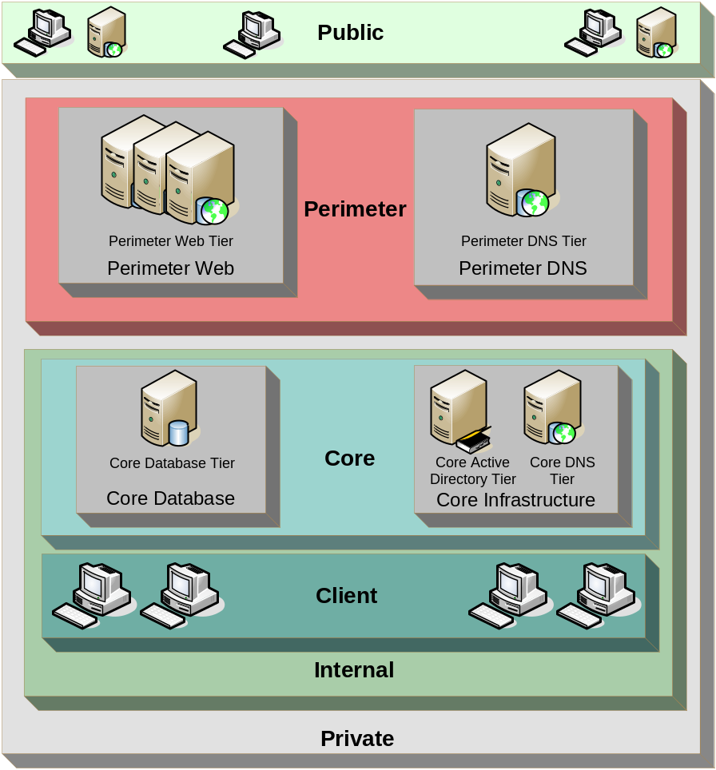
Figure 6. Wingtip Toys Security Zones and Tiers
Security zones can contain other security zones as well, as described in the following table.

Zone Name | Zones It Contains
Public | None (it is the Internet)
Private | Perimeter and Internal
Perimeter | None
Perimeter DNS | None
Perimeter Web | None
Internal | Corporate and Client
Core | Core Database and Core Infrastructure
Core Database | None
Core Infrastructure | None
Client | None - contains both LAN and wireless-based workstations.
Table 12. Wingtip Toys Security Zone Information
Internet-connected organizations typically have at least public, private, internal, and perimeter zones. How the zones are segmented further depends upon the different services in the organization. The zones are described in more detail in the following paragraphs.

Note: Even though the tiers are all in zones within the Perimeter zone, this does not necessarily have to be the case. There could also be a tier within the Public zone, which is not within another zone.

- Public Zone: This zone contains tiers that are not under the control of the enterprise. In the Wingtip Toys example, the Internet and its connection to the external interface of the organization's Internet-connected border routers are defined as the Public zone. Information in the Public zone is freely available to the public and does not need specific access rights. The Public zone includes the point of origin for customers, for remote employees connecting to the enterprise network through a virtual private network (VPN) or through branch office VPNs, and for business partners. The Internet is referred to as the Public zone simply so that access control can be implemented to and from it in the Wingtip Toys enterprise security policy.
- Private Zone: This zone contains all Wingtip Toys connectivity tiers, application tiers, and network segments connected to the internal side of the organization's Internet-connected routers. The purpose of this zone is to separate the traffic flow internal to the organization from the traffic flow of the Internet (or Public zone). The boundary between the Private and Public zones is a router on which Open Systems Interconnection (OSI) model layer 3 (L3) access control lists (ACLs) can be implemented to drop unnecessary inbound traffic, as sanctioned by the Wingtip Toys enterprise security policy. The Private zone is comprised of the Perimeter and the Internal zones.
- Perimeter Zone: This zone contains tiers that are bounded by some form of access control functionality that isolates the Public zone from the Perimeter zone and the Perimeter zone from the Internal zone, thus also isolating the Internal zone from the Public zone. The purpose of this zone is to facilitate the creation of security polices within Wingtip Toys so that traffic can be filtered between the Public and Internal zones. Its purpose does not include allowing the public general access to the internal resources of the organization. This zone is referred to as the perimeter network because it sits between the public network and the internal network and holds semi-trusted information related to the enterprise. This zone contains the Wingtip Toys firewall tiers as well as tiers that provide public facing services, such as DNS and Web services.
At Wingtip Toys, any tier in this zone has either a public IP address or a tier that provides network address translation (NAT) in front of it. The services provided on tiers in this zone are considered “public” services because the Public zone has some kind of access to them. While access control tiers are implemented between the Public and Perimeter tiers at Wingtip Toys, tiers in the Perimeter zone are still the first-level targets for malicious public users. The Perimeter zone is further subdivided into additional security zones called the Perimeter Web zone and the Perimeter DNS zone.
- Perimeter Web zone: This zone contains one tier called the Perimeter Web tier. This zone exists so that access controls can be implemented to control the flow of traffic between this zone and the Public zone. While Wingtip Toys considered just putting all tiers into the Perimeter zone without subdividing it further, the organization wanted to control traffic differently between the Public zone and the Perimeter Web tier from the way it did between the Public zone and the Perimeter DNS tier. Therefore, a zone was created for each tier.
- Perimeter DNS zone: This zone contains one tier called the Perimeter DNS tier. Wingtip Toys decided to host their own DNS rather than using their ISP’s DNS to allow for greater flexibility and self reliance. This zone exists so that access controls can be implemented to control the flow of traffic between this zone and the Public zone. While Wingtip Toys considered just putting all tiers into the Perimeter zone without subdividing it further, the organization wanted to control traffic differently between the Public zone and the Perimeter DNS tier from the way it did between the Public zone and the Perimeter Web tier. Therefore, a zone was created for each tier.
- Internal zone: The Internal zone contains all the tiers owned by Wingtip Toys. The organization’s enterprise assets such as application data, electronic messaging data, and its proprietary database are all contained within the Internal zone. The purpose of the Internal zone is to isolate the tiers running the organization’s internal services and clients from the Public and Perimeter zones. The Internal zone is further subdivided into the following zones:
- Core: The purpose of this zone is to separate the Wingtip Toys enterprise servers from their clients. The organization is aware of studies showing that a majority of security breaches originate internally. Therefore, it has defined this zone so that it can implement access control mechanisms to control the flow of traffic between tiers in this zone and tiers in the Client zone, as well as to keep Perimeter zone tiers separate from the tiers in this zone. While Wingtip Toys could have simply implemented access control mechanisms between the Client and Core zones, it wanted more granular control capabilities in implementing different types of traffic flow; therefore, the organization's security team divided the Core zone into two additional security zones.
Core Database: This zone contains the Wingtip Toys Core Database tier. The purpose of this zone is to enable implementation of access control mechanisms between it and the Client zone.
Core Infrastructure: This zone contains the Wingtip Toys Core Active Directory and Core DNS tiers. The purpose of this zone is to enable implementation of more granular access control mechanisms between it and the Client zone. While the organization could have simply done that between the Client and Core zones, it wanted more granular control capabilities in implementing different types of traffic flows between the Client zone and the Core Active Directory and Core DNS tiers than it did between the Client zone and the Core Database tier. In addition, the organization could have implemented the Core Active Directory and Core DNS tiers each into their own zones, but it did not want that additional level of traffic flow capability.
- Client: This zone contains all the client tiers in the Wingtip Toys organization. This includes personal computers (PCs) and other computing devices such as Pocket PCs. While the organization could have further subdivided the Client zone into additional zones, it did not have any requirements to do so at this time.
Security Zone Restrictions
Once security zones are defined, security restrictions can be detailed around them in the following areas:
- Tier restrictions within a zone
- Intra-zone tier communications
- Inter-zone communications
Sometimes zones inherit restrictions from zones to which they belong. For example, the restrictions applied to the Core Infrastructure zone may be the hierarchy of restrictions applied to the Private, Internal, Core, and Core Infrastructure zones. Additionally, note that only those previously identified vulnerabilities that pertain to the network layer would be addressed for intra-zone tier communications and inter-zone communications.
Tier Restrictions within a Zone
Wingtip Toys security personnel implicitly allow everything except what is listed in the following table and the restrictions apply to all the tiers within the zone. The organization imposes restrictions at multiple layers because it uses the defense-in-depth approach. The network layer is not shown in the following table because those restrictions are addressed in the following sections. The table illustrates some of the restrictions (not all) imposed on tiers at Wingtip Toys.

Zone | Identified Vulnerabilities | Physical | Host/  Device | Data | Application
Perimeter | Undesired TCP/UDP port access to tiers | All tiers in this zone must reside in access-controlled rooms | All tiers in this zone will be deployed and maintained with the latest operating system service packs and hotfixes. | Before accessing any data on these tiers, users will be authenticated by a combination of username and password. In addition, the usernames and passwords transmitted to these tiers must be encrypted. | Any applications (packaged or developed in house) on these tiers will be deployed and maintained with the latest service packs and hotfixes. In addition, they must adhere to Wingtip Toys application security guidelines (not included in this guide).
Perimeter Web | Undesired TCP/UDP port access to tiers |  | The operating system will be configured to perform TCP/IP port filtering, allowing only ports 80 and 443 inbound from the Public zone and port 3389 inbound from the Client zone. Additionally, IIS will be configured to service requests for .HTM and .JPG file types only.
Core | Undesired TCP/UDP port access to tiers | All tiers in this zone must reside in access-controlled rooms. | All tiers in this zone will be deployed and maintained with the latest operating system service packs and hotfixes. | Before accessing any data on these tiers, users will be authenticated via Kerberos-based authentication. | Any applications (packaged or developed in house) on these tiers will be deployed and maintained with the latest service packs and hotfixes. Additionally, they must adhere to Wingtip Toys application security guidelines (not included in this guide).
Table 13. Wingtip Toys Tier Restrictions
The network layer is addressed in the following “Intra-zone and Inter-zone Communications” sections.
Intra-zone Tier Communications
The example provided in the following table assumes that implicit denials of communication are not explicitly allowed.

Source Tier | Destination Tier | Mitigate d Vulnerabilities | Permissible Communication Between Tiers at the Network Layer
Core Active Directory | Core DNS | Undesired TCP/UDP port access to tiers | All TCP and UDP ports are allowed to flow between these tiers. These tiers are contained within a zone. Wingtip Toys security personnel want to control access into and out of the Core Infrastructure zone, but do not want to incur the overhead of maintaining port rules between these tiers because the vulnerability analysis showed the existing risks to be of low priority.
Table 14. Wingtip Toys Intra-zone Tier Communications Information
Inter-zone Communications
The inter-zone communications examples provided in the following tables assume that implicit denials of communication are not explicitly allowed.

Source Zone | Destination Zone | Mitigated Vulnerabilities | Permissible Communication Between Zones at the Network Layer
Public | Private | Undesired TCP/UDP port access to tiers | A device that performs the application layer proxy firewall function will exist at the network layer between these two zones, because the risk analysis identified this as a high priority risk. Communication between these zones is the first opportunity for an attacker to infiltrate the Wingtip Toys network; therefore, the organization chose to implement a firewall. To mitigate the risk further, it chose to force the usage of a single function firewall device, which does not perform the firewall function between any other zones. In addition, it required a firewall device that could provide the application layer proxy function to mitigate the risk of attackers using a Trojan piece of software on the servers that listen on allowed ports in this zone. The application layer proxy firewall will drop traffic on allowed ports if it is not the intended “type” of traffic on the allowed port (for example, HTTP traffic for Web servers). Last, the device serving the firewall role must also provide the NAT function. As an additional mitigation strategy, Wingtip Toys security personnel want to shield the organization’s internal addressing scheme from the Public zone.
Perimeter | Internal | Undesired TCP/UDP port access to tiers | A device that performs (at a minimum) the stateful packet inspection firewall function will exist at the network layer between these two zones. The ports allowed through it will be defined at a lower level. The device that performs this function must be a separate device from one that performs any other function. It must also be separate from the firewall device between the Public and Private zones. Wingtip Toys security personnel wanted the firewall device to perform the stateful packet inspection firewall function here because they were not as concerned about invalid traffic over valid ports as they were between the Public and Private zones. If other requirements exist in the organization for a firewall device that performs application layer proxy functionality between these two zones, it is perfectly acceptable to the organization’s security personnel. Traffic does not flow from the Perimeter zone to the Internal zone, but rather only from the Internal Zone (over TCP ports specified later) to the Perimeter zone because these were the only requirements for the Wingtip Toys environment.
Public | Perimeter Web | Undesired TCP/UDP port access to tiers | Traffic is allowed to flow only over TCP ports 80 (HTTP) and 443 (HTTPS) between these zones and only in the direction specified by the source and destination zones.
Public | Perimeter DNS | Undesired TCP/UDP port access to tiers | Only port UDP port 53 (DNS lookups) traffic is allowed to flow between these zones, and only in the direction specified by the source and destination zones.
Client | Perimeter Web | Undesired TCP/UDP port access to tiers | Only TCP port 3389 (Remote Desktop) traffic is allowed to flow between these zones so that Wingtip Toys administrative personnel can remotely administer the servers in this zone. The organization’s security personnel considered mandating that any connectivity device that existed between these two zones also implement, at a minimum, static packet filters. They decided not to do so because its vulnerability assessment did not conclude that the identifiable risks that exist for internal traffic between these two zones warranted the additional overhead of maintaining the additional filters. Traffic only flows in the direction specified by the source and destination zones.
Client | Perimeter DNS | Undesired TCP/UDP port access to tiers | Only TCP port 3389 (Remote Desktop) traffic is allowed to flow between these zones so that Wingtip Toys administrative personnel can remotely administer the servers in this zone. The organization’s security personnel decided not to mandate that any connectivity device that existed between these two zones also implement static packet filters, because its vulnerability assessment did not warrant the additional overhead of maintaining the additional filters. Traffic only flows in the direction specified by the source and destination zones.
Client | Core Database | Undesired TCP/UDP port access to tiers | Only TCP ports 1433 and 1434 (for Microsoft SQL Server 2000 connectivity) are allowed to flow between these zones. Wingtip Toys security personnel did not mandate that any connectivity device that existed between these two zones also implement static packet filters, because its vulnerability assessment did not warrant the additional overhead. Traffic only flows in the direction specified by the source and destination zones.
Client | Core Infrastructure | Undesired TCP/UDP port access to tiers | All TCP and UDP ports are allowed to flow between these two zones. Wingtip Toys security personnel’s asset valuation and risk assessments did not determine the risks from internal sources to be high enough to warrant maintaining filters to the tiers in this zone.
Table 15. Wingtip Toys Inter-zone Communications Information
While this table does not detail all the Wingtip Toys security restrictions, this type of information should be defined for all restrictions that the security team wants to put in place. The organization can use these definitions as a living document and as a starting point whenever new services or applications need to be added to the environment.
Technology
A variety of technologies can assist organizations in mitigating security risks.
The technologies used by Wingtip Toys in implementing their mitigation strategies are listed in the following table.

Security Mechanism | Types of Risks the Technology Helped Mitigate
Application Layer
HTML content filters | HTML content filters can be implemented as application layer mechanisms in cases where the Web server software is a product separate from the operating system. Wingtip Toys used Internet Information Services (IIS) version 6.0, which is part of the Windows Server 2003 operating system. Based on the definition of layers earlier in this document, the organization used this technology at the host/device layer. They also used URLScan to intercept HTTP requests before the Web server software processes them; URLScan drops requests if the type of request does not match an allowable type defined in a configuration file for the product.
Data Layer
Authentication | Wingtip Toys requires Windows authentication to its Microsoft SQL Server 2000 database server.
Host/Device (Tier) Layer
IIS 6.0 Hardening | Wingtip Toys uses the default installation of IIS 6.0, which only accepts requests for static content (no .ASP or .NET Framework applications) because it only serves static content about its organization to the public.
Windows Server 2003 Security templates | Wingtip Toys implements Windows Server 2003 security templates to help it set password enforcement policies, among other things, in its environment.
Network Layer
Firewalls | Wingtip Toys uses a variety of devices that perform different levels of port filtering, from simple ACLs to application layer proxying.
Physical Layer
Physically controlled access | Wingtip Toys maintains all of its computing resources in locked facilities within the organization. Only authorized personnel have access to these facilities.
Secure facilities | This mechanism is implemented as a fence around the property to prevent an attacker gaining physical access to the premises.
Table 16. Technologies to Help Implement Mitigation Strategies
Manageability
Manageability of the security architecture is probably its defining attribute. Unmanageable security architecture is very difficult to secure without monitoring mechanisms, and potential security breaches may pass unnoticed. It is harder to resolve security issues without the use of diagnostics.
The zoned approach adopted for the security architecture is also appropriate for its management. Each security zone can be treated as a management domain and security management tasks can be delegated to local administrators if necessary. Today, most security devices offer remote management capabilities along with linkage to centralized management consoles for their monitoring and configuration.
The choice of security devices will have an effect on manageability of the architecture. For more details on manageability of security technologies, see the "Firewall Services” and the "Remote Access Services” chapters in the Service Blueprints guide in this documentation kit.
Role-based Administration
The Microsoft Operations Framework (MOF) team model offers guidelines for IT service management based on a set of consistent quality goals that exist in successful IT operations organizations of various sizes, from large corporate IT departments to smaller, growing e-business data centers and application service providers. MOF defines a number of role clusters, each of which is responsible for one aspect of IT operations. The security role cluster exists to ensure confidentiality, integrity, and availability of enterprise data. Security specialists in this role focus not only on the technical intricacies of protecting the corporate network, but also on the business policies and practices of things such as organization e-mail, remote access usage, permissions on sensitive corporate financial and human resource data, and issues as specific as maintaining the confidentiality of the organization’s employee phone listing.

Note: Any management roles that have high levels of security access in the enterprise may have access to highly sensitive organization information. These personnel should be carefully selected because they might themselves constitute a security risk.

Some common role responsibilities for the security role cluster are:
- Helping to monitor correct operation of IT resources.
- Detecting intrusions and protecting against viruses.
- Providing denial-of-service protection.
- Defining policies for data retention and secure data disposal.
- Performing audit tracking and reporting.
- Providing effective network domain security design and management.
- Testing and implementing strategic security technology.
- Monitoring and assessing network vulnerability.
- Providing fast, real time network intrusion response.
- Managing public key infrastructure (PKI) technology requirements.
- Managing IP security requirements.
- Managing authentication and access methods requirements.
- Managing user policy usage and requirements (for example, a password policy).
- Managing external and physical security requirements (for example, access to computer rooms).
- Managing secure messaging requirements.
- Providing ongoing technical support and subject matter expertise for security initiatives within the organization.
Some of the roles within the security role cluster are listed in the following table.

MOF Role Cluster | Role Names | Role Responsibilities | Active Directory Permissions
Operations, Release, Infrastructure, Support, Security | Security Manager  Personnel Security Technician  Operating System Security Technician  Hardware Security Technician  Network Security Technician  Facilities Security Technician  Egress Security Technician  Outsourcing Manager  Security Compliance Auditor | See the preceding list | Access dependent on security zone
Table 17. Security Cluster Roles
For further information on role-based administration, see the MOF Team Model for operations at the following Web site:
www.microsoft.com/technet/itsolutions/tandp/opex/mofrl/moftml.asp
In the Wingtip Toys example, the security manager manages the risk lists, zone definitions, and restrictions within the organization. She works closely with the administrators of the technologies used in the security architecture as well as with the service/application administrators to ensure that the Wingtip Toys environment minimizes its risks to attack by potential attackers.
System Administration
A centralized approach to security administration is simple and straightforward for the security manager, as it focuses all the tasks in one place. However, the security architecture may make remote management impossible across certain security boundaries.
Security is distributed across servers, clients, and proprietary devices. The presentation and communications mechanisms for remote administration functionality can be of three basic types:
- Microsoft Management Console (MMC)
- Web-based
- Proprietary
Generally, MMC or proprietary solutions provide the most functionality for remote administration. However, Web-based tools are improving all the time.
There will also be some dependency on remote software distribution, such as updates to VPN clients or virus checking software. System administration of the technologies used to implement security architecture and to secure the tiers within an environment can be difficult. When the defense-in-depth strategy is used within an organization, it potentially increases the difficulty in managing the environment by orders of magnitude. Given that multiple administrators typically manage the different technologies used in the environment, any change can pose multiple opportunities for misconfiguration. Accordingly, strong communication and change management processes should exist in the environment to minimize the risks. While tools are starting to emerge in the marketplace that can manage security policy across multiple technologies, they are somewhat immature at this stage.
Performance
The performance of security architecture is primarily based on which technologies and restrictions are implemented in the environment. The primary performance impacts of technologies implemented to support security are:
- Packet filtering at the network layer: In almost all cases, packet filtering increases the time it takes from source to destination. The time varies depending on the type of inspection performed on the packet. For example, oftentimes application layer proxying takes longer than simple port filtering because the proxying process requires deeper inspection of packets.
- Encryption: Encrypting data always results in larger amounts of data to be transmitted, as well as additional CPU overhead for the devices performing the encryption/decryption. This overhead could potentially be offloaded to hardware cards designed specifically for this purpose.
For further information on security performance, refer to the following chapters of the Service Blueprints guide in this documentation kit:
- "Firewall Services"
- "Directory Service"
- "Certificate Services"
- "Remote Access Services"
Supportability
Supportability of security devices from different hardware vendors is usually documented by the respective vendors in a compatibility and/or supportability matrix. Contact the appropriate hardware vendor to ensure that all planned systems are configured in a supported fashion.
For details on supportability of these devices, refer to the "Firewall Services” and "Remote Access Services" chapters of the Service Blueprints guide and the MSA Implementation Kit.
Consolidation
Security is as disparate or consolidated as the networking and software architectures that it supports. Although the increased ease of security management is a driver for consolidation of server and network devices, consolidation should take into account the security needs of the data and the zone structure that the security architecture has been designed to support.
For information on server consolidation, refer to “A Guide to Consolidating Microsoft Servers” at the following URL:
www.microsoft.com/technet/itsolutions/consolidation/consolms.asp
When consolidating services onto fewer servers, it is important that the following be considered:
- Does the consolidation still allow autonomous administration of the services on the shared server if those services had been administered by different individuals in the organization previously?
- What additional risks (to a server already running services or applications that likely have risks of their own) does this new service or application introduce? Is the organization willing to accept that additional risk?
- Do the applications or services have different password requirements and/or encryption requirements? If so, they may not be good candidates for consolidation efforts.
- Do the applications or services have different service accounts or elevated privileges that might provide an attacker who compromises one service with access to information running in other processes on the same servers?
Interoperability
All security mitigations should be implemented as part of an overall security policy. A number of interoperability standards exist in the technologies that may be implemented as part of security architecture; these standards are addressed in the various chapters of the Service Blueprints guide.
Standards and Guidelines
ISO 17799 is an internationally accepted set of controls comprising best practices in information security. This standard was based on and supersedes the British standard BS 7799.
Security architecture employs the security role cluster defined as part of Microsoft Operations Framework (MOF). For further information, refer to the following URL: www.microsoft.com/mof/
Specific standards and guidelines relating to areas such as Internet protocols (IPSec, SSL), VPN, certificates, and directory services can be found in the following chapters of the Service Blueprints guide in this documentation kit.
- "Firewall Services"
- "Directory Service"
- "Certificate Services"
- "Remote Access Services"
CDC Design Considerations
This section identifies and references the MSA CDC scenario to illustrate how the security design process was used to mitigate the risks of data compromise.
Architecture Design
The following section illustrates the process followed for the MSA CDC scenario. To obtain the complete picture of the design process, it is important to have an understanding of the documentation provided in the MSA 2.0 Planning Guide in the MSA Implementation Kit, specifically the “Introduction to MSA Planning Guide” chapter.
The result of this process was a complete security zone design that was used to plan the complete MSA CDC scenario infrastructure as built and tested in the MSA test labs.
Technical Requirements
The MSA security team wanted to minimize the risk of attack to the infrastructure and its resources. To help achieve this, the following requirements were identified:
- All services must be highly available.
- Network services must be secure end-to-end, including communications that traverse the Internet.
- All network communications that are not explicitly allowed must be denied.
- All services must use a central authentication mechanism.
- All applications must be authenticated and auditable.
- Centralized management capability.
- Service health monitoring to prevent costly downtime.
- Data integrity must be guaranteed as uncompromised end-to-end.
These requirements were set and agreed upon by all members of the design team at the beginning of the design process.
Desired Outcome
The desired outcome for the MSA CDC design process was to create an infrastructure that meets the technical requirements of an organization and adheres to the security requirements of the architecture blueprints.
Once the requirements and desired outcome had been defined, the SRMD process was started. This process was used to assess and attempt to value the security requirements of the various tiers and data types within the proposed infrastructure.
Process
The SRMD process was used to illustrate the design and implementation of the Wingtip Toys example. For the MSA CDC design process, only the most relevant procedures of SRMD were applied. This approach was taken because the MSA implementation is a lab instantiation of the overall MSA architecture; therefore, mitigation of every risk present in the environment would be of little practical value. The MSA security team mainly focused their efforts on the following aspects:
- Network security, primarily for external penetration attacks.
- Active Directory service policies.
- Host-hardening and IPSec policies, which are currently out-of-scope for this release.
Service-specific details are available in the "Security" section in each of the service chapters of the Service Blueprints guide in this documentation kit. The following sections illustrate how security was implemented in the CDC design.
Asset Assessment and Valuation
The “Asset Assessment and Valuation,” “Data Classification,” and “Tier Classification” lists identified in the “MSA Enterprise Design” section in this chapter were used directly in the MSA CDC design process.
Tier Identification List
The following table lists the tiers identified for deployment in the CDC design scenario.

Tier Name | Tier Description | Tier Classification | Reason for Tier Classification
Firewall (public) | Enforces security policies to protect assets that are available to untrusted public users. | Primary | This tier is a core part of the corporate security enforcement mechanism. While it publishes publicly accessible data to non-trusted clients, it contains highly restricted configuration data.
Firewall (semi-trusted) | Enforces security policies to protect assets that are available to semi-trusted users, such as employees. | Primary | This tier is a core part of the corporate security enforcement mechanism. While it publishes publicly accessible data to semi-trusted clients, it contains highly restricted configuration data.
Firewall (trusted) | Enforces security policies to protect assets that are available to trusted internal users. | Primary | This tier is a core part of the corporate security enforcement mechanism. While it publishes privately accessible data to semi-trusted or trusted clients, it contains highly restricted configuration data.
External Proxy/Cache | Allows internal authenticated users or internal proxied access to the Internet. | Support | This tier is a secondary part of the corporate security enforcement mechanism. While it publishes publicly accessible data to semi-trusted or trusted clients, it contains highly restricted configuration data. This tier was consolidated with the Firewall (semi-trusted) tier.
Remote Access | Allows external authenticated users to access corporate networked services. | Primary | This tier provides a mechanism for users to connect securely to corporate services from remote locations. This service extends the core network service to encompass remote clients and facilities.
Perimeter Application | Provides business logic to Web services available to the public. | Support | This tier enhances Web service availability and scalability and adds additional Web services functionality.
Perimeter Web | Provides Web services to the public. | Isolated | While the data here is intended to be publicly accessible, its unauthorized modification could affect the organization’s reputation.
Perimeter DNS | Provides DNS services to advertise and resolve publicly available namespaces. | Primary | While the data here is intended to be publicly accessible, its unauthorized modification could affect the organization’s reputation. In addition, it could create confusion for end users if the DNS cache were "poisoned" to redirect visitors to a Web site other than Contoso, which could have long-lasting negative repercussions.
Perimeter Directory | Provides Active Directory service to centralize security policy enforcement and management access. | Support | This tier provides a mechanism for managing, deploying, and centralizing security policies across tiered services in the perimeter network. No user accounts (other than a few for administrative purposes) are contained within this directory.
Perimeter Backup | Repository to facilitate data and configuration backup to the internal backup service. | Support | Rather than pulling data from each server or tier in the perimeter directly to the internal backup system, this tier aggregates the backup function for simplification of security policies.
Perimeter Management | Provides centralized management of perimeter tiers. | Primary | This tier provides for perimeter tier management. It has access to all other internal tiers so unauthorized modification of data or unauthorized users gaining access to this tier could have an adverse impact within the organization.
Network Switching and Routing | Enables internal connectivity and enforces security policies to protect assets that are available to the trusted internal user. | Primary | This tier is a core part of the corporate security enforcement mechanism. While it publishes publicly accessible data to untrusted clients, it contains highly restricted configuration data.
Internal SQL | Provides storage availability for data records of all applications. | Primary | This tier contains information that is accessible to internal applications. Unauthorized modification of data could have an adverse impact on the organization.
SQL | Provides storage availability for data records of all applications. | Primary | This tier contains information that is accessible to internal and external applications. Unauthorized modification of data could have an adverse impact on the organization.
Internal Proxies and Access | Enforces security policies on users’ Internet access. | Support | This tier is a secondary part of the corporate security enforcement mechanism. While it publishes publicly accessible data to semi-trusted or trusted clients, it contains highly restricted configuration data.
Internal File and Print | Enables centralized storage of user data and administration of all print spools and printers. | Primary | This tier contains information that is accessible to all internal users of the organization. Unauthorized modification of data could have an adverse impact on the organization.
Internal Directory | Provides Windows Server 2003 Active Directory for internal usage. | Support | This tier contains information that is accessible to all internal users of the organization. Unauthorized modification of data could have an adverse impact on the organization. This directory contains internal user and computer accounts only; there are no perimeter accounts or computers in this directory.
Internal Backup | Provides a repository to facilitate data and configuration backup of all internal tiers. | Primary | This tier contains archive copies of data from all tiers. Loss of this tier could have an adverse impact on data integrity.
Internal Name Services | Provides DNS and WINS for internal usage. | Support | This tier contains information that is accessible to all internal users in the organization. Unauthorized modification of data could have an adverse impact on the organization.
Internal Application | Provides business logic to Web services available to internal users. | Support | This tier enhances Web service availability and scalability and adds additional Web services functionality.
Internal Web | Provides Web services to internal users. | Support | The data here is intended to be internally accessible. Unauthorized modification of data could have an adverse impact on the organization.
Internal Certificate | Provides certificate and PKI services to other services and internal users. | Primary | This tier contains information that is accessible to all internal users and services of the organization. Unauthorized modification of data could have an adverse impact on the organization.
Internal Management | Provides centralized management of internal tiers. | Primary | This tier provides the ability for internal tier management. This tier has access to all other internal tiers; unauthorized modification of data or unauthorized users gaining access to this tier could have an adverse impact on the organization.
Internal Deployment | Provides centralized deployment of internal tiers and hosts the server images and software libraries. | Primary | This tier provides for centralized deployment of servers in the internal tier. It has access to all other internal tiers; unauthorized modification of data or unauthorized users gaining access to this tier could have an adverse impact on the organization.
Client | Internal client access tiers. | Isolated | The client tiers in the organization contain information that is accessible only to them and the authorized administrative staff. The organization has a policy that all client tiers will maintain their data on servers within the organization rather than on the local hard drive, although user profile information is still stored locally.
Table 18. MSA CDC Tier Identification List
Asset Valuation List
The next step in the design process was to assign an asset value for each tier. To help simplify this process the CDC design team consolidated the list by aggregating similar tier functions and by taking into account the tier and data classifications; this provided a smaller, more manageable security working set.

Important: To complete the financial information in the following two tables the MSA team had to create values that the Contoso organization would have used. Due to the fact that these values are designed to illustrate the cost of a risk to an organization that the lab instantiation would not face, the MSA team decided not to publish the values. The process is the important element of this chapter and it was felt that the publication of fictitious numbers could serve to distract from the process that was followed.
For a real world implementation of a CDC type environment it is strongly recommended that the process be executed and the values completed. The tables used by the MSA team have been included as job aids for future implementations. It is only by completing this process can an organization gain a realistic view of the cost associated with a risk.

Tiers | Working Set ID | Hardware and Software Cost | Annual Asset Value | Exposure Factor | Direct Impact | Indirect Impact
Firewall (public)  Firewall (semi-trusted)  Firewall (trusted)  External Proxy/Cache | Firewall (primary)
Remote Access | Remote Access
Perimeter Application  Perimeter Web  Perimeter DNS | Perimeter Web, Application, and DNS
Perimeter Directory  Perimeter Backup  Perimeter Management | Perimeter Directory, Backup, and Management
Network Switches & Routing | Network Switching and Routing
Internal Application  Internal Web | Internal Web and Application
Internal Directory  Internal Certificate  Internal Name Services  Internal Proxies & Access | Internal Directory, Certificate, Name, and Proxy
Internal Backup  Internal Deployment Internal Management | Internal Backup, Deployment, and Management
Internal SQL  SQL  Internal File & Print | Data (SQL) and Internal File and Print
Storage Devices and Switching | Storage Device and Switching
Client | Out of scope
Table 19. CDC Consolidated Asset Value
Asset Prioritization List
The final table lists the CDC working set with the template for the annual overall asset value and priorities. Once these have been completed for your implementation the design team can make informed decisions on the priority and resources to allocate to each component of the working set.

Tier | Annual Overall Asset Value | Asset Priority (AP)
Firewall (primary)
Remote Access
Perimeter Web, Application, and DNS
Perimeter Directory, Backup, and Management
Network Switching and Routing
Internal Web and Application
Internal Directory, Certificate, Name, and Proxy
Internal Backup, Deployment, and Management
Data (SQL) and Internal File and Print
Storage Device and Switching
Table 20. CDC Asset Priority Job Aid
The MSA security team used the values generated in this section to determine which assets to secure first and the amount of mitigation effort they wanted to expend for the identified vulnerabilities to each asset.
Security Risk Identification
The Vulnerability Assessment, Risk Assessment, and Analysis and Remediation processes were not carried out because the MSA implementation was only a lab instantiation of the overall MSA architecture. The MSA team recommends the SRMD provided in Chapter 3 of the Securing Microsoft Windows 2000 Server solution guide. The following sections illustrate the remaining steps of the security architecture planning process used in the MSA CDC scenario.
The MSA security team focused on the following aspects:
Input
The following inputs were used in the security architecture planning process:
- Security zone definitions and restrictions: Security administrators defined security zones to help plan the security policies. As described in the “Architecture Definition” section, security zones provide logical containers to which security policies and mitigation strategies can be applied.
- Services worksheet - service consumer information: In conjunction with the network design team, a master worksheet was developed to gather service-specific requirements that affected the network and security architectures.
- Directory service policies: In conjunction with the directory service designer, Active Directory security policies were defined for each of the MSA CDC services.
- Industry standard network boilerplates: In conjunction with the network design team, industry standard router and switching ACL “best practice” boilerplates were created to be applied to the routing and switching network devices.

Note: For more information, refer to the “MSA Network Architecture” chapter of this guide and the “Directory Service” chapter of the Service Blueprints guide in this documentation kit.

Output
Following were the outputs of the security architecture planning process:
- Security zone definitions and restrictions: First, the security administrator defines zones that group policies and strategies in the best possible manner according to the data and tiers to be protected. Second, the security administrator specifies the restrictions that apply to the tiers in these zones and the intra-zone and inter-zone communications. These definitions and restrictions are also used as an input to the network design team to define the VLAN architecture and the ACLs of VLAN and selected high-risk hosts.
- VLAN matrix: This matrix was produced by reconciling the Security zone definitions and restrictions with the services worksheet. This matrix was used as the base for defining VLAN security.
- Network security matrix: This matrix was produced by reconciling the service and host required ports and protocols from the service worksheet in combination with the industry standard network boilerplates. This matrix defined the balance of the network security.
- Directory service policies: These policies were derived by adopting the Microsoft Security Polices as the base and construction of MSA overrides for service-specific issues and lockdowns not covered in the base policies.

Note: For samples of these worksheets and matrices, refer to the "Appendix" section at the end of this chapter. For network configuration and directory policy files, refer to the \NetConfigs and \Security Policies folders in the MSA 2.0 Deployment Kit. For more information, refer to the Windows Server 2003 Security Guide at:
www.microsoft.com/technet/security/prodtech/Windows/Win2003/W2003HG/SGCH00.asp

Security Zone Definitions and Restrictions
The SRMD process can be used in conjunction with the security zones defined within the organization to assist in determining the number of zones best suited for the environment.
Security Zone Definitions
In the MSA CDC scenario, the security administrator defined a number of zones to ensure protection of the organization's IT assets. The following figure depicts the security zones and tiers defined for the scenario.
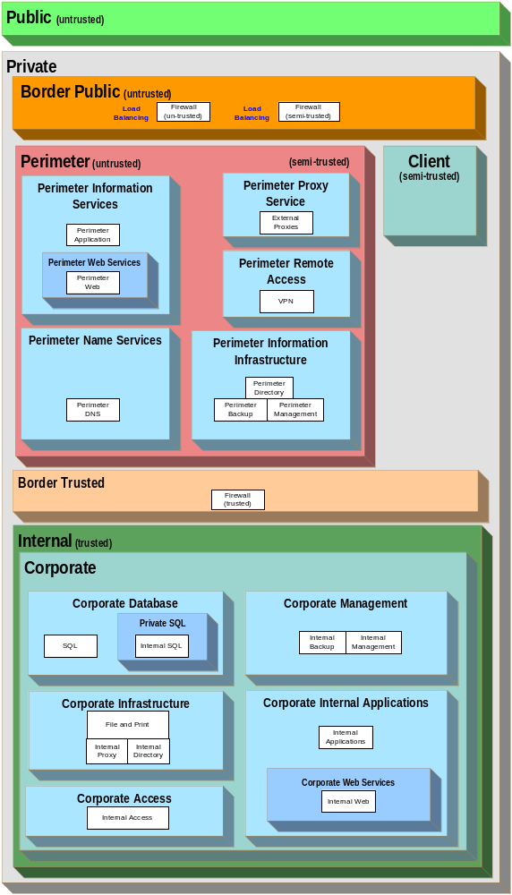
Figure 7. MSA CDC Security Zones and Tiers
The following table lists the zones for the CDC design process.

Zone Name | Zones It Contains | Tiers It Contains
Public | None (it is the Internet) | None
Private | Border Public, Perimeter, Border Trusted, Internal, and Client | None
Border (untrusted) | None | Perimeter Firewalls (untrusted and semi-trusted)
Perimeter | Perimeter Information Services, Perimeter Name Services, Perimeter Information Infrastructure, Perimeter Proxy Service, and Perimeter Remote Access | None
Perimeter Information Services | Perimeter Web Services | Perimeter Application
Perimeter Web Services | None | Perimeter Web
Perimeter Name Services | None | Perimeter DNS
Perimeter Information Infrastructure | None | Perimeter Directory, Perimeter Backup, and Perimeter Management
Perimeter Proxy Service | None | External Proxies
Perimeter Remote Access | None | VPN
Border (trusted) | None | Internal Firewalls
Internal | Corporate | None
Corporate | Corporate Database, Corporate Infrastructure, Corporate Management, Corporate Internal Applications, and Corporate Access | None
Corporate Database | Private SQL | Read-only SQL
Private SQL | None | Internal SQL
Corporate Infrastructure | None | Internal Proxy and Access, File and Print, and Internal Directory
Corporate Management | None | Internal Backup and Internal Management
Corporate Internal Applications | Corporate Web Services | Internal Applications
Corporate Web Services | None | Internal Web
Corporate Access | None | Internal Access
Client | None | Contains LAN-based client workstations.
Table 21. MSA CDC Security Zone Information
The MSA design team used the following reasoning to justify the creation of these zones:
- Public zone: In the MSA CDC scenario, the Internet and its connection to the external interface of the organization's border routers are defined as the Public zone. Customers accessing the CDC Web servers and remote employees connecting to the CDC network through a VPN are parts of this zone.
- Private zone: This zone contained all MSA CDC scenario connectivity tiers, application tiers, and network segments connected to the internal side of the organization's Internet-connected routers. The purpose of this zone was to separate the internal network traffic from the traffic to and from the Public zone. The boundary between the Private and Public zones was a router on which OSI model layer 3 ACLs were implemented to control inbound traffic, as sanctioned by the scenario’s enterprise security policy. The Private zone was comprised of the Border Public, Perimeter, Border Trusted, Internal, and Client zones.
- Border Public (untrusted) zone: This zone contained tiers that perform some form of access control functionality that isolates the Public zone from the Perimeter zone. The CDC designers decided to place the border firewall tiers into a single zone to simplify management and creation of firewall rules for the inbound and outbound traffic of the Public zone.
- Border Trusted zone: This zone also contained tiers that perform access control functionality, but here the Internal zone was isolated from the Perimeter zone. The trusted firewall tier was placed into this zone to simplify management and creation of firewall rules for inbound and outbound traffic of the Perimeter zone.
- Perimeter zone: This zone contained tiers that were bounded by some form of access control functionality that isolated the Public zone from the Perimeter zone and the Perimeter zone from the Internal zone, thereby also isolating the Internal zone from the Public zone. The purpose of this zone was to facilitate the creation of security polices within the CDC design so that traffic could be filtered between the Public and Internal zones. This zone was referred as the Perimeter network (also commonly known as a “DMZ” or “screened subnet”) by the design team because it existed between the public network and the internal network and held semi-trusted information. This zone contained tiers that provided public-facing services, such as DNS, application, and Web services. Any tier in this zone had either a public IP address or a tier that provided network address translation (NAT). The services provided on the tiers in this zone were considered public because users from the Public zone had some kind of access to them. While access control tiers were implemented between the Public and Perimeter tiers, tiers in the Perimeter zone were still likely to be the first-level targets for malicious attacks. The Perimeter zone was further subdivided into the following additional zones:
- Perimeter Information Services zone: This zone contained one tier called the Perimeter Application tier and a sub-zone for Web services. This zone existed so that access controls could be implemented to control the flow of traffic between this zone and the Public zone. While the designers considered placing the Web and Application tiers into the Perimeter zone without subdividing it further, they wanted to control traffic differently between the Public zone and the Perimeter Information Services tiers from the way it was controlled between the Public zone and the Perimeter Web tier; this allowed for more restrictive port filters to the Perimeter Web Services zone. Therefore, a zone was created for each group of tiers.
- Perimeter Web Services zone: This zone contained one tier called the Perimeter Web tier. This zone existed so that more granular access controls could be implemented to control the flow of traffic between this zone and the Public zone. The designers considered placing this tier into the Perimeter Information Services zone without subdividing it further; however, the designers wanted to restrict traffic to the Web tier to a greater degree than that of the Application tier. Therefore, a nested zone was required.
- Perimeter Name Services zone: This zone contained one tier called the Perimeter DNS tier. It was decided that the CDC scenario would host the organization’s own DNS rather than using its ISP’s DNS, which allowed for higher flexibility and self-reliance. This zone was created so that access controls could be implemented to control the flow of traffic between this zone and the Public zone. While the designers considered placing all tiers into the Perimeter zone without further subdivision, they wanted to control traffic differently between the Public zone and the Perimeter DNS tier from the way it was controlled between the Public zone and the Perimeter Web and Application tiers. Therefore, a zone was created for each group of tiers.
- Perimeter Information Infrastructure zone: This zone contained three tiers, all necessary to the operation and management of the perimeter services that are publicly accessible. These tiers were Perimeter Backup, Perimeter Directory, and Perimeter Management. This zone existed so that controls could be implemented to manage access to and from these infrastructure assets, and deny direct access from the Public zone.
- Perimeter Proxy Service zone: This zone contained one tier called the External Proxies tier. The designers decided to use a two-tier proxy architecture whereby internal clients communicated to an internal proxy service; this zone received requests from the internal proxies and retrieved the requested information from the Internet.
- Perimeter Remote Access zone: This zone contained one tier that provided remote access to internal resources. The tier was called VPN and was necessary to connect remote sites and users to the Internal zone.
- Client zone: This zone contained the client tiers in the organization. While the designers could have further subdivided the Client zone, there was no such technical requirement at this time.

Note: Remote clients accessing the network through a VPN connection were considered part of the Client zone once they were authenticated.

- Internal zone: The purpose of the Internal zone was to isolate the tiers running the organization’s internal services and clients from the Public and Perimeter zones. For this release, this zone contained only the Corporate zone, but the design was created to allow this zone to be expanded to contain other data center scenarios as required.
- Corporate: The purpose of this zone was to separate the enterprise servers from the clients. Studies show that a majority of security breaches originate internally; therefore, the MSA CDC design team defined this zone so that it could implement access control mechanisms to control the flow of traffic between tiers in this zone and the tiers in the Client zone. In addition, this zone kept the Perimeter zone tiers separated from the other tiers in this zone. While the designers could have simply implemented access control mechanisms between the Client and Corporate zones, they wanted to achieve more granular control capabilities in implementing different types of traffic flow; therefore, the MSA security team divided the Corporate zone into the following additional security zones:
Corporate Database: This zone contained the Corporate Database tier and the Private SQL zone. The purpose of this zone was to enable implementation of access control mechanisms between itself, the Perimeter zone, and the Client zone where queries and updates originate. The Private SQL zone was created within the Corporate Database zone to allow granular access control for sensitive internal data; this zone, in turn, contained a single tier called Internal SQL.
Corporate Infrastructure: This zone contained the Internal Directory, Internal Name Services, File and Print, and Internal Proxy and Access tiers. The purpose of this zone was to enable the implementation of an access control mechanism between itself, the Client zone, and the Perimeter zone. While the designers considered implementing this mechanism between the Client and Corporate zones, a more granular level of control was required for the different types of zones contained within the Corporate zone to the Perimeter and Client zone.
Corporate Management: This zone contained the tiers necessary for the management, deployment, and availability of all the systems in the Corporate zone. It encompassed the Internal Management and Internal Backup tiers. Placing these tiers into their own zone simplified the creation of their access rules. These tiers required access to all other tiers in the Corporate zone.
Corporate Internal Applications: This zone contained the Internal Applications tier and a sub-zone for internal Web services. The applications running on the hosts in these tiers were required to be accessible from the tiers in the Perimeter zone. Therefore, the level of granularity in access control to these tiers required the creation of this zone to prevent external exposure of other zones in the Corporate zone.
Corporate Web Services zone: This zone contained one tier called the Internal Web tier, which provides for the implementation of more granular access controls to control the flow of traffic between itself and the Perimeter zone. The designers considered placing the Internal Web tier in the Internal Applications zone without further subdivision. However, they wanted to restrict traffic to the Internal Web tier more than the traffic to the Internal Applications tier; hence, the requirement for an additional zone.
Corporate Access zone: This zone contained a single tier called the Internal Access tier. As queries to this tier originate from the Perimeter Remote Access zone, the original architecture design specified this as a zone requirement. When it came to the specific implementation of the MSA CDC deployment, the design was reviewed and the network design team consolidated this zone within the Corporate Infrastructure zone and complied with the security requirements of the scenario through the use of host-based ACLs. This design update was made as the number of hosts required in this Internal Access tier did not warrant the overhead of an entire security zone. It was consolidated into the Corporate Infrastructure zones because of the direct dependency on the servers in the Internal Directory tier.
Security Zone Restrictions
Once the security zones for the MSA CDC scenario were defined, the following communication and restriction requirements were identified:
- Tier restrictions within a zone
- Intra-zone tier communications
- Inter-zone communications
The following sections discuss these requirements.
Tier Restrictions Within a Zone
The MSA CDC design imposed restrictions at multiple layers to comply with the defense-in-depth approach. The following table lists the restrictions imposed on the tiers in the CDC scenario design, but does not list the restrictions imposed on the network layer; they are addressed in the following sections. For full details of these restrictions, refer to the MSA Implementation Kit.

Zone | Identified Vulnerabilities | Physical | Host /  Device | Data | Application
Perimeter | Undesired TCP/UDP port access to tiers. | All components of the tiers in this zone resided in access-controlled rooms. | All tiers in this zone were deployed and maintained with the latest operating system service packs and hotfixes. | Before accessing any data on these tiers, users were authenticated by a combination of user name and password.  In addition, the user name and passwords transmitted to these tiers were encrypted. | Any applications (packaged or developed in house) on these tiers were deployed and maintained with the latest service packs and hotfixes. Only those applications and services necessary for the proper functioning of the services within this zone were enabled; in addition, they adhered to Contoso application security guidelines (not included in this chapter). All servers within this zone were members of the Windows Server 2003 Active Directory domain. Security templates were used to limit services running on these servers to only those that were necessary for the proper functioning of the operating system and to provide the functionality for which the server was implemented (for example, the DNS service on DNS servers).
Perimeter Information Services | Undesired TCP/UDP port access to tiers.  Buffer overflows.  Format string attacks. |  | The operating system was configured to perform TCP/IP port filtering, allowing only ports 80 and 443 inbound from the Public zone. |  | The Web server (Internet Information Server) was configured to service requests only through necessary methods (for example, HTTP and ASP); all others were disabled using the IIS lockdown process.
Perimeter Web Services | Undesired TCP/UDP port access to tiers.  Buffer overflows.  Format string attacks. |  | The operating system was configured to perform IPSec port filtering; allowing only ports 80 and 443 inbound from the Public zone. |  | The Web server (IIS 6.0) was configured to service requests for static content and file types only.
Perimeter Name Services | Undesired TCP/UDP port access to tiers.  Unauthorized zone transfers. |  | The operating system was configured to perform IPSec port filtering; allowing only protocol UDP and port 53 inbound from the Public zone. |  | The DNS server was configured to only answer recursive requests for the zones for which it is the source of authority (SOA).
Internal | Undesired TCP/UDP port access to tiers. | All components of the tiers in this zone resided in access-controlled rooms. | All tiers in this zone was deployed and maintained with the latest operating system service packs and hotfixes. | Before accessing any data on these tiers, users were authenticated by a combination of user name and password. In addition, the user name and passwords transmitted to these tiers were encrypted. | Any application (packaged or developed in house) on these tiers was deployed and maintained with the latest service packs and hotfixes. Only those applications and services that were necessary for the proper functioning of the service were enabled.
Corporate |  |  |  |  | All servers within this zone were members of the Windows Server 2003 Active Directory domain. Security templates were used to limit services running on these servers to only those necessary for proper functioning of the operating system and for providing the functionality for which the server was implemented (for example, the DNS service on DNS servers).
Corporate Internal Applications | Undesired TCP/UDP port access to tiers.  Buffer overflows.  Format string attacks. |  |  |  | The Web server (IIS 6.0) was configured to service requests only through necessary methods; all others were disabled through IIS lockdown.
Corporate Web Services | Undesired TCP/UDP port access to tiers.  Buffer overflows.  Format string attacks. |  |  |  | The Web server (IIS 6.0) was configured to service requests for static content and file types only.
Table 22. CDC Tier Restrictions
The network layer is addressed in the following section on intra-zone and inter-zone communications.
Intra-zone Communications
In the MSA CDC design it was decided to not restrict the intra-zone communications at the policy level. Instead, the restrictions were applied at a host level using host-based ACLs.
Inter-zone Communications
The following table lists the communication that was allowed between various security zones in the CDC scenario.

Source Zone | Destination Zone | Vulnerabilities Mitigated | Permitted Communication Between Zones at the Network Layer
Public | Private | Undesired TCP/UDP port access to tiers. | A device that performs the function of application-layer proxy firewall was placed at the network layer between these two zones because the risk analysis identified this area as a high priority risk. Communication between these zones is the first opportunity for an attacker to infiltrate the CDC network; therefore, the organization chose to implement a firewall. To mitigate the risk further, it chose to force the usage of a single function firewall device, which does not perform the firewall function between any other zones. In addition, it required a firewall device that could provide the application layer proxy function to mitigate the risk of attackers using Trojan software on the servers that listen on allowed ports in this zone. The application layer proxy firewall will drop traffic on allowed ports if it is not the intended type of traffic on the allowed port (for example, HTTP traffic for Web servers). Last, the device serving the firewall role also provided the NAT function. As an additional mitigation strategy, the MSA security team wanted to shield the organization’s internal addressing scheme from the Public zone.
Public | Perimeter Information Services | Undesired TCP/UDP port access to tiers. | Traffic was allowed to flow only over TCP ports 80 (HTTP) and 443 (HTTPS) between these zones and only in the direction specified by the source and destination zones.
Public | Perimeter Web Services | Undesired TCP/UDP port access to tiers. | Traffic is allowed to flow only over TCP ports 80 (HTTP) and 443 (HTTPS) between these zones and only in the direction specified by the source and destination zones.
Public | Perimeter Name Services | Undesired TCP/UDP port access to tiers.  Unauthorized zone transfers.  DNS poisoning. | Traffic was allowed to flow only over UDP port 53 (DNS) between these zones and only in the direction specified by the source and destination zones. (Note: TCP port 53 was closed to prevent zone transfers and other DNS poisoning attacks. As this tier was the source of authority for the zones, responses did not go beyond the 64-byte UDP query reply limitation.)
Public | Perimeter Remote Access | Undesired TCP/UDP port access to tiers. | Traffic was allowed to flow only over ports 500 (IPSec IKE) and protocol 50 (IPSec), 1701 (L2TP), 1723 (PPTP), and 4500 (IPSec NAT-T), and only in the direction specified by the source and destination zones.
Perimeter Remote Access | Public | Undesired TCP/UDP port access to tiers. | Traffic was allowed to flow only over ports 500 (IPSec IKE) and protocol 50 (IPSec), 1701 (L2TP), 1723 (PPTP), and 4500 (IPSec NAT-T), and only in the direction specified by the source and destination zones.
Perimeter Remote Access | Corporate Access | Undesired TCP/UDP port access to tiers. | Traffic was allowed to flow only over TCP ports 1812-1813 for RADIUS authentication requests between these zones and only in the direction specified by the source and destination zones.
Perimeter Proxy Service | Public | Undesired TCP/UDP port access to tiers. | Traffic was allowed to flow over any TCP or UDP port between these zones but only in the direction specified by the source and destination zones.
Perimeter Information Services | Perimeter Information Infrastructure | Undesired TCP/UDP port access to tiers. | All traffic was allowed to flow only over a private network between these zones and only in the direction specified by the source and destination zones.
Perimeter Information Infrastructure | Perimeter Information Services | Undesired TCP/UDP port access to tiers. | All traffic was allowed to flow only over a private network between these zones and only in the direction specified by the source and destination zones.
Perimeter Name Services | Perimeter Information Infrastructure | Undesired TCP/UDP port access to tiers. | All traffic was allowed to flow only over a private network between these zones and only in the direction specified by the source and destination zones.
Perimeter Information Infrastructure | Perimeter Name Services | Undesired TCP/UDP port access to tiers. | All traffic was allowed to flow only over a private network between these zones and only in the direction specified by the source and destination zones.
Perimeter | Internal | Undesired TCP/UDP port access to tiers. | A physically separate and dedicated stateful inspection firewall was necessary to filter all traffic flowing between these two zones bidirectional. This design provided a centralized point of security enforcement.
Corporate Infrastructure | Perimeter Name Services | Undesired TCP/UDP port access to tiers. | All traffic was allowed to flow between these zones but only in the direction specified by the source and destination zones. This design was used for DNS zone updates to the publicly accessible DNS servers.
Corporate Management | Perimeter Information Infrastructure | Undesired TCP/UDP port access to tiers. | All traffic was allowed to flow between these zones but only in the direction specified by the source and destination zones. This was used to support Terminal Services from Internal to Perimeter as well as to retrieve Perimeter backups.
Corporate Infrastructure | Perimeter Information Services | Undesired TCP/UDP port access to tiers. | All traffic was allowed to flow between these zones but only in the direction specified by the source and destination zones. This design was used to support updates of the Public Key server.
Perimeter Information Services | Corporate Database | Undesired TCP/UDP port access to tiers. | Traffic was allowed to flow over TCP port 1433 (SQLnet) between these zones but only in the direction specified by the source and destination zones.
Corporate Management | Corporate Database | Undesired TCP/UDP port access to tiers. | All traffic was allowed to flow between these zones but only in the direction specified by the source and destination zones.
Corporate Management | Corporate Internal Applications | Undesired TCP/UDP port access to tiers. | All traffic was allowed to flow between these zones but only in the direction specified by the source and destination zones.
Corporate Management | Corporate Infrastructure | Undesired TCP/UDP port access to tiers. | All traffic was allowed to flow between these zones but only in the direction specified by the source and destination zones.
Corporate Internal Applications | Corporate Database | Undesired TCP/UDP port access to tiers. | Traffic was allowed to flow over port 1433 (SQLnet) between these zones but only in the direction specified by the source and destination zones.
Corporate Internal Applications | Corporate Infrastructure | Undesired TCP/UDP port access to tiers. | All traffic was allowed to flow between these zones.
Perimeter Remote Access | Corporate Infrastructure | Undesired TCP/UDP port access to tiers. | External proxies were allowed to pass responses back on any TCP or UDP high port >1024.
Client | Corporate | Undesired TCP/UDP port access to tiers. | The CDC designers had deemed it unnecessary to filter the traffic between these zones because there are many different types of communications that would be disrupted by filtering.
Client | Corporate Database Private SQL | Undesired TCP/UDP port access to tiers. | Only authenticated users may access this data. Traffic was allowed to flow over port 1433 (SQLnet) between these zones but only in the direction specified by the source and destination zones. This design approach allowed for database queries.
Table 23. CDC Inter-zone Communications Information
As stated earlier, this table does not provide details of all MSA CDC security restrictions, but illustrates a sample of the data that was generated for this project. Full details of these communications are provided in the MSA Implementation Kit, which contains the complete scenario-specific project details. These definitions should not be used only as a part of the project design but also as an ongoing document that is updated whenever new services or applications are added to the CDC environment.
Services Worksheet—Service Consumer Information
This worksheet was the result of a collaboration between the security and network design teams and the firewall service designer. The worksheet’s role was to gather the service-specific requirements from various service designers that would drive the overall network security design; this information was required for each network interface of the servers or network devices that the service introduced into the design. The following figures and requirement lists were given to the service designers as guidelines to facilitate consistent taxonomy in requesting their security and networking requirements:

Note: Much of the following section applies to the network architecture. The MSA team decided to combine the collection and provisioning of the security and networking requirements to increase overall efficiency and consistency between the security and network architecture designs.

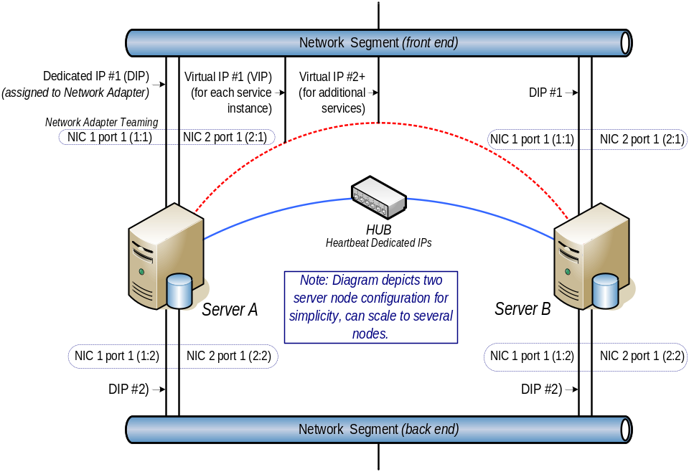
Figure 8. Standard Clustered Configuration
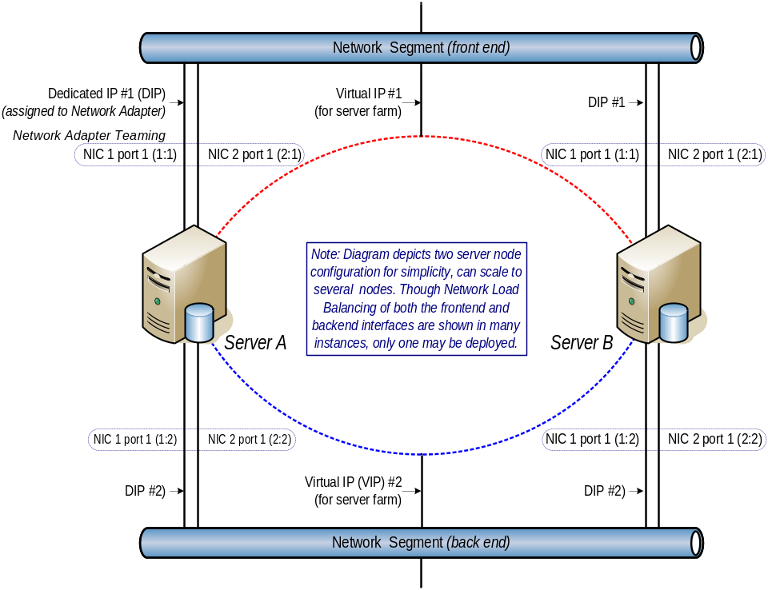
Figure 9. Standard Network Load Balanced Configuration
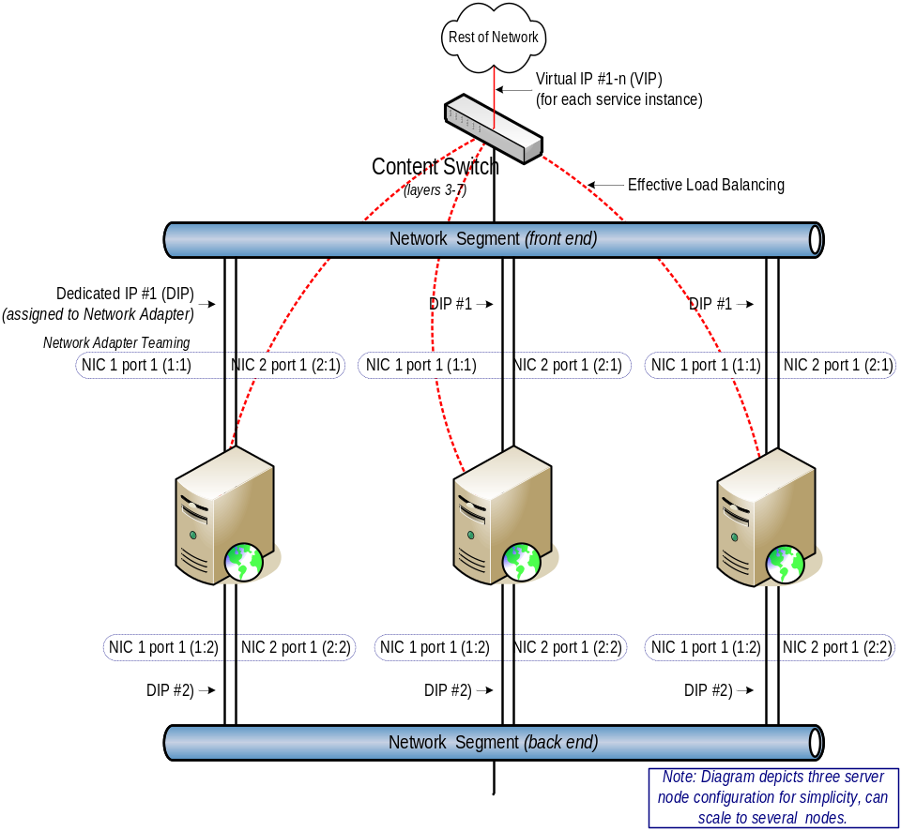
Figure 10. Standard Load Balancer Configuration
Using these figures as common reference points, the service designers completed the service worksheet for their service. The following list is an example of the information that they had to provide in these documents:
- Service definition: This was used to roll up all service requirements on a service-by-service basis.
- Service name
- Service zone: Specify the security zone in which the device was to be placed.
- Device name
- Contact (e-mail alias)
- Service consolidation: Specify what other services were hosted by this device (for example, site-to-site and user VPN services were consolidated).
- Networking requirements:
- Network segment: Specify what particular network segment, physical or virtual, the network or server network interface is placed at. A network segmentation diagram was provided for network segment IDs and device placement.
- Bandwidth: Specify the bandwidth required (for example, 10 Mbps, 100 Mbps, or 1000 Mbps) for the network interface.
- LoN participant (lights out): Specify whether this device participates in a lights-out or remote management access network through a dedicated network interface.
- DIP allocations (private or public): Specify the number of public or private dedicated IP addresses required for the network interface.
- IPSec offloading: Specify whether the network adapter needs to provide IPSec processing to reduce device CPU overhead.
- Data encryption: Specify if network packets needed to be encrypted.
- Register in DNS (internal or external): Specify whether this network interface needs to be registered in the internal or external (non-Internet, non-public) DNS; for example, the VPN back-end network interface needs to be registered in the internal DNS, whereas the front-end network interface needs to be registered into the external (Internet accessible, public) DNS.
- Packet trafficking (forwarding, recipient): Specify whether this network interface is a target or needs to forward BOOTP or DHCP or other requests.
- Routing requirements:
- Internet access: Specify if this device requires public Internet access and business justification, because the security policy restricted data center servers from accessing the Internet directly.
- Destination service (list all services): List all services (represented by the Service zone code) with which the device needs to communicate; for example, the VPN service back-end network interface needs to communicate with the DNS and IAS services whereas the front-end interface needs to communicate with external clients or site-to-site VPN devices only.
- Required routing (list all services): Specify any segment or VLAN that the network or server device needs to route or have requests forwarded to. For segmentation and traffic path information, refer to the network segmentation figure.
- Open shortest path first (OSPF) routing: Specify if any OSPF routing needs to be enabled and configured for the device.
- Static routes (device): Specify if any static routes will be provided to the device and justification for this requirement. OSPF was provided by the networking devices to provide dynamic network routing; static routing was avoided because it does not provide a highly available solution.
- LMHOSTS lookup (device): Specify if a local LMHosts or Host file lookup needs to be enabled on the device and justification. The overall security and networking policies were to avoid host files as much as possible.
- Network load balancing and clustering requirements:
- Virtual IP allocations (private or public): Specify the number of public or private virtual IP addresses required for the network interface.
- Virtual IP type: Specify the type of virtual IP required, whether it is for clustered or network load balanced devices or for content switching through a separate device.
- SSL offloading: Any service that needs to offload SSL processing to a load balancing network device needs to provide a certificate to enable this service.
- Load balancing type: Specify the type of load balancing required (for example, round robin, weighted, least connection, fastest, or custom).
- Persistence: Specify whether device persistence is necessary for the virtual IP (for example, cookie, session, SSL, or custom).
- Ports and protocol requirements:
- Ports and protocols (application specific inbound, outbound): Specify all protocols required for the network interface or virtual IP and direction of traffic flow (for example, TCP, or UDP).
- Common ports and protocols (bidirectional): Specify what common ports are required by the service and device.
This list generated a huge amount of information for each service during the MSA CDC design process. The full details of this documentation for the services in the CDC scenario can be found in the service worksheets, which are provided as part of the MSA 2.0 Deployment Kit in the MSA Implementation Kit.
VLAN Segmentation Matrix
After reconciling the security zoning and the service requirements, the VLAN security ACLs could be defined. Cross referencing all source VLANs and segments to all destination VLANs and segments and then applying the type of network device that provided security provided the ability to generate a network segmentation matrix. The following table is a sample of the data that was generated and used in the MSA CDC design; its key follows immediately after the table. This data is available in full from the ConfigurationMatrix.xls spreadsheet in the MSA Implementation Kit.

Description |  | Dest | ISPU1 | ISPU2 | ISPD1 | CPF | CPB | CPD | CPNM | CPRM | CIA | CIF
Description | Src | VLAN # | - | - | - | 517 | 518 | 519 | 523 | 524 | 316 | 317
Internet Service Provider Upstream 1 | ISPU1 | - | - | D | R | D | D | D | D | D | D | D
Internet Service Provider Upstream 1 | ISPU2 | - | D | - | R | D | D | D | D | D | D | D
Internet Service Provider Downstream 1 | ISPD1 | - | R | R | - | D | D | D | D | D | D | D
Internet Service Provider downstream 2 | ISPD2 | - | R | R | D | D | D | D | D | D | D | D
Corporate Perimeter Front End (inbound) | CPFi | - | D | D | R | D | D | D | D | D | D | D
Corporate Perimeter Front End (outbound) | CPFo | - | D | D | R | D | D | D | D | D | D | D
Corporate Perimeter Screened Subnet (inbound) | CPSi | 512 | D | D | D | V | D | V | D | D | D | D
Corporate Perimeter Screened Subnet (outbound) | CPSo | 813 | D | D | D | D | D | D | D | D | D | D
Corporate Perimeter VPN | CPV | 802 | D | D | D | D | D | D | D | D | D | D
Corporate Perimeter Application | CPA | 516 | D | D | D | D | D | D | D | D | D | D
Corporate Perimeter Front End | CPF | 517 | D | D | D | - | D | D | D | D | D | D
Corporate Perimeter Backend | CPB | 518 | D | D | D | D | - | D | D | D | F | F
Corporate Perimeter DNS (answerer) | CPD | 519 | D | D | D | D | D | - | D | D | D | D
Corporate Perimeter Network Management | CPNM | 523 | D | D | D | D | D | D | - | D | D | D
Corporate Perimeter Remote Management | CPRM | 524 | D | D | D | D | D | D | D | - | D | D
Corporate Internal Application | CIA | 316 | D | D | D | D | F | D | D | D | - | D
Corporate Internal Front End | CIF | 317 | D | D | D | D | F | D | D | D | D | -
Corporate Internal Back End | CIB | 318 | D | D | D | D | D | D | D | D | D | D
Corporate Internal Infrastructure | CII | 311 | D | D | D | D | F | D | D | D | V | V
Corporate Internal Data Front End | CIDF | 319 | D | D | D | D | F | D | D | D | V | V
Table 24. MSA CDC Network Segmentation Matrix
KEY
- (A): No ACL—allow all.
- (D): No communication—deny all.
- (F): Firewall rule is required to secure communications.
- (R): Router ACL is required to secure communications.
- (V): Switch VLAN ACL is required to secure communications.
- (-): Not applicable.
This table formed the basis of the network security requirements by proving the details of the type of security that was needed for each segment or VLAN.
Network Security Matrix
Combining the detailed port and protocol information from the service worksheets and the VLAN information from the previous Network Segmentation Matrix table provided the ability to generate the complete network security matrix. The following table provides a sample of how this information looked in the MSA CDC scenario.

IP Addressing | Destination | ISPU1 | ISPU2 | CPA | CPF |  |  | CIB | CII
 | Source | Server Name | - | - | 516 | 517 | 317 | CIF VIP 10.1.17.170 | 318 | 311 | NA-DCi | IAS
170.168.2.0/24 | ISPU1 | - | A | A | D | D | D | D | D | D | D | D
170.168.3.0/24 | ISPU2 | - | A | A | D | D | D | D | D | D | D | D
209.217.184.0/24 | ISPD1 | - | A | A | D | D | D | D | D | D | D | D
205.46.134.0/24 | ISPD2 | - | A | A | D | D | D | D | D | D | D | D
208.217.184.16/28 | CPFi | - | A | A | D | D | D | D | D | D | D | D
208.217.184.32/27 | CPFo | - | A | A | D | D | D | D | D | D | D | D
192.168.12.0/24 | CPSi | - | D | D | D | D | D | D | D | D | D | D
192.168.12.76 & 77 | - | CP-FWPb | - | - | A | A | - | - | - | - | - | -
192.168.13.0/24 | CPSo | - | D | D | D | D | D | D | D | D | D | D
192.168.14.0/24 | CPV | - | D | D | D | D | D | D | D | D | D | D
192.168.14.80 & 81 | - | VPNb | D | D | D | D | L4 | TCP:80 | D | L4 | D | UDP:1812-1813
192.168.16.0/24 | CPA | - | D | D | A | TCP: 80, 443, 8080-8085 | D | D | D | D | D | D
192.168.17.0/24 | CPF | - | D | D | TCP: 80, 443, 8080-8085 | A | D | D | D | D | D | D
192.168.19.0/24 | CPD | - | D | D | D | D | D | D | D | D | D | D
10.1.25.0/24 | CPB | - | D | D | D | D | D | D | D | D | D | D
10.1.25.14 & 15 | - | CP-DC | D | D | D | D | D | D | D | TCP: 464, 3268, 57903-57905 UDP: 123 | TCP: 464, 3268, 57903-57905, 389, 135, 445  UDP: 123, 389, 88 | TCP: 464, 3268, 57903-57905 UDP: 123
10.1.25.20 & 21 | - | CP-MGT | D | D | D | D | D | D | D | L4 | TCP: 464, 3268, 57903-57905, 389, 135, 445 UDP: 123, 389, 88 | D
10.1.25.13 | - | CP-BAK | D | D | D | D | D | D | D | D | D | D
10.1.25.22-25 | - | CP-WEB | D | D | D | D | L4 | TCP: 80, 443, 8100, 1810-1815 | D | D | D | D
10.1.25.9,10-12 | - | CP-APP | D | D | D | D | L4 | TCP: 80, 443, 8100, 1810-1815 | D | D | D | D
Table 25. MSA CDC Network Security Matrix
The process of creating this table was a collaborative effort between the MSA network, security, and firewall design experts. The following key was used:
- (A): No ACL—allow all.
- (D): No communication—deny all.
- (L4): Host based security.
- (-): Not applicable.
The table is provided as part of the “Configuration Matrix” spreadsheet in the MSA Implementation Kit because this data is highly specific to the requirements of the particular MSA CDC scenario.
Industry Standard Security and Network Settings
At this point of the design, the security requirements for the MSA CDC design have been defined and documented. However, in an area like computer security the nature of attacks and defenses keeps changing all the time. To help mitigate any current or future security risks, it is important that the design takes into account the latest industry guidance for security configuration settings and updates. Oftentimes this information is provided by the network device vendors or directly by network or security experts. Standard configuration, best practices, and guidelines can be found from the URLs listed in the “References” section in this chapter.
Once the latest security guidelines have been accounted for in the design, the process of creating the configuration files necessary to set up the various network devices and servers were created. Basic network traffic ACLs were added to the network security configuration files using the information from the previous tables. These were then uploaded to the network devices to provide the required network configuration for each device.
As stated previously, the MSA security team’s primary focus was network penetration from the Public (untrusted) zone. The Perimeter zone had a significant number of ACLs applied, whereas the Internal zone had very few ACLs because this zone is typically very specific to an organization’s needs. These ACLs would need to be generated using a specific evaluation exercise to gather the explicit requirements for each application of the organization. The MSA security team decided not to apply explicit ACLs on every VLAN, segment, or host but rather to show the process that was performed for this release because each organization’s internal applications are tailored to their respective business needs and functions. Using this process and the sample data provided, the security team of future instantiations will be able to expand on this guidance to fulfill and document the security requirements of their specific instantiation.
The configuration files that were created as part of the CDC implementation are available for download as part of the MSA 2.0 Deployment Kit in the MSA Implementation Kit.
SBO Design Considerations
This section identifies and references the MSA Satellite Branch Office (SBO) scenario to illustrate how the design process was used to mitigate the risks of data compromise.
Architecture Design
The following section illustrates the process followed for the MSA SBO scenario. To obtain the complete picture of the design process, it is important to have an understanding of the documentation provided in the MSA 2.0 Planning Guide in the MSA Implementation Kit, specifically the “Introduction to MSA Planning Guide” chapter.
The result of this process was a complete security zone design that was used to plan the complete MSA SBO scenario infrastructure as built and tested in the MSA test labs.
Technical Requirements
The MSA security team wanted to minimize the risk of attack to the infrastructure and its resources. To help achieve this, the following requirements were identified:
- The SBO sites must take advantage of all services from the CDC site.
- No servers need to be deployed in the SBO site.
- The networking services do not need to be highly available.
- Network services must be secure end-to-end, including communications that traverse the Internet.
- All network communications that are not explicitly allowed must be denied.
- All services must use the CDC central authentication mechanism.
- SBO sites must be centrally managed by the staff at the CDC site.
These requirements were set and agreed upon by all members of the design team at the beginning of the design process.
Desired Outcome
The desired outcome for the MSA SBO design process was to create an infrastructure that meets the technical requirements of an organization and adheres to the security requirements of the architecture blueprints.
Process
For the MSA SBO design process, only the most relevant procedures of SRMD were applied. This approach was taken because the MSA implementation is a lab instantiation of the overall MSA architecture; therefore, mitigation of every risk present in the environment would be of little practical value. The MSA security team mainly focused their efforts on the following aspects:
- Network security, primarily for external penetration attacks.
- Active Directory service policies.
- Host-hardening and IPSec policies (currently out-of-scope for this release).
Service-specific details are available in the "Security" section in each of the chapters of the Service Blueprints guide in this documentation kit. The following sections illustrate how security was implemented in the SBO design.
Asset Assessment and Valuation
The “Asset Assessment and Valuation,” “Data Classification,” and “Tier Classification” lists identified in the “MSA Enterprise Design” section in this chapter were used directly in the MSA SBO design process.
Tier Identification List
The following table lists the tiers identified for deployment in the SBO design scenario.

Tier Name | Tier Description | Tier Classification | Reason for Tier Classification
Firewall (untrusted) | Enforces security policies to protect assets that are available to untrusted public users. | Primary | This tier is a core part of the security enforcement mechanism. While it publishes publicly accessible data to non-trusted clients, it contains highly restricted configuration data.
Remote Access | Allows external authenticated users to access corporate networked services. | Primary | This tier provides a mechanism for users to connect securely to corporate services from remote locations. This service extends the core network service to encompass remote clients and facilities.
Client | Internal client access tiers. | Isolated | The client tiers in the organization contain information that is accessible only to them and the authorized administrative staff. The organization has a policy that all client tiers will maintain their data on servers within the organization rather than on the local hard drive, although user profile information is still stored locally.
Table 26. MSA SBO Tiers Identification List
The Firewall and Remote Access tiers were consolidated on the Cisco 1751 routing device and the client switching was provided by a Cisco 2950 switch.
For more information on the network devices used in the SBO design, refer to the “Network Devices” chapter of the Service Blueprints guide.
Security Risk Identification
The Vulnerability Assessment, Risk Assessment, and Analysis and Remediation processes were not carried out because the MSA SBO implementation was only a lab instantiation of the overall MSA architecture. The MSA team recommends the SRMD provided in Chapter 3 of the Securing Microsoft Windows 2000 Server solution guide.
The following sections illustrate the remaining steps of the security architecture planning process used in the MSA SBO scenario.
Security Zone Definitions and Restrictions
The SRMD process can be used in conjunction with the security zones defined within the organization to assist in determining the number of zones best suited for the environment.
Security Zone Definitions
In the MSA SBO scenario, the security administrator defined the zones in the following figure to ensure protection of the organization's IT assets. The figure depicts the security zones and tiers defined for the SBO scenario.

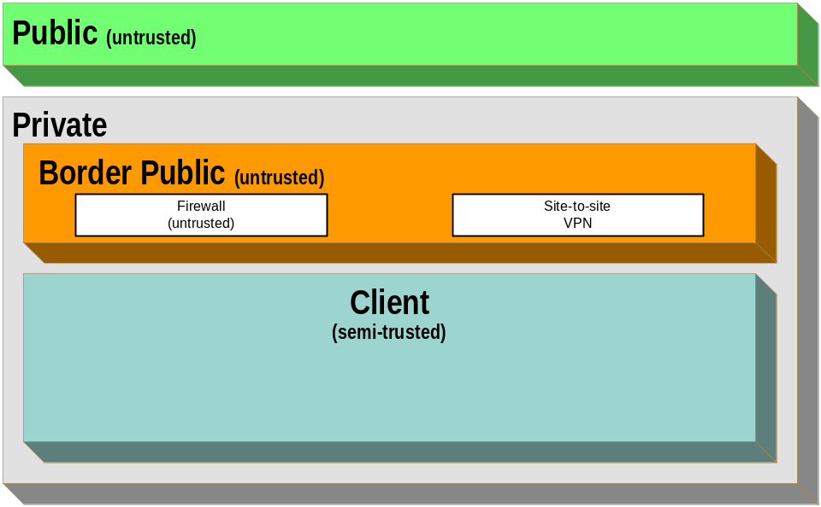
Figure 11. MSA SBO Security Zones and Tiers
The following table lists the zones for the SBO design process.

Zone Name | Zones It Contains | Tiers It Contains
Public | None (it is the Internet) | None
Private | Border Public, Perimeter, Border Trusted, Internal, and Client | None
Border (untrusted) | None | Perimeter Firewalls (untrusted and semi-trusted)
Client | None | LAN-based client workstations.
Table 27. MSA SBO Security Zone Information
The MSA design team used the following reasoning to justify the creation of these zones:
- Public zone: In the MSA SBO scenario, the Internet and its connection to the external interface of the organization's border routers are defined as the Public zone. The SBO to CDC site-to-site VPN network is part of this zone.
- Private zone: This zone contained the MSA SBO scenario connectivity tiers and network segments connected to the internal side of the organization's Internet-connected routers. The purpose of this zone was to separate the internal network traffic from the traffic to and from the Public zone. The boundary between the Private and Public zones was a router on which layer 3 (of the OSI model) ACLs were implemented to control inbound traffic, as sanctioned by the scenario’s enterprise security policy. The Private zone was comprised of the Border Public and Client zones.
- Border Public (untrusted) zone: This zone contained tiers that perform some form of access control functionality that isolates the Public zone from the Perimeter zone. The SBO designers decided to place the border firewall tiers into a single zone to simplify management and creation of firewall rules for the inbound and outbound traffic of the Public zone.
- Client zone: This zone contained the client tiers in the organization. While the designers could have further subdivided the Client zone, there was no such technical requirement at this time.
Security Zone Restrictions
Once the security zones for the MSA SBO scenario were defined, the following communication and restriction requirements were identified:
- Tier restrictions within a zone
- Intra-zone tier communications
- Inter-zone communications
The following sections discuss these requirements.
Tier Restrictions within a Zone
The MSA SBO design consisted of only one internal zone, therefore no restrictions were required. For more details of these restrictions, refer to the MSA Implementation Kit.
The network layer is addressed in the following section on inter-zone communications.
Intra-zone Communications
In the MSA SBO design it was decided to not restrict intra-zone communications at the policy level.
Inter-zone Communications
The following table lists the communications that were allowed between various security zones in the SBO scenario.

Source Zone | Destination Zone | Vulnerabilities Mitigated | Permitted Communication Between Zones at the Network Layer
Public | Private | Undesired TCP/UDP port access to tiers. | A device that performs the function of a firewall was placed at the network layer between these two zones because the risk analysis identified this area as a high priority risk. Communication between these zones is the first opportunity for an attacker to infiltrate the SBO network; therefore, the organization chose to implement a firewall. The device serving the firewall role also provided the NAT function. As an additional mitigation strategy, the MSA security team wanted to shield the organization’s internal addressing scheme from the Public zone.
Client | Corporate | Undesired TCP/UDP port access to tiers. | The MSA CDC designers deemed it unnecessary to filter the traffic between these zones because there are many different types of communications that would be disrupted by filtering.
Table 28. MSA SBO Inter-zone Communications Information
Complete details of these communications are provided in the MSA Implementation Kit, which contains the complete scenario-specific project details.
VLAN Segmentation and Security Matrix
After reconciling the security zoning and the service requirements, the VLAN security ACLs could be defined. Cross-referencing all source VLANs and segments to all destination VLANs and segments and then combining the detailed port and protocol information provided the ability to generate the complete network security matrix. The following table is a sample of the data that was generated and used in the MSA SBO design. To comply with the security policy, all VLAN communication was denied except where explicitly allowed. This data is available in more detail in the ConfigurationMatrix.xls spreadsheet in the MSA 2.0 Deployment Kit provided as part of the MSA Implementation Kit.

Description | IP Addressing | Dest. | CPV | CIA | CIF | CII | CIDF | CIM | CCN | LCN | LCII | VCN | PCN
Description | IP Addressing | Src.
Corporate Perimeter Screened Subnet (outbound) | 192.168.13.0  /24 | CPSo |  |  |  |  |  |  |  |  |  |  | A
Corporate Perimeter VPN | 192.168.14.0  /24 | CPV |  |  |  |  |  |  |  |  |  |  | A
Corporate Internal Infrastructure | 10.1.11.0/24 | CII |  |  |  |  |  |  |  |  |  |  | A
Corporate Internal Management | 10.1.22.0/24 | CIM |  |  |  |  |  |  |  |  |  |  | A
Corporate Client Network | 172.16.0.0  /19 | CCN |  |  |  |  |  |  |  |  |  |  | A
Corporate WAN Access | 10.1.1.0/24 | CWA |  |  |  |  |  |  |  |  |  |  | A
Corporate WAN Access Serial | 10.1.100.0  /24 | CWAS |  |  |  |  |  |  |  |  |  |  | A
London Client Network | 172.16.32.0  /23 | LCN |  |  |  |  |  |  |  |  |  |  | A
London Corporate Internal Infrastructure | 10.20.11.0  /24 | LCII |  |  |  |  |  |  |  |  |  |  | A
VPN Client | 10.250.0.0  /17 | VCN |  |  |  |  |  |  |  |  |  |  | A
Pittsburgh Client Network | 10.205.1.0  /27 | PCN | A | A | A | A | A | A | A | A | A | A | -
Table 29. MSA CDC Network Segmentation Matrix
This table formed the basis of the network security requirements by proving the details of the type of security that was needed for each segment or VLAN.
Industry Standard Security and Network Settings
At this point of the design, the security requirements for the MSA SBO design had been defined and documented. However, in an area like computer security the nature of attacks and defenses keeps changing all the time. To help mitigate any current or future security risks, it is important that the design takes into account the latest industry guidance for security configuration settings and updates. Oftentimes this information is provided by the network device vendors or directly by network or security experts. Standard configuration, best practices, and guidelines can be found at the URLs listed in the “References” section in this chapter.
Once the latest security guidelines have been accounted for in the design, the processes for creating the configuration files necessary to set up the various network devices and servers were created. Basic network traffic ACLs were added to the network security configuration files using the information from the previous tables, and were then uploaded to the network devices to provide the required network configuration for each device.
As stated previously, the MSA security team’s primary focus was network penetration from the Public (untrusted) zone. The Perimeter zone had a significant number of ACLs applied, whereas the Internal zone had very few ACLs because this zone is typically very specific to an organization’s needs. Such ACLs would need to be generated using a specific evaluation exercise to gather explicit requirements for each application of the organization. The MSA security team decided not to apply explicit ACLs on every VLAN, segment or host but rather to show the process that was performed for this release, because each organization’s internal applications are tailored to their respective business needs and functions. The security team for future instantiations will be able to expand on the process and sample data provided to fulfill and document the security requirements of their specific instantiation.
The configuration files that were created as part of the SBO implementation are available for download as part of the MSA 2.0 Deployment Kit in the MSA Implementation Kit.
Summary
This chapter provided a practical process for the successful creation of an enterprise security architecture that covers several aspects of the security design, including the various evaluation and classification processes required by the Security Risk Management Discipline (SRMD). The guidance provided for MSA 2.0 has been proven in the MSA test labs and is known to support all the services within the MSA 2.0 scope.
The security architecture and assessment process described in this chapter provides an excellent starting point for the design of a security architecture and strategy that can support real-world business requirements. It is important to understand that there are factors to assess and mitigate when designing even the simplest of security architectures; it is not a precise art, and the information presented in this chapter is designed to provide insights and examples to help complete a security architecture design that fits the organization’s needs.
The introduction of the simple Wingtip Toys scenario provided a demonstration of the SRMD process. The “CDC Design Considerations” and “SBO Design Considerations” sections provided valuable example data of the processes followed in the MSA CDC and SBO security architecture designs.
Security zoning was introduced in this chapter to show how this process forms a solid basis for the network and service designers to align their security efforts.
Also documented in this chapter was the process by which specific service requirements were collected from the service designers to create the VLAN segmentation and network security matrices for the MSA lab instantiation of the CDC and SBO scenarios. These matrices formed the basis of the network security and were tested by the MSA test team. Where the information generated in this process details the exact security data from the lab, the content has been provided in the ConfigurationMatrix.xls spreadsheet in the MSA Implementation Kit. This data is unique for each instantiation and therefore is only relevant in the context of the specific implementation.
Ultimately, the design is based on a combination of the specific requirements, environment, budgets, and preferences of the organization’s design team. There is no single right answer, only one that meets an organization’s requirements in a timely and affordable manner.
Because there are a great many factors that can affect the final choice of securing devices in the design, it is impossible for this one chapter to provide an exact choice. Additional relevant information can be found in the “MSA Network Architecture” chapter of this guide and "Network Devices," "Firewall Services,” and "Remote Access Services" chapters of the MSA 2.0 Planning Guide in the MSA Implementation Kit for the MSA test lab implementation.
Ultimately, the output from this design process is a completed network infrastructure design, but it is important that the documentation created is not left to stagnate. Security is not a “set it and forget it” service. These designs will need to be reviewed and updated regularly to ensure that security is maintained.
References
- “Security Services in Windows Server 2003”
www.microsoft.com/technet/prodtechnol/windowsserver2003/technologies/security
- "Application Security Best Practices at Microsoft"
www.microsoft.com/technet/itsolutions/msit/security/appsecbp.asp.
- "Windows Server 2003 Security Guide"
www.microsoft.com/technet/security/prodtech/Windows/Win2003/W2003HG
/SGCH00.asp
- The "Security" section of the Microsoft Developer Network (MSDN®) Web site at the following URL:
msdn.microsoft.com/nhp/Default.asp?contentid=28001191&frame=true
- "Writing Secure Code," by Michael Howard and David LeBlanc, ISBN 0-7356-1722-8, April 2002, from Microsoft Press®. For more information refer to the following URL:
www.microsoft.com/mspress/books/5957.asp
- "Designing Secure Web-Based Applications for Microsoft Windows 2000," by Michael Howard, ISBN 0-7356-0995-0, July 2000, from Microsoft Press. For more information refer to the following URL:
www.microsoft.com/mspress/books/4293.asp
- Microsoft Patterns & Practices: Reference Building Blocks at the following URL:
msdn.microsoft.com/practices/type/Blocks/default.asp
- For information on network security best practices, refer to the following URLs:
www.sans.org
www.cert.org
www.insecure.org
www.securityfocus.com
www.nsa.gov/snac/index.html

