Simulate Nicolas Pantano Project using Proteus
31 Maret 2015
14:13

- Run Proteus
- Create New Arduino Project
- Connect all component as in Mr Pantano paper
(http://github.com/handaga/sistem-operasi-mikro)

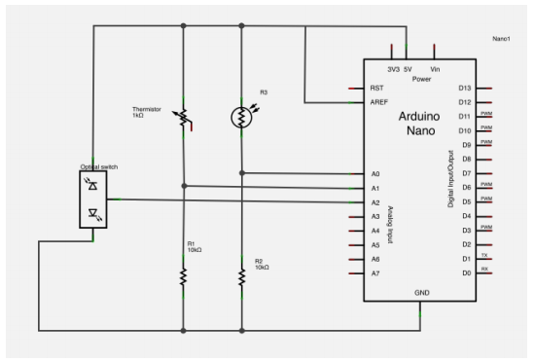

Note: All sensors (Intensity & Temperatue sensor, also OpticalSwitch) replace with active POT (we can adjust the center position when simulation run)

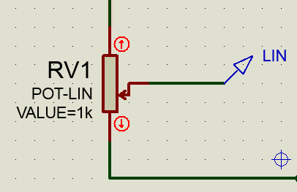

Add Tool TERMINAL connect to SERIAL COMMUNICATION (MUST BE)

Add tools DIGITAL ANALYZER to monitor activity, connect to pin number 7 - 12.

- Complete Code we can Rewrite From PAPER (page-19 until 22)

