**SUMMARY**

## USC ID/s:

6074572947

|  |  |  |  |  |
| --- | --- | --- | --- | --- |
| M+N | Time in MS  (Basic) | Time in MS  (Efficient) | Memory in KB (Basic) | Memory in KB (Efficient) |
| 16 | 0.000193 | 0.001804 | 0 | 48 |
| 64 | 0.000966 | 0.004691 | 48 | 304 |
| 128 | 0.002947 | 0.146505 | 176 | 384 |
| 256 | 0.011477 | 0.464708 | 880 | 352 |
| 384 | 0.02393 | 0.891955 | 1184 | 528 |
| 512 | 0.041201 | 1.6662 | 1616 | 448 |
| 768 | 0.095777 | 2.031357 | 3184 | 336 |
| 1024 | 0.16902 | 2.254833 | 5184 | 544 |
| 1280 | 0.290942 | 2.684382 | 7728 | 496 |
| 1536 | 0.403421 | 3.112488 | 11280 | 832 |
| 2048 | 0.76231 | 4.213395 | 19344 | 688 |
| 2560 | 1.156417 | 5.785816 | 29312 | 752 |
| 3072 | 1.747261 | 7.536842 | 31504 | 1072 |
| 3584 | 2.017363 | 9.642572 | 34208 | 1360 |
| 3968 | 2.779419 | 11.465664 | 48560 | 1232 |

## Datapoints

## Insights

### Graph1 – Memory vs Problem Size (M+N)

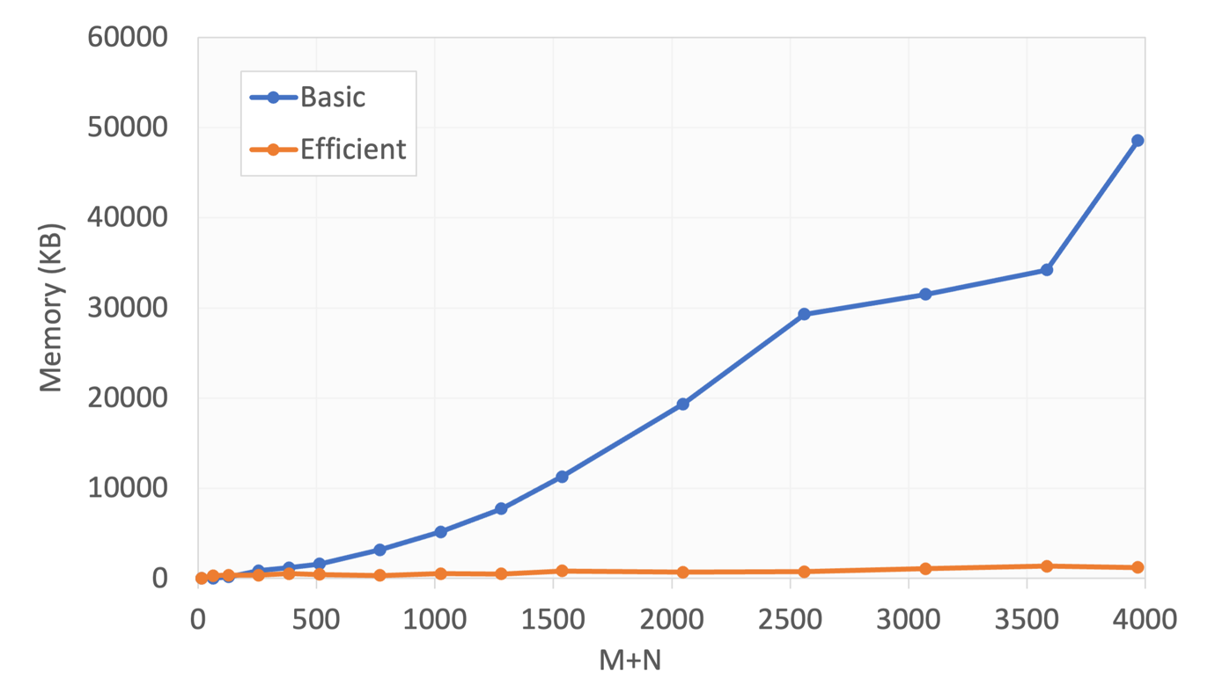

#### Nature of the Graph (Logarithmic/ Linear/ Polynomial/ Exponential)

Basic:

Efficient:

#### Explanation:

### Graph2 – Time vs Problem Size (M+N)

#### Nature of the Graph (Logarithmic/ Linear/ Polynomial/ Exponential)

Basic:

Efficient:

#### Explanation:

## Contribution

(Please mention what each member did if you think everyone in the group does not have an equal contribution, otherwise, write “Equal Contribution”)

<USC ID/s>: <Equal Contribution>