外汇经纪商基本全部和Metrader有合作，所以Mt4 是最主要的外汇零售保证金交易的交易平台。

对于部分平台，AvaTrader,Oanda他们和业界的程序化交易软件商Multicharts也有合作，宝库IB证券。

其中oanda-multicharts可以用作程序化交易外汇零售保证金业务。

在oanada开fxtrade,和fxtrade-practice帐户。

下载英文版的Multicharts,注意，在同一台电脑，中英文会导致严重的冲突，所以建议另外开VM使用或者测试。

在mc-Qm里面察看datasource-oanda
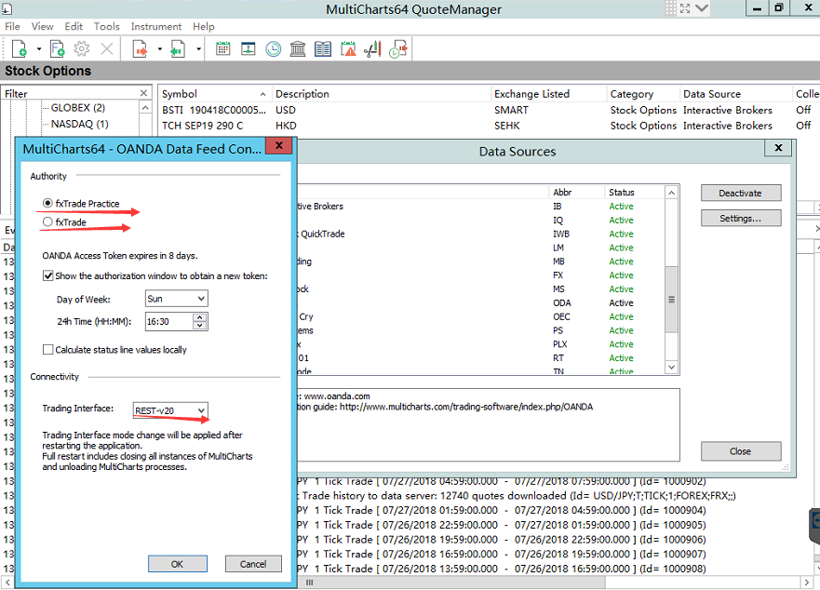
注意设置好帐户的类型和网管restful的类型。第一个是demo帐户，第二个是实盘帐户。

设置好之后，在主界面建立和oanda的连接。
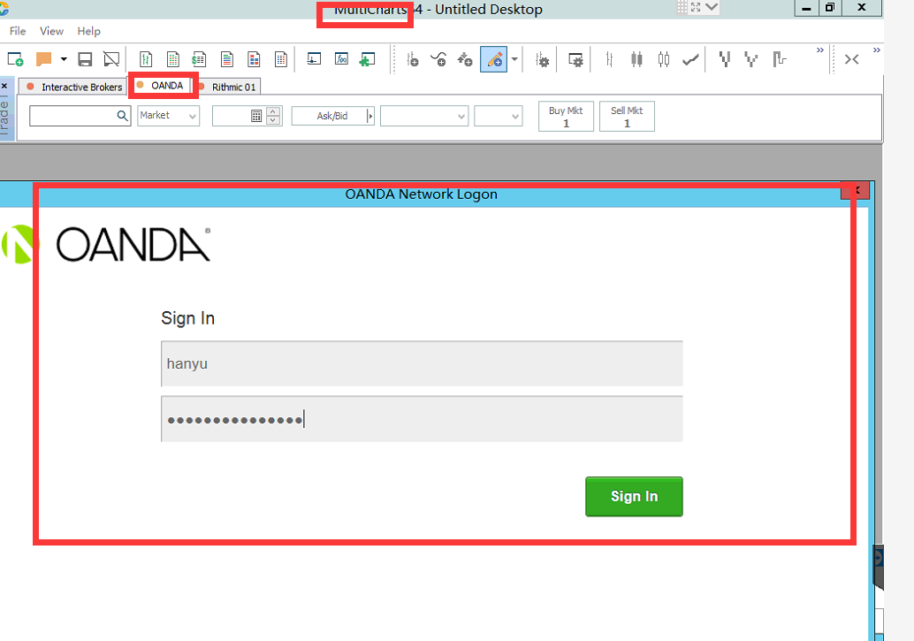
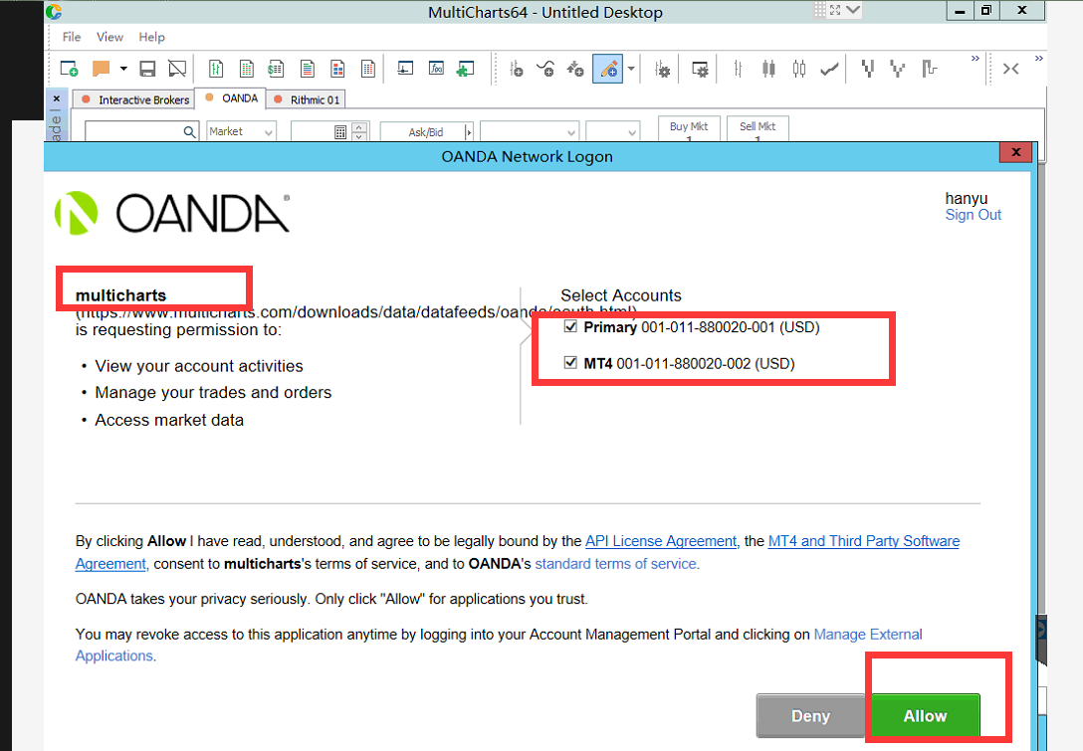

然后，连接上之后，添加品种商品，symbol进行交易。注意这里可以和mt4的行情进行比对，包括ask,bid和实时行情。经过比对，无误差。

建立模拟程序化交易，7*24小时交易/

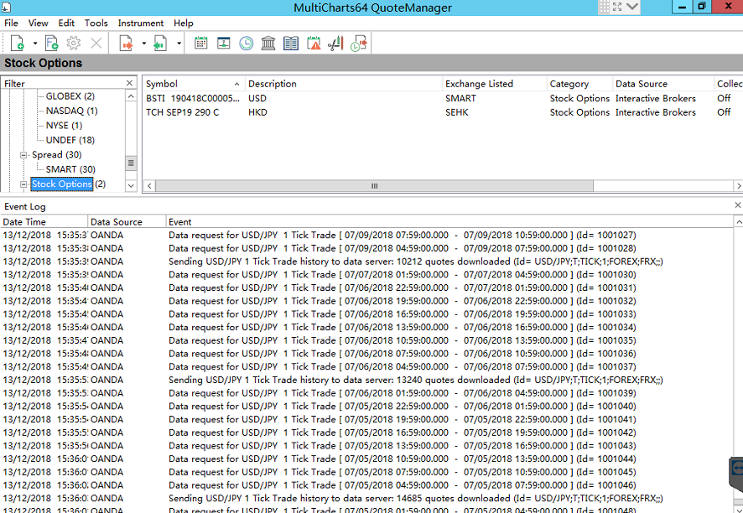
其中英文版的QM下方的日志是一个数据中心的日志重要来源，可以在这里看行情商和数据打印出的日志获取信息。注意。

另外对于英文版的MC来说，www.multicharts.com中的论坛讨论区是一个重要的资讯来源，里面有大量的关于英文版本-TWS，oanda的讨论和问题解决方案。以及交易策略讨论等。

https://www.multicharts.com/trading-software/index.php/OANDA
Note: OANDA Access Token expires in 8 days. One will need to re-authorize his OANDA connection to obtain a new token.
OANDA systems may be unavailable during the weekend due to maintenance on the broker end. Once the system is up one needs to re-authorize in the pop-up window in order to re-establish connection to OANDA.
To set up OANDA data feed connection:
- In the QuoteManager main menu select Tools and then click Data Sources. Select OANDA in the list of all supported data vendors and click the Settings button. The OANDA Data Feed Configuration window is opened.
- In the opened up window:
- Select the fxTrade Practice button for demo account or fxTrade button for live account.
- Calculate status line values locally - this option allows populating the scanner/status line with realtime values (that are not supplied by the OANDA API) calculated by MultiCharts. Having this option enabled and using a lot of instruments simultaneously may cause issues with OANDA connection due to frequent data requests, therefore if you do not need these values or have connection issues - disable the option to maintain stable connection.
- Trading Interface: REST-v1 trading interface is selected by default, but it is possible to select REST-v20 interface if your account supports this type of connection. This setting is global and affects the data feed and all existing OANDA broker profiles. Trading Interface mode change will be applied after restarting the application. Full restart includes closing all instances of MultiCharts and unloading MultiCharts processes.
To add an instrument from data source, see Adding Symbol(s) to Symbol List.
When you connect to OANDA data feed (add symbols or plot charts) a new window will open where you should enter your OANDA Username and Password.
Here you can find OANDA Video Tutorial.
Also, make sure that you set up OANDA broker profile for trading.
帐号的设置可以在管网上注册的视盘 和模拟帐号里操作，一个primary帐号下可以有多个MT4帐号，添加，视盘和模拟都可以。模拟帐号primary不能用作登录mt4，可能是默认给rest-API 提供的，如果需要模拟测试mt4，或者在mc上同步显示和mt4一样的单子，需要在这里添加一个mt4帐户。然后再mc中login登录之后，选择mt4或者两个都选择，那个帐户，这样，mc或者mt4下出去的单子，互相都能实时看得到。

