* React is JS library for building **user interface**.
* Single Page Application

CREATING REACT APPLICATION

To create react application in node-js, use **create-react-app** command.

npx **create-react-app** appName

cd appName

npm start

After npm start command, the application gets starts at **localhost:3000**.

CUSTOMIZING

To customize react application to our likings, we use **eject** command and install **@babel/preset-react** package as dev dependency.

npx create-react-app appName

cd appName

npm run **eject**

npmi -D **@babel/preset-react @babel/preset-env**

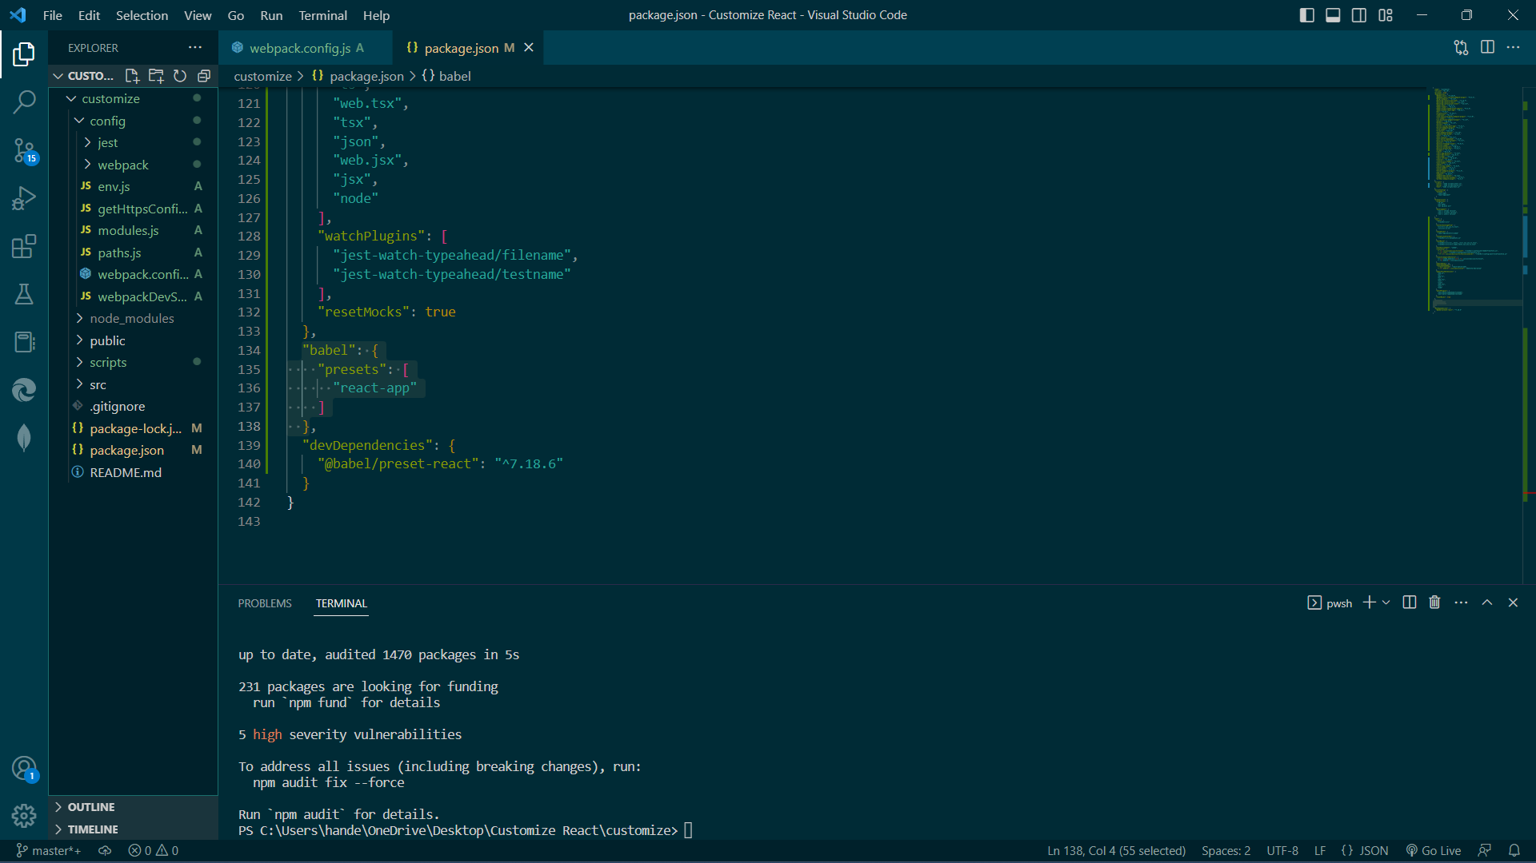

Add **css**, **js**, **data** folder in *public* folder and keep all the files relating to it in those folders.

Create a new folder called **views** and move **index.html** file from *public* folder to this newly created folder.

Now follow the below steps to customize the react application:

* **config** -> **paths.js** -> **module.exports** -> **appHtml**

Change **appHtml** value from,

*resolveApp(****'public****/index.html')*

to

*resolveApp(****'views****/index.html')*

* In **package.json:**

under **babel** :

Change,

"presets": [

"**react-app**"

]

*to*

"presets": [

"**@babel/preset-env**",

["**@babel/preset-react**", ***{"runtime": "automatic"}***]

]

* In **webpack.config.js**:

1. *ctrl+F* -> **appSrc** -> go to **4th** of **5th** selection ie.

Just below "***// Process application JS with Babel.***

***// The preset includes JSX, Flow, TypeScript, and some ESnext features.***" comment, change,

include: **path.appSrc**

*to*

include: [**paths.appSrc, paths.appPublic**]

2. ctrl+F -> **ModuleScopePlugin** -> *comment* the field