**DATABASE SYSTEMS PROJECT**

* **Detail of the scenario**

Car dearlership company. It operates a service facility.Salespersons are responsible for finding suitable vehicles and completing sales transactions according to customers' demands. If the vehicles are second hand, they may need repair or maintenance, The maintenance and repair works of the vehicles are also done by the company.Also vehicles can be new or used. We want to know which one it is.Salespersons get a commission per vehicle they sell.The company's expenses are calculated based on car sales. Each vehicle sold incurs a cost to the company.

* **Developing ERD**
* **Defining 7 entity**

|  |  |  |  |  |  |  |
| --- | --- | --- | --- | --- | --- | --- |
| Entity-1 | Entity-2 | Entity-3 | Entity-4 | Entity-5 | Entity-6 | Entity-7 |
| Delarship Office | Salesperson | Vehicle | Sale | Customer | Maintenance / Repair | Expense |

* **Defining attributes**

|  |  |  |  |  |  |  |
| --- | --- | --- | --- | --- | --- | --- |
| Delarship Office | Salesperson | Vehicle | Sale | Customer | Maintenance / Repair | Expense |
| Office name | Name | Brand | Sale date | Name | Date | Type |
| Address | Surname | Model | Comission of salesperson | Surname | Service Type (e.g., oil change, tire rotation) | Cost |
| Contact Number | Phone | Year of manufacture | Total Price | Phone | Status | Receipt Number |
| Opening hours | Email | Fuel type | Payment Method | Address |  |  |
|  | ◎Hire Date | Engine power |  | ◎Occupation |  |  |
|  |  |  |  | ◎Gender |  |  |

(The marked with “◎” attributes are optional ones.)

* **Relationships**

Each car dealership Office must to employ one ore more salesperson.

Each salesperserson must work in only one dealership Office.

Each salesperson may perform one or more sales transactions

Each sale must performed by only one salesperson

Each customer must take part one or more sales transactions.

Each sale must include only one customer.

Each vehicle may be used by for only one sales transactions.

Each sales transaction must be use one ore more vehicle.

Each second hand car may be assigned to one or more maintenance/repair operations.

Each maintenance/repair operation must associated with only one second hand car.

Each expense must made by one only one sale

Each sale may include one ore more expense.

* **Defining all necessary relationships (Identify with matrix diagram)**

|  |  |  |  |  |  |  |  |
| --- | --- | --- | --- | --- | --- | --- | --- |
|  | **Delarship Office** | **Salesperson** | **Vehicle** | **Sale** | **Customer** | **Maintenance/Repair** | **Expense** |
| **Delarship Office** |  | employee |  |  |  |  |  |
| **Salesperson** | Work in |  |  | perform |  |  |  |
| **Vehicle** |  |  |  | Used by |  | Assigned to |  |
| **Sale** |  | Performed by |  | use | include |  | include |
| **Customer** |  |  |  | Take part |  |  |  |
| **Maintenance/Repair** |  |  | Associated with |  |  |  |  |
| **Expense** |  |  |  | Made by |  |  |  |

* **If possible superype-subtype, arc and hierarchical structures, non-transferable relationship**

The “Vehicle" table serves as the supertype, while "NewVehicle" and "SecondhandVehicle" are subtypes.

* **Preparing “table instance chart” to map ERD to DB structure**

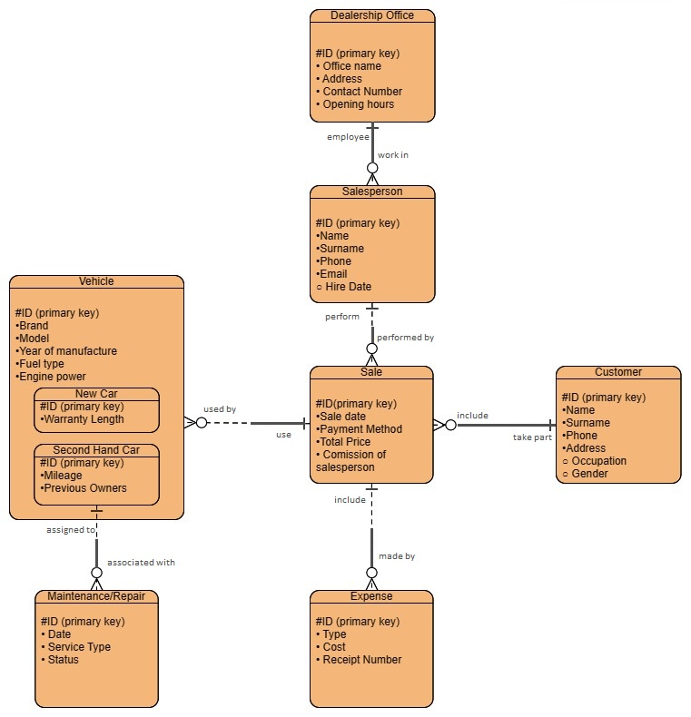

* **Writing SQL DDL statements for implementing ERD (create table, constraints, defining keys: pks and fks**

We already write DDL statements in .sql file.

* **Making Physical Database using APEX**

We already make “database create script” in .sql file.

* **Entering data to the Database**

Our “database create script” can automatically enter example data to the Database.

* **Writing SQL DML Statements to reach information**
* **One statement including subquery**

QUERY:

SELECT Name, Surname

FROM Customer

WHERE ID IN (SELECT Customer_ID FROM Sales WHERE Payment_Method = 'Credit Card');

metin, ekran görüntüsü, yazı tipi, yazılım içeren bir resim

Açıklama otomatik olarak oluşturulduIN APEX:

* **One statement including join**

QUERY:

SELECT Sales.ID, Sales.Sale_date, Sales.Payment_Method, Sales.Total_Price, Customer.Name, Customer.Surname

FROM Sales

JOIN Customer ON Sales.Customer_ID = Customer.ID;

metin, ekran görüntüsü, sayı, numara, yazılım içeren bir resim

Açıklama otomatik olarak oluşturulduIn APEX:

* **One statement including group by**

QUERY:

SELECT Brand, AVG(Engine_power) AS Average_ Engine_power

FROM Vehicle

GROUP BY Brand;

metin, ekran görüntüsü, sayı, numara, yazı tipi içeren bir resim

Açıklama otomatik olarak oluşturulduIn APEX:

* **One statement including date function**

QUERY:

SELECT ID, Sale_date, EXTRACT(YEAR FROM Sale_date) AS Sale_Year

FROM Sales;

metin, ekran görüntüsü, sayı, numara, yazılım içeren bir resim

Açıklama otomatik olarak oluşturulduIN APEX:

* **One statement including character function**

QUERY:

SELECT Name, Surname, UPPER(SUBSTR(Name, 1, 1) || '.' || Surname) AS Initials_LastName

FROM Salesperson;

metin, sayı, numara, yazı tipi, çizgi içeren bir resim

Açıklama otomatik olarak oluşturulduIN APEX:

* **One statement including update**

QUERY:

UPDATE SecondhandVehicle

SET Mileage = Mileage + 1320

WHERE Previous_Owners = 2;

metin, ekran görüntüsü, yazı tipi, sayı, numara içeren bir resim

Açıklama otomatik olarak oluşturulduIN APEX:

* **One statement including alter table**

QUERY:

ALTER TABLE Customer

ADD Date_of_Birth DATE;

IN APEX:

metin, ekran görüntüsü, yazı tipi içeren bir resim

Açıklama otomatik olarak oluşturuldu