Quantum 1/f Effect Based on Quantum Information Theory

Thomas F. George¹ and Peter H. Handel²
¹Office of the Chancellor/Departments of Physics & Astronomy and Chemistry & Biochemistry
University of Missouri-St. Louis, St. Louis MO 63121
²Department of Physics and Astronomy, Univ. of Missouri-St. Louis, St. Louis MO 63121

The Quantum Information Theory Approach (QIT) explains for the first time the apparent lack of unitarity caused by the entropy increase in the Quantum 1/f Effect (Q1/fE). This allows for a deeper understanding of the quantum 1/f effect, showing no resultant entropy increase and therefore no violation of unitarity in the quantum-mechanical dynamical evolution. This new interpretation involves the von Neumann Quantum Entropy, including the negative conditional entropy concept for quantum entangled states introduced by QIT. The Q1/fE was applied to many high-tech systems, in particular to ultra small electronic devices in nanotechnology. The present paper explains how the additional entropy implied by the observed 1/f noise arises in spite of the entropy-conserving evolution of the system. On this basis, a derivation of the conventional and coherent quantum 1/f effect is given. The latter is derived from a non-relativistic form of the branch-point propagator derived by excluding the long range Coulomb interaction from the interaction hamiltonian. The paper concludes with examples of practical applications in various devices and systems, allowing for a new characterization of high technology.

1. INTRODUCTION
1/f noise has been a problem for engineers since the early twenties, when they first learned to amplify electric signals. Much effort has been directed toward controlling it by trial and error in vacuum tubes, carbon resistors and microphones, contacts, etc. Later, it slowed the application of semiconductors and semiconductor devices, where again, its general nature remained unknown, in spite of generally unsuccessful attempts to explain it as a fortuitous superposition of lorentzian spectra caused by slow surface states, or by migrating impurities, or by other diffusion processes. It was later found that the 1/f spectrum is quite ubiquitous in nature, and present in so many places, that it even shaped our instinctive musical preferences. Indeed, nature has taught us somehow to like 1/f variations in pitch and intensity, as found in symphonic music.
Since 1962-1966 we understood the universality of 1/f noise as the result of the nonlinear reaction of currents back on themselves, as described by the magneto-hydrodynamic plasma turbulence theory of 1/f noise, developed by one of us [1], [2] by generalization of Heisenberg’s first theory of hydrodynamic turbulence. Hooge recognized this basic derivation of the 1/f spectrum as the only universal dynamical theory of 1/f noise. He noticed [3] soon thereafter, that the well-known inverse proportionality of 1/f noise with sample volume or number of current carriers in semiconductor samples, acquires a seemingly universal proportionality coefficient, when the number of carriers is chosen as the independent variable. However, this appearance strangely vanished when smaller samples, or ferroelectric materials were used. On the other hand, our turbulence theory also had difficulties, because it could only explain the spectrum, not also the intensity of low frequency noise. The latter was to be determined by the instabilities of laminary flow, which were causing instabilities and turbulence.
The ensuing 12-year hunt for new types of instabilities by one of us (PHH) yielded some, but none with zero threshold, as would have been required in order to explain 1/f noise. This led to sustained attempts to quantize the turbulence theory. The result was the quantum theory of 1/f noise, which included the conventional and coherent quantum 1/f effect. It simply described the universal 1/f noise through quantum electrodynamics, with no additional assumptions, from first principles.
The conventional Q1/fE was introduced as a fundamental fluctuation of all currents of charged particles j, of all scattering cross sections σs, recombination cross sections σr, tunneling rates or transition rates Γ of any kind, in short of all physical cross sections σ and process rates Γ, given by the universal formula

S(f) = 2αA/fN (1)

(conventional quantum 1/f equation [4]-[21]) for small devices, and

S(f) = 2α/πfN (2)

(coherent quantum 1/f equation [22], [18]-[21]) for large devices. These two Q1/fE forms can be combined into a single general formula [22], [18]-[21], as we show at the end of this paper. Here S(f) is the spectral density of fractional fluctuations in current, δj/j, in scattering or recombination cross section δσ/σ, or in any other process rate δΓ/Γ. α=e2/ch=1/137 is Sommerfeld's fine structure constant, a magic number of our world depending only on the charge of the electron e, Planck's constant hand the speed of light in vacuum c. A=2(Δv/c)2/3π is essentially the square of the vector velocity change Δv of the scattered particles in the scattering process whose fluctuations we are considering, in units of c. Finally, N is the number of particles used to define the notion of current j, of cross section σ or of process rate Γ.
Due to the presence of a bremsstrahlung emission amplitude in scattering, the scattered current per unit incoming flux, also called by us "the physical scattering cross section σ" will contain several energy and momentum components which interfere with each other, causing conventional quantum 1/f noise, i.e., quantum fluctuations of σ with a 1/f spectral density. The quantum expectation <σ> of σ gives the usual definition of the cross section. The quantum fluctuations are macroscopic at low frequencies because of the 1/f dependence, and because they do not have the fast Zitterbewegung variation which is usually associated with quantum fluctuations.
Another manifestation, or aspect, of the same Q1/fE phenomenon is the uncertainty of the mass shell of a charged particle due to the infinite range of the Coulomb interaction [24]-[28]. This requires a new picture [24]-[28] in which the long range part of the interaction is included in the unperturbed hamiltonian, which leads to the existence of the interaction representation, to finite matrix elements, to a branch-point singularity in the propagator, to a more complex free particle notion, to a coherent state of the field associated with the free particle, and as we prove below, to the presence of macroscopic coherent quantum 1/f fluctuations of all charged currents (coherent quantum 1/f effect).
How is it possible to obtain the additional entropy implied in the 2 aspects of the quantum 1/f effect, when all we have is unitary evolution of the quantum state of the particles, of the electromagnetic field of the universe, as well as of a potential observer, and when the entropy is conserved in this evolution? The quantum information theory [29] approach allows us to understand this by introducing the notion of negative entropy as we show below.

2. SCHEMATIC DERIVATION OF THE CONVENTIONAL QUANTUM 1/F EFFECT

We start here first with a schematic derivation which clarifies the essential elements. Let's simplify our world and assume only one electromagnetic mode of the universe would be present, with frequency ω and wave vector k. Consider the field mode in its ground state and a pair of 2 incoming identical charged particles with the same well-defined wave vector are being scattered by some potential. Both the initial (incoming) and the final (scattered) state represent a pure state. The initial state is |++->o, where we reserved the first two arguments of the ket for the two electrons and the last (-) for the field. Due to the interaction with the field, the final state will be

|f> = (|++-> + γ|+-+>/√2 + γ|-++>/√2)/(√1+γ2), (3)

where γ is the emission amplitude of a bremsstrahlung photon, i.e., for the excitation of the field oscillator from its ground state (-) to its first excited state (+). The first two arguments label the state of the charged particles, indicating the presence of an energy loss with (-) and the persistence in the same energy state with (+). The third argument of the kets always labels the field oscillator, as mentioned.
The corresponding density operator of the pure state obtained is ρ = |f><f|. Its quantum von Neumann entropy S/k = σ = -Tr(ρ log ρ) is zero.

2.1 Paradoxical Entropy Increase in 1/f Noise

Ignoring the field oscillator, i.e., taking the trace of over the field oscillator label, we obtain a classically correlated system, a mixture of 2 pure states, described by the density operator

[|++><++| + γ2(|+-> + |-+>)(<+-| + <-+|)/2]/(1+γ2). (4)

The second term gives the Q1/fE at f=ω/2π, as we show below. The corresponding entropy is

log(1+γ2) - (γ2logγ2)/(1+γ2) > 0 for 0≤γ2≤1.

The entropy of the system thus appears to have increased although according to quantum mechanics it can not increase. Indeed, according to quantum mechanics, time evolution of a state occurs through a unitary transformation. The latter, however, is known to leave σ = -Tr(ρ log ρ) invariant.

2.2 Quantum Information Theory

QIT [29] solves this paradox. When two systems A and B with quantum von Neumann entropy σ(A) = -TrA(ρAlogρA) and σ(B) = -TrB(ρBlogρB) form a composite system AB of entropy σ(AB) = -TrAB(ρABlogρAB), we can prove that we have to write

σ(AB) = σ(A) + σ(B|A) = σ(B) + σ(A|B), (5)

in perfect analogy with classical entropies or information. We have introduced σ(A|B) as the von Neumann entropy of A conditional on B, or the entropy of A when we know B:

σ(A|B) = -TrAB[ρABlogρA|B]. (6)

Here we have introduced the conditional density matrix ρA|B = ρAB(1A⊗ρB)-1, the quantum analog similar to the classical conditional probability, where ⊗ is the tensor product in the joint Hilbert space and ρB=TrA(ρAB) is the marginal density matrix obtained by taking a partial trace over the variables associated with A.

3. NEGATIVE ENTROPY

The conditional entropy is usually negative in quantum entangled states. Finally, we introduce the quantum mutual entropy which represents the shared entropy, corresponding to the mutual information between A and B:

σ(A:B) = -Tr[ρABlogρA:B] ≡ σ(Α) + σ(Β) − σ(ΑΒ), (7)
where
ρA:B = ρAB(ρA⊗ρB)-1. (8)

Taking all logarithms in the base of 2, the entropies will be expressed in bites. Considering our paradoxical case discussed above for simplicity with γ2=1, we obtain the following entropy diagram of our quantum mechanically entangled triplet of three systems comprising the charged particles A and B, as well as the field oscillator C:

Fig. 1: Entropy diagram of the quantum mechanically entangled triplet comprising the charged particles A and B, as well as the field oscillator C.

Here the quantum conditional entropies are underlined for emphasis, and the mutual quantum entropy has double underlining. Dotted underlining marks the mutual entropy of two of the subsystems, which is, however, not the mutual entropy of the whole system. We see that A, B and C have each 1 bit of entropy, as we expect, since each can be in a + or - state. In addition, σABC = 0 as expected for a pure state. The negative conditional entropies indicate that this state is a pure quantum state which can not be obtained in classical physics.
If we ignore C by tracing over it, we obtain the classically correlated system AB with its positive entropy of 1 and the negative quantum entropy state of the ignored field oscillator, conditional on AB:

Fig. 2: By tracing over C, we obtain the classically correlated system AB with its positive entropy of 1 and the negative quantum entropy state of the ignored field oscillator, conditional on AB.

3.1 Solution of the Paradox

In conclusion, the negative conditional entropy of the ignored field oscillator compensates the positive entropy of the system of two particles. Unitarity and entropy conservation are both satisfied. This is the solution of the paradox. It explains why our earlier explanation of the Q1/fE in terms of a two-particle wave function was correct, in spite of the apparent lack of unitarity.
In the rest of the present paper we apply the scheme developed here to the real world with all field oscillators present in |++->o and with N incident particles in |++->o. Note that the 1/f spectrum arises from the dependence of the actual bremsstrahlung coefficient γ on f, and from the summation over all field oscillators, as we see below.

4. DERIVATION OF THE CONVENTIONAL QUANTUM 1/F EFFECT

We start with the expression of the Heisenberg representation state |f> of N identical bosons of mass M emerging at an angle θ from some scattering process with undetermined bremsstrahlung energy losses reflected in their one-particle waves ϕi(ξi)

|f> = (N!)-1/2 Πi ∫d3ξiϕi(ξi)ψ+(ξi) |0> = Πi ∫d3ξiϕi(ξi) |fo>, (9)

where ψ+(ξi) is the field operator creating a boson with position vector ξi and |0> is the vacuum state, while |fo> is the vacuum field state with N bosons of position vectors ξi with i = 1...N. All products and sums in this paper run from 1 to N, unless otherwise stated.
To calculate the particle density autocorrelation function in the outgoing scattered wave, we need the expectation value of the operator

O(x1,x2) = ψ+(x1)ψ+(x2)ψ(x2)ψ(x1), (10)

known as the operator of the pair correlation. Using the commutation properties of the boson field operators, we first calculate the matrix element

N!<So|O|fo>=
Σ'μνΣ'mnδ(ην−x1)δ(ημ−x2)δ(ξn−x1)δ(ξm−x2)Σ(i,j)Π'ijδ(ηj−ξi). (11)

Here the prime excludes μ=ν and m=n in the summations and excludes i=m, i=n, j=μ and j=ν in the product. The summation Σ(i,j) runs over all permutations of the remaining N-2 values of i and j. On this basis we now calculate the complete matrix element

<f|O|f> = [1/N(N-1)] Σ'μνΣ'mn∫d3ημ∫d3ην∫d3ξm∫d3ξn
ϕμ*(ημ)ϕν*(ην)ϕm(ξm)ϕn(ξn)δ(ην-x1)δ(ημ-x2)δ(ξn-x1)δ(ξm-x2). (12)
= [1/N(N-1)] Σ'μνΣ'mn ϕμ*(x2)ϕν*(x1)ϕm(x1)ϕn(x2)

The one-particle states are spherical waves emerging from the scattering center located at x=0:

ϕ(x) = (C/x)eiKx [1 + Σklb(k,l)e-iqx a+k,l]. (13)

Here C is an amplitude factor, K the boson wave vector magnitude, γ = b(k,l) the bremsstrahlung amplitude for photons of wave vector k and polarization l, while a+k,l is the corresponding photon creation operator, allowing the photon state to be created from the vacuum if Eq. (13) is inserted into Eq. (8). The momentum magnitude loss q=Mck/hK≡Mf/hK is necessary for energy conservation in the Bremsstrahlung process. Substituting Eq, (13) into Eq. (12), we obtain

<f|O|f> = |C/x|4{N(N-1) + 2(N-1)Σk,l|b(k,l)|2[1+cosq(x1-x2)]}, (14)

where we neglected a small term of higher order in b(k,l). To perform the angular part of the summation in Eq. (14), we calculate the current expectation value of the state in Eq. (13), and compare it to the well known cross section without and with bremsstrahlung

j = (hK/Mx2)[1 + Σkl|b(k,l)|2] = jo[1 + ∫αAdf/f], (15)

where the quantum fluctuations have disappeared, where α=e2/hc is the fine structure constant, αA=(2α/3π)(Δv/c)2 is the fractional bremsstrahlung rate coefficient, also known in QED as the infrared exponent, and the 1/f dependence of the bremsstrahlung part displays the well-known infrared catastrophe, i.e., the emission of a logarithmically divergent number of photons in the low frequency limit. Here Δv is the velocity change h(K-Ko)/M of the scattered boson, and f=ck/2π the photon frequency. Eq. (14) gives

<f|O|f> = |C/x|4{N(N-1) + 2(N-1)(∫αAdf/f)[1+cosq(x1-x2)]}, (16)

which is the pair correlation function, or density autocorrelation function along the scattered beam with df/f=dq/q. The spatial distribution fluctuations along the scattered beam will also be observed as fluctuations in time at the detector, at any frequency f. According to the Wiener-Khintchine theorem, we obtain the spectral density of fractional scattered particle density ρ, (or current j, or cross section σ) fluctuations in frequency f or wave number q by dividing the coefficient of the cosine by the constant term N(N-1):

ρ-2Sρ(f) = j-2Sj(f) = σ−2Sσ(f) = 2αA/fN [or =2αA/f(N-1) for fermions], (17)

where N is the number of particles or current carriers used to define the current j whose fluctuations we are studying. Quantum 1/f noise is thus a fundamental 1/N effect.
The exact value of the exponent of f in Eq. (17) can be determined by including the contributions from all real and virtual multiphoton processes of any order, and turns out to be αA-1, rather than -1, which is important only philosophically, since αA«1. The spectral integral is thus convergent at f=0.
For fermions we repeat the calculation replacing in the derivation of Eq. (11) the commutators of field operators by anticommutators, which finally yields in the same way

ρ-2Sρ(f) = j-2Sj(f) = σ−2Sσ(f) = 2αA/f(N-1), (18)

which causes no difficulties, since N≥2 for particle correlations to be defined, and which is practically the same as Eq. (17), since usually N»1. Eqs. (17) and (18) suggest a new notion of physical cross sections and process rates which contain 1/f noise, and express a fundamental law of physics, important in most high-tech applications [14] - [20].

5. DERIVATION OF THE COHERENT QUANTUM 1/F EFFECT

The coherent Q1/fE arises from the energy uncertainty of the physical electron. Indeed, the physical electron comprises the bare particle and its electromagnetic field. The latter turns out to be in a coherent state, which is not an eigenstate of the hamiltonian. It entails partial knowledge of the phase in each of the field oscillators. According to the uncertainty principle, this precludes a well-defined energy. The state of the physical electron is therefore a non-stationary state. This, in turn, leads to the question about the spectrum of the quantum fluctuations characterizing this state. As we show below, the spectrum of the charge density and current density fluctuations in time is always 1/f, while in space it is 1/k, where k is the wave number.
The reason why the field is in a coherent state and not in an energy eigenstate, is found in the infinite range of the coulomb potential. The latter causes the usual interaction representation not to exist. As we know from Bloch and Nordsiek since 1937, the resulting infrared divergences preclude any finite matrix elements in the usual formalism, and can be eliminated only at the level of the cross section or process rate, where an integrable singularity still remains. As Dollard [24] has shown, a finite matrix element can be obtained by including the long-range part of the electromagnetic interaction into the unperturbed hamiltonian. This results in a more complicated free electron, which we are calling the physical electron, and which is in a coherent state, as we have stated above. It also results in more complicated matrix elements, in particular a branch point singularity in the propagator, rather than the usual pole. The propagator was obtained only asymptotically for large times, which corresponds exactly to the low frequency region that is of interest for the study of low frequency noise. In this section we first derive the non-relativistic form of this propagator, and then we use it to derive the coherent Q1/fE. A simple, physical derivation, often preferred due to its transparency, is given elsewhere in the present volume [30].

5.1 Derivation of the Non-Relativistic Propagator for Coherent Quantum 1/f Noise

The derivation of the Coherent Quantum 1/f Effect in second quantization was done on the basis of a new picture of Quantum Electrodynamics (QED), introduced by Dollard, Kibble and Zwanziger [24]-[28]. This new picture includes the long range part of the Coulomb potential into the unperturbed hamiltonian Ho, as mentined above. The result is a more complicated free particle and a new propagator Gs(x'-x) with a branch point instead of a pole. Handel used a nonrelativistic form of this new propagator and obtained the universal spectral density of fractional current fluctuations Sδj/j(f)=2α/3πfN, which he had called coherent quantum 1/f effect. The purpose of this section is to derive this non-relativistic propagator from the well-known relativistic propagator Gs(x'-x) based on Dollard's picture. Gs(x'-x) was derived relativistically [26]-[28] by Kibble and others in 1975 in a new QED picture required by the infinite range of the Coulomb potential.
Our derivation is similar with the derivation of the non-relativistic Schrödinger/Pauli equation from Dirac's theory of the electron. It is based on the distinction between the large components and small components of the Dirac spinor.
The relativistic propagator S(x'-x) in the equation

(19)
is, according to [26]-[28],

(20)

and is valid asymptotically for very large time t'. In the non-relativistic limit, the Dirac spinor can be written in the form

. (21)

This way we get
(22)
Therefore, we can write

(23)

Furthermore, after using the approximate relation

(24)
between the spinor components in the non-relativistic limit, we get

. (25)

If we compare with the equation

(26)

which defines the non-relativistic propagator, we get for the latter

. (27)

The propagator with a phase factor is

(28)
This is just the non-relativistic propagator that we need. It has a branch point instead of a pole. For x=x'

(29)
This is the corresponding generalization of the well-known propagator of the Schrödinger equation.

5.2 Derivation of the Coherent Quantum 1/f Effect

The present derivation is based on the well-known propagator Gs(x'-x) derived relativistically in the new QED picture required by the infinite range of the Coulomb potential, as mentioned in Sec. 5.1. The corresponding nonrelativistic form, given by Eq. (28), was derived in the previous section 5.1 and is written here for the case of a beam of fermions in vacuum, described by a the occupation numbers np,s

-i<Φo|Tψs'(x')ψ|Φo> ≡ δss' Gs(x'-x)
= (i/V)expi[p(r-r')-p2(t-t')/2m]/h}np,s{-ip(r-r')/h+i(m2c2+p2)1/2(t-t')(c/h)}α/π. (30)
Here α is again Sommerfeld's fine structure constant, np,s the number of electrons in the state of momentum p and spin s, m the rest mass of the fermions, δss' the Kronecker symbol, c the speed of light, x=(r,t) any space-time point and V the volume of a normalization box. T is the time-ordering operator which orders the operators in the order of decreasing times from left to right and multiplies the result by (-1)P, where P is the parity of the permutation required to achieve this order. For equal times, T normal-orders the operators, i.e., for t=t' the left-hand side of Eq. (30) is i<Φo|ψψs'(x')|Φo>. The state Φo of the N electrons is described by a Slater determinant of single-particle orbitals. Eq. (30) is exact at large t-t', or low frequency.
To calculate the current autocorrelation function we need the density correlation function, which is also known as the two-particle correlation function. The two-particle correlation function is defined by

<Φo|Tψψs(x)ψψs'(x')|Φo> = <Φo|ψψs(x)|Φo><Φo|ψψs'(x')|Φo> -
<Φo|Tψs'(x')ψ|Φo><Φo|Tψs(x)ψ|Φo>. (31)

The first term can be expressed in terms of the particle density of spin s, n/2 = N/2V = <Φo|ψψs(x)|Φo>, while the second term can be expressed in terms of the Green function (30) in the form

Ass'(x-x') ≡<Φo|ψψψs'(x')ψs(x)|Φo> = (n/2)2 +δss' Gs(x'-x)Gs(x-x'). (32)

The "relative" autocorrelation function A(x-x') describing the normalized pair correlation independent of spin is obtained by dividing by n2 and summing over s and s'
A(x-x') = 1 - (1/n2)s(x-x')Gs(x'-x)
= 1 - (1/N2)expi[(p-p')(r-r')-(Ep-Ep')(t-t')]/h}np,snp',s
×{p(r-r')/h-(m2c2+p2)1/2(t-t')(c/h)}α/π
×{p'(r'-r)/h-(m2c2+p'2)1/2(t'-t)(c/h)}α/π. (33)

Here we have used Eq. (30). We are considering a beam of charged fermions, e.g., electrons, represented in momentum space by a sphere of radius pF, centered on the momentum po which is the average momentum of the fermions. The energy and momentum differences between terms of different p are large, leading to rapid oscillations in space and time which contain only high-frequency quantum fluctuations. The low-frequency and low-wavenumber part Al of this relative density autocorrelation function is given by the terms with p = p'
Al(x-x') = 1 - (1/N2)p,s
×|p(r-r')/h-(m2c2+p2)1/2(t-t')(c/h)|2α/π (34)

≈ 1 - (1/N)|po(r-r')/h-mc2τ/h|2α/π for pF<<|po3-mc2τ/z|. (35)

Here we have used the mean value theorem, considering the 2α/π power as a slowly varying function of p and neglecting po in the coefficient of τ ≡ t-t', with z ≡ |r-r'|. The correlations propagate along the beam with a group velocity given by the average velocity po/m of the particles in the beam, and with the phase velocity of c2/v. Denoting θ ≡ |τ -po(r-r')/mc2|, and using a well known identity for the last step [31], we obtain from Eq. (35) the form

A1(x-x') = 1 - (1/N)|mc2θ/h)|2α/π = 1 -(1.25/N)|Θ|2α/π = 1 -(1.25/N)e(2α/π)lnΘ

≈ 1-(1.25/N)[1+(2α/π)lnΘ] = 1 - (2.5/N) + (1.25/N)[1-(2α/π)lnΘ] (36)

≈(N-2.5)/N +(1.25/N)e-(2α/π)lnΘ = (1/N){N-2.5+(2.5α/πcosα)ωΘdω/ω1-2α/π}. (37)

This indicates a ω-1+2α/π or 1/f spectrum and a 1/(N-2.5) dependence of the spectrum of fractional fluctuations in density n and current j. The total error corresponding to the two linear approximations of exponentials in Eq. (36) is less than 1%, provided |lnΘ|<20, or (250,000)-1 hours < |θ| < 250,000 hours. Here Θ=θ/1s and ω is the circular Fourier frequency in rad/s. We have used [1s mc2/h)]2α/π ≈ 1.25; this accounts also for the presence of the number 2.5 instead of the more normal number 2 in the final form. The form we have chosen here is more convenient for applications. The equivalent normal form would have been
A1(x-x') ≈ (1/N){N-2+(2α/πcosα)]2α/π cosωθ dω/ω}, (38)
in which the error caused by the two linear approximations of exponentials would have been of the order of 20%, and in which the fractional power would also have been neglected in the integrand for all purposes except for the theoretical question of the integrability of the 1/ω spectrum. The fractional autocorrelation of current fluctuations δj is obtained by multiplying Eq. (33) on both sides with (epo/m)2, and dividing by (enpo/m)2 which is the square of the average current density j, instead of just dividing by n2. So it is the same as the fractional autocorrelation for quantum density fluctuations. Therefore, the better approximation given by Eq. (37) for the universal coherent quantum-electrodynamical chaos process in electric currents finally becomes

Sδj/j(k) ≈ [2.5α/πω(N-2.5)][ω]2α/π ≈ 2.5α/πωN = 0.0058/ωN. (39)

This spectral density agrees well the result 2α/πfN, derived directly in [30] in this volume, from the coherent state of the electromagnetic field of a physical charged particle. Taking into account the approximate, asymptotic character of the propagator used here, this agreement is remarkable. The connection with the conventional quantum 1/f effect is discussed in Sec. 6.
Being observed in condensed matter in the presence of a constant applied field, these fundamental quantum current fluctuations are usually perceived as mobility fluctuations. Most of the conventional quantum 1/f fluctuations in physical cross sections and process rates are also mobility fluctuations, but some are also in the recombination speed or tunneling rate.
A similar calculation yields the gravidynamical quantum 1/f effect (QGD 1/f effect) instead of Eq. (39), by substituting gravitons for the photons considered so far as infraquanta.

6. DISCUSSION

In practice, the connection between the coherent and conventional Q1/fE is of considerable importance when the sample or device is in the transition range. The coherent state in a conductor or semiconductor sample is the result of the experimental efforts directed towards establishing a steady and constant current, and is therefore the state defined by the collective motion, i.e. by the drift of the current carriers. It is expressed in the Hamiltonian by the magnetic energy Em, per unit length, of the current carried by the sample. In very small samples or electronic devices, this magnetic energy

Em = ∫(B2/8π)d3x = [nevS/c]2ln(R/r) (40)

is much smaller than the total kinetic energy Ek of the drift motion of the individual carriers

Ek = Σmv2/2 = nSmv2/2 = Em/s. (41)

Here we have introduced the magnetic field B, the carrier concentration n, the cross sectional area S and radius r of the cylindrical sample (e.g., a current carrying wire), the radius R of the electric circuit, and the "coherence ratio"

s = Em/Ek = 2ne2S/mc2ln (R/r) ≈ 2e2N'/mc2 = 2N'ro, (42)

where N' = nS is the number of carriers per unit length of the sample and the natural logarithm ln(R/r) has been approximated by one in the last forms. Here ro = 2.84 10-13 cm is the classical radius of the electron. In general, thus, s = 5.69.10-13 cm ×N', i.e., the number of carriers in a very thin sample slice of about 5.7 fermi thickness. We expect the observed spectral density of the mobility fluctuations to be given by a relation of the form

(1/μ2)Sμ(f) = [1/(1+s)][2αA/fN] + [s/(1+s)][2α/πfN] (43)

which can be interpreted as an expression of the effective Hooge constant if the number N of carriers in the (homogeneous) sample is brought to the numerator of the left hand side

αH = [1/(1+s)]αHconv + [s/(1+s)]αHcoh. (44)

In these equations αA=2α(Δv/c)2/3π is the usual nonrelativistic expression of the infrared exponent, present in the familiar form of the conventional quantum 1/f effect. These equations are limited to quantum 1/f mobility (or diffusion) fluctuations, and do not include the quantum 1/f noise in the surface and bulk recombination cross sections, in the surface and bulk trapping centers, in tunneling and injection processes, in emission or in transitions between two solids.
Note that when n = 1016 cm-3, the coherence ratio s introduced here equals the unity for the critical value N' = N" = 2•1012/cm., e.g. for a cross section S = 2•10-4 cm2 of the sample. For small samples with N'<<N" only the first term survives, while for N'>N" the second term in Eq. (63) is dominant.
The conventional and coherent Q1/fE was successfully applied to FETs, HFETs, BJTs, and HBTs, as well as to quartz resonators and amplifiers.

7. EXAMPLES OF APPLICATIONS

Applications refer to materials, devices and systems. Materials can be optimized for FET or HFET-type devices, or for junction devices. Devices subject to quantum 1/f optimization (Q1/fO) are collision-free devices, or the most common collision-dominated devices, e.g., semiconductor devices. They may be either low-frequency devices operating at baseband, or high-frequency resonant or non-resonant devices in which Q1/fO with respect to phase noise is sought. Finally, the Q1/fO of systems is particularly important both for civilian and military uses.
The quantum 1/f effect was verified by A. van der Ziel and his collaborators first in collision-free devices, such as vacuum tubes, and then in semiconductor devices. Both types of results are presented in a large number of publications. A review is provided in [17], where many comparisons between quantum 1/f theory and experiment are graphically represented for vacuum tubes, photomultipliers, vacuum photdiodes, infrared detectors, p-n diodes, FETs and BJTs. Both conventional and coherent quantum 1/f noise was verified and used to predict or improve devices. On the other hand the conventional Q1/fE was also verified in β-radioactive decay [32], where it predicted a deviation from the Poisson distribution at low frequencies, or long times. The results are displayed in Fig. 3 for ⁹⁰Y [32] and in Fig. 4 for ²⁰⁴Tl [[33]. The superpoissonian deviation is clearly visible in the two-sample (Allan) variance at long sampling times T, as predicted by conventional quantum 1/f theory.
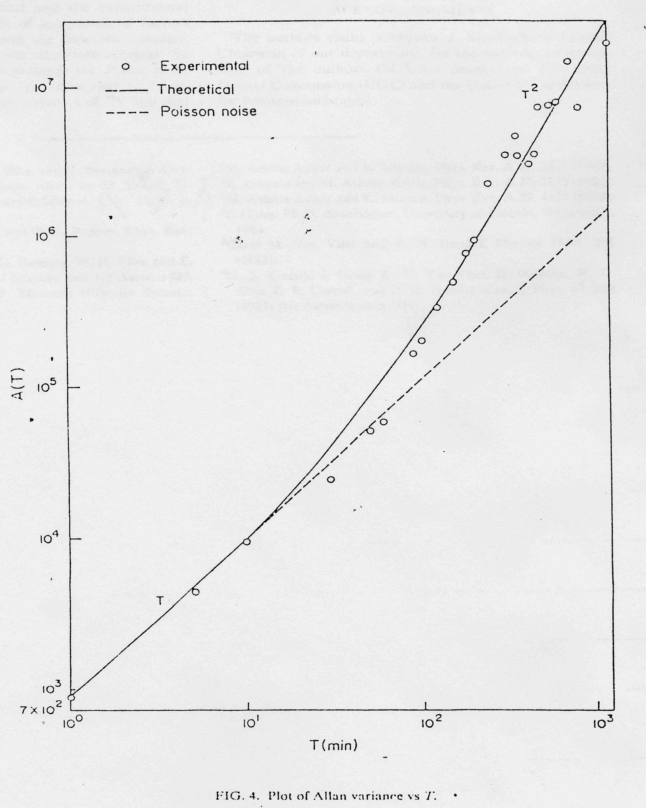
Fig. 3. A plot of the Allan variance versus the sample duration T in the β-radioactive decay of ⁹⁰Y (E_{max}=720 keV).

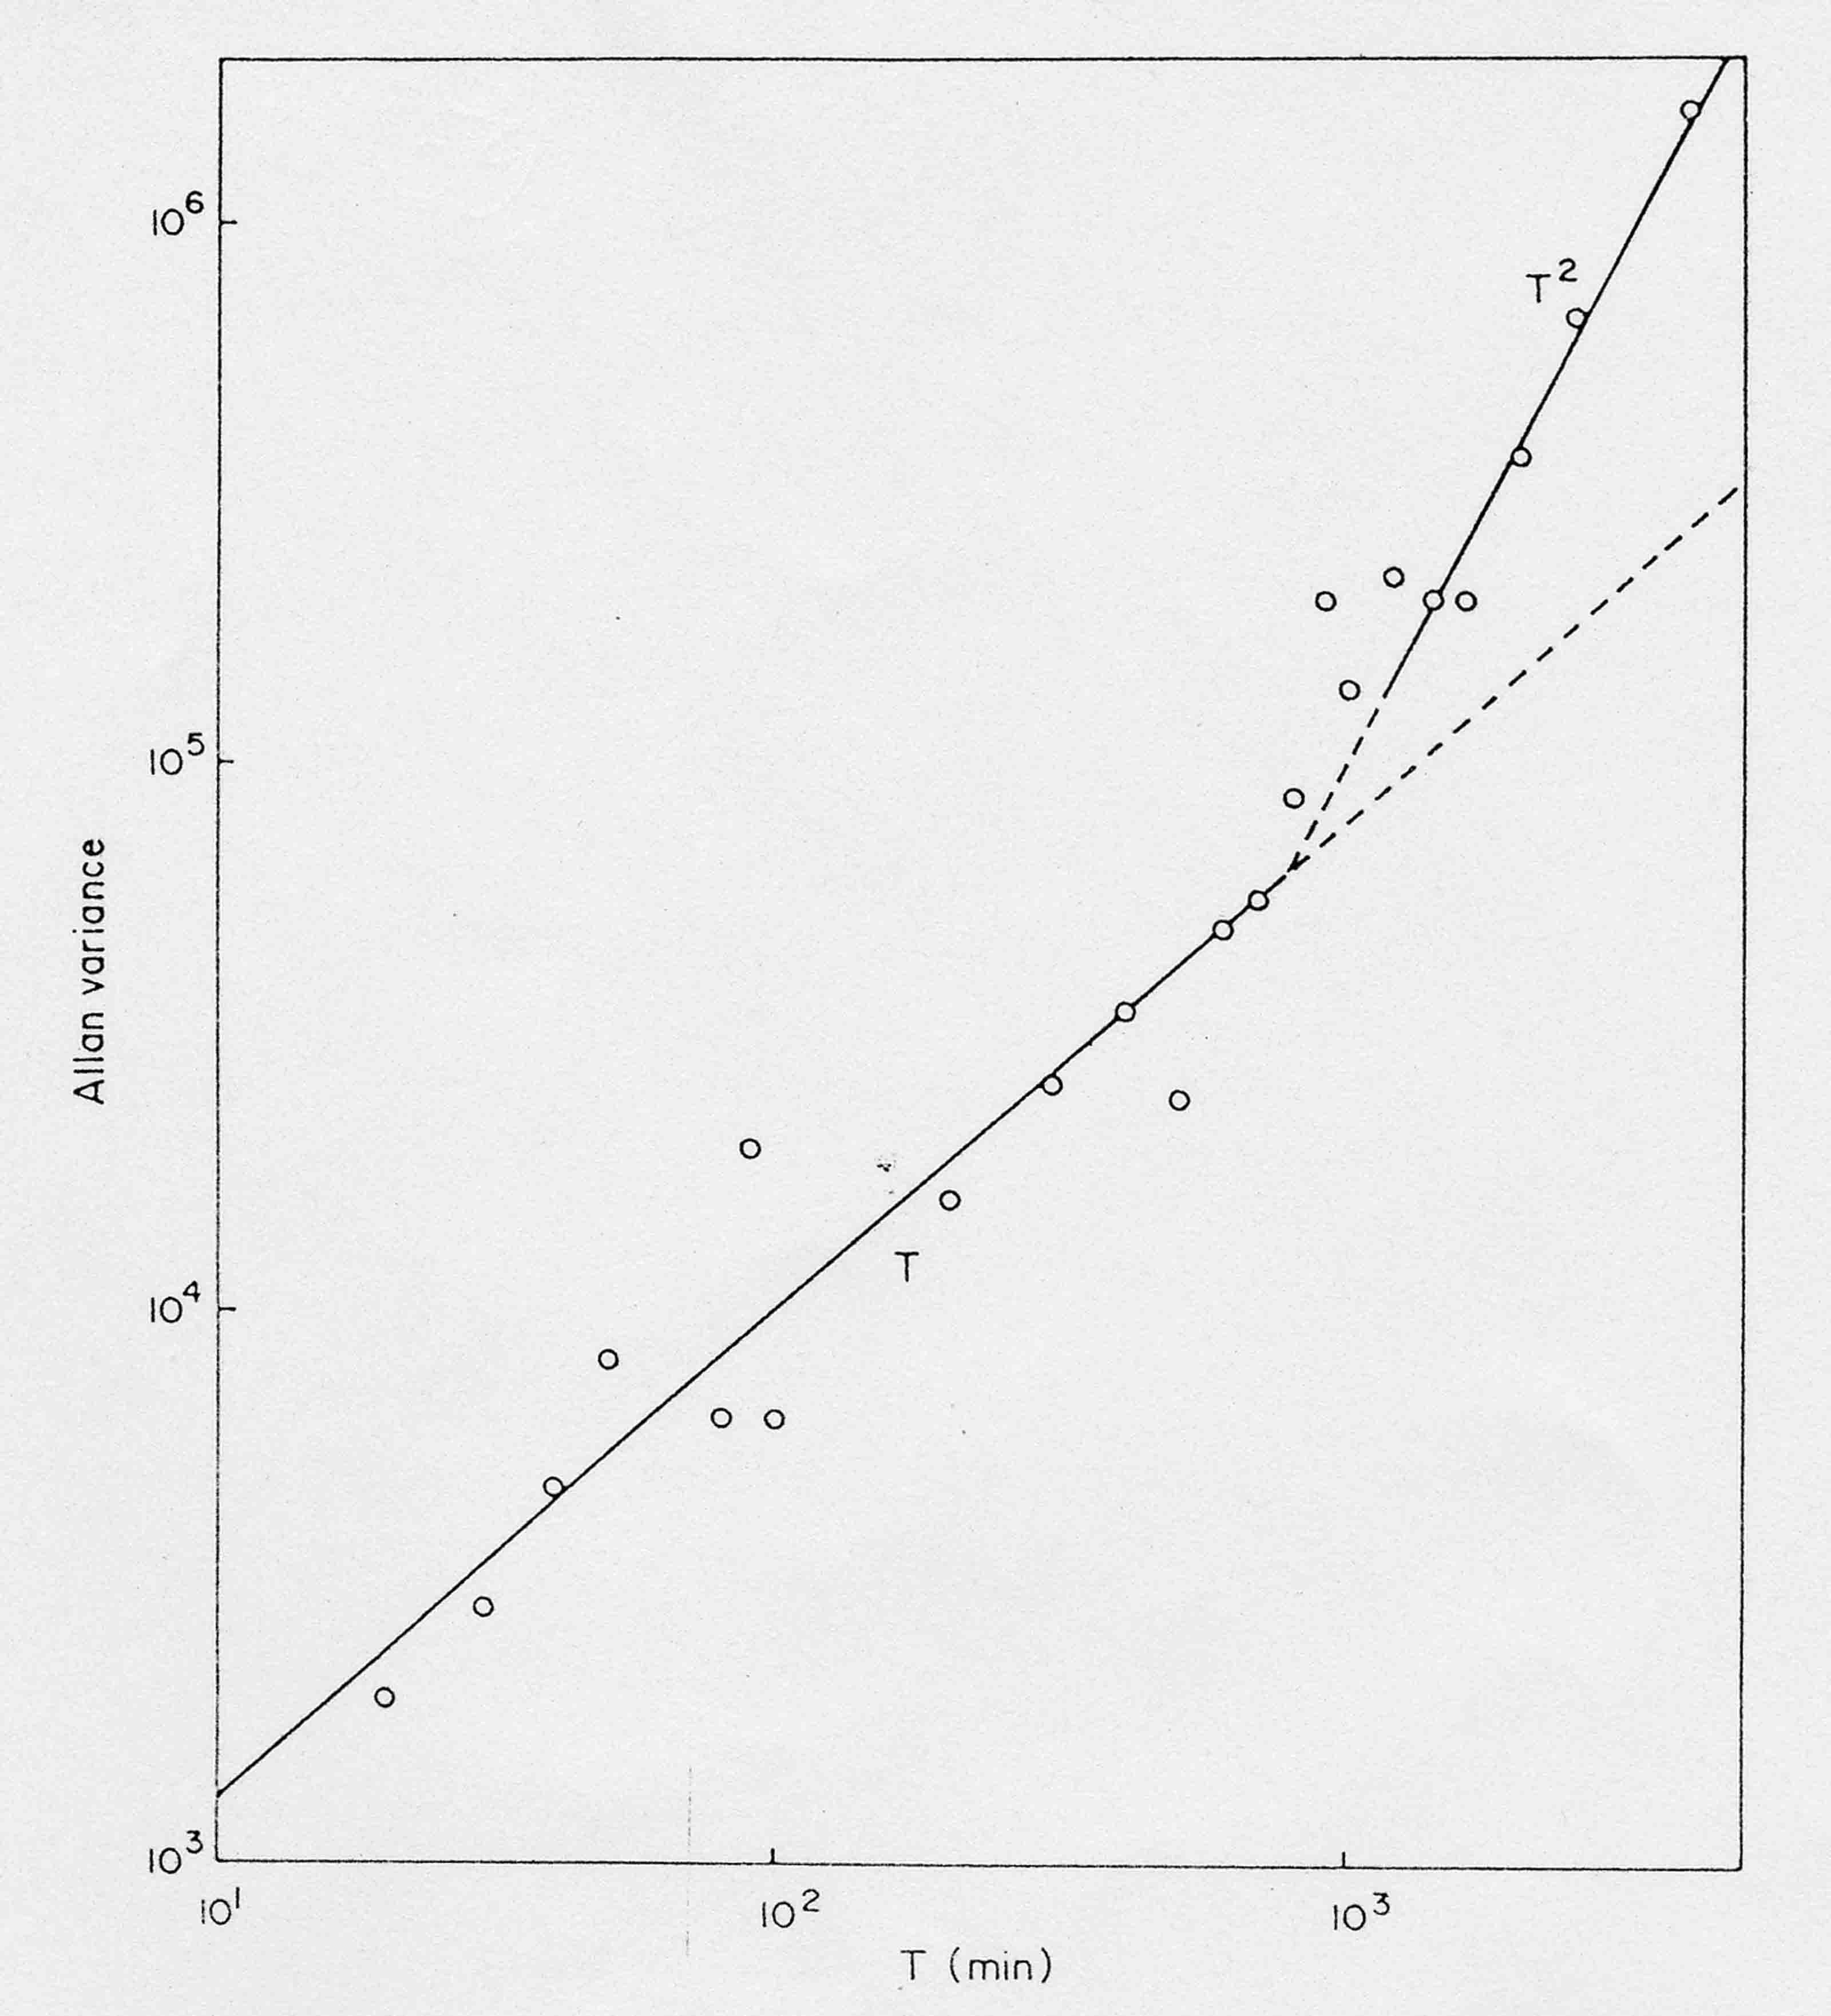
Fig. 4: A plot of the Allan variance versus the sample duration T for the172 keV β energy channel from ²⁰⁴Tl. (The figure is sent on its own as an E-mail)

As a collision-dominated example, the comparison of the temperature dependence of quantum 1/f noise calculated for focused ion beam (FIB)-implanted filaments of GaAs with the measured values [33] is displayed in Fig. 5 below.
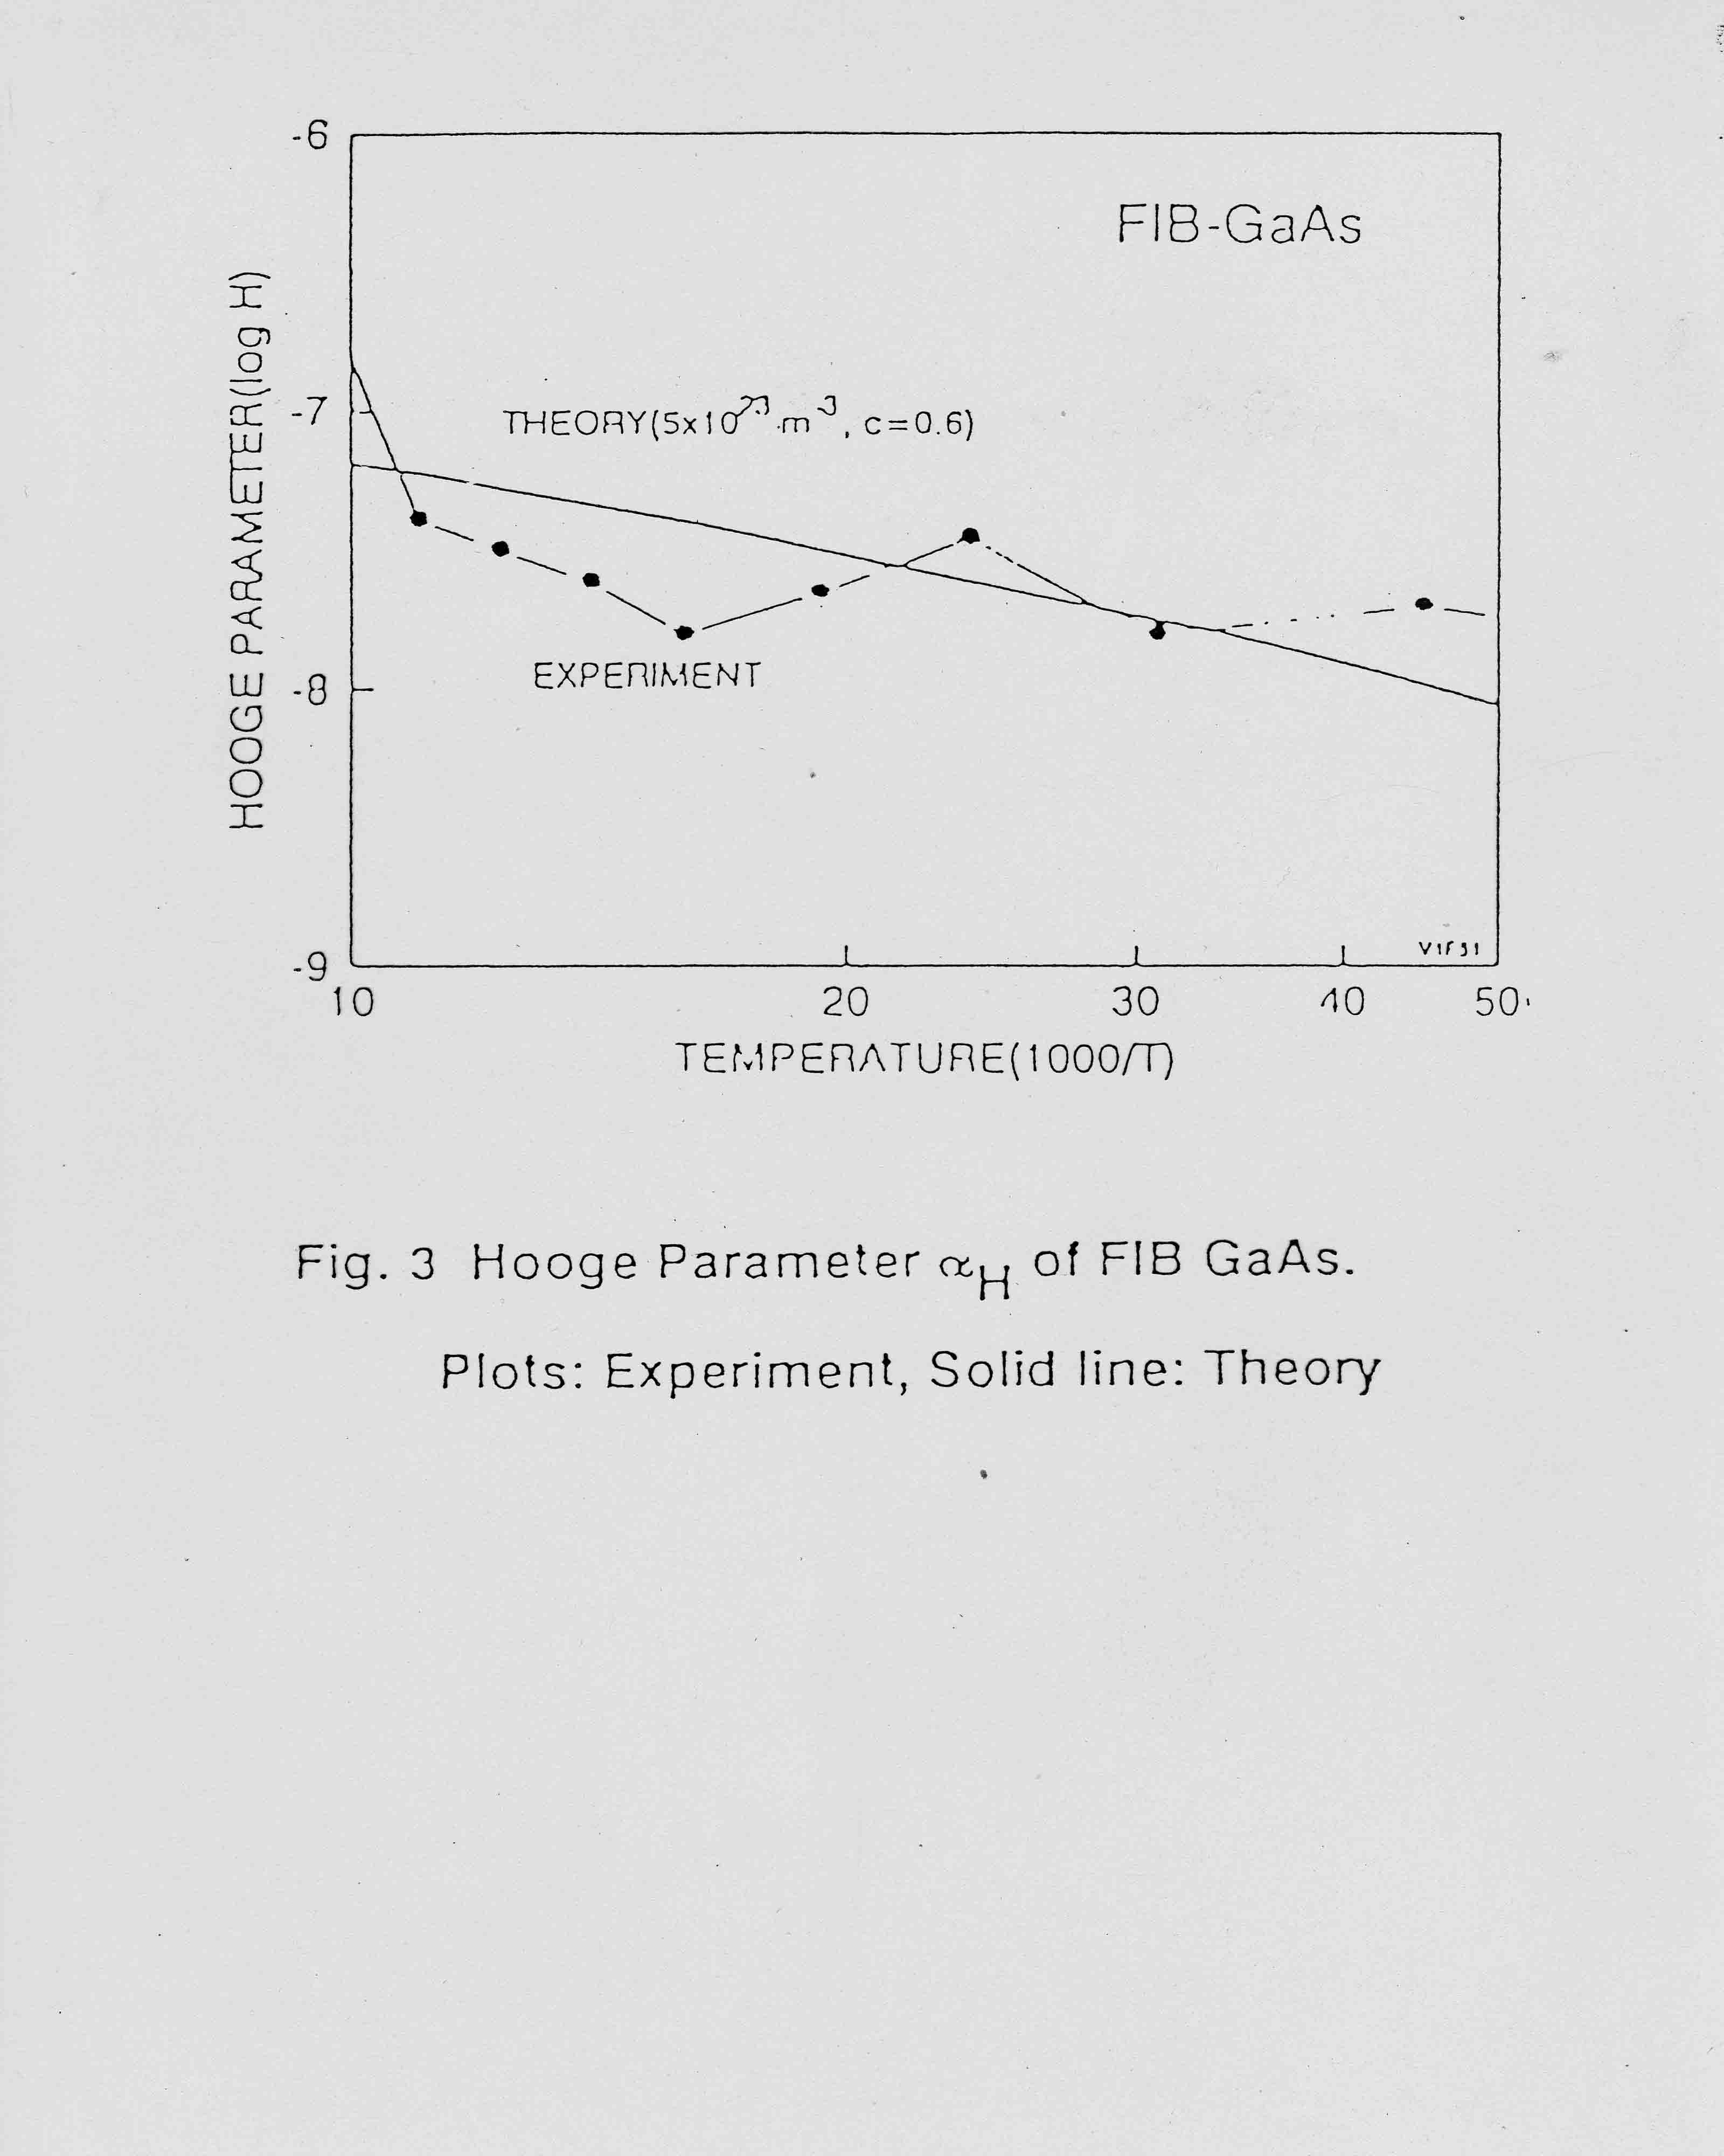
Fig. 5: Hooge parameter α_{H} for FIB implanted GaAS filaments. The solid line shows the quantum 1/f theory, whereas the points are measured.

An example of coherent quantum 1/f noise verification in HgCdTe infrared detectors is found [35] in Fig. 6 below. Here the band gap is very narrow, the effective mass of the carriers is almost 2 orders of magnitude smaller, and therefore the s parameter very large, favoring the coherent Q1/fE. The results are in very good agreement with the 4.6 10⁻³ value of the (Hooge) coherent quantum 1/f noise parameter. See also the figure in [30].
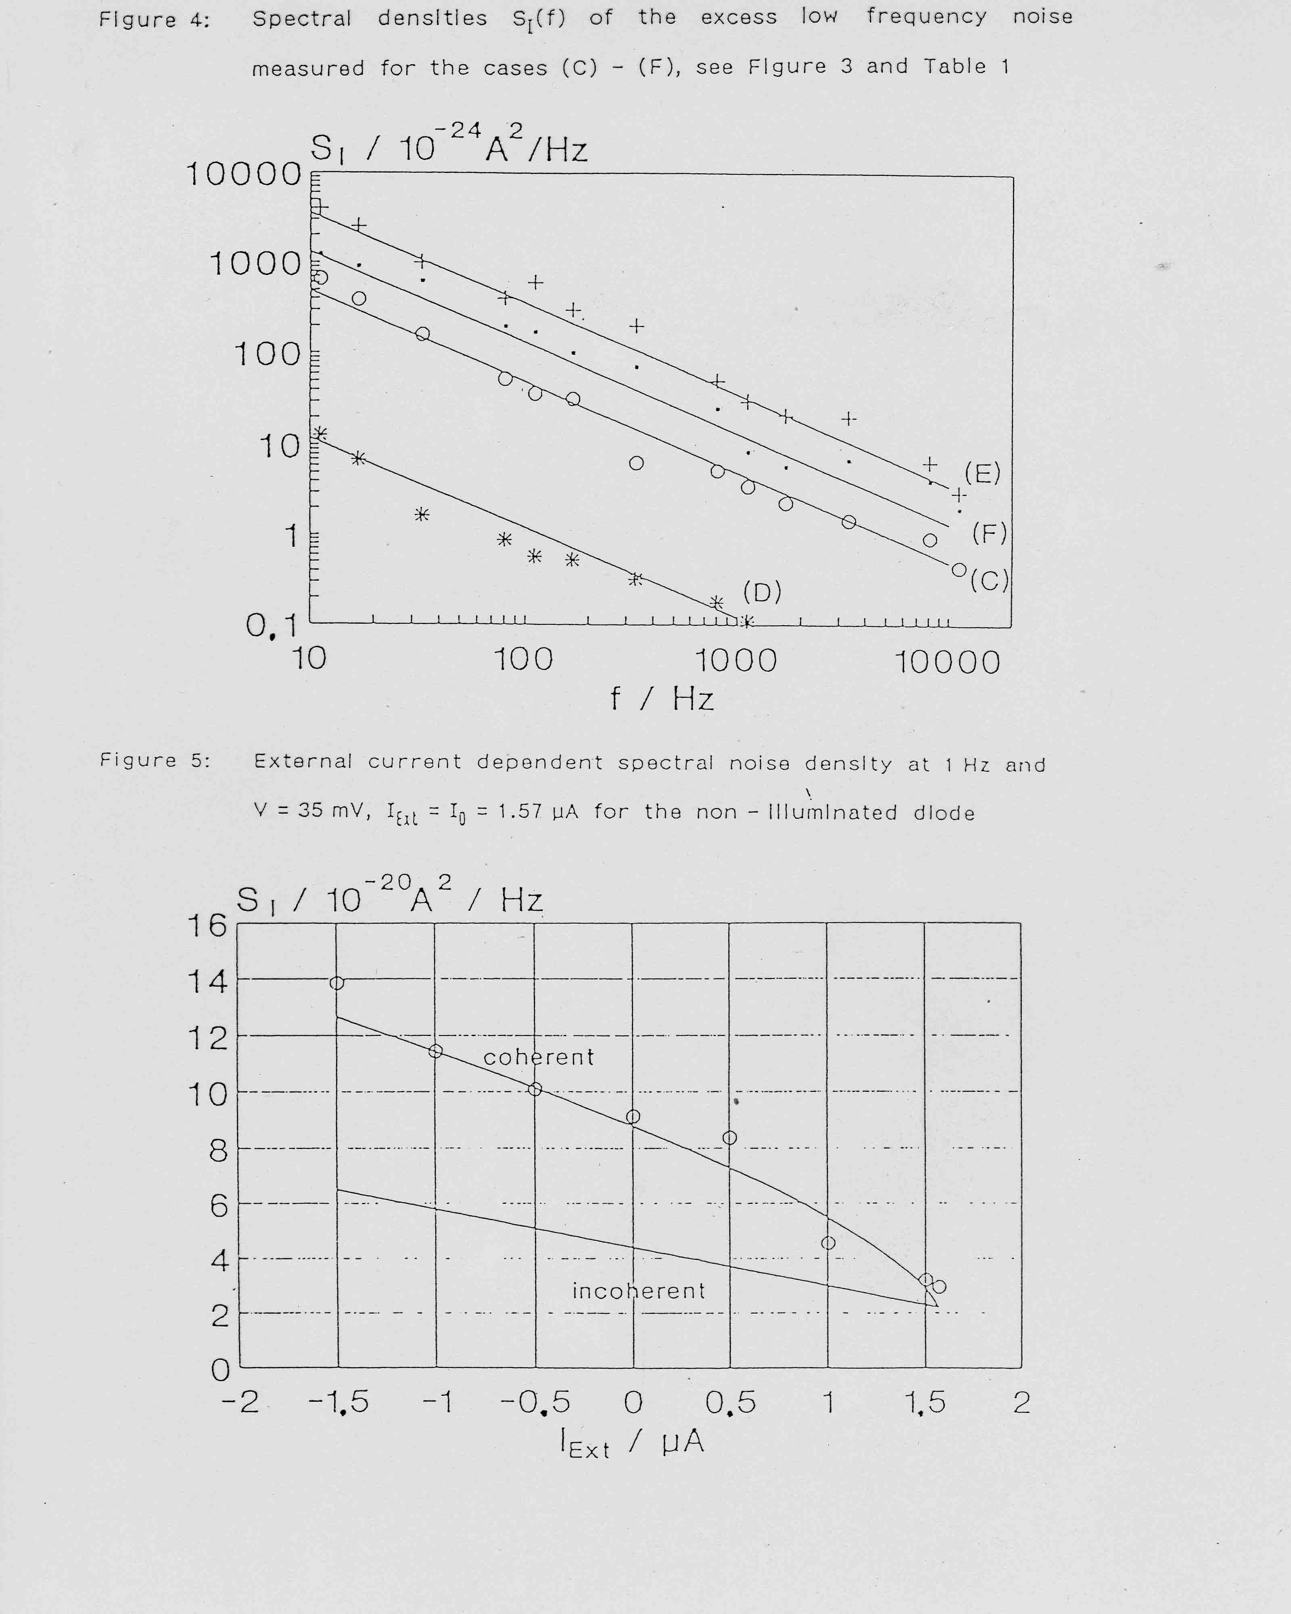
Fig. 6: 1/f Current noise spectrum at 1 Hz and the coherent Q1/fE prediction (solid line)at V=35 mV and I_{Ext}≈I_{o}=1.57 μA in the non-illuminated HgCdTe diode.

As part of the Ultra-Low Phase Noise MURI, engineering formulas for the Q1/fE in GaN/AlGaN HFETs were developed and used for device and system (oscillator) phase noise optimization. Part of these new results are in press [36], part were submitted to the planned Blue Sky Issue of IEEE Proceedings. Additional reviews have been incorporated in larger volumes [37], [38].
A number-theoretical model of the transition from white noise to 1/f frequency noise, based on the properties of the 1/ζ(s) function close to s=1/2 was developed by Planat [39]. The connection of the number-theoretical approach to 1/f noise with the Q1/fE was explored in [40]. The fractal properties of quantum 1/f noise have also been explored [41]. Most important, the behavior (and possible reduction in qubit decoherence) under the influence of strong and sufficiently fast pulses applied to the quantum systems was recently studied by Shiokawa and Lidar [42]. Finally, a more complete Quantum 1/f Bibliography with references to many additional practical applications is available [43].

8. CONCLUSIONS

The following conclusions can be drawn from our results:
-- Macroscopic quantum interference is present both in the conventional and coherent quantum 1/f effect and is a simple way to describe the quantum fluctuations characterizing a non-stationary quantum state of the nonlinear system of particle and field.
-- The quantum 1/f effect appears to generate entropy, but this is only because we do not observe the negative conditional entropy contribution of the emitted soft bremsstrahlung photons, or of the oscillator states present in the photon cloud of a physical charged particle. The latter applies to the coherent Q1/fE.
-- The quantum 1/f effect contains Planck's constant in the denominator and diverges in the classical limit. This is connected with the fact that the Q1/fE is observable in the low frequency limit, while other quantum effects appear at high frequencies.
-- The quantum 1/f effect represents a new aspect of quantum physics. Indeed, it requires the notion of physical cross sections and process rates whose quantum expectation values yield the usual definition of cross sections and process rates. The physical quantities contain in addition the macroscopic quantum fluctuations known as quantum 1/f fluctuations.
-- The quantum 1/f effect is a form of quantum chaos, arising only from spontaneous bremsstrahlung.
-- The quantum /f effect limits most high-technology applications and devices. Its knowledge allows us to optimize materials, devices and systems, based on the simple quantum 1/f formulas introduced earlier.
The authors acknowledge the support of the ARO, through Drs. D. Woolard and C. Fazi.

References

[1] P.H. Handel: "Instabilities, Turbulence and Flicker-Noise in Semiconductors I-III, Turbulence in Semiconductor Plasma and Flicker-Noise", Z.f. Naturforsch 21a, 561-593 (1966).
[2] P.H. Handel: "Turbulence Theory for the Current Carriers in Solids and a Theory of 1/f Noise", Phys. Rev. A3, 2066-2073 (1971).
[3] F.N. Hooge, “1/f Noise is no Surface effect” Phys. Lett., 29A, 139 (1969); “1/f noise” Physica 83B, 19 (1976).
[4] P.H. Handel: "1/f Noise - an 'Infrared' Phenomenon", Phys. Rev. Letters 34, 1492-1495 (1975).
[5] P.H. Handel: "Nature of 1/f Phase Noise", Phys. Rev. Letters 34, 1495-1498 (1975).
[6] P.H. Handel: "Quantum Approach to 1/f Noise", Phys. Rev. 22A, 745-757 (1980).
[7] T. Sherif and P.H. Handel: "Unified Treatment of Diffraction and 1/f Noise", Phys. Rev. A 26, 596-602 (1982).
[8] P.H. Handel and D. Wolf: "Characteristic Functional of Quantum 1/f Noise", Phys. Rev. A26, 3727-30 (1982).
[9] P.H. Handel: "Infrared Divergences, Radiative Corrections and Bremsstrahlung in the Presence of a Thermal Equilibrium Radiation Background", Phys. Rev. A38,.3082-3085 (1988).
[10] G.S. Kousik, C.M. van Vliet, G. Bosman and P.H. Handel: "Quantum 1/f Noise Associated with Ionized Impurity Scattering and Electron-phonon Scattering in Condensed Matter", Advances in Physics 34, 663-702 (1985).
[11] P.H. Handel: "The Quantum 1/f Effect and the General Nature of 1/f Noise", Archiv für Elektronik und Übertragungstechnik (AEÜ) 43, 261-270 (1989); invited paper.
[12] C.M. Van Vliet: "Quantum Electrodynamical Theory of Infrared Effects in Condensed Matter. I.: Radiation Damping of Cross Sections and Mobility." Physica A, 165, 101-125 (1990).
[13] C.M. Van Vliet: "Quantum Electrodynamical Theory of Infrared Effects in Condensed Matter. II.: Radiation Corrections of Cross Sections and Scattering Rates and Quantum 1/f Noise." Physica A, 165, 126-155 (1990).
[14] A. van der Ziel: "Noise in Solid State Devices and Circuits", J. Wiley, New York 1986, Ch. 11, pp. 254 - 277.
[15] A. van der Ziel: "Semiclassical Derivation of Handel's Expression for the Hooge Parameter", J. Appl. Phys. 63, 2456-2457 (1988).
[16] A. van der Ziel: "The Experimental Verification of Handel's Expressions for the Hooge Parameter", Solid State Electronics, 31, 1205-1209 (1988).
[17] A. Van der Ziel, "Unified Presentation of 1/f Noise in Electronic Devices; Fundamental 1/f Noise Sources", Proc. IEEE 76, 233-258 (1988); review paper.
[18] P.H. Handel: "The Nature of Fundamental 1/f Noise", XII. Internatl. Conf. on Noise in Physical Systems and 1/f Fluctuations, St. Louis, MO, Aug. 16-20, 1993, AIP Conf. Proceedings No. 285, P.H. Handel and A.L. Chung, Editors, pp. 162-171 (1993).
[19] P.H. Handel: "Fundamental Quantum 1/f Noise in Semiconductor Devices", IEEE Trans. on Electr. Devices 41, 2023-2033 (1994).
[20] P.H. Handel: “1/f Noise Universality in High-Technology Applications”, Proc. 1994 IEEE Internatl. Frequency Control Symp., June 1-3, 1994, Boston, MA, L. Maleki, Editor (Plenary Invited paper) IEEE Press, IEEE Catalog No. 94CH3446-2, Library of Congress No. 87-654207, pp. 8-21.
[21] P.H. Handel: "Coherent and Conventional Quantum 1/f Effect" Physica Status Solidi b194, pp. 393-409 (1996)
[22] P.H. Handel, "Any particle represented by a coherent state exhibits 1/f noise" in "Noise in physical systems and 1/f noise", edited by M. Savelli, G. Lecoy and J.P. Nougier (North - Holland, Amsterdam, 1983), p. 97.
[23] P.H. Handel, "Coherent states quantum 1/f noise and the quantum 1/f effect" in "Proceedings of the VIIIth international conference on noise in physical systems and 1/f noise" (Elsevier, New York, 1986), p.469
[24] J.D. Dollard, J. Math. Phys. 5, 729 (1965).
[25] Chung, V., “Infrared Divergence in Quantum Electrodynamics”, Phys. Rev. 140B , 1110-1122 (1965)
[26] Jauch, J.M. and Rohrlich, F., The Theory of Photons and Electrons (Springer, Heidelberg, 1976)
[27] D. Zwanziger, Phys. Rev. D7, 1082 (1973); Phys. Rev. Lett. 30, 934 (1973); Phys. Rev. D11, 3481 and 3504 (1975).
[28] T.W.B. Kibble, Phys. Rev. 173, 1527; 174, 1882; 175,1624 (1968); J. Math. Phys. 9, 315 (1968).
[29] N. Cerf and C. Adami, Phys. Rev. Lett. 79, 5194 (1997).
[30] A.G. Tournier and P.H. Handel, “Quantum 1/f Noise and Quantum 1/f Phase Noise Related to the Uncertainty Relations” in this volume.
[31] J.S. Gradshteiyn and I.M. Ryzhik, "Table of Integrals, Series and Products" Sec. 3.761, No. 9 and No. 7, Academic Press, New York 1965.
[32] M. Athiba Azhar and K. Gopala: "1/f Fluctuations in β-decay of 90Y", Phys. Rev A43, pp. 1044-1048, (1990). [33] M. Athiba Azhar and K. Gopala: "1/f Noise in the Radioactive β Decay of Tl204" Phys. Rev. A 39, 4137-4139 (1989).
[34] M. Tacano, K. Tamisawa, H. Tanoue and Y. Sugiyama: "Dependence of Hooge Parameter of Compound Semiconductors on Temperature", Jpn. J. Appl. Phys. 31 232-235 (1992).
[35] Möllmann, K.-P.; Happ, M.; Herrmann, K.-H.: "Evidence of coherent quantum 1/f noise in long n+p diffusion current dominated (Hg,Cd)Te photodiodes." Optical Engineering, May 1994, vol.33, (no.5):1429-33.
[36] P.H. Handel, A.G. Tournier and B. Henning: “Quantum 1/f Effect in Resonant Biochemical Piezoelectric and MEMS Sensors”, IEEE Transactions on Ultrasonics, Ferroelectrics, and Frequency Control, Accepted for publication.
[37] P.H. Handel: “Noise, Low Frequency”, Wiley Encyclopedia of Electrical and Electronics Engineering, vol. 14, pp. 428-449, John Wiley & Sons, Inc., John G. Webster, Editor, 1999.
[38] P.H. Handel: “Noise” in Survey of Semiconductor Physics (K.W. Böer Editor) IInd Edition, Vol.2, J. Wiley & Sons 2002, pp. 203-219.
[39] M. Planat: “1/f Frequency noise in a Communication receiver and the Riemann Hypothesis.” CNRS Thematic Spring School on Frequency Noise in Ocillators and Dynamics of Algebric Numbers, Chapelle Des Bois, France, M. Planat Editor, Published in pp. 265-287 of the book “Noise, Oscillators and Algebraic Randomness” by Springer Publ. Co., Berlin, Heidelberg, 2000.
[40] P.H. Handel: “The general nature of fundamental 1/f noise in oscillators and in the high-technology domain” CNRS Thematic Spring School on Frequency Noise in Ocillators and Dynamics of Algebric Numbers, Chapelle Des Bois, France, M. Planat Editor, Published in pp. 233-264 of the book “Noise, Oscillators and Algebraic Randomness” by Springer Publ. Co., Berlin, Heidelberg, 2000.
[41] P.H. Handel, X. Hu, T.F. George and L. Nánai: “Fractal Dimension of Quantum 1/f Noise Samples” J. Chaos, Solitons & Fractals, 23, 1-4, (2004).
[42] K. Shiokawa and D.A. Lidar: ), "Dynamical Decoupling Using Slow Pulses: Efficient Suppression of 1/f Noise," Phys. Rev. A Rapid Comm. 69, 030302 (2004).
[43] See the General Quantum 1/f Bibliography at www.umsl.edu/~handel.

